Jessica Gallo

CSC715 Database

Prof. Chi

November 5, 2021

Problem Set 4

Q1: Find the names of all professors who are not students but took at least one course.

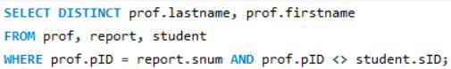 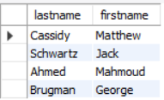

Q2: Find the sID and names of all students who are not in the CS department who took a CS course. Also find the cnum and name the course and the secnum, term, and grade the student received.

SELECT distinct sID, firstname, lastname, se.cnum

FROM student st, report r, section se

WHERE st.dept = 'CS' AND st.sID = r.snum AND r.secnum = se.secnum AND se.cnum LIKE 'CSC%';

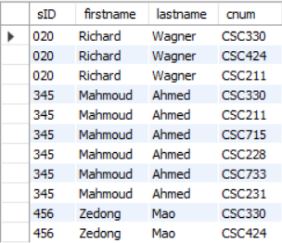

Q3: Find the names of all students who have taken every CS course

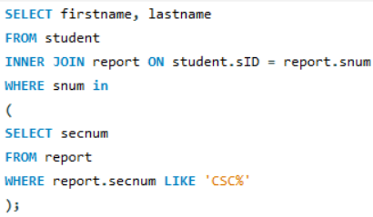



Q4: Find the names of all students all of whose grades are better than 'C'

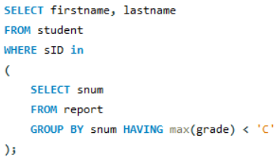



Q5: Find two students who each took at least two identical courses (possibly different sections) in the same department and who got the same grade in the lower-level course but different grades in the higher level course.

Q6: find the course numbers and names of all courses taken by at least one student who has taken CSC424

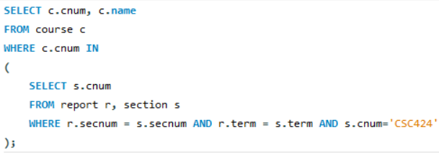

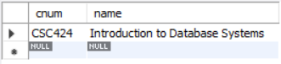

Q7: Find all students who took two courses in the same department and got a better grade in the higher-level course

Q8: Find all pairs of one professor and one student who each took at least two identical courses (possibly different secnums and different terms) in the same department and who got the same grade in the lower level course but different grades in the higher level course.

Retrieve and print the pID of the prof, the sID of the student, their last names, the cnum, secnum, term, and grade of each of the courses they took.

e.g. in the current dataset, professor Ali and student Lincoln satisfy this query.

