Jessica Gallo

CSC715 Database

Prof. Chi

November 12, 2021

Problem 5

1. Find the names and partner's names of all hamsters who have partners of the same gender. *Note:* A hamster may have many partners who can be either gender. Sort by gender, then by name within each gender. Alex and King are an example.

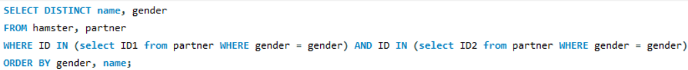

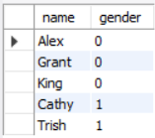

1. Find the names and partner's names of all hamsters who **only** have partners of the same gender. *i.e.* they have no partners with the opposite gender. Sort by gender, then by name within each gender. Cathy and Amy are an example

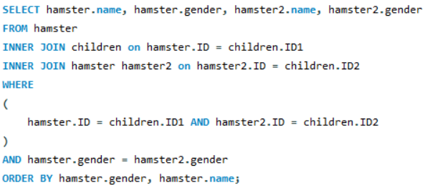

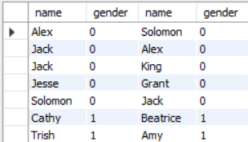

1. For every situation where hamster A has a child B, but we have no information about whether B has children (that is, B does not appear as an ID1 in the Children table), return A and B's names and gender. Sort by parent's gender then by parent's name within each gender. Trish and Amy are an example.

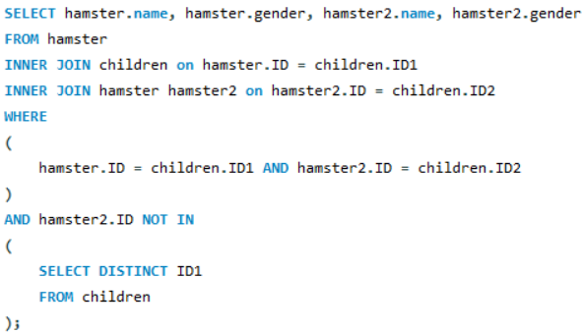

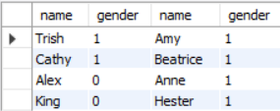

1. Find the names and gender of all hamsters who are not a child of any hamster in the lab (*i.e.* do not appear as ID2 in the Children table. Sort by gender, then by name within each gender. Donald is an example. Note: repeat of problem on the midterm exam





1. Find the names and gender of all hamsters who are not a parent of any hamster in the lab (*i.e.* do not appear as ID1 in the Children table. Sort by gender, then by name within each gender. Amy is an example.

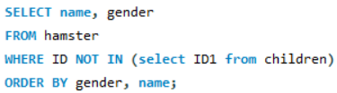

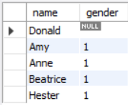

1. Find ID of all of the ancestors of the hamster whose ID is 109.

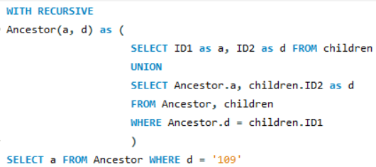

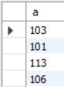

1. Find ID and name of all of the ancestors of the hamster whose name is Amy.

