IT 440 – Spring 2018

Minnesota State University, Mankato

GROUP 7 – CAR RENTAL DATABASE

Nhung Do – Khuzaima Shahid – Ezana Tesfaye – Saiteja Thota

Version 1.0

April 22, 2018

TABLE OF CONTENT

DATABASE 2

Entity Relationship Diagram 2

Assumptions 2

Business Rules 2

Normalization steps 3

Unnormalized Form (UNF) 3

First Normal Form (1NF) 3

Second Normal Form (2NF) 4

Third Normal Form (3NF) 5

SQL SERVER 5

Inner Join Statement 5

Subquery 6

CTE 6

Pivot 7

Clustered Index 8

MYSQL 8

WEB FORM 10

Login Page 10

Authentication 10

About Page 11

Dashboard 11

Logout Page 12

# DATABASE

## Entity Relationship Diagram

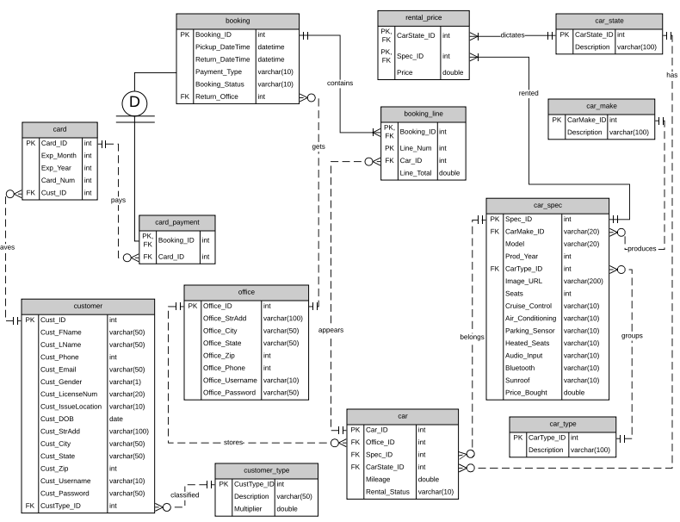

## Assumptions

The business only accepts card payments.

The rented car can be returned at another office different from the original office.

The customer type determines what multiplier will be applied to the total charge. The multiplier includes discounts, insurance, fees if any.

## Business Rules

One booking must have at least one booking line.

One car may appear on many booking lines. One booking line must contain only one car.

One card may pay many card payments. One card payment must be paid by only one card.

One car make may produce many car specs. One car spec must be produced by only one car make.

One car state may have many cars in it. One car must belong to only one car state.

One car type may have many car specs. One car spec must belong to only one car type.

One customer may have many cards on profile. One card must belong to only one customer.

One customer type may include many customers. One customer must be categorized into only one customer type.

One office may store many cars. One car must be present at only one office.

One office may appear on many bookings. One booking must have only one office to return the car to.

One car spec may belong to many cars. One car must have only one car spec.

One car state may dictate many rental prices. One rental price must be dictated by only one car state.

One car spec may dictate many rental prices. One rental price must be dictated by only one car spec.

## Normalization steps

### Unnormalized Form (UNF)

In the unnormalized form, all information regarding car rentals is in one big table including the following columns:

Booking_ID  
Line_Num  
Car_Make  
Model   
Prod_Year  
Car_Type  
Car_Spec  
Image_URL  
Seats  
Cruise_Control  
Air_Conditioning  
Parking_Sensor  
Heated_Seats  
Audio_Input  
Bluetooth  
Sunroof  
Price_Bought  
Office_StrAdd  
Office_City  
Office_State  
Office_Zip  
Office_Phone  
Office_Username  
Office_Password  
Car_State  
Mileage  
Line_Total  
Pickup_DateTime  
Return_DateTime  
Payment_Type  
Booking_Status  
Return_Office  
Cust_Fname  
Cust_Lname  
Cust_Phone  
Cust_Email  
Cust_Gender  
Cust_LicenseNum  
Cust_IssueLocation  
Cust_DOB  
Cust_StrAdd  
Cust_City  
Cust_State  
Cust_Zip  
Cust_Username  
Cust_Password  
Cust_Type  
Multiplier

For each booking record there are details about the car to be rented, the office the car is at, the customer that is renting the car, and the booking details.

### First Normal Form (1NF)

The first step in normalizing a relation is to remove the repeating groups. The unnormalized relation is broken into 4 separate relations:

1. **Relation beween booking and booking details**

Booking_ID Line_Num Line_Total Pickup_DateTime Return_DateTime Payment_Type Booking_Status Return_Office Car_ID Card_ID

This relation contains all the attributes that were not repeating.

1. **Relation between booking and car**

Booking_ID Line_Num Car_ID Car_Make Model Prod_Year Car_Type Car_Spec Image_URL Seats Cruise_Control Air_Conditioning Parking_Sensor Heated_Seats Audio_Input Bluetooth Sunroof Price_Bought Mileage Car_State

In this relation, one must use a concatenated key to access the repeating data regarding the car rented.

1. **Relation between booking and customer**

Booking_ID Line_Num Card_ID Cust_ID Cust_FName Cust_LName Cust_Phone Cust_Email Cust_Gender Cust_LicenseNum Cust_IssueLocation Cust_DOB Cust_StrAdd Cust_City Cust_State Cust_Zip Cust_Username Cust_Password Cust_Type Multiplier

In this relation, one must use a concatenated key to access the repeating data regarding the customer.

1. **Relation between booking and office**

Booking_ID Line_Num Car_ID Office_ID Office_StrAdd Office_City Office_State Office_Zip Office_Phone Office_Username Office_Password

In this relation, one must use a concatenated key to access the repeating data regarding the office.

### Second Normal Form (2NF)

In the second normal form, all the attributes will be functionally dependent on the primary key. Therefore, the next step is to remove all the partially dependent attributes and place them in another relation.

Booking_ID Pickup_DateTime Return_DateTime Payment_Type Booking_Status Return_Office Card_ID

Booking_ID Line_Num Line_Total Car_ID

Car_ID Car_Make Model Prod_Year Car_Type Car_Spec Image_URL Seats Cruise_Control Air_Conditioning Parking_Sensor Heated_Seats Audio_Input Bluetooth Sunroof Price_Bought Mileage Car_State

Cust_ID Cust_FName Cust_LName Cust_Phone Cust_Email Cust_Gender Cust_LicenseNum Cust_IssueLocation Cust_DOB Cust_StrAdd Cust_City Cust_State Cust_Zip Cust_Username Cust_Password Cust_Type Multiplier

Office_ID Office_StrAdd Office_City Office_State Office_Zip Office_Phone Office_Username Office_Password

### Third Normal Form (3NF)

A normalized relation is in the third normal form if all the nonkey attributes are fully functionally dependent on the primary key and there are no transitive (nonkey) dependencies.

Booking_ID Pickup_DateTime Return_DateTime Payment_Type Booking_Status Return_Office

Booking_ID Line_Num Car_ID Line_Total

Car_ID Spec_ID Office_ID CarState_ID Mileage

Spec_ID CarMake_ID Model Prod_Year CarType_ID Image_URL Seats Cruise_Control Air_Conditioning Parking_Sensor Heated_Seats Audio_Input Bluetooth Sunroof Price_Bought

CarMake_ID Description

CarState_ID Description

CarType_ID Description

Card_ID Exp_Month Exp_Year Card_Num Cust_ID

Booking_ID Card_ID

Cust_ID Cust_FName Cust_LName Cust_Phone Cust_Email Cust_Gender Cust_LicenseNum Cust_IssueLocation Cust_DOB Cust_StrAdd Cust_City Cust_State Cust_Zip Cust_Username Cust_Password CustType_ID

CustType_ID Description Multiplier

Office_ID Office_StrAdd Office_City Office_State Office_Zip Office_Phone Office_Username Office_Password

CarState_ID Spec_ID Price

# SQL SERVER

## Inner Join Statement

--list revenue collected by each office

SELECT c.Office_ID, SUM(bl.Line_Total) AS Revenue

FROM car_rental.booking_line AS bl

INNER JOIN car_rental.booking AS b

ON bl.Booking_ID = b.Booking_ID

INNER JOIN car_rental.car AS c

ON c.Car_ID = bl.Car_ID

GROUP BY c.Office_ID

ORDER BY Office_ID;  
GO

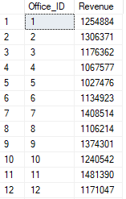

## Subquery

--list all cars along with their IDs, types, models and production years

SELECT Car_ID AS 'Car ID', CarType AS 'Type', CarMake AS 'Make', Model, Prod_Year AS 'Production Year'

FROM (

SELECT c.Car_ID, t.Description AS CarType, m.Description AS CarMake, s.Model, s.Prod_Year

FROM car_rental.car AS c

INNER JOIN car_rental.car_spec AS s

ON c.Spec_ID = s.Spec_ID

INNER JOIN car_rental.car_make AS m

ON s.CarMake_ID = m.CarMake_ID

INNER JOIN car_rental.car_type AS t

ON s.CarType_ID = t.CarType_ID

) AS p

GO

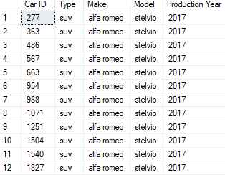

## CTE

--list car models that are rented for more than 300 per day

;WITH Car_CTE(Make, Model, Price) AS

(

SELECT m.Description AS 'Make', sp.Model, p.Price

FROM car_rental.rental_price AS p

INNER JOIN car_rental.car_spec AS sp

ON sp.Spec_ID = p.Spec_ID

INNER JOIN car_rental.car_make AS m

ON sp.CarMake_ID = m.CarMake_ID

)

SELECT *

FROM Car_CTE

WHERE Price > 300;  
GO

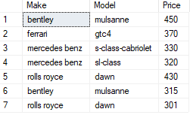

## Pivot

--pivot to list number of orders at each branch in April, May, June

SELECT Office_ID, [4] AS April, [5] AS May, [6] AS June

FROM (

SELECT c.Office_ID, b.Booking_ID, DATEPART(M, b.Pickup_DateTime) AS PickupMonth

FROM car_rental.booking AS b

INNER JOIN car_rental.booking_line AS bl

ON b.Booking_ID = bl.Booking_ID

INNER JOIN car_rental.car AS c

ON bl.Car_ID = c.Car_ID

) AS piv

PIVOT (

COUNT(Booking_ID) FOR PickupMonth IN([4], [5], [6])

) AS p

ORDER BY p.Office_ID;  
GO

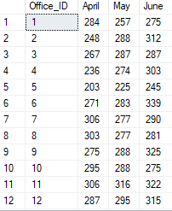

## Clustered Index

--create an index on customer table using the first name column

CREATE CLUSTERED INDEX CustomerIndex

ON car_rental.customer (Cust_FName DESC);

--list customers with first name Dakota along with their birthdate and customer type

SELECT Cust_FName, Cust_LName, Cust_DOB, Description AS 'Type'

FROM car_rental.customer AS c WITH (INDEX(CustIndex))

INNER JOIN car_rental.customer_type AS t

ON c.CustType_ID = t.CustType_ID

WHERE Cust_FName = 'Dakota';

GO

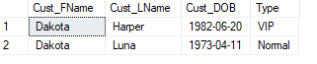

# MYSQL

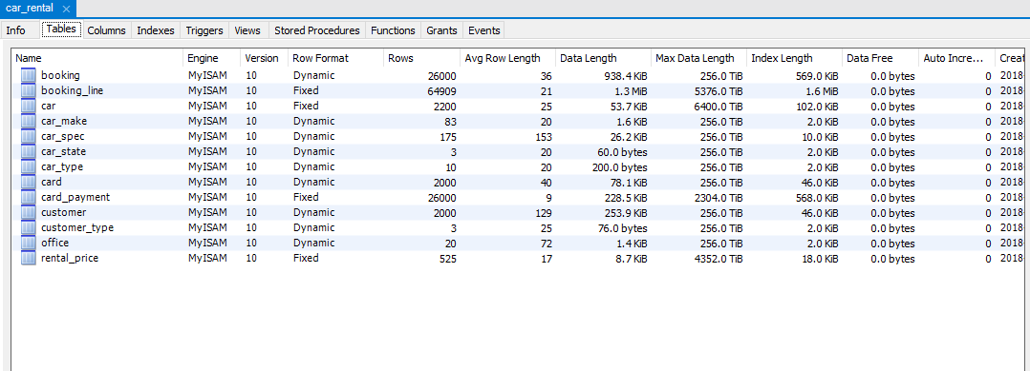

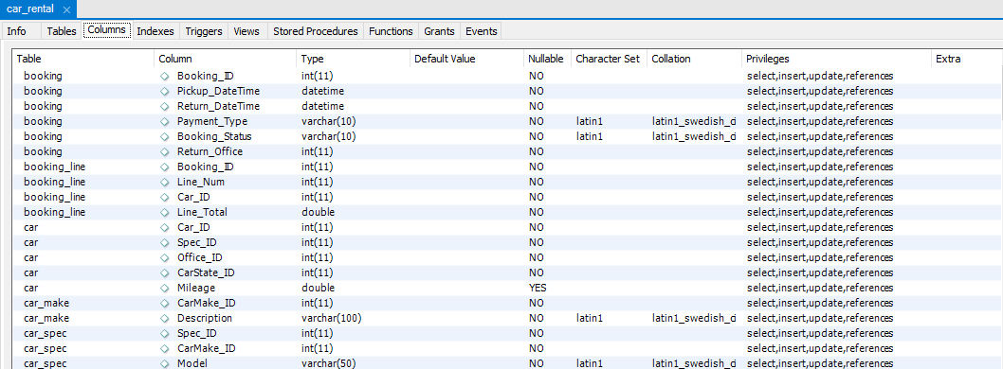

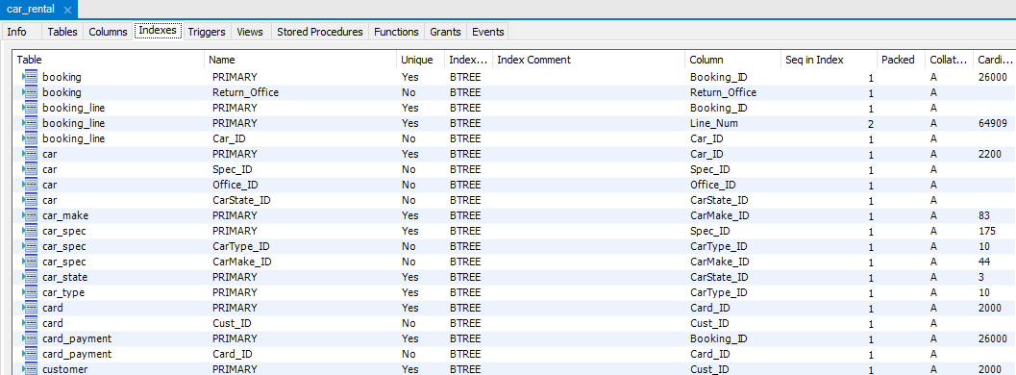

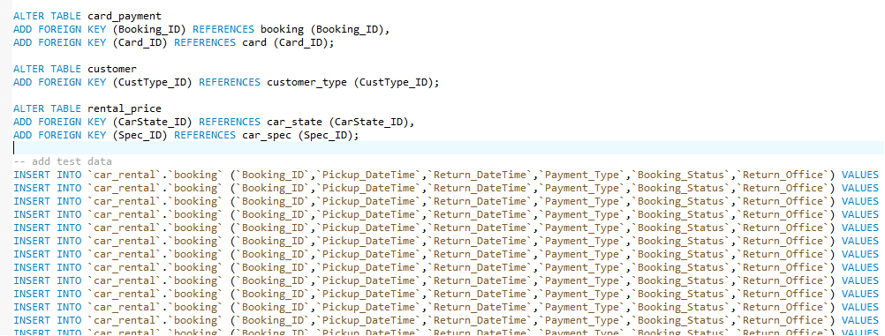

# WEB FORM

## Login Page

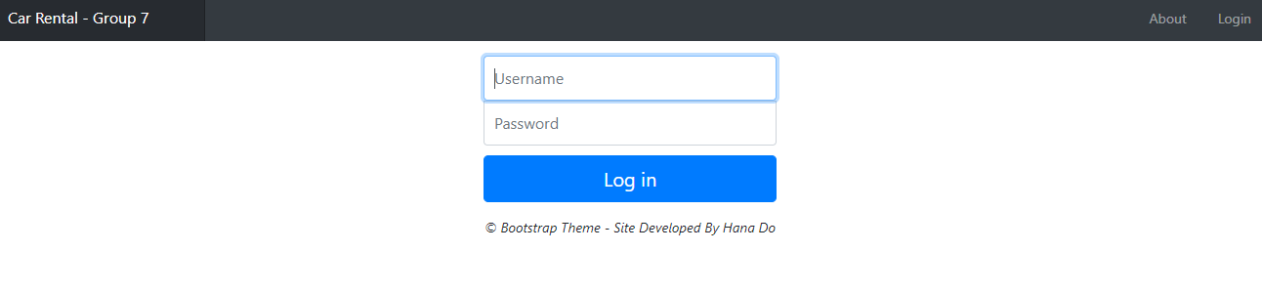

## Authentication

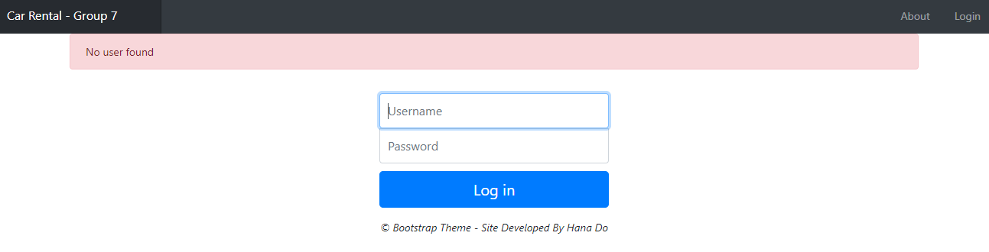

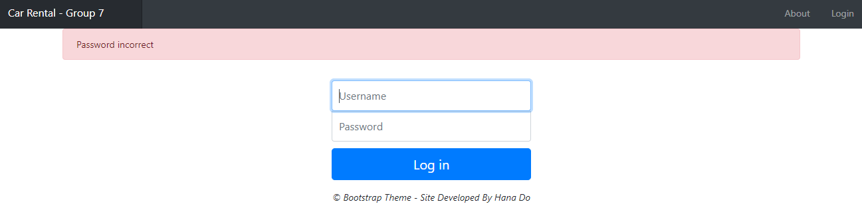

## About Page

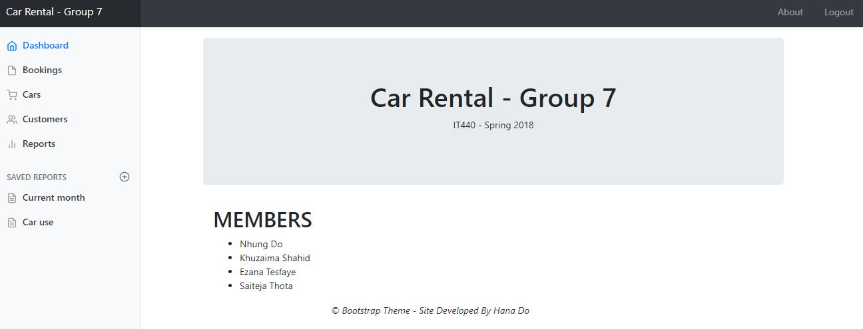

## Dashboard

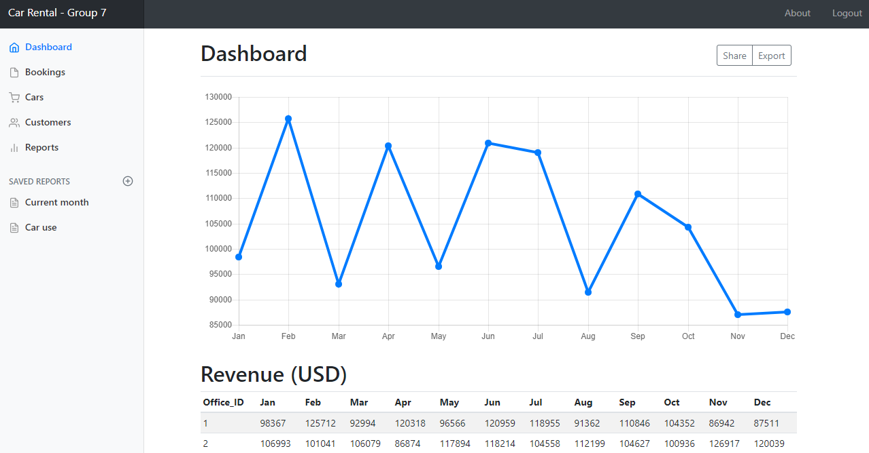

## Logout Page

