JUNSON Capital Research
Private Credit Quarterly Report (2026Q3)
Coverage: private credit / direct lending / BDC / MM CLO 13 Aug, 2026
Market Size
Private credit market size
Global private debt AUM has reached approximately US$2,557bn, of which the institutional channel accounts for 77.1% (~US$1,971bn), retail 15.5% (~US$396bn) and the insurance estimate 7.4% (~US$189bn). Institutional AUM has grown from US$601bn in 2015 (dry powder US$241.0bn + NAV US$360.2bn) to ~US$1,970bn as of mid-2025 (dry powder US$618.2bn + NAV US$1,352.1bn).
Exhibit 1: Private debt AUM (US$bn) by channel, 2015–2025
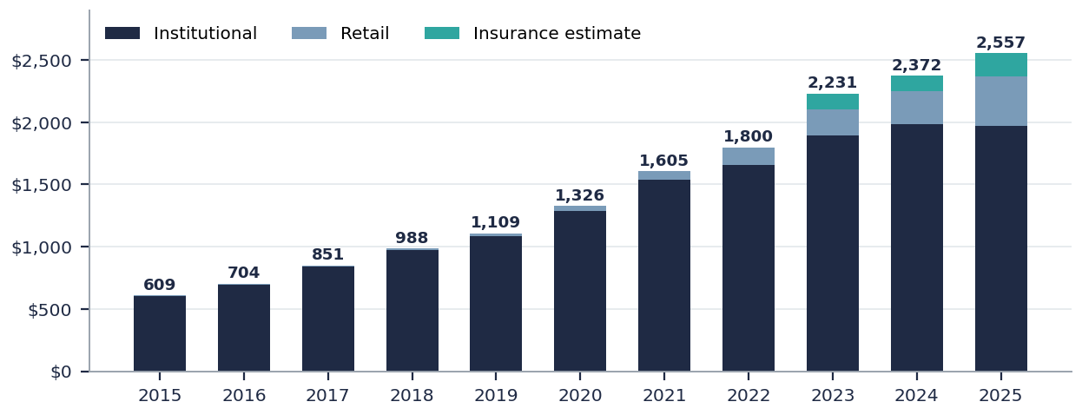
Note: Institutional bars are exact PitchBook values (dry powder + NAV); the retail / insurance split is approximated from the source chart for earlier years, with 2025 exact (total US$2,557bn). Source: PitchBook.
Within the US, the leveraged credit market totalled approximately US$4.4tn in 1Q26: leveraged loans US$1.5tn (35%), high yield US$1.5tn (33%) and private credit US$1.4tn (32%). Within private credit, BDCs hold 38%, direct lending funds 29%, PC CLOs 14%, pensions 11% and insurers 8%.
Exhibit 2: US leveraged credit market in 1Q26 — total US$4.4tn
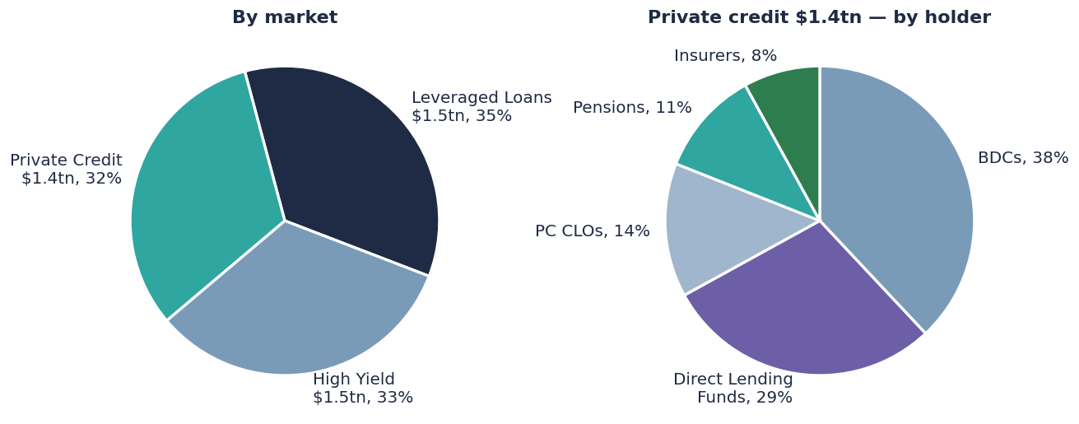
Note: Left: by market; right: holders of the US$1.4tn private credit stack. All values as labelled in the source. Source: PitchBook | LCD, MS Research.
Supply side
Dry powder peaked in 2024 at US$634.8bn and edged down to US$618.2bn by mid-2025. On the newly added dry powder as % of NAV measure, the ratio has declined steadily from 66.9% in 2015 to 45.7% in mid-2025, indicating a shift from fundraising-driven growth to deployment of existing capital. The contraction is clearer on the fundraising side: 2025 global private debt fundraising was US$221.2bn across only 206 funds, down 30% and 60% respectively from the 2021 peak (US$318.2bn / 511 funds), with fund count also far below the 2022 record of 568.
Exhibit 3: Private debt institutional fund AUM (US$bn)  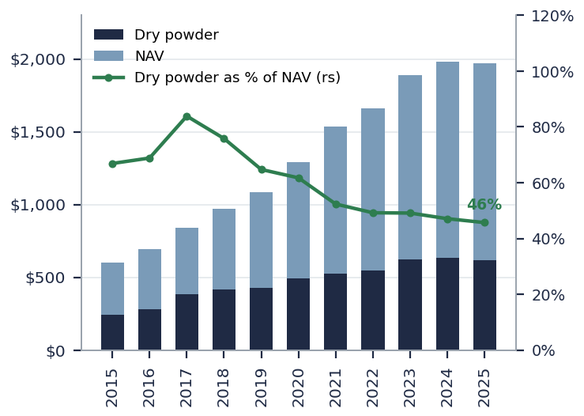  Note: NAV + dry powder are exact values; the dry powder as % of NAV line (right scale) is newly added this quarter, calculated by Junson. Source: PitchBook. | Exhibit 4: Private debt fundraising activity  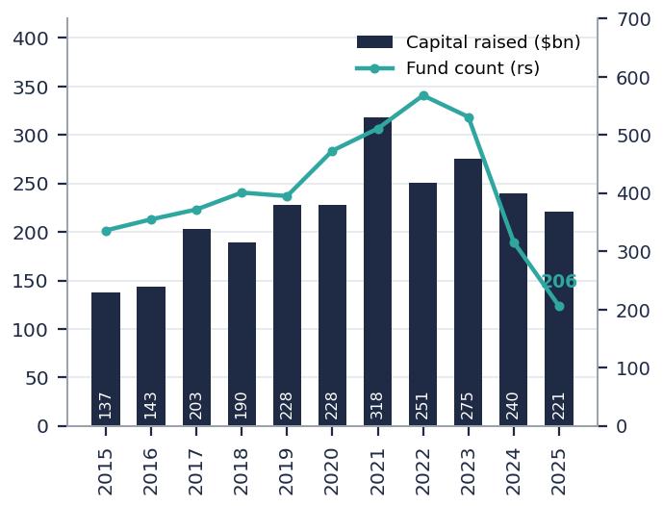  Note: Capital raised (US$bn) and fund count are exact values, as of 12/31/2025. Source: PitchBook.
Demand side
Private credit remains dominant in LBO financing: on an LTM count basis it financed roughly 80–83% of LBOs as of 1Q26, after peaking near ~90% in early 2023. Absolute volumes are weakening, however: KBRA tracked ~US$87bn of direct lending originations YTD 2026, down 24% y/y, with the refi share holding around 40% since 2024. 2Q26 was weaker still: LCD recorded US$33bn across 149 direct lending deals, versus US$74.1bn across 217 deals in 1Q26 — the highest-volume quarter in two years.
Exhibit 5: Direct lending origination (US$bn, monthly)  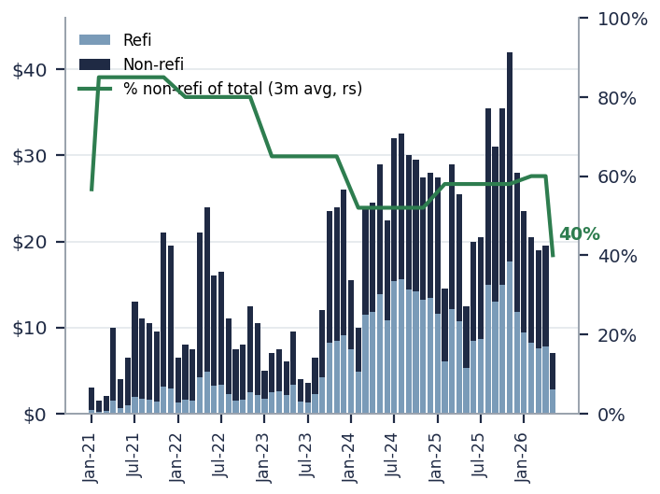  Note: Monthly refi / non-refi values are digitised approximations; the % non-refi share of total (right scale, 3m average) is calculated by Junson from those approximations. The 2026 YTD total of ~US$87bn (-24% y/y) is as disclosed in the source. Source: KBRA, MS Research. | Exhibit 6: LBOs financed in BSL vs private markets (by count)  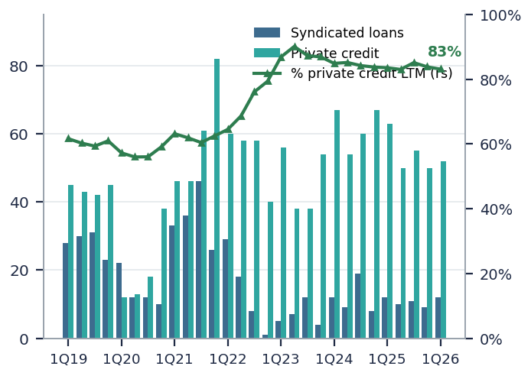  Note: Bar values are digitised approximations from the source chart; the % private credit LTM line (right scale) is computed by Junson from those approximations (ends ~83%). Source: PitchBook | LCD, MS Research.
Fund flow
MM CLOs remain a key source of leverage for direct lending. 2026 YTD (through March) MM CLO new issuance was US$9.54bn, down 5.9% y/y (US$10.13bn in the prior-year period); full-year 2025 issuance of US$38.50bn was broadly flat versus the 2024 record of US$39.71bn, and MM CLOs accounted for 21.48% of total CLO new issue. On pricing, the average MM CLO 'AAA' spread has compressed from ~265bp in 2023 to ~150bp in early 2026, but widened modestly at the end of 1Q26 as the basis versus BSL CLOs widened.
Exhibit 7: US MM CLO new issuance and avg. MM CLO 'AAA' spread
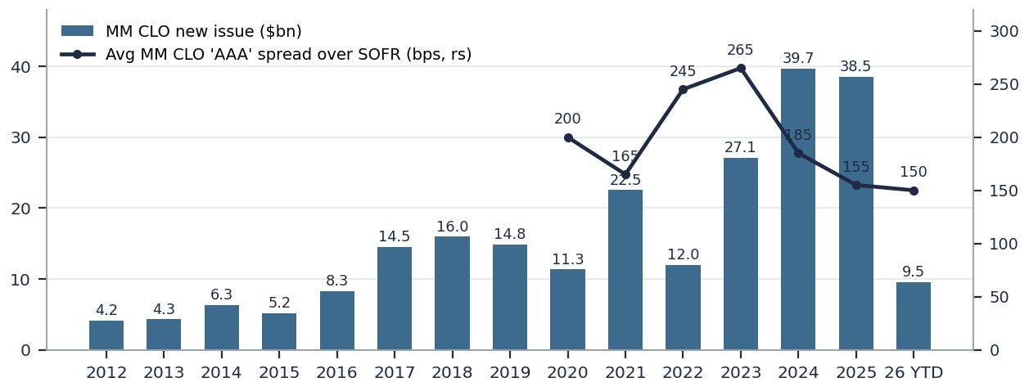
Note: Annual issuance bars are exact values; the 'AAA' spread line (bps over SOFR, right scale) uses annual averages approximated from the source chart. Per the framework, only MM CLO and its spread are shown. Source: S&P Global Ratings, LevFin Insights.
Returns & Relative Value
Direct lending quarterly return vs. HY
From 2015 through March 2026, private debt (all) delivered a 7.8% annualised return with 2.2% annualised volatility and a 3.6 Sharpe ratio — well ahead of HY (5.3% / 8.0% / 0.7) and all BSL (5.0% / 6.0% / 0.8). Note, however, that PD returns are fair-value based and therefore smoothed, and the correlation with BSL is high at 82.4%. Direct lending T12M returns moderated to 8.7% as of 1Q26, down 2.2pp from a year ago.
Exhibit 8: Private debt vs public assets: return, volatility and Sharpe (2015 – Mar 2026)
Metric | PD (All) | Lower MM | Upper MM | HY | All BSL | Single B BSL | S&P 500
Annualised return | 7.8% | 8.2% | 8.0% | 5.3% | 5.0% | 5.3% | 13.5%
Annualised volatility | 2.2% | 1.8% | 2.9% | 8.0% | 6.0% | 6.4% | 15.0%
Sharpe | 3.6 | 4.6 | 2.8 | 0.7 | 0.8 | 0.8 | 0.9
Yield (2017–now) | 9.8% | 11.1% | 9.5% | 6.7% | 7.2% | 7.3% | 5.3%
Correlation with PD | – | – | – | 71.7% | 82.4% | 81.4% | 61.3%
Note: Quarterly data through 4Q25; PD returns are fair-value based. Source: Lincoln International VOG, PitchBook | LCD, Bloomberg, MS Research.
On a stock (portfolio) basis, direct lending yields remain above public comparables: Lincoln International's senior debt portfolio yields 9.7% as of 1Q26, 1.3pp above Single B BSL — an illiquidity premium that has persisted through the rate cycle even as both series roll over from their 2023 peaks.
Exhibit 9: Private vs public credit yields: Lincoln senior debt vs Single B loans (quarterly) – add ICE BofA US HY YTW to this exhibit
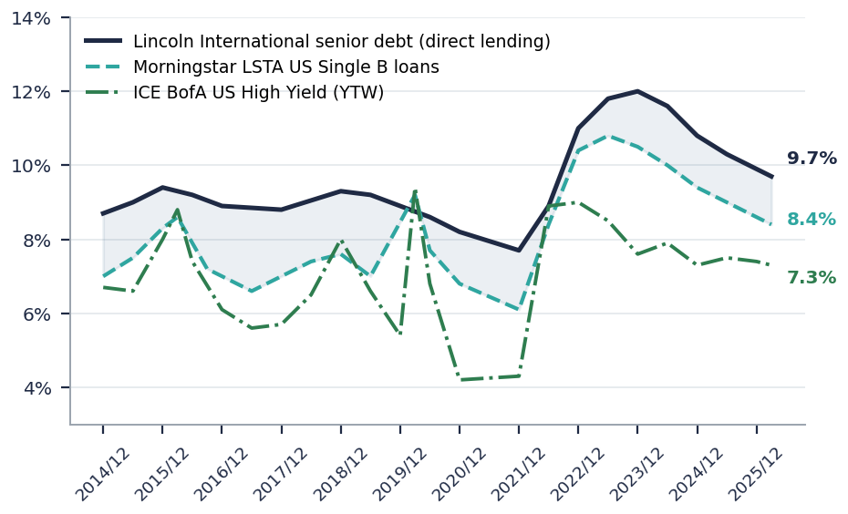

Note: Endpoints 9.7% / 8.4% (1Q26) are as disclosed in the source; intermediate points are digitised approximations. Lincoln yields are fair-value based estimates, not observed market prices. Source: Lincoln International VOG, PitchBook | LCD, MS Research.
Private credit spread premium over BSL
Unitranche new-origination spreads (rolling 90 days) rose to 508bp in May, up from the February trough of 490bp; Single B BSL stood around 430bp, putting the private credit premium at roughly 78bp — narrow by 2022 standards but stabilising and turning higher.
Exhibit 10: DL new origination spreads vs Single B BSL (bps)  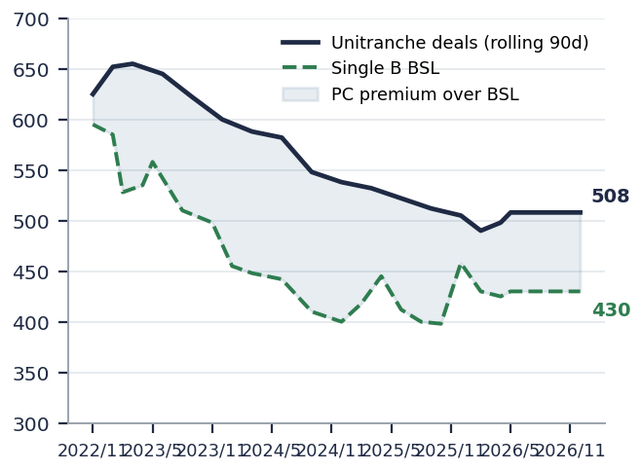  Note: Endpoints of 508bp / 430bp are as labelled in the source; the shaded area is the PC premium; intermediate points are digitised approximations. Source: KBRA, PitchBook | LCD, MS Research. | Exhibit 11: Spread of DL new originations by EBITDA cohort (bps)  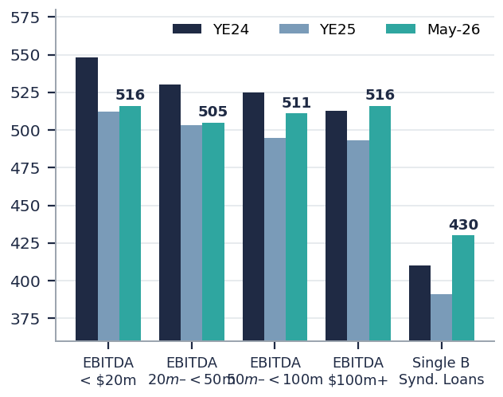  Note: May-26 values are as labelled in the source (516/505/511/516/430); YE24 and YE25 bars are approximated from the source chart. Source: KBRA, PitchBook | LCD, MS Research.
Across EBITDA cohorts, May-26 new-issue spreads converged into a 505–516bp band, with upper MM (EBITDA $100m+) widening most (up ~23bp from ~493bp at YE25), in sync with the BSL sell-off. LCD's 2Q26 data corroborates: plain-vanilla spreads have moved out roughly 25–50bp versus late last year, with a small recent LBO sample averaging S+509 versus S+474 in 1Q26.

Pricing & Term
Spread
Synthesising the above: unitranche new-issue spreads printed 508bp in May versus 430bp for Single B BSL. LCD's survey adds colour: for a $50m-EBITDA business in a non-cyclical industry (40% LTV unitranche), a plurality of 2Q26 respondents saw pricing at S+500–549 and roughly a quarter at S+550–599 — but a plurality also expected the same loan to price below S+500 in six months, suggesting the premium pricing may not last.
Covenant structure & PIK % (share of new deals with PIK toggle)
Terms show the same stratification: cov-lite keeps rising in the upper middle market, where only ~37% of 2024-vintage deals carry at least one financial covenant (vs ~54% in 2021), while the lower MM remains near 100% covenanted. Meanwhile the share of 2024-vintage deals with PIK toggles rose to ~41% in the upper MM and ~22% in the core MM.
Exhibit 12: Financial covenants across vintages and segments (% of deals)  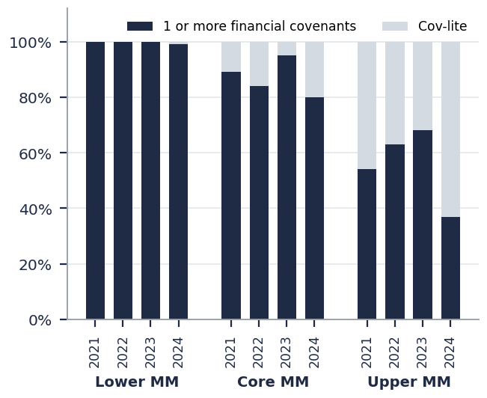  Note: Bar values are approximate readings from the source chart. Source: S&P, MS Research. | Exhibit 13: % of deals with PIK toggle across vintages  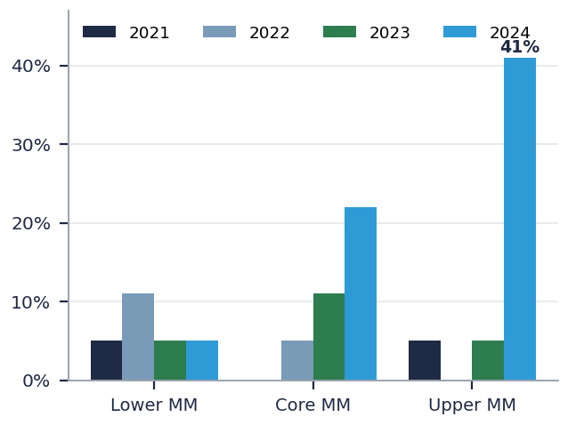  Note: The ~41% upper-MM reading for 2024 is from the source chart; other bars are approximate readings. Source: S&P, MS Research.
Non-sponsored private credit
Non-sponsored borrowers — companies with no private equity backing, typically founder- or family-owned — account for roughly 90% of private companies in the US and Europe, yet remain a minority of institutional direct lending: at the last published composition of the KBRA DLD Direct Lending Index, about 600 of its ~2,300 tracked borrowers (~26%) were non-sponsored (Mar-2024), and within our own portfolio Guggenheim PDF IV runs 28% non-sponsored by NAV as of 1Q26.
Pricing has held up better than in the sponsored channel. Sponsor-led, large-cap lending compressed to roughly 400–450bp over base rates through 2025 (50–70bp tighter than at the start of that year), while Cliffwater series show non-sponsor borrower spreads maintaining a premium over directly originated upper-MM loans through 2025. As a 2Q26 market colour point, one middle-market lender described typical non-sponsored terms at ~S+500 with 40–50% LTV, ~4x leverage, roughly 60% equity support and one to two maintenance covenants — materially more lender-protective structures than prevailing sponsored documentation.
The trade-off is a persistently higher default rate. KBRA DLD’s last openly published split put the non-sponsored TTM default rate at 3.5% versus 1.5% for sponsored borrowers (by issuer count, TTM through Mar-2024; non-sponsored names were 23 of 48 defaults from ~26% of index borrowers), and its 2025 forecast kept the gap: 3.75% non-sponsored versus 2.75% sponsored. Current-vintage splits are no longer published openly — KBRA DLD and the Proskauer index both restrict the full sponsored / non-sponsored breakdown to subscribers or clients — so the segment’s spread premium has to be read against this structurally higher default incidence and the absence of a sponsor-equity backstop.
Note: Non-sponsored share of private companies — PGIM, "Enhancing Diversification Through Non-Sponsored Direct Lending", Jan 2025. KBRA DLD index composition and sponsored / non-sponsored default split — KBRA DLD Direct Lending Default Report, Mar 2024 (via Business Wire); 2025 sponsored / non-sponsored forecasts — KBRA DLD 2025 outlook as summarised by the LSTA, Jan 2025. Sponsored large-cap pricing and non-sponsor spread premium — Partners Capital, Insights 2026 (Dec 2025; underlying non-sponsor spread data: Cliffwater). 2Q26 non-sponsored terms — Amplifi Capital, Q2 2026 Credit & Debt commentary (anecdotal, single lender). All figures above are web research and predate, or do not cover, 1Q26 on a sponsored / non-sponsored basis. Guggenheim PDF IV split — manager 1Q26 investor report (Fund Update section of this document).
Credit Fundamentals
Default rate
On S&P's credit-estimate measure, the TTM default rate including selective defaults continued to trend down to 4.37% (March 2026 / 1Q26 data), while conventional defaults excluding SDs have crept up since 2022 (~0.9%), reflecting weaker issuers with little runway amid high funding costs.
Exhibit 14: S&P Credit-estimate default rates vs US spec-grade (TTM, %)  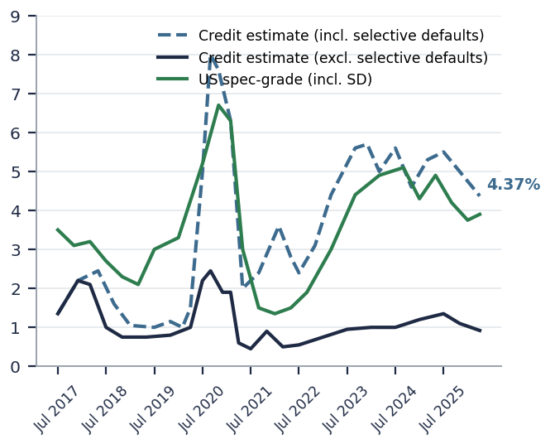  Note: Jul-2017 to Apr-2026. The 4.37% endpoint is the disclosed value; curves are digitised approximations. Source: S&P Global Ratings. | Exhibit 15: S&P T12M default rate: direct lending 4.4% vs BSL 3.3%  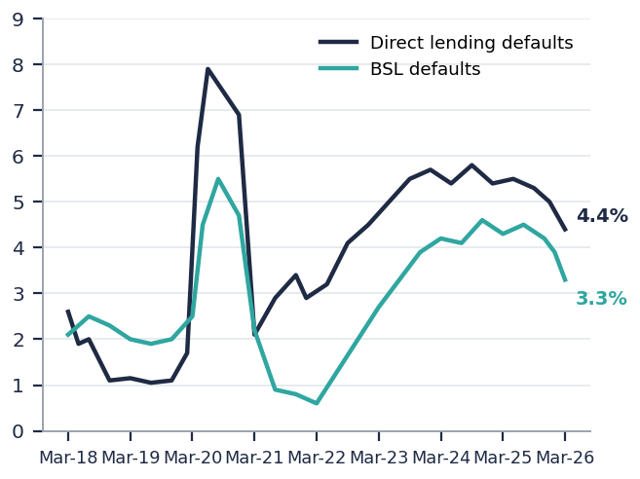  Note: Mar-18 to Mar-26; endpoints as labelled in the source, curves digitised. Context: MS forecasts ~8% annualised PC defaults for 2H26–1H27. Source: S&P, PitchBook | LCD, MS Research.
The five data providers differ materially in definition, sample and weighting, and even in direction in 1Q26 (Fitch and Proskauer up; S&P, KBRA DLD and Lincoln down):
Exhibit 16: Summary of private credit default measures (4Q25 vs 1Q26)
Provider | Sample / scope | Definition / methodology | 4Q25 | 1Q26 | Trend | Cohort
Fitch | Privately rated MM companies (≤$500m debt or ≤$100m EBITDA); >1,000 companies | Bankruptcies, payment defaults, distressed exchanges; annualised, issuer weighted | 5.6% | 5.7% | ↑ | Core-to-upper MM
S&P | 2,500 credit estimates (median EBITDA ~$30m, median adj. debt ~$195m) | Same; TTM, issuer weighted | 4.9% | 4.4% | ↓ | Lower MM
KBRA DLD | US companies financed by direct lending; 2,400 companies with senior secured non-syndicated term loans | Same; TTM, issuer weighted | 2.2% | 1.6% | ↓ | Upper MM
Lincoln Intl | Private companies owned by alternative funds; ~1,000 companies | Covenant default (once resolved, no longer deemed in default); quarterly index, size weighted | 3.2% | 3.1% | ↓ | All included
Proskauer | US senior secured & unitranche; 1,000 active loans / $148.9bn original principal | Broad definition incl. covenant defaults; quarterly index, facility-count weighted | 2.5% | 2.7% | ↑ | All included
Source: Fitch, S&P, KBRA DLD, Lincoln International VOG, Proskauer, MS Research.
Exhibit 17: Fitch TTM private credit default rate: 6.0% as of Apr 2026  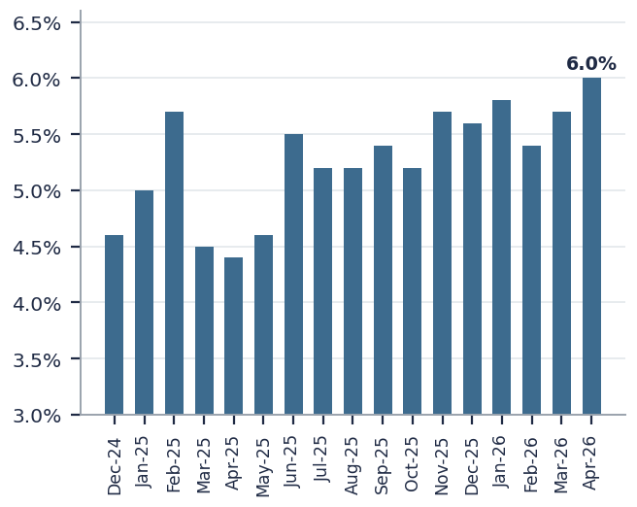  Note: Ticking up from end-1Q26; monthly values are as read from the source chart. Source: Fitch, MS Research. | Exhibit 18: KBRA DLD issuer TTM default rate: direct lending declining  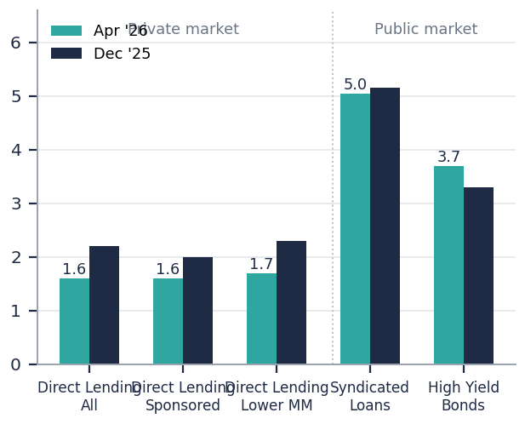  Note: Apr-26 1.6% vs Dec-25 2.2% for DL All, diverging from public markets (syndicated 5.0%+); values as read from the source chart. Source: KBRA, MS Research.
Software deserves a separate line: software loans carry a TTM default rate of only 2.3% versus 5.7% for the broader asset class — realised defaults have not yet validated the fear. MS expects the coming pickup in defaults to be driven by refinancing pressure rather than payment default, concentrated in software and skewed to distressed exchanges, with recoveries in the 70–80% range.
Exhibit 19: Fitch LTM default rate by sector (%)
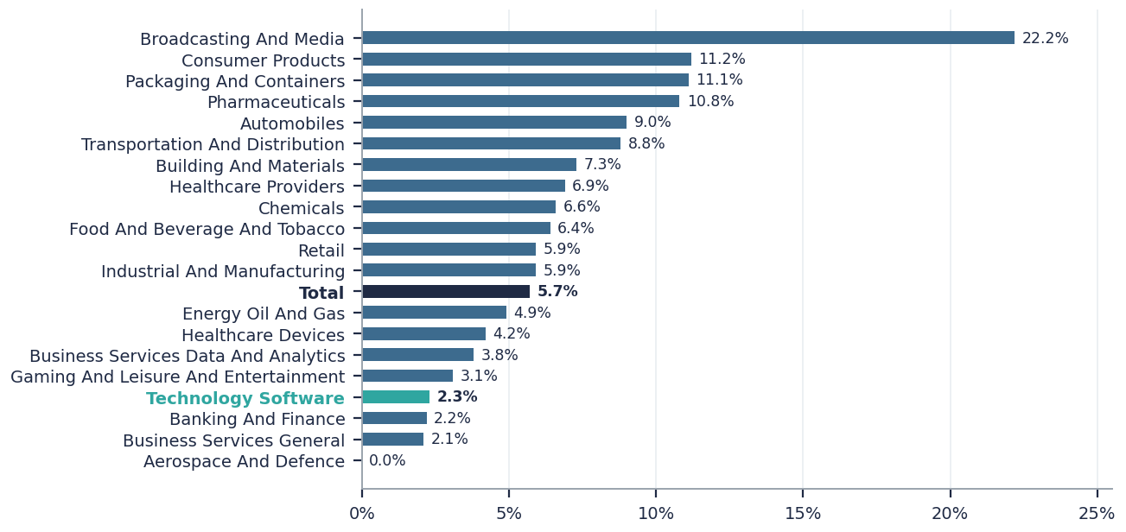
Note: Values as labelled in the source; Technology Software 2.3% vs asset-class total 5.7%, Fitch TTM basis as of 1Q26. Source: Fitch, MS Research.
Recovery rate
BDC-mark implied recoveries show pricing deteriorates a full year before default: among 2025 defaults, direct lending (all) fell from 81.1pt one year pre-default to 45pt at the default date, below syndicated loans at 53pt; PIK loans marked just 41.6pt at default versus 52.6pt for non-PIK. By sector (2023–2026 average, first-lien sample, data as of Apr 2026), software implied recovery averaged 47.8pt, mid-pack and well below building/construction at 66.8pt.
Exhibit 20: Average implied recoveries (2025 defaults), unweighted  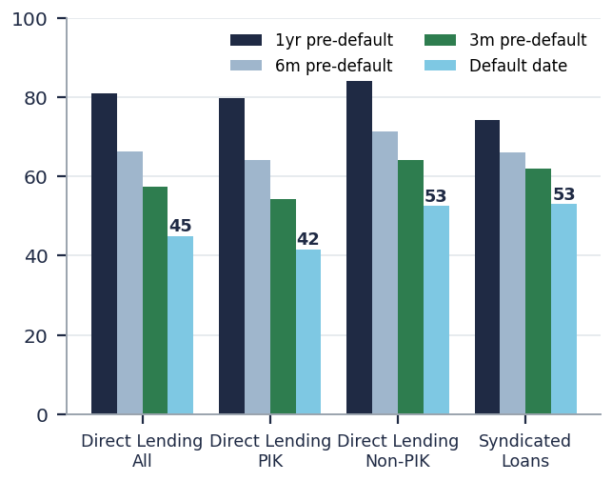  Note: DL All 45pt at default vs syndicated 53pt; PIK 41.6 vs non-PIK 52.6. Values as labelled in the source. Source: KBRA, MS Research. | Exhibit 21: Implied recovery average across sectors (2023–2026)  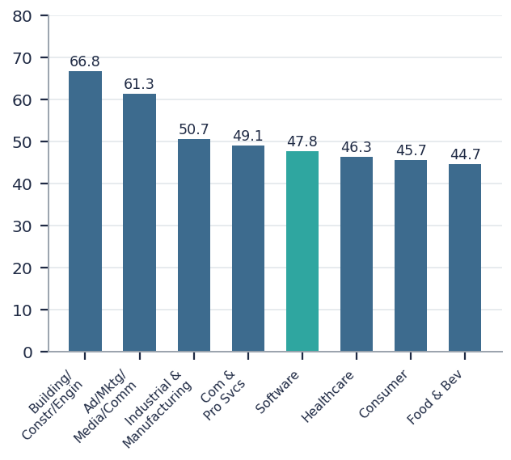  Note: Software ~48pt. Values as labelled; first-lien loans only, data as of Apr 2026. Source: KBRA, MS Research.
Leverage ratio (debt/EBITDA)
Cross-market positioning (fundamental data as of 1Q26): gross leverage runs HY 3.6x (BB band), syndicated loans 4.0x, and direct lending 5.7x (B3/CCC band) — private credit structurally carries more leverage. The time series is flat-to-slightly-down: Fitch's private MM portfolio has eased from ~6.9x at end-2022 to ~5.9x at 4Q25, Lincoln sits around 5.2x, and public Single B around 5.5x.

Exhibit 22: Gross leverage in US leveraged credit  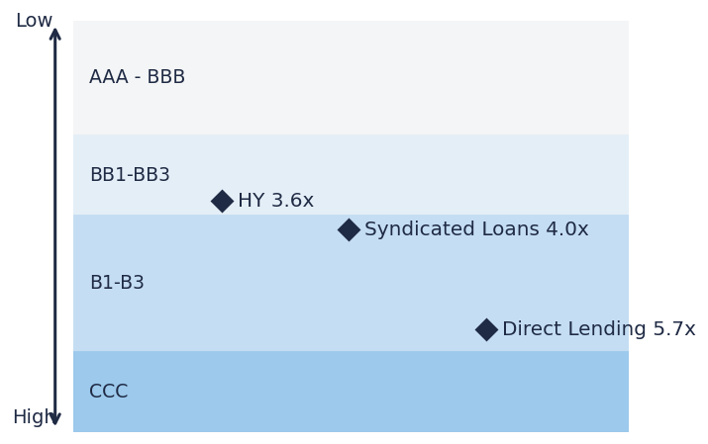  Note: HY 3.6x / Syndicated Loans 4.0x / Direct Lending 5.7x, mapped to rating bands; fundamental data as of 1Q26. Source: Fitch, S&P, KBRA, Lincoln International VOG, Bloomberg, FactSet, MS Research. | Exhibit 23: Total leverage (x): Fitch private MM vs Lincoln vs public Single B  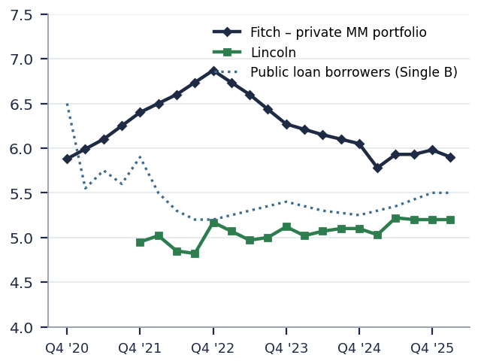  Note: Curves are digitised approximations (endpoints Fitch ~5.9x / Lincoln ~5.2x). Source: Fitch, Bloomberg, FactSet, Lincoln International VOG, MS Research.
Interest coverage ratio
Interest coverage positioning: HY 4.7x / syndicated loans 4.0x / direct lending only 2.0x — the mirror image of higher leverage. At the margin it is improving: EBITDA coverage has recovered from the ~1.4–1.6x trough in 2023 and improved q/q to roughly 2.0x in 1Q26, helped mainly by falling base rates.
Exhibit 24: Interest coverage in US leveraged credit  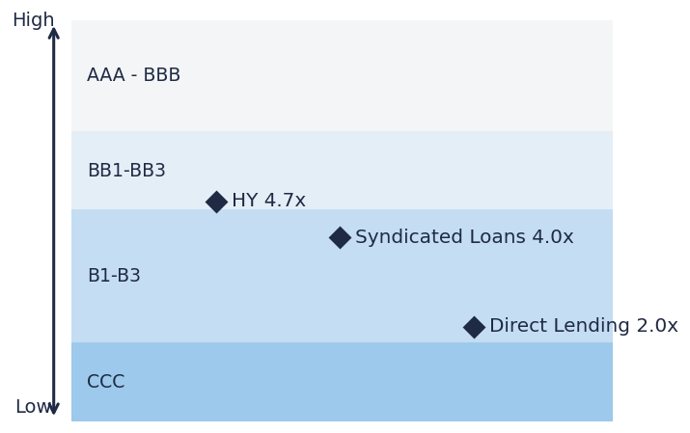  Note: HY 4.7x / Syndicated Loans 4.0x / Direct Lending 2.0x, mapped to rating bands. Source: Fitch, S&P, KBRA, Lincoln International VOG, Bloomberg, FactSet, MS Research. | Exhibit 25: EBITDA coverage (x): continued q/q improvement to ~2.0x in 1Q26  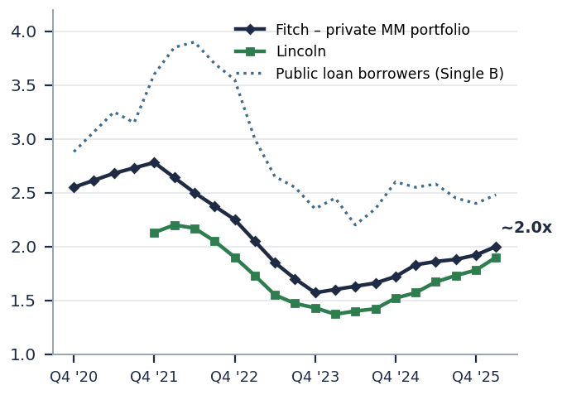  Note: Curves are digitised approximations. Source: Fitch, Bloomberg, FactSet, Lincoln International VOG, MS Research.

BDC non-accrual rate
Average BDC nonaccruals (at cost) rose to 2.8% in 1Q26 — a five-year high — with the share of BDCs above 8% nonaccruals climbing to ~11%. The split is stark: public BDC nonaccruals jumped to ~4.5% in 1Q26, a post-COVID high, versus ~2.0% for private BDCs — but much of the private-BDC advantage reflects vintage (post-2021 portfolios are simply younger), with deeper erosion inside pre-2021 books.

Exhibit 26: Nonaccruals across BDCs: average at cost up to 2.8% (5-yr high)  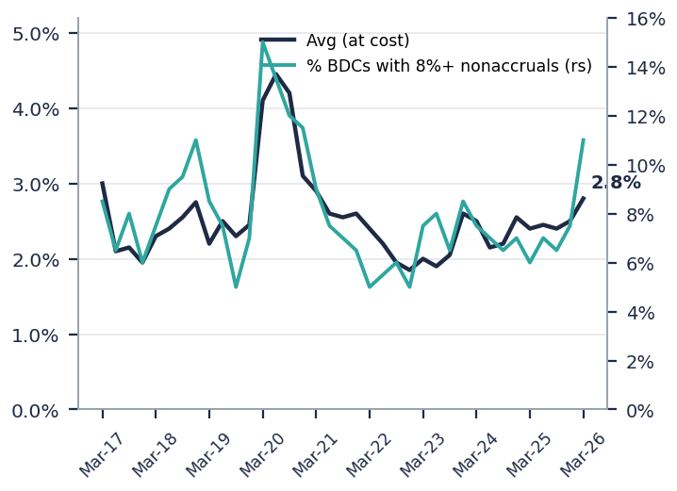  Note: The 8%+ share rose to ~11% (right scale). Curves digitised; endpoints as disclosed. BDCs with total assets >$50m only. Source: BDC Collateral, MS Research. | Exhibit 27: Average nonaccruals at cost: public vs private BDCs  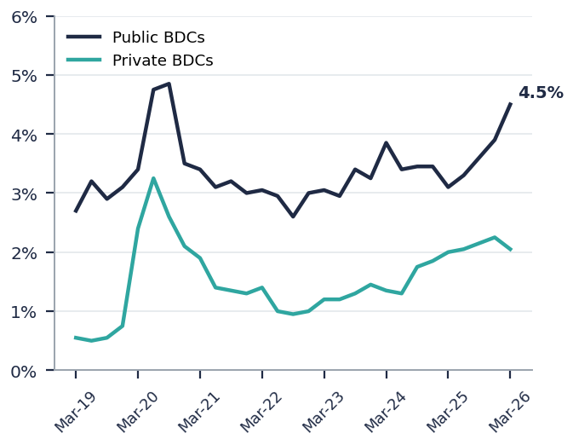  Note: Public BDCs ~4.5% in 1Q26, a post-COVID high. Curves are digitised approximations. Source: BDC Collateral, MS Research.
PIK income % of total income
Average BDC PIK income as a share of total investment income rose to 6.4% in 1Q26, with more BDCs above the 12% concentration threshold (~8%). Public BDC average PIK keeps climbing toward ~8% while private BDCs oscillate in a 5–6% range. Separately, sub-90 (priced-below-90) PIK loans are concentrated in Information Technology (~8.4% in 1Q26) and Healthcare (~8.0%) — a leading indicator of 'bad PIK'.
Exhibit 28: % PIK income over total investment income: average up to 6.4%  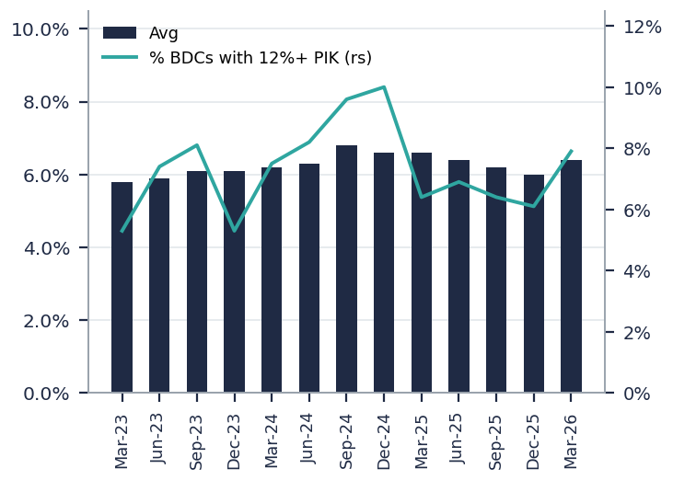  Note: Share of BDCs with 12%+ PIK on the right scale. Bars/line approximated; endpoints as disclosed. BDCs with total assets >$50m only. Source: BDC Collateral, MS Research. | Exhibit 29: Average PIK rate: public BDCs rising vs private range-bound  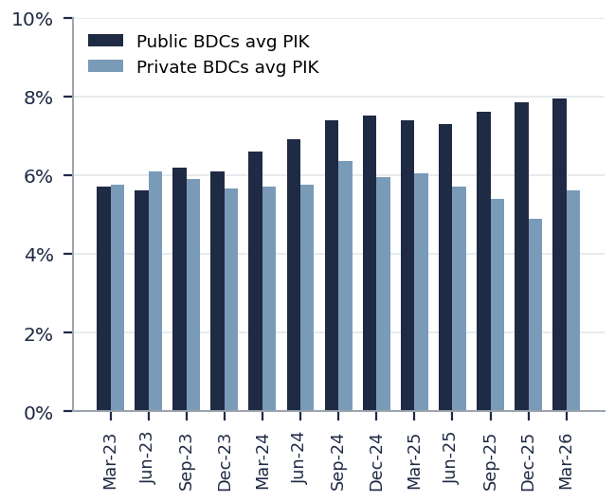  Note: Bar values are approximated from the source chart. Source: BDC Collateral, MS Research.
Sentiment
Broker summary
Exhibit 30: Broker summary — private credit views, key points and QoQ change
 | Morgan Stanley (Connecting the Dots 4/2; PC Tracker 1Q26 6/18; Sunday Start 7/12) | J.P. Morgan (Life Insurance PC Snapshot, 6/26) | Goldman Sachs (Macro Credit Views, 6/29) | Barclays (BDC 2Q Early Themes, 8/4) | UBS (Public & Private Credit Outlook, 7/22)
View | Cautious-to-neutral: pressures contained, not resolved — significant, not systemic; softening fundamentals with growing dispersion | Comfortable with insurers' PC exposure; transparency a rising concern | Constructive base case: dispersion, not widespread disruption | Neutral-to-constructive: normalizing, not cratering | Bearish: short private credit in model portfolio
Key points | · Forecasts 2H26–1H27 annualised defaults of ~8% in PC and ~5.5% in BSL — concentrated in software, skewed to distressed exchanges, 70–80% recoveries; software is ~26% of BDC collateral / ~20% of PC CLOs / ~16% of BSL. · Systemic risk contained: bank PC exposure ~3% of loans; software repricing turning selective with wider single-name dispersion. · Tracker 1Q26: ~$12bn of 2Q redemption requests (~$32bn YTD) but gates working — liquidity, not solvency; nonaccruals 2.8% (5-yr high), PIK 6.4%, dispersion vintage-driven (younger post-2021 private-BDC books flatter the optics); DL T12M return 8.7% (-2.2pp y/y). · IG BDC spreads retraced ~280bp → ~190bp; retail only ~20% of PC AUM, institutions re-engaging. | · Life insurers' PC exposure ~17% of invested assets, but ~90% sits in the IG segment (private placements ~55%, infra debt and private ABS ~15–17% each) — far from middle-market risk. · MM-lending concentration is idiosyncratic: FG 46%, RGA 37%, AFL 28% of their PC books. · Growing use of private letter ratings has reduced transparency (regulatory-data exposure nearly doubled since 2012 to ~40%). · Losses would bite hardest at high-asset-leverage annuity writers. | · Sentiment improved vs 1Q as the market learned not to extrapolate retail dynamics to institutions (85%+ of AUM, no comparable redemption rights; retail capped ~5%/qtr). · Fundamentals not deteriorating broadly: CDLI +1.1% in 1Q26 vs HY -0.5% / LL -0.6%; T12M realised losses 58bp vs 100bp historical average against a 9.8% yield; LBO illiquidity premium ~140bp. · Watch leading indicators: amended-PIK rate plus new nonaccrual volume (CDLI stress rate). · Only modest spread widening ahead, contained by the yield-based bid. | · 2Q results so far: asset quality weakening at a manageable rate; 1Q26 industry WA nonaccrual ~2.0% could drift toward the ~4% long-term average. · Problems concentrated in older vintages: 2022-and-earlier account for >70% of DL nonaccruals (2022 LTM ~2x 2023), mostly at public BDCs. · Banks are competing again — SLOOS shows eased C&I terms, C&I balances growing. · Hyperscaler financings appearing in BDC portfolios; contained but growing. · GCRED 3Q26 redemptions 4.8% vs 8.5% in 2Q — early sign flows are improving, too soon to call a bottom. | · US is late-cycle, led by private credit; positioned short PC (via BDC hedges to monetise dispersion) and long securitised. · AI disruption is the key risk: baseline lifts PC default rates by ~5pp, ~10pp in an aggressive-disruption tail; PC screens worst across markets on high-disruption-risk share, with ~50% of BDC technology portfolios at high+mid risk. · Contagion framework: closest analogy is the 2015–17 HY shale cycle (sector-contained), not a systemic event. · US LL spreads to widen to ~575bp by 4Q26.
QoQ · change | New 8%/5.5% default forecast framework; Tracker title shifted to 'Softening Fundamentals & Growing Dispersion'; July tone better than April — 'contained, not resolved'. | New this quarter (first insurance-lens PC deep-dive in our set). | Tone improved vs 1Q; upgraded from 'watching retail stress' to explicit dispersion-not-disruption base case. | New this quarter; first read on 2Q actuals — incrementally reassuring vs 1Q data. | New this quarter; the clearest bear among the five, expressed via positioning rather than systemic-risk claims.
Source: MS Research, J.P. Morgan, Goldman Sachs, Barclays, UBS; Junson AID summary.
Related news
- Redemption wave intensified in 2Q26: BCRED requests rose from 7% in Q1 to 10% in Q2; Apollo Debt Solutions from 11% to 17%; Cliffwater CCLFX from 14% to 17%; after HLEND first enforced its 5% cap, the market fell in line. Industry-wide requests are estimated at ~$12bn in 2Q26 and ~$32bn YTD, but gates are working and, in some cases, non-traded funds reported net inflows — liquidity stress is not becoming a solvency problem. An early inflection sign: GCRED's 3Q26 withdrawal requests fell to 4.8% from 8.5% in 2Q — improving, though too soon to call a bottom.
- Medallia default and debt-for-control: Lenders led by Blackstone, Apollo and FS KKR took the keys to the software company from Thoma Bravo (a $6.4bn 2021 buyout supported by a $1.8bn recurring-revenue loan), significantly cutting debt and injecting $150m of new capital — the quarter's most watched software default and a live test of recovery assumptions on ARR loans.
- Anthropic US$36bn chip-lease financing: Apollo and Blackstone led an investment-grade structured-notes financing for an SPV that buys TPUs and leases them to Anthropic — ~$6bn 'super-senior' A1 (price talk T+100), $25bn first-lien A2 (all-in yield talk 5.50–5.75%) and $4.5bn second-lien B (8.5% fixed), with a Broadcom residual-value backstop. Structured as IG notes, it sits outside LCD's direct lending volume — evidence of private credit pushing into investment-grade / asset-backed territory.
- Secondaries and valuation transparency: JPMorgan had traded roughly $2bn of private credit loans by mid-May across 20+ borrowers — more than all prior years combined — at prices from par to 3–10+ points below; Antares completed a $1.7bn continuation vehicle and StepStone closed its second credit-opportunities fund at $1.6bn. In parallel, Apollo will provide daily mark-to-market valuations on all credit assets by 9/30/26 and the US DOL proposed moving private credit closer to 401(k) inclusion — observable prices and regulatory scrutiny of marks are both rising.
- Volumes down, sector switch on: The Iran war and the Strait of Hormuz closure stalled M&A: 2Q26 direct lending was just $33bn / 149 deals (vs $74.1bn / 217 in Q1), with no >$2bn direct-lender LBO tracked since early March. Healthcare overtook Technology in new-deal count; >50% of surveyed lenders have cut software exposure (21% significantly, 6% stopped entirely) while 9% added into the dislocation.
Things We Should Know
Five observations we consider important after reading all of this quarter's uploaded materials — points not covered by the framework sections above and directly relevant to the Junson portfolio:
- Software repricing has moved from beta to alpha. Unlike the broad-based 1Q26 repricing, current software-loan weakness is increasingly selective, with much wider dispersion across issuers — investors are underwriting business-model resilience, AI exposure and data moats name by name. Software borrowers must be 'pristine' to get financed, and Vista Credit estimates ~20% of software businesses fall into a 'failure to thrive' bucket. Implication: evaluate our BDC / fund holdings at the single-name level of software composition, not by sector weight alone.
- The 2028 refinancing wall did not shrink — it is being pushed out. The near-term BDC maturity wall remains concentrated in 2028–2030 at roughly $80bn per year, and the QoQ snapshot shows the 2031–2033 bucket growing from ~$194bn to ~$207bn while 2026–27 maturities shrink — consistent with amend-and-extend activity deferring rather than resolving the wall (Exhibit 31). Combined with mounting software refinancing pressure and the ~8% default forecast, 2028 remains the operative year of this cycle, corroborating at the industry level the judgement we made on OTF last quarter.
Exhibit 31: BDC maturity wall (US$bn): Dec-25 vs Mar-26 snapshot, with vintage timing
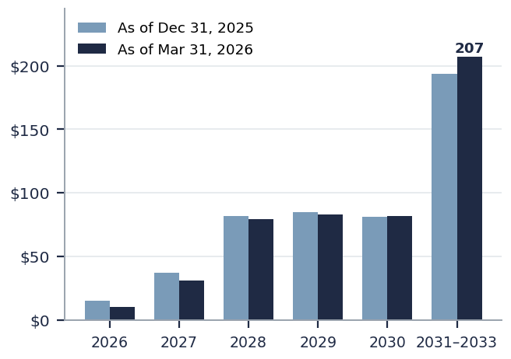 | When does the 2021–22 vintage wall hit?  At 5–7yr original tenors, 2021–22 originations mature contractually across 2026–2029, concentrated in 2027–2029 with the peak at 2028 — consistent with this chart's ~$80bn/yr plateau in 2028–2030 and with BDC filings showing loan maturities peaking in 2028–29.  The market entered 2024 with ~$430bn maturing in 2028; roughly $230–250bn remains after two years of refinancing — the residue skews to credits that could not refi on better terms (software ~$50bn of it).  The 2021–22 vintages already carry the largest nonaccrual balances in the CDLI (~3x the 2024 vintage as of 1Q26), so the wall arrives at the weakest cohort — and the QoQ growth of the 2031–33 bucket here shows A&E pushing, not solving, that maturity.
Note: Excludes equity and CLO holdings; data through 3/31/2026. Bar values are approximate readings from the source chart (2031–2033 bucket ~$194bn → ~$207bn). Source: PitchBook | LCD (chart); side comments: Junson research (Reuters, Rithm Capital, CDLI, KBRA).
- Vintage is now the most important stratification variable. The apparently better nonaccrual / PIK metrics of private BDCs largely reflect younger post-2021 vintages, with deeper erosion in pre-2021 books; sub-90 PIK loans are concentrated in IT (8.4%) and healthcare. When diligencing new funds or reviewing incumbent managers, request portfolio metrics split by vintage.
- Supply contraction is improving new-deal terms, and the capital base is rotating institutional. Guggenheim observes that non-traded BDCs have cut hold sizes sharply and pulled back from software, and that reduced competition should deliver better pricing, documentation and LTV; its PDF IV's latest six deals carry a weighted average spread of SOFR+546bp, 4.0x first-lien net leverage and a 42% blended LTV — consistent with LCD's recorded +25–50bp spread widening. Meanwhile retail is only ~20% of PC AUM and institutions are re-engaging: Ares closed $8bn+ (~$1bn above target) and Guggenheim PDF IV closed at its $4.5bn hard cap, 50% above the $3.0bn initial target. The current vintage may prove the best-terms deployment window of the cycle.
- Junson's three fund holdings show no warning signals this quarter, but marks lag secondary prints. Guggenheim PDF IV held its final close and is deploying normally; PAG BRS Fund III runs a current net IRR of 14.7% / gross 20.8% (and exited Project Veleta in January at a 12% unlevered IRR); HSBC RCF Partnership Fund's watchlist is empty. All three are valued as of 3/31/26 and do not yet fully reflect the 2Q public-market repricing of software and private credit; with PC secondary trading now scaled (JPMorgan ~$2bn; prices par to -10pts), we recommend cross-checking our funds' quarterly marks against available secondary prints.

Fund Update
Quarterly updates on Junson's three private credit fund holdings, based on each manager's Q1 2026 investor report. All valuations are as of 31 March 2026 and therefore predate the 2Q public-market repricing discussed above.
PAG BRS Fund III (SRT strategy)
Fund snapshot
  Strategy | Bank significant risk transfer (SRT)
  Total commitments | US$952m
  Final close | 28 Jan 2025
  Investment period ends | 28 Dec 2026
  Initial term ends | 28 Dec 2029 (+1+1 extensions)
  Status | Investment period; fully invested expected by end-2026
  Metric | 4Q25 | 1Q26 | QoQ Δ
  Total invested (US$m) | 1,258 | 1,258 | –
  Investments (total / exited) | 20 / 2 | 20 / 3 | +1 exit
  NAV (US$m) | 537 | 468 | -69
  Unpaid commitments (US$m) | 435 | 391 | -44
  Fund facility (US$m) | 149 | 175 | +26
  Investment-level leverage (US$m) | 354 | 349 | -5

- Quarter activity: exited Project Veleta (subscription line finance, European bank) at a 12% unlevered IRR; distributed US$59m alongside a US$25m capital call refund.
- Manager commentary: the SRT market stayed resilient through the Iran war with only a brief two-week pause in primary activity; the Fed's March Basel III Endgame proposals reduce regulatory uncertainty and support a nascent US SRT market, while the UK PRA/FCA moves toward a principles-based securitisation framework.
Portfolio composition
The book remains concentrated in low-credit-beta, senior secured specialised bank loan portfolios: subscription line finance is 62% of total investment amount, with fund-domicile exposure at 66% and a balanced USD/EUR currency split. Bank counterparty concentration is moderate, with the top five banks at ~73%.
Exhibit 32: PAG BRS III — investment amount by portfolio type  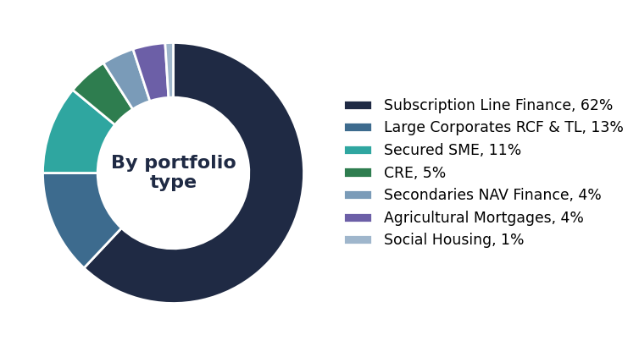  Note: Subscription line finance 62%; all shares by total investment amount, as labelled in the source. Source: PAG. | Exhibit 33: PAG BRS III — investment amount by geography  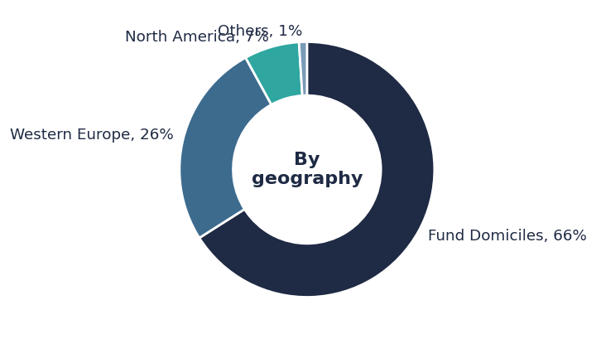  Note: Fund domiciles 66% / Western Europe 26% / North America 7% / others 1%. Source: PAG.
Exhibit 34: PAG BRS III — investment amount by currency  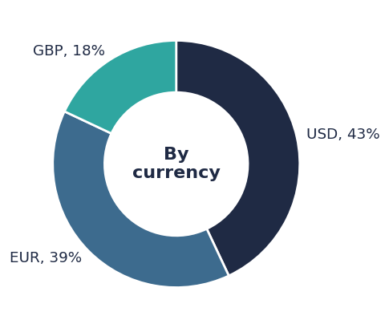  Note: USD 43% / EUR 39% / GBP 18%. Source: PAG. | Exhibit 35: PAG BRS III — investment amount by bank counterparty  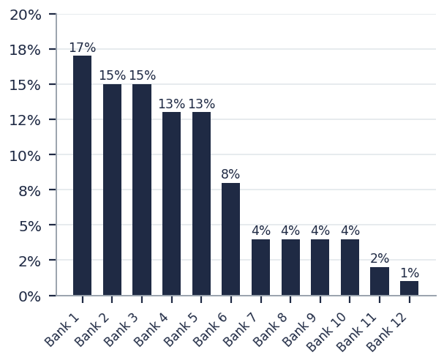  Note: Top five bank counterparties account for ~73% of investment amount; all counterparties are anonymised in the source. Source: PAG.
Exhibit 36: PAG BRS III — composition QoQ: by portfolio type and by currency (% of total investment amount)
By portfolio type | 4Q25 | 1Q26 | QoQ Δ | By currency | 4Q25 | 1Q26 | QoQ Δ
Subscription Line Finance | 62% | 62% | 0.0pp | USD | 43% | 43% | 0.0pp
Large Corporates RCF & TL | 13% | 13% | 0.0pp | EUR | 39% | 39% | 0.0pp
Secured SME | 11% | 11% | 0.0pp | GBP | 18% | 18% | 0.0pp
CRE | 5% | 5% | 0.0pp
Secondaries NAV Finance | 4% | 4% | 0.0pp
Agricultural Mortgages | 4% | 4% | 0.0pp
Social Housing | 1% | 1% | 0.0pp
Note: Shares are of cumulative total investment amount since inception, so quarterly composition moves little; 1Q26 saw no new investments (last addition Dec-25) and one exit, leaving rounded shares unchanged QoQ. Source: PAG.
Fund level performance detail
Current net IRR of 14.7% (gross 20.8%) with net MOIC of 1.11x and DPI of 0.30x; IRR/MOIC edged down q/q on the exit mix and mark movements while DPI rose sharply on the quarter's distributions. Performance sits above the expected net IRR range of 11–13% (expected net MOIC 1.2–1.3x). The three realised investments — Veleta, Artos and Saba, all subscription line finance — returned realised IRRs of 12%, 11% and 12% respectively on US$279.4m of cost.
Exhibit 37: PAG BRS Fund III — key performance and capital metrics, Q1 2026 vs Q4 2025
Metric | Q1 2026 | Q4 2025
Current gross / net IRR | 20.8% / 14.7% | 22.3% / 15.6%
Current gross / net MOIC | 1.15x / 1.11x | 1.12x / 1.09x
Capital contributions (US$m / %) | 561 / 59% | 586 / 62%
Distributions (US$m) | 167 | 108
DPI | 0.30x | 0.18x
NAV (US$m) | 468 | 537
Investments (total / exited) | 20 / 3 | 20 / 2
Total value (US$m) | 1,404 | 1,383
Investment-level leverage (US$m) | 349 | 354
Source: PAG.
Exhibit 38: PAG BRS Fund III — top 10 current investments by investment amount
Investment | Date | Portfolio type | CCY | Spread | Amount ($m) | Total value ($m) | UW IRR | Expected IRR
Cilo | Apr-25 | Subscription Line Finance | USD | 6.00% | 135.5 | 148.3 | 11% | 10–11%
Valentin | Jun-25 | Large Corporates RCF & TL | EUR | 8.25% | 96.5 | 105.3 | 10% | 10–12%
Moffat | Dec-25 | Subscription Line Finance | EUR | 4.95% | 80.3 | 82.3 | 9% | 7–8%
Kaschak | Nov-25 | Subscription Line Finance | USD | 5.13% | 72.5 | 74.8 | 9% | 9–10%
Ultar | Jan-25 | Subscription Line Finance | USD | 5.88% | 65.0 | 73.4 | 11% | 10–11%
Pandim | Jul-24 | Subscription Line Finance | EUR | 6.50% | 64.9 | 80.3 | 11% | 10–12%
Rinjani | Oct-25 | Subscription Line Finance | USD | 5.13% | 59.0 | 61.6 | 9% | 9–10%
Elbert | Jul-23 | Large Corporates RCF & TL | USD | 9.75% | 55.0 | 76.7 | 12% | 11–13%
Ossa | Dec-23 | Secured SME | GBP | 9.04% | 50.5 | 66.2 | 10% | 10–11%
Dixon | Oct-25 | Secondaries NAV Finance | USD | 6.25% | 50.0 | 52.6 | 11% | 11%
Note: Condensed from the full 17-position schedule; all 17 current investments total US$978.7m of investment amount and US$1,096.3m of total value. All counterparties are European or North American banks. Source: PAG.
Guggenheim Private Debt Fund IV (US direct lending)
Fund snapshot
  Strategy | US middle-market direct lending, 1L / unitranche
  Inception | 30 May 2024
  Final close | 31 Mar 2026 at US$4.5bn hard cap
  Initial target | US$3.0bn (closed 50% above target)
  Performance basis | Fund-level IRR/NAV not disclosed; Junson investor-level figures used
  Metric | 4Q25 | 1Q26 | QoQ Δ
  Investments | 38 | 40 | +2
  Invested capital (US$m) | 3,035 | 3,202 | +167
  First-lien net leverage | 4.9x | 4.9x | –
  LTV | 37% | 38% | +1pp
  WA spread (2025 avg / new deals) | S+544 | S+546 | +2bp

- Quarter activity: closed three deals in 1Q26, closed a further three after quarter-end and signed another three; the six closed deals represent US$668m committed at a weighted average spread of SOFR+546bp, 4.0x first-lien net leverage and a 42% blended LTV.
- Manager commentary: retail redemption pressure has forced non-traded BDCs to cut hold sizes sharply and pull back from software; reduced competition should translate into better pricing, documentation and LTV for new private credit transactions.
Portfolio composition
Aggregate portfolio characteristics (as of 3/31/26): weighted average spread 540bp, first-lien net leverage 4.9x, LTV 38%, weighted average borrower EBITDA US$115m, and a 72% / 28% sponsored / non-sponsored split. Sector exposure is diversified across 25 GICS sub-industries; combined software exposure (Systems 10% + Application 7%) is ~17% of par — well below the ~26% software share of BDC collateral cited by MS Research in the industry sections above.
Exhibit 39: Guggenheim PDF IV — GICS sub-industry mix (% of par)  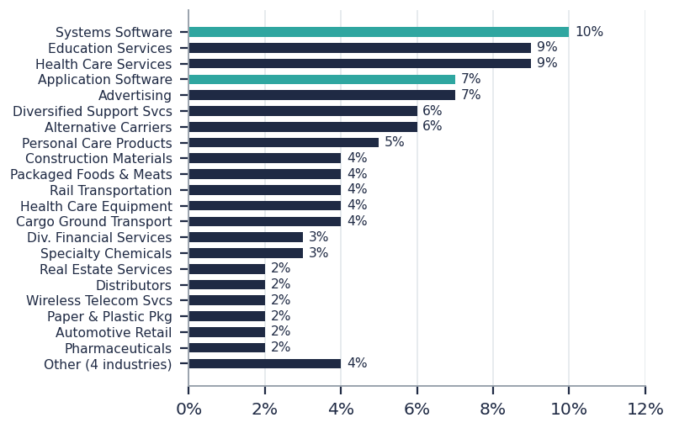  Note: Software sub-industries highlighted in teal (combined ~17%); shares as labelled in the source. Source: Guggenheim. | Exhibit 40: Guggenheim PDF IV — sponsored vs non-sponsored (% of NAV)  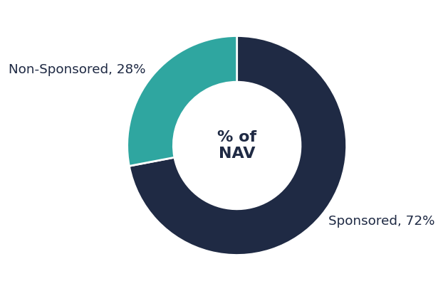  Note: Sponsored 72% / non-sponsored 28%. Source: Guggenheim.
Exhibit 41: Guggenheim PDF IV — composition QoQ: GICS sub-industry mix and sponsored split
GICS sub-industry (top) | 4Q25* | 1Q26 | QoQ Δ* | Sponsored (% of NAV) | 4Q25 | 1Q26 | QoQ Δ
Software (Sys + App) | 20% | 17% | -3pp | Sponsored | 69% | 72% | +3pp
– Systems Software | 9% | 10% | +1pp | Non-sponsored | 31% | 28% | -3pp
– Application Software | 11% | 7% | -4pp
Health Care Services | 14% | 9% | -5pp
Education Services | 9% | 9% | 0.0pp
Advertising | 4% | 7% | +3pp
Alternative Carriers | 7% | 6% | -1pp
Diversified Support Svcs | 7% | 6% | -1pp
Personal Care Products | – | 5% | new
Construction Materials | – | 4% | new
Note: *Basis change: the 4Q25 GICS mix is disclosed as % of NAV and the 1Q26 mix as % of par, so GICS deltas are indicative only; the sponsored split is % of NAV in both quarters. The software reduction and HC Services dilution partly reflect the two new investments and the par-vs-NAV re-basing. Source: Guggenheim.
Fund level performance detail
The report does not disclose fund-level IRR or NAV; performance is presented at asset level: 39 of 40 investments are Performing, with one name on the Monitor List (Inspired Pet, packaged foods & meats, 6.1x first-lien net leverage, invested Sep-25). No positions are on non-accrual. The 1Q26 case studies illustrate the current sourcing edge: Global Cellulose (US$135m 1L term loan at S+550 @ 95.0, 2.5x net leverage, ~47% LTV, plus an US$11m equity co-invest, sourced from a stalled BSL syndication), Adevinta Spain (€110m unitranche at E+475 @ 99.5, 6.9x, ~35% LTV, won on prior knowledge of the asset), and Wells Concrete (construction materials, closed 3/9/26 at S+475).
Exhibit 42: Guggenheim PDF IV — 1Q26 closed transactions
Deal | Structure | Pricing | Net leverage | LTV | Differentiator
Global Cellulose (absorbent pulp) | $135m 1L TL + $11m equity co-invest | S+550 @ 95.0 | 2.5x | ~47% | Diligence rigor; only lender with equity co-invest
Adevinta Spain (online classifieds) | €110m unitranche | E+475 @ 99.5 | 6.9x | ~35% | Industry knowledge (prior investor 2020–23)
Wells Concrete (construction materials) | 1L term loan | S+475 | 4.5x | n.d. | Non-sponsored sourcing
Note: Condensed; the full 40-position schedule is available in the manager's report. Source: Guggenheim.
HSBC RCF Partnership Fund (RCF strategy)
Fund snapshot
  Strategy | Revolving credit facility (RCF) fund
  Initial close | Q4 2023
  Final close | 30 Jun 2026
  Term | 8 years (+1+1 extensions)
  Base currency | EUR
  Watchlist | Empty — all positions rated Green (both quarters)
  Metric | 4Q25 | 1Q26 | QoQ Δ
  Fund size (€m) | 268.8 | 334.8 | +66.0
  Investments (current) | 8 | 11 | +3
  Capital called (€m) | 3.4 | 8.4 | +5.0
  NAV (€m) | 3.2 | 9.0 | +5.8
  Average drawn (settled book) | 9.2% | 11.7% | +2.5pp
  Credit facility outstanding (€m) | 3.9 | 4.2 | +0.3

- Quarter activity: €66m of new commitments in Q1 (pro-forma size ~€435m incl. €100m signed post quarter-end, ahead of the 30 Jun final close); three investments traded during the quarter (Projects Oliver, Tooth and Box); post quarter-end agreed Project Aventa (€7.5m, pan-European private healthcare) and Project Pique II (€8m, MedTech), with Projects Swan (insurance software), Book (K-12 education) and Knight (French insurance broker) in the pipeline.
- Manager commentary: European leveraged issuance was tempered by the Iran conflict and dominated by refinancings; secondary trading levels fell early in Q1 — led by Software (AI-related sell-off) and Chemicals — before recovering toward end-2025 levels, with the RCF strategy having limited exposure to the affected sectors.
Portfolio composition
Portfolio statistics (settled positions, excluding realised): 9 investments at an average RCF commitment of €8.4m, weighted average margin 319.6bp plus 95.3bp of commitment fees, weighted average purchase price 92.7%, and weighted average commitment maturity of 49.7 months. The current book spans nine sectors across seven European countries.
Exhibit 43: HSBC RCF — current portfolio by sector (share of 11 investments)  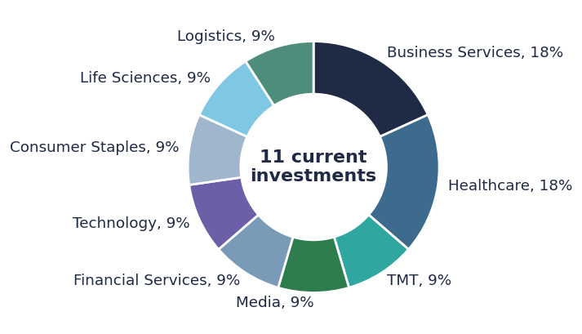  Note: By count of current investments; Business Services and Healthcare 2 each, all other sectors 1 each. Source: HSBC AM. | Exhibit 44: HSBC RCF — current margin by project (bps)  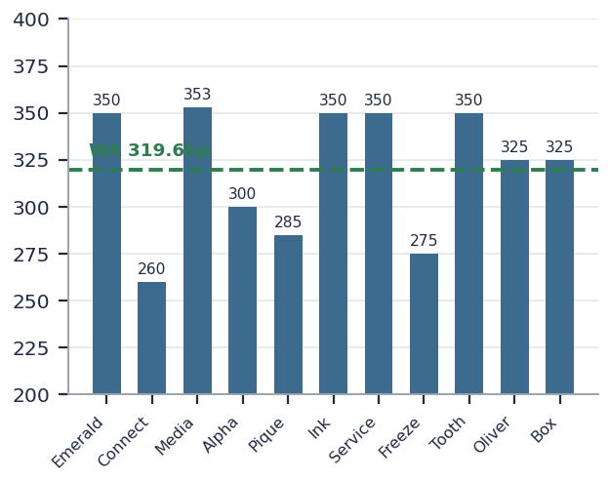  Note: Current applicable margins as of Q1-26 versus the 319.6bp weighted average (settled portfolio). Source: HSBC AM.
Exhibit 45: HSBC RCF — composition QoQ: current portfolio by sector (count of investments)
Sector | 4Q25 | 1Q26 | QoQ Δ | Sector | 4Q25 | 1Q26 | QoQ Δ
Business Services | 2 | 2 | – | Technology | 1 | 1 | –
Healthcare | 1 | 2 | +1 (Tooth) | Consumer Staples | 1 | 1 | –
TMT | 1 | 1 | – | Life Sciences | – | 1 | +1 (Oliver)
Media | 1 | 1 | – | Logistics | – | 1 | +1 (Box)
Financial Services | 1 | 1 | – | Total | 8 | 11 | +3
Note: By count of current (unrealised) investments; Projects Vision and Clark were realised in 4Q25 and are excluded from both columns. Source: HSBC AM.
Fund level performance detail
Fund performance stands at TVPI 1.21x, DPI 0.14x and a 34.5% IRR (post-fee, pre-carried interest); the IRR is elevated by early OID-driven realisations during ramp-up and the manager expects it to normalise toward target as the fund deploys. The two realised positions delivered estimated ROICs of 45.4% (Project Clark) and 91.4% (Project Vision); across the current book, estimated ROICs range from 10.7% (Ink) to 23.8% (Emerald).
Exhibit 46: HSBC RCF — current portfolio summary
Project | Sector | Country | Margin | Committed (€m) | Drawn (€m) | Maturity | Est. ROIC | Watchlist
Emerald | Business Services | UK | SOF+350 | 8.4 | 0.0 | Jan-29 | 23.8% | Green
Connect | TMT | Netherlands | EUR+260 | 10.0 | 0.0 | Sep-28 | 13.9% | Green
Media | Media | UK | SON+353 | 9.2 | 3.5 | Jun-28 | 22.3% | Green
Alpha | Financial Services | France | EUR+300 | 5.0 | 0.0 | Sep-30 | 12.2% | Green
Pique | Healthcare | Spain | EUR+285 | 10.0 | 0.0 | Jun-30 | 13.8% | Green
Ink | Technology | Italy | EUR+350 | 15.0 | 0.0 | Jan-32 | 10.7% | Green
Service | Business Services | Finland | EUR+350 | 5.0 | 3.4 | Apr-31 | 15.6% | Green
Freeze | Consumer Staples | UK | EUR+275 | 4.0 | 0.0 | Jun-31 | 13.4% | Green
Tooth | Healthcare | Switzerland | EUR+350 | 5.0 | 0.0 | Sep-31 | 12.6% | Green
Oliver | Life Sciences | UK | EUR+325 | 8.6 | 1.9 | Oct-29 | 17.4% | Green
Box | Logistics | Germany | EUR+325 | 5.0 | 1.6 | Feb-32 | 13.5% | Green
Note: Estimated ROIC per the manager's stated assumptions (25% average RCF drawn, 20% equity called); Projects Tooth and Box were in settlement at quarter-end. Source: HSBC AM.

Competitor Analysis
Quarterly peer tracker for the three fund holdings against vintage-matched cohorts from a 333-fund PitchBook screen of North America direct lending funds. 2026Q3 is the baseline quarter — all QoQ delta fields read n/a and the delta machinery activates from 2026Q4. Vintage conventions, metric-basis definitions (†/*) and the quarterly snapshot process are documented in the Appendix at the end of this section.
Positioning scorecard
The scorecard is the object of each quarter's update: levels, QoQ changes, cohort medians and their changes, and each fund's percentile rank within its vintage cohort (percentile = share of cohort funds below the fund's value). Quartile migration — not the absolute level — is the primary signal.
Exhibit 47: Positioning scorecard — Junson holdings vs vintage-matched cohorts (baseline: 2026Q3)
Fund / basis | Metric | 2026Q3 | QoQ Δ | Cohort median | Cohort Δ | Percentile | Pct Δ | Read
PAG BRS III (2023v, fund-level) | Net IRR | 14.7% | n/a | 10.7% | n/a | P92 | n/a | Top quartile
 | TVPI (net MOIC) | 1.11x | n/a | 1.15x | n/a | P28 | n/a | Below median
 | DPI | 0.30x | n/a | 0.15x | n/a | P72 | n/a | 2nd quartile
Guggenheim PDF IV (2024v, investor-level †) | Net IRR † | 9.3% | n/a | 12.7% | n/a | P18 † | n/a | Understated — see basis note
 | TVPI † | 1.20x | n/a | 1.10x | n/a | P100 | n/a | Top of cohort
 | DPI † | 0.18x | n/a | 0.10x | n/a | P62 | n/a | 2nd quartile
HSBC RCF (2024v, fund-level) | IRR (pre-carry) * | 34.5% | n/a | 12.7% | n/a | P100 * | n/a | Ramp-up distorted
 | TVPI | 1.21x | n/a | 1.10x | n/a | P100 | n/a | Top of cohort
 | DPI | 0.14x | n/a | 0.10x | n/a | P62 | n/a | 2nd quartile
Note: Cohort sizes: 2023 IRR n=26 / TVPI n=25 / DPI n=25; 2024 IRR n=11 / TVPI n=8 / DPI n=8 — 2024 percentiles are noisy at this sample size. † investor-level (typically below fund-level); * ramp-up distorted. Source: PitchBook; fund reports; Junson calculations.
Two readings deserve comment. PAG's below-median TVPI (1.11x vs 1.15x) against a top-quartile IRR and strong DPI is a profile artefact: SRT positions distribute early and MOIC accretes more slowly than in unitranche books — DPI at P72 confirms the cash is coming back faster than the cohort's. Guggenheim's †-basis IRR of 9.3% plots at P18, but this is not comparable to the fund-level cohort: our capital was called from mid-2024 at full fees, and the same portfolio measured at fund level would rank materially higher — the top-of-cohort TVPI (1.20x) is the cleaner cross-check.
Beyond the cohort statistics, the table below benchmarks our holdings against a named comparator set: the latest flagship funds of KKR, Ares and Apollo in the upper middle market, and of TPG Twin Brook, Golub, HarbourVest and Oaktree in the core middle market. Vintages span 2021–2025, so absolute levels are not directly comparable — read each fund against its own age (Twin Brook VI, at 5% called, is pure J-curve).
Exhibit 48: Junson holdings vs named competitor funds (latest flagship vehicles)
Fund | Vintage | Size ($m) | Net IRR | TVPI | DPI | Called % | Dry powder % | PB quartile
Junson — PAG BRS III (SRT) | 2023 | 952 | 14.7% | 1.11x | 0.30x | 59% | 41% | n/a
Junson — Guggenheim PDF IV † | 2024 | 4,500 | 9.3%† | 1.20x† | 0.18x† | ~71% | ~29% | n/a
Junson — HSBC RCF * | 2024 | 435 (PF) | 34.5%* | 1.21x | 0.14x | 2.5%* | 97.5%* | n/a
Core-to-upper MM
KKR Lending Partners IV | 2022 | 1,472 | 11.2% | 1.25x | 0.23x | 66% | 34% | Q2
Ares Senior Direct Lending Fund II | 2021 | 8,036 | 13.0% | 1.35x | 0.63x | 61% | 39% | Q1
Apollo Origination Partnership I | 2022 | 2,350 | 9.8% | 1.23x | 0.54x | 100% | 0% | Q3
Low-to-core MM
TPG Twin Brook Direct Lending VI | 2025 | 1,701 | -4.4% | 0.96x | 0.00x | 5% | 95% | Q4
Golub Capital Partners 15 | 2023 | 2,579 | 8.5% | 1.15x | 0.15x | 60% | 40% | Q3
HarbourVest Direct Lending Fund II | 2023 | 711 | 7.6% | 1.05x | 0.11x | 44% | 56% | Q4
Oaktree Direct Lending Fund | 2022 | 366 | 9.8% | 1.18x | 0.42x | 92% | 8% | Q4
Note: Comparator set per Junson selection: upper MM — KKR / Ares / Apollo latest flagship; core MM — TPG Twin Brook / Golub / HarbourVest / Oaktree latest. Rows 4–10 from the PitchBook screen (marks lag by one to two quarters); Junson rows from fund reports (3/31/26). † investor-level (typically below fund-level); * ramp-up distorted; PF = pro forma incl. post-quarter commitments. Source: PitchBook; fund reports.
Relative momentum
From 2026Q4 this module becomes the quarter's headline chart: each fund's QoQ change in IRR/TVPI plotted against its cohort median's QoQ change, answering whether we beat or lagged peer marks this quarter. For the baseline quarter we record the levels from which those deltas will be measured.
Exhibit 49: Baseline levels: fund IRR vs vintage cohort median  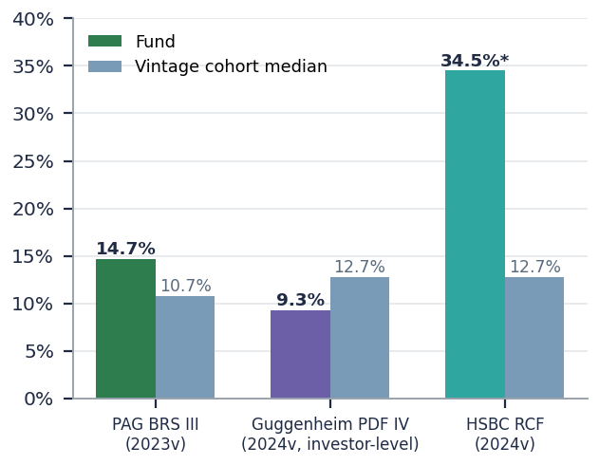  Note: PAG 14.7% vs 2023 median 10.7%; Guggenheim 9.3%† vs 2024 median 12.7%; HSBC 34.5%* vs 12.7%. † investor-level; * ramp-up distorted. From 2026Q4 this chart plots QoQ deltas. Source: PitchBook; fund reports; Junson calculations. | Exhibit 50: Baseline levels: fund TVPI and DPI vs vintage cohort medians  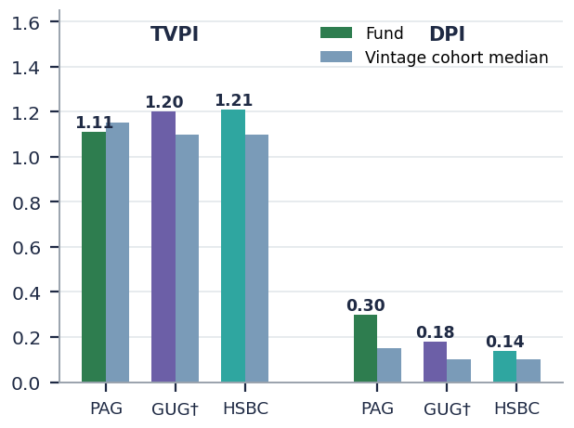  Note: TVPI: PAG 1.11x vs 1.15x; GUG† 1.20x vs 1.10x; HSBC 1.21x vs 1.10x. DPI: 0.30x / 0.18x† / 0.14x vs 0.15x / 0.10x / 0.10x. Source: PitchBook; fund reports; Junson calculations.
Percentile trajectory
Each quarter adds one point per fund; over time these lines become the clearest picture of relative performance through the cycle — a fund drifting down through P75 or P50 is the actionable signal, regardless of absolute IRR.
Exhibit 51: IRR percentile rank within vintage cohort — trajectory (baseline point)  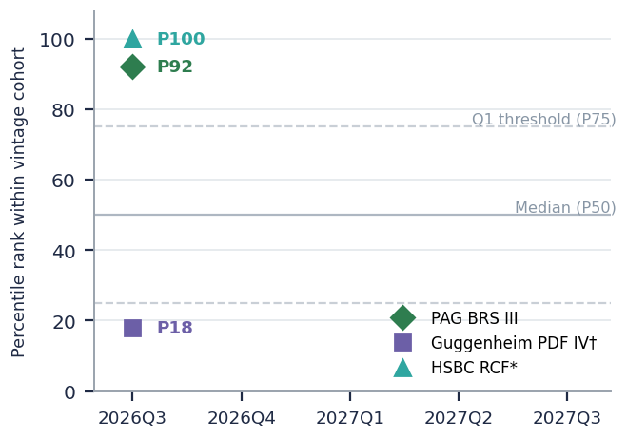  Note: PAG P92; Guggenheim P18† (investor-level basis, understated vs a fund-level cohort); HSBC P100* (ramp-up). Source: PitchBook; fund reports; Junson calculations. | Exhibit 52: TVPI percentile rank within vintage cohort — trajectory (baseline point)  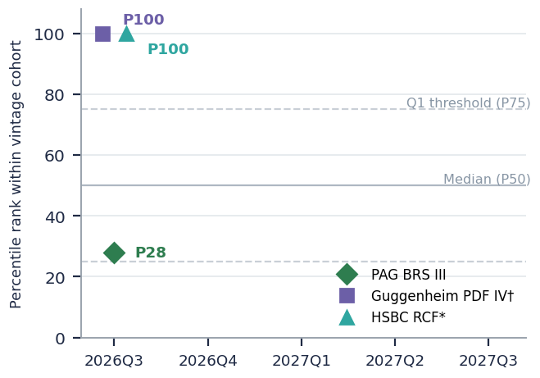  Note: PAG P28; Guggenheim P100†; HSBC P100. The 2024 TVPI cohort has only 8 observations — ranks will move as the cohort fills in. Source: PitchBook; fund reports; Junson calculations.
Cohort health monitor
Beyond our own funds, we track the health of the benchmark cohorts themselves: the QoQ drift of cohort medians and, above all, the width of the interquartile range. Widening dispersion is the early signal that industry stress — software marks, nonaccruals, PIK erosion — is reaching fund-level books. At baseline, the 2023 cohort already shows the widest IRR dispersion of recent vintages (IQR 4.6pp vs 2.1pp for 2021), consistent with the vintage that deployed straight into the 2023–24 wide-spread window now differentiating on credit selection. The 2024 TVPI IQR of just 0.04x reflects a young cohort whose marks have not yet dispersed — watch this widen as the AI/software repricing flows into private marks over coming quarters.
Exhibit 53: Cohort dispersion: interquartile range width by vintage (IRR, pp; TVPI, x)
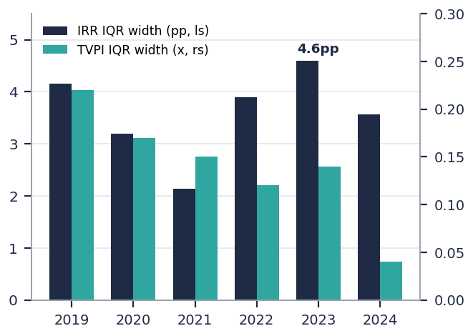
Note: Baseline snapshot; tracked QoQ from 2026Q4. 2023-vintage IRR dispersion (4.6pp) is the widest of recent cohorts. Source: PitchBook; Junson calculations.
Appendix — structural benchmarks & methodology (annual refresh)
The static universe and benchmark structure below is refreshed annually or upon material change, not quarterly.
Exhibit 54: Peer universe by vintage: aggregate fund size and fund count
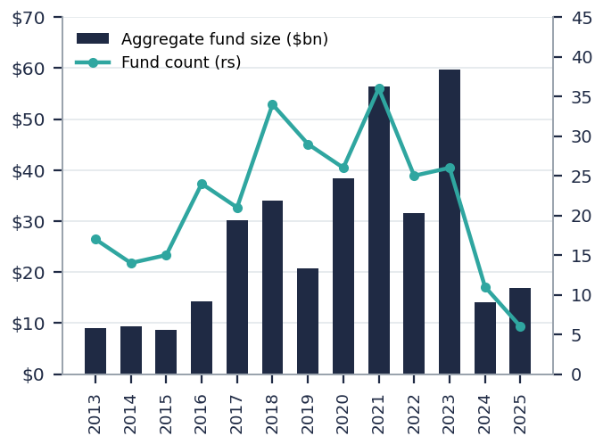
Note: 333-fund North America direct lending screen; vintages 2013–2025 shown. Source: PitchBook.
Exhibit 55: Manager consistency: average PitchBook quartile vs median net IRR (≥4 ranked funds)
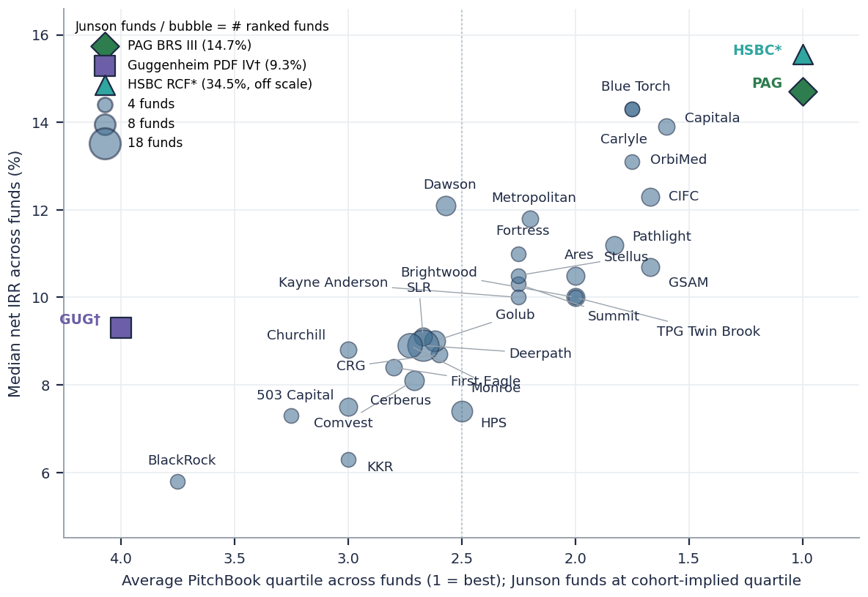
Note: Bubble size = number of ranked funds; x-axis inverted so better average quartiles plot to the right; all managers labelled with leader lines in dense areas. Junson funds shown in colour at their vintage-cohort-implied quartile (PAG and HSBC* Q1, Guggenheim† Q4 on the investor-level basis); HSBC plotted at the chart edge, actual IRR 34.5% off scale. Source: PitchBook; Junson calculations.
Exhibit 56: Net IRR by vintage: median and interquartile range, with Junson funds  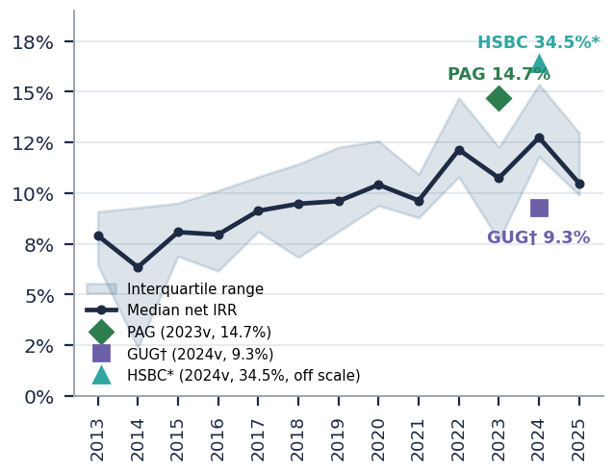  Note: Fund vintages per Junson convention (first-investment year): PAG 2023, Guggenheim† and HSBC* 2024. Source: PitchBook; fund reports; Junson calculations. | Exhibit 57: TVPI by vintage: median and interquartile range, with Junson funds  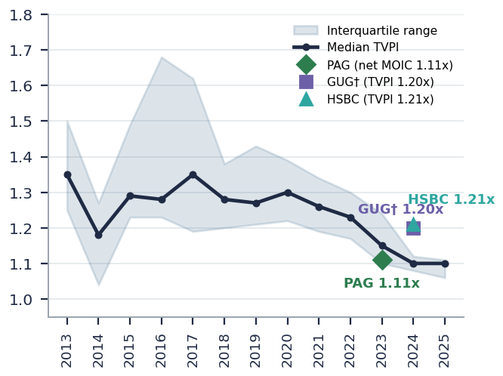  Note: GUG† 1.20x and HSBC 1.21x both plot above the thin 2024 cohort (TVPI n=8). Source: PitchBook; fund reports; Junson calculations.
Exhibit 58: Called-down % by vintage: median and interquartile range, with Junson funds
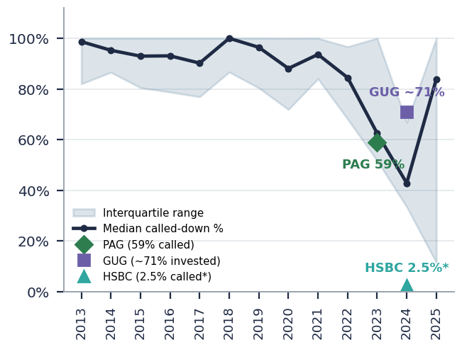
Note: HSBC RCF's 2.5% called reflects the RCF strategy's structurally low capital calls rather than slow deployment. Source: PitchBook; fund reports; Junson calculations.
Methodology. Peer universe: PitchBook screen of 333 North America direct lending funds (drawdown structures), exported 13 Aug 2026. Vintage convention (Junson): the vintage of our fund holdings is defined by the year of first investment — PAG BRS III = 2023 (first investments Jul-23), Guggenheim PDF IV = 2024 (May-24), HSBC RCF = 2024 (Feb-24) — consistent with PitchBook's methodology for the peer universe (year of first investment, with final close as fallback), so fund and cohort vintages are like-for-like. Percentile = share of cohort funds with the metric strictly below the fund's value; cohort denominators vary by metric with disclosure coverage. Quarterly process: each quarter the same screen is re-exported, cohort statistics are recomputed on fresh marks, and every metric is diffed against the archived prior-quarter snapshot (this quarter's baseline is archived as CA_snapshot_2026Q3.json). Metric basis: PAG and HSBC figures are fund-level as reported; Guggenheim PDF IV does not disclose fund-level performance, so we use Junson-calculated, investor-level figures as of 2Q26 (net IRR 9.3%, TVPI 1.20x, DPI 0.18x), marked † — investor-level metrics reflect our subscription timing, day-one fee drag and the J-curve of our capital calls and therefore typically sit below fund-level equivalents; †-marked readings are conservative. HSBC RCF's IRR is marked * as ramp-up distorted (2.5% of commitments called; OID-driven early realisations).
For Junson Capital internal research use only. Except where marked as exact / as-labelled / as-disclosed values, intermediate points of time series in redrawn charts are digitised approximations from the source charts, shown for trend only; please refer to the original reports when citing. The 2026Q3 competitor-analysis baseline snapshot is archived as CA_snapshot_2026Q3.json for next quarter's delta computation.

