JUNSON Capital Research
US Private Equity Quarterly Report (2026Q3)
Coverage: US PE / buyout & LBO / middle market / GP stakes 26 Aug, 2026

Market Overview
Q2 2026 was another false start for US private equity: deployment, exits and fundraising weakened together. Deal value fell -37.5% QoQ to US$177.3bn, exit value nearly halved to US$102.6bn, and YTD fundraising of US$159.6bn is flowing overwhelmingly to the largest managers. Valuation marks are holding while dry powder of US$1,067bn offers only ~0.9 years of runway at the 2025 deployment pace — pressure that cuts toward deployment, not discipline. The through-line, as PitchBook puts it, is liquidity: until distributions resume in earnest, both fundraising and new deployment stay under pressure.

Deal Activity

2.1 Deal value and count
Deployment stalled abruptly. Q2 deal value of US$177.3bn was down 37.5% QoQ and 23.9% YoY — one of the steepest single-quarter contractions in PitchBook's dataset — while deal count held up at 2,384 (-1.1% QoQ), meaning the pullback concentrated in larger transactions. The forces were simultaneous rather than singular: a Fed that shelved cuts and debates hikes, wider direct-lending spreads, an energy-driven inflation shock, and an accelerating AI-driven reassessment of software.
Exhibit 1: US PE deal value and count by quarter
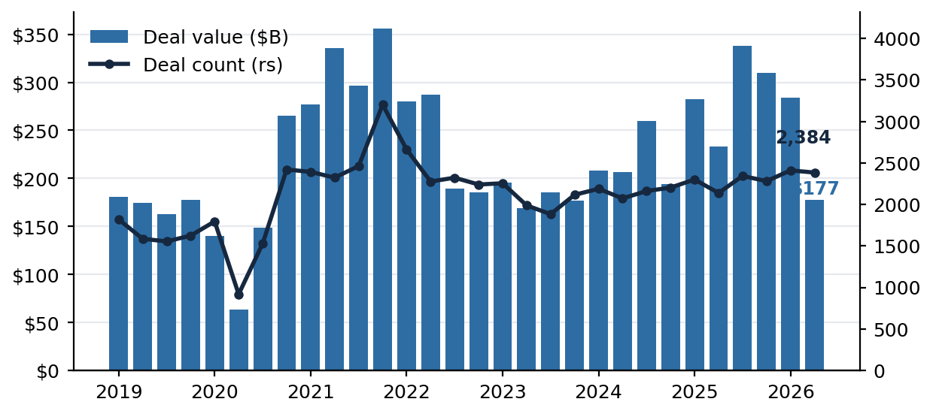
Note: Total deal value and count including PitchBook estimated figures; count on right scale. Source: PitchBook; as of 30 Jun 2026.

2.2 Deal composition
The structural work is being done by add-ons: 75.2% of buyout count and 40.8% of buyout value YTD. Median deal size held at US$53.4m in Q2 while the average fell with the megadeal retreat — consistent with a market still transacting in the middle while the top end waits. Secondary buyouts held around 25% of buyout value: sponsor-to-sponsor remains a working exit lane even in a weak tape.
Exhibit 2: Add-on share of US buyout count  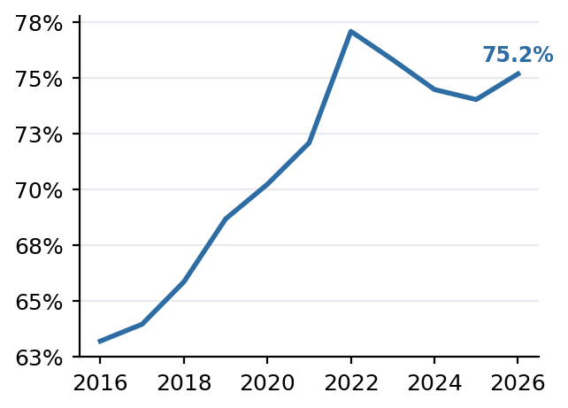  Note: Count basis; the value-basis share is 40.8%. Source: PitchBook; as of 30 Jun 2026. | Exhibit 3: Median and average PE deal size (US$m)  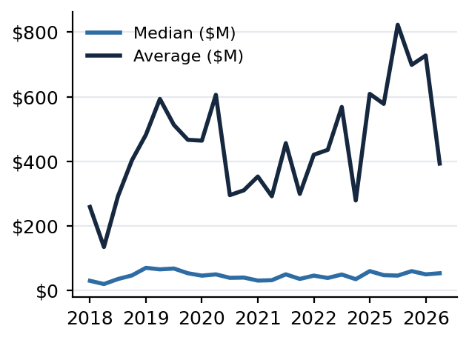  Note: Quarterly. Source: PitchBook; as of 30 Jun 2026.

Sector rotation was the quarter's defining feature. Software — PE's anchor allocation of the last decade — collapsed to an estimated US$10.7bn of deal value, -65.7% YoY and 90.3% below peak, while energy is the standout at +80.5% YTD on AI-driven structural power demand. YTD deal value splits 33% B2B, 17% energy, 15% IT.
Exhibit 4: US software deal value and count by quarter
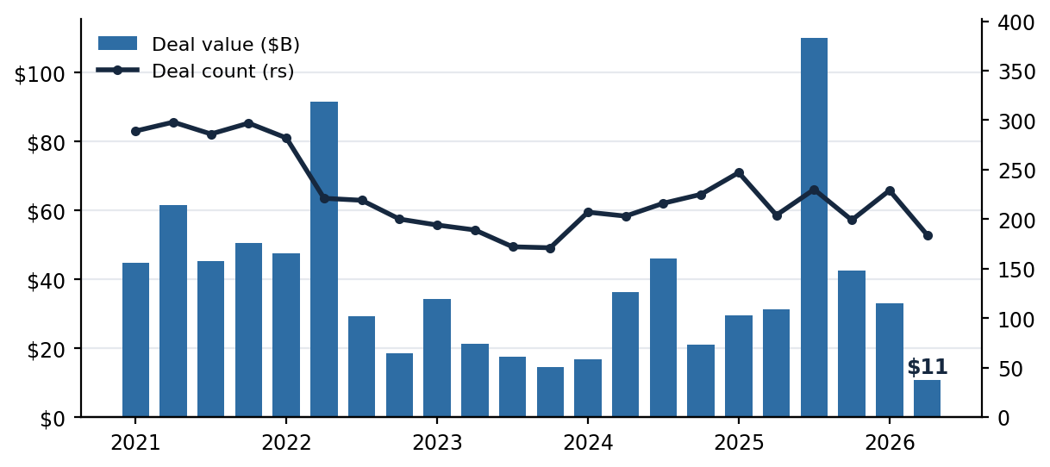
Note: Source: PitchBook; as of 30 Jun 2026.
Exhibit 5: Share of 2026 YTD deal value by sector  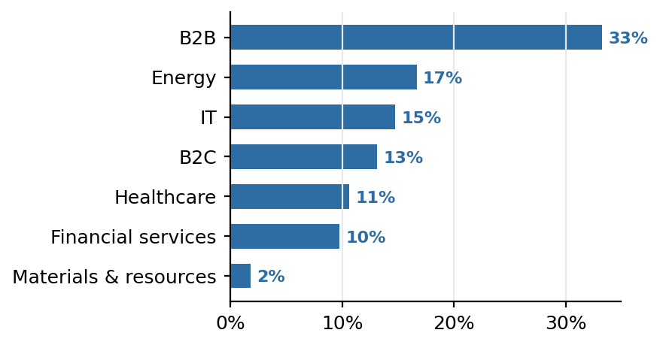  Note: Q1+Q2 2026 deal value shares; Junson calculation. Source: PitchBook; as of 30 Jun 2026. | Exhibit 6: Secondary buyouts, share of buyout value  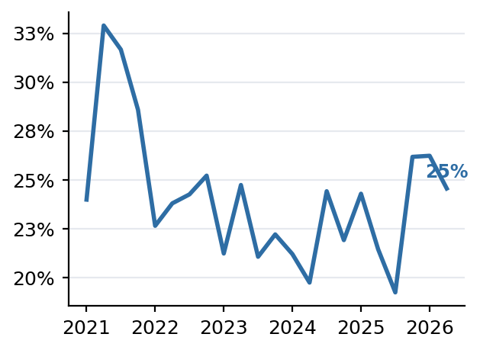  Note: Source: PitchBook; as of 30 Jun 2026.

2.3 LBO volume in M&A context
PE is ceding M&A share to strategic acquirers — and the report data pack now quantifies it. Buyout/LBO value of US$734.2bn YTD represents 27.1% of the US$2,710.7bn of global M&A in H1 2026, down from 41.2% for full-year 2025 — a 14.1pp collapse to the lowest share since 2016 and the sharpest one-year drop in the series. The overall market did not shrink with it: global M&A totalled US$1,306.2bn in Q2 (up 35.3% YoY, down 18.4% from Q1's record US$1,601.2bn), and North America printed US$787.0bn across 4,476 deals (+37.4% YoY, -24.3% QoQ). Strategic buyers filled the space sponsors vacated — consistent with EY's read of US US$100m+ deal value up 88% YoY with megadeal value up 148%, and with sponsored M&A loan volume shrinking 54% QoQ while corporate borrowers more than doubled theirs.
Exhibit 7: North America M&A deal value and count by quarter  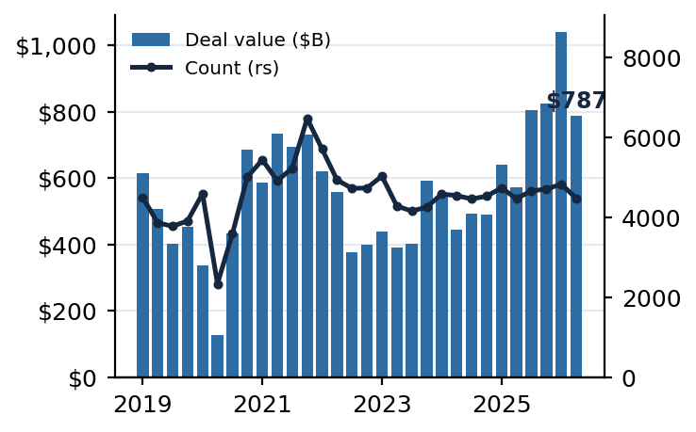  Note: Deal value plus estimated values; count on right scale. Source: PitchBook; as of 30 Jun 2026. | Exhibit 8: Buyout/LBO share of global M&A value  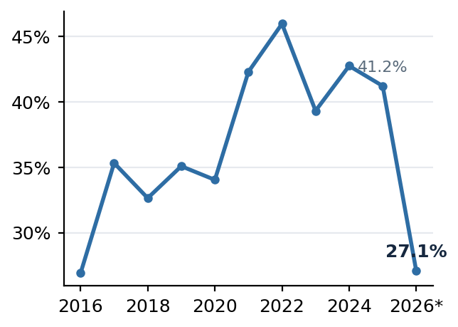  Note: Buyout/LBO value ÷ (Buyout/LBO + corporate M&A value); 2026* = H1. Junson calculation. Source: PitchBook; as of 30 Jun 2026.

2.4 Middle market
The middle market (US$25m–1bn EV) held up better than the headline market — its share of all US PE buyout value rose toward ~40% as megadeals retreated (data lag one quarter, as of 31 Mar 2026). MM buyout multiples sit 1–2 turns below their 2024 peak, and MM rolling one-year IRR of 8.7% leads both megafunds (5.7%) and US PE overall (7.2%). For fund selection this supports a middle-market tilt: cheaper entry, less exit-route dependence on IPOs, better recent relative performance — offset by thinner financing depth if credit tightens further.
Exhibit 9: US PE middle-market deal activity  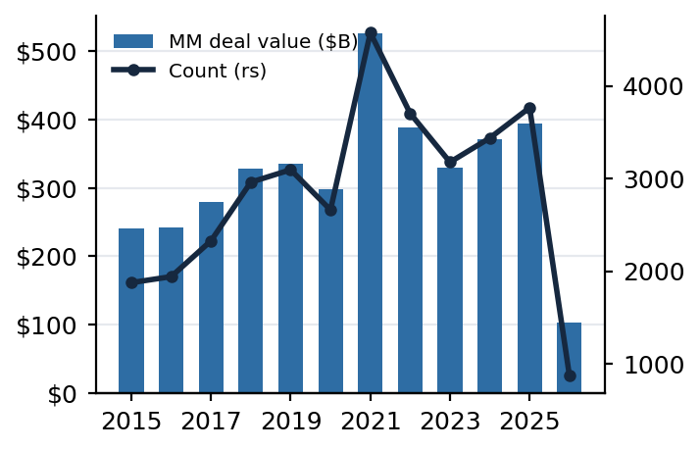  Note: Total incl. estimated; 2026* = Q1 only; count on right scale. Source: PitchBook; as of 31 Mar 2026. | Exhibit 10: MM share of all US PE buyout value  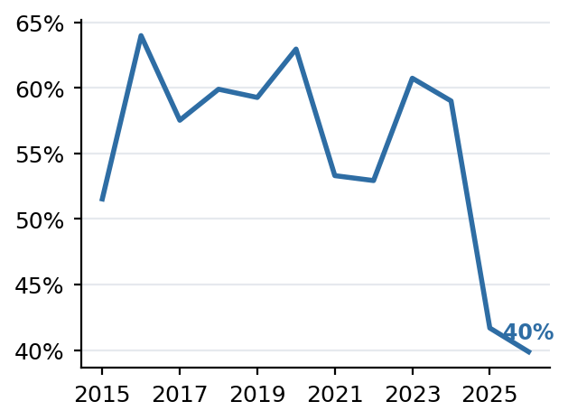  Note: Source: PitchBook; as of 31 Mar 2026.

2.5 How the volume measures nest — and where private credit connects
The four volume measures in this report are nested cuts of one market, from broadest to narrowest: global M&A (US$2,710.7bn in H1 2026) contains both corporate-led and sponsor-led deals; North America M&A (US$1,826.5bn) is its geographic slice; US PE deal value (US$461.0bn) is the sponsor-only slice of the US market across all deal types (buyout, add-on, growth); US PE buyout/LBO (US$347.3bn) strips out growth deals; and the middle market (US$25m–1bn EV, ~US$139bn est.) is its size slice, roughly 40% of buyout value. The 'LBO volume in M&A' ratio in §2.3 (27.1%) is the top two layers divided: global buyout ÷ global M&A. Three definitional wrinkles when quoting across layers: NA includes Canada while US PE does not; US PE deal value includes growth/expansion minority deals that sit outside the M&A universe, so it is not a strict subset of the Buyout/LBO line; and every layer includes PitchBook's estimated values for undisclosed deals.
Exhibit 11: How the volume measures nest (H1 2026)
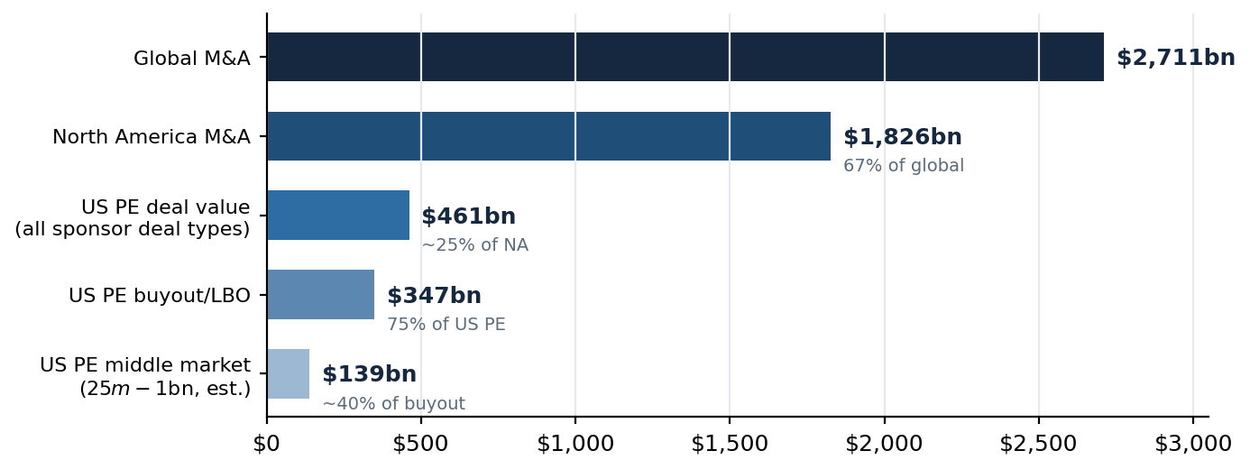
Note: All layers from PitchBook; middle market estimated as ~40% of buyout value (share as of 31 Mar 2026) — Junson calculations. Layer shares are approximate: geographies and deal-type definitions do not align perfectly between layers (see text).
Private credit connects to this hierarchy on the financing side, at the third and fourth layers. Every buyout carries a debt package sourced from either the broadly syndicated loan market or private credit — and private markets financed 82% of LBOs by count as of 1Q26 — so buyout/LBO volume is the demand engine for direct-lending origination: this quarter's -37.5% QoQ fall in PE deal value is the same event as the -24% y/y decline in direct-lending origination that the Private Credit report tracks. The middle market is private credit's home turf — deals in this size band rarely access the BSL market, and the resulting loans are the collateral behind middle-market CLOs. The top two layers (global and NA M&A) sit largely outside private credit's reach: corporate-led M&A is financed with investment-grade debt and balance-sheet cash. The mapping below cross-references the companion report.
Exhibit 12: Where private credit connects (2026Q3)
This report | Financing-side linkage | Private Credit Quarterly reference
Buyout/LBO volume (§2.1, §2.3) | Demand engine for direct-lending origination; each LBO's debt is sourced from BSL or private credit | §2.3 Demand side: 82% of LBOs financed in private markets (1Q26, by count); KBRA origination ~US$87bn Jan–May 2026, -24% y/y
Middle market deal value (§2.4) | Core direct-lending market; loans collateralize middle-market CLOs | §2.4 Fund flow: MM CLO issuance US$38.5bn in 2025, 19.7% of all US CLO issuance
Sponsor credit conditions & maturity wall | Private credit vs. BSL share of sponsor financing; refinancing and A&E activity | §3 Returns & relative value: direct lending priced 178bp over single-B BSL (2Q26); §7 BDC maturity profile
Note: Cross-references are to the Junson Private Credit Quarterly Report (2026Q3), 26 Aug 2026 edition. The two reports share the sponsor-deal interface: PE deal volume (this report) should directionally track direct-lending origination (PC report) each quarter — a divergence between the two is a data or definition question before it is a market signal.

Valuations, Performance & Financing

3.1 Entry multiples
Entry marks are softening but have not reset. US PE EV/EBITDA stood at 12.5x and EV/revenue at 2.8x for 2025 (SPI by StepStone, as of 31 Dec 2025, reproduced in the Breakdown p. 10). North America & Europe middle-market buyout EV/EBITDA was 12.3x in 2025 and 10.4x YTD 2026 — the YTD print rests on only 13 observations and is indicative (US-only: 11.5x on n=6). The size spread has inverted: US$5bn+ global M&A cleared at 11.1x against 11.8x for US US$25m–1bn deals in the latest year — an unusual reversal of the large-cap premium worth watching.
Exhibit 13: MM buyout median EV/EBITDA (NA & Europe)  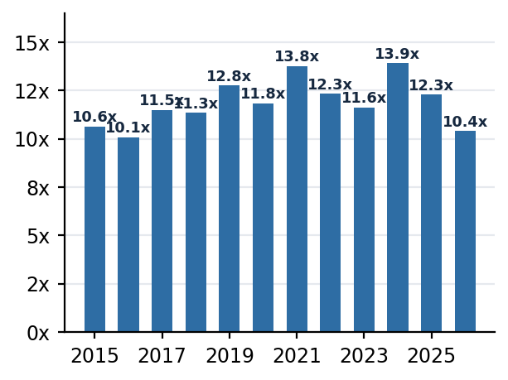  Note: 2026* is YTD on n=13, indicative. Source: PitchBook; as of 31 Mar 2026. | Exhibit 14: M&A EV/EBITDA by deal size  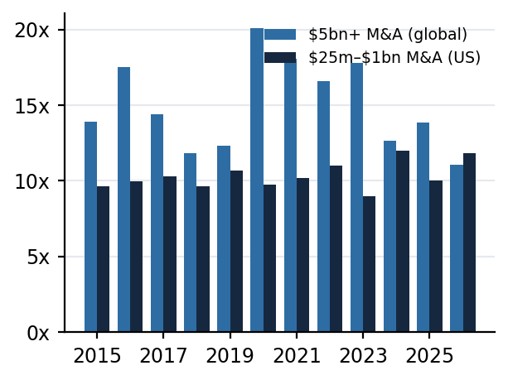  Note: US$5bn+ is global; US$25m–1bn is US. Source: PitchBook; as of 31 Mar 2026.

Isolating the US middle market, the same series is noisier but tells a consistent story: the US MM buyout median printed 16.5x EV/EBITDA in 2025 (n=22) before falling to 11.5x YTD 2026 (n=6) — wide swings that reflect thin samples as much as price, which is why the blended NA & Europe series above is the primary reference. On revenue, the US MM median sits at 2.7x YTD against 3.0x at the 2021–22 peak.
Exhibit 15: Median US PE middle-market buyout EV/EBITDA multiple  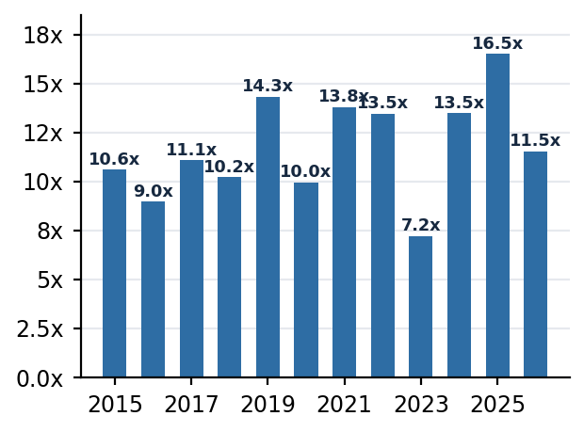  Note: US-only series; 2026* is YTD on n=6, indicative. Source: PitchBook; as of 31 Mar 2026. | Exhibit 16: Median US PE middle-market buyout EV/revenue multiple  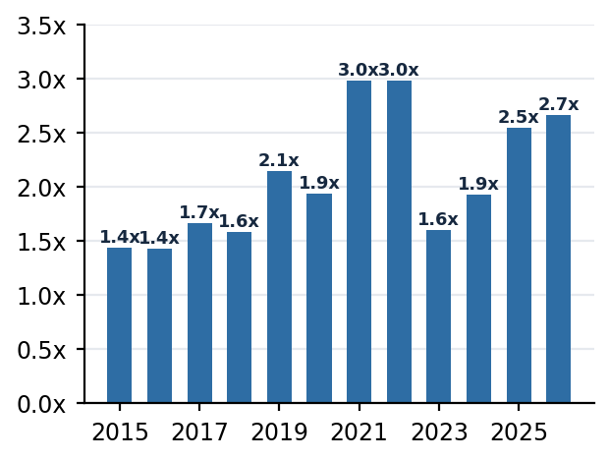  Note: US-only series; 2026* is YTD on n=11, indicative. Source: PitchBook; as of 31 Mar 2026.

3.2 Fund performance: rolling horizon IRR
Rolling one-year horizon IRRs have settled in single digits, and the ordering matters as much as the level: the middle market leads at 8.7%, US PE overall runs at 7.2%, and megafunds trail at 5.7% (as of 30 Sep 2025 — performance lags ~3 quarters). The cycle context makes the reset stark: the same series peaked above 50% in the 2021 revaluation wave, swung to roughly -5% for megafunds in the 2022–23 correction, and has since flattened into a narrow single-digit band — marks have stabilised, but at a level below most funds' underwritten hurdles. In a slow-exit regime DPI is the honest measure; the distribution shortfall in §4 is precisely what keeps LP re-up capacity constrained in §5.
Exhibit 17: US rolling one-year horizon IRR by segment
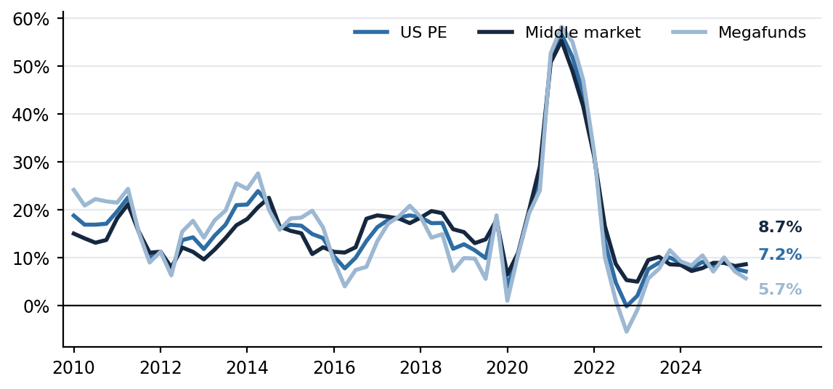
Note: Latest values labelled at right (as of 30 Sep 2025): middle market 8.7%, US PE 7.2%, megafunds 5.7%. Source: PitchBook.
The European read is materially weaker: Europe PE overall runs at just 1.4% rolling one-year IRR, European megafunds are negative at -2.6%, while the European middle market at 7.8% performs almost exactly in line with its US counterpart (8.7%). Two implications: the middle market's relative resilience is a trans-Atlantic pattern, not a US quirk, supporting the fund-selection tilt in §2.4; and the megafund segment's weakness is amplified in Europe, where FX and a thinner exit market compound the same liquidity drought.
Exhibit 18: Europe rolling one-year horizon IRR by segment
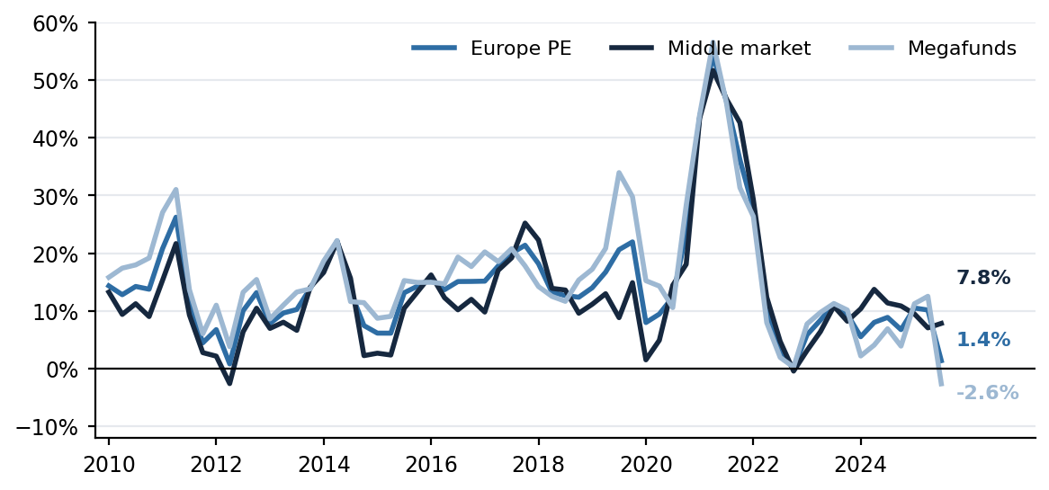
Note: Latest values labelled at right (as of 30 Sep 2025): Europe middle market 7.8%, Europe PE 1.4%, Europe megafunds -2.6%. Source: PitchBook.

Exits & Liquidity

4.1 Exit activity
Distribution conditions worsened. Exit value fell to US$102.6bn (-46.3% QoQ, -7.4% YoY) on 353 exits, with US$1bn+ mega-exits anchoring more than 60% of quarterly value. The lone bright spot was the public window: listing value rose 42.2% sequentially to US$27.6bn and the count doubled to 12, though the reopening was narrow and skewed to B2B and industrials. The deals-to-exits ratio widened to 1.41 from 1.35 in 2025: the industry is still adding inventory faster than it clears it.
Exhibit 19: US PE exit value and count by quarter
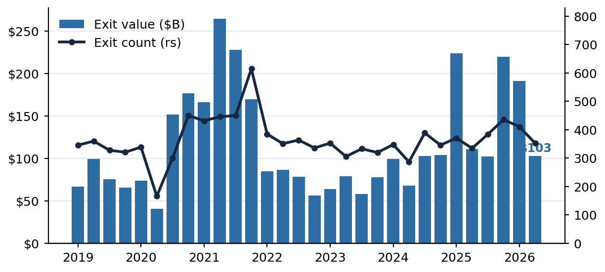
Note: Total exit value and count including PitchBook estimated figures; count on right scale. Source: PitchBook; as of 30 Jun 2026.
Exhibit 20: Exit value by route (US$bn, quarterly)  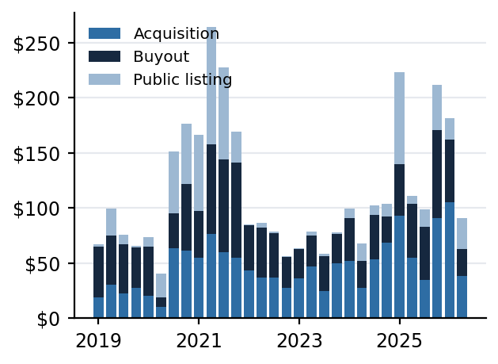  Note: Series names as per the source data (Acquisition / Buyout / Public listing). Source: PitchBook; as of 30 Jun 2026. | Exhibit 21: Median and average exit size (US$m)  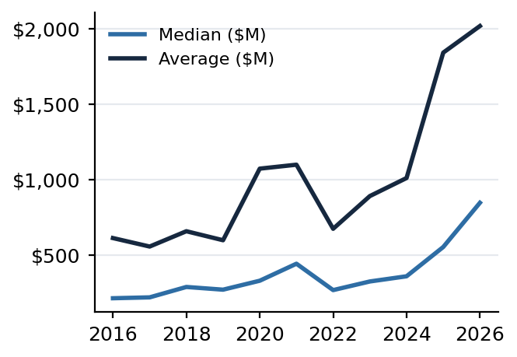  Note: Annual. Source: PitchBook; as of 30 Jun 2026.

The US PE middle market held up better on the way out. MM exit value of US$32.0bn across 218 exits in Q1 2026 was down 19.0% QoQ (from US$39.5bn / 283 in Q4 2025) but up 13.9% YoY (US$28.1bn in Q1 2025), against full-year 2025's US$130.3bn across 969 exits. The middle market supplies the bulk of exit traffic but not of proceeds: 69.7% of all US PE exits YTD by count, yet only 24.8% by value (84.0% and 26.1% respectively in 2025) — mega-exits sit entirely outside the MM band. By route, sponsor-to-sponsor sales carry the market: buyout exits account for US$16.1bn (~70%) of YTD MM route value versus US$7.1bn sold to corporates and zero IPO proceeds — the listing window that reopened for US$1bn+ companies (Exhibit 20) has not reached the middle market.
Exhibit 22: US PE middle-market exit value and count by quarter  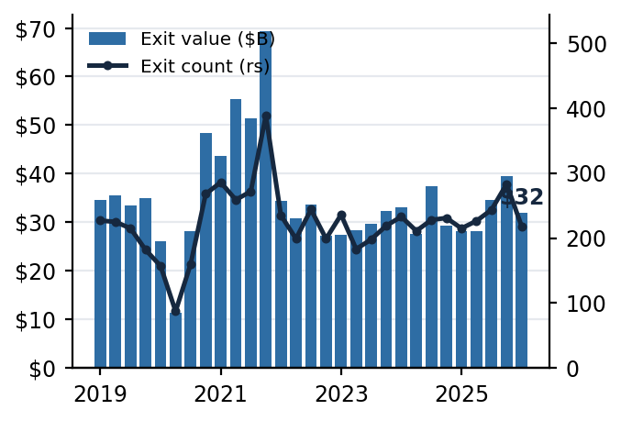  Note: Total exit value and count including PitchBook estimated figures; count on right scale. Source: PitchBook; as of 31 Mar 2026. | Exhibit 23: US PE middle-market exit value by route (US$bn)  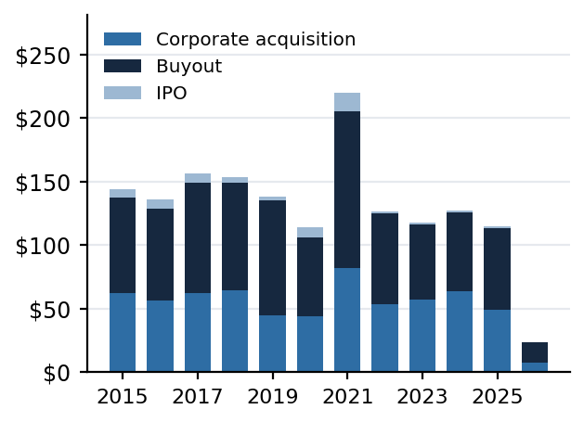  Note: Annual; 2026* is YTD (Q1 only). Series names as per the source data (corporate acquisition / buyout / IPO). Source: PitchBook; as of 31 Mar 2026.

4.2 Holding periods and inventory
The backlog kept building: 13,509 sponsor-held companies, of which 1,506 (11%) have been held nine years or longer and 3,905 (29%) six years or longer. Median exited-deal hold time is 5.5 years, and the median company still in portfolio has been held ~4.2 years and rising — the age pyramid guarantees exit supply, the question is at what price. GP-led secondaries, the pressure valve, ran at US$23bn YTD through May after a record ~US$98bn in 2025 — below last year's pace, so little of the backlog is reaching liquidity through that route either.
Exhibit 24: Median PE holding period (years)  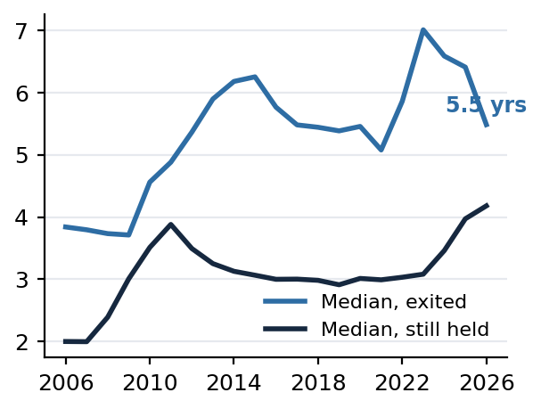  Note: Source: PitchBook; as of 30 Jun 2026. | Exhibit 25: PE company inventory by years held  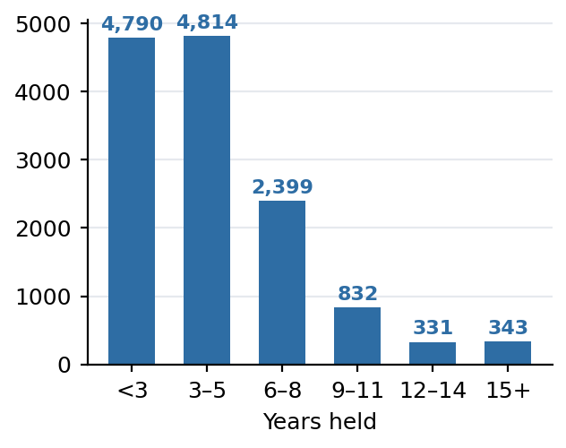  Note: 13,509 companies in total. Source: PitchBook; as of 30 Jun 2026.

Exhibit 26: Global GP-led secondary exit value (US$bn)
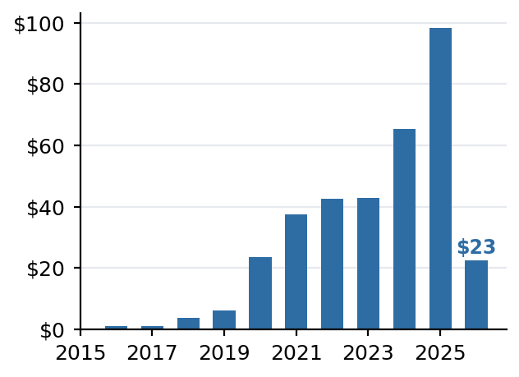
Note: 2026* is YTD through May. Source: PitchBook; as of 30 May 2026.

Fundraising & Dry Powder

5.1 Fundraising
The fundraising market is clearing only at the top. YTD capital raised of US$159.6bn across 223 funds is on pace with 2025's muted US$308.0bn, but fund counts have fallen dramatically and commitments flow overwhelmingly to the largest managers: funds under US$1bn have drawn just 16.7% of 2026 commitments, and first-time and emerging managers are squeezed hardest. The clearest growth is outside the closed-end machine — US evergreen PE assets nearly doubled over the past year to US$99bn. Median step-ups compressed to 1.44x for both buyout and all PE funds. Implication for Junson: LP-favorable terms and co-invest access are most negotiable in the sub-US$1bn cohort, where the capital shortage is acute.
Exhibit 27: US PE fundraising: capital raised and fund count (2026* = YTD)
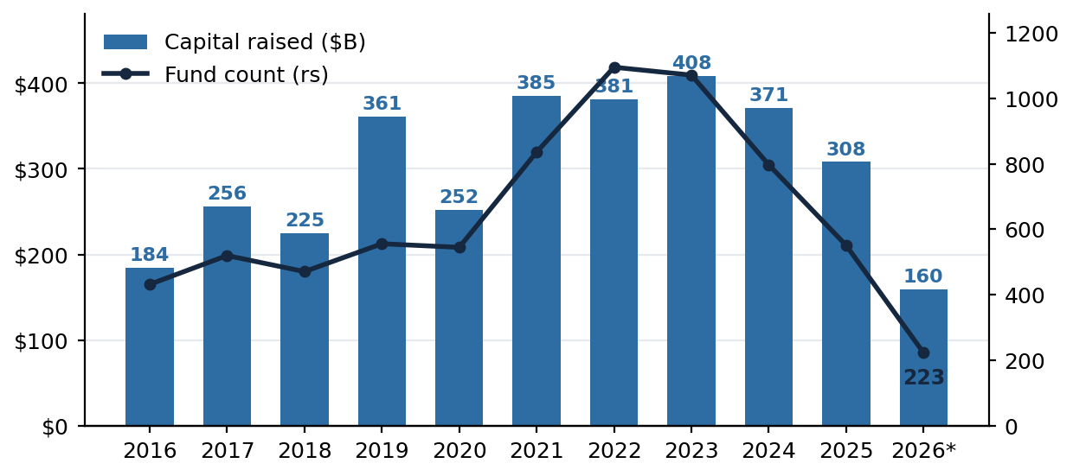
Note: Equity capital counted at final close; 2026 understates the final total because of late-reporting funds. Fund count on right scale. Source: PitchBook; as of 30 Jun 2026.
The US PE middle market shows the same shape one notch down: MM fundraising reached US$102.1bn across 130 funds in 2025 and stands at US$33.4bn across 38 funds YTD 2026 (Q1 only, as of 31 Mar 2026). The concentration signature is clearest in fund sizes for US PE overall: the average fund closed YTD is ~US$753m against a median of just ~US$75m — a 10x gap that widens every time a megafund closes while small funds stall. And with megafund closes largely absent from the Q1 tape, middle-market buyout capital spiked to 73% of all US PE buyout capital raised YTD — against 46% in 2025 — a share that will normalise as large closes land, but which shows the MM fundraising engine still turning.
Exhibit 28: US PE middle-market fundraising: capital raised and fund count  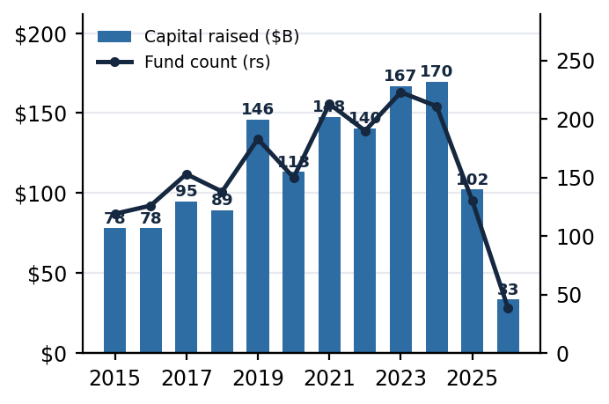  Note: US PE middle-market funds only; 2026* = Q1 YTD. Source: PitchBook; as of 31 Mar 2026. | Exhibit 29: US PE median and average fund size (US$m)  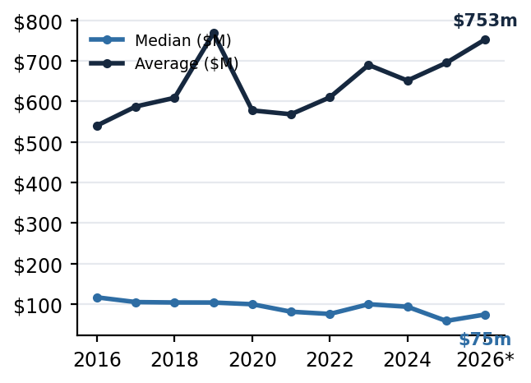  Note: All US PE funds (not middle-market only); 2026* = YTD. Source: PitchBook; as of 30 Jun 2026.

Exhibit 30: US middle-market buyout capital raised as a share of all US PE buyout capital raised  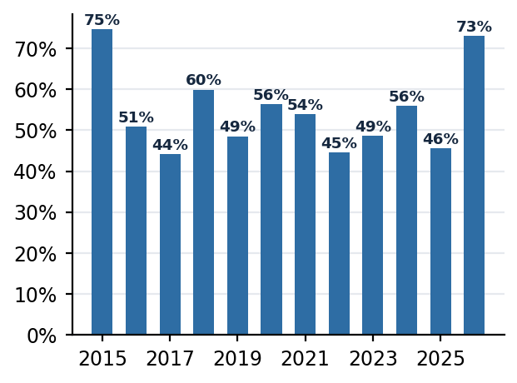  Note: 2026* = Q1 YTD only — the 73% share reflects the absence of megafund closes in the quarter and will normalise as large funds close. Source: PitchBook; as of 31 Mar 2026. | Exhibit 31: US PE median fund step-up (x prior fund)  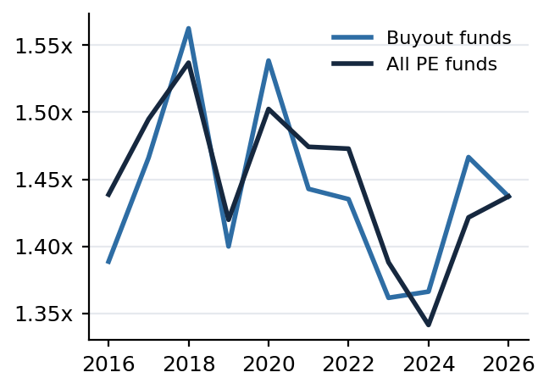  Note: All US PE funds; median table. Source: PitchBook; as of 30 Jun 2026.

5.2 Dry powder and deployment runway
Dry powder stands at US$1,067bn (as of 30 Sep 2025), of which megafunds hold ~US$485bn. Measured against deployment, the overhang is thin: at the 2025 pace it is roughly 0.9 years of runway — the low end of the past decade. That argues deployment pressure persists even in a weak exit tape, favouring entry-price discipline as the differentiator among managers rather than deal access.
Exhibit 32: US PE dry powder by fund size, and deployment runway
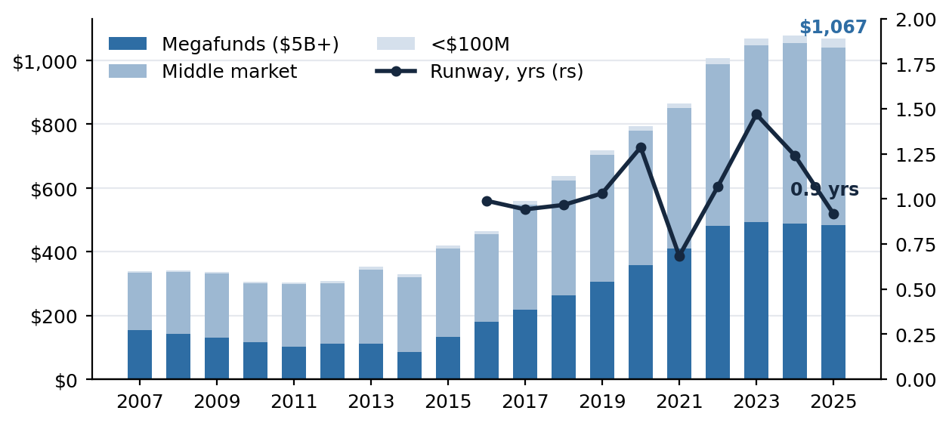
Note: Runway (right scale) = total dry powder ÷ same-calendar-year total deal value — a Junson calculation; PitchBook does not publish this ratio. Dry powder as of 30 Sep 2025. Source: PitchBook.

Things We Should Know

7.1 AI is repricing PE's favourite sector
The AI reassessment is now a first-order PE fundamental, cutting both ways. Software slid from PE's anchor allocation to one of its least wanted — Q2 estimated software deal value of US$10.7bn, -65.7% YoY and 90.3% below peak — as AI compresses the perceived disruption timeline for incumbent software business models. The same force is rebuilding the case for the physical infrastructure that feeds it: energy YTD deal value is up 80.5%, the only major sector to grow in both count and value. For a fund allocator the test is portfolio-level: managers with heavy 2020–2022 software cohorts face both mark risk and extended holds; managers positioned in energy, industrials and AI-adjacent infrastructure get a cyclical and structural tailwind. Claim to revisit in Q3: software's share of US PE deal value stays below 15% for the rest of 2026 despite the valuation reset.

7.2 Scale is the dividing line of this fundraising cycle
The average US PE fund closed YTD is ~US$753m against a ~US$75m median (§5.1); funds under US$1bn drew just 16.7% of commitments; and yet alternative-manager platforms keep clearing at size — GP Stakes VI at US$8.9bn, Veritas IX at US$15.3bn, HPC Fund II launching — while first-time and emerging managers are squeezed hardest. Whatever the deal tape does, capital formation is consolidating around platforms.

7.3 How the PE market impacts the private credit market
The transmission runs through three channels, all visible this quarter. Origination demand: every buyout's debt package is sourced from either the BSL market or private credit, and private markets financed 82% of LBOs by count as of 1Q26 — so the -37.5% QoQ fall in US PE deal value (§2.1) and the -24% y/y decline in direct-lending origination tracked in our Private Credit Quarterly are the same event seen from two sides. Portfolio behaviour: with sponsors in balance-sheet defense — 45% of non-refinancing BSL issuance versus a ~70% five-year average, 53% of refinancing volume, 74% of extension amendments — private credit books rotate from new deployment toward amendments, repricings and PIK toggles, which is where credit-quality signals surface first. Pricing power: scarcer new deals plus returning bank competition move the direct-lending premium around, but at 178bp over single-B BSL (2Q26, PC Quarterly §3) private credit is still being paid for illiquidity. Net: a weak PE deal tape slows private credit's growth but fattens its seasoned-book economics — the risk to watch is not volume, it is the extend-and-hope cohort inside existing books as holds lengthen (§4).

7.4 How the PE market impacts GP-stakes funds
A GP-stakes fund owns three cash-flow streams — management-fee earnings, carried interest, and the terminal value of the stake — and each maps to one part of this report. Fundraising (§5) drives the fee stream, the largest component of value: concentration toward large platforms is a structural tailwind for a book like GPS V's (Stonepeak, Veritas, CVC, PAI, H.I.G — ~80% of holding value), and Veritas IX's US$15.3bn close shows it; but fundraising failure is the sharpest markdown trigger in the strategy — MBK -14.2% this quarter and DivCore/Bitkraft last quarter were all fundraising-driven. Exits (§4) drive carry crystallisation, and the drought explains why only 8.2% of GPS V's US$3.4bn gross distributions are sale proceeds while 36.2% come from securitization — engineered, not market, liquidity; the offset is that longer holds extend the fee-collection period, the strategy's built-in hedge. Performance and multiples (§3) drive the marks: single-digit rolling IRRs defer carry value, and listed alt-manager prices transmit instantly — CVC's -19.2% quarter took roughly two points off GPS V's portfolio on its own. Deal activity (§2) is the slow variable, governing future carry-pool formation and successor-fund timing. Net read: fee streams are secure at scale, carry is deferred, and marks are volatile — exactly the profile GPS V prints in §9 (17th percentile on IRR, 71st on DPI).

7.5 Implications for Junson
Implication for Junson: treat 2026 as a selectively attractive commitment vintage — entry multiples are drifting down and competition for deals is thinner — but only with managers who can demonstrate realized DPI, not marked IRR. Maintain the pacing plan (falling multiples plus thin runway favour steady 2026–27 commitments over waiting); tilt toward middle-market buyout and energy/industrial exposure while stress-testing software-heavy GPs' 2020–22 cohorts; evaluate GP-led/continuation opportunities, where 29% of inventory held 6+ years plus below-pace GP-led volume implies unmet demand and widening LP-stake discounts. What would change our mind: quarterly exit value above US$200bn for two consecutive quarters (liquidity turning); deals-to-exits below 1.25 (inventory clearing); sub-US$1bn share of fundraising above 25% (breadth returning).

Fund Update

8.1 Blue Owl GP Stakes V
We received Blue Owl's quarterly investor letter for GP Stakes V for 1Q26 (report date 31 Mar 2026, delivered 14 Aug 2026); the prior letter (4Q25, as of 31 Dec 2025) is the comparison base. The quarter was a giveback: the GP portfolio value fell -2.3% after +1.8% in 4Q25, LP net blended TVPI slipped to 1.1x from 1.2x, and net blended IRR fell to 7.6% from 10.7% — DPI was flat at 0.4x, so the decline is a markdown story, not a distribution story. Distributions to LPs did edge up to US$3.1bn cumulative from US$2.9bn, helped by WarwickRe's final redemption settlement (fully exited in January 2026). Separately, Blue Owl closed approximately US$8.9bn for successor fund GP Stakes VI as of 31 Mar 2026 — the peer-scale benchmark for §9.

8.1.1 Fund snapshot
  Strategy | Minority GP stakes in PE / alternative asset managers
  Total commitments | US$12.9bn
  Final close | 2022
  Partner managers | 20 (WarwickRe exited Jan 2026)
  Fund-level financing | US$1.3bn IG securitization (Sep 2023); credit facility
  Status | 64% called; successor GP Stakes VI raising (US$8.9bn closed)
  Metric | 4Q25 | 1Q26 | QoQ Δ
  Committed to invest. (US$bn) | 11.7 | 12.0 | +0.3
  Called capital (US$bn / %) | 8.2 / 64% | 8.2 / 64% | —
  GP holding value (US$m) | 13,763.6 | 13,689.5 | -74.1
  Distributions to LPs (US$bn) | 2.9 | 3.1 | +0.2
  Net TVPI / DPI (x) | 1.2 / 0.4 | 1.1 / 0.4 | -0.1 / —
  Net blended IRR (%) | 10.7 | 7.6 | -3.1pp
  Credit facility applied (US$m) | 2,974.3 | 2,527.3 | -447.0

- Quarter activity: exited WarwickRe in full via its final redemption settlement; sold part of the Lead Edge stake via tag-along rights at a premium to the mark (US$4.7m received at closing plus US$14.2m deferred through 2029; +23.7% Q1 markup); purchased an incremental ~€230.0m of CVC shares at a weighted average €12.02 per share into the drawdown. GP portfolio value fell -2.3% in the quarter after +1.8% in 4Q25.
- Manager commentary: Blue Owl argues the perceived structural decline in DPI is more nuanced — dispersion between performance quartiles is meaningfully wider than between vintages, top-5% managers keep distributing across cycles, and the depressed 2021 vintage is primarily cyclical; it sees the market shifting away from the traditional “five-year hold, five-year harvest” model toward dynamic cash-flow management. GP Stakes VI closed on approximately US$8.9bn as of 31 Mar 2026.
Note: Called capital and % called as reported (capital called stated as of 30 Mar 2026 in the 4Q25 letter). Net figures are LP net blended (all fee classes, excluding the SLP); the 4Q25 letter separately shows highest-fee-payer LP net IRR of 8.1%; 1Q26 net IRR excluding the credit facility is 7.1%. Credit facility applied = drawings applied to investments per the Portfolio Summary; total facility outstanding US$5,330.9m at 31 Mar 2026 (endnote 21). Source: Blue Owl, GP Stakes V Quarterly Investor Letters — 1Q26 (report date 31 Mar 2026; received 14 Aug 2026) pp. 2, 4, 6–8; 4Q25 (31 Dec 2025; received 30 Mar 2026) pp. 4, 7–8.

8.1.2 Portfolio composition
Composition was stable at the asset-class level — partner-manager asset exposure is unchanged QoQ at 43% buyout, 28% real assets, 18% venture/growth and 11% private debt — and the underlying portfolio-company mix remains concentrated in IT (22.8%), industrials (19.0%), health care (13.6%) and real estate (13.5%). Movement was at the manager level: MBK's share of GP holding value fell to 5.1% from 5.9% on its markdown, CVC rose to 8.5% on the upsize, and WarwickRe left the book. The top-10 managers account for ~80% of the US$13.7bn GP holding value, led by Stonepeak (12.9%), Veritas (11.8%) and H.I.G (8.8%).
Exhibit 33: Partner manager asset exposure (1Q26)  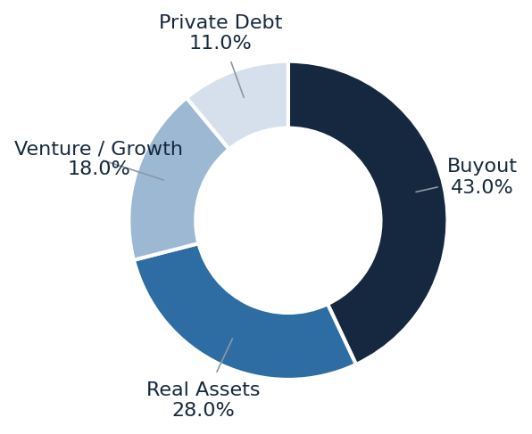  Note: Unchanged from 4Q25. Source: Blue Owl, GP Stakes V 1Q26 letter, 'Portfolio Diversification', p. 5. | Exhibit 34: Partner manager underlying portfolio companies (by sector)  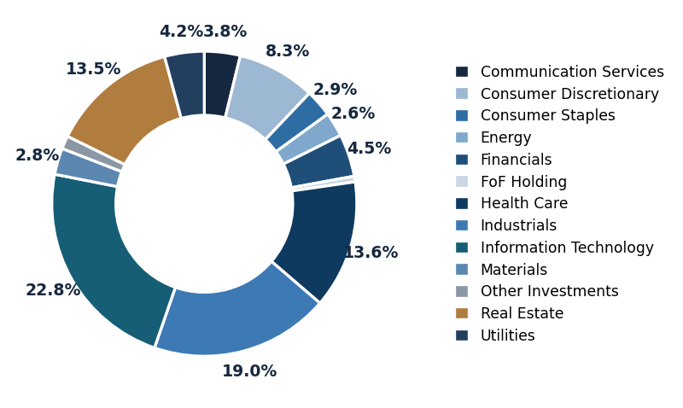  Note: Underlying portfolio-company data as of 31 Dec 2025 (per source note). Source: Blue Owl, GP Stakes V 1Q26 letter, 'Portfolio Diversification', p. 5.

Exhibit 35: GP holding value by partner manager (1Q26)  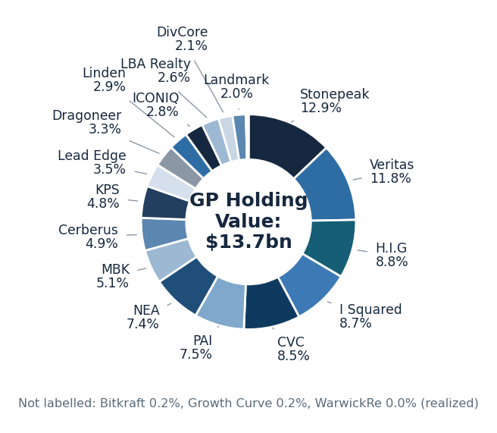  Note: Shares of the US$13.7bn GP holding value as labelled in the source chart; WarwickRe 0.0% (realized in Jan 2026). Source: Blue Owl, GP Stakes V 1Q26 letter, 'GP Holding Value', p. 6. | Exhibit 36: Net TVPI progression (LP net blended)  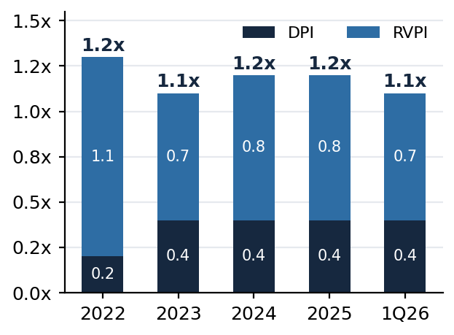  Note: DPI + RVPI stacks as reported; totals as labelled in the source chart. Source: Blue Owl, GP Stakes V letters, 'Fund Overview' (1Q26 p. 4; 4Q25 p. 4).

Exhibit 37: Composition QoQ — by asset class and by partner manager (share of GP holding value)
  Asset class | 4Q25 | 1Q26 | QoQ Δ
  Buyout | 43% | 43% | —
  Real Assets | 28% | 28% | —
  Venture / Growth | 18% | 18% | —
  Private Debt | 11% | 11% | —
  Partner manager | 4Q25 | 1Q26 | QoQ Δ
  Stonepeak | 12.9% | 12.9% | —
  Veritas | 11.7% | 11.8% | +0.1pp
  H.I.G | 8.7% | 8.8% | +0.1pp
  I Squared | 8.7% | 8.7% | —
  CVC | 8.3% | 8.5% | +0.2pp
  PAI | 7.6% | 7.5% | -0.1pp
  NEA | 7.3% | 7.4% | +0.1pp
  MBK | 5.9% | 5.1% | -0.8pp
  Cerberus / KPS | 4.9% / 4.8% | 4.9% / 4.8% | —
  All other (10 positions) | 19.2% | 19.6% | +0.4pp
Note: Manager shares = holding value ÷ total GP holding value (4Q25: US$13,763.6m; 1Q26: US$13,689.5m); Junson calculation from the letters' Quarterly Change in GP Valuation tables. WarwickRe (0.3% at 4Q25) realized in the quarter and included in 'All other'. Asset-class mix per 'Portfolio Diversification' pages. Source: Blue Owl, GP Stakes V letters — 1Q26 pp. 5, 7; 4Q25 pp. 5, 7.
Exhibit 38: Quarterly valuation bridge and movers, 12/31/25 → 3/31/26 (US$m)
Partner manager | Holding 12/31/25 | Upsize | Realized | Unrealized Δ | Holding 3/31/26 | QoQ | Driver (per letter)
Lead Edge | 391.4 | — | (4.7) | +90.3 | 477.0 | +23.7% | Tag-along sale of part of stake at a premium to the mark
CVC | 1,149.1 | 292.4 | — | (276.3) | 1,165.2 | -19.2% | Listed shares fell ~19.2% in Q1; fund added ~€230.0m at €12.02 avg
MBK | 815.8 | — | — | (115.8) | 700.0 | -14.2% | Slower realizations; delay in fundraising of new products
PAI | 1,042.9 | — | — | (19.8) | 1,023.1 | -1.9% | FX appreciation
WarwickRe | 40.0 | — | (40.0) | — | — | Realized | Final redemption settlement; position fully exited
Total fund | 13,763.6 | 292.4 | (44.7) | (321.5) | 13,689.5 | -2.3% | ITD change in value +20.1%
Note: Managers with no QoQ change omitted (14 of 20 positions were held flat this quarter). Source: Blue Owl, GP Stakes V 1Q26 letter, 'Quarterly Change in GP Valuation' table, p. 7, and 'GP Valuation Update' commentary, p. 6.

8.1.3 Fund-level performance
Gross metrics softened a notch: portfolio gross TVPI 1.5x (4Q25: 1.6x) on ITD gross distributions of US$2,142.1m against paid-in cost of US$10,705.7m; gross DPI held at 0.4x. Cumulative gross distributions of US$3.4bn remain heavily engineered — securitization proceeds are the largest component at 36.2% (the 2023 US$1.3bn IG note issuance), ahead of carried interest at 27.6% and management-fee income at 23.4% — while sale proceeds are just 8.2%, mirroring the market-wide realization drought in §4. Net blended IRR of 7.6% now sits below the fund's 4Q25 print (10.7%) and only modestly above the rolling one-year US PE IRR of 7.2% (§3.2). Implication for Junson: the mark, not the model, drove this quarter — CVC's listed-price drawdown is transparent and partly self-correcting, but MBK warrants monitoring as a fundamentals markdown; and with 64% called, ~US$5.3bn of credit facility outstanding and DPI parked at 0.4x, the fund's next leg of net return depends on realization mechanics (tag-alongs, securitization, GP distributions) that the Lead Edge transaction shows are executable at or above marks.
Exhibit 39: Key performance and capital metrics, QoQ
Metric | 4Q 2025 | 1Q 2026 | Δ
GP portfolio value change (QoQ) | +1.8% | -2.3% | -4.1pp
GP holding value (US$m) | 13,763.6 | 13,689.5 | -0.5%
Portfolio gross TVPI / DPI | 1.6x / 0.4x | 1.5x / 0.4x | -0.1x / —
ITD gross distributions, portfolio (US$m) | 2,011.7 | 2,142.1 | +130.4
Cumulative gross distributions, fund (US$bn) | 3.3 | 3.4 | +0.1
LP net blended TVPI / DPI | 1.2x / 0.4x | 1.1x / 0.4x | -0.1x / —
LP net blended IRR | 10.7% | 7.6% | -3.1pp
Called capital / % called | US$8.2bn / 64% | US$8.2bn / 64% | —
Distributions to LPs (cumulative) | US$2.9bn | US$3.1bn | +US$0.2bn
Committed to investments | US$11.7bn | US$12.0bn | +US$0.3bn
Note: Gross portfolio metrics exclude LP investments and securities received in-kind (totals including them: 1Q26 gross TVPI 1.5x on US$13,801.0m holding value). Net figures are LP net blended per the letters' endnote formulas; 1Q26 net IRR excluding the credit facility is 7.1%. Gross distribution mix percentages read from the 'Gross Distributions by Type' chart (1Q26 p. 4); securitization share cross-checks to the US$1,229.7m securitization line in the Portfolio Summary (p. 8). Source: Blue Owl, GP Stakes V quarterly letters — 1Q26 pp. 4, 7–8; 4Q25 pp. 4, 7–8.

Competitor Analysis
This section benchmarks Blue Owl GP Stakes V (§8) against the GP-stakes competitor set, following the positioning approach of the Private Credit report §9 and focusing on QoQ change. A note on vintages before comparing: PitchBook defines vintage year as the year of a fund's first investment (final-close year only when the first investment cannot be confirmed). Applying the same convention to our holding, GPS V's earliest at-transaction dates are Nov 2020 (Veritas) and Dec 2020 (ICONIQ, NEA) against a 2022 final close — so its effective vintage is 2020–21, and its fund age for benchmarking is ~5 years, not ~4. HPC Fund I's first investment is Oct 2021 (MidOcean) against a Jan 2025 final close — effective vintage 2021. All league-table vintages below are on the first-investment basis.

9.1 Positioning vs. the GP-stakes universe
Within the reporting GP-stakes universe, GPS V's 7.6% net blended IRR sits at the low end — the seven PitchBook-reporting peers span -1.6% (Rosemont I, 2000) to 23.6% (Azimut I, 2024), with the post-2015 reporting funds clustered around ~21–24% — while its 0.4x DPI leads every young peer (Odyssey 0.35x, Azimut 0.26x, GP Stakes VI 0.01x). Both readings need the same caveats: PitchBook figures are self-reported/FOIA-sourced and lagged, GPS V's is the freshest mark in the table (31 Mar 2026) taken in a markdown quarter, and the young funds' high IRRs rest on early, largely unrealized marks. HPC Fund I screens strongest on a like-for-like basis: 16.6% net IRR with 1.2x TVPI — though 11.8% pro forma once its subscription-line effect is stripped out, a flattering mechanic GPS V's blended figure does not enjoy (its credit facility cuts the other way: 7.6% with, 7.1% without).
Exhibit 40: GP-stakes league table — Junson holding vs. competitors (vintage = first-investment year)
Fund | Manager | Vintage | Size (US$m) | Net IRR (%) | TVPI | DPI
Blue Owl GP Stakes V (Junson) | Blue Owl | 2020–21 (FC 2022) | 12,900 comm. | 7.6 | 1.1x | 0.4x
Rosemont Partners I | Rosemont Investment Group | 2000 | 38 | -1.6 | 0.94x | 0.36x
Petershill I | Goldman Sachs Asset Management | 2007 | 589 | 14.0 | 2.11x | 2.10x
Petershill Private Equity | Goldman Sachs Asset Management | 2017 | 2,500 | 22.0 | 2.54x | 0.62x
Petershill IV | Goldman Sachs Asset Management | 2020 | 5,000 | — | — | —
HPC Fund I | Hunter Point Capital | 2021 (FC Jan 2025) | 3,300 investable | 16.6 (pro forma 11.8) | 1.2x | 0.2x
Blue Owl GP Stakes Odyssey | Blue Owl | 2022 | — | 20.9 | 1.63x | 0.35x
Azimut GP Stakes Fund I | Azimut Alternative Capital Partners | 2024 | 219 | 23.6 | — | 0.26x
Blue Owl GP Stakes VI | Blue Owl | 2024 | 9,098 | — | 0.70x | 0.01x
Note: Vintages per PitchBook's first-investment convention (pitchbook.com/news/pitchbook-report-methodologies); FC = final close. GPS V and HPC rows are from manager reporting and are not directly comparable to PitchBook's lagged, self-reported figures; net bases also differ (GPS V net blended across fee classes; HPC net includes subscription-line effect, pro forma removes it). PitchBook universe: 33-fund GP-stakes screen (PitchBook_Search_Result_Columns_2026_08_14), of which the seven with reported performance are shown; the remainder (Alpinvest, Armen, AXA IM Prime, CAZ, SNB, Trestle, Validus, and other Blue Owl vehicles) disclose no performance. Δ vs GPS V computed by Junson against the reference row (IRR in percentage points; TVPI/DPI in turns); HPC Δ uses its headline 16.6% net IRR — on the pro forma basis the gap narrows to +4.2pp. QoQ movers log starts next quarter against this archived baseline. Data as of: PitchBook rows — latest reported marks in the 14 Aug 2026 screen (lagged); GPS V — 31 Mar 2026 (manager letter, §8); HPC Fund I — 31 Dec 2025 (manager report). PitchBook quartile flags where assigned: Petershill PE top quartile; Petershill IV and Azimut I upper-mid. Sources: PitchBook, dl. 14 Aug 2026; Blue Owl GPS V 1Q26 letter; HPC Fund I Q4 2025 Portfolio Summary (Feb 2026), p. 3.

9.2 Head-to-head QoQ: GPS V vs. HPC Fund I
HPC Fund I (from Hunter Point Capital) is the only competitor with a quarterly report in hand, and the two funds' latest quarters ran in opposite directions: HPC generated +US$144m (+4.5%) of total value appreciation in 4Q25, while GPS V's GP portfolio fell -2.3% in 1Q26 — note the one-quarter timing mismatch. The underlying stories differ too. HPC is still deploying (committed US$284m to Equitix in October, an US$87m follow-on into L Catterton, +US$25m into Bayview) and its marks are rising on young positions (L Catterton gross TVPI 1.99x→2.11x, Vistria 1.06x→1.11x), with SLR its problem position (0.89x→0.86x; gross IRR -14.8%). GPS V is later-cycle: fully committed, managing liquidity through securitization and tag-alongs, and absorbing public-mark volatility (CVC) and fundamentals markdowns (MBK). One shared risk thread: HPC eliminated all growth associated with Pretium's single-family-rental segment (~12% of Pretium's fee-related earnings) after the January 2026 policy proposal on institutional SFR ownership — policy risk hitting GP-stakes marks directly, a channel GPS V's real-assets exposure (28%) is not immune to. HPC also announced Fund II with a first close expected March 2026 — alongside GP Stakes VI's US$8.9bn, evidence that GP-stakes fundraising is clearing even in a weak PE tape.
Exhibit 41: Blue Owl GPS V vs. HPC Fund I — latest reported quarters
Item | Blue Owl GP Stakes V (1Q26, 31 Mar 2026) | HPC Fund I (4Q25, 31 Dec 2025)
Effective vintage (first investment) | 2020–21 (Veritas Nov-20; final close 2022) | 2021 (MidOcean Oct-21; final close Jan 2025)
Scale | US$12.9bn commitments; 20 partner managers | US$3.3bn investable; US$2.4bn committed across 11 GPs
Quarterly value change | -2.3% (GP portfolio) | +4.5% (+US$144m on committed capital)
Net TVPI / DPI | 1.1x / 0.4x (net blended) | 1.2x / 0.2x (pro forma TVPI 1.20x)
Net IRR | 7.6% (excl. credit facility 7.1%) | 16.6% (pro forma excl. sub line 11.8%)
Quarter's activity | CVC upsize ~€230m; Lead Edge partial sale via tag-along at premium; WarwickRe exit | US$284m Equitix commitment; US$87m L Catterton follow-on; +US$25m Bayview
QoQ movers (gross) | Lead Edge +23.7%; CVC -19.2%; MBK -14.2%; PAI -1.9% | L Catterton 1.99x→2.11x; Vistria 1.06x→1.11x; SLR 0.89x→0.86x; Pretium SFR growth eliminated
Balance-sheet tools | US$1.3bn securitization; credit facility US$5,330.9m outstanding | Subscription line; deal-level securitizations; US$620m dry powder
Successor fund | GP Stakes VI: ~US$8.9bn closed (31 Mar 2026) | Fund II announced; first close expected Mar 2026
Note: Quarters differ by one period (GPS V reports to 31 Mar 2026; HPC to 31 Dec 2025) — comparisons are latest-available, not same-quarter. HPC per-investment figures are gross of fund-level fees. Sources: Blue Owl, GPS V 1Q26 letter pp. 4–8; HPC Fund I Q4 2025 Portfolio Summary (Feb 2026), pp. 3–6, 10.

9.3 DPI benchmark: where the holdings sit on the buyout distribution curve
Blue Owl's own market commentary supplies the benchmark: MSCI Burgiss DPI quartile paths for the 2010, 2016, 2019 and 2021 buyout vintages (data as of 31 Dec 2025). The four cohorts are market-wide buyout-fund universes — not Blue Owl funds — chosen to show that dispersion between quartiles now exceeds dispersion between vintages, and that the 2021 cohort is depressed across all quartiles outside the top 5%. Placing the holdings on those curves at their first-investment fund ages: GPS V (age ~5, DPI 0.4x) sits at the top quartile of the 2021 cohort (0.4x at year 5) and between median (0.35x) and top quartile (0.5x) of the 2019 cohort — a solid relative DPI, with the §8 caveat that 36.2% of its gross distributions are securitization-engineered rather than exit-driven. HPC Fund I (age ~4, DPI 0.2x) sits between the median (0.15x) and top quartile (0.25x) of the 2021 cohort at year 4. The comparability caveat runs the other way, too: GP-stakes economics front-load cash (management-fee share of GP earnings) relative to buyout funds, so a same-age DPI comparison flatters GP-stakes structurally.
Exhibit 42: DPI performance trends — buyout vintages, with Junson-tracked funds marked
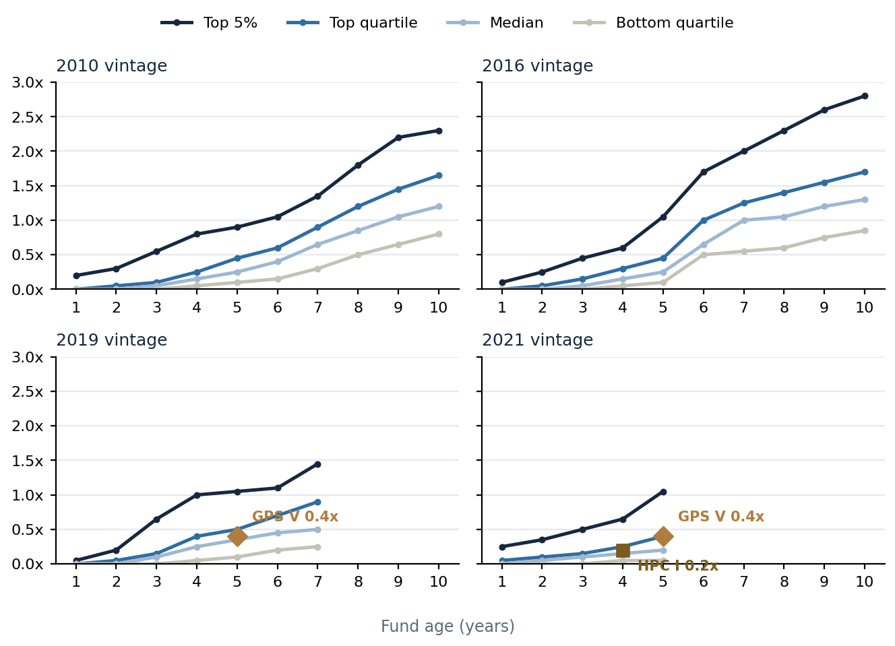
Note: Quartile paths digitised as approximations from the source chart (Blue Owl, GPS V 1Q26 letter, Figure 1, p. 3; underlying data MSCI Burgiss, as of 31 Dec 2025); markers placed at first-investment-basis fund ages (GPS V ~5 yrs, DPI 0.4x, shown on the 2019 and 2021 panels; HPC Fund I ~4 yrs, DPI 0.2x, 2021 panel). Benchmark cohorts are buyout funds; GP-stakes cash-flow mechanics differ — see text.

9.4 Relative momentum and percentile trajectory
This is the first quarter recorded in the competitor ledger, so — as in the Private Credit report's inaugural run — the momentum exhibits show levels against the reporting-peer median rather than quarter-on-quarter change, and the trajectory charts carry a single baseline point; both become genuine time series from next quarter by appending to the ledger rather than recomputing. One momentum reading does already exist: GPS V is the only fund in the set with two net observations, and its own QoQ is negative — net blended IRR -3.1pp (10.7%→7.6%) and TVPI -0.1x (1.2x→1.1x) against 4Q25. On levels, GPS V trails the reporting-peer medians on IRR (7.6% vs 20.9%) and TVPI (1.1x vs 1.63x) but leads on DPI (0.4x vs 0.36x); its percentile ranks are 17th on IRR, 33rd on TVPI and 71st on DPI — the same shape as §9.1 and §9.3: weak on marked performance, strong on realized cash. HPC Fund I baselines at the 50th percentile on both IRR and TVPI and 14th on DPI.
Exhibit 43: Baseline levels: net IRR vs reporting-peer median  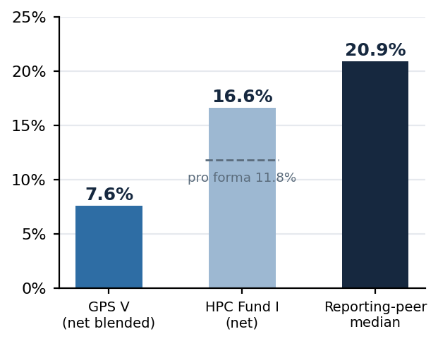  Note: Peer median across the five PitchBook-reporting GP-stakes funds with net IRR (Rosemont I, Petershill I, Petershill PE, Odyssey, Azimut I). Momentum begins next quarter; this quarter shows levels. Pro forma 11.8% (dashed line): HPC's headline 16.6% net IRR is inflated by its subscription line — the fund invests on bank bridge financing and calls LP capital later, which shortens the period LP capital is at work and mechanically raises IRR without changing value creation (net TVPI is unchanged at 1.20x). The 11.8% is HPC's own disclosure of net IRR with all subscription-line-funded activity hypothetically replaced by capital calls (HPC Q4 2025 Portfolio Summary, p. 3), and is the like-for-like figure against GPS V, whose credit facility works in the opposite direction (7.6% with, 7.1% without). Sources: fund reporting (§8, §9.2); PitchBook, dl. 14 Aug 2026; Junson calculations. | Exhibit 44: Baseline levels: TVPI and DPI vs reporting-peer medians  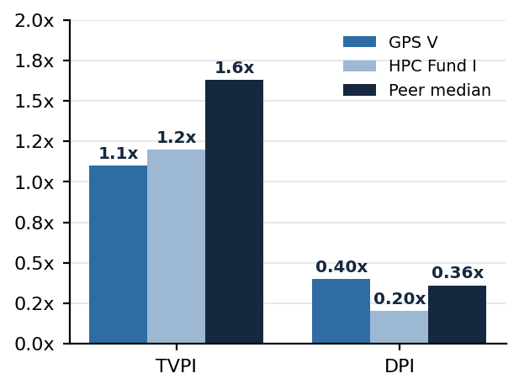  Note: Peer medians across PitchBook-reporting funds disclosing each metric (TVPI n=5; DPI n=6). Sources: fund reporting; PitchBook, dl. 14 Aug 2026; Junson calculations.

Exhibit 45: Net IRR percentile within reporting peers — trajectory (baseline point)  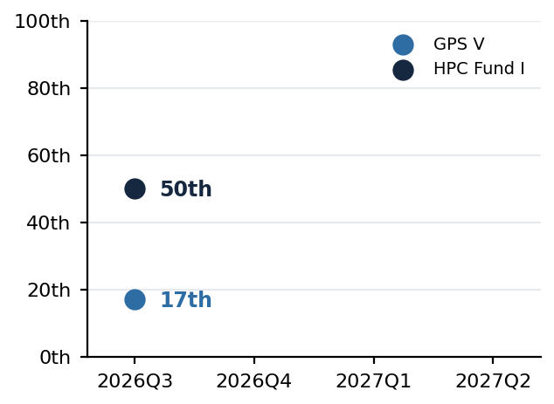  Note: Percentile = share of the reporting cohort strictly below the subject fund, subject excluded (PC-report convention); one point added per quarter, series starts 2026Q3. Cohort n=6 per subject. Sources: fund reporting; PitchBook; Junson calculations. | Exhibit 46: TVPI and DPI percentile — trajectory (baseline point)  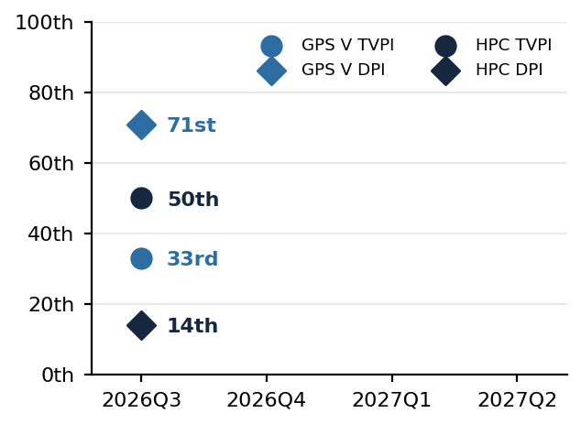  Note: Same convention; TVPI cohort n=6, DPI cohort n=7 per subject. Percentile history archived in comp_series.json alongside the source files for next quarter's delta computation. Sources: fund reporting; PitchBook; Junson calculations.

9.5 Appendix — peer universe and methodology
The full screen holds 33 GP-stakes and adjacent vehicles, of which 19 carry a PitchBook vintage and 7 report performance. The vintage profile shows the strategy's institutionalization: formation is sparse and episodic before 2020, then steps up to 5 funds in the 2024 vintage with ~US$9.4bn of reported aggregate size — dominated by Blue Owl GP Stakes VI's US$9.1bn — with 2025–26 vintages already forming (Trestle II, AXA IM Prime). Two reads for Junson: the competitive set for large-cap GP stakes remains effectively three platforms (Blue Owl, Petershill, and now HPC), and the entry of small first-time vehicles (US$20–640m) signals the strategy is being retailed down-market — watch for cohort-quality dilution in future vintages. Methodology: vintages follow PitchBook's first-investment convention throughout; percentile = share of reporting cohort strictly below the subject, subject excluded; manager-reported figures (GPS V, HPC) and PitchBook's lagged, self-reported figures are shown side by side but are not strictly comparable; aggregate size only sums funds that disclose it, so the size line is a floor, not a total. The cohort-dispersion (IQR) monitor from the Private Credit report is omitted: with at most two ranked funds per vintage the statistic is not meaningful; it will be reinstated on PitchBook Benchmarks buyout cohorts once that release joins the source library.
Exhibit 47: GP-stakes peer universe: fund formation and reported size by vintage year
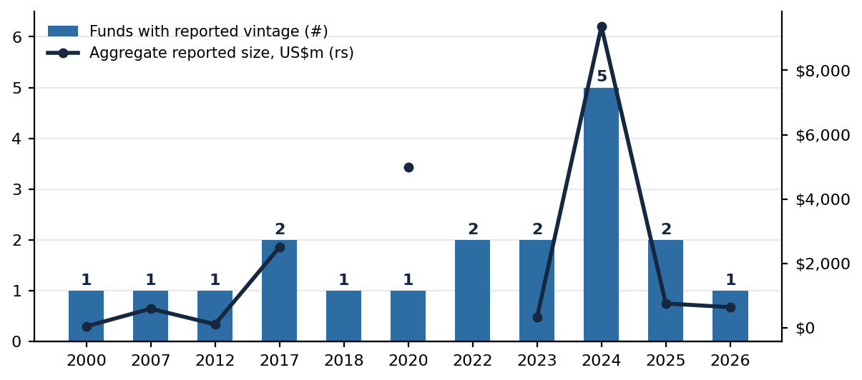
Note: All 33 screen funds with a reported PitchBook vintage (n=19; 14 vehicles — mainly co-invest sleeves and evergreen feeders — carry no vintage and are excluded). Size line aggregates only funds disclosing size. GPS V and HPC Fund I are not in the screen. Source: PitchBook, dl. 14 Aug 2026; Junson calculations.

