Blue Owl Technology Finance Corp. (NYSE: OTF) 17 Aug,2026
Software & OTF Quarterly Update — 2026Q2 review, published 17 August 2026

Summary
Software industry by AI impact
- Broker tone turned incrementally more constructive at the infrastructure and data layer: BofA raised its infrastructure-software peer target multiple to 5.8x from 5.0x EV/CY27E revenue, while UBS procurement checks left application software as the funding source, not the beneficiary, of AI budgets.
- Hybrid seat-plus-consumption pricing became the operating default this quarter — 50% of ServiceNow net-new business is now non-seat-based and Microsoft moved GitHub Copilot to usage pricing on June 1 — and the transition friction is surfacing first in bookings and renewals.
- Company AI monetization kept accelerating against the cautious broker view: Microsoft AI ARR passed $37bn, up 123% y/y, and Salesforce agentic ARR passed $1bn; the layer-vulnerability ranking is unchanged with applications most at risk.
Private credit & public BDC industry
- Credit migration continued: average non-accruals across JPM's 29-BDC universe rose 40bp QoQ to 2.46% of cost in 1Q26, and Morgan Stanley's broader universe average of 2.8% is a five-year high, with the sharpest sector rises in IT and healthcare.
- The two largest losses of the software private-credit cycle crystallized in April — Medallia was handed to lenders in a $5.1bn equity wipeout and Affordable Care defaulted on a $1.4bn loan — yet JPM's credit team stayed overweight BDC debt as index spreads retraced to ~217bp.
- Non-traded BDC redemption requests averaged 12.2% of NAV in 2Q against 5% caps that held everywhere; estimated net outflows of $3.1bn equal 2.56% of NAV, and KKR's $300mm support of FS KKR set the template for sponsor backstops.
OTF update
- Q2'26 NAV was $16.48, down $0.01 QoQ; non-accruals rose to 0.6% of cost from 0.3% on one small software addition while staying at 0.1% of fair value; GAAP NII of $0.30 covered 75% of the $0.40 distribution.
- Net leverage rose to 0.93x from 0.85x — the first quarter inside the 0.90–1.25x target — funded by $500mm of new 6.50% Oct-2029 notes and $280mm of net SPV draws; PIK fell to 12.5% of investment income from 13.1%.
- Litigation escalated from investigation notices to a filed complaint: a Section 36(b)¹ excessive-fee suit against the OTF adviser was filed June 18 in the S.D.N.Y., alleging inflated marks and fees charged on non-cash PIK accruals.
1 Section 36(b) of the Investment Company Act imposes a fiduciary duty on a fund's investment adviser with respect to the compensation it receives; shareholders may sue the adviser directly for excessive fees.

1. News

1.1 Key news on Blue Owl & OTF
- First excessive-fee complaint filed directly against OTF's adviser. On June 18 two stockholders sued Blue Owl Technology Credit Advisors in the S.D.N.Y. under Section 36(b) of the Investment Company Act, alleging the adviser inflated asset marks to extract fees: advisory fees grew 191% from 2021 to 2025 against 134% asset growth, and fees are charged on PIK accruals that reached ~$43mm, about 25% of net investment income, in Q1'26. This escalates last quarter's plaintiff-firm investigation notices into discovery risk on OTF's Level-3 marks — though Section 36(b) plaintiffs have historically never prevailed at trial, so near-term economics are unchanged. Source: investmentnews.com
- Q2'26 results, August 5: NAV $16.48 vs $16.49, NII $0.30, non-accruals 0.6% of cost and 0.1% of fair value, net leverage 0.93x, $55mm of stock repurchased in the quarter and ~$170mm over three quarters. The stock rose 7.4% on the print to $11.20, still ~0.7x NAV; management noted the discount implies roughly 40% portfolio defaults at 50-cent recoveries and expects lock-up-related selling to fade. Source: prnewswire.com
- Second consecutive quarter of capped redemptions at Blue Owl's non-traded tech-credit funds, disclosed July 2: OCIC requests eased to 18.8% of shares from 21.9% and OTIC to 38.1% from 40.7%, $4.7bn combined vs $5.4bn in 1Q; both funds again honored only the 5% quarterly cap. OCIC holds $11.6bn of cash and capacity, about twelve quarters at the cap. The overhang on the franchise is stabilizing, not resolved; 3Q requests publish around early October. Source: semafor.com
- OTF priced $500mm of 6.50% senior unsecured notes due October 2029 in early June; KBRA assigned BBB. Unsecured IG market access at a mid-6% coupon despite sector redemption stress is funding-side validation, at a cost of debt above much of the legacy stack. Source: businesswire.com
- Moody's cut OCIC's outlook to negative on April 8, Baa2 affirmed, citing peer-high redemption requests and expected capital erosion — the first agency acknowledgment that the redemption run is a credit issue for Blue Owl's non-traded vehicles. No OTF-level rating action followed; the contagion channel to OTF is reputational and funding-cost, not direct. Source: alternativecreditinvestor.com
- OCIC itself returned to the IG bond market on June 8 with $500mm of 5-year notes at roughly T+255, and Blue Owl Capital's Q2 results beat with shares recovering about 21% off the July lows — the manager-level franchise is proving more resilient than the redemption narrative implied. Source: bloomberg.com
- Sell-side tail-risk framing persists: a July UBS note argued private credit defaults could reach ~15% in software-heavy funds, citing Blue Owl's $4.7bn of 2Q redemption requests. Single-source and unverified, but it keeps the software-credit narrative over the stock regardless of OTF's 0.1% fair-value non-accruals. Source: cryptobriefing.com

1.2 Key private credit news
- Medallia handed to lenders — a $5.1bn equity wipeout. Thoma Bravo agreed in late April to transfer the customer-experience software company, bought for $6.4bn in 2021, to creditors Blackstone, KKR, Apollo and Antares holding $3bn of debt; BDC marks on the loans sat at 74–79 cents beforehand. The largest software-LBO equity wipeout of the cycle, and direct evidence that 2021-vintage software buyout debt is where private credit losses are crystallizing — distressed software loans market-wide stood near $47bn. Source: in.investing.com
- Affordable Care defaulted on a $1.4bn private credit loan in April, with Blackstone and KKR moving to take control of the dental-services provider bought by Harvest Partners for ~$2.7bn in 2021 — stress is not software-only; 2021-vintage healthcare-services unitranches are defaulting too. Source: privateequitywire.co.uk
- KKR injected $300mm of sponsor capital into FS KKR alongside Q2 results — the first large explicit sponsor-support action of this downturn. JPM's credit team reads manager support of this kind as a sector-wide backstop; it is also an admission that BDC balance sheets need parent capital. Source: privateequitywire.co.uk
- Marks moved at blue-chip platforms in Q2: Blackstone Secured Lending posted its largest quarterly NAV decline in six years with its bottom decile marked at 70 cents vs 73, and BlackRock TCP moved 48% of a $523mm loan pool into a continuation vehicle — liquidity engineering for credit tails is spreading and invites mark-management disputes. Source: privateequitywire.co.uk
- The BDC litigation wave broadened beyond Blue Owl: a Section 36(b) suit against Ares Capital's adviser in May alleges fees up 53% to $773mm with look-through leverage of 2.06x vs the 1.12x headline, and securities class actions are pending against BlackRock TCP, Hercules and FS KKR — Level-3 marks and PIK-linked fees are now a sector-wide legal theme. Source: octus.com
- The Q2 BDC reporting season read as stabilization, not resolution: non-accruals at cost rose at ARCC to 2.4% and OBDC to 2.8% while improving at FS KKR and Oaktree; origination stayed subdued, with Blue Owl vehicles repaying $747mm against $319mm of new commitments. Source: privateequitywire.co.uk

1.3 AI related news
- Enterprise software spend is being re-priced as tokenized labor: a leading model developer's revenue run-rate passed $30bn, from $9bn at end-2025, alongside managed-agent tooling that collapses the time to build enterprise agents; roughly $1.4tn of SaaS market value has repriced since early 2025 and the demand question for every application vendor is now which workflows agents absorb first. Source: cnbc.com
- SaaS economics are being rewritten from the cost side: AI inference introduces genuine variable cost of goods into ~80%-gross-margin businesses — one marketing-tech company grew revenue 38% while costs rose 349% — pushing the industry toward a transitional Rule of 30 as vendors reinvest against AI-native entrants; margin durability, not growth, becomes the variable to underwrite. Source: bain.com
- The offensive case for incumbents was quantified at ~$100bn in the US alone: agentic AI that automates cross-system labor — the human coordination between ERP, CRM, billing and ticketing that rules-based automation never captured — converts labor budgets into software spend, and vendors holding proprietary workflow data are best positioned to capture it. Source: bain.com
- Research across 45 public SaaS companies concluded the build-vs-buy shift is real but uneven: AI coding tools let enterprises rebuild commodity workflow software in-house, while SaaS powered by pooled cross-customer data performing predictive tasks retains pricing power — software credit should be sorted by data moat and task type, not treated as one risk bucket. Source: hbr.org
- Software producers themselves are restructuring: revenue at leading software companies grew 22% faster than headcount over the past year, and the standard 7–9-person engineering squad is giving way to 3–5-person hybrid-agentic pods — structurally lower headcount intensity, and lower seat counts for the tools sold into those teams. Source: bain.com
- Monetization began moving from seats to agent consumption: major platforms started billing directly for agent usage and standing up enterprise agent-governance layers during the quarter — an early template for recapturing value when the user is software, and an accelerant of the industry-wide shift toward usage and outcome pricing. Source: techtimes.com
- The AI-software story formally crossed into credit: major financial press mapped how private equity and private credit concentrated in software ahead of the AI shock, connecting agent-substitution risk to the ~$47bn distressed software-loan stack — AI is now an underwriting variable in leveraged software credit, not just an equity theme. Source: bloomberg.com

2. OTF update

2.1 Portfolio composition

Capital structure
Asset class | Q1'26 | Q2'26 | QoQ Chg
First-lien senior secured debt | 77.7% | 77.8% | ↑ +0.1pp
Second-lien senior secured debt | 3.5% | 3.3% | ↓ −0.2pp
Unsecured & specialty finance debt | 3.5% | 3.5% | flat
Preferred equity | 7.0% | 6.5% | ↓ −0.5pp
Common equity & JV | 8.3% | 8.9% | ↑ +0.6pp
Total | 100.0% | 100.0% | —
Memo: senior secured debt | 81.5% | 81.4% | ↓ −0.1pp
Memo: total debt investments | 84.7% | 84.6% | ↓ −0.1pp
Memo: total equity & joint ventures | 15.3% | 15.4% | ↑ +0.1pp
Memo: unitranche share of first-lien debt | 57% | 56% | ↓ −1pp
Percent of total investments at fair value, by 10-Q asset class. Unsecured & specialty finance debt combines the two debt buckets; common equity & JV includes specialty finance equity. Portfolio fair value was $14.1bn across 203 companies at Q1'26 and $14.7bn across 205 at Q2'26. Source: OTF Q2'26 and Q1'26 10-Q; Q2'26 Earnings Presentation slide 5
The mix was essentially static this quarter: the largest move was common equity & JV at 8.9%, up 0.6pp, driven by specialty finance equity additions, against preferred equity at 6.5%, down 0.5pp. First-lien exposure held at 77.8% and total debt investments at 84.6% of fair value.

Industry
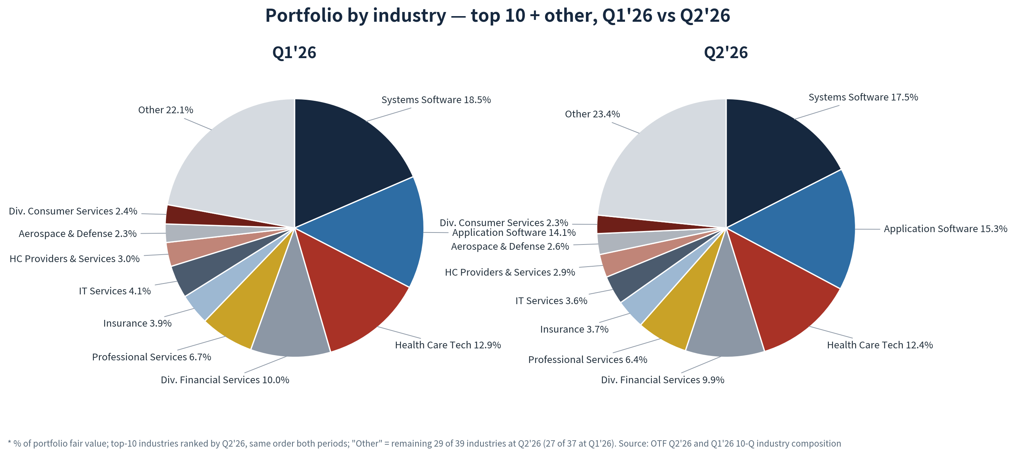
Industry | Q1'26 | Q2'26 | QoQ Chg
Systems Software | 18.5% | 17.5% | ↓ −1.0pp
Application Software | 14.1% | 15.3% | ↑ +1.2pp
Health Care Technology | 12.9% | 12.4% | ↓ −0.5pp
Diversified Financial Services | 10.0% | 9.9% | ↓ −0.1pp
Professional Services | 6.7% | 6.4% | ↓ −0.3pp
Insurance | 3.9% | 3.7% | ↓ −0.2pp
IT Services | 4.1% | 3.6% | ↓ −0.5pp
Health Care Providers & Services | 3.0% | 2.9% | ↓ −0.1pp
Aerospace & Defense | 2.3% | 2.6% | ↑ +0.3pp
Diversified Consumer Services | 2.4% | 2.3% | ↓ −0.1pp
Other industries | 22.1% | 23.4% | ↑ +1.3pp
Total | 100.0% | 100.0% | —
Memo: Systems + Application Software | 32.6% | 32.8% | ↑ +0.2pp
Memo: top ten industries | 77.9% | 76.6% | ↓ −1.3pp
Memo: number of industries held | 37 | 39 | ↑ +2
GICS sub-industry, percent of total investments at fair value. The ten largest are ranked by Q2'26 and the same order is held in both quarters. A 10-Q's comparative column is the prior year end rather than the prior quarter, so the Q1'26 column is taken from the Q1'26 10-Q. Source: OTF Q2'26 and Q1'26 10-Q
The top three industries — Systems Software 17.5%, Application Software 15.3% and Health Care Technology 12.4% — together account for 45.2% of fair value, down 0.3pp QoQ; the notable rotation is within software, where Application Software gained 1.2pp while Systems Software gave up 1.0pp. On the internal AI-impact grading, High-impact industries — Application Software, Systems Software, Internet & Direct Marketing Retail, IT Services and Professional Services — sum to 44.6% of fair value, down 0.7pp QoQ, and Mid-impact industries — the two healthcare buckets, the three diversified-services buckets and Life Sciences Tools — sum to 30.0%, down 0.6pp; the four industries carrying the model's highest 30% default assumption total 27.1%, up 0.3pp.

Software layer exposure
Layer | % of portfolio FV | Representative holdings
Application | 49.5% | Anaplan, AlphaSense, Acquia
Platform | 11.4% | Databricks, Boomi, Algolia
Infrastructure | 12.4% | Arctic Wolf, Barracuda, Proofpoint
Non-software | 26.8% | —
Internal layer mapping of the portfolio per the 202607 draft model Crosscheck sheet, classified position-by-position from the Q1'26 schedule of investments; shares of portfolio fair value. Source: internal draft model; OTF 10-Q schedule of investments
Application-layer software is by far the largest sleeve at roughly half of portfolio fair value, four times the platform layer. Set against the layer-vulnerability ranking maintained in section 4.3 — applications most at risk, then platforms, then infrastructure — OTF's book is weighted precisely toward the layer under the most AI pressure, which is the structural reason the stock carries a software-concentration risk premium that diversified BDCs do not.

Borrower fundamentals
Metric — first & second lien group | Q1'26 | Q2'26 | QoQ Chg
Weighted avg annual revenue | $0.9bn | $1.0bn | ↑
Weighted avg annual EBITDA | $285mm | $291mm | ↑ +2.1%
Weighted avg enterprise value | $5.5bn | $5.7bn | ↑
Weighted avg net LTV | 40% | 40% | flat
Average position size (whole portfolio) | $69mm | $72mm | ↑
Portfolio companies | 203 | 205 | ↑ +2
Lien-group statistics cover first- and second-lien borrowers, 74.5% of portfolio fair value at Q2'26. Net LTV valuation basis per the 10-Q and earnings deck: the net ratio of loan to value for each portfolio company weighted by the fair value of OTF's loan; the attachment point is the principal senior to OTF's loan, that amount plus OTF's loan and equally ranked debt is the last-dollar amount, and value is an estimate of each company's enterprise value, a calculation that varies by portfolio company. Source: OTF Q2'26 Earnings Presentation slide 7; 10-Q MD&A
The only move of note is weighted-average borrower EBITDA at $291mm, up 2.1% QoQ and up 15.9% from $251mm at Q1'25 — underlying borrower earnings are still growing, which is the single most direct rebuttal available in OTF's own disclosure to the thesis that AI erosion is already visible in its book.

2.2 Financial & debt

Cash yield trend
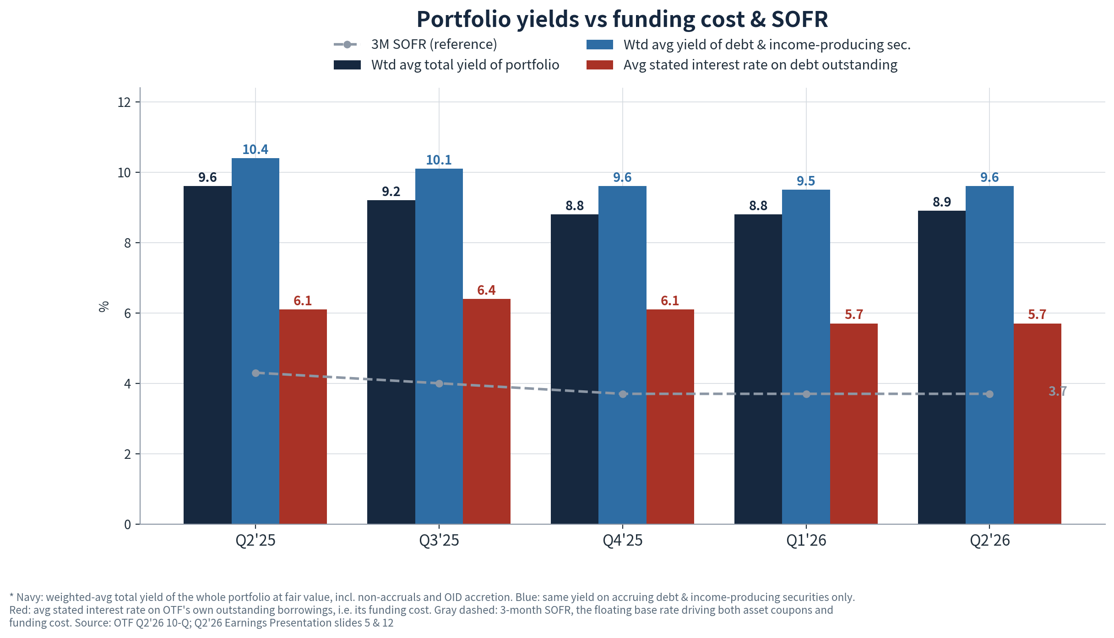
Asset yields stabilized after four quarters of compression: the weighted-average yield on accruing debt and income-producing securities was 9.6% at fair value, up 10bp QoQ, and the total portfolio yield 8.9%, up 10bp. The decomposition assigns none of it to the base rate — 3M SOFR was unchanged at 3.7% and the weighted-average spread of floating-rate debt was likewise flat at 5.3% — so the uplift is mix rather than repricing, while the average stated interest rate on debt outstanding held at 5.7%, leaving the net interest margin roughly 390bp.

NAV bridge
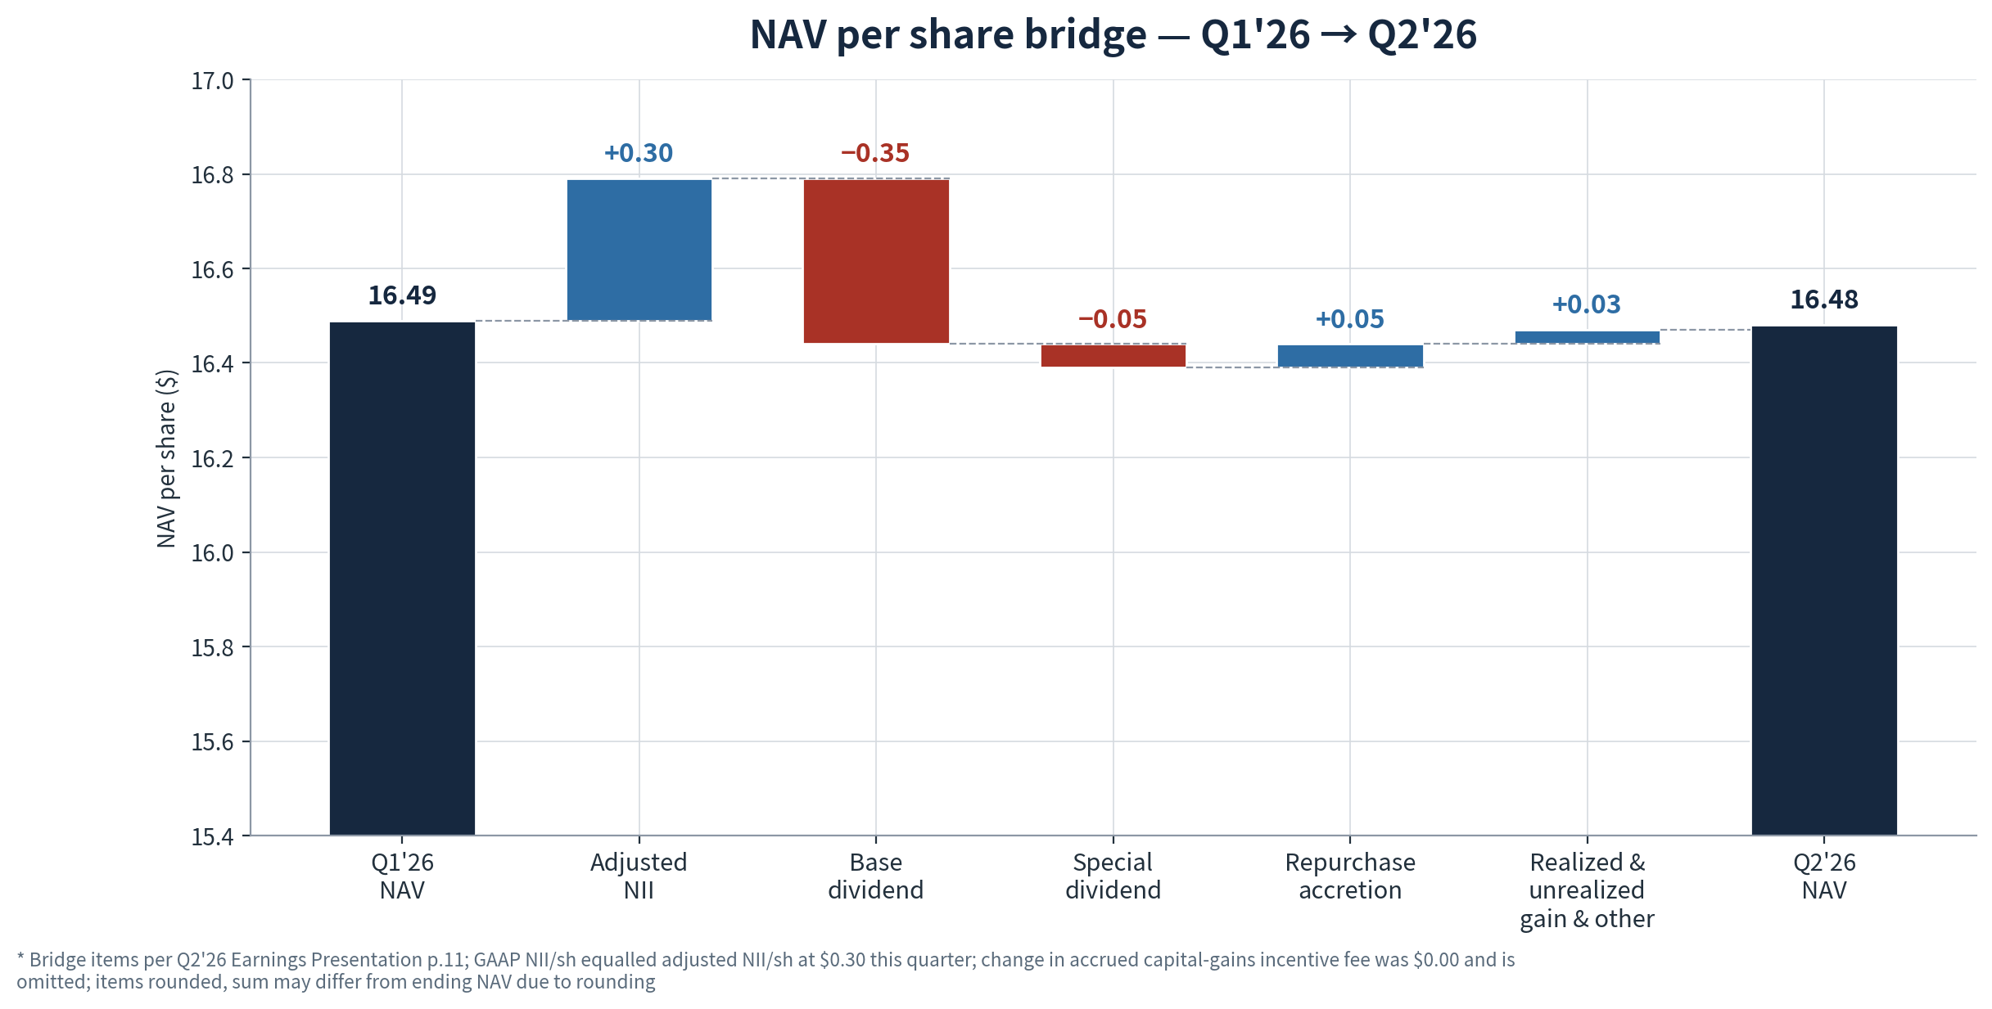
NAV was effectively flat at $16.48, down one cent. Unlike Q1'26 — when an $0.84 unrealized spread-mark drag drove NAV down 4.9% — this quarter's realized and unrealized result was positive at +$0.03, and the $0.10 gap between NII of $0.30 and the $0.40 distribution was nearly closed by $0.05 of buyback accretion. The reversal in the mark line is consistent with spread stabilization rather than credit improvement, and it leaves the recovery option on last quarter's marks intact: the Q1 write-down was priced off public credit spreads, and a further retracement would flow back through this same line.

NII & dividend coverage
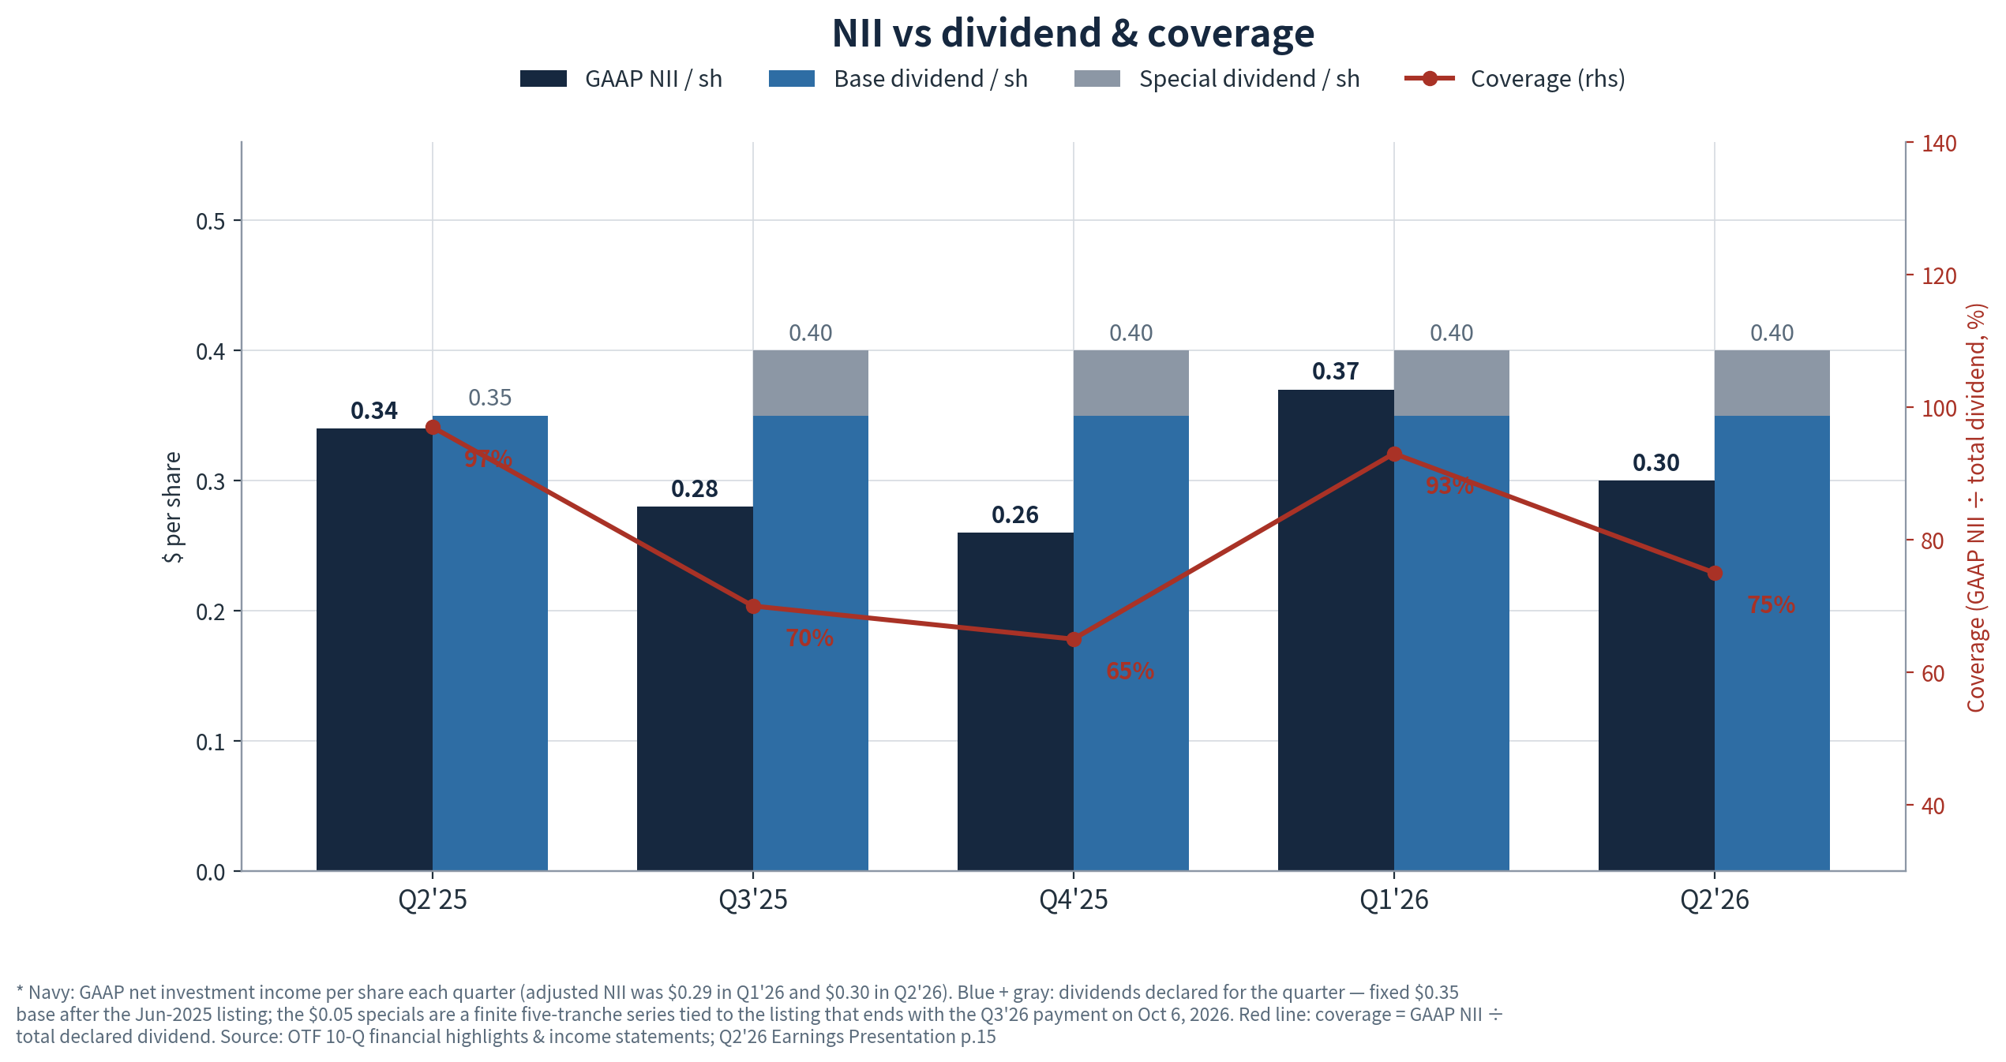
GAAP NII of $0.30 covered 75% of the $0.40 total distribution, down from 93% in Q1'26 on the reversal of the one-off capital-gains incentive-fee benefit; against the $0.35 base dividend alone, coverage was 86%. Income quality moved the right way — the PIK share of investment income declined for a second quarter, as shown in section 2.3, and cash interest remains the dominant revenue line — but the base dividend is not yet fully cash-earned, which keeps the payout dependent on the leverage build discussed below.

Financing profile
Facility / notes | Committed | Q1'26 drawn | Q2'26 drawn | QoQ Chg
Revolving credit facility | 2,675 | 1,640 | 1,620 | ↓ −20
SPV asset facilities I–III | 2,200 | 1,650 | 1,650 | flat
SPV asset facility IV | 500 | 270 | 370 | ↑ +100
SPV asset facility V — new, May-26 | 150 | — | 75 | ↑ +75
Athena CLOs II / IV / V | 915 | 915 | 915 | flat
June 2026 notes — matured | — | 375 | — | ↓ −375
January 2027 notes, 2.50% | 300 | 300 | 300 | flat
March / September 2028 notes | 725 | 725 | 725 | flat
April 2029 notes, 6.75% | 700 | 700 | 700 | flat
October 2029 notes, 6.50% — new, Jun-26 | 500 | — | 500 | ↑ +500
January 2031 notes, 6.125% | 400 | 400 | 400 | flat
Total debt | 9,065 | 6,975 | 7,255 | ↑ +280
Unsecured share of outstanding debt |  | 35.8% | 36.2% | ↑ +0.4pp
Available liquidity — cash + undrawn |  | $2.3bn | $2.0bn | ↓ −$0.3bn
Principal amounts, $mm; committed amounts as of Q2'26 — total committed was $8,790mm at Q1'26. Weighted-average debt maturity ~5.8 years on committed debt; four investment-grade issuer ratings. Source: OTF Q2'26 10-Q Note 5; Q2'26 Earnings Presentation slide 14; Q1'26 10-Q
The quarter's funding actions extended the curve: the $375mm June-2026 notes were repaid at maturity, replaced by $500mm of new 6.50% October-2029 notes, a new $150mm SPV facility V and a further $100mm draw on SPV IV. Maturities are light until 2028 — 2027 carries only $300mm — with the concentration in 2030 and beyond at $7.3bn of committed capacity, so refinancing pressure over the next 18 months is limited to the low-coupon January-2027 notes.

Leverage ratio
Net leverage ended Q2'26 at 0.93x, up from 0.85x in Q1'26 — the first quarter inside the management target range of 0.90x–1.25x since listing. The increase was deployment-led rather than write-down-led: $478mm of net funded investment activity was financed with the new unsecured notes and SPV draws while net assets were flat, and asset coverage remained comfortable at 203% against the 150% statutory floor, although down from 226% at year-end 2025. From here the fund retains roughly $2.4bn of debt capacity to the top of the target range, equivalent to about a third of current net assets, which is the principal forward driver of NII per share while base rates are flat. Symmetrically, the cushion to the regulatory floor is wide: net assets would have to absorb roughly $4.0bn of portfolio value decline, about 27%, before the 150% test binds.
Leverage & capital | Q1'26 | Q2'26 | QoQ Chg
Net leverage | 0.85x | 0.93x | ↑ +0.08x
Management target range | 0.90–1.25x | 0.90–1.25x | —
Asset coverage ratio — statutory floor 150% | 226% (12/31/25) | 203% | ↓
Debt capacity to 1.25x target ceiling |  | ~$2.4bn
Portfolio decline absorbed before 150% floor |  | ~$4.0bn / ~27%
Asset coverage comparative is the year-end 2025 disclosure; the buffer to the 150% floor is computed from Q2'26 net assets of $7,540mm and debt of $7,158mm carrying value. Source: OTF Q2'26 10-Q liquidity & capital resources; Q2'26 Earnings Presentation

2.3 Default concern

PIK
之后的可以把括号里的删了
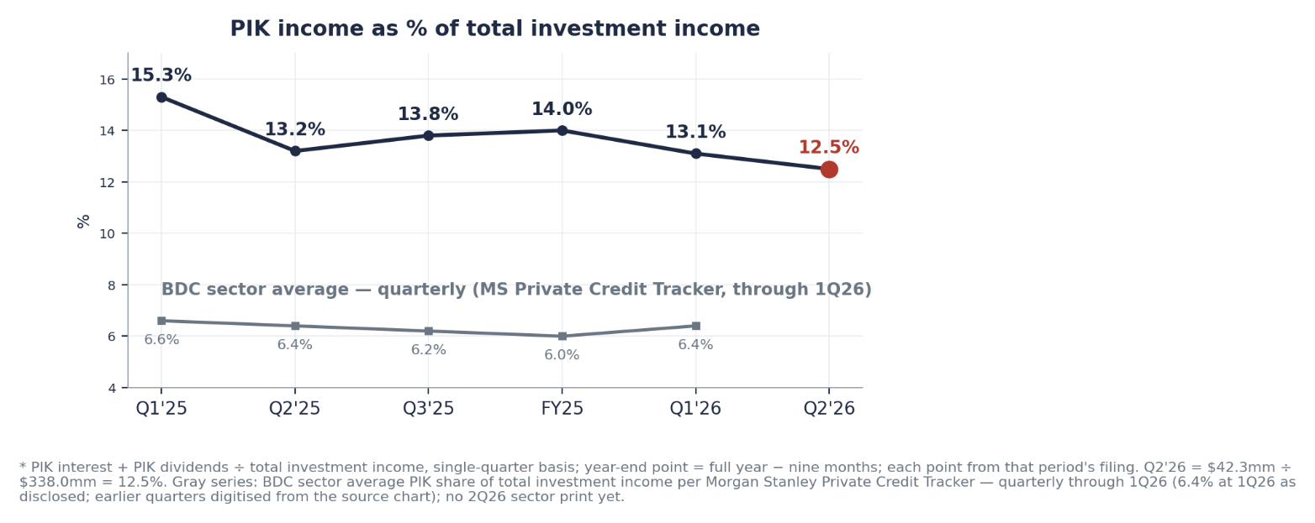

PIK income was 12.5% of total investment income, down 0.6pp QoQ and the second consecutive decline; per the earnings call roughly 98% of it was structured at original underwriting rather than amendment-driven, though the level remains about twice the 6.4% BDC sector average.

Non-accrual
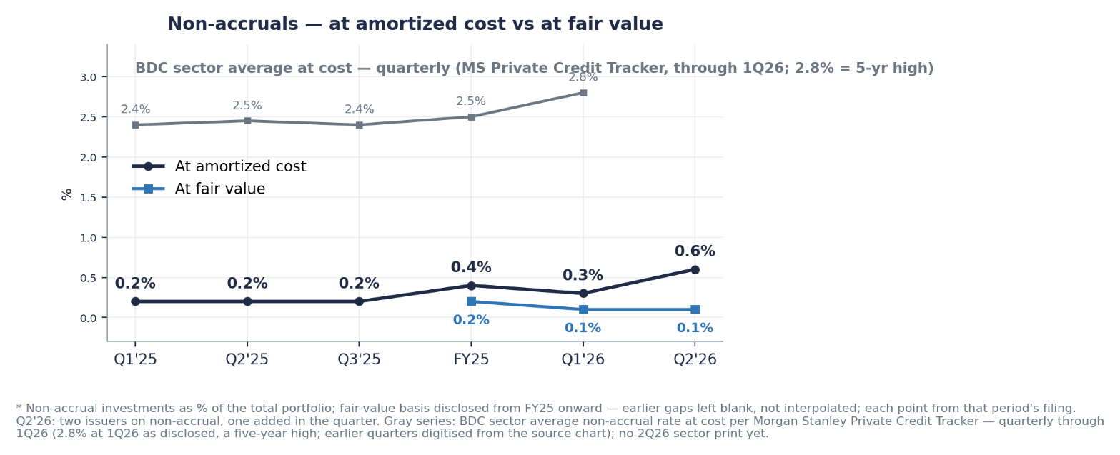
Non-accruals rose to 0.6% of cost from 0.3%, on one small addition — a software preferred position of roughly $53mm at cost — against one exit, leaving two issuers and about $20mm of fair value, or 0.1% of the portfolio, unchanged QoQ and a fraction of the 2.8% sector average.

Internal risk rating
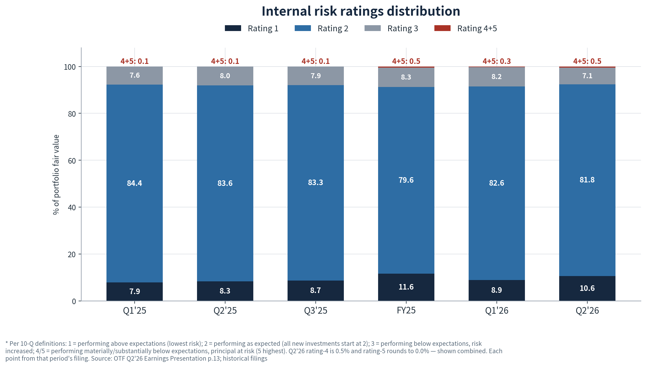
Ratings 4+5 were 0.5% of fair value, up 0.2pp QoQ, while rating 3 improved 1.1pp to 7.1% — leaving 92.4% of the book rated 1 or 2, up 0.9pp.

2.4 Sell-side view & TP
- BofA maintained Neutral with an unchanged $11.50 price objective at ~0.7x NAV after Q2 results, having cut from $14.00 in May. The house titled the quarter Stable — NAV flat at $16.48 and portfolio yield up 10bp to 9.3% — after Q1's Challenging quarter framing, so the negative-revision cycle paused. Adjusted core EPS of $0.30 rose 3% QoQ, one cent below the $0.31 consensus but above the broker's own $0.28 on stronger interest and dividend income; standing core EPS estimates for 2026 and 2027 remain $1.21 and $1.26 with no new revision published. On credit the note counts non-accruals of 0.6% at cost across two issuers — one software addition, one exit — among the lowest in the industry, and flags PIK declining to 12.5% of revenue, substantially all original-underwrite. The core argument for staying at Neutral despite the discount: credit is pristine and the outlook slowly improving, but core profitability will lag peers for the near future given significant excess capital. Versus last quarter the rating, objective and multiple are unchanged and the tone shifted from yield-pressure caution to stabilization.
 | BofA | Citizens JMP | Wells Fargo | Truist
Rating | Neutral — maintained, 8/6 | Market Outperform — maintained, 8/7 | Overweight — reiterated, 8/7 | Buy — reaffirmed, 8/6
Target price | $11.50 | $17.00 | $12.00 | $15.00
QoQ Chg | Unchanged; cut from $14.00 in May | ↑ Raised from $16.00 — the only post-Q2 increase | Unchanged; cut from $13.00 in May | Unchanged; cut from $16.00 in May
Valuation | ~0.7x NAV | NA; implies ~1.03x NAV | NA; implies ~0.73x NAV | NA; implies ~0.91x NAV
Key points | • Stable quarter: NAV flat, credit pristine  • Profitability to lag peers on excess capital  • Q3 distribution $0.40 incl. final special | • Long-standing bull; normalized ROE seen as the valuation driver  • Upside optionality from equity-linked tech exposure  • Only target above NAV | • Upgraded to Overweight Oct-25 on discounted valuation  • Post-Q2 reiteration; target carried over from May  • Discount seen as sentiment, not credit | • Reaffirmed post-Q2; target carried over from May  • May cut reflected faster leverage build and higher debt-cost assumptions
Current-quarter coverage only — actions dated 5–17 August 2026 post Q2 results. RBC and KBW carry $12 targets from May with no post-Q2 action found; aggregator consensus averages ~$13.6, Moderate Buy, across 7–9 analysts. Targets span 0.70x–1.03x of the $16.48 NAV, i.e. roughly flat to +47% vs the $11.46 close of 8/14. Source: broker notes on file; MarketBeat, StockAnalysis, Benzinga rating feeds

2.5 Price comparison
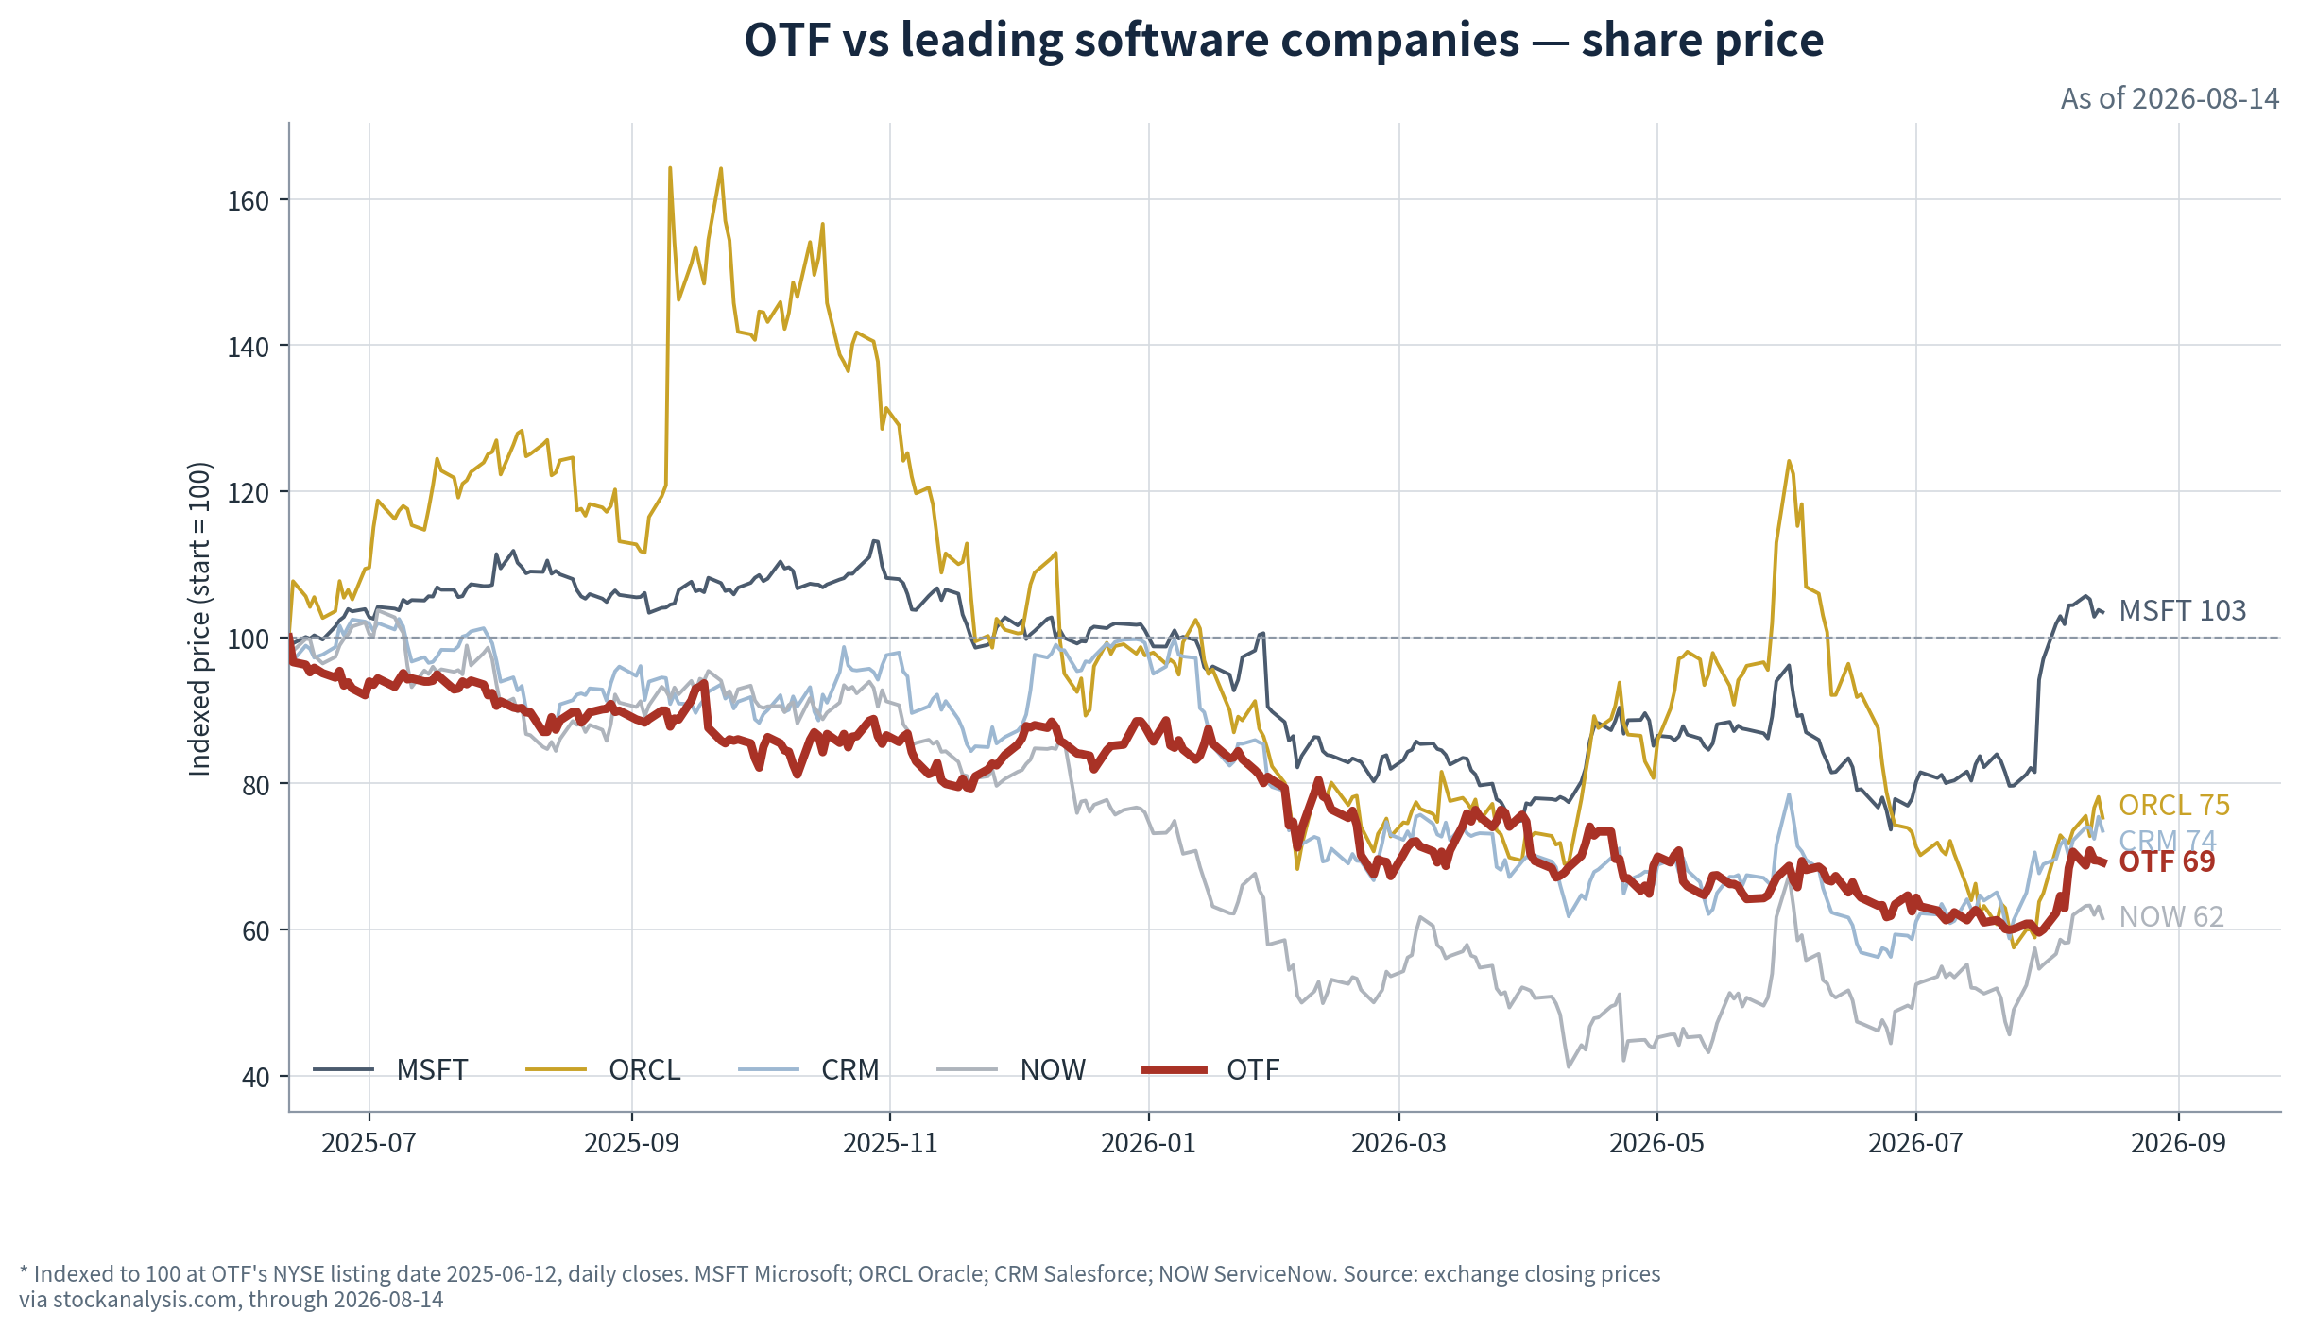
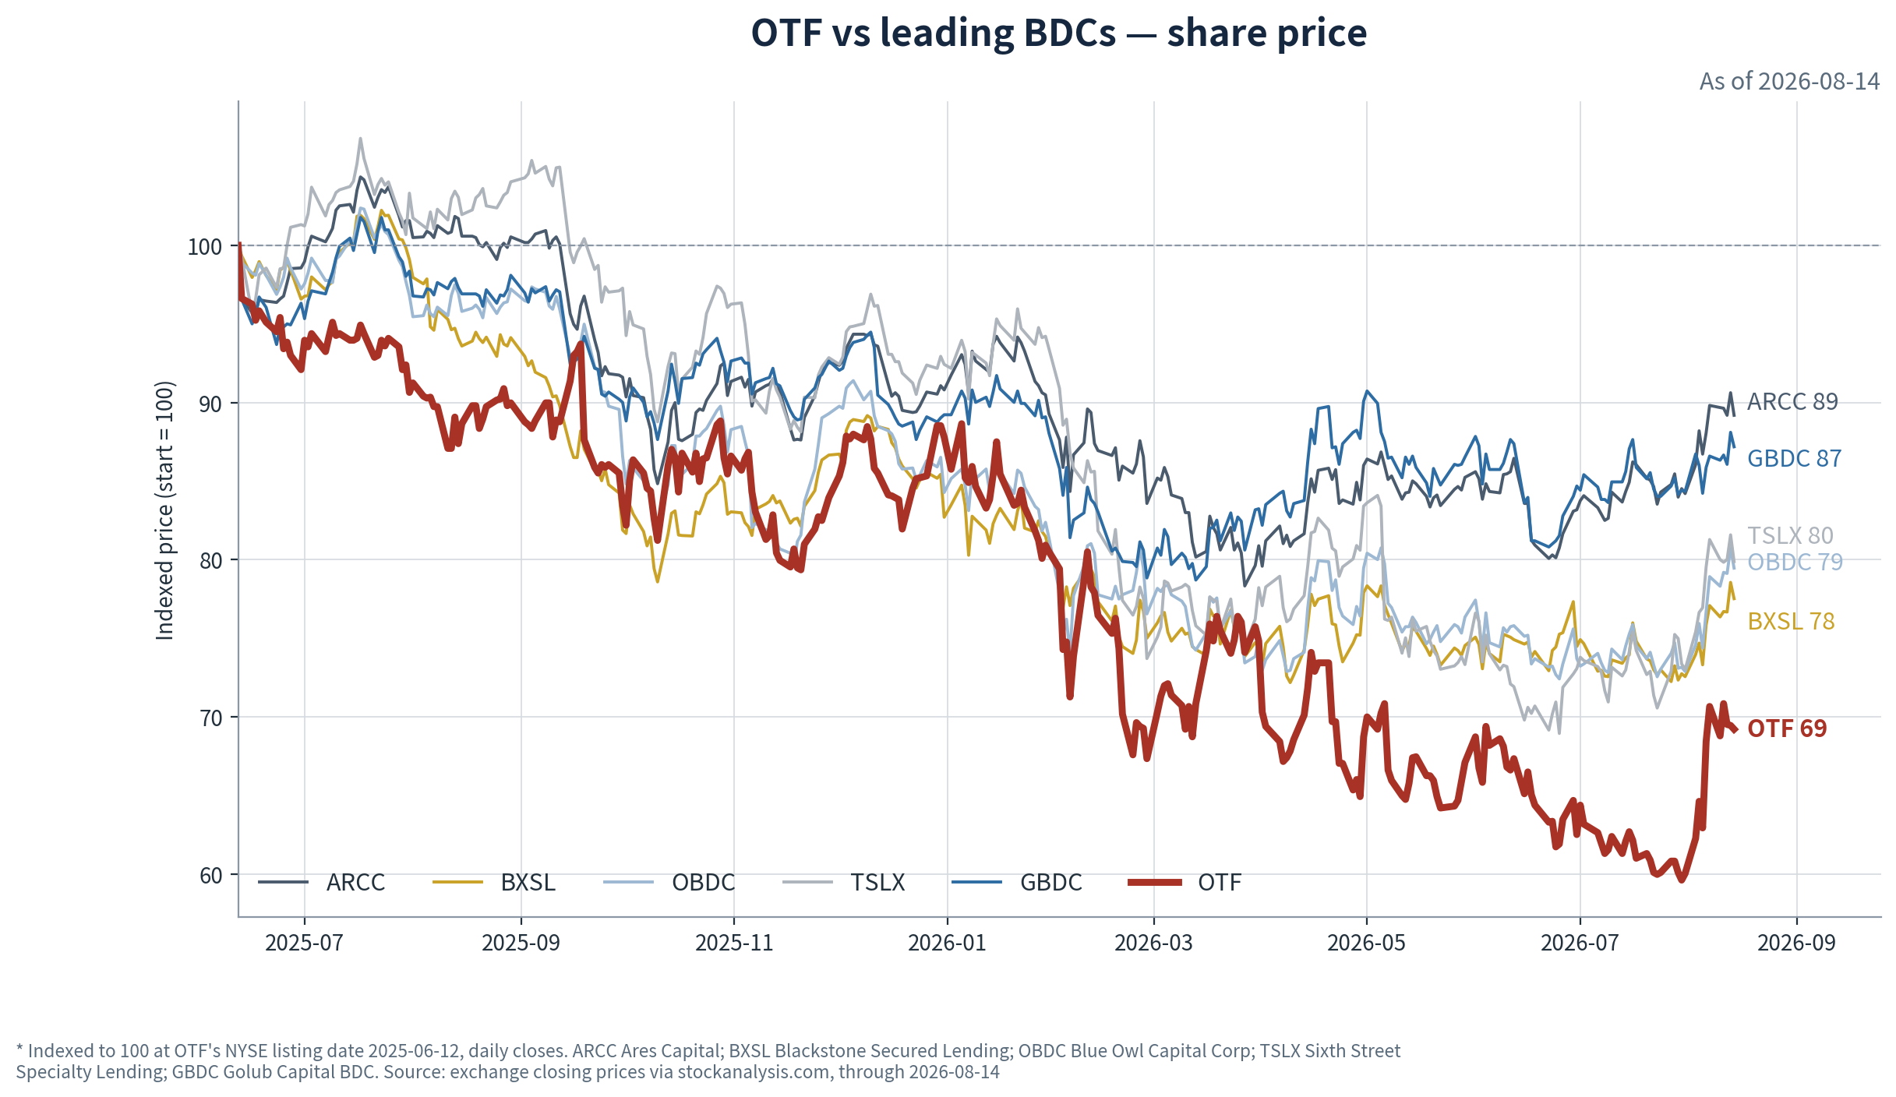
Ticker | Listing-day close 6/12/25 | Close 8/14/26 | Since listing
OTF — Blue Owl Technology Finance | $16.56 | $11.46 | −30.8%
NOW — ServiceNow | $201.47 | $124.00 | −38.5%
CRM — Salesforce | $266.91 | $196.21 | −26.5%
ORCL — Oracle | $199.86 | $150.52 | −24.7%
BXSL — Blackstone Secured Lending | $31.84 | $24.68 | −22.5%
OBDC — Blue Owl Capital Corp | $14.75 | $11.72 | −20.5%
TSLX — Sixth Street Specialty Lending | $23.50 | $18.77 | −20.1%
GBDC — Golub Capital BDC | $15.21 | $13.26 | −12.8%
ARCC — Ares Capital | $22.28 | $19.87 | −10.8%
MSFT — Microsoft | $478.87 | $495.40 | +3.5%
Closing prices, unadjusted for dividends; OTF first, peers ranked by drawdown. Source: exchange closing prices via stockanalysis.com
OTF remains the worst performer in the BDC cohort by roughly 8pp and sits below every software name except ServiceNow, despite a NAV that fell only about 4% over the same period.

2.6 Competitor analysis

2.6.1 BDC competitor analysis
This quarter confirms that the sector's NAV drawdown is a valuation reset, not yet a credit-cycle break — but the credit dispersion beneath it widened materially. Every one of the six NAVs fell or held over the first half with the declines still dominated by spread marks — ARCC's Q2 NAV slipped 1.2% while its NII covered the dividend at 104%, and TSLX and GBDC earned their reset payouts in full — yet the quarter also produced the cycle's first genuinely idiosyncratic credit prints: BXSL's cost-basis non-accruals jumped from 0.6% to 3.6% almost entirely on Medallia, GBDC's reached 2.9% across twenty issuers including preferred positions, and three of the six cut distributions.
Two layers should be read separately: the NAV drawdown is sector beta that all six share, while the price discount dispersion — 0.70x at OTF against 1.16x at TSLX — is priced off each fund's software concentration, dividend policy and credit outliers. The opportunity, if any, sits in that discount dispersion rather than in the NAV line itself: OTF carries the widest discount of the six against the cleanest reported credit book, which is either the market correctly pricing its unmatched application-software concentration ahead of realized losses, or the residual mispricing this report has tracked since listing.
 | OTF — Blue Owl Technology Finance | ARCC — Ares Capital | BXSL — Blackstone Secured Lending | OBDC — Blue Owl Capital Corp | TSLX — Sixth Street Specialty Lending | GBDC — Golub Capital BDC
Underlying assets | • $14.7bn FV, 205 cos; largest tech-focused BDC  • First-lien 77.8%, senior secured 81.4%; ~96% floating  • Software 32.8% by GICS, ~50% tech-related — highest of six  • NAV $16.48, flat QoQ | • $29.3bn FV, 619 cos; largest and most diversified BDC  • First-lien 59.1%; 71% floating; senior-loan JV adds 3.9%  • Software & services 22.0% of FV, down from 23.8%  • NAV $19.35, −1.2% QoQ | • $13.4bn FV, 313 cos  • First-lien 96.8% — highest of six; 99.3% of performing debt floating  • Software 18.9% plus IT services 4.7%  • NAV $25.53, −5.2% over 1H26 | • $15.0bn FV, 229 cos; OTF's diversified sister vehicle — 63% issuer overlap per MS  • First-lien 73.2%, senior secured 77.7%; 96% floating  • Software ~18% of portfolio  • NAV $14.26, −3.7% over 1H26 | • $3.3bn FV, 137 cos — the specialist of the group  • First-lien 88.3%; 96.1% floating; 11.2% yield on debt, highest of six  • Software not disclosed as a category; end-market classification  • NAV $16.24, −4.4% over 1H26 | • $8.2bn FV, 424 cos — most granular book  • One-stop loans 87.4%, senior secured ~92%; floors on 98% of loans  • Software inside granular GICS mix; Symplr preferred on non-accrual  • NAV $14.25, −4.8% FYTD
Key factors | • Non-accruals 0.6% cost / 0.1% FV — cleanest of six; one software addition in Q2  • PIK 12.5% of TII, second highest; ~98% original-underwrite  • Section 36(b) suit filed vs adviser June 18; specials end with Q3'26 payment  • Borrower EBITDA $291mm, +2.1% QoQ; net LTV 40% | • NII $0.50 covered the $0.48 dividend at 104% — no cut  • PIK 15.8% of TII, highest of six  • Non-accruals 2.4% cost / 1.4% FV, up from 1.8%/1.2% at YE; grade-2 bucket up $0.4bn  • Q2 EPS $0.24 vs NII $0.50 on net losses | • Medallia moved to non-accrual — $383mm cost marked ~$196mm — driving cost non-accruals 0.6% → 3.6%  • Coverage 97%; JPM models a cut to $0.70 from $0.77 in 3Q26  • PIK 6.6% of TII, low  • Portfolio yield compressed to 9.2% from 9.5% | • Regular dividend cut $0.37 → $0.31 from Q2'26; $0.02 supplemental added  • Non-accruals 2.8% cost / 0.8% FV across 7 cos  • TII −17% y/y on lower rates and a smaller book  • Buyback accretive: 6.3mm sh for $70.3mm in 1H, +$0.05/sh NAV | • Base dividend cut $0.46 → $0.42; supplemental suspended  • Non-accruals 1.9% cost / 1.3% FV; ASP Unifrax among names  • Deployment near-stop: $115mm new commitments vs $192mm repayments  • NII $0.43 covers the reset base at 102% | • Distribution cut $0.39 → $0.33, −15%, from the Mar-26 quarter  • Non-accruals 0.6% → 2.9% cost in three fiscal quarters — 15 loan + 5 preferred issuers  • PIK 8.6% of TII, up from 6.1% y/y  • New commitments just $12.6mm in the June quarter
Liquidity pressure | • None — $2.0bn liquidity; net leverage 0.93x, low end of 0.90–1.25x target  • Issued $500mm 6.50% Oct-29 notes; June-26 notes repaid  • $55mm buyback in Q2, ~$170mm over three quarters | • None — ~$6.7bn facility capacity; ~1.11x net  • $750mm 5.343% 2031 notes issued Jan; $1.0bn Jul-26 notes repaid at maturity  • $1bn buyback authorization untouched | • None, but $700mm 2.750% notes mature Sep-26 — next test  • $2.8bn unused facilities + $183mm cash; 1.25x net  • $250mm buyback authorized Feb-26, unused | • None — $4.1bn undrawn + $238mm cash; 1.11x net, coverage 187%  • $1.5bn of notes repaid across 1H and July  • $300mm buyback program, $230mm remaining | • None — $1.1bn revolver capacity + $194mm cash; 1.27x gross, ~1.17x net  • $300mm 5.65% 2031 notes issued May; Aug-26 notes repaid post-quarter  • Small buyback resumed — first repurchases in over a year | • None — $1.7bn undrawn JPM facility, extended to 2031 in July; 1.23x net  • $500mm 6.25% 2031 notes issued May  • $78mm repurchased FYTD, accretive +$0.04/sh
P/NAV & dividend yield | • P/NAV 0.70x — widest discount of six  • Yield on price 12.2% base; 14.0% incl. final special | • P/NAV 1.03x  • Yield on price 9.7% | • P/NAV 0.97x  • Yield on price 12.5% — pre-modelled cut | • P/NAV 0.82x  • Yield on price 10.6% regular; ~11.3% incl. supplemental | • P/NAV 1.16x — only premium of six  • Yield on price 9.0% | • P/NAV 0.93x  • Yield on price 10.0%
All fundamentals from each company's Q2'26 Form 10-Q — GBDC's June quarter is its fiscal Q3, so its balance-sheet comparatives run from September 2025; BXSL, OBDC, TSLX and GBDC 10-Qs print half-year or fiscal-year-to-date NAV comparisons rather than QoQ. P/NAV and dividend yields computed on 14 August 2026 closes against June-30 NAV; dividend yields annualize the declared regular dividend. Source: company 10-Q filings; stockanalysis.com closes

2.6.2 Return comparison
NAV per share & Dividend yield
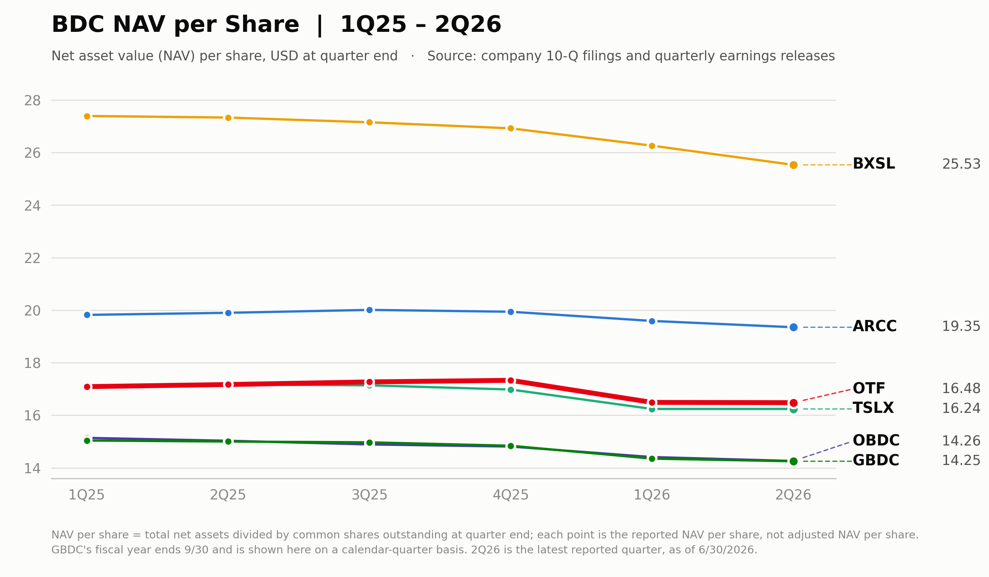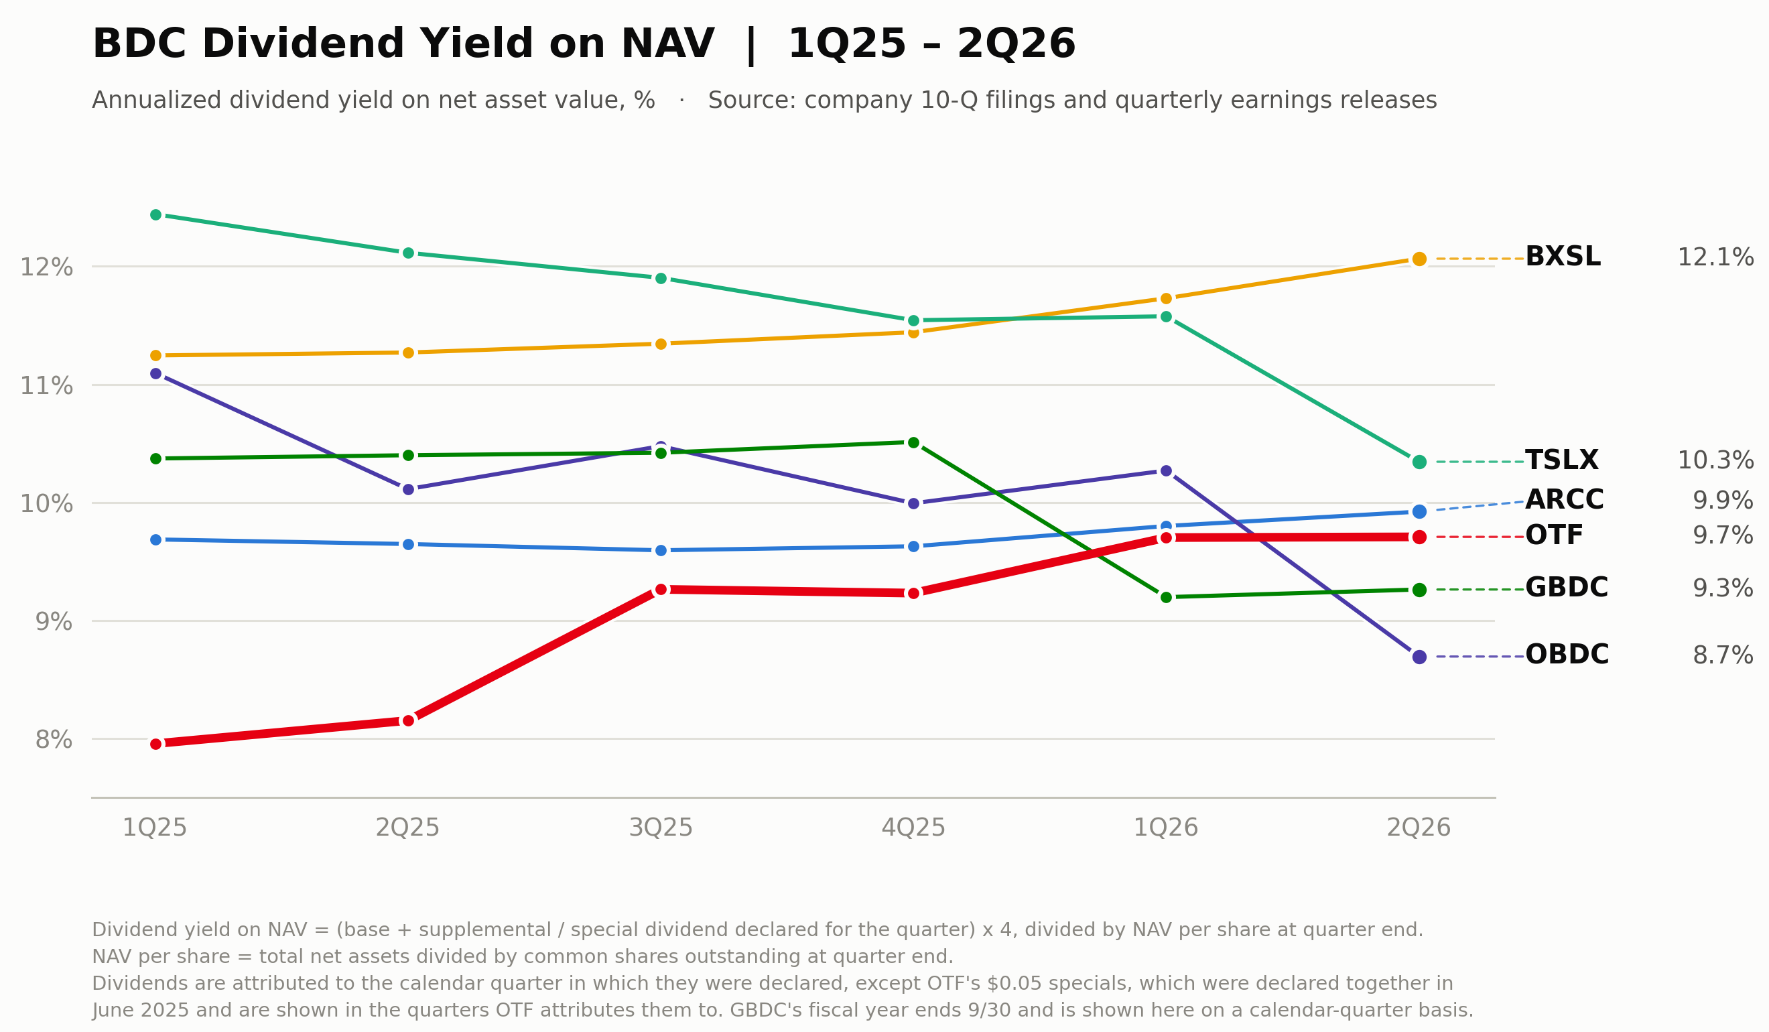
Every NAV in the cohort is lower than five quarters ago, and the declines cluster in a narrow band — BXSL −6.8% from its 1Q25 level, TSLX −5.0%, OTF −3.6% from its 1Q25 $17.1 — which is the signature of a common spread-mark shock rather than firm-specific credit losses. OTF's flat Q2 print, alongside ARCC's −1.2%, puts the two portfolios with the largest software books at opposite ends of the same narrow outcome, and the QoQ stabilization across the group is the first since the software repricing began in 4Q25.
The payout resets of the past two quarters show up as converging yields on NAV: OBDC's cut takes it to 8.7% and GBDC's to 9.3%, while OTF's 9.7% — still flattered by the final $0.05 special — lands in the middle of the pack rather than at the top. BXSL's 12.1% is the outlier and is best read as unsustainable: its coverage is 97% ahead of a modelled cut, so the chart overstates its durable yield. From Q4'26 OTF's base-only yield on NAV is 8.5%, which repositions it toward the low end — the price yield story at 12%+ exists only because of the 0.70x discount.
PIK income %
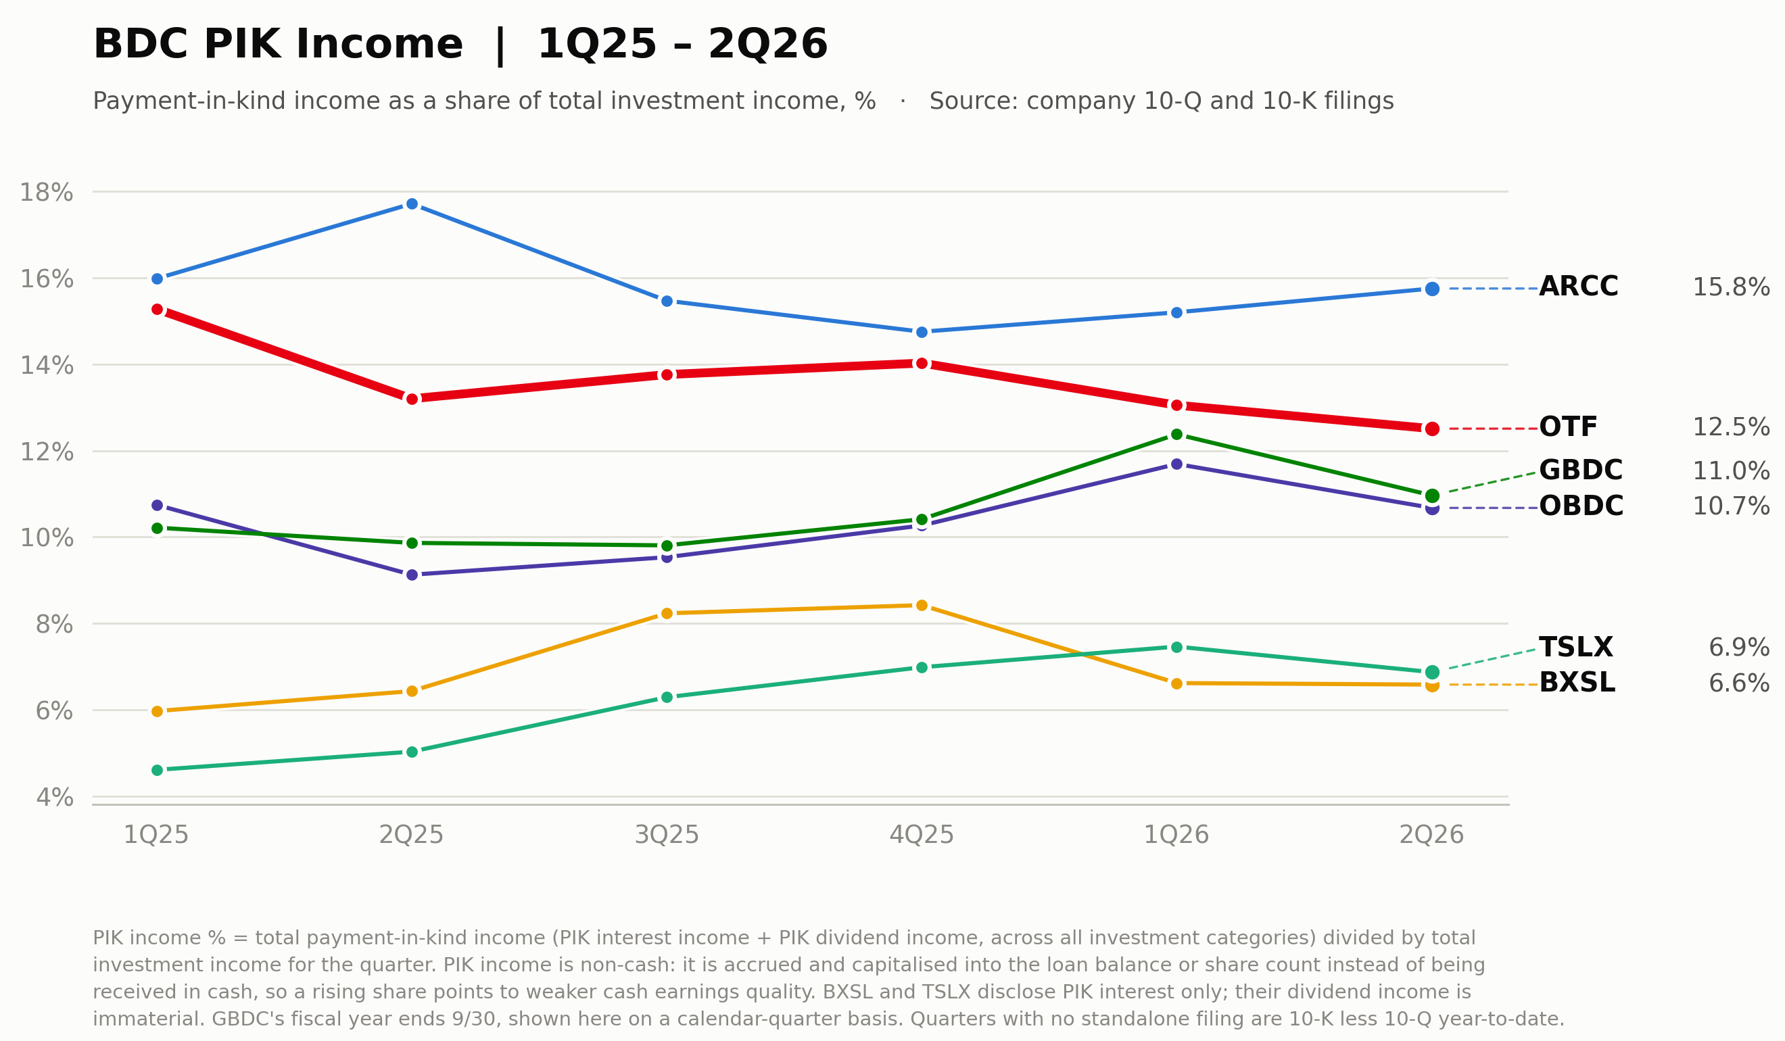
OTF's PIK share has declined for two straight quarters to 12.5% while the group's diversified names drifted up — GBDC to 11.0% from 10.2% five quarters ago, OBDC to 10.7% — so the gap between OTF and the diversified cohort has narrowed from roughly 5pp at the start of 2025 to under 2pp. ARCC remains the highest at 15.8%, a reminder that elevated PIK is partly a business-model choice in upper-middle-market lending; the credit-relevant question is direction, and OTF is the only name of the six trending down for two consecutive quarters.

2.6.3 Asset quality comparison
Non-accrual% & Portfolio company average EBITDA
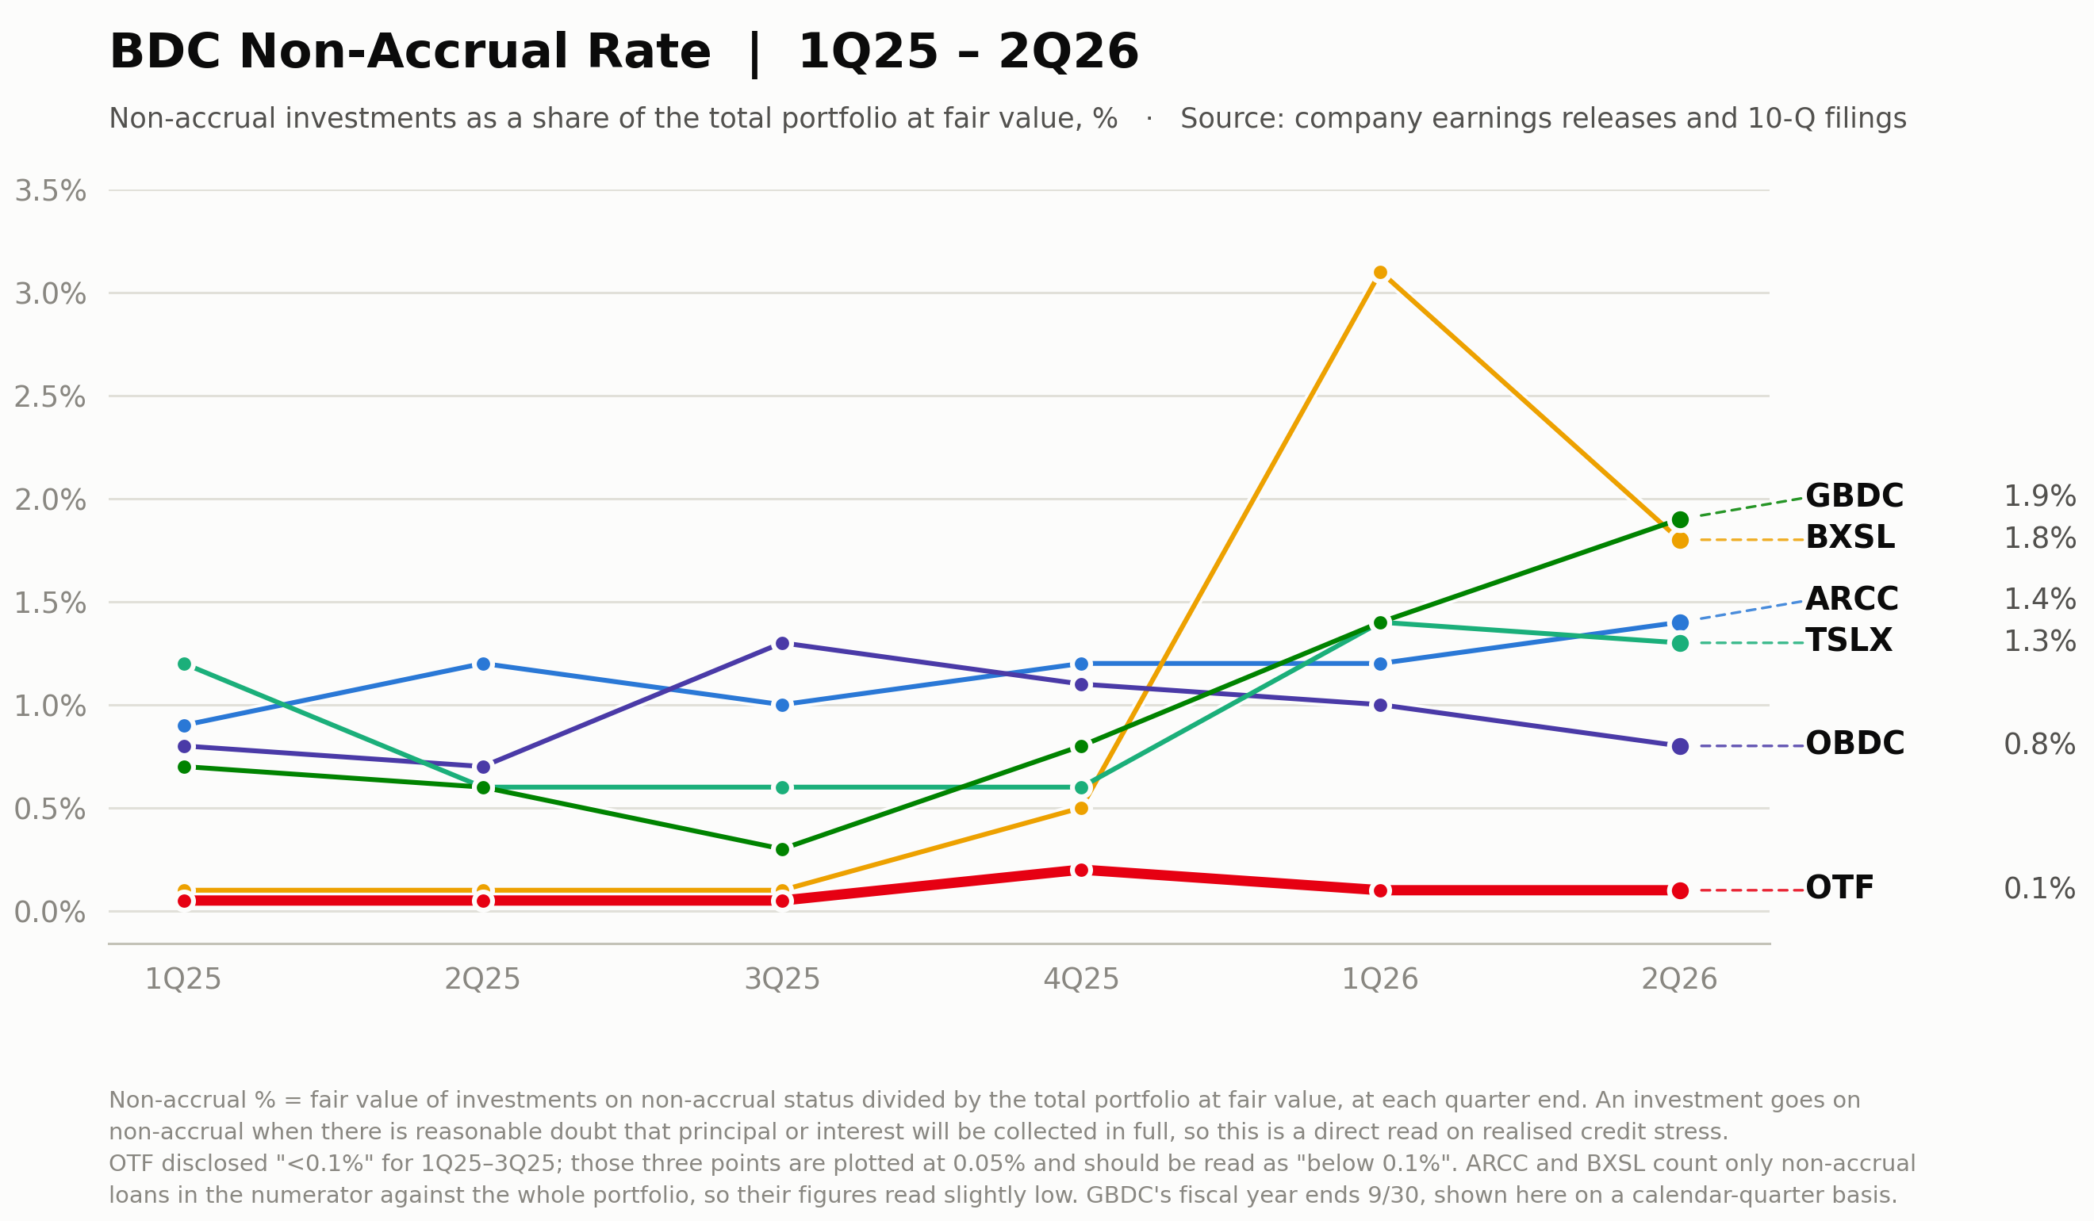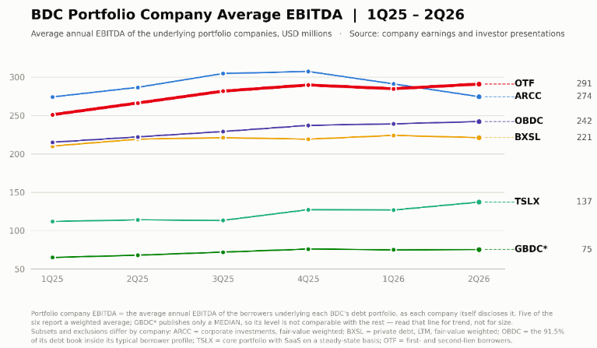
The fair-value non-accrual chart makes the quarter's dispersion visible: BXSL spiked to 3.1% in 1Q26 on Medallia before settling at 1.8% as marks were taken, GBDC ground steadily higher to 1.9%, and ARCC and TSLX sit in the 1.3–1.4% band — while OTF has never printed above 0.2% since listing and ended at 0.1%. Two caveats keep the comparison honest: OTF's book is younger post-merger and its software borrowers' stress, if it comes, would arrive on the 2028 refinancing wall rather than in current coupons; and ARCC and BXSL count only loans in the numerator, which reads slightly low. Even so, five quarters into the AI repricing, realized credit stress at OTF remains an order of magnitude below every peer.
Borrower size sorts the six into three tiers: ARCC and OTF at $270–290mm of weighted average EBITDA, OBDC and BXSL at $220–240mm, TSLX's core book at $137mm, and GBDC — which publishes only a median, so its level is not comparable — at $75mm. OTF has risen every quarter but one since 1Q25, $250.9mm to $290.8mm or +15.9%, and crossed above ARCC for the first time this quarter as ARCC rolled over $32.8mm from its 4Q25 peak of $307.2mm. The direction is right but the composition is not: $38.7mm of OTF's $39.9mm increase landed in the three quarters through 4Q25, when the OTF II merger pulled larger borrowers into the book, and the two quarters since have added $1.2mm. Borrower earnings growth is the variable the AI disruption thesis says should deteriorate first; at the portfolio-weighted level it has stopped compounding without yet turning down, which is a weaker read than the 2025 slope suggests. Three caveats: the figures are fair-value weighted, so a handful of large positions drive them; they come from borrower financials roughly a quarter in arrears, so 2Q26 reflects results through March; and none of the six discloses position-level dispersion.

2.7 Things we should know
Fee mechanics have entered a non-linear zone
Two fee breakpoints now sit close to current operating levels. First, the management fee steps from 1.50% to 1.00% on average gross assets below a 200% asset-coverage ratio; OTF ended the quarter at 203%, so nearly all incremental leverage from here is charged at the lower 1.00% marginal rate — a modest but real offset to the cost of the leverage build. Second, the income incentive fee moved to the post-listing schedule of 17.5% above a 1.5% quarterly hurdle, with the catch-up completing at 1.82% of NAV per quarter. Q2 pre-incentive income ran at roughly 2.2% of opening NAV, safely in the 17.5% marginal zone, but a decline of about 18% in quarterly NII would drop the fund into the catch-up band, where each marginal dollar of income accrues entirely to the adviser. With base coverage at 86%, this non-linearity deserves a standing line in the quarterly review; the capital-gains incentive accrual was zero this quarter after Q1's $38.8mm reversal.
The distribution resets from Q4'26
The five-tranche $0.05 special series ends with the October 6 payment, taking the run-rate distribution to the $0.35 base from Q4'26. On the August 14 close that resets the forward yield from 14.0% to 12.2%, and on NAV from 9.7% to 8.5% — repositioning OTF from the top half of the peer yield table to the middle. The board's response is the thing to watch: spillover income of $0.32 per share, roughly one quarter of base dividend, gives it room to bridge with a supplemental if it chooses, while GAAP base coverage of 86% argues for letting the yield reset. A supplemental announcement alongside Q3 results would be a deliberate signal about how management weighs the discount against balance-sheet conservatism.

3. Private credit & public BDC industry

3.1 Broker view summary
 | J.P. Morgan — credit team | J.P. Morgan — equity team | Morgan Stanley | Goldman Sachs
Coverage | BDC debt / private credit | Public BDC equities | Private credit & BDC — strategy | Leveraged credit, software focus
View | Overweight — bad news priced in, spread compression the story | Remain cautious — credit headwinds offset rate tailwinds | Cautious — pressures contained, not resolved | Dispersion, not broad deterioration
Key points | • Spreads round-tripped: BDC index ~290bp in April to ~217bp by July, 8bp wide of the 2025 average; sees 20bp+ further compression  • 29-BDC non-accruals 2.46% at cost, +40bp QoQ; NAVs −3.25% with 28 of 29 down — deterioration quantified and contained  • Bad PIK optically fell to 1.83% of debt books but rose ~50bp adjusting for Medallia and Affordable Care rolling into non-accrual; combined bad PIK + non-accruals 4.21%  • 2Q redemption requests 12.2% of NAV, all met at 5% caps; net outflows $3.1bn vs $17bn bank lines — a liquidity event, not solvency | • Sector P/NAV down ~13.4% YTD near TTM lows; will re-rate only on sustained credit and earnings stability  • 1Q NAV declines mostly spread-driven; expects a modestly positive NAV quarter in 2Q  • Deterioration concentrated and software-driven: FSK 8.1% cost non-accruals, BXSL to 4.7% on three software additions  • Dividend resets nearly complete — 2026 coverage clusters at 91–101%; models a BXSL cut to $0.70; non-traded redemptions a net tailwind for publics | • Formal default forecast: ~8% private credit and 5.5% BSL from 2H26 through 1H27, software-centered, skewed to distressed exchanges; recoveries 70–80%  • Average BDC non-accruals 2.8% at cost — a five-year high; PIK 6.4% of income; ~20% of PIK loans marked below 90, a post-COVID high  • Liquidity is not solvency: $14bn IG issuance YTD at ~240bp; 2Q redemption requests ~$12bn all capped; retail only ~20% of AUM  • Software is the fault line but not yet in default data: software median leverage 8.3x vs 7.0x all-sector, cash coverage 1.4x lowest; ~25% of software loans mature by YE28 | • Software is the largest sector weight in both markets — 15%+ of the USD loan index, 23% of the direct-lending index — and USD software loans are −9pts YTD  • The maturity wall is the catalyst: $98bn USD software loans due through 2028, 29% of software maturities; 50% rated B− or lower leaves no downgrade cushion  • Recovery pessimism overdone: across 30 software loan defaults since 2016, recoveries track overall first-lien rates; risks are repeat defaulters and cov-lite LMEs  • Private credit absorbs the fallout via ~$200bn of opportunistic dry powder; house default forecasts benign at 4.75% loans FY26
QoQ Chg | More constructive — held Overweight since April's upgrade path and now argues for further compression; prefers private non-traded structures | Unchanged cautious — no rating changes at the 2Q preview; only Overweights ARCC and BXSL | Framework unchanged from significant-not-systemic; marginally calmer on liquidity but a formal 8% default forecast is now in place | Reaffirmed dispersion view with new recovery-study evidence; modestly constructive on private credit's absorber role
Columns reflect the research houses actually received this quarter; the two J.P. Morgan teams are shown separately because their stances diverge. Source: 11 broker reports on file, April–July 2026

3.2 Consensus & key debate
Market consensus
- Software and AI exposure is the sector's defining fault line, but the stress to date is idiosyncratic and concentrated — Medallia alone accounted for 26% of all 1Q26 non-accrual additions at cost — rather than systemic.
- Fundamentals are directionally worsening off a manageable base: non-accruals at multi-year highs on every universe measured, PIK elevated, and NAV declines driven predominantly by spread marks rather than realized losses.
- Redemption pressure at non-traded funds is a liquidity event, not a solvency event: 5% caps held everywhere in 2Q, net outflows were about 2.6% of NAV against far larger bank-line and liquid-asset buffers, and public-market funding reopened.
- The 2028 software maturity wall — not current payment default — is the operative catalyst all four houses watch; refinancing friction is where AI-era credit stress will first crystallize.
- Recovery pessimism on software credit is viewed as overdone: posited recoveries of 70–80% on smaller lender groups, and realized software recoveries since 2016 track overall first-lien rates.
Key focus / key debate
The disagreements reduce to two: whether current pricing already discounts the coming credit cycle, and how severe that cycle gets.
Debt versus equity at the same house. J.P. Morgan's credit team is overweight BDC debt — the index sits 8bp from its 2025 average, manager support has a demonstrated template, and 20bp+ of further compression is projected — while its own equity team remains cautious at 0.84x sector P/NAV, refusing to re-rate before sustained credit stability. The contested question is whether debt-market normalization or equity-market caution correctly discounts the deterioration both teams document.
Default severity: 8% or dispersion. Morgan Stanley forecasts an above-average default wave of ~8% in private credit over 2H26–1H27, the highest since 2010; J.P. Morgan's credit team sees no near-term bankruptcy pipeline that would drive non-accruals materially higher, and Goldman's FY26 loan default forecast of 4.75% sits below the current 4.9% — framing the outcome as refinancing friction and dispersion. Whether the 2028 software wall converts into a default wave or is absorbed by amend-and-extend, sponsor equity and dry powder is the sector's defining bet.

3.3 Fundamentals

Leverage & EBITDA coverage multiple
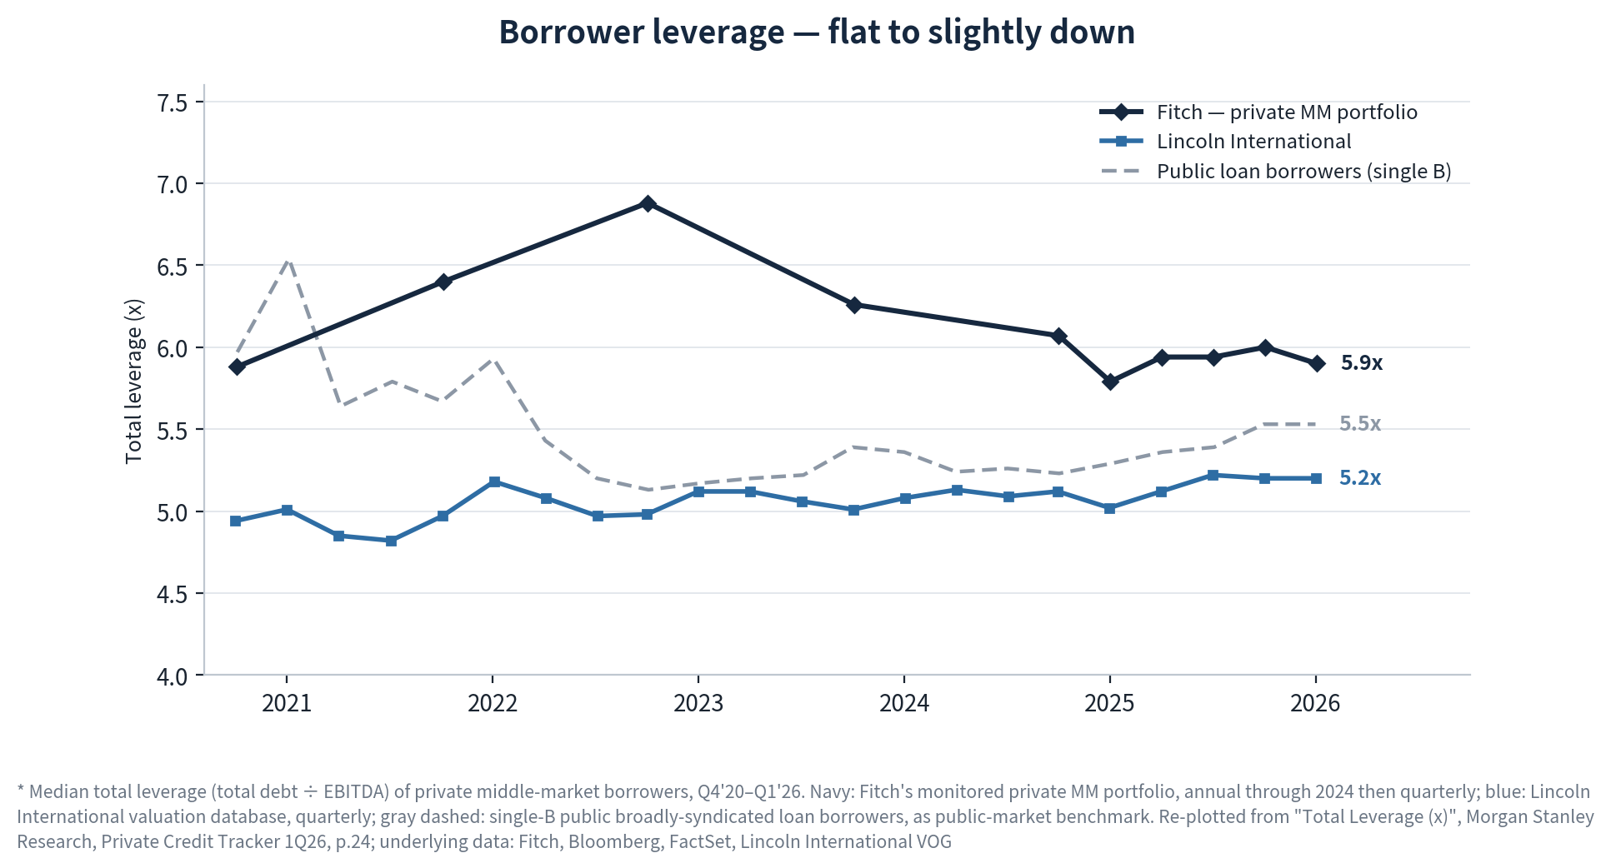
Private middle-market leverage has been de-levering for three years while its public comparable re-levered. Fitch's monitored private portfolio sits at 5.9x, down a tenth QoQ and roughly a full turn below the near-6.9x peak of late 2022, while the Lincoln valuation sample has been remarkably stable at 5.2x inside a 4.8–5.2x band across the whole period. The line that has actually moved against the trend is the gray one: single-B public loan borrowers have re-levered from a 5.1x trough to 5.5x, so the private-versus-public gap has narrowed from about 1.7 turns at the 2022 peak to 0.4 turns on the Fitch measure — and on the Lincoln sample private borrowers now carry 0.3 turns less leverage than comparable public issuers. The read for OTF is that the aggregate borrower entering this credit cycle is less levered than the one that entered 2023, so the sector's rising non-accruals are not being driven by balance-sheet gearing at the median. Where gearing does bite is sectoral: software borrowers run a median 8.3x against the 7.0x all-sector figure on the S&P credit-estimate universe, i.e. more than two turns above the Fitch median shown here, concentrated precisely in the end-market that dominates OTF's book.
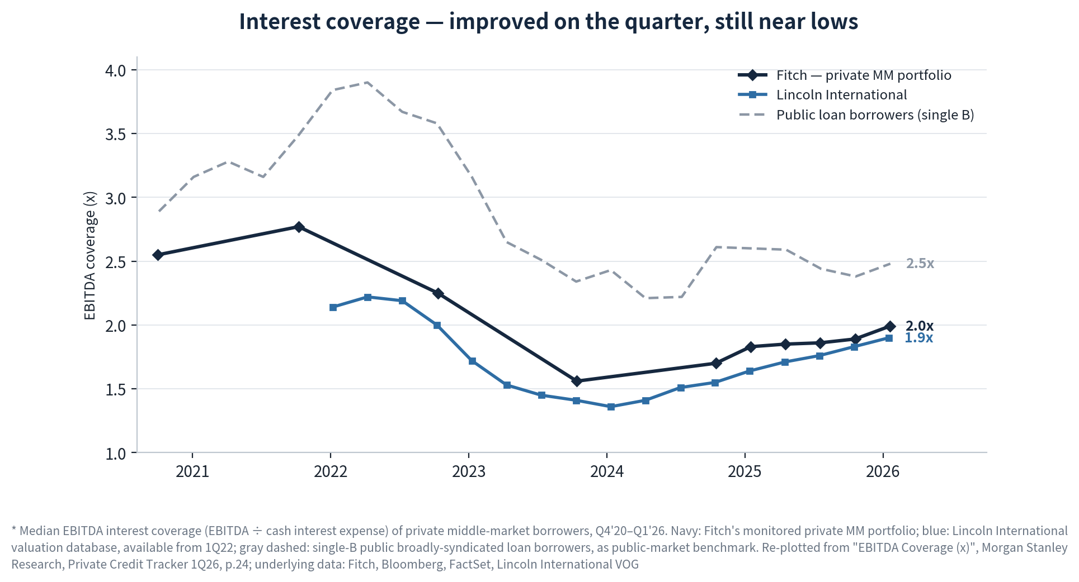
Coverage tells the opposite story to leverage — it collapsed through the hiking cycle and has only partly healed. Fitch's private median troughed at 1.56x in early 2024 and has recovered to 2.0x; Lincoln troughed at 1.36x and is back to 1.9x. Both remain roughly 0.8 turns below their 2021–22 levels and still sit under the 2.5x public single-B benchmark, so the typical direct-lending borrower continues to profile like a low-single-B credit on cash-flow cushion even after four quarters of improvement. The mechanism matters for forecasting: this recovery is base-rate driven rather than earnings driven — falling SOFR cut cash interest expense on floating-rate loans, the same move that compressed OTF's asset yields from 10.4% to 9.6% over five quarters. That symmetry is the key point for the portfolio: the rate path that repairs borrower coverage is the same one that erodes OTF's investment income, so improving borrower fundamentals and falling NII are two views of one variable rather than offsetting signals. It also means the cushion is fragile — a stall in cuts halts the coverage repair with the median still under 2.0x.

Non-accruals & PIK level
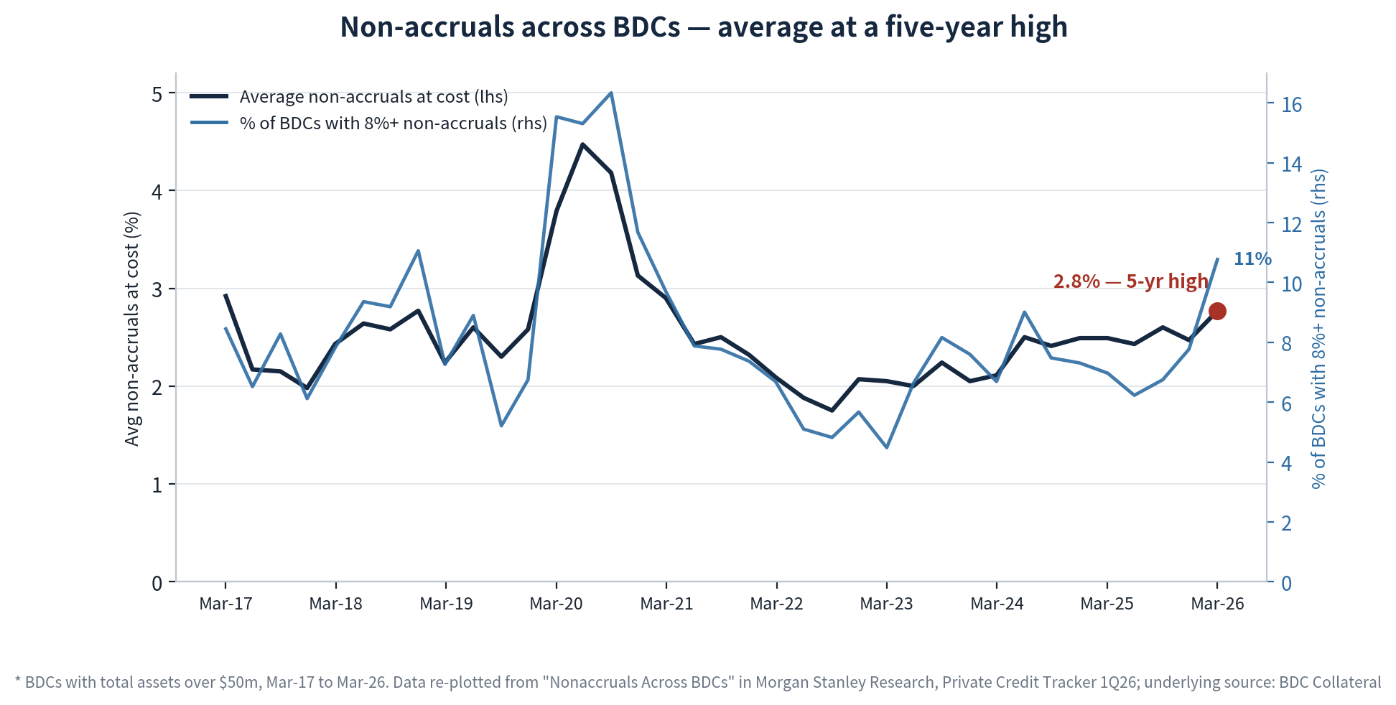
The sector average reached 2.8% of cost in March 2026, the highest in five years, and the nine-year series puts that number in useful perspective: it is well below the roughly 4.5% COVID peak and broadly in line with the 2.0–2.9% range that prevailed in 2017–18, so the level is a return to pre-2020 norms rather than crisis territory. What is genuinely new is the shape of the distribution. The right-hand series — the share of BDCs carrying more than 8% non-accruals — jumped to 11% from about 8% in a single quarter, its sharpest move since the COVID spike, while the average rose only 0.35pp. Deterioration is therefore concentrating in a widening tail rather than shifting the whole cohort, which is consistent with the named-credit pattern this quarter: Medallia alone accounted for roughly a quarter of all sector non-accrual additions at cost. For OTF the relevant question is which side of that split it sits on. At 0.6% of cost and 0.1% of fair value it remains an order of magnitude below the average, so the sector chart is currently a statement about OTF's risk premium rather than its realized credit.
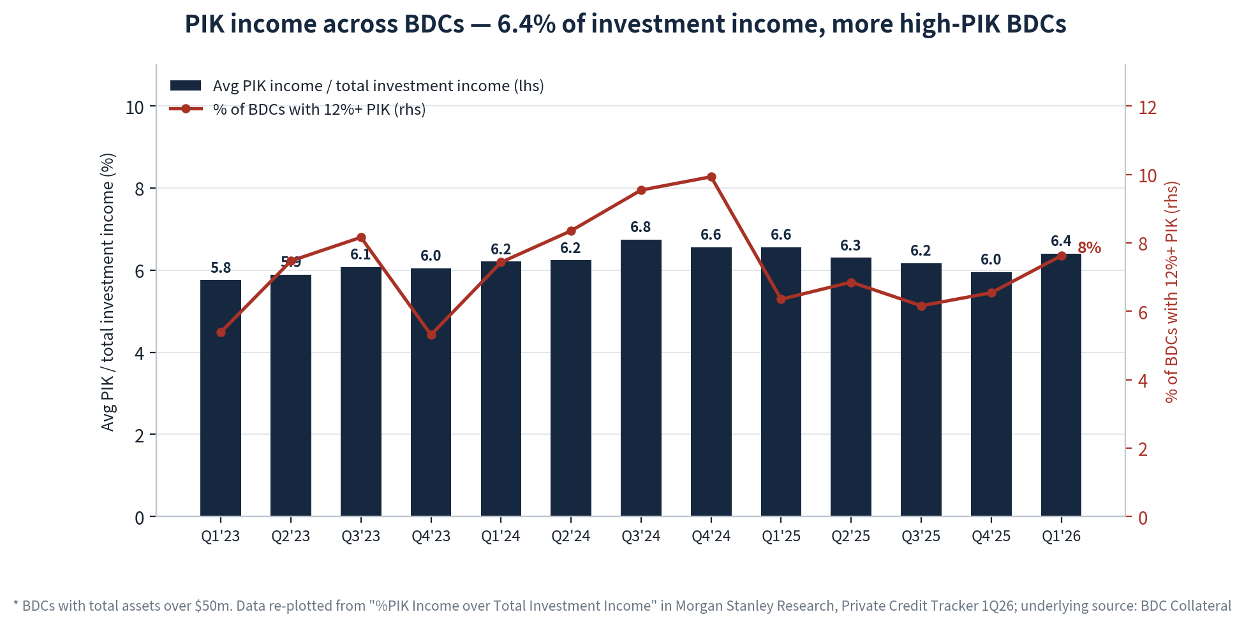
On the investment-income basis PIK looks static: 6.4% in Q1'26, up 0.4pp QoQ, and range-bound between 5.8% and 6.8% for thirteen consecutive quarters. The average is not where the information is. The right-hand line — the share of BDCs with PIK above 12% of investment income — rose to 8% from 6.5%, its highest since the 10% peak of Q4'24, so once again the tail is moving while the median holds. That distinction is what makes PIK a dispersion indicator rather than a level indicator: a sector average near 6% coexists with a cohort of vehicles running double that, and roughly a fifth of all PIK loans are now marked below 90, a post-COVID high. OTF sits structurally in the upper half of this distribution — 12.5% of investment income, about twice the average — but for two reasons that are worth separating from the tail names: roughly 98% of it was contracted at original underwriting rather than granted through amendment, and its bad-PIK reading of 0.98% is about half the sector's 1.83%. The direction is also favorable: OTF has fallen for two consecutive quarters while the high-PIK cohort has grown.
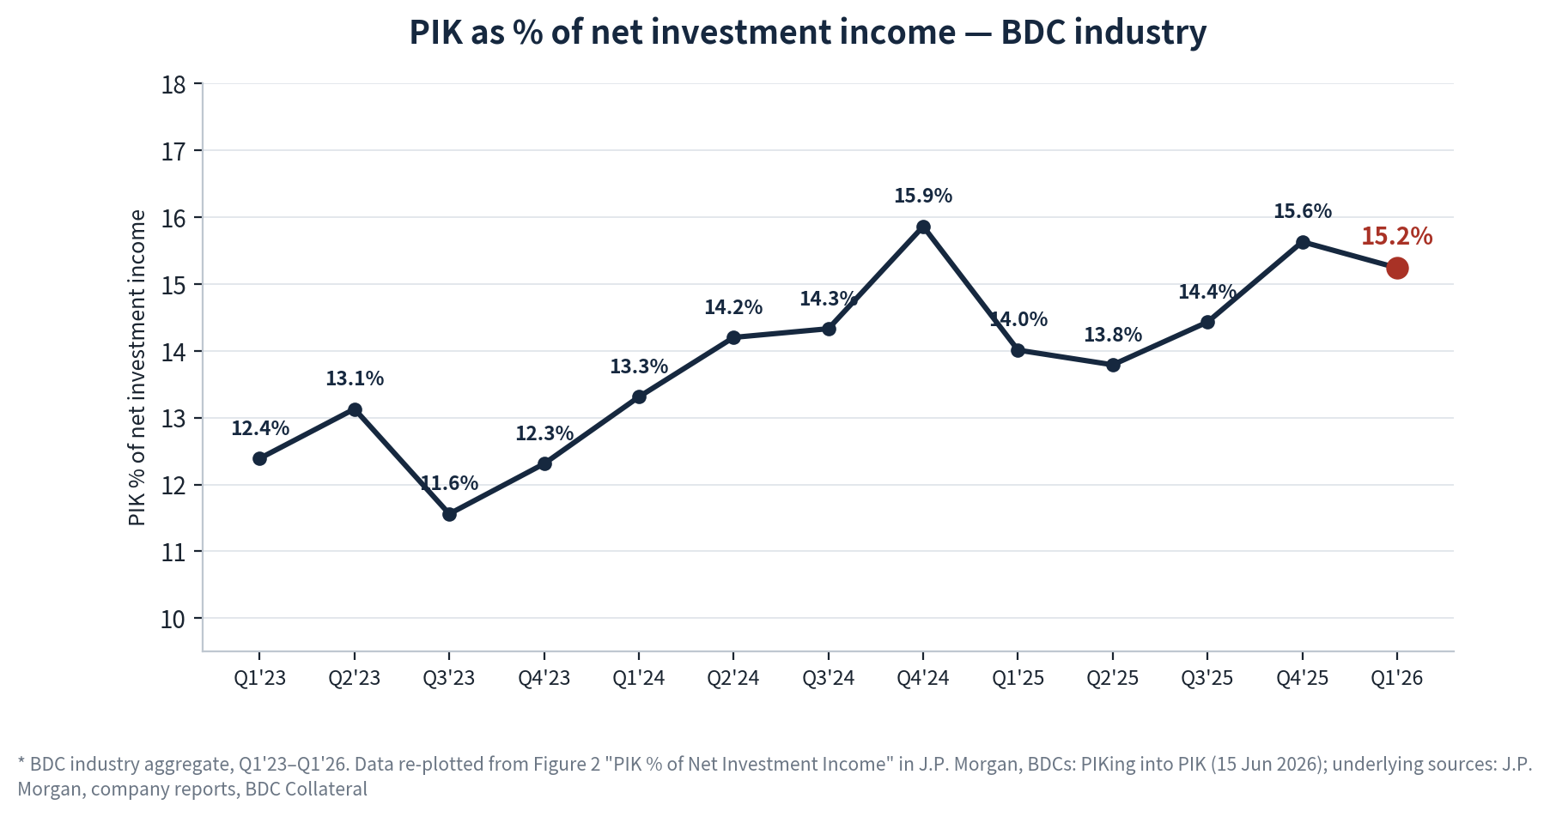
Measured against net investment income the same PIK dollars look far heavier — 15.2% in Q1'26 versus 6.4% on the gross basis — because NII is struck after interest and management expenses, so the ratio is geared. This is the more decision-relevant cut for a dividend-paying vehicle: it says roughly one dollar in seven of the sector's distributable earnings is accrued rather than collected. The trend here is clearly upward where the gross measure was flat, rising about 2.8pp from 12.4% at Q1'23 to 15.2% now, with the Q1'26 print the second-highest of the series and down only 0.4pp from the Q4'25 high. The divergence between this chart and the one above is the actual finding: PIK's share of gross income has not grown, but its share of net income has, because rising funding costs shrank the denominator. That is a quiet erosion of dividend quality across the sector, and it is the same arithmetic that leaves OTF's $0.35 base dividend covered at 86% on GAAP NII despite reported PIK falling for two quarters.
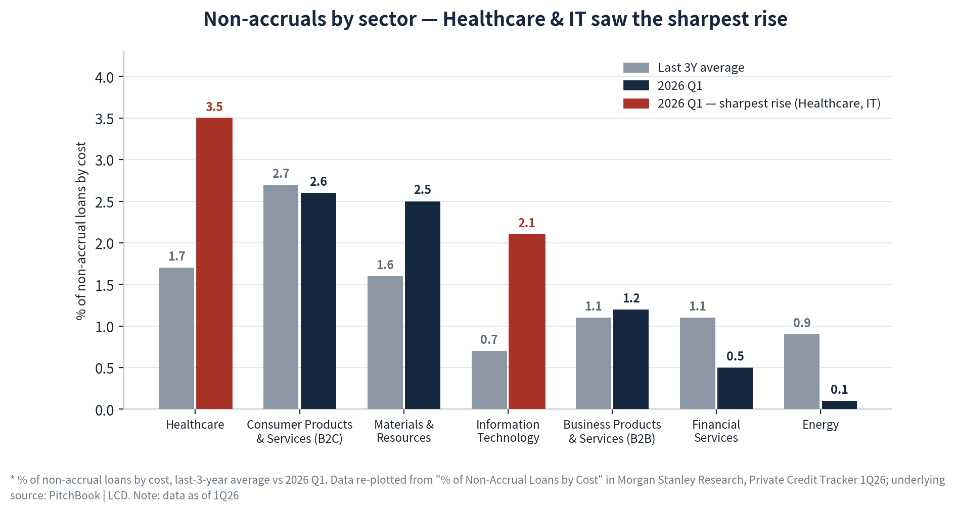
The sector decomposition explains where the aggregate deterioration came from and why it matters more for OTF than OTF's own 0.6% print suggests. Information technology's non-accrual rate tripled against its three-year average, to 2.1% from 0.7%, and healthcare's doubled to 3.5% — now the highest of any sector — while financial services and energy actually improved, to 0.5% and 0.1%. IT also posted the worst average quarterly write-down at −2.7% and the highest share of sub-90 PIK loans at 8.4% against a 3.7% three-year average, so marks, PIK stress and non-accruals all point at the same two sectors rather than disagreeing. Those two sectors are OTF's book: systems and application software are 32.8% of fair value, health care technology a further 12.4%, and health care providers 2.9% — roughly 48% of the portfolio sits in the two end-markets driving the sector's credit migration. This is the transmission channel to watch, and it operates through marks and spreads well before it reaches non-accruals: sector-wide software and healthcare stress re-prices OTF's Level-3 valuations and its equity discount whether or not its own borrowers miss a payment.

3.4 Things we should know

3.4.1 Software exposure in leveraged credit
Software is now the single largest sector in both leveraged credit markets — more than 15% of the USD loan index and 23% of the direct-lending benchmark, over 70% of it sponsor-backed — and it is repricing as one block: USD software loan prices are down 9 points year-to-date with over 60% of BDC software loans marked down more than a point since 3Q25. Goldman's transmission paths run from refinancing concessions on the $98bn of USD software maturities through 2028, to downgrades against a cohort already 50% rated B− or lower, to defaults whose recoveries have historically tracked overall first-lien rates rather than collapsing. Mapped onto OTF, the read-through is more than one-for-one: at 32.8% GICS software and roughly 50% technology-related fair value against a 22% peer average, sector-wide software spread widening moves OTF's marks — and its equity discount — before any of its own borrowers miss a payment.

4. Software industry by AI impact

4.1 Broker & company view summary
Broker view
 | UBS | Goldman Sachs | BofA
Key points | • Application software remains the funding source, not the beneficiary, of AI budgets — license rationalization, consolidation and 3–5% price-increase caps hit mature seat-based apps hardest, though deeply embedded apps resist cuts absent a replacement  • Token-cost optimization is curbing growth, not cutting spend: per-employee caps and model routing are guardrails on a rising line, and down-tiering stays within the frontier labs  • The seat-plus-usage transition will be messy for applications — buyers resist paying twice and cannot forecast consumption, so sales cycles lengthen; vendors staying on per-user pricing get hurt first  • A token-orchestration layer above the models is emerging as a new value pool, while AI-enabled DIY becomes a competitive threat to niche apps and IT services — the most-cited budget offsets | • Value accrues to the data and platform layer that enables custom agentic apps between SaaS silos — a 20% software TAM uplift by 2030, with organizational complexity drawing the custom-vs-packaged line  • AI erodes bad-sticky moats: companies held only by migration costs are exposed as AI cheapens migration itself; durable moats need accelerating innovation and open ecosystems  • Front-office monetization shifts to usage — per conversation, per resolution — and the customer-service TAM inflects down as profit pools shift to agents; marketing software is comparatively resilient  • The system of record captures ~5% of deal-relevant information; contested value sits in context and intelligent-action layers over unstructured data, with headless surfaces amplifying upstream data owners | • AI has become a monetization event delivered through hybrid pricing — uniformly constructive management tone across 25 conference sessions, with explicit winners and losers  • Infrastructure re-rated: peer-group target multiple raised to 5.8x from 5.0x EV/CY27E revenue on consumption models capturing AI workloads directly  • The defensible application pattern is the coordination, context and governance layer above the LLM — persistent context plus permissions is the moat, not the interface  • Front-office incumbents claim AI is net seat-expansive via 60–80% premium-SKU uplift and consumption credits, while conceding the agentic layer itself may commoditize
QoQ Chg | No shift — same framework, cautious on applications; the procurement channel reinforced the existing view | Incrementally more constructive on agentic applications — new Buy initiations in customer-experience software on share-shift to modern stacks | More constructive — infrastructure multiple lifted, price objectives raised across the data layer
Columns reflect the research received this quarter — five reports across three houses, June–July 2026; same-house reports merged. Source: broker reports on file
Company view
 | MSFT — Microsoft, FY26Q3 call Apr 29 | ORCL — Oracle, FY26Q4 call Jun 10
View | Offense — monetizing AI across all three layers now | Offense — full-stack AI-infrastructure landgrab with embedded apps AI
Key points | • AI business ARR passed $37bn, +123% y/y; M365 Copilot exceeded 20mm paid seats with record adds  • Every per-user business becomes per-user plus usage — seat pricing framed as an entitlement to consumption; GitHub Copilot moved to usage pricing June 1  • Commercial RPO $627bn, +99% y/y; Azure ~+40% and capacity-constrained through 2026; ~$190bn CY26 capex  • Friction is visible where the pricing shift bites: Dynamics 365 bookings hit by renewal hesitation between per-seat and seats-plus-consumption | • RPO $638bn, +363% y/y, with $67bn of AI-infrastructure contracts signed in the quarter; GPU utilization 97.5%  • FY27 revenue guided +34% cc; ~$70bn net capex funded partly by a planned $40bn raise; infrastructure ROIC guided high-20s  • New pricing models across the app suite: token bundles with 33 early customers plus outcome-based pricing per candidate screened or per upsell  • Management dismissed the SaaSpocalypse — decision delays of two quarters ago have passed in mission-critical categories; SaaS deferred revenue +16%

 | CRM — Salesforce, FY27Q1 call May 27 | NOW — ServiceNow, CY26Q1 call Apr 22
View | Pivot to offense — usage exploding ahead of reported revenue | Offense — the governance and control-tower layer monetizing early
Key points | • Agentforce ARR passed $1bn; 28.6tn tokens processed, +152% q/q; agentic work units +111% q/q  • Three levers with seats still growing: premium-SKU bookings +60% y/y, seven of the top ten deals added net-new human seats, consumption flex credits  • Headless 360 exposes everything as API and MCP — 4.5mm MCP calls in two months; management admits headless pricing is not yet settled  • Reality check: revenue +12% cc with marketing, commerce and Tableau still weak — the agentic metrics run ahead of reported growth | • 2026 AI-commitment target raised 50% to $1.5bn; the whole portfolio made AI-native rather than sidecar-priced  • 50% of net-new business is now non-seat-based — tokens, connectors and other assets; seat-productivity losses offset by consumption upside  • Differentiation framed as context, not model IQ: AI control-tower deal sizes doubled q/q on a platform trained on 95bn annual workflows  • Subscription revenue +19% cc, RPO $27.7bn +23.5% cc, renewal rate 97% — the core is not yet showing AI cannibalization
Stance labels and points from each company's most recent earnings-call transcript on file. Source: MSFT, ORCL, CRM, NOW earnings calls, April–June 2026
Market consensus & key focus
Market consensus
- AI’s net impact on software is highly differentiated, not wholesale disruption — value extracted from the record/application layer accrues to the data/platform, orchestration/intelligence and infrastructure layers; brokers and companies agree (GS, UBS, BofA; company calls).
- Seat-to-hybrid monetization (seat + consumption / outcome-based) is the consensus path and already ~half of net-new business at leading platforms; but the transition is long and buyers resist double charging (BofA; UBS; company disclosures).
- The moat test has shifted from “is it sticky” to “what kind of sticky” — data assets, workflow depth and context layers are durable; system-of-record front-office software held together only by switching costs is most fragile (GS).
- Infrastructure and security software are the most direct AI-demand beneficiaries and the most defensive; the application/record layer faces the heaviest pressure (UBS; BofA).
- Agentic AI opens incremental TAM in cross-system coordination labor and agent-native applications, rather than merely cannibalizing existing SaaS (GS).

Key focus / key debate
Debate | Broker stance | Software-company stance | Core of the disagreement
Application-layer SaaS outlook | System-of-record SaaS has value extracted; bad stickiness eroded. | Companies self-attest value is rising, not falling — customers deepening existing platforms. | Is the application layer a value donor, or can it still retain value?
Build vs buy (in-house substitution) | AI coding tools cut build costs; procurement self-builds replace applications. | Customers deepen existing platforms rather than starting from scratch. | Does the collapse in build cost genuinely favor building?
Can seat + consumption pricing deliver? | Buyers strongly resist hybrid pricing as double charging. | Already ~half of net-new business, progressing smoothly. | Pace of consumption monetization and buyer acceptance.
Lag from token usage to revenue | Token spend faces optimization — slowing, not cut. | Token volumes compounding QoQ; demand tailwind. | Can usage growth convert to revenue in time?
Source: Junson AID synthesis of GS / UBS / BofA research vs MSFT / ORCL / CRM / NOW company communications.

4.2 Things we should know
- AI inference is putting genuine variable cost into SaaS gross margins for the first time — the transitional framing is a Rule of 30 rather than 40 — so margin durability joins growth as an underwriting variable for software credit.
- Software producers are restructuring around agents: revenue at leading companies grew 22% faster than headcount over the past year and engineering squads are shrinking toward 3–5-person agentic pods — a structural headwind for per-seat developer tooling.

4.3 AI impact on software layers
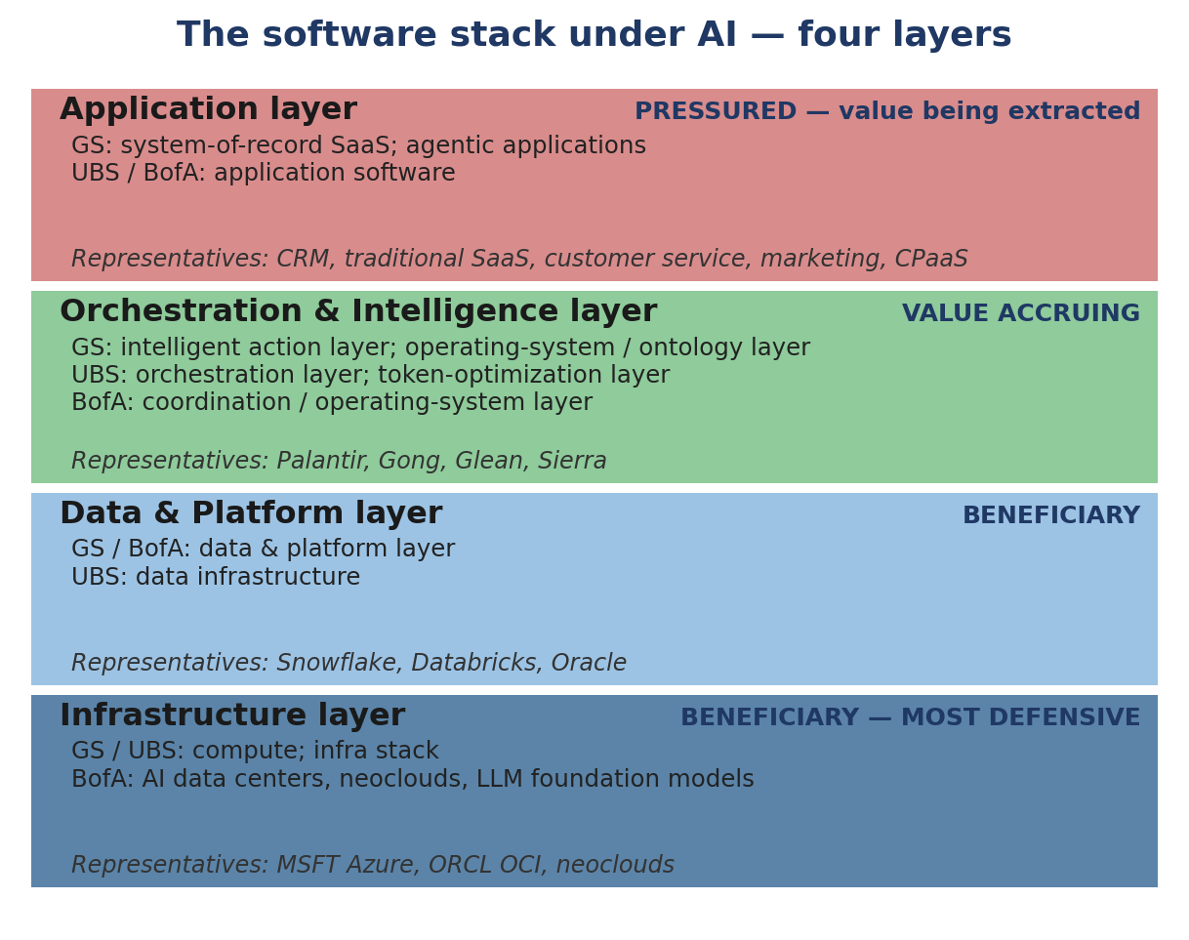
Exhibit 6 The software stack under AI — layer taxonomy across GS / UBS / BofA frameworks.
Source: GS, UBS, BofA software research frameworks; diagram by Junson AID.
Application layer: record- and transaction-oriented front-office software facing business users, carrying CRM, marketing, customer-service and CPaaS workflows.
Orchestration & Intelligence layer: the agent and operating/ontology layer above applications that judges, orchestrates and executes — turning records of what happened into decisions and action.
Data & Platform layer: the foundation that consolidates enterprise data and unified governance, providing data, model access and controls to the agents and applications above.
Infrastructure layer: compute, cloud and foundation models — the underlying supply carrying AI training and inference workloads.

AI’s impact across the layers
- The four-layer framework (infrastructure — data/platform — orchestration/intelligence — application/record) still holds, but the boundaries are blurring — the data/platform layer is extending upward into intelligent-OS and ontology layers, and the line between infrastructure and applications weakens as customized agent applications spread.
- The core test of durable value per layer has shifted from “is it sticky” to “the quality of stickiness” — good stickiness built on continuous innovation and high-frequency genuine usage endures; bad stickiness maintained by switching costs and contractual lock-in erodes.
Vulnerability ranking: Application/Record > Orchestration/Intelligence ≈ Data/Platform > Infrastructure
- The application/record layer is most fragile — systems of record capture only ~5% of decision-relevant information, and ~99% of relevant customer intelligence never enters the system of record; value is most easily lifted into the intelligence layer above, especially for vendors relying purely on seats and switching costs (GS).
- The orchestration/intelligence and data/platform layers sit in the middle — value recipients, yet exposed to entry-point competition and commoditization; they need data assets and governance as a second moat.
- The infrastructure layer is most resilient — AI workload volume directly drives demand, least exposed to budget rationalization, with demand driven by incremental usage rather than price increases.
Marginal change: application/services pricing reconstruction most acute > infrastructure/data demand acceleration > orchestration entry points opening
- The sharpest marginal change is pricing reconstruction in the application/services layer — from pure seats to seat+consumption and even outcome-based pricing; the transition is long and friction-heavy, only vendors delivering quantifiable savings can raise prices, and mature seat-priced applications are hit hardest.
- Next is demand acceleration in the infrastructure/data layer — larger attack surfaces lift security demand, machine-generated code volume lifts data, governance and observability demand, and consumption pricing scales naturally with workloads.
- Entry points in the orchestration/intelligence layer are opening — intelligent-OS/ontology layers, headless calls and open agent protocols expand the surfaces through which intelligence is consumed; first movers accumulating proprietary data assets benefit.
Key implication: value shifts from recording what happened to intelligence that judges and executes, settling into data and infrastructure
- Software value migrates from the record layer to the orchestration/intelligence layer, and further down into the data/platform and infrastructure layers — the application/record layer is the value donor, not the recipient.
- Beneficiaries: owners of underlying technical moats and proprietary data assets — the data/platform and infrastructure/security layers, plus intelligence-layer vendors able to compound unstructured interactions into data assets and monetize headless calls.
- Pressured: pure-record front-office/application software held together by switching costs and seat lock-in — model intelligence itself is only ~10% of the value; the moat is not the model but context, workflow, governance and data.

