JUNSON Capital | Alternative Investment Division
OTF Research Report Summary — 2026Q4
Blue Owl Technology Finance Corp. | Coverage: BDCs / technology direct lending | Data to 4 Nov 2026 (share price to Oct 13)
Verdict: the Q3'26 print validated NAV and the dividend but delivered the first real credit datapoint — and our own P/NAV trigger line is breached. NAV rose for the first time since Q4'25 (+0.8% to $16.62, marks positive two straight quarters); the Q4'26 base was held at $0.35; non-accruals tripled to 1.8% of cost on the Signifyd preferred — still the lowest of the six peers on Q2'26 data, but no longer an order of magnitude below the industry. At $9.21 / 0.55x the stock trades through the 0.60x line set in Section 4 last quarter: per the framework, the position goes back to IC two-way rather than defaulting to hold.

OTF key metrics at a glance
Metric | Q2'26 | Q3'26 | QoQ | Notes
NAV / share | $16.48 | $16.62 | +$0.14 | First increase since Q4'25; realized + unrealized +$0.19/sh (deck p.11)
NII / share & total div. coverage | $0.30 / 75% | $0.29 / 73% | ↓ | 83% coverage of the $0.35 base; Q4'26 base held on Nov 3
Net leverage | 0.93x | 0.94x | +0.01x | Fifth straight quarterly rise from 0.57x at Q3'25; inside 0.90–1.25x target
Non-accruals (cost / FV) | 0.6% / 0.1% | 1.8% / 1.1% | +1.2pp / +1.0pp | Signifyd preferred added ($158.7mm cost); pool carried at 58% of cost
PIK % of investment income | 12.5% | 11.5% | −1.0pp | Down every reported quarter from 13.8% in Q3'25; Signifyd stops accruing
Asset coverage | 203% | 201% | ↓ | Statutory floor 150%; absorbs ~24% portfolio decline (derived)
Available liquidity | $2.0bn | $2.9bn | +$0.9bn | Cash + undrawn (deck p.14); ~$2.3bn debt headroom to top of target (derived)
Share price / P/NAV / yield (10/13) | $11.46 / 0.70x / 12.2% (8/14) | $9.21 / 0.55x / ~15.1% | −19.6% px | Deepest discount of the six; through the 0.60x trigger line
Source: OTF Q3'26 and Q2'26 10-Qs, Q3'26 earnings presentation; share price = Oct 13 close per stockanalysis.com / MarketBeat.
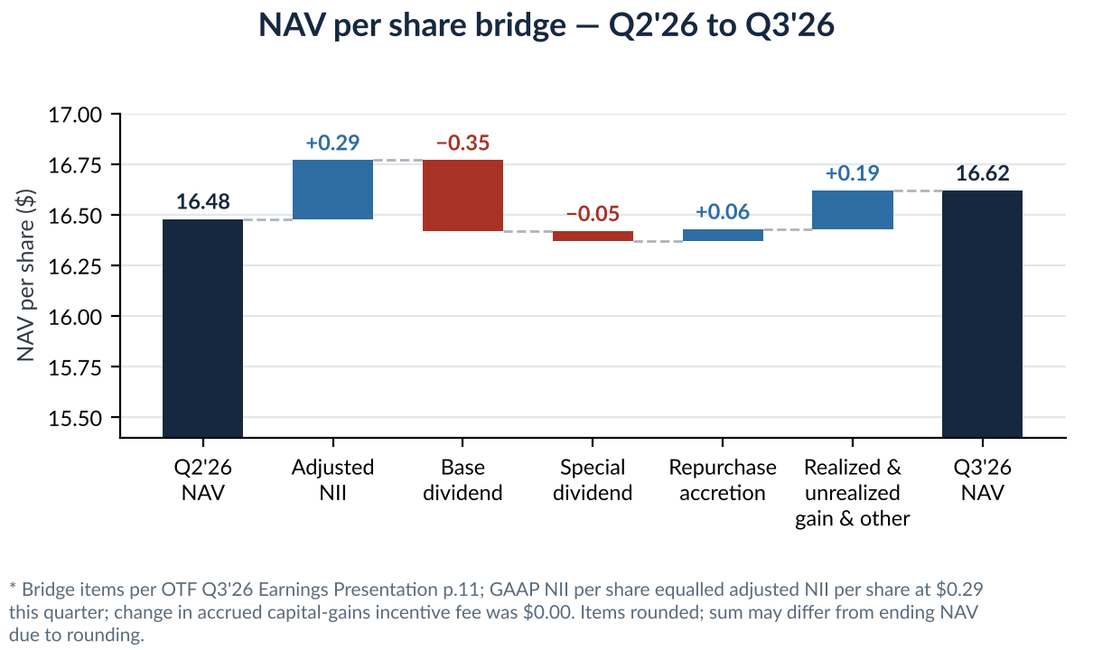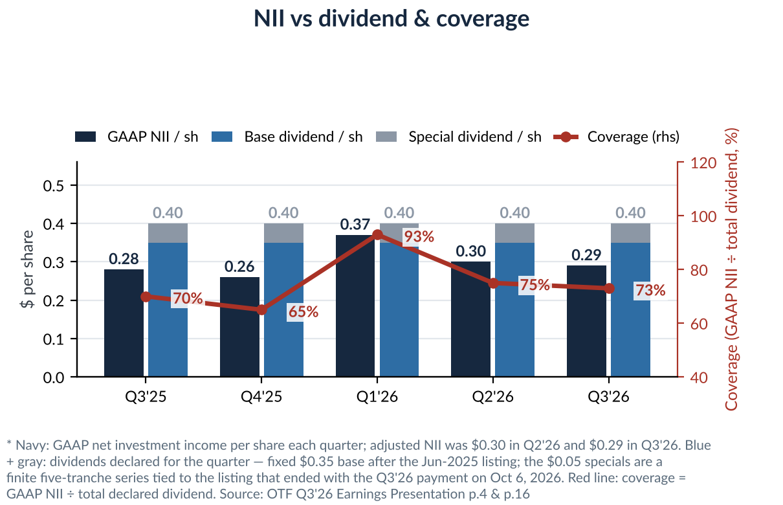
Left: NAV bridge — +$0.29 NII, −$0.40 dividends, +$0.06 repurchase accretion, +$0.19 marks: the first NAV increase since Q4'25. Right: NII dividend-coverage trend — 83% of the $0.35 base, which the board held on November 3.
1. Key News (this quarter)
- Q3'26 results (11/4) and dividend decision (11/3): NAV $16.62, +0.8% QoQ, first rise since Q4'25; adjusted NII $0.29 vs the $0.32 Earnings Whispers consensus — a miss; non-accruals 1.8% of cost; $55.2mm repurchased in Q3 at ~$11.03 average; the Q4'26 base dividend was held at $0.35 rather than cut toward NII.
- Second lawsuit added (10/7): Girard Sharp filed a securities class action for former OTF II shareholders who received OTF stock in the March 24, 2025 merger, citing the share-price decline since issuance — alongside the 36(b) excessive-fee suit filed 6/18. Near-term economics limited; the discovery risk now runs on two tracks.
- New 52-week low (10/13): $9.14 intraday in a global tech selloff, prior close $9.21; sell-side consensus Moderate Buy, average target $13.60, 4 Buy / 3 Hold — implying +48% vs the Oct 13 close.
- Blue Owl redemption pressure rotated, not resolved: OTIC 3Q requests rose to 39% of shares, $1.1bn (2Q: 38.1%) while OCIC eased to 16.8% (2Q: 18.8%); $4.2bn combined, and the 5% cap bound for a third straight quarter. Contrast: KKR's K-FITS went past its 5% cap to pay all requests in full.
- Macro and industry: the 10-year UST touched 5.35% intraday on Oct 7, the highest since 2002, and ended that week at 5.24%, +107bp YTD; gating reached Australia as Metrics Credit Partners (~A$40bn) froze redemptions on some funds after its auditor declined to sign off.
2. Market Trend (industry data)
Industry indicator | Reading | Read-through
BDC average non-accruals (cost, MS basis) | 2.87% (five-year high) | Medallia-driven — tech non-accruals 2.1% → 0.7% ex-Medallia (MS); OTF's Halo equity is the same exposure
Industry PIK (% of total income) | 5.8% in 2Q26 (1Q26: 6.4%) | OTF's 11.5% runs ~2x the average, but both are trending down
Median public-BDC P/NAV | 78% at Aug 31, +2pp QTD (MS) | OTF at 0.55x sits ~23pp below the median — the de-rating is OTF-specific, not sector-wide
BDC bonds vs equities | Bonds +2.2% YTD vs equities −0.4% through Aug 31; OAS −92bp from March wides (MS) | The debt-vs-equity split persists: funding markets open while equity de-rates
Software share of BDC assets | 20.8% of FV per PitchBook 2Q26 (Barclays); software + IT ~25% (MS) | OTF's 32.3% software core is the highest of its comp set
Software maturity wall | Sub-3-year software maturities 32% in 2Q26 vs 17% in 1Q25; 2028 due 18.9% → 16.7% (MS) | Push-out is working but front-loading grows — the four houses' common catalyst is 2027–28 refinancing, not current defaults
Software borrower fundamentals | Median leverage 8.1x vs 7.1x all-sector; cash interest coverage 1.5x, lowest of top-10 sectors (S&P in MS) | Stress sits in OTF's core lane; two-sided: S&P upgraded 8% of software credit estimates vs 5% downgrades in 2Q26
Source: Barclays / Morgan Stanley / J.P. Morgan / UBS research, Sep–Oct 2026 (4 reports on file); MS Private Credit Tracker 2Q26, Exhibits 18 and 22.
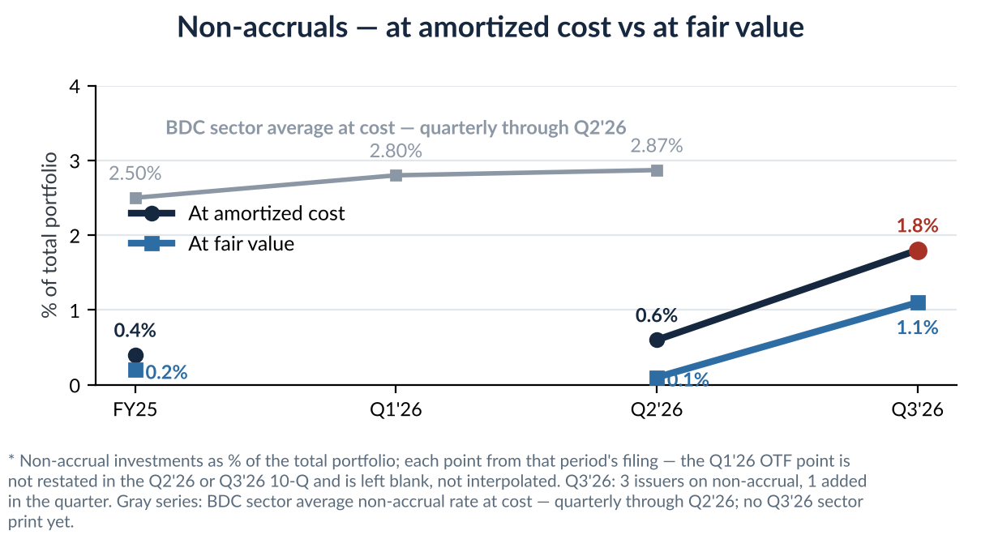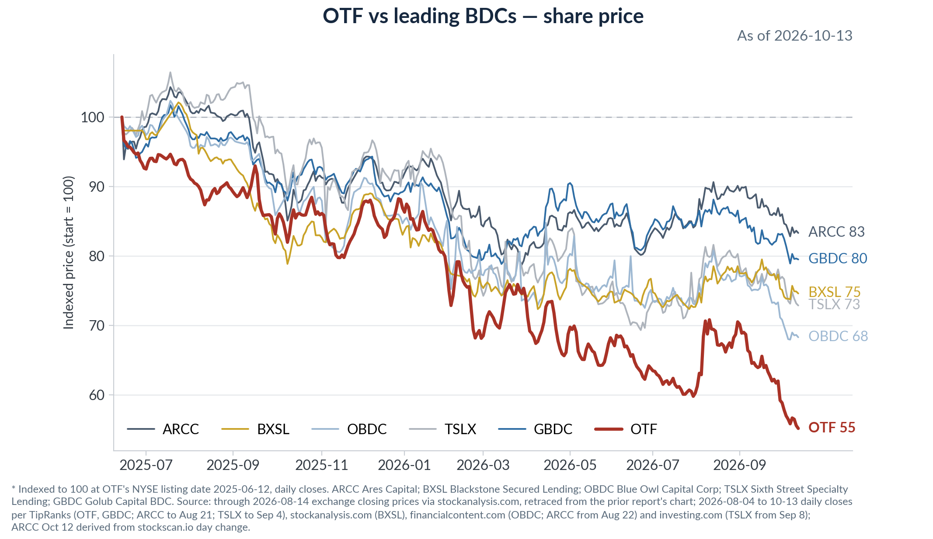
Left: OTF vs the BDC sector on non-accruals — the sector's five-year high is itself Medallia-driven, and OTF converges toward the mean from below. Right: share price since the June 2025 listing — OTF ~−44%, worst of the BDC set and the visual source of the 0.55x discount.
3. Impact on Our Portfolio
- The transmission channel is still valuation first, but credit has entered: ~47.6% of fair value sits in the heaviest-migration end-markets (software 32.3% + healthcare tech 12.3% + healthcare providers 3.0%, Q3'26 10-Q). The Q1'26 −0.84 write-down was spread-driven and marks have run positive two straight quarters (+$0.03, +$0.19/sh); Q3'26 added the first credit-channel datapoint — the Signifyd preferred.
- OTF's own data is now mixed: cohort EBITDA printed its first QoQ decline, $291mm → $287mm (deck p.7, one quarter in arrears), though EV rose to $6.2bn and Net LTV held 40%; PIK is down every reported quarter to 11.5%; non-accruals at fair value 1.1% vs the 2.87% industry cost average — still below, no longer an order of magnitude.
- Three changes: net leverage rose a fifth straight quarter to 0.94x; base coverage slipped 86% → 83%, so the payout leans on spillover with specials ended; and the yield reset is in the price — at $9.21 the $0.35 base yields ~15.1%, so the income-rotation risk is largely realized, not pending.
Six-BDC peer comparison — OTF Q3'26, peers Q2'26
Metric | OTF | ARCC | BXSL | OBDC | TSLX | GBDC
P/NAV (OTF 10/13; peers 8/14) | 0.55x | 1.03x | 0.97x | 0.82x | 1.16x | 0.93x
NAV change | +0.8% QoQ | −1.2% QoQ | −5.2% 1H | −3.7% 1H | −4.4% 1H | −4.8% FYTD
Non-accruals (cost) | 1.8% | 2.4% | 3.6% | 2.8% | 1.9% | 2.9%
PIK % of TII | 11.5% ↓ | 15.8% | 6.6% | 10.7% | — | 8.6% ↑
Dividend action | Base held $0.35; specials ended on schedule | No cut | JPM forecasts cut | Cut −16% | Cut −9% | Cut −15%
OTF per Q3'26 10-Q and Oct 13 close; peers per Q2'26 10-Qs and Aug 14 prices — Q3 peer filings pending; refreshes in the full report's 2.6. OTF software 32.3% (GICS) still highest vs ARCC 22.0%, BXSL 18.9%, OBDC ~18%; TSLX no breakout.
4. Our Position: Assessment, Watch List & Action
- Overall assessment: fundamentals validated ex-credit, valuation trigger breached — back to IC per our own framework. Credit remains lowest-of-six on non-accruals (1.8% vs TSLX 1.9% at Q2'26) but is no longer unambiguously clean; the discount is the deepest at 0.55x; consensus target $13.60 (+48% vs $9.21); the risks are application-software concentration (53.4% of fair value on the house T3 re-tier, pending freeze), the rating-3 build to 9.0%, and two lawsuits.
Watch list (next-quarter checks and trigger lines)
Item | Current | Trigger / timing | Action if triggered
Non-accruals (cost) | 1.8% | > 2% | Re-table at IC — 20bp from the line; rating-3 is the feeder
P/NAV | 0.55x (10/13) | < 0.60x — BREACHED | Re-table at IC, two-way: add / exit — this summary executes it
Base-dividend coverage (GAAP NII) | 83% | < 80%, or two consecutive declining quarters | 86% → 83% is one decline; a Q4'26 drop triggers the review
Non-traded funds' 4Q redemption requests | 3Q $4.2bn combined; OTIC 39%, OCIC 16.8% | Early-Jan disclosure | If OTIC ratchets higher, watch funding-cost pass-through
Litigation — 36(b) + securities class action (10/7) | Both pre-dismissal | Motion to dismiss / discovery | If discovery begins, assess Level-3 disclosure risk
Rating-3 migration | 9.0% of FV, $1,327mm, +1.9pp QoQ | Q4'26 print — does rating-3 feed non-accruals | A second preferred / PIK flip = credit line trending to breach

Action: re-table at IC. The 0.60x P/NAV trigger set last quarter is breached (0.55x on the Q3'26 NAV), and the discussion is two-way by design. The hold case: NAV +0.8%, base dividend held, marks positive two straight quarters, non-accruals still lowest of six on Q2'26 peer data, consensus +48% to target. The bear case gained its first datapoint: non-accruals 0.6% → 1.8% of cost and the rating-3 build to 9.0%. Our framing into IC: the discount prices the 2027–28 software-credit and platform thesis, not the reported book — position unchanged until IC rules.

