JUNSON Capital Research
Aircraft Leasing Quarterly Report (2026Q3)
Coverage: aviation / aircraft leasing / lessors / BCGAF 13 Oct, 2026
Demand
Macro backdrop
The macro frame for travel demand is one of slow but positive growth, with little change month-over-month. Barclays’ economists forecast global GDP running at 2.3–3.4% saar per quarter through 3Q27, with the US revised up (2.5% in 3Q26, ~2.0% through 2027) and the euro area anaemic — broadly 0.9–1.1% saar from 4Q26 through 2Q27 after a 2.6% print in 2Q26 — with France and Italy capped under 1ppt through 2Q27 and Germany brightening into 2027. GS’s read is consistent: Europe real GDP is expected to average ~0.9% and US ~2.0% over the next four quarters. On the leading indicators GS tracks for aircraft orders, the July US ISM sat slightly above its historical average while China PMI remained slightly below its long-term average. Nothing in the macro data argues for a demand-side break; the pressure on the industry this year is a cost shock, not an income shock.
Exhibit 1: GDP forecasts by economy, % over previous period (saar)
 | 2Q26 | 3Q26 | 4Q26 | 1Q27 | 2Q27 | 3Q27
Global | 3.1% | 2.7% | 3.4% | 3.0% | 2.3% | 2.6%
United States | 1.5% | 2.5% | 2.0% | 2.0% | 2.0% | 1.5%
Euro area | 2.6% | 1.0% | 0.9% | 1.0% | 1.1% | 1.5%
United Kingdom | 1.7% | 1.6% | 0.7% | 0.8% | 1.1% | 1.4%
Germany | 1.3% | 0.7% | 0.9% | 1.0% | 1.3% | 1.7%
France | 0.1% | 0.6% | 0.6% | 0.8% | 0.8% | 1.3%
Italy | 0.7% | 0.4% | 0.4% | 0.6% | 0.6% | 0.8%
Spain | 2.8% | 2.1% | 1.9% | 1.8% | 1.9% | 1.9%
Note: Forecasts as of 18 September 2026; changes vs the prior month are broadly neutral across economies. Source: Barclays.
Global passenger traffic
The demand picture softened through 1H26 but did not break. IATA's June update cut its full-year 2026 traffic growth forecast from +4.9% to +2.1%, and year-to-date global RPK growth through July was running at just +0.6%. The monthly cadence has nevertheless been improving: GS forecasts that IATA will report July traffic up 2.4% yoy with a global load factor of 85%, while Barclays’ read of the published IATA series shows industry traffic recovering to roughly flat yoy in July as the Middle East recovers, with Europe up 2%. The three July readings are differently constructed rather than contradictory — GS is forecasting the IATA print from individual airline reports and TSA volumes, Barclays tracks the published IATA series, and the IATA YTD figure averages the weak conflict months — but the spread illustrates how noisy single-month demand data currently is. We standardise on the IATA release as the reference series for this tracker.
The May regional breakdown (the latest complete IATA dataset, published with a ~4–6 week lag) shows the disruption remains regionally contained: five of six regions posted positive yoy RPK growth, led by Latin America (+10.5%) and Africa (+8.9%), against a –28.4% collapse in the Middle East. Barclays’ tracking through July indicates the Middle East drag has since narrowed enough to pull the global aggregate back to roughly flat.
Exhibit 2: Passenger demand by region, May 2026, yoy change in RPKs
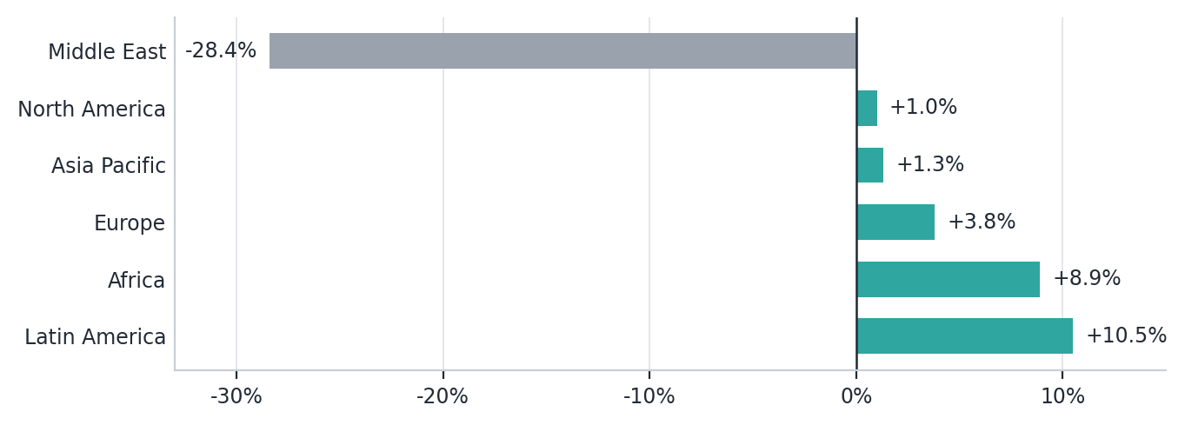
Note: May 2026 is the most recent complete regional dataset given IATA’s ~4–6 week reporting lag; Barclays’ tracking shows the Middle East drag narrowing through July. Source: IATA.
Capacity is the other half of the load-factor story. Global airline forward scheduled capacity shows yoy growth of just +2/+3/+3% for August, September and October — which GS characterises as disciplined expansion and a modest stabilisation following the fuel-driven slowdown — while JPM notes capacity worldwide has been cut versus entering-the-year plans specifically to prop up fares against higher fuel. In other words, record load factors are being engineered through restraint on frequency, not carried by accelerating volume; that restraint supports fares and lessee cash flow, but it also means utilisation of the in-service fleet, rather than fleet growth, is doing the work.
Exhibit 3: Global airline forward scheduled capacity, yoy growth
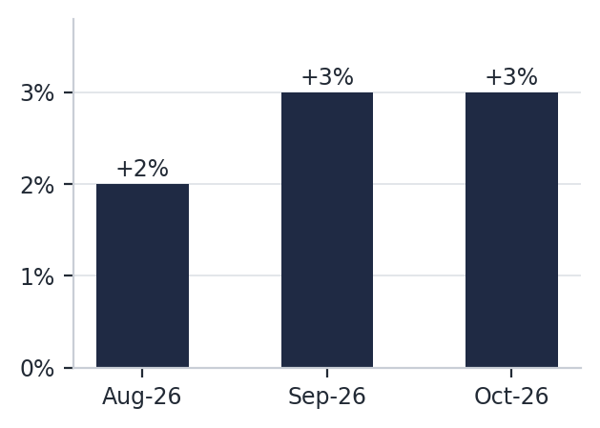
Source: GS.
US demand
The US is the firmest major demand pocket in the dataset — and it is pricing-led, not volume-led. Volumes are near-flat: North America RPKs were up just +1.0% yoy in May (IATA, Exhibit 2), the slowest growth of any region outside the Middle East collapse, and Barclays notes TSA international travel volumes are now falling yoy — the basis for its view that RASK will evolve weaker than fares as loads fade. Pricing is carrying the P&L instead: US airline yields were up 6.7% yoy in 1Q26 per GS, and on the transatlantic — the premium long-haul market that matters most for US network carriers — Barclays’ August screen-scrape has American’s economy fares +32% yoy, United’s +26% and Delta’s in the +10–20% band. The backdrop supports it: Barclays revised US GDP up to 2.5% saar for 3Q26 and ~2.0% through 2027 (Exhibit 1), and GS’s high-end corroborator — US business jet operations — was up 7% yoy in July after +5% in June. For the Fund, this two-speed US market maps directly onto the book: the fare strength accrues to network carriers with transatlantic exposure — United, the book’s Tier-1 anchor at ~25% of lessee exposure including the monetised JOLCO aircraft — while the soft end sits in domestic leisure LCCs, where the Fund’s one such position, ex-Spirit, has already been realised at 2.11x gross MoM.
Exhibit 4: US demand dashboard
Metric | Latest reading | Source
Real GDP, saar (3Q26E / through 2027) | 2.5% / ~2.0% | Barclays
N. America passenger demand, RPK yoy (May-26) | +1.0% | IATA
US airline yields, yoy (1Q26) | +6.7% | GS
N. Atlantic economy fares, yoy (Aug-26) | American +32% / United +26% / Delta +10–20% | Barclays
TSA international travel volumes | falling yoy | TSA via Barclays
US business jet operations, yoy (Jul-26) | +7% | GS
Note: Fare readings are screen-scraped economy fares — direction credible, scale with caution, per Barclays; TSA volumes cited qualitatively in Barclays’ RASK commentary. Δ QoQ columns begin from 2026Q4 per the tracker’s baseline convention. Source: Barclays, GS, IATA.
European airline pricing & consumer demand
Barclays’ August screen-scraped fare data shows the post-conflict fare support cracking on short-haul: every European full-service carrier tracked was down yoy on intra-Europe fares — Austrian –1%, Brussels –2%, Lufthansa and SWISS –3%, Aer Lingus and Iberia –4%, TAP, KLM, Aegean and Air France down mid-single digits, with British Airways –11% and Finnair –18% the weakest. The LCC picture is mixed: Vueling +5%, Eurowings +4% and Transavia France +4% were up, while Wizz –11%, Ryanair –10%, Norwegian –9%, TUI –8% and Jet2 –5% were lower. Barclays itself cautions that the screen-scraping rests on booking-curve assumptions — direction credible, scale less so — and notes the Ryanair reading is weaker than the company’s own ~–2% guidance for the quarter, with both Ryanair and Wizz flagging that September data was brightening. Long-haul is the offset: North Atlantic economy fares remain strong, led by Brussels +43%, British Airways +37%, Swiss +29% and Austrian +28%, with only Aer Lingus (–2%) and TAP (–8%) down. At group level the split is stark: Lufthansa Group –2% short-haul vs +22% North Atlantic, AF-KLM –6% vs +6%, IAG –8% vs +21%.
Consumer spending corroborates the stabilisation. Barclays’ proprietary UK card data puts spending on airlines at –1.6% yoy over the 28 days through 11 September — little changed from –1.5% in the prior edition but a material improvement from –10% yoy in June, which Barclays attributes to a later booking pattern for peak-summer travel this year. The recovery is broad-based across age groups, though the youngest cohorts (–10.1% yoy) continue to lag older travellers (+10.9%), and airline spend as a share of total card spend is running a touch below 2025 YTD. For a lessor book this matters mainly through the lessee P&L: European short-haul operators — the natural home of mid-life narrowbody aircraft — are facing softening yields into a high fuel-cost winter, while long-haul widebody operators retain pricing power.
Exhibit 5: European airline groups — August achieved fares, yoy
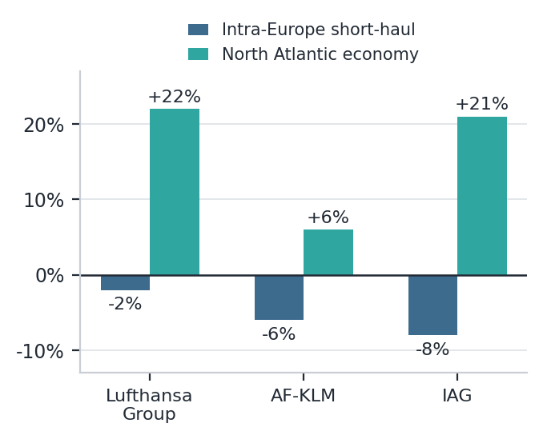
Note: Screen-scraped economy fares; Barclays treats the direction of moves as credible, the scale with caution. Source: Barclays.
Airline profitability & fuel
Profitability is where the conflict bites. IATA’s post-conflict forecast puts 2026 industry net profit at US$23bn on a 2.0% net margin — roughly half the US$41bn / 3.9% it projected in December 2025 before the conflict — with jet fuel assumed to average US$152/bbl for the full year versus US$90/bbl in 2025, lifting the industry fuel bill to US$350bn. Demand fundamentals stay intact: IATA still expects a record 84.0% load factor for 2026, up from 83.5% in 2025. Record load factors alongside collapsing margins frame this as a cost shock to airline P&Ls rather than a demand shock to aircraft. JPM makes the same point from the credit side: US$23bn is still a healthy absolute figure — if an anaemic return on the capital employed to generate it — and most airlines under its coverage are holding up well, especially those focused on premium, international and loyalty revenue.
The open question is whether the fuel assumption holds. JPM notes NY Harbor jet fuel has risen over 136% YTD, from ~US$2.00/gal at end-2025 to above US$4.70/gal in mid-September — well above the run-rate implied by IATA’s US$152/bbl (≈US$3.62/gal) full-year average — with fuel representing 15–30% of airline operating expenses. Forward curves imply lower fuel costs, and GS observes crude and jet fuel prices are already off their recent highs. Either spot follows the curve down in 4Q26, or IATA’s profit forecast gets cut a third time.
Exhibit 6: Global airline net profit and load factor, 2023A–2026F
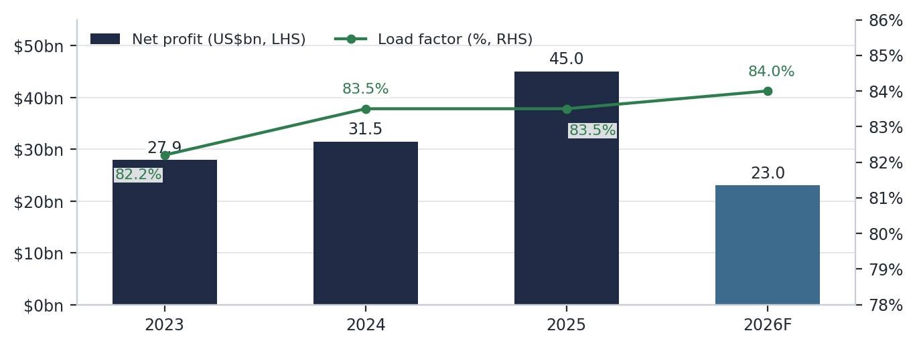
Note: 2026F is IATA’s post-conflict forecast, cut from the US$41bn / 3.9% margin forecast issued in December 2025; JPM references an initial 2026 projection of US$45bn, which corresponds to the 2025 outturn — we use the IATA release figures. Source: IATA.
Supply
Order backlog & deliveries
The order book remains the structural anchor: IATA counted more than 18,000 aircraft on order as of May 2026, over half the active global fleet. Monthly order flow stayed healthy through the conflict — Boeing booked 38 gross orders against 8 cancellations in July and Airbus 204 against 1 — with GS characterising net orders as consistent with prior mid-cycle periods, order campaigning activity as robust for both growth and replacement, and cancellations as a share of backlog as below historical averages. Parked aircraft stood at 11.1% of the total fleet in July, down 40bp month-over-month and nearing pre-pandemic levels — the clearest single indicator that the usable surplus in the system is thin.
Exhibit 7: Boeing and Airbus gross orders and cancellations, July 2026
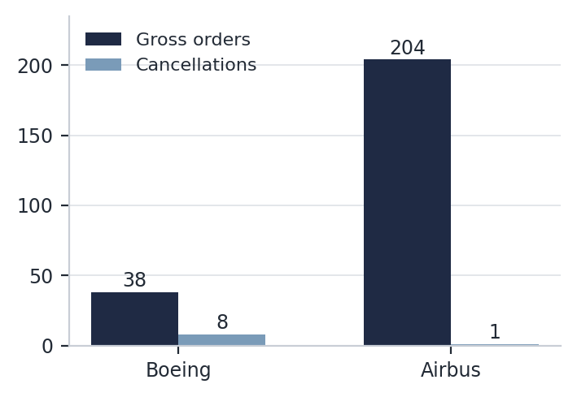
Source: GS.
Supply normalisation watch
The more important development is the direction of travel. JPM argues the supply-demand imbalance that defined the post-COVID market is normalising: OEM production rates are rising (MAX 7/10 certification expected this year, 777X next year), the GTF engine overhaul queue is shrinking, and the Spirit liquidation and Air Baltic fleet reduction are returning aircraft to the market. The depressed retirement rate — which has pushed lease renewal rates from a typical 50–60% to often above 80% across many portfolios — is expected to normalise as OEM supply recovers, whether or not fuel recedes. Higher fuel itself cuts both ways for fleets: all else equal it raises demand for newer, fuel-efficient aircraft and lowers demand for older, less efficient models, though JPM stresses that six months of elevated fuel does not materially alter fleet plans when the futures curve implies lower costs ahead. None of this is distress: JPM frames it as an industry “playing from a position of strength”, with the secondary trading market arguably the strongest it has ever been. But it marks a turn in the cycle narrative that the record-backlog headline alone does not capture.
Values & Lease Rates
Aircraft values & lease rates by segment
Appraiser data now shows the first clear bifurcation of the cycle. Per IBA (as cited by JPM), 10-year-old widebody values are up sharply — the 777-300ER roughly +40% yoy and the A330-300 roughly +15% — on persistent scarcity and delayed fleet renewal, while 10-year-old A320-200 and 737-800 values both fell marginally QoQ and yoy, the first outright declines in older narrowbody values this cycle. Market lease rates show the same split: A320-200 rates down 13.0% yoy and 737-800 down 11%, against roughly +20% for the 777-300ER. New-delivery values and lease rates remain far less volatile, and because new lease rates are indexed to interest rates they are under upward pressure — the 10yr UST is +80bp YTD, approaching 5% — even as new narrowbody lease rate factors compress with normalising supply. The appraiser consensus JPM describes is of slightly weakening mid-life lease rates concentrated on the single-aisle side, with the twin-aisle runway for lease rate improvement remaining longer.
Exhibit 8: 10-year-old aircraft — value and market lease rate change, yoy
Aircraft type | Value, yoy | Market lease rate, yoy
777-300ER | ~ +40% | ~ +20%
A330-300 | ~ +15% | n.d.
A320-200 | marginally negative* | –13.0%
737-800 | marginally negative* | –11%
Note: Values marked ~ are approximations as characterised in the source; *older-narrowbody value declines are described qualitatively (“fell ever so slightly QoQ and yoy”) with no figure disclosed. n.d. = not disclosed. Source: IBA, JPM.
Lessor portfolio economics
Portfolio-level economics are still improving on the strength of leases written into the shortage, and Avolon’s 2Q26 results are the cleanest read. Its CFO put the portfolio lease rate factor at 10.4%, “a nudge below what it peaked at pre-COVID”, with lease yields up 20bp yoy from 10.2%, and management stating it continues to place aircraft at the highest lease rates it has seen in years. 2Q26 net income was US$209mm, up 45% yoy, bringing trailing 12-month net income to US$702mm, up 31% yoy — “almost back to peak profitability levels back in the 2018–2019 range” per the CFO — and management continues to believe the persistent OEM production delays at Airbus and Boeing will support the sector through the end of the decade (all per JPM’s 2Q26 recap). Across JPM’s comps, LTM lease yields run from 8.6% (SMBC Aviation Capital) to 12.7% (BOC Aviation) — see Exhibit 9 — with the spread largely a function of fleet age and funding mix rather than underwriting. On the origination side, sale-leasebacks represented ~31% of total 2025 deliveries per Cirium (via GS), keeping competition for new-delivery deals intense.
Financing & Credit
Lessor credit & relative value
The ratings catch-up trade is over. AerCap now carries Baa1/BBB+ and AVOL, ACGCAP, AYR and DUBAEE have reached mid-BBB; JPM’s view is that most of the expected upgrades have played out and the market is now “fighting for a few basis points here and there in a compressed spread market”. On relative value, 5yr AER trades ~5bp wide of the GSIB cohort (versus ~20bp when JPM downgraded the name in August 2024), offers ~35bp over NSC 5yr green bonds (49bp) and ~20bp over CP and FDX (5yr FDX at 64bp), while the most recent AAL first-lien EETC trades just inside 100bp — lessors screen a touch cheap versus other equipment lessors and transports, but rich versus GSIBs, which JPM regards as the floor on further spread compression outside a true financial crisis.
The sector recommendation stays Neutral with a mid-BBB bias: JPM is Overweight AVOL, GALCLD, DUBAEE, SMBCAC and ACGCAP, Underweight BOCAVI (tight spreads plus the Chinese-ownership risk factor), and downgraded both SUMIAL and AYR from Overweight to Neutral purely on relative spread performance. AVOL, ACGCAP and DUBAEE are flagged as the favoured mid-BBB opportunities, and Moody’s upgraded AVOL to Baa2 during the quarter with the GALCLD HoldCo upgraded in conjunction. One technical JPM highlights for sector demand: lessor paper is benefiting as financials investors diversify away from the hyperscaler bond supply wave.
Exhibit 9: Aircraft lessor credit comps — ratings, lease yield, leverage and returns (LTM 2Q26)
Issuer | Moody’s / S&P  (unsecured) | Lease yield  (LTM) | Net debt /  equity | RoE  (ttm)
AER (AerCap) | Baa1 / BBB+ | 11.5% | 2.2x | 18.6%
AVOL (Avolon) | Baa2 / BBB | 10.8% | 2.5x | 8.3%
ACGCAP (Aviation Capital Group) | Baa2 / BBB– *+ | 11.0% | 2.1x | 5.0%
DUBAEE (Dubai Aerospace) | Baa2 / NR | 11.5% | 2.6x | 12.7%
SMBCAC (SMBC Aviation Capital) | NR / A– | 8.6% | 2.6x | 8.3%
BOCAVI (BOC Aviation) | NR / A– | 12.7% | 2.6x | 11.9%
SUMIAL (Sumisho Air Lease) | NR / BBB | 9.3% | 3.3x | 5.9%
AYR (Aircastle) | Baa2 / BBB | 10.6% | 1.9x | 6.9%
AVILES (AviLease) | Baa2 / NR | 9.4% | 0.8x | 3.6%
AZORRA (Azorra) | B1 / BB– | 10.4% | 2.6x | 13.9%
Note: Financials are LTM to 30-Jun-26 (31-May-26 for Aircastle); lease yield is annualised aircraft-related revenue over average book value of flight equipment per JPM’s methodology and is not directly comparable to company-reported lease rate factors. Source: JPM.
Funding & maturity profile
Funding markets remain wide open for the rated lessors, and the model keeps shifting unsecured. Avolon — which runs the largest order book in the space and is among the most active public issuers — ended 2Q26 with an unsecured debt / total debt ratio of 79%, up from 77% at year-end 2025, issued US$1.5bn of senior unsecured notes during 1H26, upsized a revolver by US$175mm to a US$6.38bn commitment, and generated US$2.4bn of LTM operating cash flow, with JPM also noting a wide-open unsecured bank market (all per JPM’s 2Q26 recap).
The refinancing calendar is the thing to watch into a ~5% 10yr: aggregating JPM’s issuer schedules, upcoming maturities across the eight lessors with disclosed profiles step up from ~US$9.4bn in 2026 to ~US$22.9bn in 2027 and ~US$23.4bn in 2028. The 2027 towers are concentrated at SMBCAC (US$5.3bn) and SUMIAL (US$5.0bn), with AER carrying the single largest 2028 load (US$6.1bn). None of this is a solvency question for investment-grade issuers in an open market — but it anchors why new-delivery lease rates, indexed to funding costs, stay under upward pressure, and why cost of debt is the competitive variable among origination platforms.
Exhibit 10: Aircraft lessor debt maturities by issuer, 2026–2028 (US$bn)
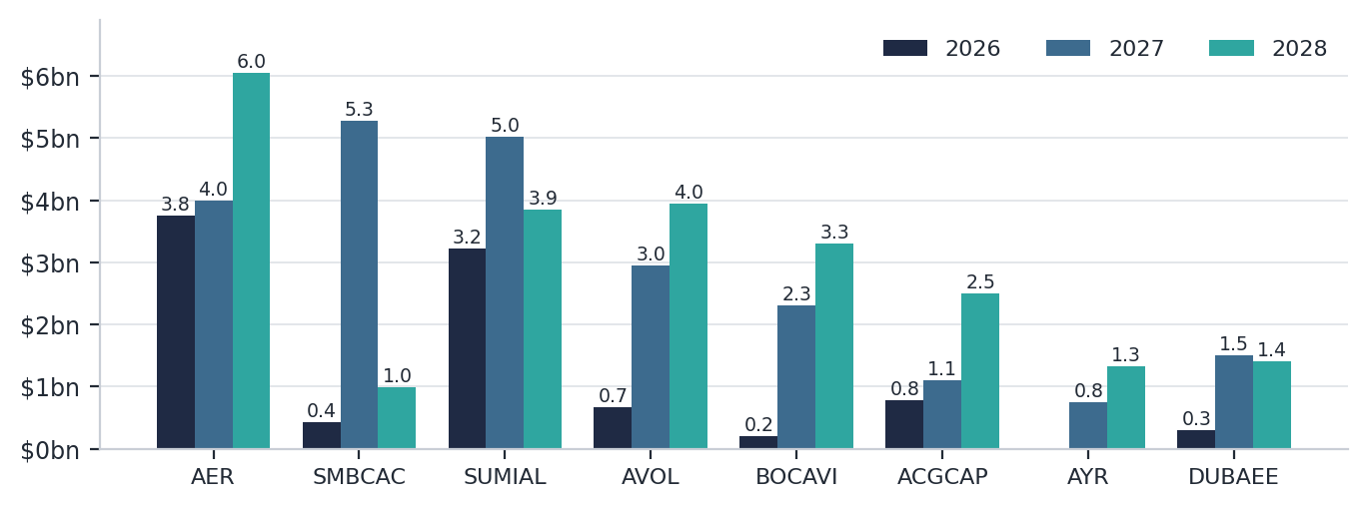
Note: Issuer schedules as compiled in the source comps; AviLease not disclosed and Azorra shows no maturities in the window. Aggregates of ~US$9.4bn / US$22.9bn / US$23.4bn for 2026 / 2027 / 2028 are Junson sums of the issuer-level figures. Source: JPM.
Airline credit backdrop
On the lessee side, high-yield airline debt trades roughly in line with the broad HY market per GS, and investment-grade airline paper is well bid — DAL’s 4yr unsecured trades inside 70bp per JPM, with LUV a touch wide of DAL despite one notch higher S&P / Fitch ratings. The stress is idiosyncratic rather than systemic: the fuel shock has already produced the Spirit liquidation and the Air Baltic fleet restructuring, both of which add aircraft supply while removing weaker lessee credits. For a lessor book, the watch item is Tier-3 carriers with thin liquidity heading into an expensive winter fuel season.
Sentiment
Broker & GP summary
Exhibit 11: Broker and GP summary — aviation / aircraft leasing views and key points
 | GS | JPM | Barclays
Stance | Constructive on demand; supply discipline holding | Sector Neutral; mid-BBB bias; supply-demand imbalance normalising | European airlines Neutral; demand improving, fares softening
Key points | Jul traffic +2.4%E yoy, load factor 85%E; forward capacity +2/3/3% Aug–Oct; net orders consistent with mid-cycle; parked fleet 11.1%, near pre-pandemic; crude / jet fuel off recent highs | Upgrade cycle played out, spreads compressed; mid-life narrowbody values / rates rolling over vs widebody rising; favours AVOL / ACGCAP / DUBAEE; lessors cheap vs transports, rich vs GSIBs; SUMIAL & AYR cut to N | UK card spend on airlines –1.6% yoy (vs –10% in June); Aug short-haul fares down across FSCs and LCCs (LH group –2%, AF-KLM –6%, IAG –8%); N Atlantic economy fares strong (LH group +22%, IAG +21%); Wizz –11% weakest LCC
Δ QoQ | n/a — baseline quarter | n/a — baseline quarter | n/a — baseline quarter
Source: GS, JPM, Barclays; Junson AID summary.
GP narrative (Bain Capital Griffin, Q2 letter): the GP frames the environment as “a cost crisis for airline owners rather than a demand crisis for aircraft”, with lessor lease income contractually insulated from airline margin pressure; argues the conflict has deepened the supply imbalance and extended the window during which carriers must rely on leased in-service aircraft; and cites the record order backlog as supportive of origination. We track this narrative each quarter against the sell-side view — the divergence that has already opened versus JPM is discussed in Things We Should Know.
Related news
Spirit liquidation and Air Baltic restructuring: the first fuel-shock casualties of the cycle; both events return aircraft to the market and remove weaker lessee credits, and JPM cites them among the drivers of normalising supply.
Avolon upgraded to Baa2: Moody’s upgrade completed during the quarter, with the GALCLD HoldCo upgraded in conjunction — effectively closing out the lessor upgrade cycle JPM had anticipated.
Volaris–VivaAerobus merger approved: shareholders approved the combination in March 2026, set to create the dominant Mexican ULCC platform with stronger combined scale and capital-market access.
Korean Air–Asiana formal merger set for December 2026: completion would create one of Asia-Pacific’s largest carriers, with Korean Air’s ownership providing financial backing through the transition.
TAP Portugal privatisation in progress: an active process with Air France-KLM and Lufthansa among reported bidders — a potential positive credit catalyst for the Portuguese flag carrier.
Things We Should Know
Five observations we consider important after reading this quarter’s materials, ordered by importance:
1. GP and sell-side cycle narratives have diverged. The GP’s letter leans on the record backlog and supply scarcity; JPM’s same-quarter judgment is that the imbalance “is or will normalise”, with retirements picking up and lease renewal rates mean-reverting from 80%+ toward the typical 50–60%. Both can be true — the backlog is a stock, supply recovery is a flow — but the flow is what prices mid-life aircraft, and the fund’s two portfolio acquisitions are weighted to A320ceo / 737NG vintages that sit exactly where IBA records the first value declines of this cycle. The pace and pricing of the in-progress monetisations is the practical test; we will track the GP’s supply language each quarter as the leading indicator.
2. The fuel assumption is the single biggest swing factor for lessee health. The September NY Harbor spot above US$4.70/gal runs ~30% above the rate implied by IATA’s US$152/bbl full-year average (≈US$3.62/gal): either 4Q fuel follows the futures curve down, or IATA cuts industry profits a third time. Lease-income insulation is contractual, not economic — it holds only until a lessee files, as Spirit and Air Baltic have just demonstrated. The watch-list is Tier-3 and fuel-exposed European short-haul carriers, where Barclays shows achieved fares already softening, into the winter season.
3. Mid-life narrowbody repricing is new information; widebody strength is not. The first outright declines in 10-year-old A320-200 / 737-800 values, with market lease rates down 13.0% / 11% yoy against ~+40% / ~+20% on 777-300ER values and rates, mean portfolio mix — not market level — will drive marks from here. Any mid-life narrowbody exposure should be monitored at the asset level rather than through fleet-wide averages.
4. New-delivery economics are being squeezed from both ends. New narrowbody lease rate factors are compressing as supply normalises while funding costs have risen (10yr UST +80bp YTD, approaching 5%), sale-leasebacks at ~31% of 2025 deliveries keep origination competitive, and the lessor refinancing calendar steps up from ~US$9.4bn in 2026 to ~US$23bn p.a. in 2027–28. The environment favours platforms with the cheapest ABS / unsecured funding — the right lens for assessing any GP’s claim of an accretive pipeline.
5. Data hygiene for this tracker. We standardise on IATA releases as the reference demand series (the GS / Barclays / IATA July readings differ by construction); the pre-conflict 2026 profit baseline is US$41bn per the December 2025 IATA forecast — JPM’s cited “US$45bn initial projection” corresponds to the 2025 outturn; and appraiser (IBA) datapoints currently arrive via JPM until we source the index directly. 2026Q3 is the baseline edition, so all Δ QoQ columns read n/a.
Fund Update
Quarterly update on Junson’s holding in the Bain Capital Griffin Aircraft Fund, based on the manager’s Q2 2026 quarterly investor update and Q1 2026 investor overview. Data as of 30-Jun-26 unless noted; GP figures are unaudited estimates until completion of year-end audits.
Bain Capital Griffin Aircraft Fund (aviation hard assets)
Fund snapshot
  Strategy | Aviation hard assets — young, new-technology aircraft on long-term leases
  Total commitments | US$353.0M (target US$1bn; GP ~US$50M)
  Initial close | April 2025
  Final close | Expected October 2026
  Term | 3-yr investment period from final closing; 6-yr harvest + two 1-yr extensions
  Fees | Mgmt 1.50% / 1.25% / 1.00% tiers on invested capital; 20% carry over 8% pref
  Status | Investment period; deploying and selectively monetising
  Metric | 1Q26 | 2Q26 | QoQ Δ
  Portfolio value (US$m)¹ | 1,245 | 1,352 | +107
  % of scaled target | ~33% | 36% | +~3pp
  Aircraft / engines² | 33x / 5x | 29x / 5x | ²
  Invested capital (US$m) | n.d. | 194.4 | –
  Inv.-level gross IRR / MoM | n.d. | >50% / 1.60x | –
  NAV (US$m / % cmt) | n.d. | 227.6 / 64.5% | –
  Contributions (US$m / called) | n.d. | 127.1 / 36.0% | –
  Fund ITD IRR / MoM / DPI | NM | NM | –
Note: ¹Purchase-price basis, pro forma monetisations. ²Pro forma bases differ — 1Q26 nets 2x monetisations (1x closed, 1x pending), 2Q26 nets 6x closed and in progress. n.d. = not disclosed in the 1Q26 investor overview; fund-level performance not meaningful while <50% called. Source: Bain Capital Griffin.
- Quarter activity: funded the Q1-acquired aircraft portfolio at Q2 quarter-end, taking capital called to 36.0% of commitments (ITD contributions US$127.1M); the aircraft were subsequently included in the platform’s second Master Trust ABS issuance, completed in June for US$568M. One aircraft monetisation has closed ITD, with five further assets in the process of being monetised and estimated to generate gains on closing in Q3/Q4 2026 — the ex-Spirit aircraft closed post quarter-end in August 2026 at >50% gross IRR / 2.11x gross MoM. ITD distributions stand at US$6.2M (1.8% of commitments, 100% profit distributions), with a further US$12.7M distributed post quarter-end.
- Manager commentary: the GP frames the environment as a cost crisis for airline owners rather than a demand crisis for aircraft, and believes the Fund’s asset-backed, long-term lease structure provides meaningful insulation from near-term fuel price volatility; reports the Fund tracking above its high-single-digit distributable cash yield target; and is actively evaluating several new investments while advancing discussions with prospective investors toward the October final close.
Portfolio composition
The Fund has sourced five transactions to date; pro forma for monetisations executed and in progress it holds 29x aircraft and 5x engines. The current portfolio stands at US$1,352M on a purchase-price basis against the US$3,750M scaled target (36%, up from US$1,245M / ~33% at Q1 2026). Concentration sits in the two newest transactions — Portfolio Acquisition #2 (14x aircraft, 40% of current portfolio value) and VietJet (6x 737-8 delivering July–November 2026, 32%) — followed by United (19%), Portfolio Acquisition #1 (6%) and the Rolls-Royce engine pool (3%); the Fund holds minority equity allocations in the two opportunistic pools (~19% of the 9-aircraft 2025 pool and ~23% of the engine pool) alongside the platform. As of Q1 2026 the delivered fleet was 94% new technology with ~3 years weighted average age and ~12 years average remaining lease term. The lessee book mixes Tier-1 anchors (United) with recovery credits (GOL post-Chapter 11, Garuda, Lion Air) and consolidation stories (Asiana under Korean Air; Volaris–VivaAerobus) — the Tier-3 tail is where the market section’s fuel watch-list applies. On the GP’s scorecard, nine of eleven parameters are meeting target with age at acquisition and lessee counterparty mix near target; return conditions improved from near to meeting target during the quarter.
Exhibit 12: BCGAF — transactions and realisation status (as of 2Q26)
Transaction | Units | Lessee status | % of portfolio value | Status / realisations
United Airlines | 6x 737-9 | New | 19% | 1x JOLCO monetisation closed (1.40x gross MoM); 1x pending, est. in-line
Rolls-Royce | 5x spare engines | New | 3% | Financed via existing Master Trust
Portfolio Acquisition #1 | 9x aircraft: 2x A320ceo, 5x 737-800, 1x 737-900ER, 1x 787-8 | 8x new credits | 6% | 2x monetisations in progress (est. 2.95x gross MoM, single transaction)
VietJet | 6x 737-8 | New | 32% | Deliveries July–November 2026
Portfolio Acquisition #2 | 14x aircraft: 8x A320ceo, 2x 737-800, 2x A320neo, 1x A321ceo, 1x 777-300ER | 10x new parent credits | 40% | ex-Spirit realised Aug-26 (2.11x); Air France pending (est. 1.82x)
Note: % of current portfolio value on a purchase-price basis, pro forma for monetisations closed and in progress; the two portfolio pools were acquired as single portfolios and contributed into the platform’s ABS. Source: Bain Capital Griffin.
The GP’s exposure breakdown as of 30-Jun-26 (Exhibit 13, redrawn from the quarterly report with monetised assets shaded grey) shows the pro-forma book concentrated in narrowbody 737 / A320-family metal by asset type and market class, APAC-weighted by region, and spread across Tiers 1–3 by credit — the GP targets ~75% Tier 1/2 at scale and itself marks this parameter near target.
Exhibit 13: BCGAF exposure — sector / asset type / market class / lessee / region / credit tier (30-Jun-26)
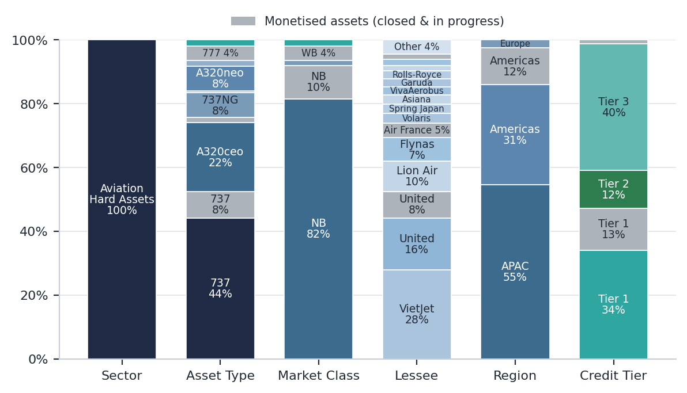
Note: Segment shares are approximate Junson readings from the source chart, which does not label values (pixel-measured; each column reconciles to 100%). Grey = monetised assets, closed and in progress. ‘Other’ comprises American, Ethiopian, GOL, Jetstar Japan, Thai Lion Air, Virgin Australia and Vueling; unlabelled thin slices are TAP Portugal, GlobalX and ex-Spirit (grey). Exposure reflects invested and committed capital; lessees reflect parent credits. Source: Bain Capital Griffin.
Exhibit 14: BCGAF portfolio scorecard — status vs scaled target, 2Q26 vs 1Q26
Parameter | Scaled target | Status (2Q26) | Δ QoQ
Asset type split | 70% NBs / 30% WBs at 50%+ target size | Meeting | —
Age at acquisition | ~90%+ newbuild by purchase price | Near | —
Purchase price discount | 5–10% | Meeting | —
LRF (monthly) | 65–75bps | Meeting | —
Lessee counterparty | ~75% Tier 1 or Tier 2 | Near | —
Maintenance reserves | 20–30% by count | Meeting | —
Security deposit | > 1x months rent | Meeting | —
Return conditions | ~90%+ full-life | Meeting | Near → Meeting
Gross target returns | 15–20% | Meeting | —
Net target returns | Blended, 15% | Meeting | —
Run-rate equity yield | 7–10% | Meeting | —
Note: Status per the GP’s pro forma scorecard in each quarterly report. Source: Bain Capital Griffin.
Fund level performance detail
Fund-level ITD IRR, MoM and DPI remain not meaningful with the Fund <50% called, unchanged from Q1. At the investment level, gross performance on US$194.4M invested (100% unrealised) stands at >50% gross IRR / 1.60x gross MoM — flattered by early monetisation gains on short holding periods, so we treat the MoM as the more informative figure. On capital: commitments US$353.0M; ITD contributions US$127.1M (36.0%); ITD distributions US$6.2M (1.8%, 100% profit distributions, plus US$12.7M post quarter-end); NAV US$227.6M (64.5% of commitment); ITD proceeds realised US$39.4M (11.2%). The Q1 investor overview does not disclose a comparable fund-level capital schedule (the n.d. lines in the snapshot panel), so full Δ coverage begins from 2026Q4. Realisation prints are the strongest early signal: ex-Spirit closed at >50% gross IRR / 2.11x gross MoM in August and the United 737-9 JOLCO monetisation at 1.40x gross MoM (IRR not meaningful on a sub-one-year hold), with three further assets in process at estimated 1.82–2.95x. All figures are gross, pre-fee GP estimates and unaudited until year-end — net economics will run meaningfully lower after fees and the 20%-over-8% carry.
Exhibit 15: BCGAF — asset monetisations, closed and in progress
Asset / lessee | Market / timing | Status | Gross IRR | Gross MoM
1x 737-9 / United | Japanese tax equity (JOLCO), Mar-26 | Closed | NM* | 1.40x
1x A320-family / ex-Spirit | Closed Aug-26 (post quarter-end) | Closed | >50% | 2.11x
1x 737-9 / United | Japanese tax equity (JOLCO) | Pending | est. in-line | est. in-line
2x / American & Virgin Australia | Single transaction, in closing | Pending | NM* | est. 2.95x
1x / Air France | In closing | Pending | NM* | est. 1.82x
Note: *GP considers asset-level IRRs not meaningful for assets held less than one year; pending figures are GP estimates of returns on closing and are not guaranteed. Source: Bain Capital Griffin.
Platform context: the Fund is explicitly benchmarked against the Griffin platform’s two prior vintages, which as of Q1 2026 showed Vintage 1 at 15% gross / 11% net ITD IRR (1.6x / 1.4x MoM) on US$852M invested with 0.76x ITD DPI, and Vintage 2 at 33% gross / 26% net ITD IRR (1.8x / 1.6x MoM) on US$841M with 0.51x DPI — both ahead of their respective base cases on IRR — and platform ITD fund cashflows of US$955M, of which US$158M sale proceeds and US$199M ABS net proceeds. The high-single-digit cash yield the Fund targets is the same profile the vintages have delivered.
Exhibit 16: Griffin platform track record — Vintage 1 & 2 vs Aircraft Fund (as of 1Q26)
 | Vintage 1  (ITD / base case) | Vintage 2  (ITD / base case) | Aircraft Fund | Vintage DPI  (gross inv. capital)
Gross IRR | 15% / 15% | 33% / 26% | NM | V1: 0.76x
Gross MoM | 1.6x / 1.9x | 1.8x / 2.3x | NM | V2: 0.51x
Net IRR | 11% / 12% | 26% / 21% | NM | Fund: NM
Net MoM | 1.4x / 1.6x | 1.6x / 2.0x | NM
Invested capital | US$852M | US$841M | US$194.4M (2Q26)
Note: Vintage data as of 31-Mar-26 under the GP’s revised reporting methodology; MoM shown on gross invested capital, not inclusive of return-of-capital adjustments; DPI denominator is gross invested capital. Aircraft Fund performance not meaningful while <50% called; its invested capital is shown as of 30-Jun-26 for reference. Source: Bain Capital Griffin.
Competitor Analysis
This section benchmarks BCGAF against the aviation-fund competitor set, following the positioning approach of the PE report’s Competitor Analysis (thin-cohort variant) and the Private Credit report’s ledger conventions. A note on vintages before comparing: PitchBook defines vintage year as the year of a fund’s first investment. BCGAF’s first assets were acquired and delivered through 2025 against an expected October 2026 final close, so its effective vintage is 2025 and its fund age for benchmarking is ~1 year. On the same basis the Griffin platform vintages date to their first aircraft: Vintage 1 to 7-Jan-2021 (vintage 2021, age ~5) and Vintage 2 to 23-Sep-2022 (vintage 2022, age ~4), per the GP’s endnotes. All figures below are per PitchBook’s 14-Aug-2026 screen unless noted; 2026Q3 is the baseline quarter of the competitor ledger.
League table
Within the reporting aviation-fund universe, the standout read is how modest realised outcomes have been: the four fully-called funds finished (or sit) at 1.02–1.54x net TVPI — Falko I at 1.02x / 0.78x DPI (2015 vintage), Falko II 1.13x / 0.88x (2019), Sciens ASOF II 1.33x / 1.33x (2012, upper-mid quartile), Investec’s aircraft debt fund 1.54x / 0.54x (2014). The one live same-era comparator, Castlelake Aviation V Stable Yield (2023 vintage, US$2bn), marks at 26.65% net IRR / 1.23x / 0.11x DPI at 28.3% called — top quartile per PitchBook — on early, largely unrealised marks. BCGAF’s fund-level metrics are not meaningful at 36.0% called; its investment-level gross figures (>50% IRR / 1.60x on US$194.4M invested) are pre-fee and sit on a different basis entirely, so the row below carries them for reference only.
Exhibit 17: Aviation fund league table — Junson holding vs competitors (vintage = first-investment year)
Fund | Manager | Vintage | Size (US$m) | Net IRR (%) | TVPI | DPI | Called %
BCGAF (Junson) | Bain Capital × Griffin | 2025  (FC Oct-26E) | 353.0 comm. | NM† | NM† | 0.05x‡ | 36.0
Castlelake Aviation V Stable Yield | Castlelake | 2023 | 2,000 | 26.65 | 1.23x | 0.11x | 28.3
Falko Regional Aircraft II | Falko | 2019 | 650 | — | 1.13x | 0.88x | 100
Falko Regional Aircraft I | Falko | 2015 | 415 | — | 1.02x | 0.78x | 100
Investec Aircraft Debt Fund | Ninety One | 2014 | 200 | — | 1.54x | 0.54x | 100
Sciens Aviation Special Opps II | Carlyle Aviation / Sciens | 2012 | 595 | — | 1.33x | 1.33x | 100
Note: Vintages per PitchBook’s first-investment convention; FC = final close. †BCGAF fund-level performance not meaningful (<50% called); investment-level gross performance of >50% IRR / 1.60x (US$194.4M invested, pre-fee, GP-reported, 30-Jun-26) is not comparable to PitchBook’s net, lagged, self-reported figures. ‡DPI on a contributions basis (US$6.2M / US$127.1M), Junson calculation. PitchBook quartiles where assigned: Castlelake V SY top quartile; Sciens ASOF II upper-mid. Non-reporting screen remainder: Napier Park Aircraft Leasing I (2015, US$454m), two Guggenheim vehicles, Horizon I/II, PR Aircraft Fund I and others disclose no performance. Baseline archived; QoQ movers log starts next quarter. Source: PitchBook (dl. 14-Aug-26); Bain Capital Griffin; Junson calculations.
DPI vs fund age: platform pacing against the aviation base rate
Placing every fund on a DPI-versus-age axis (first-investment basis) gives the aviation analogue of the PE report’s quartile-curve exhibit — with the realised peers standing in for a benchmark curve that does not exist for this asset class. The base rate is slow: the fully-realised peers took 7–14 years to reach 0.54–1.33x DPI. Against that, Griffin Vintage 1’s 0.76x at age ~5 is within two points of Falko I’s full-life 0.78x reached at age ~11, and Vintage 2’s 0.51x at age ~4 matches the Investec debt fund’s 0.54x at age ~12 — the platform is distributing at roughly twice the pace of the reporting base rate, consistent with its securitisation- and JOLCO-led monetisation model. BCGAF at 0.05x / age ~1 sits where an early-life fund should; the pacing question becomes testable from 2027. Caveats run in both directions: Griffin DPI is GP-reported on a gross-invested-capital denominator versus PitchBook’s contributions basis, the reporting peer set is small and survivor-tilted, and monetisation-led DPI recycles asset value rather than harvesting lease yield — the same “engineered versus exit-driven distributions” caveat the PE report applies to GPS V.
Exhibit 18: DPI vs fund age — aviation peers, Griffin platform vintages and BCGAF
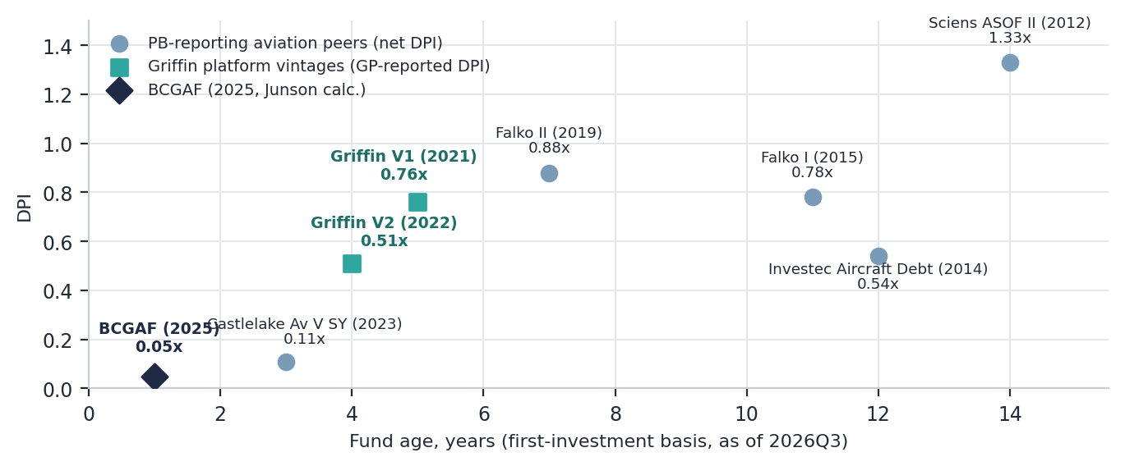
Note: Ages from first-investment year to 2026Q3 (~ approximations). Peer DPI per PitchBook (net, contributions basis, lagged); Griffin V1/V2 DPI GP-reported on gross invested capital as of 1Q26; BCGAF DPI is a Junson calculation on contributions (US$6.2M / US$127.1M, 30-Jun-26). Bases differ — see text. Source: PitchBook (dl. 14-Aug-26); Bain Capital Griffin; Junson calculations.
Deployment pace
The one genuine QoQ-capable comparison available before fund-level performance prints is deployment pace — and it cuts both ways. BCGAF has called 36.0% of commitments at age ~1, against Castlelake Aviation V Stable Yield’s 28.3% at age ~3 (per PitchBook), with the portfolio at 36% of its US$3,750M scaled target within five quarters of initial close. Fast deployment into a cycle the market section describes as normalising — supply recovering, first value declines printing in 10-year A320ceo/737NG metal — is vintage-concentration risk: the capital is being put to work fastest exactly where the fund’s two portfolio acquisitions sit. The mitigants are the GP’s 5–10% purchase-price discounts (scorecard: meeting target), the staged VietJet deliveries through 2H26, and the fact that it is simultaneously selling into the same bid at 1.40–2.95x monetisation marks — a two-sided book rather than a one-way ramp. The called-percentage series for BCGAF and the live peers starts in the ledger this quarter; pace divergence becomes a tracked QoQ item from 2026Q4.
ABS funding cost league
Funding cost is the competitive variable the market section flags on the liability side, and aviation ABS pricing is public — so this module tracks it deal by deal. The trend into the conflict was steady compression: senior lease-ABS spreads went from T+205bp at the 2024 reopening (AASET 2024-1) to +160–180bp through 2025 and +145bp by February 2026 (CLAS 2026-1), with aviation loan ABS printing the floor at +105bp AAA (PKAIR 2026-1) and Merit’s March deal achieving what bank reports called the second-lowest Class A spread in aviation ABS/CLO history. The Iran-war escalation in late February paused the lease market for ~7 weeks; Castlelake’s CLAS 2026-2 reopened it in April, and by Sky’s SLAM 2026-1 — the eighth aviation lease ABS of 2026 and third post-conflict — five-month issuance was running roughly double 2025’s pace (per Ishka). For the Fund specifically: Griffin’s inaugural Master Trust series (Nov-25, US$1,245M) was the largest aircraft ABS ever issued, and its measurable efficiency is in the advance rate — a 77.6% senior LTV at single-A versus 69–75% on the discrete-trust peers — paired with 14-year mortgage-style amortisation that matches aircraft depreciation. The June 2026 US$568M second series, which carries the Fund’s Q1-acquired aircraft, priced with spreads tightening versus the inaugural per Ishka’s report; the exact level is not yet publicly disclosed and populates from the presale next quarter. The allocator read: cheap senior funding is available to every scaled platform (Castlelake alone has raised ~US$8.6bn of ABS debt since inception, per KBRA), so market access per se is not differentiation — the edge shows in advance rate and master-trust re-issuance speed, and the same spread compression that funds the GP’s pipeline is what is compressing the new-delivery lease rate factors on the asset side.
Exhibit 19: Aviation ABS new-issue funding costs — senior tranches, 2024–2026 YTD
Deal | Sponsor / platform | Priced | Size (US$m) | Senior class (rating) | Coupon | Spread | Snr LTV
AASET 2024-1 | Carlyle Aviation | 2024 | 749 | A-1/A-2 (A) | 6.26% | T+205 | 65–69%
AASET 2025-1 | Carlyle Aviation | Feb-25 | 518 | A (A) | 5.943% | T+170 | 69%
SLAM 2025-1 | Sky Leasing | 2025 | 503 | A | 5.807% | T+180 | 73%
AASET 2025-2 | Carlyle (master trust) | Jun-25 | 526 | A-2 (A) | 5.522% | T+160 | 69%
GGAM 2025-1 | Griffin (master trust, inaugural) | Nov-25 | 1,245 | A US$1,120 (Fitch A) | n.d. | n.d. | 77.6%
CLAS 2026-1 | Castlelake | Feb-26 | 843 | A (A, KBRA/Fitch) | 5.073% | T+145 | 72%
PKAIR 2026-1 (loan) | PK AirFinance | Feb-26 | 832 | A (AAA) | 4.614% | T+105 | n/m
MERIT 2026-1 (loan) | Merit AirFinance | Mar-26 | 817 | A (AAA) | 4.852% | n.d.* | n/m
CLAS 2026-2 | Castlelake | Apr-26 | 888 | A/B (KBRA) | n.d. | n.d. | —
GGAM series 2 | Griffin (master trust; incl. Fund aircraft) | Jun-26 | 568 | — | n.d. | tightened† | —
AASET 2026-1 | Carlyle Aviation | Jul-26 | 717 | — | n.d. | n.d. | —
SLAM 2026-1 | Sky Leasing | Jul-26 | 813 | A only (A+e, KBRA) | n.d. | n.d. | 75%
Note: Lease ABS unless marked (loan); spreads to US Treasuries at pricing; AASET 2024-1 shows the A-1/A-2 range, size is both tranches; AASET 2025-2 size is A-2+B-2. *Merit’s A spread reported only as the second-lowest in aviation ABS/CLO history, per bank reports. †Per Ishka’s pricing report (26-Jun-26); exact level undisclosed — n.d. cells populate from presales/trade press next quarter. GGAM 2025-1 senior LTV per Fitch presale commentary; CLAS 2026-2 was the first lease ABS priced after the late-Feb Iran-war escalation. Source: Ishka, Aviation News, Asset Securitization Report, KBRA, Fitch, GlobalCapital; Junson compilation.
Momentum ledger — baseline
This is the first quarter recorded in the aviation competitor ledger, so — as in the Private Credit and PE reports’ inaugural runs — this module records levels rather than quarter-on-quarter change, and the series becomes genuine momentum from next quarter by appending to the ledger. With BCGAF itself not meaningful, the baseline percentile reading uses the Griffin platform vintages as proxy, on the strict-below convention (share of the reporting cohort strictly below the subject, subject excluded; TVPI cohort n=5): Vintage 2’s 1.6x net MoM baselines at the 100th percentile and Vintage 1’s 1.4x at the 80th — with the usual caveat that the GP’s gross-invested-capital MoM is not identical to PitchBook TVPI. BCGAF enters the percentile series the quarter its own fund-level metrics print; the practical trigger to watch is PitchBook back-filling its row, which today still shows a stale US$30M fund size against the actual US$353.0M. Baseline levels, peer rows and methodology are archived in av_comp_series_2026Q3.json alongside the source screen for next quarter’s delta computation.
Appendix — peer universe and methodology
The current screen holds 17 vehicles of which 5 report performance — but it is a keyword screen (“aircraft”, all investors) and therefore under-captures the true universe: Carlyle Aviation’s SASOF III–VI, Castlelake’s flagship Aviation IV/V, Sky Leasing and the transport-ABF sleeves at ITE and others typically carry no “aircraft” in the fund name (the screen’s Sciens ASOF II is the SASOF lineage’s predecessor), and PitchBook strategy tags are unreliable in this niche — Castlelake V Stable Yield, a leasing vehicle, is tagged “distressed debt” — so strategy-filter screens misfire too. An investor-based re-pull (Carlyle Aviation Partners / Castlelake / Sky Leasing / Falko / Napier Park / ITE / Bain Capital, unioned with keywords) is the planned refresh; the fund-formation-by-vintage exhibit is deferred to that re-pull, since charting the keyword sample would mislead. On fundraising competition, the visible points are Castlelake’s US$2bn raised for V Stable Yield (2023 vintage) and BCGAF’s US$353.0M raising toward a US$1bn target into an October 2026 final close. Methodology: vintages follow PitchBook’s first-investment convention throughout; percentile = share of the reporting cohort strictly below the subject, subject excluded; manager-reported and PitchBook figures are shown side by side but are not strictly comparable. The cohort-dispersion (IQR) monitor from the Private Credit report is omitted: at n=5 with vintages spanning 2012–2023 the statistic is not meaningful; it will be reinstated if the cohort is broadened to PitchBook’s transportation / asset-based benchmark universes. ABS pricing in the funding-cost league is compiled from trade press and rating-agency presales (Ishka, Aviation News, ASR, KBRA, Fitch); paywalled 2026 prints are carried as n.d. and populate next quarter. The 14-Aug-26 screen is archived as the 2026Q3 baseline snapshot.

