JUNSON Capital | Alternative Investment Division
OTF Research Report Summary — 2026Q3
Blue Owl Technology Finance Corp. | Coverage: BDCs / technology direct lending | Data to 14 Aug 2026
Verdict: OTF stabilised this quarter (NAV flat at $16.48; non-accruals of 0.6% at cost still the lowest of the six peers), but the industry's credit tail is deteriorating and the portfolio is concentrated precisely in the application-software layer where AI pressure is greatest. Holding assessed as “sound overall, continued monitoring required”: hold the position unchanged, track against the Section 4 trigger lines — no action needed until a line is breached.

OTF key metrics at a glance
Metric | Q1'26 | Q2'26 | QoQ | Notes
NAV / share | $16.49 | $16.48 | −$0.01 | Spreads stabilised; valuation gains turned positive +$0.03
NII / share & total div. coverage | $0.37 / 93% | $0.30 / 75% | ↓ | 86% coverage of the $0.35 base dividend
Net leverage | 0.85x | 0.93x | +0.08x | First quarter inside the 0.90–1.25x target range
Non-accruals (cost / FV) | 0.3% / 0.1% | 0.6% / 0.1% | +0.3pp / flat | One software preferred added (~$53mm cost)
PIK % of investment income | 13.1% | 12.5% | −0.6pp | Second straight quarterly decline; ~98% originally underwritten
Asset coverage | 226% (12/31/25) | 203% | ↓ | Statutory floor 150%; absorbs ~27% portfolio decline
Available liquidity | $2.3bn | $2.0bn | −$0.3bn | ~$2.4bn debt headroom to top of target range
Share price / P/NAV / yield (8/14) | — | $11.46 / 0.70x / 12.2% (14.0% incl. special) | — | Deepest discount of the six; specials end from Q4'26, yield resets to 12.2%
Source: OTF Q2'26 and Q1'26 10-Qs, Q2'26 earnings presentation; share price = exchange close via stockanalysis.com.
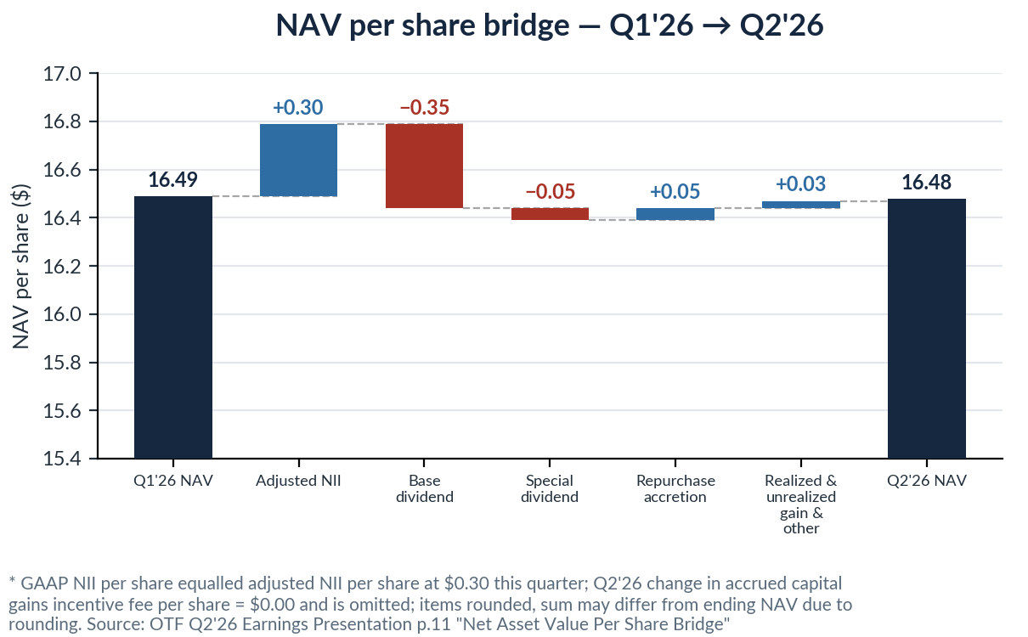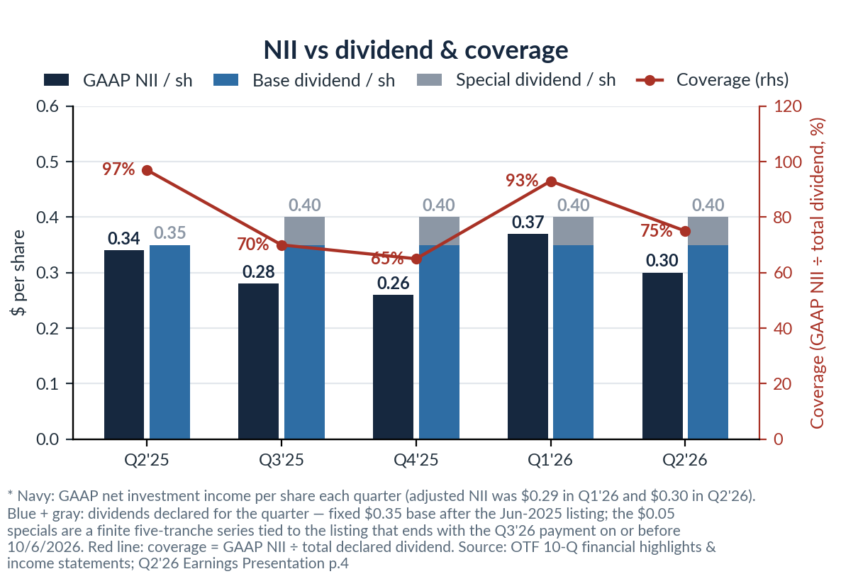
Left: NAV bridge — the $0.10 dividend gap largely refilled by $0.05 repurchase accretion, with valuation gains turning positive. Right: NII dividend-coverage trend — cash coverage of the base dividend at 86%.
1. Key News (this quarter)
- Section 36(b) excessive-fee lawsuit filed 6/18 (S.D.N.Y.): alleges advisory fees +191% over 2021–25 vs assets +134%, with fees charged on ~$43mm of PIK accruals (~25% of NII). No 36(b) plaintiff has ever prevailed — near-term economics limited, but it introduces Level-3 valuation discovery risk.
- Q2 results (8/5): NAV flat at $16.48; NII $0.30; $55mm repurchased in the quarter, ~$170mm over three quarters; shares +7.4% to $11.20 on the day. Management noted the 0.7x discount implies a ~40% portfolio default rate (at 50c recovery).
- Funding-side validation: $500mm of 6.50% Oct-2029 unsecured notes issued in June (KBRA BBB) — IG market access at mid-6% coupons despite sector-wide redemption pressure.
- Sister-fund redemption pressure stabilising but unresolved: OCIC requests 21.9%→18.8%, OTIC 40.7%→38.1%, $4.7bn combined (1Q: $5.4bn); the 5% cap was hit for a second straight quarter; Moody's cut OCIC's outlook to negative (Baa2 affirmed).
- Industry losses crystallising: Medallia handed to lenders ($5.1bn equity wiped out; prior BDC marks 74–79c); Affordable Care's $1.4bn default; KKR's $300mm injection into FS KKR sets a sponsor-backstop template.
2. Market Trend (industry data)
Industry indicator | Reading | Read-through
BDC average non-accruals (cost, MS basis) | 2.8% (five-year high) | Deterioration concentrates in the tail: BDCs >8% rose from 8% to 11%
JPM 29-BDC non-accruals (cost) | 2.46% (+40bp) | NAV −3.25% on average; 28 of 29 down
BDC index spread | 290bp → ~217bp | Back to the 2025 average +8bp; JPM credit desk overweight while its equity desk stays cautious — the debt-vs-equity split is the key live debate
Industry PIK (% total income / % net income) | 6.4% / 15.2% | Flat on gross, rising on net — dividend quality is being quietly eroded
Median software borrower leverage (vs all sectors) | 8.3x vs 7.0x | Industry stress sits exactly in OTF's core lane
USD software loans maturing by 2028 | $98bn (29%) | 50% rated ≤B−; the four houses' common catalyst is the maturity wall, not current defaults
Borrower interest coverage (Fitch median) | 1.99x (+0.10x) | Rate-cut-driven and reversible — the rate path repairing borrower coverage also erodes OTF asset yields
Source: JPM / Morgan Stanley / Goldman Sachs / BofA research, Apr–Jul 2026 (11 reports on file); Fitch, Lincoln and S&P credit-estimate samples.
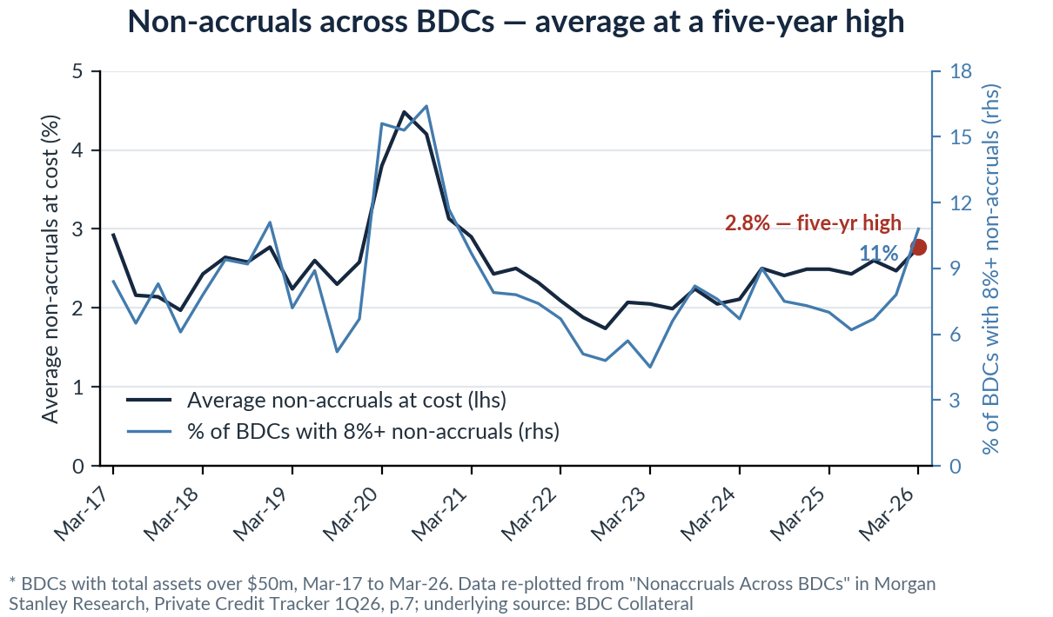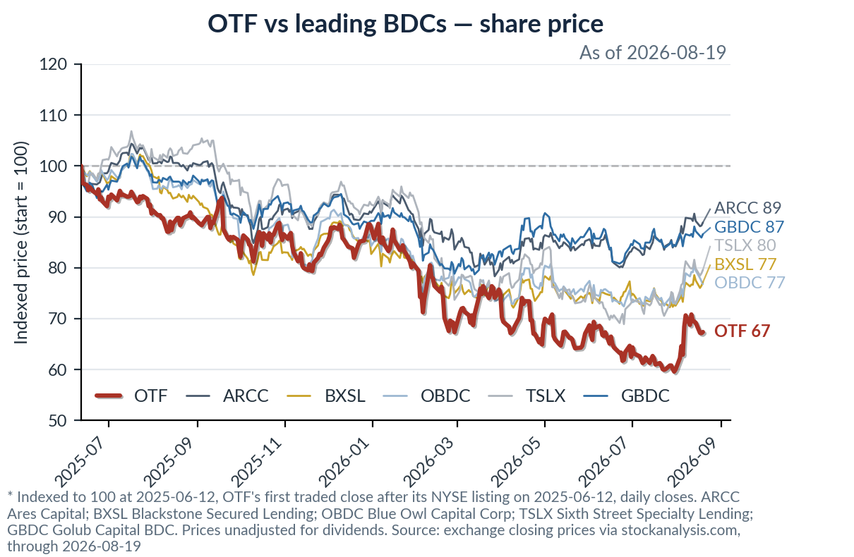
Left: BDC industry non-accruals at a five-year high, with the tail (>8% share) jumping faster than the mean. Right: share price since IPO — OTF −30.8%, worst of the BDC set and the visual source of the 0.70x discount.
3. Impact on Our Portfolio
- The transmission channel is valuation, not default: ~48% of OTF's fair value sits in the two end-markets with the heaviest credit migration (software 32.8% + healthcare tech 12.4% + healthcare services 2.9%). Industry software spread widening reprices OTF's Level-3 marks and the equity discount first — last quarter's $0.84 NAV write-down was spread-driven, and partially recovered this quarter (+$0.03).
- OTF's own data remains the counter-evidence: weighted borrower EBITDA of $291mm (+2.1% QoQ, +15.9% YoY) is still growing; PIK is down two straight quarters; non-accruals at fair value are 0.1%, an order of magnitude below the 2.8% industry average. But $38.7mm of the EBITDA gain came from pre-4Q25 consolidation effects — only +$1.2mm over the last two quarters: growth is slowing, not yet falling.
- Three changes worth noting: net leverage entered the target range for the first time (0.93x; incremental leverage now billed at the lower 1.00% management-fee tier); base-dividend cash coverage is only 86%, so the payout rests on rising leverage; specials end from Q4'26, resetting the yield from 14.0% to 12.2% (9.7% → 8.5% on NAV), which may trigger rotation by income holders.
Six-BDC peer comparison (Q2'26)
Metric | OTF | ARCC | BXSL | OBDC | TSLX | GBDC
P/NAV (8/14) | 0.70x | 1.03x | 0.97x | 0.82x | 1.16x | 0.93x
NAV change | Flat QoQ | −1.2% QoQ | −5.2% 1H | −3.7% 1H | −4.4% 1H | −4.8% FYTD
Non-accruals (cost) | 0.6% | 2.4% | 3.6% | 2.8% | 1.9% | 2.9%
PIK % of TII | 12.5% ↓ | 15.8% | 6.6% | 10.7% | — | 8.6% ↑
Dividend action this quarter | No cut | No cut | JPM forecasts cut | Cut −16% | Cut −9% | Cut −15%
Each company's Q2'26 10-Q; BXSL / OBDC / TSLX / GBDC disclose semi-annual or FYTD NAV comparisons. OTF software exposure of 32.8% (GICS) is the highest of the six, vs ARCC 22.0%, BXSL 18.9%, OBDC ~18%; TSLX does not break out software. OBDC dividend $0.37→$0.31 (plus $0.02 supplemental), TSLX $0.46→$0.42, GBDC $0.39→$0.33.
4. Our Position: Assessment, Watch List & Action
- Overall assessment: sound, monitoring required. Credit (non-accruals, PIK direction, borrower earnings) is the best of the six; valuation shows the deepest discount at 0.70x, with sell-side targets of $11.50–17.00 (consensus ~$13.6, flat to +47% vs spot); the risks are application-software concentration (the application layer is roughly half of portfolio fair value) and the 36(b) lawsuit — both “watch items”, not “action items”.
Watch list (next-quarter checks and trigger lines)
Item | Current | Trigger / timing | Action if triggered
Non-accruals (cost) | 0.6% | > 2% | Re-table the position at IC
P/NAV | 0.70x | < 0.60x | Re-table at IC (two-way: add / exit)
Base-dividend cash coverage (GAAP NII) | 86% | < 80%, or two consecutive declining quarters | Review dividend sustainability
Non-traded funds' 3Q redemption requests | 2Q $4.7bn (receding) | Early-Oct disclosure | If rebounding, watch funding-cost pass-through
36(b) lawsuit | Filed 6/18 | Motion to dismiss / discovery | If discovery begins, assess Level-3 disclosure risk
Q3 supplemental dividend decision | Specials end 10/6; spillover $0.32/sh | Early Nov, with Q3 results | Either way a management signal; fold into next summary

Action: hold, no change. The 0.70x discount is the market pre-pricing application-software concentration, not a signal of OTF-specific credit deterioration — its non-accruals, PIK direction and borrower earnings all beat peers. If the discount widens below 0.60x or non-accruals breach 2%, take the position back to IC.

