JUNSON Capital | Alternative Investment Division
US Private Equity Research Summary — 2026Q3
Conclusion: all three legs weakened together this quarter — deployment (-37.5% QoQ), exits (-46.3% QoQ) and fundraising (extreme concentration at the top) — and the through-line is liquidity: until distributions resume, neither fundraising nor new deployment recovers. Dispersion matters more than the aggregate: the middle market outperforms on all four dimensions (deal share, entry multiples, rolling IRR, exits), while AI has turned software into PE's least-wanted sector (-65.7%) and energy into the lone bright spot (+80.5%). We view 2026 as a selectively attractive commitment vintage (falling multiples, thinner competition) — but only with managers who can show realized DPI. On the holding, GPS V printed a markdown quarter (net IRR 10.7%→7.6%) while DPI of 0.4x still leads peers (71st percentile); no red flags — assessed as 'hold, watch the marks'.
Key market indicators at a glance (2026Q2)
Indicator | Reading | Context | Direction
Quarterly deal value | US$177.3bn (-37.5% QoQ, -23.9% YoY) | Count flat at 2,384 — the pullback is concentrated in larger deals | ↓
Quarterly exit value | US$102.6bn (-46.3% QoQ) / 353 exits | Deals-to-exits 1.41 (1.35 in 2025) — inventory still building | ↓
Fundraising (YTD) | US$159.6bn / 223 funds | Sub-US$1bn funds drew just 16.7% of commitments | ↓
Dry powder | US$1,067bn (≈0.9 yrs of runway) | Megafunds hold ~US$485bn; low end of the decade | Flat
Entry multiples | US PE EV/EBITDA 12.5x (2025) | MM (NA & Europe) 10.4x YTD, 1–2 turns below the 2024 peak | ↓
Rolling 1-yr IRR | MM 8.7% / US PE 7.2% / megafunds 5.7% | Europe: 7.8% / 1.4% / -2.6% | ↓
Deal/exit/fundraising data as of 30 Jun 2026; middle market as of 31 Mar 2026; dry powder and IRR as of 30 Sep 2025 (performance lags ~3 quarters). Source: PitchBook; Junson calculations.
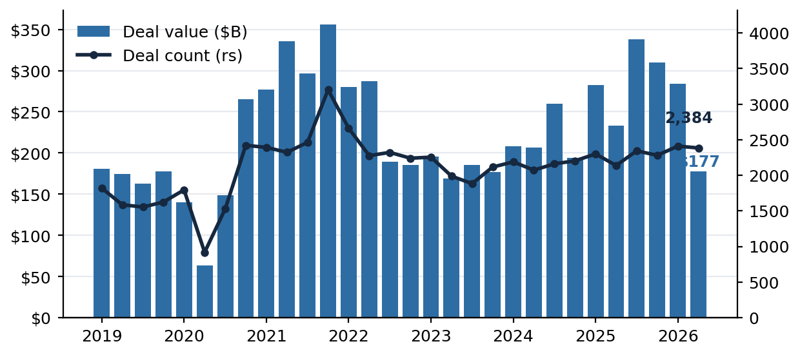 | 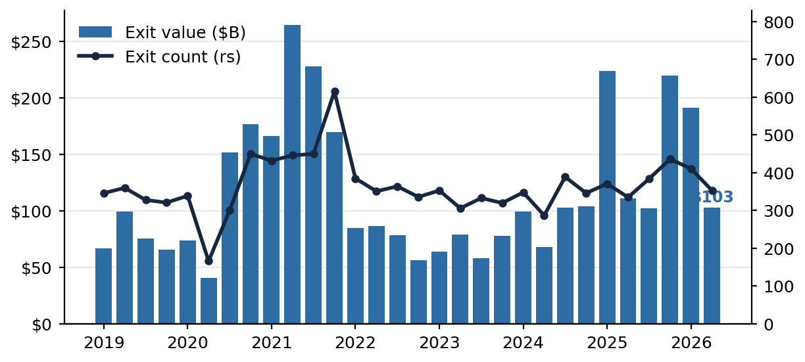
Left: US PE quarterly deal value and count — Q2 US$177.3bn, -37.5% QoQ, count flat at 2,384. Right: quarterly exit value and count — US$102.6bn, -46.3% QoQ, 353 exits. (Source: PitchBook; as of 30 Jun 2026)
1. Key News
• AI is repricing PE's sector map both ways: software deal value collapsed to an estimated US$10.7bn (-65.7% YoY, -90.3% vs peak) while energy is +80.5% YTD, the only major sector growing in both count and value; GPs heavy in 2020–22 software cohorts face mark risk plus extended holds.
• PE is ceding M&A share: buyout/LBO fell to 27.1% of global M&A (41.2% in 2025, a 14.1pp drop, lowest since 2016); strategic buyers filled the space — US US$100m+ deal value +88% YoY.
• The exit drought deepened, held up by mega-exits: US$1bn+ exits anchor 60%+ of quarterly value; the listing window reopened (US$27.6bn, 12 IPOs) but narrowly, and not for the middle market (MM IPO proceeds: zero); 13,509 companies in inventory, 29% held 6+ years, GP-led secondaries at US$23bn run below last year's pace.
• Fundraising clears only at the top: average fund closed ~US$753m vs a ~US$75m median (a 10x gap); evergreen PE assets nearly doubled to US$99bn; median step-ups compressed to 1.44x — the LP negotiating window is in the sub-US$1bn cohort.
• The middle market outperforms across the board: ~40% of buyout value, multiples 1–2 turns below peak, 8.7% rolling IRR leads all segments, exits +13.9% YoY — a trans-Atlantic pattern (Europe MM 7.8%) supporting an MM tilt in fund selection.
2. Market Trend
Indicator | Reading | Interpretation
Global M&A | H1 US$2,710.7bn; Q2 US$1,306.2bn (+35.3% YoY) | The market didn't shrink — the sponsor share did: LBO share 27.1%, lowest since 2016
US PE deal value | H1 US$461.0bn; Q2 US$177.3bn (-37.5% QoQ) | Add-ons are 75.2% of buyout count — transacting in the middle, top end waiting
Exits | Q2 US$102.6bn (-46.3% QoQ, -7.4% YoY) | Deals-to-exits 1.41: inventory added faster than cleared; DPI is the honest measure
Fundraising | YTD US$159.6bn / 223 funds | On pace with 2025 (US$308.0bn) but flowing overwhelmingly to the largest managers
Dry powder | US$1,067bn / ≈0.9 yrs runway | Low end of the decade — deployment pressure persists; entry-price discipline differentiates
Middle market | ~40% of buyout value; 8.7% IRR; 73% of Q1 fundraising | Outperforms on all four dimensions; the 73% share normalises as megafund closes land

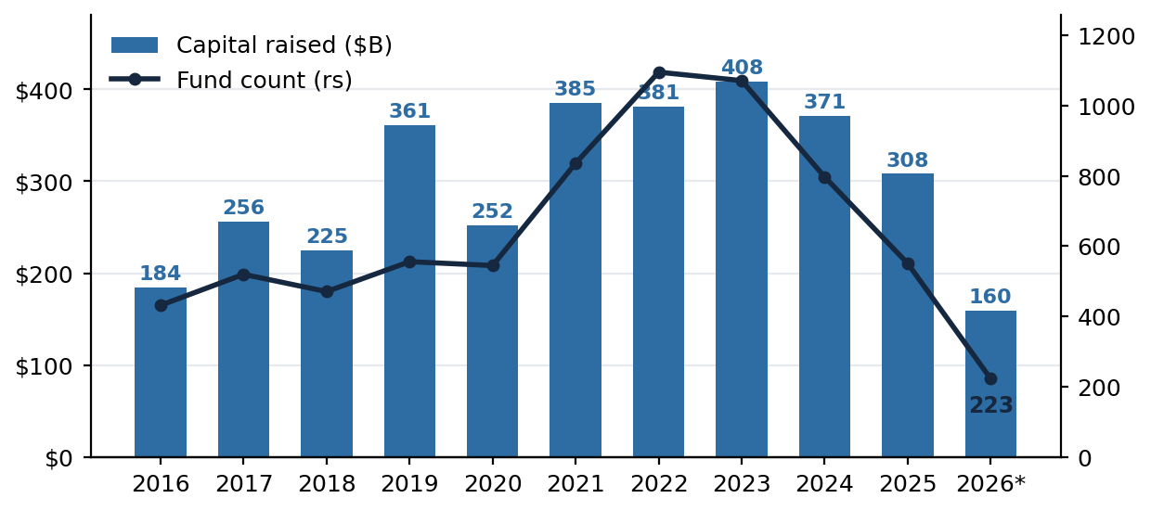 | 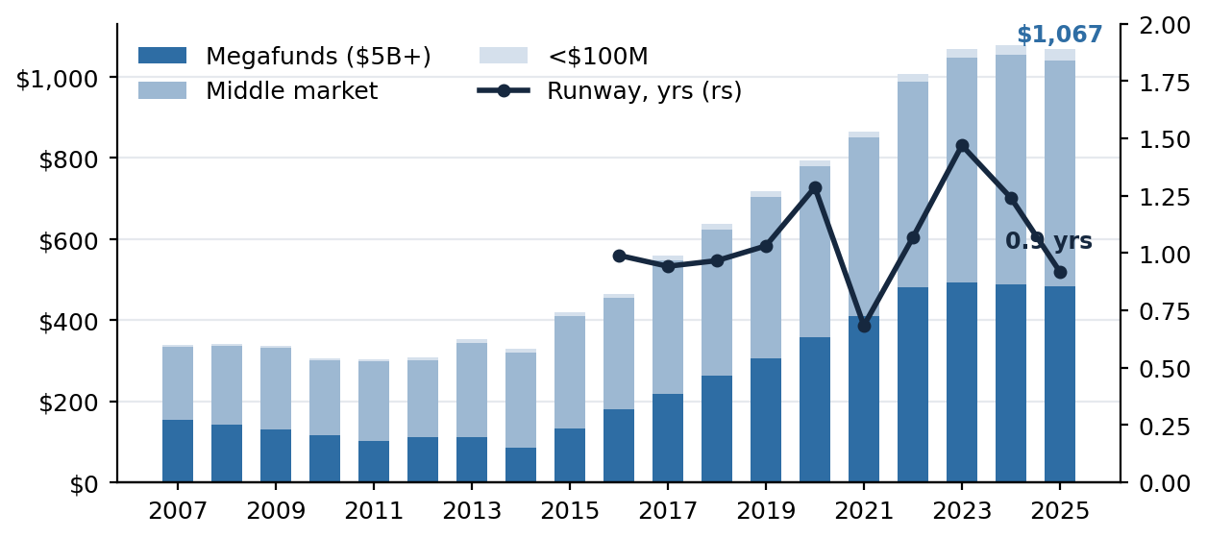
Left: US PE fundraising — on pace with 2025, concentrated at the top. Right: dry powder US$1,067bn with ≈0.9 years of runway at the 2025 pace (right scale), the low end of the decade. (Source: PitchBook; fundraising as of 30 Jun 2026, dry powder as of 30 Sep 2025)
3. Impact on Our Portfolio (GP stakes)
• The fee stream — the largest value component — is secure: fundraising concentration toward large platforms favours GPS V's book (top-5 managers ~80% of holding value) — Veritas IX's US$15.3bn and GP Stakes VI's US$8.9bn closes are the evidence; but fundraising failure is the sharpest markdown trigger — MBK's -14.2% this quarter was fundraising-driven.
• Carry is deferred and distributions are engineered: in the exit drought only 8.2% of GPS V's gross distributions are sale proceeds while 36.2% come from securitization; the offset is that longer holds extend the fee-collection period — the strategy's built-in hedge.
• Marks are volatile but mostly systematic: listed alt-manager prices transmit instantly — CVC's -19.2% quarter alone took ~2 points off the portfolio; combined with single-digit industry rolling IRRs, the 10.7%→7.6% net IRR decline is an industry pattern rather than GPS V-specific; DPI flat at 0.4x confirms a markdown story, not a distribution story.
4. Our Position: GPS V, benchmark and actions
Fund (effective vintage) | Net IRR | TVPI | DPI | Peer percentile | Comment | Action
Blue Owl GPS V (2020–21) | 7.6% (excl. facility 7.1%) | 1.1x | 0.4x | IRR P17 / TVPI P33 / DPI P71 | Markdown quarter: CVC listed price, MBK fundamentals; DPI at top quartile of the 2021 cohort, but 36.2% of distributions securitization-engineered | Hold · watch the marks: verify MBK and CVC next quarter; track repeatability of Lead Edge-style premium realizations
HPC Fund I (2021) ※benchmark | 16.6%* (pro forma 11.8%) | 1.2x | 0.2x | IRR P50 / TVPI P50 / DPI P14 | Still deploying, young marks rising; SLR the problem position; Pretium policy markdown | Competitor benchmark (not held): watch Fund II first close (exp. Mar 2026) and the policy-risk channel
*Inflated by the subscription line (pro forma 11.8% is the like-for-like figure). Percentiles vs the PitchBook-reporting GP-stakes cohort (n=6–7, subject excluded); GPS V as of 31 Mar 2026, HPC as of 31 Dec 2025. Portfolio-level actions: treat 2026 as a selective commitment vintage — tilt toward middle-market buyout and energy/industrial exposure, stress-test software-heavy GPs' 2020–22 cohorts, require realized DPI; evaluate GP-led/continuation opportunities (29% of inventory held 6+ years plus below-pace GP-led volume = widening LP-stake discounts).
Watch List (items and signals for next quarter)
Item | Current | Signal / timing | Why it matters
Quarterly exit value | US$102.6bn | >US$200bn for two consecutive quarters | The primary signal of liquidity turning and carry recovering
Deals-to-exits ratio | 1.41 | <1.25 | Inventory genuinely clearing; distributions recovering in substance
Sub-US$1bn share of fundraising | 16.7% | >25% | Breadth returning; emerging managers recovering
Software share of US PE deal value | Our call: <15% | Verify quarterly through 2026 | Whether the AI repricing has bottomed; mark risk for software-heavy GPs
GPS V next letter | Net IRR 7.6% / DPI 0.4x | 2Q26 letter (expected Nov) | Does MBK fall further, does CVC recover; GP Stakes VI close progress

