JUNSON Capital Research
Royalty Investing 101: An Asset-Class Primer (2026Q4)
Coverage: royalties / music / pharmaceuticals / US natural gas / evergreen structures 26 Oct, 2026
Summary
· A royalty is a claim on revenue, not on profit — and not equity. The investor pays upfront for a contractual right to a fixed percentage of an asset’s revenue; opex, capex and cost inflation stay with the operator. The result is exposure to price and volume with none of the margin risk — which is why royalties have historically hedged inflation.
· A ~USD 2tn market, institutionalizing fast. Established sectors: pharma ~USD 185bn, green metals ~USD 260bn, US natural gas ~USD 140bn, music ~USD 70bn; emerging: brands, carbon offsets, sports. Fund product has moved from closed-end specialists to evergreen platforms.
· Between private credit and private equity — until bankruptcy. Typical market gross returns of 10-14%, vs 8-12% for private credit and 18-22% for buyouts; cash-yielding from day one, upside geared to the asset, downside structurable like credit. In insolvency, however, position depends entirely on legal form: a property interest survives the operator; a contractual claim ranks unsecured.
· Self-liquidating cash flows make exit optional — and evergreen natural. Royalties can be underwritten on a hold-for-life basis; the four exit routes (run-off, secondary sale, operator buy-back, securitization/portfolio sale) are upside, not requirement. The same feature supplies the internal liquidity, J-curve-free entry and data-anchored NAVs that semi-liquid structures need.
· Risk lives in three places, none of them a payment waterfall: revenue sustainability (volume/price), operator going-concern, and contract legal strength. Sector-specific expressions: streaming royalty rates and catalog decay (music), patent cliffs (pharma), commodity price (gas).
· The investable universe is a 2×2 of sector focus × structure. PG Diversified Royalties (multi-sector evergreen; 8.9% annualized net since Q4 2020), HCRx (pharma evergreen; 12.6% net in 2025), Primary Wave and HarbourView (music closed-end). Liquidity mechanics — monthly NAV vs a four-yearly run-off option vs GP-led secondary sales — differ more than the headline labels suggest.
What is a Royalty
A contractual claim on revenue, senior to every cost line
In its simplest form, a royalty investor pays an upfront amount to the owner or operator of a revenue-generating asset in exchange for the contractual right to receive a percentage of that asset’s revenue. Qualifying assets are rights to intellectual property — drug patents, music copyrights, brand trademarks — and exclusive rights over natural resources such as gas or minerals. Payments are scheduled monthly or quarterly, the payor is required to deliver regular sales reports, and contracts typically carry periodic audit rights. An investor can either buy a royalty that already exists, or create one — a "synthetic royalty" — by providing capital to an operator in exchange for a share of the revenue the asset generates.
Exhibit 1: How a royalty is acquired — buy existing vs create synthetic
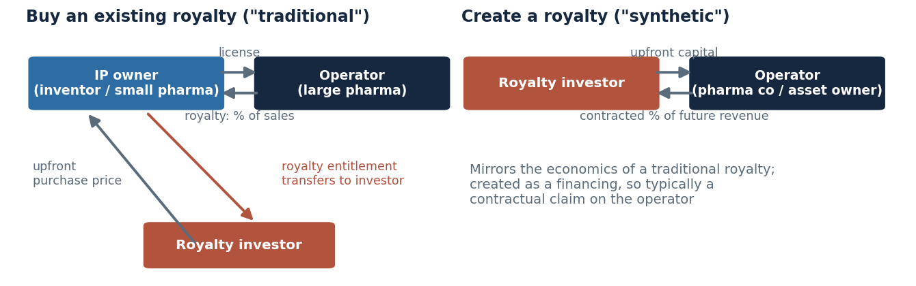
Source: Partners Group; Junson schematic.
The defining feature is where the claim sits. The royalty is carved out of revenue before any cost line: the investor is not responsible for funding opex or capex and is therefore insensitive to cost inflation and profit margins. Exposure is to revenue drivers — price and volume — only. This is also the inflation-hedge mechanism: payments rise with price while cost inflation is absorbed entirely by the operator. Exhibit 1 makes the point with numbers: in the inflation scenario, revenue +20% lifts the royalty by exactly 20%, while the operator’s profit is flat because costs rose faster.
Exhibit 2: Where the royalty sits — illustrative operator cash flow, 2% gross revenue royalty
Line | Base case | Inflation case (+20% price, +33% costs) | Who bears it
Asset revenue | 100.0 | 120.0 | Driver of royalty
Royalty payment (2% of revenue) | (2.0) | (2.4) ↑ +20% | Paid to royalty investor, first
Operating costs + capex | (60.0) | (80.0) | Operator
Operator profit | 38.0 | 37.6 → flat | Operator (and its lenders / equity)
Note: Illustrative figures for exposition only. Source: Junson AID.
Between private credit and private equity — until bankruptcy
The structured nature of royalty contracts gives clarity and control over payment terms and durations, akin to private credit; unlike credit, royalties also carry upside geared to the underlying asset’s performance. This places the risk-return profile between private credit and private equity. Royalties are cash-yielding from day one, which builds MOIC through the holding period; where the IP is long-lived (music) or the right is a sub-surface ownership, yield is complemented by potential long-term NAV accretion.
Exhibit 3: Asset-class comparison — private equity vs royalties vs private credit
 | Private equity | Private markets royalties | Private credit
Investment horizon | 4-6 years | Long term, >10 years | 3-4 years
Investor exposure | Profit | Revenue | Interest + amortization
Return generation | Capital appreciation and exits | Share of an asset’s revenue stream | Interest and capital repayments
Upside gearing | Yes | Yes — asset outperformance and/or an exit, like equity | Limited
Downside mitigation | No | Can be structured in, like credit | Yes
Reliance on exit | High | Hold-for-life underwriting possible; self-liquidating | Low
Cash distributions | Limited | Yes (producing assets) | Yes
Typical gross returns | 18-22% | 10-14% | 8-12%
Note: Typical market gross returns; forward-looking, market-wide assumptions. Source: Partners Group.
The comparison above describes normal operation. In stress, position depends on something the marketing materials rarely dwell on: legal form. Where the royalty constitutes a property interest attached to the asset — US mineral rights are real property ownership of the sub-surface — the claim travels with the asset through an operator insolvency or change of control. Where the royalty is only a contractual claim against the operator (the case for many pharma and media royalties), the investor ranks as an unsecured creditor and the contract can be compromised in a restructuring. Two instruments with identical economics in good times can therefore sit at opposite ends of the capital structure in bad times. The instrument mix is DD question ② in the fund section.
Exhibit 4: Typical cash flow and TVPI profiles across asset classes
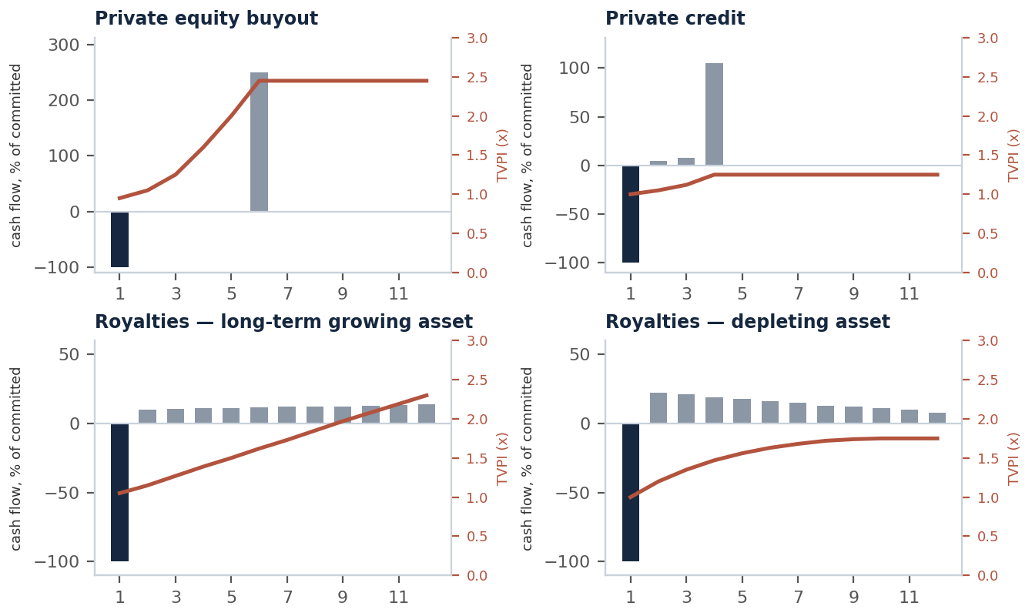
Note: Stylized; bar and line values approximate; TVPI includes residual NAV. Source: Partners Group; Junson redraw.
Exhibit 5: Risk-return positioning across asset classes (schematic)
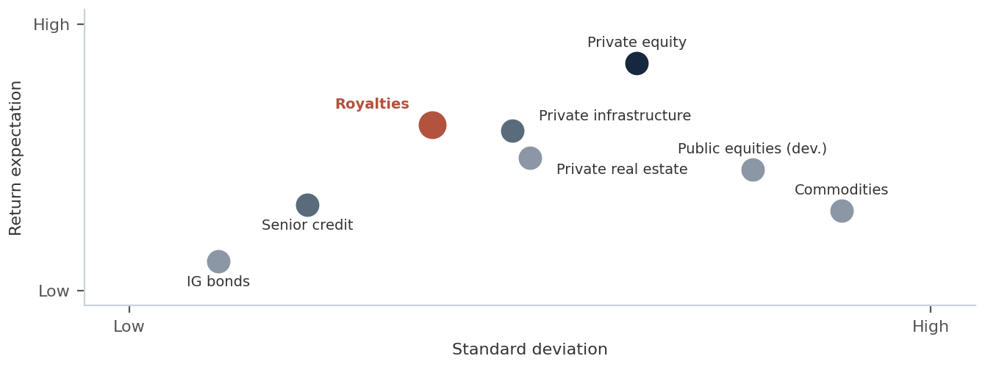
Note: Relative positions only; no numeric axes. Source: Partners Group; Junson redraw.
Terminology: not everything called a royalty is the same
Exhibit 6: Royalty instrument glossary
Instrument | What it is | Cost exposure / legal strength | Source
GRR (gross revenue royalty) | Fixed % of gross revenue | No cost exposure; strength depends on documentation | Partners Group
Fee minerals (US oil & gas) | Perpetual ownership of sub-surface rights; leased to operators for an upfront lease bonus plus a 12.5-25% royalty on production | No cost liability; real property — strongest form | Partners Group
ORRI (overriding royalty interest) | % of production tied to a specific lease | No cost liability; expires with the underlying lease | Partners Group
NPI (net profits interest) | % of profits from a well / lease | Burdened by proportional share of capital and operating costs — economically closer to equity | Partners Group
NSR (net smelter return, mining) | % of smelter proceeds net of transport / refining charges | Minor cost netting; no opex / capex exposure | Industry convention (Junson AID)
Stream (metals) | Upfront payment for the right to purchase future physical output at a fixed low price | Not a revenue %; a purchase contract — different insolvency treatment by jurisdiction | Industry convention (Junson AID)
Synthetic royalty | Capital provided to an operator in exchange for a share of future revenue; mirrors a traditional royalty | As contracted; a financing, so typically a contractual claim | Partners Group
Royalty-backed note (RBN) | Debt instrument secured on a royalty / IP cash flow stream (e.g. PG’s South Park RBN) | Credit instrument with royalty collateral | Partners Group
Note: Names are used loosely in GP materials; the economic and legal differences above are the substance. Source: as per final column.
Taxonomy and Market Size
A ~USD 2 trillion opportunity set — on the GP’s own estimates
Partners Group estimates the global royalties market at over USD 2 trillion, compiled from various industry resources. The number should be read as a GP’s market-sizing of everything royalty-like, not an investable float; per-sector figures below carry their own sources and the same caveat. What the sizing does establish is breadth: four established sectors with functioning transaction markets, and a tail of emerging sectors where institutional capital is only starting to arrive.
Exhibit 7: Royalty sector market sizes (GP estimates)
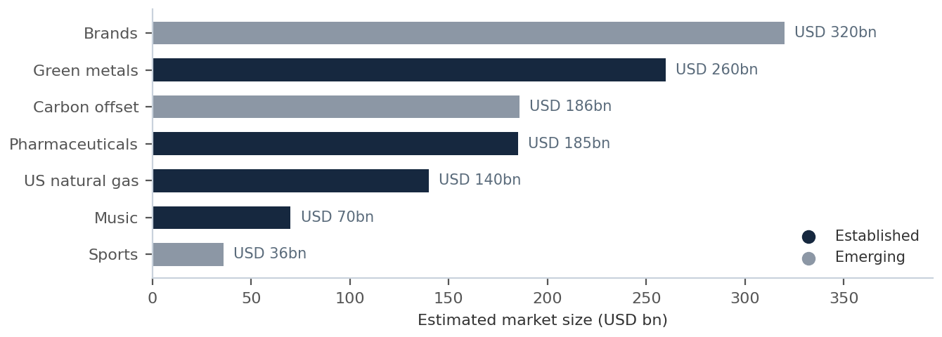
Note: GP estimates of total market value; per-sector detail in Exhibit 8. Source: Partners Group; Junson redraw.
Exhibit 8: Sector map and market size
Sector | Est. size | Status | Underlying right | Size source
Pharmaceuticals | USD 185bn | Established | Drug IP license royalties | Partners Group estimate
Green metals | USD 260bn | Established | Royalty interests over mines producing metals for renewables | Partners Group estimate
US natural gas | USD 140bn | Established | Privately owned mineral rights | Kimbell Royalty Partners, via Partners Group
Music | USD 70bn | Established | Masters and compositional copyrights | Partners Group estimate
Brands | USD 320bn | Emerging | Trademark / licensing royalties | Partners Group estimate
Carbon offset | USD 186bn | Emerging | Interests in carbon credits | MSCI Trove, via Partners Group
Sports | USD 36bn | Emerging | Media / licensing revenue shares | Deloitte / PwC, via Partners Group
Other | n/a | Emerging | Agriculture, video gaming, water entitlements | Partners Group
Note: All figures are GP estimates of total market value, not investable fund capacity; size sources as per final column.
The cut that matters more than sector labels: what drives the revenue
For underwriting, the more useful taxonomy is the revenue driver, because it determines duration, exit dependence and the right valuation anchor. Three families cover the asset class:
Exhibit 9: Revenue-driver typology
Family | Sectors | Duration profile | Return shape | Valuation anchor | Exit dependence
Declining annuity | Pharma (post-approval) | 10-15 years to patent expiry | High cash yield, amortizing; like an IO strip | DCF of prescription-data forecast | None — fully self-liquidating
Perpetual / growing | Music; fee minerals | Life + 70 years (music, US); perpetual (fee minerals) | Yield + NAV accretion | Multiple of NPS / cash flow | Partial — terminal value needs a buyer or a structure that can hold
Commodity-linked | Natural gas; green metals | Mine / reservoir life — decades | Yield, volatile with spot price | Volume forecast × price deck; price leg hedgeable | Low — depletion is the exit
Note: Durations per Partners Group materials. Framework: Junson AID.
Sector Deep Dives
Music: the most institutionalized royalty market
Music gets the longest treatment here not because it is the largest market — on PG’s own sizing it is the smallest of the four established sectors — but because it is the most institutionalized: rights are fully assignable, income data arrives monthly, the specialist GP population is the deepest, and it is where allocator deal flow actually shows up. Every song carries two separate copyrights: the masters (the specific recording, controlled by artists and record labels) and the composition (notes, melodies, lyrics — controlled by songwriters and publishers). One composition can sit under many recordings. The two copyrights earn from the same four income types in different mixes:
Exhibit 10: Two copyrights per song — ownership and indicative income mix
 | Masters (recording) | Compositional (publishing)
What it covers | The specific recording of the song | Notes, melodies, harmonies and lyrics
Typical owners | Artist; record label | Songwriter; music publisher
Note: Income mix by type shown in Exhibit 11. Source: Partners Group; HarbourView.
Exhibit 11: Masters vs compositional — indicative income mix by type
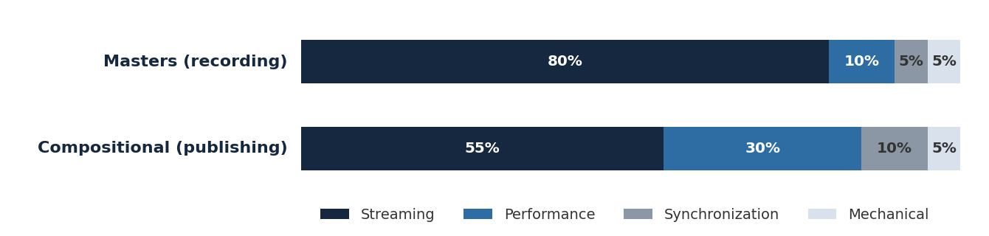
Note: Indicative only; every copyright earns differently. Source: Partners Group; Junson redraw.
Follow the dollar through a stream. Of a USD 10 consumer payment to a streaming platform, the platform retains ~USD 3.5; ~USD 5.2 flows to the recording side, of which the label keeps ~USD 3.9 and the artist receives ~USD 1.3; and ~USD 1.3 flows to the publishing side, split roughly evenly between publisher and songwriter at ~USD 0.65 each. Administrators — labels, publishers and performance rights organizations — collect, take their contractual cut, and pass the remainder to the rightsholder: the Net Publisher’s Share (NPS), which is the cash flow a royalty investor actually buys and the unit in which catalogs are priced. A portion of US publishing income is set by statutory rates rather than free negotiation — a regulatory lever that sits directly on the revenue line.
Exhibit 12: Follow the dollar — distribution of a USD 10 streaming payment
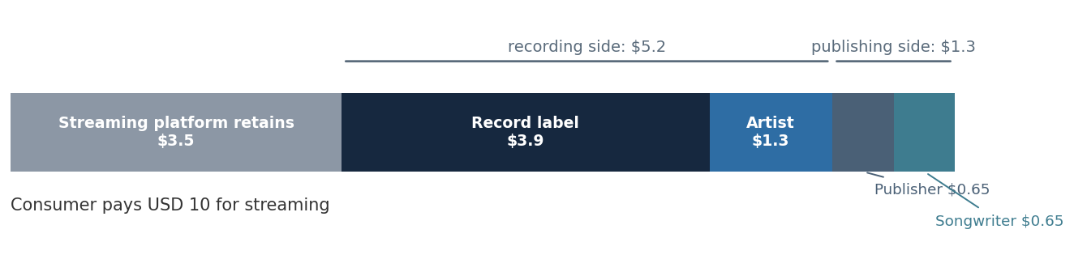
Note: Simplified illustration. Source: Partners Group; Junson redraw.
Exhibit 13: The regulatory lever — US statutory mechanical royalty rate on streaming
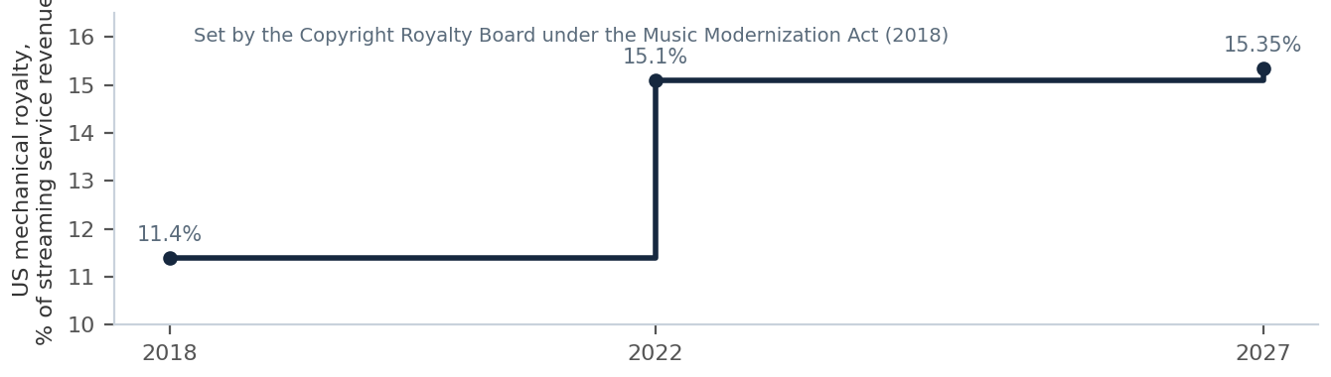
Note: US statutory rates set by the Copyright Royalty Board under the Music Modernization Act. Source: Primary Wave; Junson redraw.
Market. Global recorded music has grown at ~10% CAGR over the last five years to ~USD 29bn in 2023, with a forecast of ~8% CAGR to ~USD 50bn by 2030, driven by streaming adoption and pricing. Streaming revenue alone is expected to reach ~USD 40bn by 2030; music publishing was a ~USD 6bn (net) market as of 2020, and HVEP’s estimate of the total music industry across recorded, publishing, live and adjacent services is ~USD 95bn. Royalty income has shown low correlation to consumer spending and financial markets and has tracked inflation, including through the pandemic.
Exhibit 14: Music industry revenue, 1999-2030E — piracy, inflection, streaming
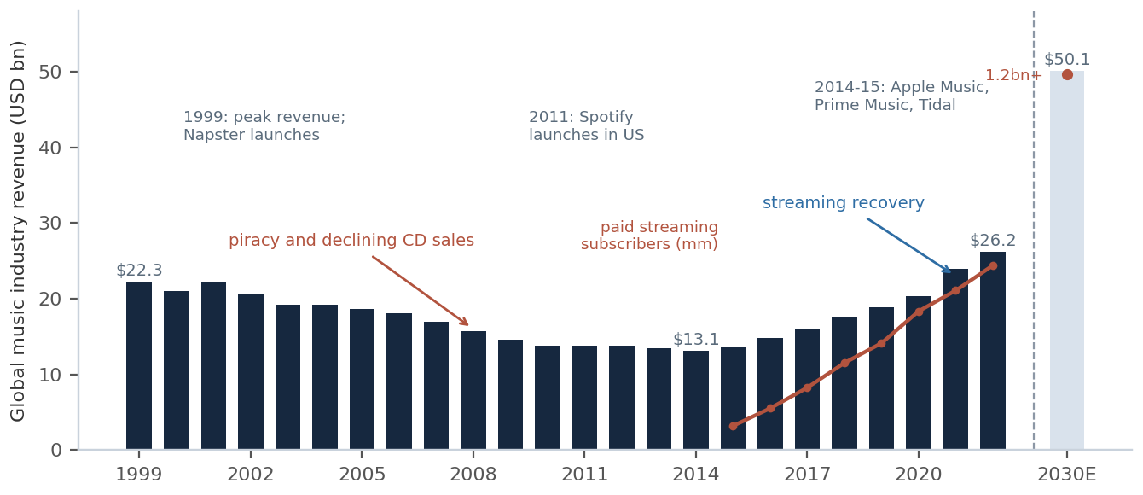
Note: Red line: estimated global paid streaming subscribers (mm). Source: Primary Wave; Junson redraw.
Exhibit 15: Global recorded music by format, 2018-2030F
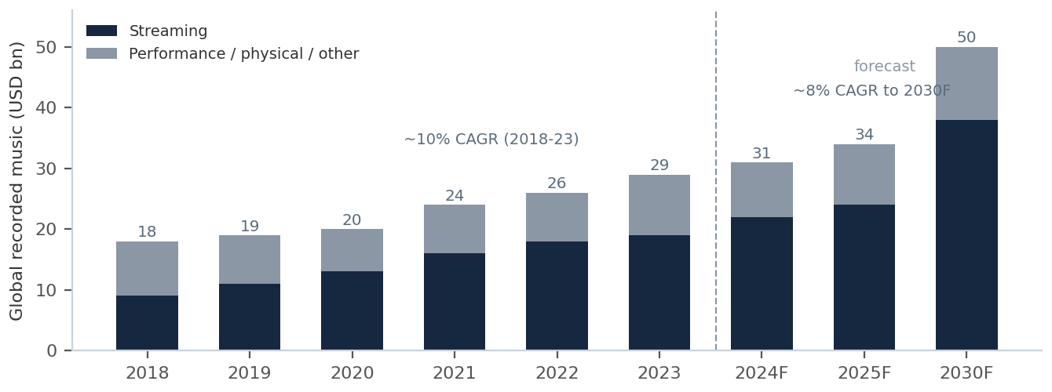
Note: Non-streaming = total less streaming. Source: Partners Group; Junson redraw.
Exhibit 16: Low correlation — recorded music vs equities and consumer spending (yoy growth)
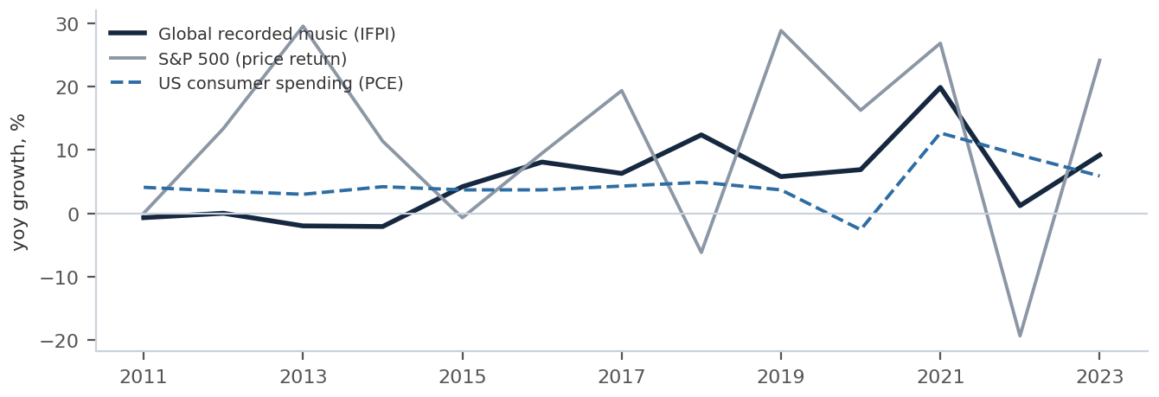
Note: Reconstructed by Junson from the public series underlying the original chart. Source: Partners Group; Junson calculations.
Duration and valuation. US copyright runs for the life of the (last surviving) artist plus 70 years (minimum 50 years by jurisdiction) — the perpetual-growing family of Exhibit 9. Catalogs trade at multiples of NPS; transaction multiples for publishing catalogs have risen over the last decade, and HVEP sizes its pipeline using a standardized 15x multiple on annual revenue — a useful rough anchor for where the market clears, and a sensitivity every music-fund underwriting should run both ways.
Exhibit 17: Publishing catalog transaction multiples, 2008-2020
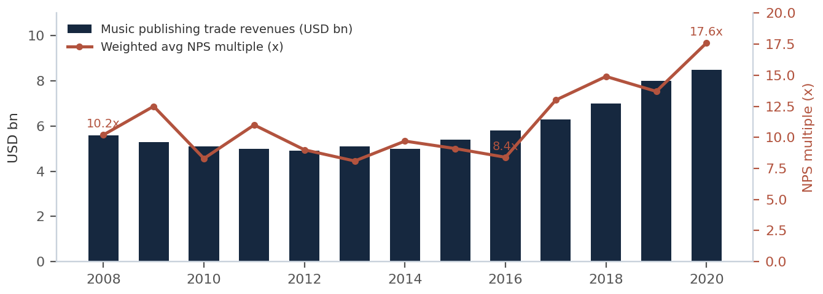
Note: Public and private transactions; deals under USD 5mm excluded. Source: HarbourView; Junson redraw.
Underwriting. Catalog acquisitions are underwritten by forecasting royalties with decay curves — observed consumption patterns by genre and income type — overlaid with market growth. Mature catalogs are predictable; the idiosyncratic risk is the artist: conduct issues can see songs temporarily pulled from streaming platforms. PG’s stated discipline — seasoned catalogs only, zero value to unreleased music, artists in good standing — is the passive end of the strategy spectrum. The active end is Primary Wave, whose model is to buy iconic catalogs and market them to lift NPS: catalogs held in Fund 1 had achieved 92% cumulative NPS growth since purchase as of 2024 (Fund 2: 76%; Fund 3: 41%). HarbourView sits on a data/sourcing axis: ~28,100 songs accumulated since 2021 and a proprietary ingestion platform ("HITS") driving underwriting. The strategy choice matters for DD because it determines what the return actually is: beta to streaming growth, or alpha from marketing execution that must be re-proven catalog by catalog.
Exhibit 18: Underwriting music: decay curves
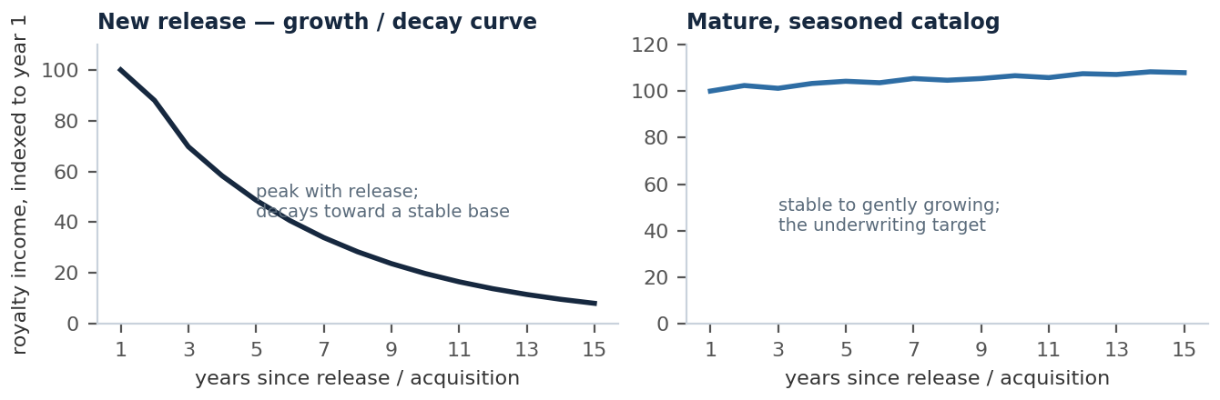
Note: Illustrative schematic; not drawn from catalog data. Source: Junson AID.
Pharmaceuticals: the original royalty market
How the royalties come to exist. Drug IP typically originates with inventors who cannot manufacture or distribute at scale — academic institutions and small biopharma — and is licensed to large pharma in exchange for royalty payments on future sales. Those royalty entitlements are then monetized: IP holders sell them to investors, usually to fund further R&D ("traditional royalty"); alternatively an investor pays a pharma company upfront for a share of a product’s future sales ("synthetic royalty"). Large pharma’s patent cliffs keep the machine running — big companies replace expiring revenue by buying external innovation, transferring IP from emerging biopharma and creating royalties in the process; the emerging companies are voracious consumers of capital and increasingly sell royalties to fund growth.
Clock and duration. A pharma patent runs 20 years; development and regulatory approval absorb 8-10 of them, leaving a royalty life of 10-12 years — the textbook declining annuity. PG targets post-regulatory-approval products only, where binary approval risk is gone and the remaining risks are commercial:
Exhibit 19: The pharma lifecycle — where royalty investors enter
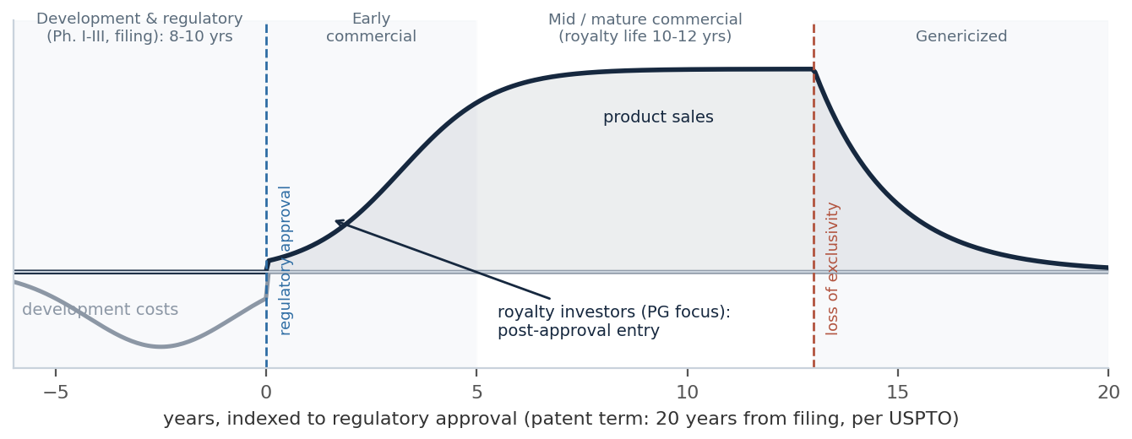
Note: Schematic; patent arithmetic per USPTO. Source: Partners Group; HCRx; Junson redraw.
Exhibit 20: Pharma product lifecycle — phase map and key risks
Phase | Years (indexed to approval) | Key risks | Royalty relevance
Discovery to filing (pre-approval) | -6 to 0 | Approval failure; no visibility on efficacy, safety, pricing, reimbursement | Binary risk — outside PG’s stated focus
Early commercial | +1 to ~+5 | Peak-sales estimation; clinically superior entrants | Highest return potential, widest error bars
Mid / mature commercial | ~+5 to +12 | IP litigation risk grows with time on market; less room for valuation error | Core underwriting zone — predictable scripts data
Genericized | +12 onwards | Loss of exclusivity; pricing collapse; loss of insurance coverage | The cliff the DCF must end on
Note: Patent arithmetic per USPTO. Source: Partners Group; HCRx.
Market. Worldwide prescription drug sales were ~USD 1,053bn in 2023 and are forecast to reach ~USD 1,743bn by 2030E (+6% CAGR), with pharma R&D spend rising from ~USD 225bn to ~USD 341bn over the same period (+7% CAGR). Royalty financing is growing faster than the industry it funds: ~USD 10bn in 2023, projected to ~USD 25bn by 2030E (+18% CAGR) across traditional and synthetic structures; KKR puts annual royalty monetizations or related debt at USD 15bn+ already. Pharma sales have grown through every recession in the KKR chart series — the non-correlation claim rests on demographics and medical need, not on the cycle.
Exhibit 21: The supply engine — biopharma revenue lost to patent expiry
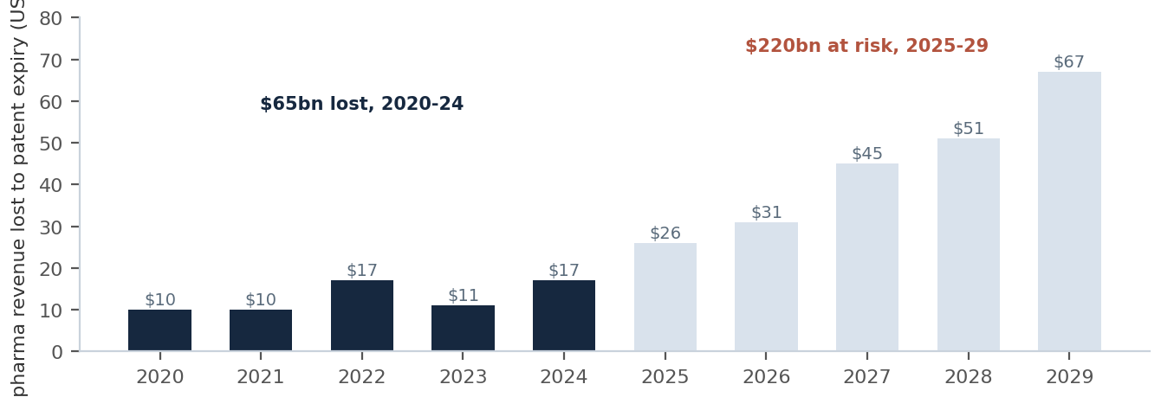
Note: Revenue at risk due to loss of exclusivity across the top 10 developed nations. Source: KKR; Junson redraw.
Exhibit 22: Global prescription drug sales, 2016-2030E
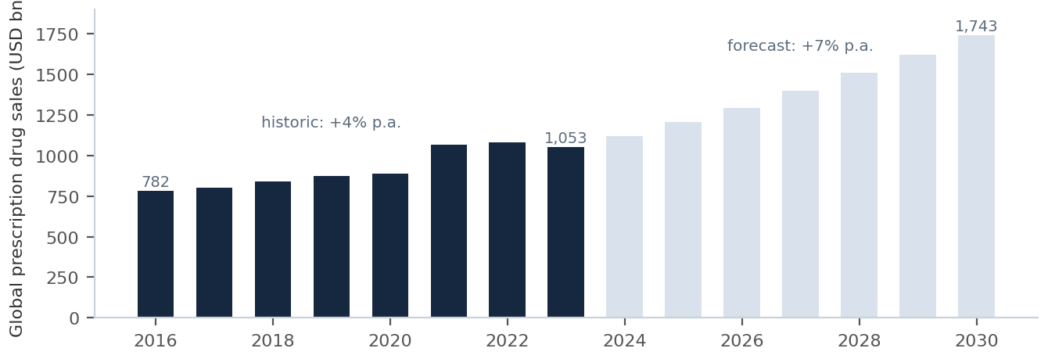
Source: Partners Group; Junson redraw.
Exhibit 23: Pharma royalty financing and R&D spend
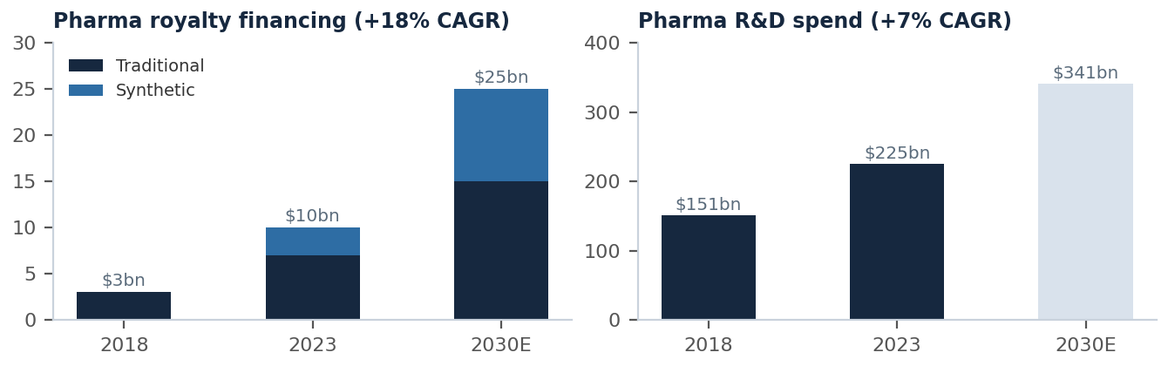
Note: 2023 and 2030E royalty totals split between traditional and synthetic as shown in the source. Source: Partners Group; Junson redraw.
Exhibit 24: Pharma revenue has grown through every recession since 2000
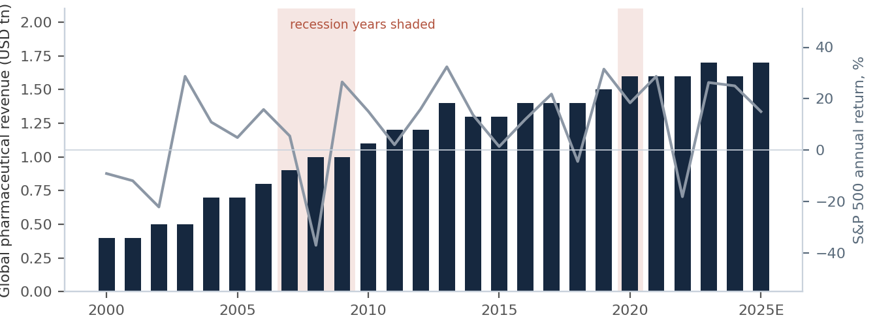
Note: S&P 500 overlay rebuilt by Junson from public annual returns; recession years shaded; 2025 values are estimates. Source: KKR; Junson redraw.
Inflation and pricing. US branded drug price growth has run at roughly 5-8% a year against CPI averaging 2-3% over 2017-23 — the pharma expression of the revenue-line inflation hedge. The honest caveat sits in 2022, when CPI at 8.0% outran drug price growth of 4.9%: the hedge is structural, not year-by-year.
Exhibit 25: Branded drug price growth vs CPI, 2017-23
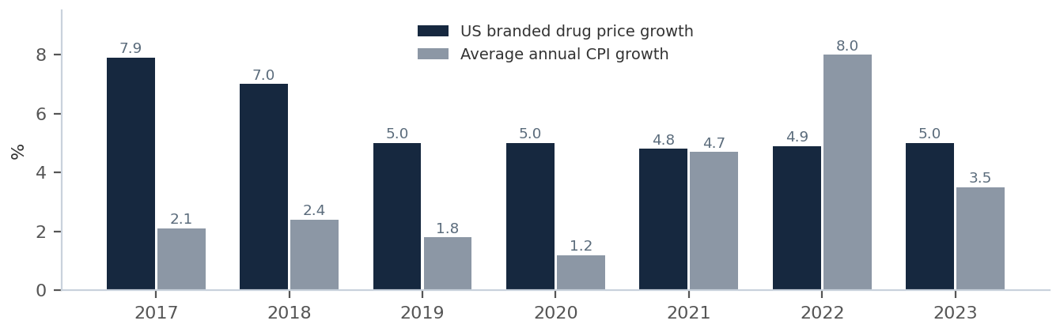
Source: Partners Group; Junson redraw.
The supply side is structural. Emerging biopharma now originates ~72% of new regulatory filings, up from 65% in 2014. The sector consumed over USD 310bn of funding across 2020-24; the average R&D investment to progress a drug from discovery to launch has reached ~USD 2.3bn; and the capital required to sustain biopharma innovation over the next decade is projected to exceed USD 1tn. Among the three channels in the biopharma capital stack, royalties are the only one that is simultaneously non-dilutive, operationally light and product-specific (Exhibit 27) — which is why monetization volumes keep compounding.
Exhibit 26: Emerging biopharma originates ~3/4 of new innovation
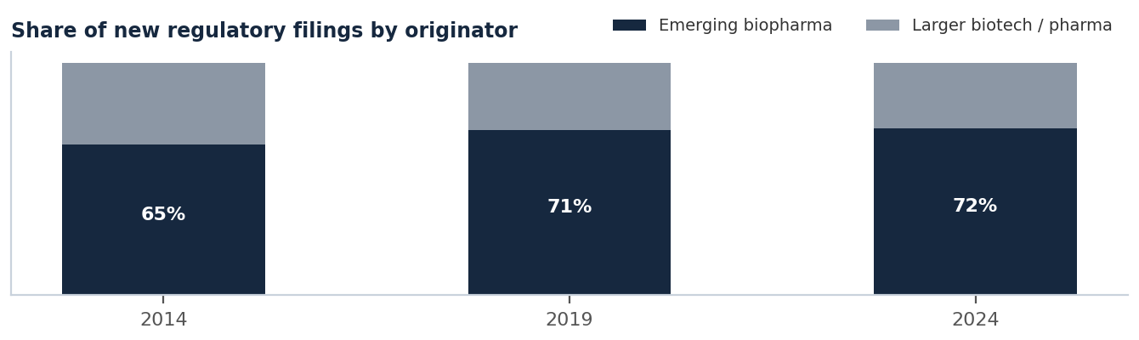
Note: Share of new regulatory filings by originator. Source: KKR; Junson redraw.
Exhibit 27: Three sources of capital for biopharma
 | Debt | Royalties | Equity
Cost of capital | Low | Low to medium | High
Flexibility | Low | High | Low
Operationally restrictive | High | Low | Low
Broad availability | Post approval | Post science risk | All stages
Market sensitivity | Medium | Low | High
Product-specific | No | Yes | No
Note: Royalties are often originated through licensing deals. Source: KKR.
Return anchors. PG frames the pharma royalty opportunity as a ~USD 185bn addressable market, 10-14% gross return targets, ~15-year duration. HCRx’s realized record is the live benchmark: ~12% net IRR across legacy drawdown funds since 2011 with a realized loss ratio below 1.5%.
US natural gas: royalties as real property
Mineral rights are the real-property ownership of everything beneath the surface, and private ownership of them exists essentially only in the US (and a small part of Canada) — elsewhere sub-surface rights belong to governments. The investor acquires the mineral rights and leases them to operators, receiving an upfront lease bonus plus a royalty of 12.5-25% of gross production revenue, with no liability for any capital or operating costs. The instrument hierarchy — fee minerals (perpetual, strongest) > ORRI (lease-linked) > NPI (cost-burdened) — is Exhibit 6’s legal-strength spectrum in its purest form: fee minerals are the one corner of the royalty universe where the claim is unambiguously senior to the operator’s entire capital structure, because it is not a claim on the operator at all.
Exhibit 28: US natural gas royalties — how the structure works
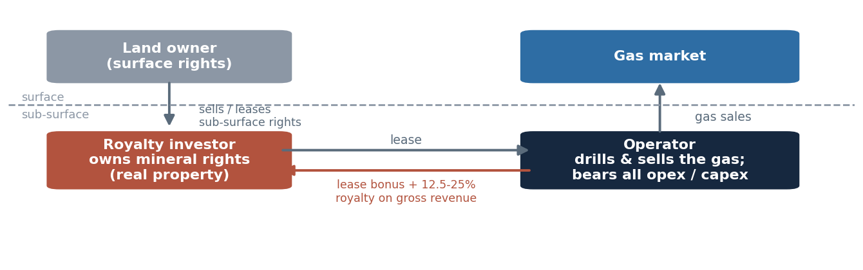
Source: Partners Group; Junson schematic.
Market and thesis. PG frames US natural gas royalties as a ~USD 140bn addressable market (as of Dec-23), 12-15% gross return targets, long-term duration. The demand thesis: natural gas’s share of US energy consumption rose from 18% in 2005 to 39% in 2023; ~25% of global energy demand growth through 2040 is projected to be met by gas; over 200 US coal plants are expected to be decommissioned or converted to gas; and the US is now the world’s largest producer, with AI / data-center load growth and rising LNG exports as incremental drivers. The offsetting exposure is the commodity itself: the royalty hedges cost inflation, not the gas price. Volume × spot is the revenue line, and the price leg is the piece prudent investors hedge.
Exhibit 29: The demand backdrop for US natural gas
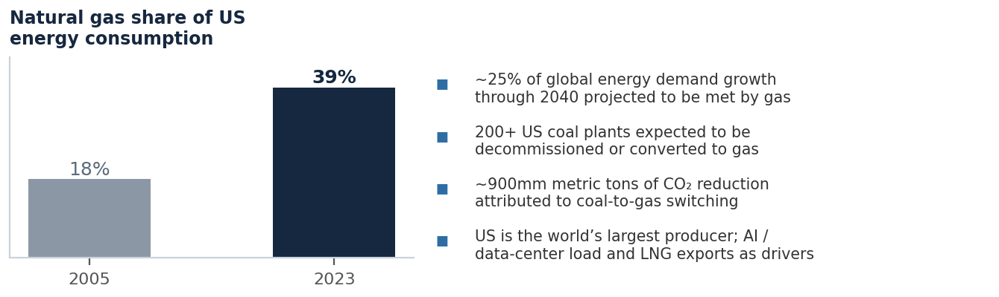
Source: Partners Group; Junson redraw.
Emerging sectors: large numbers, thin markets
Green metals (~USD 260bn) is established on PG’s map — royalty interests over mines producing the metals behind renewable technologies — while brands (~USD 320bn), carbon offsets (~USD 186bn, MSCI Trove-based) and sports (~USD 36bn, Deloitte / PwC-based) are the emerging tail. The pattern to expect: first movers earn pricing power against limited competition, but secondary depth is shallow, valuation marks are soft, and exit depends on the asset class continuing to institutionalize. In fund DD these sleeves deserve the concentration treatment, not the diversification credit.
Sports: institutionalization first, royalties next. The preconditions that made music and pharma royalty-investable are now assembling in sports. The revenue pool is contracting and compounding: the global sports market is projected to grow 44% from 2025 to USD 602bn by 2030, and media rights — the most contract-like revenue line in the ecosystem — grew 41% from USD 41bn in 2020 to USD 58bn in 2025, heading for ~USD 67bn by end-2026, with streaming platforms now controlling roughly 20% of the market. Governance frameworks for institutional capital are in place: private equity deal count in sports is up 284% since 2018, every major US league now admits institutional investors — the NFL, the largest league at over USD 23bn of 2024 revenue, was the last to open in 2024 — and average franchise valuations have compounded at 14% a year since 2020. Contracted, growing revenue pools plus league-sanctioned capital frameworks are precisely the substrate that royalty-like claims are written on.
Exhibit 30: The contracted revenue pool — global sports media rights
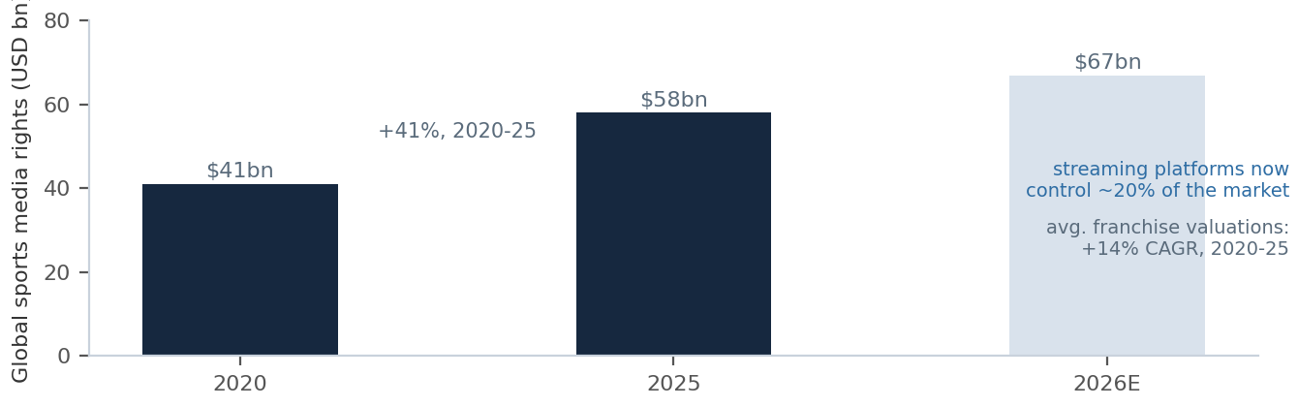
Note: Franchise-valuation CAGR per the same source. Source: Goldman Sachs; Junson redraw.
Where royalty structures are already forming: collegiate sport. The 2021 NCAA v. Alston ruling ended amateur-status protections; donor collectives began paying athletes for their name, image and likeness — NIL is a licensing royalty in all but name — and the 2025 NCAA settlement added USD 2.8bn of back damages plus a framework for schools to share revenue with athletes directly. The money is real: Division 1 FBS football generated USD 7bn of revenue in FY2024-25, with the Big Ten and SEC each above USD 1bn. To fund the new landscape, universities are standing up for-profit commercial entities that raise private capital against athletic-department revenues — Otro Capital’s USD 500mm into Utah’s Crimson Brand Partners, RedBird’s investment into the Big 12 alongside a USD 30mm credit line to member schools — structures one documentation cycle away from the synthetic royalties of Section 1. The distinction to hold onto: franchise equity earns valuation multiples, a royalty earns a revenue share — the sports bull case in circulation belongs to the former, and the ~USD 36bn sizing in Exhibit 8 remains the addressable figure for the latter. The gap between the two is the opportunity to watch.
Exhibit 31: Collegiate restructuring — the making of a royalty market
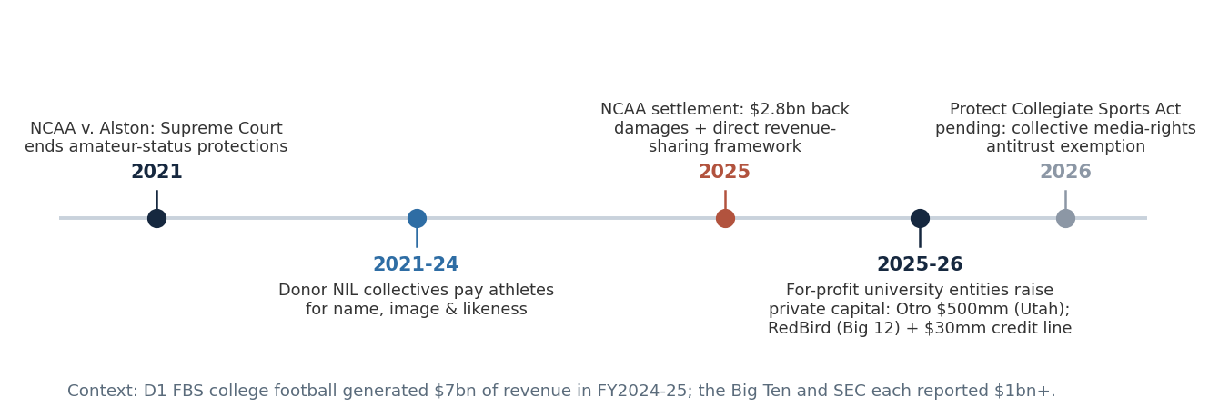
Source: Goldman Sachs; Junson redraw.
Exit and Fund Structure
Four exit routes — all of them optional
Because a royalty amortizes itself, "exit" is not the load-bearing part of the return. Royalties are largely self-liquidating — not reliant on an exit to meet target returns — and sale is an upside case, not the plan. Four routes exist, with very different depth by sector:
Exhibit 32: Exit routes
Route | Mechanics | Where it is deep | Evidence / watch items
1. Hold to run-off | Collect the contracted cash flows to depletion / expiry; underwrite hold-for-life | Pharma (10-15y amortizing); any finite royalty | The default. Requires no market at all
2. Secondary sale | Sell the royalty to an aggregator — listed royalty companies, specialist funds, insurers | Pharma, mining: mature; music: developed; niche media / sports: thin | Listed aggregators are the standing bid and the pricing anchor
3. Operator buy-back | Operator repurchases the royalty, often pre-refinancing / sale; buy-back clauses can be contracted upfront | Case-by-case, all sectors | Buy-back clauses are listed among standard liquidity options in GP materials
4. Portfolio exit: securitization, continuation vehicle, listing | Package diversified streams into ABS, roll into a CV, or list the aggregate | Music ABS; GP-led secondaries emerging | PG led a CV for a film/TV rights acquirer; Primary Wave’s Brookfield PCV bought USD 700mm+ of LP interests
Note: Route framework: Junson AID; mechanics and examples per GP materials.
Why the asset class migrated to evergreen
PG’s stated case for evergreen royalty funds is alignment: the structures match the longer-term nature of the assets and pair them with liquidity provisions. The underlying logic is that royalties neutralize, one by one, the classic failure points of semi-liquid structures:
· ① Internal liquidity. Redemptions can be met from contractual cash flow rather than forced asset sales. The scale is material: HCRx’s evergreen portfolio generated ~USD 228mm of 2025 free cash flow on a USD 2bn+ portfolio fair value — roughly 11% of portfolio value returning as cash in a year.
· ② No J-curve, no vintage lottery. Returns are yield-led and begin on day one, so any entry point buys a producing portfolio — HCRx markets exactly this: immediate ownership of 50+ approved products across 40+ therapeutic areas, with capital compounding far sooner than in a drawdown fund. The drawdown alternative forces deployment deadlines and concentrates each fund in a single pricing vintage.
· ③ NAV with data anchors. Royalty NAVs discount observable, high-frequency revenue data — prescription scripts, streaming statements, production reports — rather than comparable-company multiples. Still GP-marked (see DD question ⑤), but the inputs are harder to argue with than most private-asset marks.
Exhibit 33: Closed-end vs evergreen — invested exposure through time (schematic)
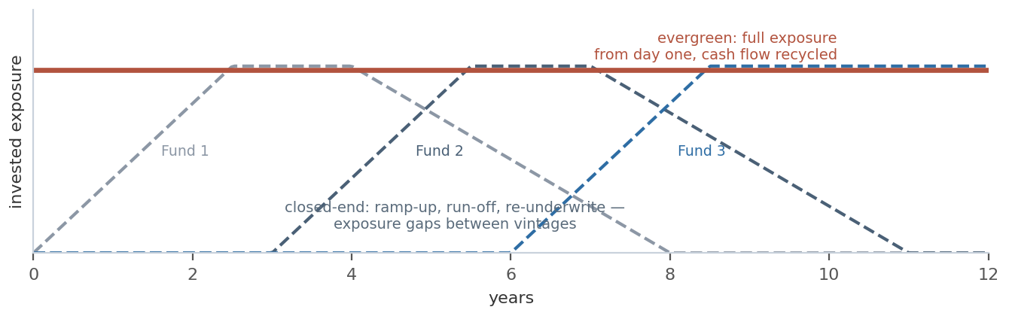
Note: Schematic. Source: HCRx; Junson redraw.
The caveat is duration matching: a portfolio tilted to perpetual-family assets (Exhibit 5) has a low cash-yield share of value, and a redemption run would then require selling into whatever secondary depth the sector has. The four live funds in Part II already span the entire liquidity spectrum — which is the single clearest illustration that "evergreen" is not one thing:
Exhibit 34: The liquidity spectrum across the four live funds
Fund | Structure | Liquidity mechanics | Source
PG Diversified Royalties Opportunities | Luxembourg evergreen (multiple share classes) | Monthly NAV; external subscriptions accepted into the Lux evergreen funds from Jun-25 | Partners Group
HCRx Evergreen Fund | Evergreen LP | Subscription queue by date; liquidity via a run-off option once every four years — no periodic redemption | HCRx
Primary Wave (Funds 1-4 + PCV) | Closed-end funds + Brookfield Permanent Capital Vehicle | GP-led purchase offers: PCV bought USD 700mm+ of F1/F2 LP interests across three liquidity offers at 16.5-19.2% net returns to sellers | Primary Wave
HarbourView Royalties Fund I | Closed-end | None until realization; USD 500mm target / USD 1bn hard cap | HarbourView
Note: The spectrum runs from true semi-liquid (PG) through quasi-closed evergreen (HCRx) to closed-end with engineered liquidity (PW) to plain closed-end (HVEP). Source: as per final column.
Downside Risk and DD Framework
Risk lives in three places — none of them a payment waterfall
In normal operation the royalty is paid first, so the credit-style question "who ranks ahead of me" is the wrong frame. The three dimensions that actually determine loss are: whether the revenue persists, whether the operator keeps producing it, and what the contract is worth when the operator fails. PG’s own risk list — sector regulatory change, technology shifts, consumer behavior, counterparty risk, legal and regulatory risk, concentration, asset impairment and operational issues at the operating company — sorts cleanly into these three:
Exhibit 35: Risk framework and sector expressions
Dimension | What goes wrong | Sector expressions | Mitigants
① Revenue sustainability | Volume decays faster than underwritten; price falls or is re-set | Music: decay-curve deviation; statutory / streaming royalty rates; artist conduct pulling songs from platforms. Pharma: patent cliff timing, superior entrants, pricing & reimbursement. Gas / metals: spot price | Seasoned assets; genre- and income-type decay curves; no value to unreleased music; post-approval products only; price hedging
② Operator going-concern | Production stops — royalty on zero revenue is zero, regardless of seniority | Single-operator exposure in gas; marketer concentration in pharma; label / DSP disputes in music | Operator diversification; audit rights and sales reporting; established marketers (HCRx: approved products sold by established pharma)
③ Legal strength | Contractual claim compromised in restructuring; license rejected | Pharma / media royalties as unsecured contract claims vs fee minerals as real property | "Prudent structuring and documentation are essential"; prefer property-interest instruments; step-up / step-down economics and make-whole payments once hurdles hit
Note: Framework: Junson AID; component risks and mitigants per GP materials.
Two portfolio-level risks sit on top: valuation (GP-marked NAVs; the discipline is third-party appraisal coverage and data-driven inputs — Primary Wave’s NAVs, for instance, rest on independent third-party expert appraisals under its valuation policy) and structure mismatch (portfolio duration and cash yield vs the vehicle’s redemption terms — the Section 4 caveat). Both are fund-selection questions rather than asset questions, which is where Part II picks up.
Fund Universe and Evaluation
The investable universe: a 2×2 of sector focus and structure
Sector focus and vehicle structure are independent axes — the pharma specialist in our set is an evergreen, and the multi-sector platform could equally have been drawdown. The four funds on which we hold materials fill three cells of the 2×2; each axis carries its own DD load (sector axis → revenue-driver and concentration questions; structure axis → duration-matching and liquidity questions).
Exhibit 36: Fund universe — sector focus × structure
 | Evergreen | Closed-end
Multi-sector | PG Diversified Royalties Opportunities | — (no live example in our set)
Single-sector | HCRx Diversified Healthcare Royalty Evergreen Fund (pharma) | Primary Wave Funds 1-4 (music); HarbourView Royalties Fund I (music)
Note: Listed royalty aggregators (Franco-Nevada, Wheaton — mining; Royalty Pharma — pharma) are the reference layer rather than a target: the standing secondary bid, the public valuation anchor, and — in the case of the UK-listed music vehicle that was ultimately sold after a NAV dispute — the cautionary tale on marks. Sports: no royalty fund has yet reached our materials set — on the watchlist (see Section 3). Source: Junson AID.
The four funds, in brief
· PG Diversified Royalties Opportunities — multi-sector evergreen.
Luxembourg evergreen, inception Q4 2020; fund size USD 345.4mm at Jun-26 within ~USD 1.5bn of commitments raised across PG’s royalties evergreen platform (as of Jul-26); 53 investments completed. Annualized net performance since inception 8.9% with 2.1% annualized volatility (vs 14.5% MSCI World, 3.4% leveraged loans); H1 2026 net 3.2% against royalty asset-level performance of ~7% — the gap is dilution from new investments held at cost, with the 2026 vintage already 36% of the portfolio. Sector mix: Media 46%, Music 17%, Natural Gas 16%, Life Sciences 15%, Carbon Reduction 4%; transaction type: directs 66%, primaries 25%, secondaries 9%. Top five positions: South Park (a royalty-backed note to the owner of the franchise IP) 17.0% of NAV, Media Music Fund 10.8%, Media Fund (continuation vehicle, ~600 films / ~2,500 TV episodes) 8.6%, Ultra Natural Gas Royalties 7.4%, The Weeknd 7.3%.
Exhibit 37: PG Diversified Royalties — portfolio composition (Jun-26)
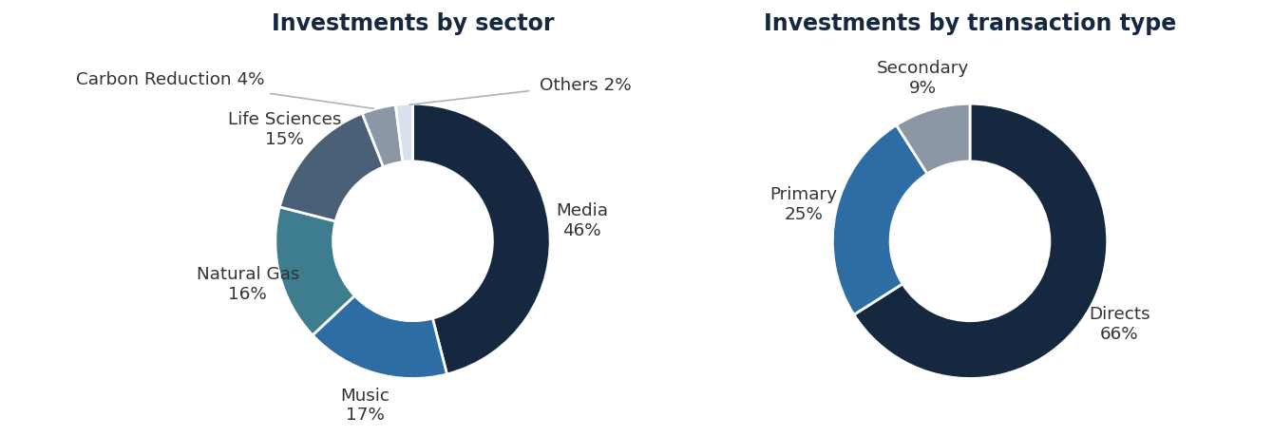
Source: Partners Group; Junson redraw.
Exhibit 38: PG Diversified Royalties — annual net returns and volatility
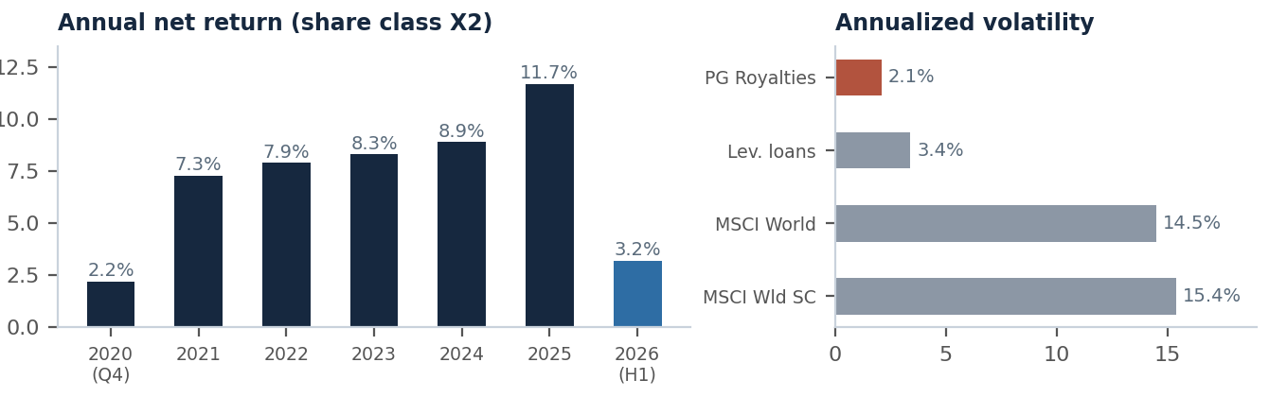
Note: Annual net returns are calendar-year figures (share class X2; 2020 = Q4 only; 2026 = H1). Source: Partners Group; Junson redraw.
· HCRx Diversified Healthcare Royalty Evergreen Fund — pharma evergreen (KKR platform).
Evergreen ownership of 50+ approved commercial biopharma product royalties across 40+ therapeutic areas; portfolio fair value USD 2bn+; ~USD 228mm of 2025 free cash flow, recycled into new investments. Track record: ~12% net IRR in legacy drawdown funds since 2011 across 75+ investments, realized loss ratio <1.5%; evergreen net returns 6.9% (2023), 10.0% (2024), 12.6% (2025), 4.8% (Q1-26). Franchise: founded 2006, ~27% 2025 market share by number of transactions, ~USD 900mm average annual capital committed 2023-25, 68% of current holdings sourced proprietarily and 77% with downside protection. Terms: management fee tiered on annual royalty receipts (3.50% / 3.25% / 3.00%; historically ~93bps of NAV), performance fee 15% of GAAP income over a 5% hard hurdle and 25% over 8%; team holds USD 50mm+ (~3%) of the fund, with a minimum 40% of incentive comp taken in fund units; liquidity is a run-off option once every four years.
Exhibit 39: HCRx Evergreen Fund — net returns
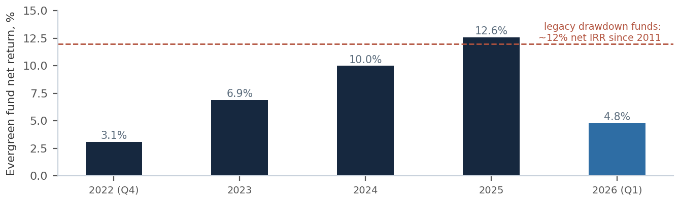
Note: 2022 is Q4 only; 2026 is Q1. Source: HCRx; Junson redraw.
· Primary Wave — music closed-end platform with engineered liquidity.
Music IP specialist founded on an active-management model (publishing, marketing, branding, talent management) with USD 4.5bn+ AUM by original commitment across six vehicles: Fund 1 USD 268mm (2017), Fund 2 USD 520mm (2020), Prince co-invest USD 41mm (2021), Fund 3 USD 785mm (2022), Brookfield Permanent Capital Vehicle USD 1.7bn (2022), Fund 4 USD 1,230mm+ raised toward a USD 2bn hard cap. Net IRRs (highest-fee basis, hypothetical liquidation at 12/31/24 NAV per third-party appraisals): F1 16.2%, F2 15.7%, F3 12.4%, Prince 11.6%, F4 14.6%. Realized evidence: in the 2022 purchase offers, selling F1 LPs received 19.2-20.2% net IRR (1.87-1.93x) and F2 sellers 16.5% (1.28x); USD 700mm+ of LP interests have been sold across three liquidity offers to the PCV at 16.5-19.2% net. Operating proof point: cumulative NPS growth on catalogs since purchase of 92% (F1), 76% (F2), 41% (F3); F1/F2 have paid or reinvested ~8% on called capital since inception.
Exhibit 40: Primary Wave — platform scale and NPS growth
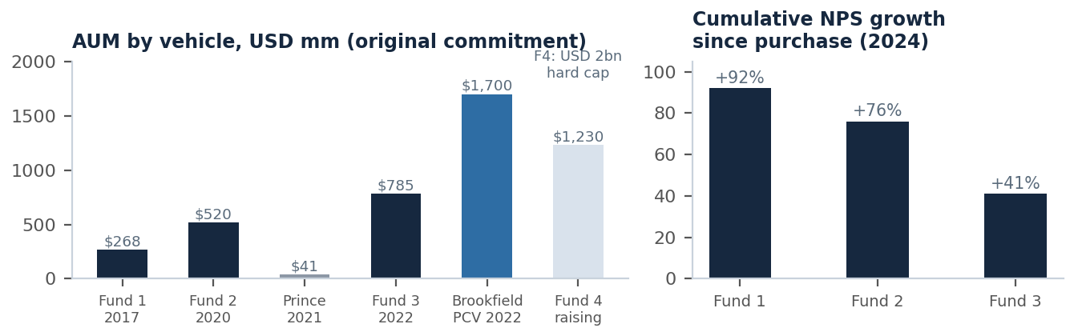
Note: AUM by original commitment; NPS growth is 2024 annualized NPS/NLS over at-purchase. Source: Primary Wave; Junson redraw.
· HarbourView Royalties Fund I — music closed-end, data-driven sourcing.
Second music vehicle of HarbourView (founded Jan-21; Brookfield, CAA and Oaktree as strategic investors): USD 500mm target / USD 1bn hard cap, targeting ~2-2.5x MOIC on catalogs with USD 1-25mm+ of annual net royalties. Platform: ~28,100 songs accumulated across masters and publishing since 2021; 400+ catalog opportunities sourced since launch, equivalent to ~USD 9.4bn of pipeline at a standardized 15x market multiple. A fund-level DD questionnaire (Oct-23) is on file and should anchor the manager-level review.
Five evaluation questions
· ① What is the portfolio actually made of? Instrument mix — GRR / fee minerals / ORRI / NPI / stream / synthetic / RBN (Exhibit 6). The names are interchangeable in marketing; the cost exposure and insolvency treatment are not. An "NPI-heavy" gas book or an RBN-heavy media book is a different asset class from its label.
· ② What is the legal-strength mix? Share of NAV in property-interest form (registered mineral / mining interests) vs contractual claims against operators, cut by jurisdiction. This is the loss-given-stress driver the asset-level marketing skips.
· ③ What is the duration mix by revenue driver? Weight the book across Exhibit 9’s three families. A declining-annuity book (pharma) is self-liquidating; a perpetual-family book (music, fee minerals) parks its value in the terminal — fine, but only in a structure built to hold it.
· ④ Does the structure match the book? Cash-yield share of value vs the vehicle’s redemption terms; stress internal cash flow coverage of a redemption run. Note where each fund already sits on Exhibit 34’s spectrum — and that fee bases differ (HCRx charges on royalty receipts, not NAV), which changes the GP’s incentive between collecting cash and marking value.
· ⑤ Who marks the book, against what data? Valuer independence, third-party appraisal coverage, input data frequency (scripts / streaming statements / production reports), discount-rate policy vs rates, and realized-vs-NAV evidence. Track records built on hypothetical-liquidation NAVs deserve a different weight from realized DPI.
Type-specific watch items
· PG: the "Diversified" label vs the book — Media is 46% of the portfolio and South Park alone 17.0% of NAV; single-name concentration of that size inside a monthly-NAV evergreen puts real weight on the mark. Also note the growth-stage pattern: H1-26 net 3.2% vs ~7% at asset level because 2026 vintage (36% of book) is held at cost — returns are being shaped by fundraising pace, in both directions.
· HCRx: the liquidity term is the closest to closed-end of any evergreen in the set — a run-off option once every four years, with subscriptions queued. Treat it as a long-lock vehicle with evergreen accounting, not as semi-liquid. The receipts-based fee (~93bps of NAV historically) is cheap for the asset class but scales with collections, so model it against the book’s amortization profile.
· Primary Wave: the headline IRRs are hypothetical-liquidation NAV figures; the only realized prints are GP-led sales to the affiliated Brookfield PCV — a related-party buyer, albeit at third-party-appraised prices. DD should test price discovery in those transactions and the independence of the appraisals; the Oct-23 DDQ is the starting point. The active-marketing alpha (NPS growth) is real but execution-dependent and must be re-proven each fund.
· HarbourView: single-strategy exposure to music multiples: pipeline is sized at a standardized 15x, so underwrite the MOIC target against multiple compression as well as decay-curve risk; and as a 2021-founded firm, the track record predating Fund I is short.
Scorecard and comparison log
Exhibit 41: Fund evaluation scorecard — template
Criterion | What to assess | Evidence source
Position in the 2×2 | Sector focus × structure per Exhibit 36; stated strategy vs actual holdings | PPM strategy section; portfolio schedules
Instrument & legal mix | GRR / ORRI / NPI / stream / synthetic shares; property-interest vs contractual-claim share by jurisdiction | Portfolio schedules; sample purchase agreements
Revenue-driver duration | Declining-annuity vs perpetual vs commodity-linked weights (Exhibit 9); duration and cash-yield share of value | Portfolio cash-flow projections
Return engine | Contracted yield vs NAV accretion vs operating alpha (e.g. NPS growth); attribution of target returns | Track-record attribution; prior-fund distributions by source
Track-record quality | Realized DPI vs hypothetical-liquidation NAV; related-party transactions in "realized" prints | Audited financials; secondary transaction docs; DDQ
Fees & alignment | Fee base (NAV vs receipts), hurdles, GP / team co-investment | LPA; HCRx-style terms pages
Structure & liquidity | Redemption terms vs book duration; internal cash-flow coverage of a redemption run | LPA; portfolio FCF (e.g. HCRx USD 228mm on USD 2bn+)
Valuation governance | Valuer, third-party coverage, data inputs, discount-rate policy | Valuation policy; appraisal reports
Concentration | Single-asset / single-sector / single-operator maxima | Portfolio schedules (e.g. PG: South Park 17% of NAV)
Note: Template mirrors the Fund Evaluation scorecard of our AI Infrastructure report (2026Q3). Source: Junson AID.
Exhibit 42: Fund comparison log
Fund / manager | 2×2 cell | Size | Structure / liquidity | Return | Cash flow / yield | Portfolio & key watch items
PG Diversified Royalties Opportunities | Multi-sector × evergreen | USD 345mm fund; ~USD 1.5bn platform | Lux evergreen; monthly NAV; external subs since Jun-25 | 8.9% net ann. since Q4-20; H1-26 net 3.2% (asset level ~7%) | Vol 2.1% ann.; accumulation and distribution share classes | Media 46%; South Park 17% NAV; 2026 vintage 36% at cost. Watch: concentration vs "diversified" label; growth-stage dilution
HCRx Evergreen Fund (KKR) | Pharma × evergreen | USD 2bn+ portfolio FMV | Evergreen LP; subscription queue; run-off option every 4 years | 12% net IRR legacy funds since 2011; 12.6% net 2025; loss ratio <1.5% | ~USD 228mm 2025 FCF (~11% of FMV, Junson calc), recycled | 50+ products, 40+ therapeutic areas. Watch: 4-year liquidity = quasi closed-end; receipts-based fee (~93bps NAV)
Primary Wave (F1-F4 + PCV) | Music × closed-end | USD 4.5bn+ AUM; F4 USD 2bn hard cap | Closed-end + Brookfield PCV purchase offers | F1-F4 net IRR 11.6-16.2% (NAV-based); realized F1 sellers 19.2-20.2% | F1/F2 ~8% paid or reinvested on called capital | NPS growth F1 +92% / F2 +76% / F3 +41%. Watch: NAV-based IRRs; related-party PCV as the only realized buyer
HarbourView Royalties Fund I | Music × closed-end | USD 500mm target / USD 1bn hard cap | Closed-end | Target ~2-2.5x MOIC | Catalog net royalties USD 1-25mm+ per target | ~28,100 songs since 2021; ~USD 9.4bn pipeline at standardized 15x. Watch: multiple compression; short pre-fund track record
Note: Return bases differ (annualized net NAV return, net IRR, hypothetical-liquidation NAV IRR, target MOIC) and are not directly comparable — see evaluation question ⑤. Source: respective GP fund documents.

