JUNSON Capital | Alternative Investment Division
BCGAF Research Report Summary — 2026Q3
Bain Capital Griffin Aircraft Fund | Coverage: aviation / aircraft leasing / lessors | Market data to 13 Oct 2026, fund data to 30 Jun 2026
Verdict: BCGAF's baseline quarter reads well: 36.0% of commitments called with the portfolio at 36% of the US$3,750M scaled target, investment-level gross performance of >50% IRR / 1.60x MoM, and realisations printing at 1.40–2.95x gross MoM (all per the GP's Q2'26 update). The caveat is market-side: JPM judges the post-COVID supply-demand imbalance to be normalising, and IBA (via JPM) records the cycle's first mid-life narrowbody value declines — exactly the A320ceo / 737NG metal where the Fund's two portfolio acquisitions concentrate. Holding assessed as "performing, continued monitoring required": no action needed; track the GP's monetisation prints and supply language against the Section 4 trigger lines.

BCGAF key metrics at a glance
Metric | Q1'26 | Q2'26 | QoQ | Notes
Portfolio value (US$m) | 1,245 | 1,352 | +107 | 36% of US$3,750M scaled target, vs ~33% (GP)
Capital called (US$m / % cmt) | n.d. | 127.1 / 36.0% | — | Q1-acquired portfolio funded at Q2-end (GP)
Inv.-level gross IRR / MoM | n.d. | >50% / 1.60x | — | 100% unrealised, pre-fee GP estimate; we lean on the MoM
NAV (US$m / % cmt) | n.d. | 227.6 / 64.5% | — | GP unaudited estimate
ITD distributions (US$m / % cmt) | n.d. | 6.2 / 1.8% | — | 100% profit distributions; +US$12.7M post Q-end (GP)
Fund ITD IRR / MoM / DPI | NM | NM / 0.05x‡ | — | NM while <50% called; ‡DPI = Junson calc. (6.2 / 127.1)
Aircraft / engines (pro forma) | 33x / 5x | 29x / 5x | n.c.¹ | ¹Bases differ: 1Q nets 2x, 2Q nets 6x monetisations (GP)
Commitments / final close | 353.0 | 353.0 | — | Target US$1bn, GP ~US$50M; final close expected Oct-26 (GP)
Source: Bain Capital Griffin Q2'26 quarterly investor update and Q1'26 investor overview; data to 30-Jun-26, unaudited GP estimates; n.d. = not disclosed in the Q1'26 overview. Δ QoQ columns begin from 2026Q4 (baseline convention).
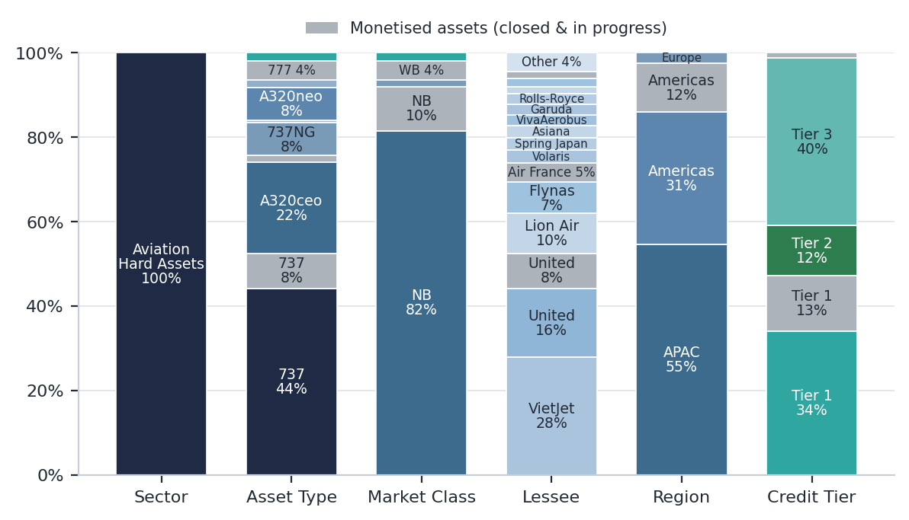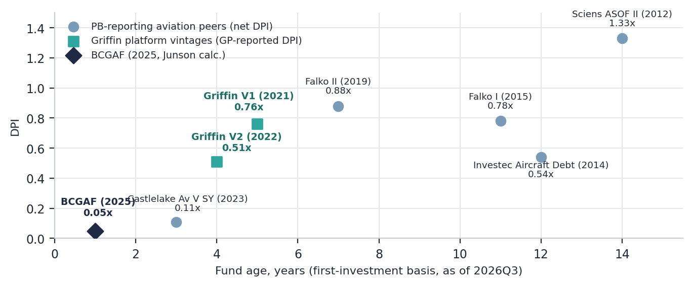
Left: BCGAF pro-forma exposure, 30-Jun-26 — narrowbody 737 / A320-family metal, APAC-weighted, Tier 1 ~34% / Tier 3 ~40% (Junson pixel-read of the GP chart; monetised assets grey). Right: DPI vs fund age — Griffin V1 at 0.76x (age ~5) and V2 at 0.51x (age ~4) distribute at roughly twice the realised-peer base rate; BCGAF at 0.05x sits where an age-1 fund should (PitchBook 14-Aug-26; GP-reported DPI).
1. Key News (this quarter)
- Capital call and second ABS series: the Q1-acquired aircraft portfolio was funded at Q2 quarter-end, taking called capital to 36.0% of commitments (ITD contributions US$127.1M, GP); the aircraft then went into the platform's second Master Trust ABS series — US$568M, completed June, spreads tightening versus the inaugural per Ishka (26-Jun-26), exact level not yet disclosed.
- Realisation prints are the strongest early signal: the ex-Spirit A320-family aircraft closed Aug-26 (post Q-end) at >50% gross IRR / 2.11x gross MoM; the United 737-9 JOLCO closed at 1.40x (IRR NM on a sub-one-year hold); three further assets pending at est. 1.82–2.95x; US$12.7M distributed post Q-end (all GP, gross pre-fee).
- Final close approaching: US$353.0M committed (GP ~US$50M) toward the US$1bn target; final close expected October 2026, with the GP actively evaluating new investments (GP).
- IATA halved 2026 industry profit: US$23bn / 2.0% net margin vs the US$41bn / 3.9% forecast of Dec-25, on jet fuel assumed at US$152/bbl (2025: US$90/bbl) — yet load factor is still a record 84.0%E: a cost shock to airline P&Ls, not a demand shock to aircraft (IATA).
- First fuel-shock casualties; upgrade cycle closed: Spirit's liquidation and Air Baltic's fleet restructuring return aircraft to the market while removing weak lessee credits (JPM); Moody's upgraded Avolon to Baa2, effectively ending the lessor upgrade cycle (JPM).
2. Market Trend (industry data)
Industry indicator | Reading | Read-through
2026 traffic growth forecast (IATA) | +2.1%, cut from +4.9% (Jun); YTD RPK +0.6% to Jul | Softened, not broken — Jul back to ~flat per Barclays, +2.4%E per GS; five of six regions positive in May
Jet fuel, NY Harbor (JPM) | >US$4.70/gal, +136% YTD, vs US$3.62/gal implied by IATA’s US$152/bbl | Either 4Q spot follows the futures curve down, or IATA cuts profits a third time
Parked fleet (GS, Jul) | 11.1% of total fleet, −40bp MoM | Usable surplus thin — near pre-pandemic levels
Order backlog (IATA, May) | >18,000 aircraft, >half the active fleet | Stock vs flow: JPM sees the imbalance normalising, renewal rates mean-reverting from 80%+ to 50–60%
10-yr-old values / lease rates (IBA via JPM) | 777-300ER ~+40% / ~+20% yoy; A320-200 / 737-800 first declines, rates −13.0% / −11% | Mix, not market level, drives marks from here — BCGAF’s two portfolio pools sit in this metal
Aviation ABS senior spreads (Ishka et al.) | T+205 (AASET 2024-1) → T+145 (CLAS 2026-1, Feb-26) | Cheap senior funding available to every scaled platform; the edge is advance rate, not access
Lessor refi calendar (Junson sum of JPM schedules) | ~US$9.4bn (2026) → ~US$22.9bn (2027) → ~US$23.4bn (2028) | New-delivery lease rates, indexed to a ~5% 10yr UST (+80bp YTD), stay under upward pressure
Source: GS / JPM / Barclays research to Oct-26; IATA; IBA appraiser data via JPM; Ishka, KBRA, Fitch and trade press for ABS pricing; Junson compilation.
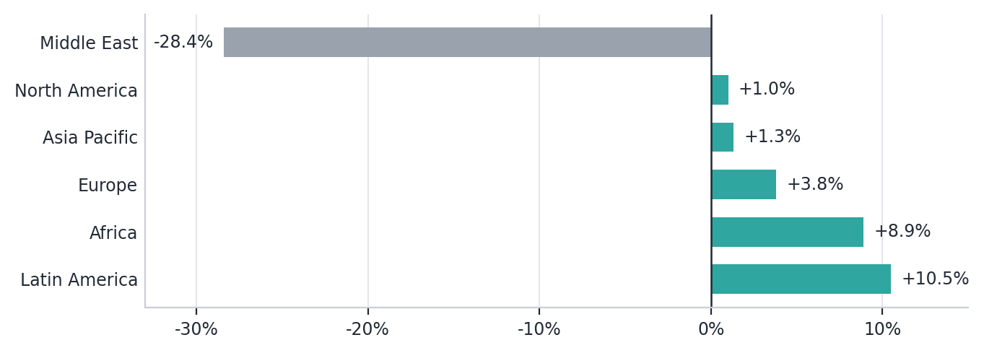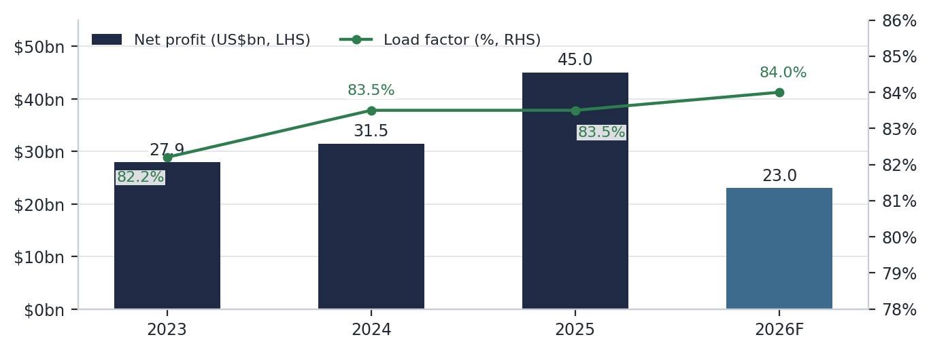
Left: passenger demand by region, May-26 (latest complete IATA set) — five of six regions positive; the Middle East (−28.4%) is the contained drag, narrowing through July per Barclays. Right: industry net profit vs load factor (IATA) — a record 84.0% load factor against profits halved to US$23bn frames 2026 as a cost shock, not a demand shock.
3. Impact on Our Portfolio
- Vintage concentration is the live risk: deployment is fastest exactly where values turned — 36.0% called at age ~1 vs Castlelake Aviation V Stable Yield's 28.3% at age ~3 (PitchBook) — and the two portfolio acquisitions (46% of portfolio value: PA#2 40% + PA#1 6%, GP) are weighted to the A320ceo / 737NG vintages where IBA records the first declines. Mitigants: 5–10% purchase-price discounts (GP scorecard: meeting), staged VietJet 737-8 deliveries through 2H26, and simultaneous selling into the same bid at 1.40–2.95x — a two-sided book, not a one-way ramp.
- Lease-income insulation is contractual, not economic: it holds until a lessee files, as Spirit and Air Baltic have just demonstrated. The watch-list is the Tier-3 tail (~40% of exposure by credit tier, Junson pixel-read of the GP chart) and fuel-exposed European short-haul, where Barclays' August screen-scrape shows achieved intra-Europe fares down at every full-service carrier tracked.
- Funding is the platform's measurable edge: the inaugural Master Trust (Nov-25, US$1,245M) was the largest aircraft ABS ever issued, with a 77.6% senior LTV at single-A (Fitch presale) vs 69–75% at discrete-trust peers; series 2 (Jun-26, US$568M) carries the Fund's aircraft and priced tighter per Ishka. The same spread compression that funds the GP's pipeline is compressing new-delivery lease rate factors on the asset side.
Aviation fund league table (PitchBook screen, 14-Aug-26)
Fund | Vintage | Size (US$m) | Net IRR (%) | TVPI | DPI | Called %
BCGAF (Junson) | 2025 | 353.0 comm. | NM† | NM† | 0.05x‡ | 36.0
Castlelake Aviation V Stable Yield | 2023 | 2,000 | 26.65 | 1.23x | 0.11x | 28.3
Falko Regional Aircraft II | 2019 | 650 | — | 1.13x | 0.88x | 100
Falko Regional Aircraft I | 2015 | 415 | — | 1.02x | 0.78x | 100
Investec Aircraft Debt Fund | 2014 | 200 | — | 1.54x | 0.54x | 100
Sciens Aviation Special Opps II | 2012 | 595 | — | 1.33x | 1.33x | 100
Source: PitchBook (dl. 14-Aug-26; vintage = first-investment year); Bain Capital Griffin; Junson calculations. †Fund-level NM while <50% called — inv.-level gross >50% IRR / 1.60x (US$194.4M, pre-fee, GP) is not comparable to PitchBook's net, lagged figures. ‡DPI on contributions (US$6.2M / US$127.1M), Junson calc. Momentum baseline on Griffin proxies (strict-below, n=5): V2's 1.6x net MoM = 100th pct, V1's 1.4x = 80th.
4. Our Position: Assessment, Watch List & Action
- Overall assessment: performing, monitoring required. Deployment, realisations and funding all run ahead of plan on the GP's Q2 numbers (nine of eleven scorecard parameters meeting target), and fund-level metrics stay NM until >50% called — so the realisation prints (2.11x ex-Spirit, 1.40x United JOLCO) are the strongest early signal. The quarter's key tension is narrative: the GP's letter leans on record backlog and scarcity while JPM judges the imbalance “is or will normalise” — the pace and pricing of the five in-progress monetisations is the practical test.
Watch list (next-quarter checks and trigger lines)
Item | Current | Trigger / timing | Action if triggered
Monetisation prints | 2x closed (1.40x / 2.11x); 3 pending est. 1.82–2.95x (GP) | Closings land below estimates, or slip past 4Q26 | Re-table the GP's supply narrative and marks at IC
GP supply language | Scarcity framing (Q2 letter) | Shift toward JPM's normalisation read | Leading indicator — re-underwrite mid-life mark assumptions
Jet fuel vs IATA assumption | Spot >US$4.70/gal vs US$3.62 implied (JPM / IATA) | 4Q spot fails to follow futures down; third IATA profit cut | Re-screen the Tier-3 lessee tail (~40% of exposure)
Final close | US$353.0M raised, Oct-26E, target US$1bn (GP) | Close slips, or lands well short of target | Revisit scaled-target maths and concentration at IC
GGAM series-2 ABS spread | “Tightened” per Ishka; level n.d. | Presale / trade-press disclosure | Populate the ABS cost league; test the funding-edge claim
Δ QoQ coverage | Baseline quarter — Δ columns n/a | 2026Q4 edition | QoQ ledger starts: called-% pace; PitchBook backfill (size still US$30M vs actual US$353.0M)

Action: continue to hold; no change. The baseline quarter shows deployment, realisation and funding metrics all ahead of plan per the GP, while the market section marks where the cycle is turning — first mid-life narrowbody value declines, normalising supply. Track the watch list quarterly; take the position back to IC only if monetisation prints disappoint or the GP's supply language turns.

