Software & OTF Quarterly Update
2026Q4 · Q3'26 results per the November 4 10-Q and earnings deck; prices and news through October 13, 2026
Scope: Summary, news, OTF Q3'26 update — portfolio composition, financials & debt, default metrics — plus the share-price analysis and the private credit / BDC industry read. Competitor analysis, the industry fundamentals exhibits and the AI × software section follow once this quarter's peer filings and broker inputs are in the folder.
Summary
OTF Q3'26 results
- NAV $16.62, ↑ +0.8% QoQ from $16.48 — the first increase since Q4'25 and the second straight quarter of net positive marks, +$0.19/sh realized and unrealized in Q3'26 per the deck bridge; at $9.21 the stock sits at 0.55x the fresh NAV.
- NII $0.29, ↓ $0.01 QoQ; coverage 83% of the $0.35 base and 73% of the $0.40 total declared. The $0.05 listing specials ended with the October 6 payment, and the board declared the Q4'26 base at $0.35 on November 3 — held, not cut to NII.
- Non-accruals 1.8% of cost / 1.1% of fair value, from 0.6% / 0.1% at Q2'26 — three issuers, with the Signifyd preferred at $158.7mm cost added in Q3'26; rating-3 rose 7.1% → 9.0% of fair value while rating-4+5 stayed at 0.4%, so the stress shows in non-accruals, not yet in tail ratings.
OTF share price & valuation
- OTF closed at ~$9.2 on October 13 after printing a new 52-week low of $9.14 intraday, per MarketBeat and the October 13 market-wrap data; against the $11.46 close of August 14 recorded in last quarter’s price ledger, the stock is down ~20% in two months, −28.2% YTD per TipRanks, and ~−44% since the June 2025 listing, derived from the prior report’s listing-base return of −30.8% at $11.46.
- At $9.21 the stock trades at 0.55x the Q3'26 NAV of $16.62 per the November 4 10-Q — 0.56x on the prior Q2'26 NAV of $16.48, versus 0.70x on August 14 per the prior report — the widest discount since listing and far below the 78% median public-BDC price-to-NAV as of August 31 per Morgan Stanley; the forward yield on the $0.35 base dividend is ~15.1% per Google Finance.
- The sell-off ran ahead of the company's own numbers — non-accruals were 0.6% of cost / 0.1% of fair value at Q2'26 per the 10-Q, the lowest of the six-name comp set — and the Q3'26 print then closed part of the gap: non-accruals rose to 1.8% of cost, detailed in 2.3. Five stacked pressures explain the move — the rate shock, AI-software credit fears, the Blue Owl redemption overhang, dividend-reset expectations, and litigation. Section 2.4 takes these one by one.
Private credit & public BDC industry
- The sector sold off again in September–October on rates: the 10-year UST touched 5.35% on October 7, the highest since 2002 per CNBC, after a September Fed hike per Morningstar; BDC bond spreads backed up ~20bp off YTD tights of +161bp reached in late September per Barclays, and bearish positioning against private credit proxies rebuilt toward Q1 levels per Bloomberg, October 7.
- Retail redemptions are past peak but unresolved: requests at Blue Owl’s two non-traded funds fell to $4.2bn in 3Q from $4.7bn in 2Q and $5.4bn in 1Q per Reuters, yet aggregate perpetual-BDC net flows stayed negative at −$3.1bn in 3Q26, a third negative quarter, per Barclays; gating reached Australia, where Metrics Credit Partners, ~A$40bn AUM, froze some funds per Reuters, September 30.
- Consolidation has begun: Ares, Barings, BC Partners and Churchill have examined troubled listed BDCs, with TCP Capital, WhiteHorse and Investcorp Credit Management reviewing strategic options, per Bloomberg, October 8; Blackstone raised ~$1bn for a private credit continuation vehicle per Bloomberg via Private Equity Wire, October 9.

1. News
1.1 Key news on Blue Owl & OTF
- Oct 2 — Blue Owl again capped OCIC and OTIC at the 5% quarterly limit. 3Q repurchase requests at OTIC were 39% of shares, $1.1bn, up from 38.1% in 2Q; OCIC fell to 16.8% from 18.8%; the two funds combined drew $4.2bn of requests versus $4.7bn in 2Q and $5.4bn at the 1Q peak. OTIC’s 39% compares with 10–17% at the largest non-traded BDC managers this quarter. Reuters, Oct 2; Bloomberg, Oct 2
- Oct 2 — Backlog math behind the headline. Counting the 3Q payment, OCIC will have returned $2.8bn to shareholders within six months, filling ~60% of original 1Q tender requests; OTIC will have returned ~$446mm, filling ~35%. Unfilled requests do not carry over; holders must re-tender each quarter. AltsWire, Oct 2
- Oct 7 — Securities class action filed against OTF. Girard Sharp filed on behalf of former OTF II shareholders who received OTF stock in the March 24, 2025 stock-for-stock merger, citing the share-price decline since issuance. This is a filed complaint, a step beyond the plaintiff-firm investigation notices tracked last quarter, and sits alongside the Section 36(b) excessive-fee suit filed June 18 in the SDNY per last quarter’s news ledger. GlobeNewswire via FinancialContent, Oct 7
- Oct 13 — New 52-week low at $9.14 during a global tech selloff; the prior close was $9.21. Sell-side consensus stands at Moderate Buy with an average target of $13.60, 4 Buy / 3 Hold; the last post-Q2 actions were BofA cutting its target to $11.00 from $11.50 on August 24 and Citizens JMP raising to $17.00 from $16.00 on August 6–7. MarketBeat, Oct 13; PT actions per CNN Markets quote page
- Oct 1 — Q3’26 results scheduled for November 4 after close, call November 5 at 11:30am ET; consensus adjusted NII is $0.32 per share per Earnings Whispers. PRNewswire, Oct 1; estimate per Earnings Whispers
- Oct 6 — Final listing special dividend of $0.05 paid; the run-rate drops to the $0.35 base from Q4’26 onward. The Board approved the Q3 base dividend of $0.35, record date September 30, payable on or before October 15, on August 4 per the Q2’26 10-Q subsequent-events note. Dividend history, Digrin; OTF Q2’26 10-Q, SEC
- Manager level: OWL trades ~$9.4, −40% YTD. Wells Fargo initiated OWL at Equal Weight, target $10, on October 1, calling it not a doom-and-gloom situation but one needing time; TD Cowen raised its target to $16 from $15 on October 12; OWL reports Q3 on October 29. StockAnalysis news feed; GuruFocus, Oct 12; Q3 date per PRNewswire via MarketScreener, Oct 1
1.2 Key private credit news
- Sep 30 — Gating reached Australia. Metrics Credit Partners, ~A$40bn AUM, froze investor redemptions from some funds and delayed full-year accounts after auditor KPMG declined to sign off by the September 30 deadline; three listed funds were written down ~A$169mm and suspended from trading. The local regulator had warned the prior week of unrealistic valuations in private credit. Reuters, Sep 30; Bloomberg, Sep 30
- Oct 5 — KKR’s K-FITS went past its cap to pay everyone out. The $996mm non-traded BDC received repurchase requests for 5.06% of shares for the period ended September 29 and will exceed the 5% limit to honor them in full; sister fund K-FIT saw requests of 1.53%, down from 1.65%. Bloomberg, Oct 5; Private Equity Wire, Oct 6
- Oct 7 — Rates are the macro driver. The 10-year UST touched 5.35% intraday, the highest since 2002, before a well-bid $39bn auction pulled it back to ~5.29%; the week-ending-October-9 close was 5.24%, up 107bp YTD per Nuveen. The Fed hiked at its September meeting on sticky inflation, with heavy AI-related corporate borrowing cited among the pressures on yields. CNBC, Oct 7; Nuveen weekly, Oct 9; Morningstar, Sep 29
- Oct 7 — Shorts are back. Bearish bets against private credit proxies climbed through September toward levels last seen during the Q1 exodus, as the bond selloff deepened. Bloomberg Going Private, Oct 7
- Oct 8 — Consolidation of battered BDCs is on the table. Ares, Barings, BC Partners and Churchill have run the rule over troubled funds in recent months; BlackRock TCP Capital, WhiteHorse Finance and Investcorp Credit Management BDC have said they are reviewing strategic options that could include a sale. Bloomberg, Oct 8; Private Equity Wire, Oct 9
- Oct 9 — Liquidity engineering continues. Blackstone raised ~$1bn for a private credit continuation vehicle holding assets of Capital Opportunities Fund IV, with Allianz Global Investors as lead buyer alongside StepStone; the original fund ran an 11% net IRR through June 30. Bloomberg via Private Equity Wire, Oct 9
1.3 AI related news
- Oct 13 — Global tech selloff. Semiconductor and AI-linked names fell on Chinese memory-chip competition and AI capex concerns; OTF printed its 52-week low of $9.14 in the same session, listed in the day’s market wrap under BDC under pressure. EverHint market wrap, Oct 13
- AI borrowing is now a rates story. Heavy corporate issuance to fund the AI buildout was cited alongside sticky inflation and oil as a driver of the Q3 bond selloff that took 10- and 30-year yields to their highest in over two decades. Morningstar, Sep 29
- AI financing enters credit strategy. UBS, October 12, flags hyperscaler and data-center financing as now material across IG, HY, loans and securitized markets, and prefers long-equity-versus-short-credit baskets and IG tech curve steepeners to express AI financing risk, rather than outright shorts of software credit — folder report, pages 2 and 12.
2. OTF update
2.1 Portfolio composition
Portfolio fair value $14.8bn across 207 companies at Q3'26, from $14.7bn across 205 at Q2'26 — but growth has nearly stopped: net funded activity was $61mm against $478mm in Q2'26 and $1,282mm of fundings in Q1'26, and new commitments of $441mm were down 57% YoY, per deck p.6. What was added skewed short and defensive: weighted average term on new commitments fell to 3.6 years from 6.5, and 45.3% of new debt commitments were fixed-rate against 1.1% a year earlier.
Capital structure
Asset class, % of fair value | Q2'26 | Q3'26 | QoQ Chg
First-lien debt | 77.8% | 78.0% | ↑ +0.2pp
Second-lien debt | 3.3% | 3.4% | ↑ +0.1pp
Specialty finance debt | 0.3% | 0.3% | flat
Unsecured debt | 3.2% | 3.2% | flat
Preferred equity | 6.5% | 6.7% | ↑ +0.2pp
Common equity | 5.1% | 4.6% | ↓ −0.5pp
Specialty finance equity | 3.5% | 3.4% | ↓ −0.1pp
Joint ventures | 0.3% | 0.4% | ↑ +0.1pp
Total | 100.0% | 100.0% | —
Memo: senior secured = first + second lien | 81.1% | 81.4% | ↑ +0.3pp
Memo: equity-type incl. preferred & JV | 15.4% | 15.1% | ↓ −0.3pp
* % of portfolio at fair value. Source: OTF Q3'26 Earnings Presentation p.5. The standard T1 exhibit, asset-type table rendered as PNG with memo rows per the house format, follows with the full chart pass.
Industry
Software core slipped to 32.3% of fair value from 32.8% at Q2’26, ↓ −0.5pp QoQ — Systems Software flat at 17.5%, Application Software 15.3% → 14.8% — while IT Services jumped 3.6% → 5.4%, ↑ +1.8pp QoQ, the largest single-industry move, with the AI-compute build detailed in 2.7 part of it. Health Care Technology eased 12.4% → 12.3%. The same ten industries were 78.0% of fair value against 76.6% at Q2’26, ↑ +1.4pp QoQ, and the top-10 borrowers are 16% of the portfolio per deck p.8.
Industry, % of fair value | Q2'26 | Q3'26 | QoQ Chg
Systems Software | 17.5% | 17.5% | flat
Application Software | 15.3% | 14.8% | ↓ −0.5pp
Health Care Technology | 12.4% | 12.3% | ↓ −0.1pp
Diversified Financial Services | 9.9% | 9.8% | ↓ −0.1pp
Professional Services | 6.4% | 6.5% | ↑ +0.1pp
IT Services | 3.6% | 5.4% | ↑ +1.8pp
Insurance | 3.7% | 3.9% | ↑ +0.2pp
Health Care Providers & Services | 2.9% | 3.0% | ↑ +0.1pp
Diversified Consumer Services | 2.3% | 2.7% | ↑ +0.4pp
Aerospace & Defense | 2.6% | 2.1% | ↓ −0.5pp
Other (29 industries) | 23.4% | 22.0% | ↓ −1.4pp
Total | 100.0% | 100.0% | —
Memo: Systems + Application Software | 32.8% | 32.3% | ↓ −0.5pp
* Top 10 ranked by Q3'26 share, same grouping both periods; Other = the remaining 29 of 39 industries held. Source: OTF Q3'26 10-Q and Q2'26 10-Q industry composition tables; top-10 borrower share per Q3'26 Earnings Presentation p.8.
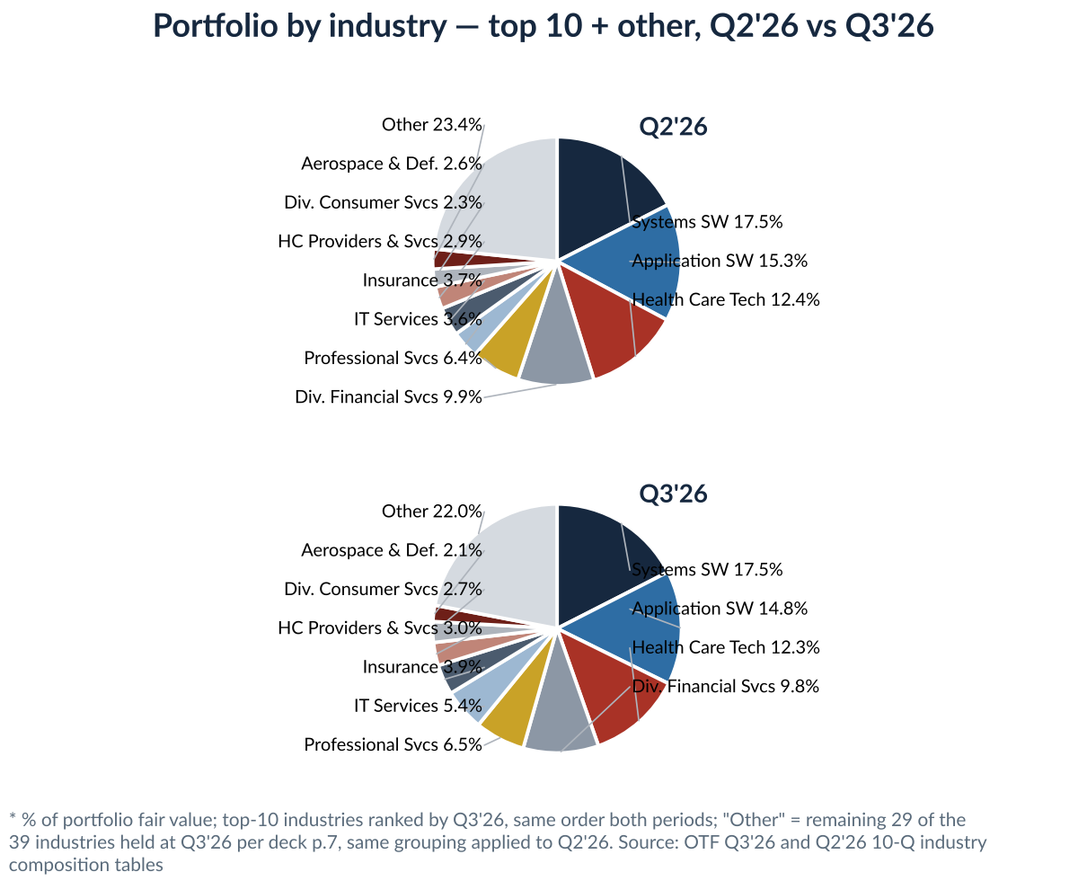
Borrower fundamentals
Borrower quality held: in the first & second lien cohort, 82.0% of fair value, EBITDA was $287mm vs $291mm, Net LTV 40% flat and enterprise value up $5.7bn → $6.2bn per deck p.7 — the loan book's equity cushion did not deteriorate this quarter. In the unsecured & equity cohort, 12.7% of fair value, weighted enterprise value jumped $15bn → $23bn QoQ, which is marks on a handful of large private names rather than new underwriting.
Weighted average borrower metric | Q2'26 | Q3'26 | QoQ Chg
Revenue, first & second lien cohort | $1.0bn | $0.9bn | ↓
EBITDA, first & second lien cohort | $291mm | $287mm | ↓ −$4mm
Net LTV, first & second lien cohort | 40% | 40% | flat
Enterprise value, first & second lien cohort | $5.7bn | $6.2bn | ↑ +$0.5bn
Enterprise value, unsecured & equity cohort | $15bn | $23bn | ↑ +$8bn
Average investment size, whole portfolio | $71.6mm | $71.6mm | flat
Portfolio companies | 205 | 207 | ↑ +2
* Source: OTF Q3'26 Earnings Presentation p.5 and p.7. Borrower financials are typically one quarter in arrears and not independently verified per the deck's endnote 10; Net LTV = last-dollar attachment over estimated enterprise value per endnote 20.
Software layer exposure, T3: tiering each portfolio company in the Q3’26 schedule of investments by the house layer framework puts Application at 53.4% of portfolio fair value, Platform 5.4%, Infrastructure 14.3% and Non-software 26.8%. Blended AI exposure on the tier weights — Application 30%, Platform 20%, Infrastructure 5%, Non-software 0% — is 17.8% of fair value.
Layer, % of fair value | Q3’26 | Largest positions, fair value $mm
Application | 53.4% | Inovalon 259, Certinia 226, CSI 226
Platform | 5.4% | Boomi 189, Databricks 130, Tricentis 118
Infrastructure | 14.3% | Arctic Wolf 315, New Relic 209, Nexthink 189
Non-software | 26.8% | Revolut 258, LSI 231, Audiotonix 214
Total | 100.0% | —
* Company-level tiering recomputed this quarter from the Q3'26 10-Q schedule of investments — the frozen layer map is not in this folder, so Application/Platform boundary calls may differ from the prior freeze and the mapping is pending sign-off. Parsed schedule total $14,889mm vs the reported $14,815mm, +0.50%; industry sub-totals reconcile to the 10-Q composition table within ±0.1pp. AI tier weights per the 2026Q1 industry AI tiers table.
2.2 Financial & debt
Cash yield trend
Asset yields inched up while funding repriced faster: total portfolio yield 9.0% at fair value, ↑ +0.1pp QoQ, debt & income-producing 9.8%, ↑ +0.2pp, against a funding cost of 5.9%, ↑ +0.2pp, on 3M SOFR at 4.1%, ↑ +0.4pp, per deck p.5 and p.12. New commitments priced at 9.1% with a 5.1% spread. The gross asset-to-funding gap is 3.9pp and has held in a 3.5–3.9pp band for five quarters — the margin story is stable; the expense line is not, with interest expense at $117.3mm, ↑ +$8.5mm QoQ.
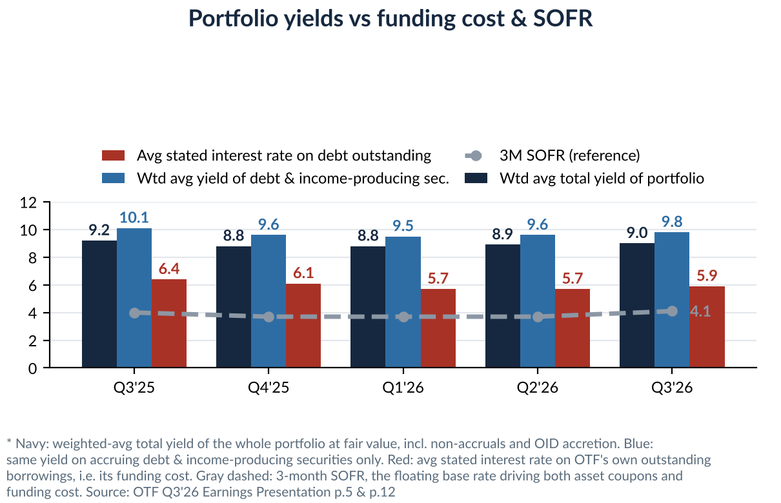
NAV bridge
NAV $16.48 → $16.62, ↑ +0.8% QoQ — the first increase since Q4'25. The bridge: +$0.29 adjusted NII, −$0.40 dividends declared, +$0.06 accretion from repurchases below NAV, +$0.19 realized and unrealized gains and other, per deck p.11. That is two straight quarters of net positive marks, +$0.03/sh in Q2'26 and +$0.19/sh in Q3'26, against the −$0.84/sh Q1'26 markdown — the 0.55x price-to-NAV discount is not being fed by the reported marks.
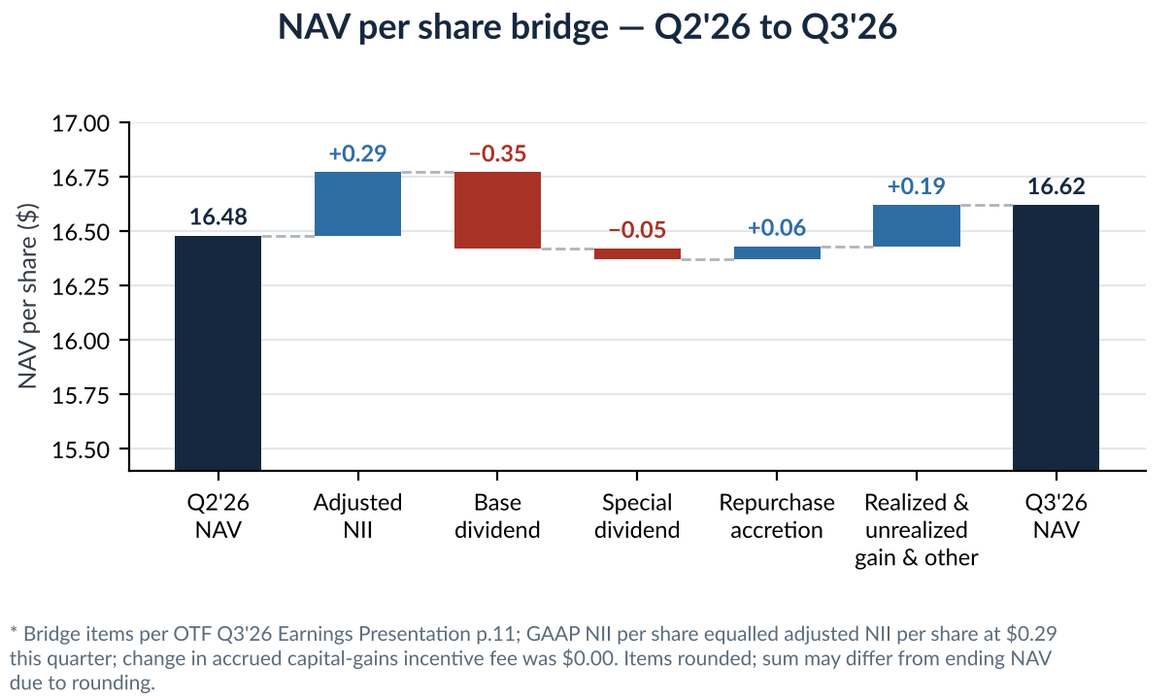
NII & dividend coverage
NII $0.29/sh, ↓ $0.01 QoQ; GAAP equalled adjusted for the second quarter running — zero capital-gains incentive accrual either way, per deck p.20. Coverage: 73% of the $0.40 total declared, 83% of the $0.35 base. The $0.05 listing specials ended with the October 6 payment, so from Q4'26 the declared dividend is $0.35 against $0.29 of run-rate NII — a ~$0.06/sh gap — and the November 3 board declaration held the base at $0.35 rather than cutting toward NII. Spillover and the fee structure carry the difference for now; the coverage math is the single number to re-run each quarter.
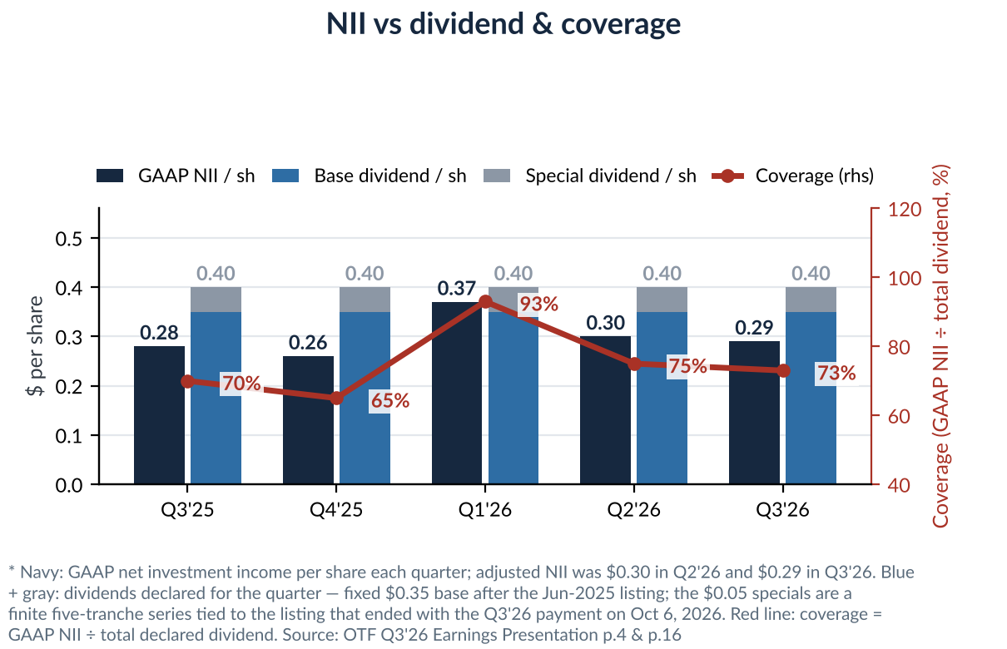
Financing profile
Total debt $7,325mm outstanding at par on $9,965mm committed; 43% unsecured, weighted average maturity 5.6 years, and $2.9bn of liquidity in cash and undrawn capacity, per deck p.14. The nearest maturity is the $300mm January 2027 notes at a 2.50% coupon — the cheapest liability in the stack — so every refinancing step from here reprices upward against the 6.10–7.60% coupons on the 2028–2032 notes.
Facility | Committed | Outstanding | Interest rate | Maturity
Revolving Credit Facility | $2,675mm | $1,015mm | S + 1.875% | 6/16/2031
SPV Asset Facilities I–VI | $3,200mm | $2,220mm | S + 2.00–2.25% | 2030–2036
Athena CLO II / IV / V | $915mm | $915mm | S + 1.76–2.05% | 2037–2039
January 2027 Notes | $300mm | $300mm | 2.50% fixed | 1/15/2027
March 2028 Notes | $650mm | $650mm | 6.10% / S + 1.767% swapped | 3/15/2028
September 2028 Notes | $75mm | $75mm | 8.50% fixed | 9/27/2028
April 2029 Notes | $700mm | $700mm | 6.75% / S + 2.5645% swapped | 4/4/2029
October 2029 Notes | $900mm | $900mm | 6.50% / S + 2.457% swapped | 10/15/2029
January 2031 Notes | $400mm | $400mm | 6.125% / S + 2.495% swapped | 1/23/2031
September 2032 Notes | $150mm | $150mm | 7.60% / S + 3.228% swapped | 9/3/2032
Total debt, par | $9,965mm | $7,325mm | — | WAM 5.6y
* Source: OTF Q3'26 Earnings Presentation p.14; SPV facilities and CLOs grouped here — the deck lists each line. Q2'26 drawn amounts, the T5 QoQ column, follow once the Q2 deck is in the folder.
Leverage ratio
Net leverage 0.94x debt-to-equity, ↑ +0.01x QoQ, inside the 0.90–1.25x target; regulatory asset coverage 201% at Q3'26 against 226% at YE25 and the 150% statutory floor, per the 10-Q. The cushion is adequate but one-directional — leverage has risen five straight quarters from 0.57x at Q3'25 as the OTF II merger debt, deployment and buybacks worked through the balance sheet.
Metric | Q2'26 | Q3'26 | QoQ Chg
Net leverage, debt-to-equity | 0.93x | 0.94x | ↑ +0.01x
Management target range | 0.90–1.25x | 0.90–1.25x | —
Asset coverage, 1940 Act, 150% floor | YE25: 226% | 201% | —
Debt headroom to 1.25x target, derived | — | ≈$2.3bn | —
Portfolio decline absorbable to the 150% floor, derived | — | ≈24% of FV | —
* Net leverage and target per deck p.2; asset coverage per the Q3'26 10-Q, Note 6 — the Q2'26 coverage ratio is not restated there, so YE25 is shown. The two derived rows are our arithmetic on Q3'26 equity of $7.52bn and debt of $7.17bn carrying value, not company disclosures.
2.3 Default concern
PIK
PIK income was $39.2mm in Q3'26 — $24.9mm PIK interest plus $14.3mm PIK dividends — equal to 11.5% of $341.3mm total investment income per the 10-Q income statement, down from a 12.8% average across 1H26. The denominator effect of the Signifyd preferred going on non-accrual cuts the forward PIK-dividend line: its 11% PIK dividend stops accruing from the placement date.
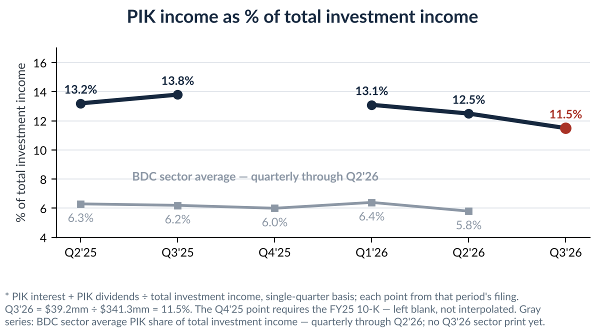
Figure 5 sets it against the sector: the BDC average PIK share of total investment income was 5.8% in Q2'26, down from 6.4% in Q1'26 per the MS tracker Exhibit 22 — OTF's 11.5% runs at roughly twice the sector average even after declining in every reported quarter from 13.8% in Q3'25. No Q3'26 sector print is out yet.
Non-accrual
Non-accruals tripled: 1.8% of cost and 1.1% of fair value at Q3'26, from 0.6% and 0.1% at Q2'26. Three issuers per the 10-Q schedule: the Pluralsight loans at $64.8mm cost, the Halo Purchaser equity at $53.1mm, and — added this quarter — the Signifyd preferred at $158.7mm cost held at $122.9mm. Two features frame it: the new name is a preferred whose PIK dividend stopped accruing, income-statement pain rather than a loan payment default; and the pool is carried at 58% of cost, so $116mm of loss content is already in the marks.
Non-accrual, % of total portfolio | YE25 | Q2'26 | Q3'26
At amortized cost | 0.4% | 0.6% | 1.8%
At fair value | 0.2% | 0.1% | 1.1%
Issuers on non-accrual | 2 | 2 | 3
* YE25 and Q3'26 per the Q3'26 10-Q performing/non-accrual table and schedule-of-investments footnotes; Q2'26 per the Q2'26 10-Q performing/non-accrual table. One issuer added in Q3'26 per the 10-Q MD&A.
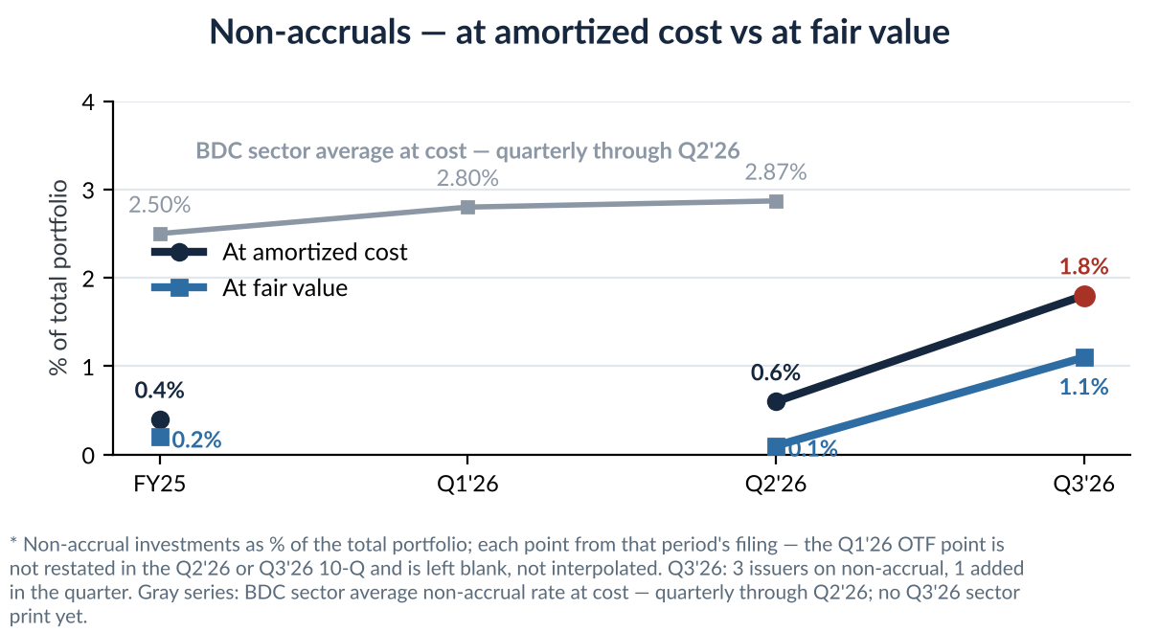
Figure 6 does the same for non-accruals: the sector average at cost reached 2.87% in Q2'26, a five-year high per the MS tracker Exhibit 18, and the industry jump is itself Medallia-driven — MS shows technology-sector non-accruals falling from 2.1% to 0.7% once Medallia is excluded. OTF's Halo Purchaser equity is that same Medallia exposure. At 1.8% of cost OTF still sits below the sector average even after this quarter's tripling; the sector print covering Q3'26 is not out yet.
Internal risk rating
Ratings moved both ways and do not yet confirm the non-accrual signal: rating-1 rose to 12.4% of fair value, rating-3 rose 7.1% → 9.0%, ↑ +1.9pp QoQ at $1,327mm, and rating-4+5 fell to 0.4%. The watch-list build is in rating-3 while the bottom ratings sit near zero — the Q4'26 credit question is whether that rating-3 build feeds the non-accrual line the way the Signifyd preferred did this quarter.
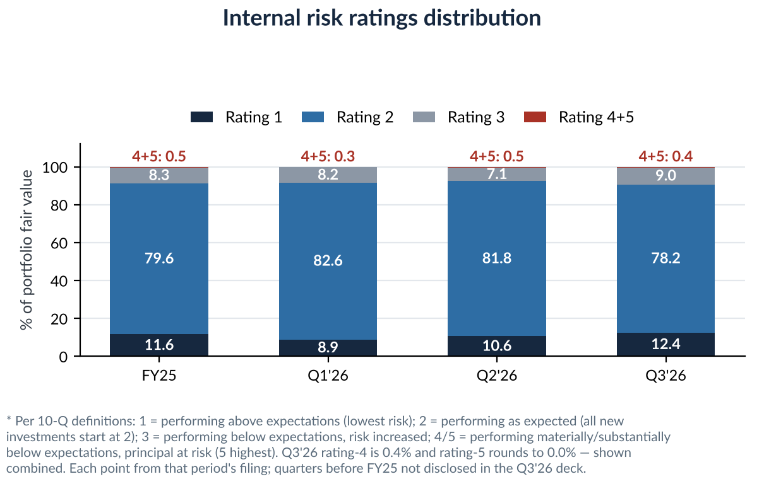
2.4 Share price & sell-side view — anatomy of the de-rating
Conclusion first: the stock has been de-rated, not downgraded by its own numbers. OTF's reported credit was the cleanest in its comp set at Q2'26 — non-accruals 0.6% of cost / 0.1% of fair value and internal ratings 4+5 at 0.5% per the 10-Q — yet the share price fell from $11.46 on August 14, prior-report price ledger, to ~$9.2 on October 13, MarketBeat, a ~20% drop that took price-to-NAV from 0.70x to 0.56x on the unchanged Q2 NAV. The market was repricing the discount rate and the 2027–28 outlook for software credit, the dividend, and the Blue Owl platform — all things outside the quarter's P&L. The Q3'26 print then validated the NAV side, $16.62 up $0.14, while adding the first real credit datapoint — the non-accrual step-up in 2.3. Section 2.4.2 sizes each driver.
2.4.1 Price path since the Q2 print
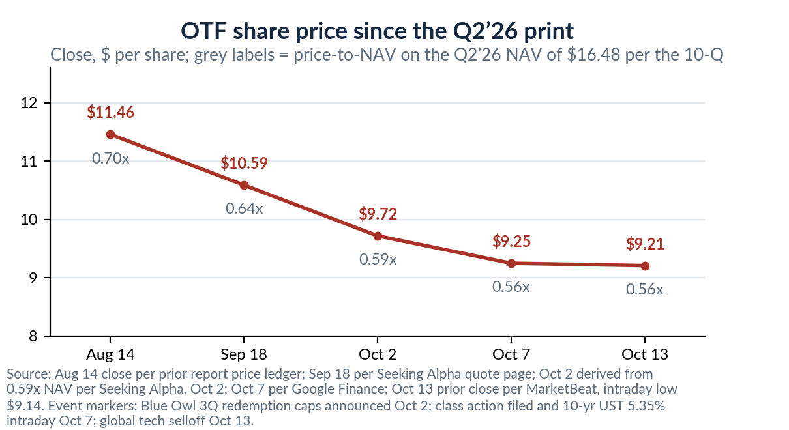
Date | Price $ | P/NAV (x)* | Marker | Source
Aug 5 | — | — | Q2’26 results: adj NII $0.30, NAV $16.48, first quarter without NAV decline since listing | OTF Q2’26 10-Q / earnings release
Aug 14 | 11.46 | 0.70 | Post-earnings rebound high in last quarter’s ledger; Cliffwater BDC index returned +9.1% in August | Prior report prices.csv; MS tracker Exh 1
Sep 18 | 10.59 | 0.64 | Drift lower as UST yields climbed through September | Seeking Alpha quote page, Sep 18
Oct 2 | ~9.7 | 0.59 | Blue Owl 3Q redemption caps announced — OTIC 39%; sell-side notes OTF at 0.59x after a ~40% one-year selloff | Bloomberg Oct 2; Seeking Alpha Oct 2
Oct 7 | 9.25 | 0.56 | 10-yr UST touches 5.35% intraday, highest since 2002; OTF class action filed same day | Google Finance; CNBC Oct 7; GlobeNewswire Oct 7
Oct 13 | ~9.2 | 0.56 | New 52-week low $9.14 intraday amid global tech selloff; prior close $9.21 | MarketBeat Oct 13; EverHint Oct 13
* P/NAV computed on the Q2'26 NAV of $16.48 per the 10-Q, the latest reported during the window; the Q3'26 NAV of $16.62, reported November 4, puts the October 13 close at 0.55x. Cumulative: −28.2% YTD per TipRanks, Oct 13; ~−44% since the June 12, 2025 listing, derived from the prior report’s −30.8% listing-to-Aug-14 return at $11.46.
2.4.2 Five drivers, in order of weight
Driver 1 — The rate shock hit yield vehicles first
A 15%-yielding, NAV-discounted BDC is a long-duration income instrument; the September Fed hike, per Morningstar, and the 10-year’s run from ~4.2% at year-end to 5.24% by October 9, +107bp YTD per Nuveen, mechanically raise the required return on that income stream. The sector shows the same pattern: BDC bond spreads widened ~20bp off the +161bp late-September tights per Barclays, October 6, the BDC–BB spread basis turned negative for the first time this year per the same report, and BDC equities were already lagging before this leg — −0.4% YTD through August 31 versus +12.3% for the S&P 500 and +2.2% for BDC bonds per Morgan Stanley. OTF, the highest-yield name in the comp set, has the longest lever to this repricing. Fundamental offset to keep in view: OTF’s book is 100%-floating on new commitments per the Q2 10-Q, so higher-for-longer supports asset yields even as it de-rates the equity.
Driver 2 — OTF is the market’s purest AI-credit short
Software & services is 64% of OTF’s fair value per Morgan Stanley’s September 8 BDC screen on PitchBook data, versus 22% at ARCC, 21% at BXSL and 18% at OBDC — nothing else of OTF’s size comes close. Every piece of software-credit research therefore trades through OTF: Barclays’ October 6 report put the 2028 software maturity wall on page one — software is 21% of BDC AUM, 2028-maturing software loans are marked $89.4 versus $92.8 for non-software 2028 paper, and the one BDC disclosing marked software LTV, Oaktree Specialty Lending, reported 56% at June 30 versus 47% at December 31. Morgan Stanley adds the fundamental case: S&P-tracked software names carry 8.1x median leverage against 7.1x all-sector and 1.5x cash interest coverage, the lowest of the top ten sectors. Realized stress remains limited — Fitch software LTM defaults of 1.2% versus 6.0% for direct lending overall, per MS — but with the October 13 tech selloff the market is not waiting for defaults to reprice the equity. Note the sector’s own caveat, per MS: software exposure has so far been a weak predictor of BDC returns — GSBD at 47% software returned +19% YTD while OTF at 64% returned −14% through August 31 — which is consistent with OTF’s discount being as much about flows and platform as about assets.
Driver 3 — The Blue Owl platform overhang
OTIC — the non-traded sister fund running the same technology-lending strategy — drew 3Q repurchase requests of 39% of shares, the worst in the industry against 10–17% at the largest managers, per Reuters, October 2. That reads through to OTF three ways: it signals how the marginal private-wealth holder values the same assets; it raises the possibility of strategy-level asset sales setting price discovery; and it pressures the manager — OWL is −40% YTD at ~$9.4 per MarketScreener and CNN, with Wells Fargo initiating at Equal Weight on October 1 saying recovery needs time. Cross-holdings deepen the linkage: 65% of OTF’s AUM by cost is invested in issuers also held by OBDC, per Morgan Stanley’s overlap matrix, so the market treats Blue Owl credit marks as one book. The counterpoint: platform redemption totals are falling — $4.2bn in 3Q from $5.4bn in 1Q per Reuters — and OTF itself is a closed, listed vehicle with no redemption mechanics.
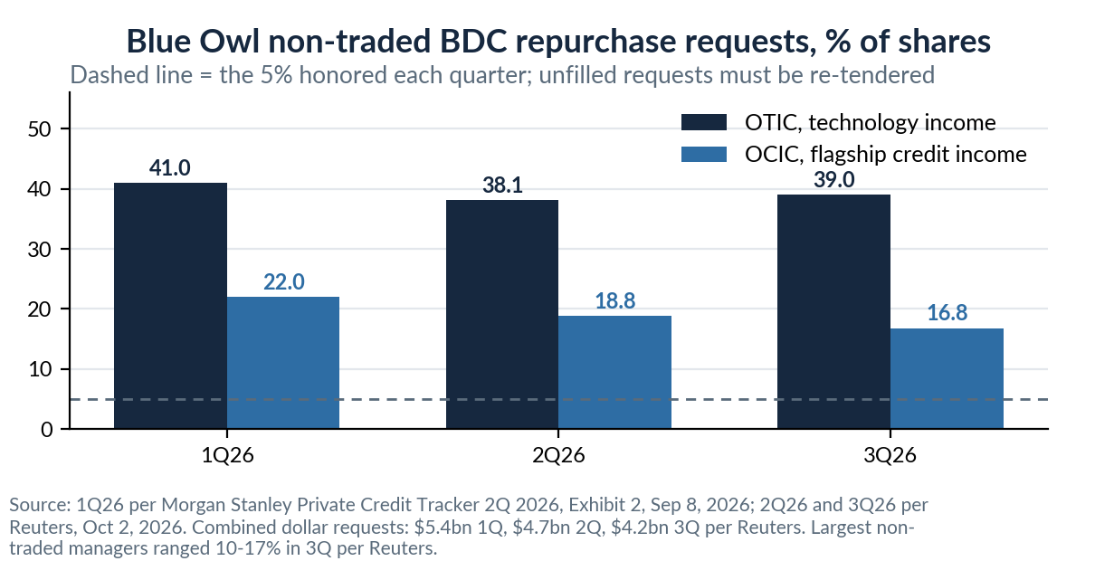
Driver 4 — The dividend reset is being priced now
The $0.05 listing specials ended with the October 6 payment per the dividend history, so Q4’26 begins the clean $0.35 base run-rate. Against that base, Q2’26 adjusted NII of $0.30 covers 86% per the 10-Q, and consensus Q3 adjusted NII of $0.32 per Earnings Whispers still leaves coverage below 100%. Management’s bridge — leverage toward the ~1.08x midpoint, 150–200bp wider new-deal spreads, repricing ~$4.7bn of below-market loans, and rotating ~$125mm of residual SpaceX gains, per the Q2 earnings call recorded in last quarter’s ledger — lands at full base coverage only around mid-2027. A 15.1% forward yield per Google Finance is the market saying it does not believe the $0.35; the October 13 TipRanks note tied the latest leg down explicitly to dividend-sustainability doubt, and the October 2 Seeking Alpha piece models a reset toward ~$0.30 absent an earnings recovery.
Driver 5 — Litigation drip and a one-sided flow picture
Litigation moved from investigation notices to filed cases: the Section 36(b) excessive-fee suit, filed June 18 in the SDNY alleging 2021–25 fees grew +191% against +134% asset growth per last quarter’s news ledger and the related Form 40-33 exhibits, was joined on October 7 by the Girard Sharp securities class action for former OTF II holders, per GlobeNewswire. Neither quantifies near-term economics, but both keep headline risk attached to the fee structure and the merger marks. On flows, the buyback is the only structural bid: Q2 repurchases were $55.1mm at ~$10.96 average with $194.7mm left of the $300mm OTF program per the Q2 10-Q — roughly 1.3% of the $4.2bn market cap per quarter at that pace, against ~2.2mm shares of average daily volume per CNN, while the post-June-2026 lock-up shareholder base per last quarter’s ledger still lacks a natural institutional buyer at this discount.
2.4.3 What was priced in and what the sell side said into the print
- Priced in: at 0.56x NAV the market was implying either a NAV markdown far beyond anything reported — Q2 marks were net positive, +$34.7mm unrealized per the 10-Q — or a required yield above 15% on the base dividend. The October 2 Seeking Alpha analysis framed the price as implying default and loss assumptions many multiples of the then-reported 0.6%-of-cost non-accrual level; the Q3'26 print moved that reference point to 1.8% of cost.
- Sell side: consensus Moderate Buy, average target $13.60 with 4 Buy / 3 Hold per MarketBeat, October 13; the range is $11.00 BofA, cut August 24, to $17.00 Citizens JMP, raised August 6, per CNN’s action log — targets imply +19% to +84% from $9.25 per Google Finance, which mostly tells you the targets have not caught down to the tape.
- Watch Nov 4–5: Q3 NAV and the technology marks — sector tech marks fell from 99.3 to 96.5 over 1H26 per Morgan Stanley, so a flat OTF NAV would be a differentiator; the Q1’27 dividend declaration — any base-dividend language matters more than the NII print; buyback pace against the $194.7mm remaining authorization; OTIC 4Q redemption requests, due early January; and docket movement on the two filed cases.
- Post-print scorecard, November 4: Q3'26 NAV $16.62, ↑ +0.8% QoQ, against the markdown scenario; the Q4'26 base dividend was held at $0.35; repurchases ran $55mm in Q3'26 at a ~$11.03 average — none in July, none disclosed for October — with $139.5mm of the $300mm program left; the negative was credit, non-accruals 0.6% → 1.8% of cost on the Signifyd preferred. Sections 2.1–2.3 carry the detail.
2.5 Price comparison — vs BDC peers and vs software equities
Measured from the June 12, 2025 listing, OTF is down 43.3% through October 8 — against −15.9% for ARCC, −19.7% for GBDC, −24.3% for BXSL, −25.2% for TSLX and −31.0% for OBDC (anchor prices and sources per the chart below). Two readings. First, the whole sector is down — that is the rates story of Driver 1 — but OTF sits roughly 12pts below the next-worst name. Second, the next-worst name is OBDC, the Blue Owl diversified sibling: on the August 14 to October 8 leg OTF fell 18.1% ($11.46 to $9.39) and OBDC 13.2% ($11.72 to $10.17), against −5.7% for ARCC, −2.3% for BXSL, −6.4% for TSLX and −7.9% for GBDC — the two Blue Owl vehicles occupy the bottom two slots of the recent drawdown, which is direct market evidence for the platform overhang of Driver 3 being priced across the complex rather than against OTF’s software book alone. The valuation panorama matches: per Raymond James (Oct 8, FactSet data) the sector trades at a mean 0.74x and median 0.68x P/NAV, with ARCC at 0.97x, BXSL 0.94x, TSLX 1.08x, GBDC 0.86x, OBDC 0.71x and OTF at 0.57x near the bottom of the table. One detail in the same dataset is worth keeping: on FactSet 2026E EPS, OTF trades at 7.3x against a sector median of 7.4x — the entire discount sits in the NAV multiple, not the earnings multiple. The market is pricing NAV risk, not an earnings collapse this year.
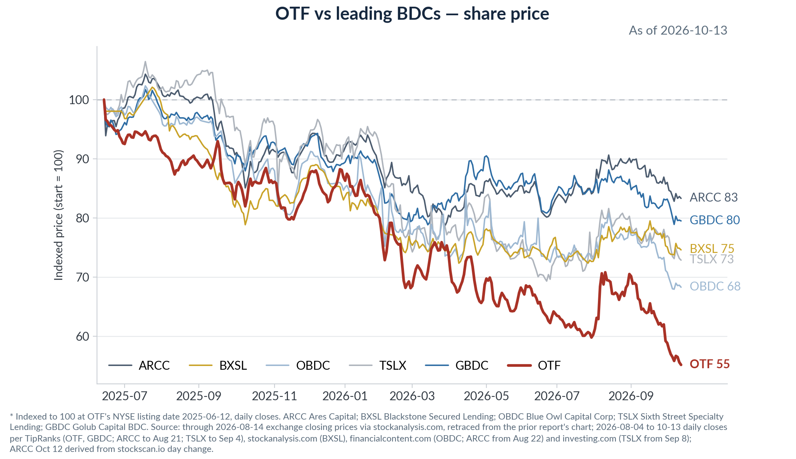
Against the software sector itself the picture splits by period. Since listing, OTF (−44.4% through Oct 13) has drawn down more than every software bellwether — NOW −31.3%, ORCL −28.4%, CRM −10.8%, MSFT +9.2% — a senior-secured lender’s equity falling further than the equities of the sector it lends to, which is what roughly 0.95x regulatory leverage (94.9% debt/equity per Raymond James, Oct 8) plus the income-vehicle discount mechanism produce. The recent leg is the more telling one: since August 14, software has rebounded — CRM +21.3% ($196.21 to $238.01), NOW +11.8% ($124.00 to $138.61), MSFT +5.5% ($495.40 to $522.61), ORCL −4.9% ($150.52 to $143.20) — while OTF fell a further ~20% ($11.46 to $9.21). Even on October 13, the global tech selloff day, ORCL rose 4.2% (stockanalysis.com) while OTF printed its 52-week low. The implication: the latest leg of OTF’s decline is not software equity beta — software beta would have pulled OTF up since mid-August — it is the BDC-specific stack of Section 2.2 (rates duration, Blue Owl platform, dividend reset, litigation). The software-concentration driver runs on the slower clock of the 2028 maturity wall in Section 3 and explains the since-listing gap to diversified BDCs; the August-to-October gap belongs to the platform and income-vehicle factors. One caveat cuts the other way: listed mega-cap equity performance is a poor proxy for the credit health of sponsor-owned mid-size software borrowers at 8.1x median leverage (S&P data per Morgan Stanley) — the recovery of the listed right tail says little about the left tail OTF lends into, which is why the Barclays mark-versus-BSL question in 3.2 remains the harder test than any chart of MSFT.
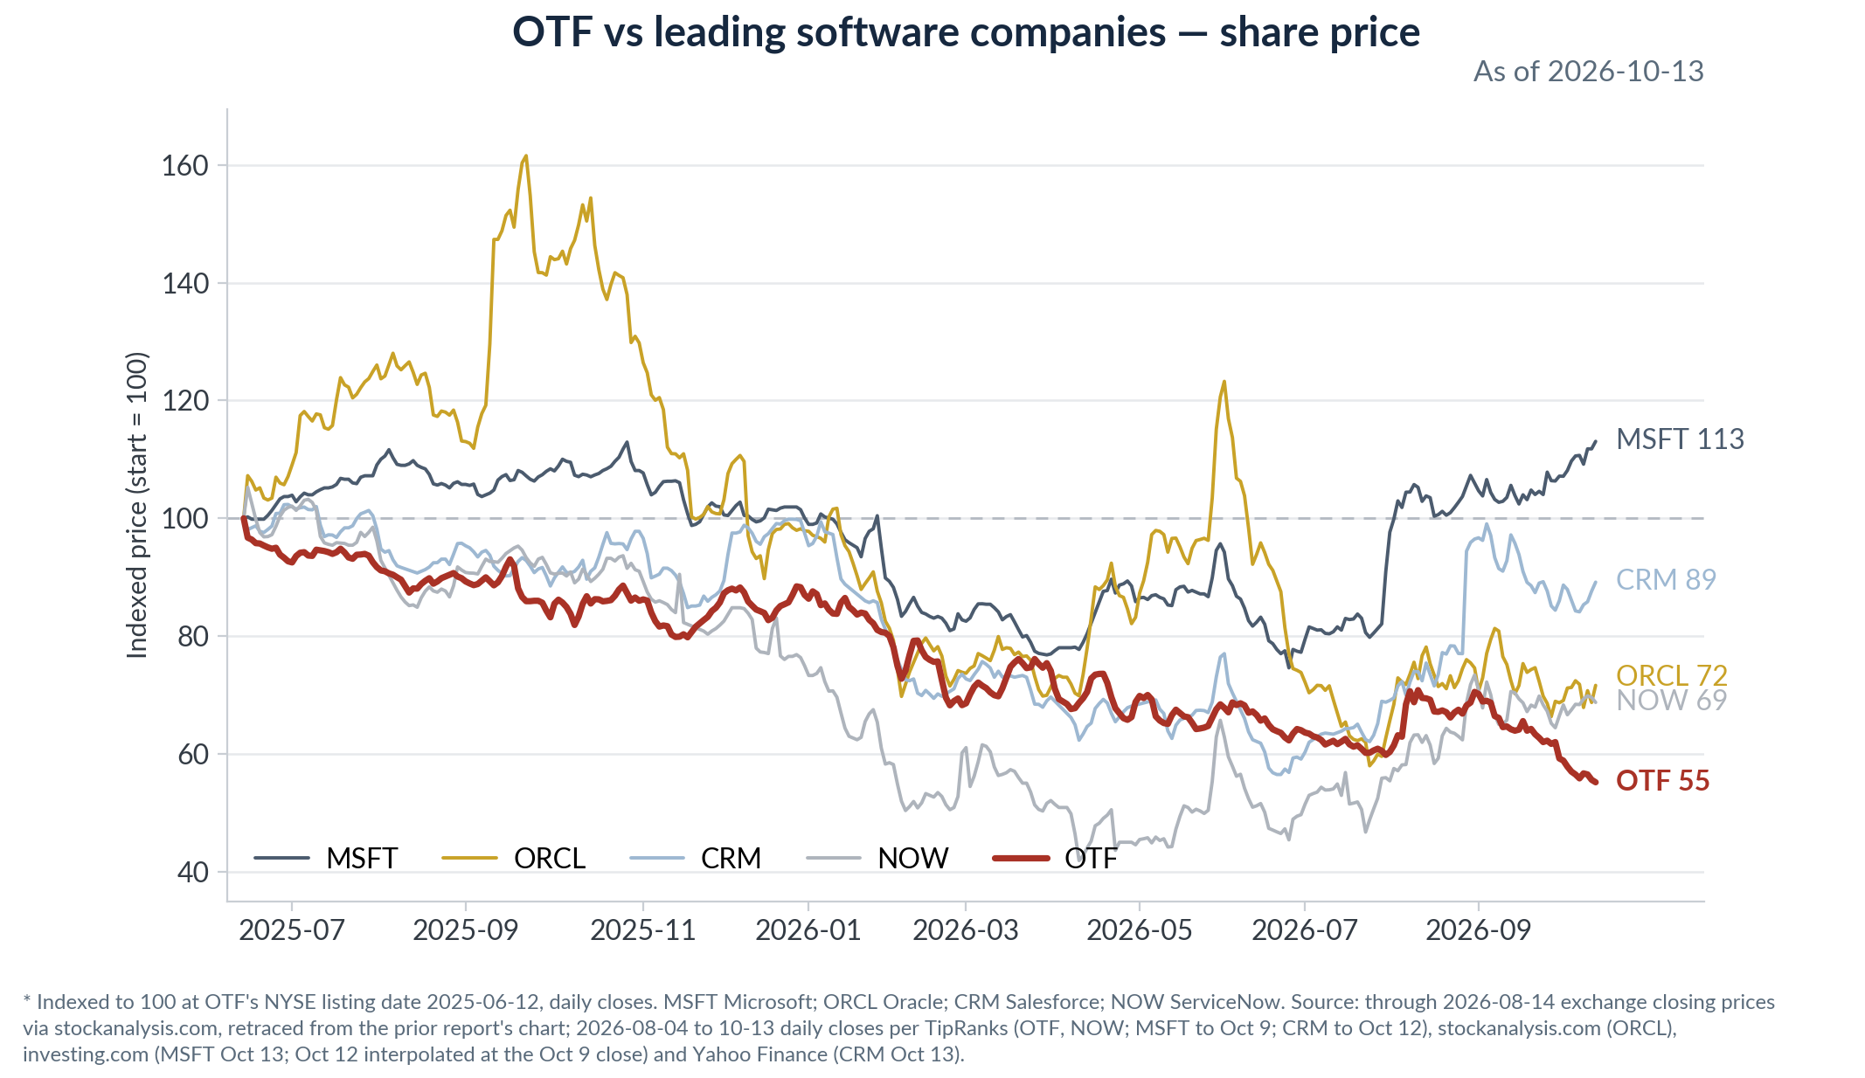
2.7 Things we should know
SpaceX — Class C monetized, Class A still on the book
OTF sold its SpaceX Class C common stock in Q3’26: the MD&A attributes part of the quarter's realized gains to exited investments whose prior unrealized gains reversed, and SpaceX is the single largest line in the ten-largest unrealized-change table at −$85.7mm, while the schedule of investments now carries only the Class A position, $125.3mm fair value against $7.6mm cost. It matters because it turns a slice of the portfolio's most-questioned line——large private marks——into realized cash gains, and those gains feed the spillover that stands behind the held $0.35 base dividend. The remaining Class A sits at roughly 16x cost and stays a concentrated unrealized gain. Watch next quarter: whether Class A follows, and how much of dividend coverage is realized-gain spillover versus NII. Source: Q3'26 10-Q MD&A unrealized table and schedule of investments; Class A cost per the prior report's ledger.
AI-compute lending steps up — Nscale and CoreWeave
AI-compute exposure stepped up materially this quarter: the Nscale delayed-draw term loan went $7.0mm funded at Q2'26 → $51.2mm at Q3'26 with $145.4mm still committed undrawn, maturity August 2027; a CoreWeave financing DDTL is a new name at $9.0mm funded and $6.0mm unfunded, December 2026; and the Nscale Series B preferred was the quarter's second-largest unrealized gain at +$19.4mm. This is different underwriting from sponsor software lending——short-dated, fast-drawing, tied to GPU build-out economics rather than ARR——inside the same book whose software core is shrinking. The transmission is forward: ~$151mm of undrawn compute commitments keeps funding into Q4'26. Watch: draw pace, whether further compute names enter, and the internal ratings these credits carry. Source: Q3'26 and Q2'26 10-Q schedules of investments and unfunded-commitment tables; MD&A unrealized table.
3. Private credit & public BDC industry
3.1 Broker view summary — reports in this quarter’s folder
Broker | Report / date | Key points, each with the numbers
Barclays | BDCs: Software Flips Focus to the Other Side of the Balance Sheet — Oct 6, 2026 | Valuation focus shifts in 2027 from redemptions to the asset side: software is 21% of BDC AUM per PitchBook 2Q26 and 2028 software maturities ramp alongside the broader book.  Marks already differentiate the front end: software weighted-average mark $93.1 at Jun 30, −1pt vs 4Q25 and ~−3pts vs YE24; 2028 software marked $89.4 vs $92.8 for non-software 2028 paper; BSL software index trades high-$80s, with far wider dispersion than BDC marks.  LTV evidence is thin: origination software LTVs reported at 35–45%; the one marked disclosure, OCSL, moved to 56% at Jun 30 from 47% at Dec 31.  RV: BDC spreads +20bp off YTD tights of +161bp; BDC–BB basis now negative for the first time this year, so BDC paper screens rich; prefers adding on spread pickup to BBs.  Flows: perpetual-BDC net flows −$0.6bn 1Q26, −$3.1bn 2Q26, −$3.1bn 3Q26 vs +$11.2bn as recently as 3Q25; redemption requests honored ~5% per quarter.
Morgan Stanley | Private Credit Tracker 2Q 2026 — Resilience Meets Refinancing Risk — Sep 8, 2026 | Bonds over equities: BDC bonds +2.2% YTD vs Cliffwater BDC equities −0.4% through Aug 31; BDC bond OAS −92bp from the March wides, 7bp tighter than YE25; median public-BDC P/NAV 78% at Aug 31, +2pp QTD.  Fundamentals soften but concentrated: avg non-accruals 2.87% at cost, five-year high; public BDCs 5%, above the COVID peak, private BDCs still declining; Medallia alone is two-thirds of tech non-accruals — 2.1% falls to 0.7% excluding it; ex-top-3 the overall rate drops 2.0% to 1.5%.  PIK: income share down to 5.8% of TII from 6.4% in 1Q26, but loans with PIK up to 13% of the universe from 10% in 2022; avg PIK rate 4.2% vs 5.5% at YE22; sub-90-marked PIK at 2.5% and rising.  Software wall: PC software 2026–27 maturities cut to 5.7% from 8.4% YTD and 2028 to 16.7% from 18.9%, but sub-3-year maturities hit a series-high 32% vs 17% in 1Q25 — runway bought, problem deferred; software leverage 8.1x / coverage 1.5x per S&P; Fitch software LTM defaults 1.2% vs 6.0% direct lending overall.  Funding: $18bn of IG BDC/PC-fund bonds YTD, in line with 2025; 3Q new-issue spreads ~240bp; PC CLOs now ~12% of BDC funding per S&P, $25bn YTD issuance, AAA ~155bp, ~30bp over BSL.
J.P. Morgan | CLO — Private Credit Q&A — Sep 16, 2026 | PCLO issuance resilient: $25.8bn YTD, 22% of US CLO new supply vs 12% historical average — third-highest share ever after 2023 at 24% and 2009 at 28% — while total US CLO origination is −19% y/y.  Concentration flag: top-5 PCLO managers hold 52% of the $206bn market, more than the top-10 share in US BSL at 27% or EUR at 31%; only 71 PCLO issuers vs 166 US BSL.  RV: PCLO AAA primary 145bp = +26bp over BSL AAA at 119bp and −60bp inside BDC unsecureds at 205bp — for credit investors BDC paper offers the value.  Collateral: PCLO default exposure 0.75%; S&P CCC bucket 8%, inside PCLO limits of 15–20% but above the typical 7.5% BSL limit; loan default rate incl. distressed exchanges 2.33% per JPM HY.  BDC colleagues read the lack of new BDC bond supply as absence of balance-sheet pressure, while still tracking redemptions and non-accruals.
UBS | Public and Private Credit Outlook — Oct 12, 2026 | House stance: underweight private credit vs public market carry; model portfolio runs an explicit short private credit position; recession probability 15% over 12 months.  Rates: US 10y at 5.25% as of Oct 8, year-end forecast 4.80%; policy rate 4.00% top of range now, 4.25% by 4Q26 — higher-for-longer exposes low-quality borrowers first.  Refi wall is 2028–29, not now: near-term maturities manageable; risks build sharply in CCCs and technology-heavy private credit; default forecasts call a moderate uptick into year-end led by leveraged loans and private credit.  AI read: disruption is a leveraged-software problem, not a blanket short — evidence consistent with pricing-power pressure rather than business-model obsolescence; prefers equity-vs-credit and IG tech curve steepeners to express AI financing risk.  BDC data point: non-accruals held at elevated levels in Q2 while PIK rates eased; bankruptcy filings in tech, services and healthcare still trending higher per UBS Evidence Lab.
Source: the four reports in the 2026Q4 - Software/Industry folder: Barclays HG Financials & Leveraged Finance Research, Oct 6; Morgan Stanley Global Credit Strategy, Sep 8; J.P. Morgan Global Securitized Products Research, Sep 16; UBS Global Strategy, Oct 12. No research-analyst names are shown per house rule.
3.2 Consensus & key debate
Consensus, versus last quarter: the redemption story is fading as the headline risk; the software maturity wall is replacing it. All four brokers treat 2026 realized credit as contained — Fitch software defaults 1.2%, PCLO default exposure 0.75%, non-accrual increases traced to a handful of names led by Medallia — and all four date the real test to 2028, when software maturities concentrate. That is a change in kind from the 1H26 debate, which was about whether retail outflows would force asset sales; with Blue Owl requests down to $4.2bn in 3Q from $5.4bn in 1Q per Reuters and perpetual-BDC net outflows steady rather than accelerating at −$3.1bn per Barclays, the funding question is largely answered — liquidity levers, IG issuance of $18bn YTD per MS, and PC CLOs at ~12% of BDC funding did the work.
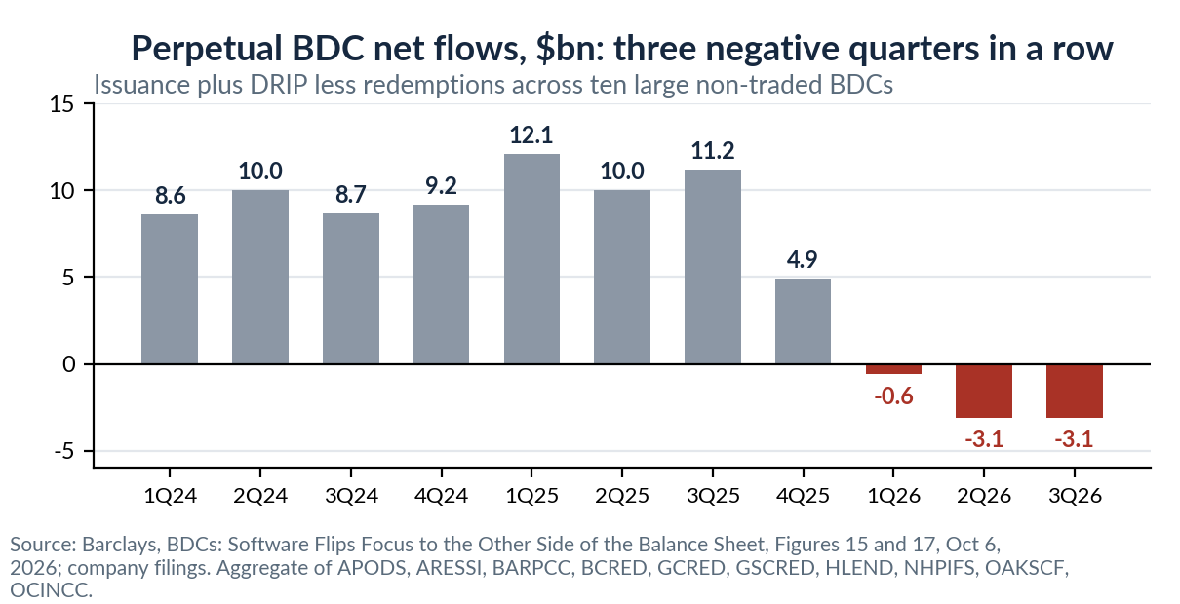
The debate is what an $89–93 software mark is actually worth. Barclays is the most pointed: a $93.1 average software mark prices software flat to the rest of the book, and even the $89.4 on 2028 paper may understate refinancing risk given the BSL software index in the high-$80s with much fatter left tails — the gap between BDC and BSL pricing of the same risk is the single number to argue about. Morgan Stanley’s version: BDC marks fell 0.9pt in 1H26 versus 1.6pt for BSL, in line with the historical 55% beta, so private marks are following, not denying, the public market. UBS turns the same evidence into positioning — underweight and short — while J.P. Morgan’s securitized-products desk draws the opposite relative-value conclusion from the same spread stack, preferring BDC unsecureds at 205bp over PCLO AAAs at 145bp. For OTF monitoring, the operative question for November 4 is which side of this mark debate the Q3 technology marks land on.
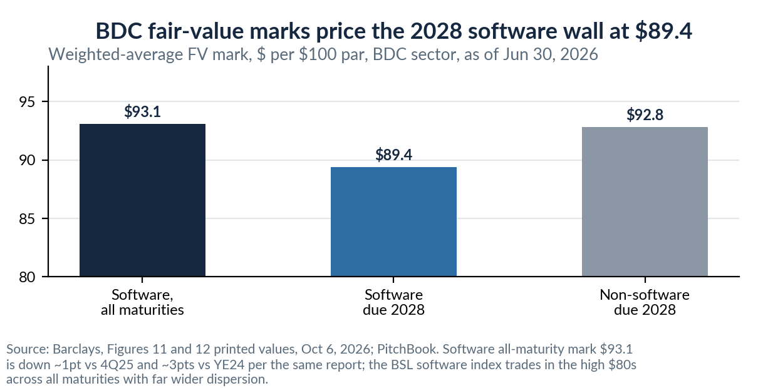
3.3 Software exposure in leveraged credit — the 2028 wall in numbers
- Stock of exposure: software is 20.8% of BDC investments at fair value per PitchBook 2Q26 in Barclays; software and IT services are 25% of BDC holdings per MS, with the broader IT category at 27%.
- Progress made: PC software maturities due 2026–27 fell from 8.4% to 5.7% of loans during 1H26, and 2028 from 18.9% to 16.7%, while 2033 maturities rose from 1% to 8% — classic push-out with new 7-year paper, per MS.
- Problem deferred: sub-3-year software maturities reached a series-high 32% in 2Q26 versus 17% in 1Q25 per MS; ~21% of all direct-lending assets mature by end-2028 versus ~17% in BSL, and PC CLO collateral is more front-loaded still at 34% by 2028 versus ~16% for BSL CLOs, per MS.
- The fundamental overlay: software median leverage 8.1x versus 7.1x all-sector and cash interest coverage 1.5x, lowest of the top ten sectors, per S&P data in MS — which is why the wall matters more for software than its 1.2% default rate suggests today.
- Rating signal, two-sided: S&P upgraded 8% of credit-estimated software names in 2Q26 against 5% downgrades, per MS — the winners-and-losers pattern rather than uniform decay.


