About Job 01 : Penetration Map

What is penetration rate? The definition of penetration rate is the numbers of member divided by households’ number given a specific area and period.

For example:

Penetration rate could be applied on several purposes. We could apply penetration rate on a four-quadrant diagram with X axis as household's number and Y axis as penetration rate to enact our business development strategy.

High households – High penetration: it indicates that our products are very competitive in this area and the residents are loyal to our brand. Our target is to keep them from switching to other brands.

High households – Low penetration: we could put more resources to develop the areas. They are more likely to perform higher growth return for our business

Low households – High penetration: it is very similar to High households – High penetration. Certain amount of resources are still needed to maintain the business of saturate market. Besides, new business ideas could be tested first in these areas and we can examine the effectiveness of those new ideas and further implement them into other market later on.

Low households – Low penetration: the ROI in this area is not high. Unless we have special target, maybe we could spend less time and money in this place.

Second, penetration rate contains households’ number, members’ number, geography information, etc. It facilitates data visualization work and helps the firm to grasp the environment efficiently. The firm then can enact business strategy based on the visualized analysis.

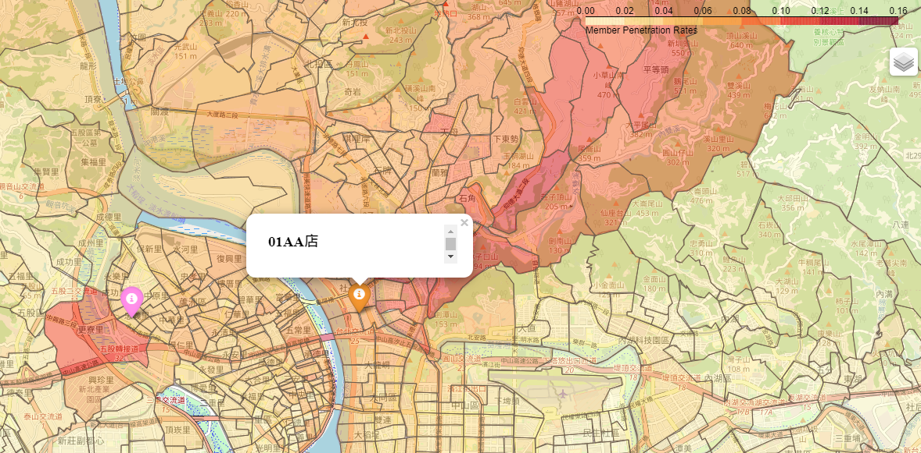

Look at the above picture. From the penetration map, we could find that most of the customers of 01AA-shop come from the north area. For people from the south, even the distance to our business location is closer, the existence of rivers and high-speed roads still become critical hurdles hindering them from visiting. The distribution is very uneven and we could make different strategies in different places.

Finally, through the penetration map, we could easily find potential business places. If we do not have any shops there, we could consider opening a new one. Besides, we could mark rival brands’ shops in the map. Combined with delta maps, the strategic business team could quickly observe the effects of new shops or rival shops.

It’s an article that I want to record my works and practice my English writing.If there is any suggestion or critique, please don't hesitate to give me any comment. I also upload python code and sample data to github. Website: <https://github.com/GallonShih/Projects/tree/main/AboutJob/PenetrationMap>