BI-VWM

Semestral Project

Documentation

Boolean Model

Galymzhan Dosmagambet

2020

**Project description**

The goal of the project is to implement and represent Boolean Model and Inverted Index search on different collections of documents. Representation includes comparison to Sequential (Linear) search over documents.

Output of the project is web application which uses Boolean model and Inverted index and Sequential search against 3 different sets of documents. Also application shows how much Boolean model is beneficial and prints out results of a query (list of documents).

• **Solution**

Main approach is built around Boolean model and Inverted index.

Before querying it is required to preprocess data:

* From each document in database terms are extracted and lemmatized.
* To every lemma a document it appears in is added (Inverted index).
* All lemmas stored in sorted LemmaStorage.

General algorithm of querying over text file database is:

* Receiving query.
* Extracting tokens for parsing.
* Parsing tokenized query using expression/term/factor (ETF) grammar and providing Abstract Search Tree (ATS).
* Going through ATS. In case of Sequential search tokens(lemmas) in leafs of ATS will be searched linearly through the whole database. When in the Inverted Index search list of documents where the lemma appears will be given right away. Then internal nodes of ATS (operators AND, OR, NOT) will process results of leafs. Time used for each search is recorded and saved as well as the result.
* Returning respond with needed operational time and query result.

**Implementation**

The web application is written in Java 8. It runs on Apache Tomcat 9 web server (<https://tomcat.apache.org/download-90.cgi>). And uses one third party library StanfordNLP for lemmatization (<https://stanfordnlp.github.io/CoreNLP/>).

Application has 3 logically different parts: Web Interface, Core and Database.

Web Interface is using Apache Tomcat to handle http communication. Java Servlets are used to serve http requests and responses among with JSP files to support dynamic web pages. Java Servlet uses Core (or main Service) to process queries.

Core of application is a Service which does all main logic and implements algorithms described above, but for 3 different databases (100, 500 and 1000 documents). It is made for representational and experimental purposes, so user can see efficiency growth with only one query.

Database as mentioned consists of 3 sets of text documents. It is not relational database, just text files.

Running requirements are Java 8 and Apache Tomcat 9 web server (but I believe 7+ should work too).

**Examples of Input and Output**

Input should be valid boolean query (only AND, OR, NOT, “(“, and “)” allowed).

*Input example:*

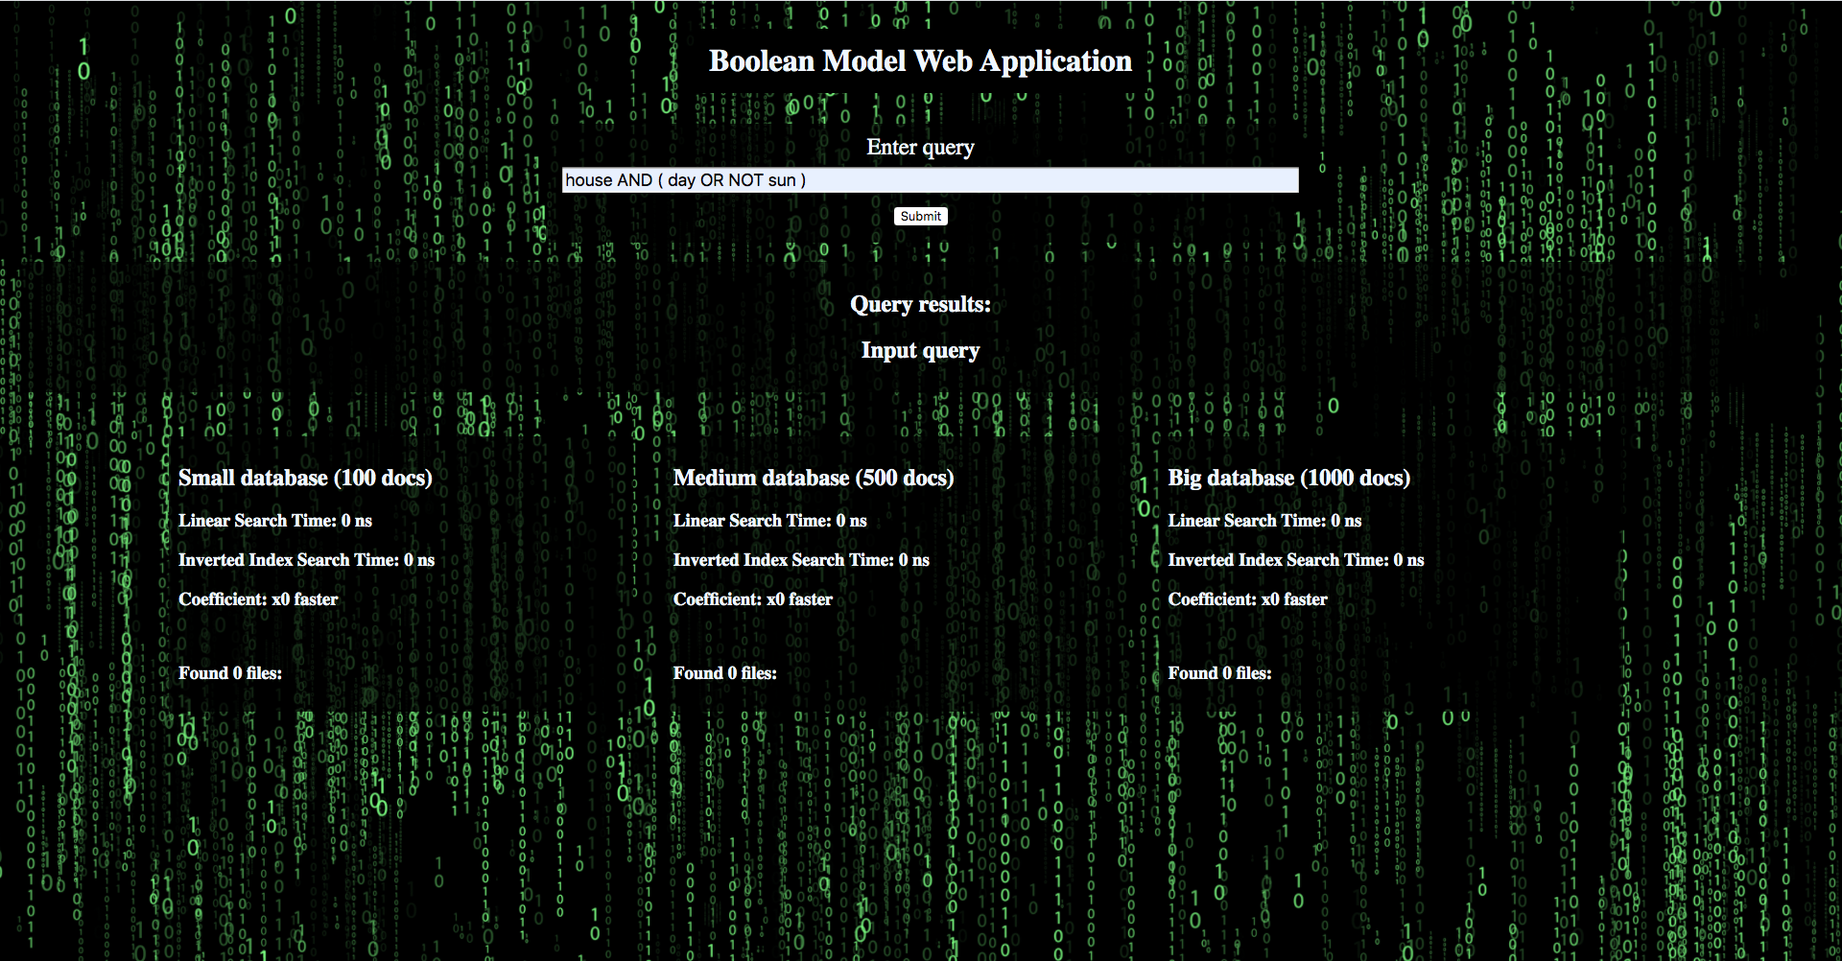

*Output example:*

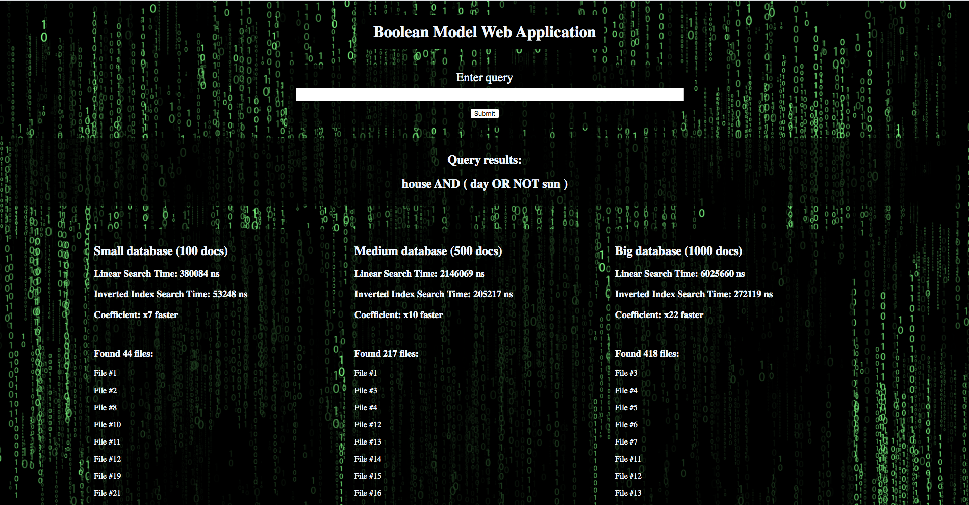

**Experiments**

Experiments were conducted at 3 different bases with different amount of documents to show how efficiency coefficient grows. On next 3 tables there are results for databases where queries are same.

|  |  |  |  |  |
| --- | --- | --- | --- | --- |
| **Small Database (100 docs)** | | | | |
| **Query** | **Linear time (ns)** | **Inv. Index time (ns)** | **Coefficient** | **Files** |
| money | 72318 | 5866 | 12 | 17 |
| house | 82250 | 6802 | 12 | 44 |
| office | 77469 | 6525 | 11 | 36 |
| NOT money | 162753 | 21489 | 7 | 83 |
| NOT house | 109010 | 15822 | 6 | 56 |
| NOT office | 107650 | 14646 | 7 | 64 |
| house AND day | 288668 | 28179 | 10 | 25 |
| house AND NOT day | 176005 | 24059 | 7 | 19 |
| house AND day AND sun | 187032 | 14770 | 12 | 1 |
| office OR flower | 109415 96436 | 6928 | 13 | 36 |
| office OR NOT flower | 133827 | 20538 | 6 | 100 |
| office OR flower OR gun | 157107 | 9958 | 15 | 39 |

|  |  |  |  |  |
| --- | --- | --- | --- | --- |
| **Medium Database (500 docs)** | | | | |
| **Query** | **Linear time (ns)** | **Inv. Index time (ns)** | **Coefficient** | **Files** |
| money | 879815 | 11565 | 86 | 98 |
| house | 955504 | 12590 | 75 | 220 |
| office | 1206609 | 15771 | 76 | 173 |
| NOT money | 759061 | 39015 | 19 | 402 |
| NOT house | 760360 | 54498 | 13 | 280 |
| NOT office | 810064 | 62304 | 13 | 327 |
| house AND day | 1566876 | 60244 | 26 | 154 |
| house AND NOT day | 1554633 | 98215 | 15 | 66 |
| house AND day AND sun | 1561487 | 51068 | 30 | 4 |
| office OR flower | 1079863 | 13236 | 81 | 181 |
| office OR NOT flower | 1509403 | 115611 | 13 | 492 |
| office OR flower OR gun | 1638884 | 25340 | 64 | 199 |

|  |  |  |  |  |
| --- | --- | --- | --- | --- |
| **Big Database (500 docs)** | | | | |
| **Query** | **Linear time (ns)** | **Inv. Index time (ns)** | **Coefficient** | **Files** |
| money | 2421929 | 18192 | 133 | 217 |
| house | 2853011 | 21611 | 132 | 423 |
| office | 3917387 | 23190 | 168 | 348 |
| NOT money | 2586434 | 70870 | 36 | 782 |
| NOT house | 2780836 | 106737 | 26 | 576 |
| NOT office | 2597284 | 89702 | 28 | 651 |
| house AND day | 4293803 | 88954 | 48 | 286 |
| house AND NOT day | 6195255 | 200898 | 30 | 137 |
| house AND day AND sun | 7945598 | 114984 | 69 | 9 |
| office OR flower | 4030245 | 21435 | 188 | 362 |
| office OR NOT flower | 5784310 | 165580 | 34 | 985 |
| office OR flower OR gun | 6505269 | 39833 | 163 | 394 |

On the next table shown comparison of coefficients between databases. It is clear that with bigger database speed of search increases dramatically.

|  |  |  |  |
| --- | --- | --- | --- |
| **Coefficients** | | | |
| **Query** | **Small DB** | **Medium DB** | **Big DB** |
| money | 12 | 86 | 133 |
| house | 12 | 75 | 132 |
| office | 11 | 76 | 168 |
| NOT money | 7 | 19 | 36 |
| NOT house | 6 | 13 | 26 |
| NOT office | 7 | 13 | 28 |
| house AND day | 10 | 26 | 48 |
| house AND NOT day | 7 | 15 | 30 |
| house AND day AND sun | 12 | 30 | 69 |
| office OR flower | 13 | 81 | 188 |
| office OR NOT flower | 6 | 13 | 34 |
| office OR flower OR gun | 15 | 64 | 163 |

**Discussion**

Boolean Model has some huge advantages like simplicity and speed in particular cases, but doesn’t make it any worse. Thus it is important tool. Disadvantages present as well and partially resolved in Extended Boolean and Model Vector Model, but it is a situation depended.

Since Boolean Model is pretty a simple concept, an implementation of it in the application almost repeats its idea. Benefits of using it are more visible with increasing amount of data. Although not every query gives a good example of efficiency. With growing complexity of queries more optimization is required, especially for an operator NOT. Another interesting moment is hardware. I was using my PC for testing and because I had to restart a web server quite a lot of times while testing and some results were ridiculous because of decreasing performance of my PC. Also it really depends on amount of data. Most of queries (even in linear search) take less than second to process on 1000 files. Difference between 1 thousand and 1 billion ns looks good, but actually does not feel a lot in real life. I would use bigger database, but my laptop takes lots of time during every restart of the application. One of the solutions I see is to do a preprocessing in separate application or independent (micro) service and connect to it with main one. Overall each step in algorithm could be improved and optimized (for example lemmatization or indexing). Here only basic and general approach is implemented and for small simple queries it works great.

**Conclusion**

Boolean Model and Inverted Index is a great example of simple but powerful search over huge pool of text files even though it requires preprocessing. Boolean Model does not work efficiently with small amount of data or complex queries and does not give you much information about context of document. But provides you with another type of instrument which fast and simple in implementation.

It is a good start for exploring other similar and more complex models with more parameters and slightly different goals. Apart from other advantages presented in lecture I find this project very educational. I have learned new interesting concepts and understand them deeply. So to prove that concept really works I had to make sure that every step from web page to actual execution of query works correctly. And exactly this verification helped me to understand better not only Boolean Model and Inverted Index but also ETF grammar, architecture of this type of application (which in my case can be improved) and other small things.