

Functional Specification
Import BVI Wizard subtask of Bluespec Workstation

Department: | R&D
Process: | Product development
Version: | 0.1
Project: | Bluespec, Bluespec Workstation, FSPEC
Last modified: | 2009-Feb-16, 17:32
Status: | Draft
Pages: | 18

Document History
Revision date | Description | Author(s)
2008-Nov-3 | Added “Introduction” and “Overview of the Solution” sections | Hmayak,  Andranik
2008-Nov-4 | Added Verilog module overview section | Hmayak,  Andranik
2008-Nov-5 | Reviewed | Khachik
2008-Nov-10 | Added Bluespec module Definition section | Hmayak,  Andranik
2008-Nov-13 | Reviewed | Khachik
2008-Nov-14 | Added Method Port Binding section | Hmayak,  Andranik
2008-Nov-14 | Reviewed | Khachik
2008-Dec-01 | Added Combinational Path section | Hmayak,  Andranik
2008-Dec-02 | Added Scheduling Annotation section | Hmayak,  Andranik
2008-Dec-03 | Added Finish section | Hmayak,  Andranik
2008-Dec-03 | Reviewed | Khachik
2009-Feb-16 | Updated | Hmayak,  Andranik

Table of Contents
1 Introduction 5
1.1 Document Identifier 5
1.2 Definition of Terms and Acronyms 5
1.3 Problem Statement 5
1.4 Scope 5
1.5 References 5
2 Overview of the Solution 5
2.1 Interface 5
2.2 Screens 6
3 Verilog Module Overview 6
4 Bluespec Module Definition, Parameter, Clock and Reset Binding 9
5 Method Port Binding 12
6 Combinational Paths 15
7 Scheduling Annotation 15
8 Finish 17
9 Use cases coverage 17
10 Dependencies, Assumptions, Risks 17
11 Questions and Answers 17

Introduction

Document Identifier
This is a functional specification for the Bluespec Workstation "Import BVI Wizard" subtask. The wizard will give ability to the user to "wrap" an existing Verilog or VHDL module to a special sub-language that associates Verilog ports with Bluespec methods.

Definition of Terms and Acronyms
BVI – A special sub-language that associates Verilog ports with Bluespec methods.
BSV – Bluespec System Verilog
BSC – Bluespec System Verilog compiler

Problem Statement
The goal of this document is to describe the interface and the main functionality of the Bluespec Workstation “Import BVI Wizard” window. The functionality and implementation requirements are described in the PRD [1]. The PRD also describes various use case scenarios that must be supported by the Bluespec Workstation “Import BVI Wizard” subtask.

Scope
Section 2 provides the overview of the solution functionality. The following sections define the functionality of each step of the wizard:
Section 3 provides the description of “Verilog module overview” screen.
Section 4 provides the description of “Bluespec Module Definition” screen.
Section 5 provides the description of “Method Port Binding” screen.
Section 6 provides the description of “Combinational Paths” screen.
Section 7 provides the description of “Scheduling Annotation” screen.
Section 8 provides the description of “Finish” screen.
Usage scenarios are described in section 9.
Dependencies from Bluespec and other projects are listed in the section 10.
Section 11 contains list of questions and answers arose as result of interaction with Bluespec.

References
- workstation/doc/import_bvi_wizard_prd.odt Product requirement documentat for Bluespec Workstation “Import BVI Wizard” subtask.
- reference_guide_rev_30_march_2007.pdf – Bluespec System Verilog reference guide
- bsv_user_guide_rev_30_march_2007.pdf – Bluespec System Verilog user guide

Overview of the Solution

Interface
The wizard will consist of one main window which consists of several screens to take the user through the creation of the import BVI module.
The wizard will have “Wizard” and “Help” menus.
The “Wizard” menu will consist of the following menu items:
- Verilog module overview
- Bluespec module definition
- Method port binding
- Combinational path
- Scheduling annotations
- Finish
- Close
Selecting the menu items (except Close) will switch the wizard to the appropriate step of the wizard if the step is already passed.
Selecting the “Close” menu item will close the wizard.
All of the screens of the wizard will contain “Back”, “Check”, “Show”, “Next” and “Cancel” buttons.
At the last step of the wizard the “Next” button will be replaced with “Finish” button.
The functionality of “Check” button will be different in separate steps of the wizard.
Pressing the “Back”/“Next” buttons will switch to the previous/next step of the wizard. The “Back“ button will be disabled at the first step of the wizard.
Pressing the “Show” button will open a dialog where the code generated at the current step will be shown.Pressing the “Next” button will call the function to be executed under “Check” button before executing the main command. The “Next” button will be renamed to “Close” at the Finish step of the wizard.Pressing the “Cancel” button will close the wizard without saving the changes. A warning dialog is generated before closing the wizard.

Screens
The wizard will consist of the following screens:
- Verilog module overview – In this step, information (the module name, parameters and the list of ports) about the Verilog module is gathered and brought into the wizard. The user will have opportunity to annotate the ports with attributes, such as clock, clock gate, reset, etc.
- Bluespec module definition, parameter, clock and reset binding – At this time, the Bluespec module definition is created. This includes the Bluespec module name, parameters to the module and the provided interface. Additionally, provisos are added, Verilog parameters are bound to Bluespec expressions, clocks and resets are defined.
- Method Port binding – During this step, the Bluespec methods are bound to Verilog ports by an automate generation, manual editing or some combination of these activities. Details of the Verilog ports, and if they have been bound will be provided.
- Combinational paths – In this step the user specifies any combinational paths from input to output ports for the Verilog module.
- Scheduling annotation – The scheduling annotations between all pairs of methods are specified in this step, that is n*(n+1)/2 annotations.
- Finish – At this step, a Bluespec System Verilog file is created which includes the module definition and optionally any interface definitions.
At each step it should be possible to generate a temporary file and compile the design to a certain point. A filtered set of errors will be reported back to the user.
The color for all Bluespec names will be Blue (#0000ff).
The color for all Verilog names will be "dim grey" (#696969).

Verilog Module Overview
The “Verilog module overview” screen should contain “Read Verilog”, “Read From File” and “Save List To File” buttons which are located on the left side of the screen.
Pressing “Read Verilog” button will open an appropriate dialog which will give opportunity to open a *.v file.
Pressing “Read From File” button will open an appropriate dialog which will give opportunity to choose any file to open. The information which is written via “Save List To File” will be read.
Pressing “Save List To File” button will open a dialog in order to give a name for file where the verilog data will be written. “<module name>_verilog.info” will be chosen as filename by default.
The “Verilog module overview” screen contains “Module name” combo box which will contain all module names which are defined in the opened verilog file. The first defined module will be selected by default. Selecting the module from module list will put the module information (parameters, ports) in appropriate tabs.
The screen contains “Parameters”, “Inputs”, “Outputs” and “Inouts” tabs.
Each tab will contain fields with corresponding information from verilog file and fields to change/choose the value of the variables. Also an ability to add or remove the mentioned fields will be provided.
Each tab contain “+” and “-” buttons.
Pressing “+” button adds a field under the field which is on the same level as the button.
Pressing “-” button removes the field from the tab.
“Parameters” tab consists of 2 entry fields for verilog parameter name and range.
“Inputs” tab consist of 2 entry fields for port name, range and “Clock”, “Clock gate”,”Reset” radiobuttons.
“Outputs” tab consist of 2 entry fields for port name, range and “Clock”, “Clock gate”,”Reset” and “Registered” radiobuttons.
“Inouts” tab consists of 2 entry fields for verilog inout port name and range.
Pressing the “Check” button will do the following checks and generate an error if needed:
- check for duplicate names in the “Name” field,
- check for an empty “Range” field in “Parameters” and “Inouts” tabs.

The “Verilog module overview” screen shots are illustrated below:
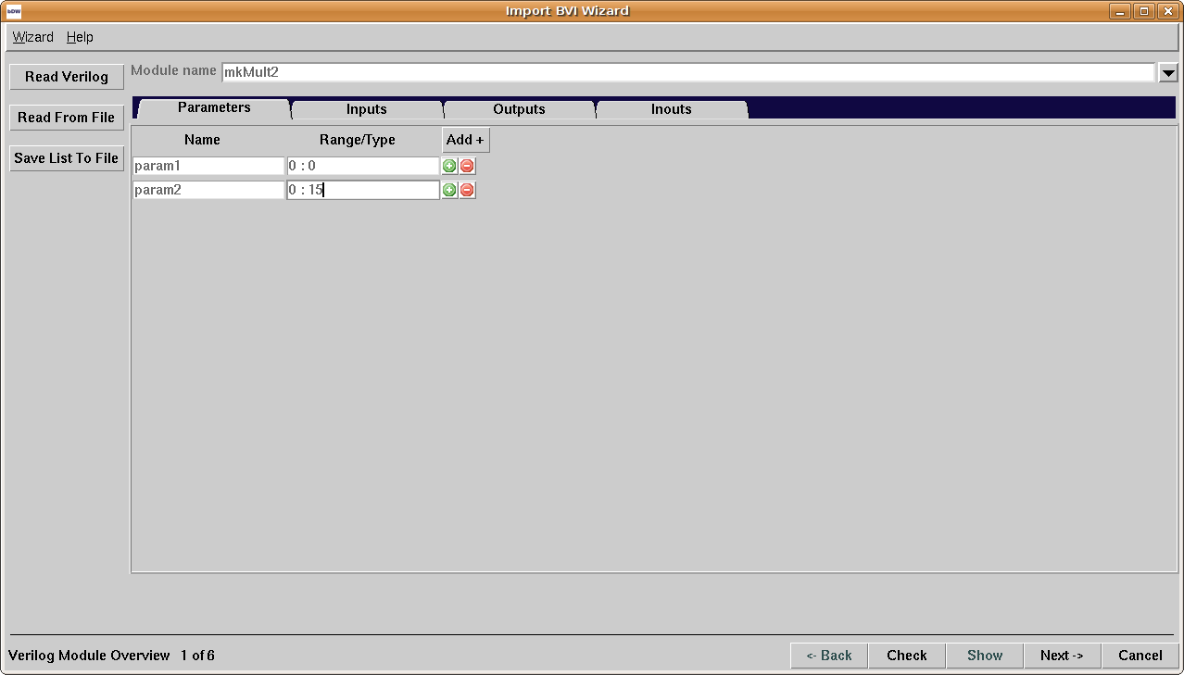Illustration 1: Verilog module overview, "Parameter" tab
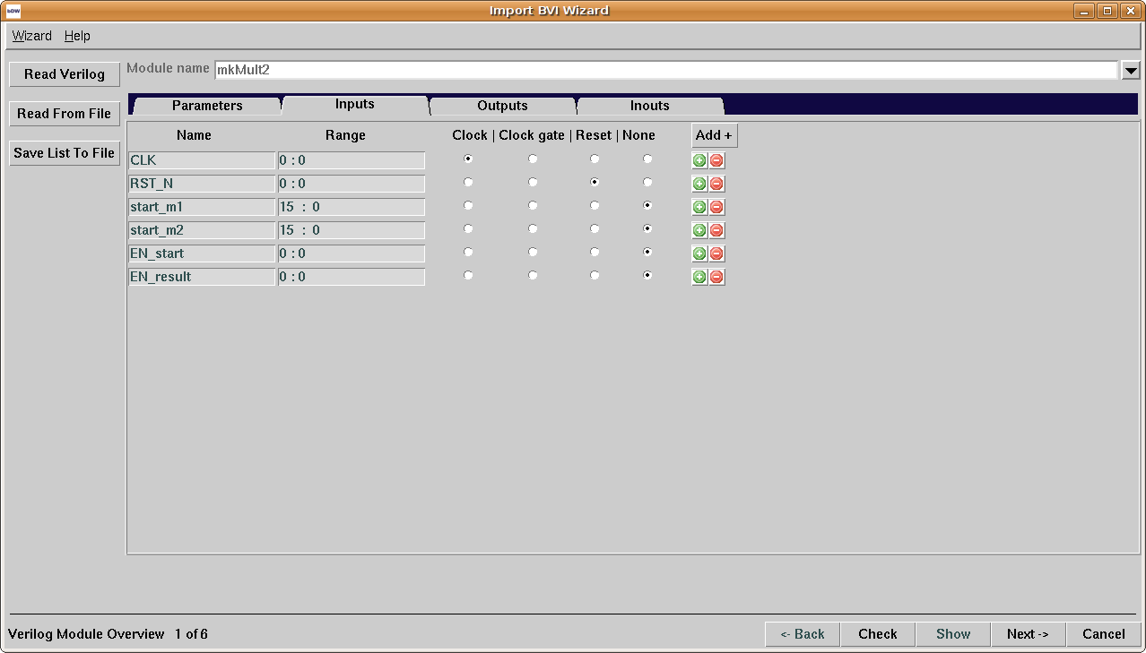Illustration 2: Verilog module overview, "Inputs" tab

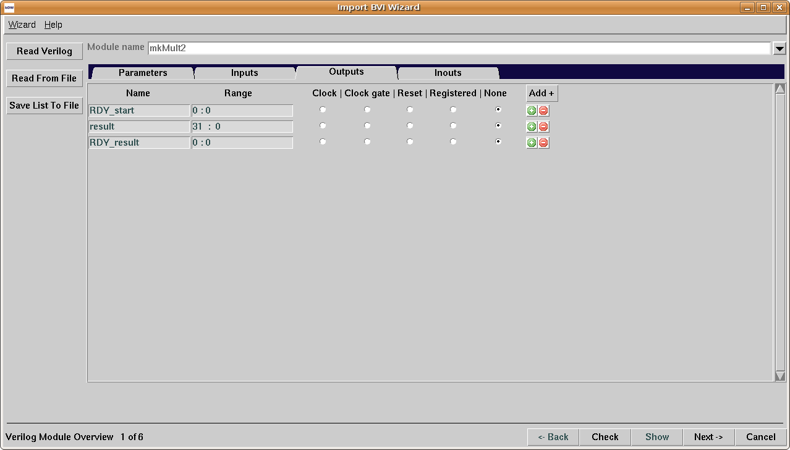Illustration 3: Verilog module overview, "Outputs" tab.

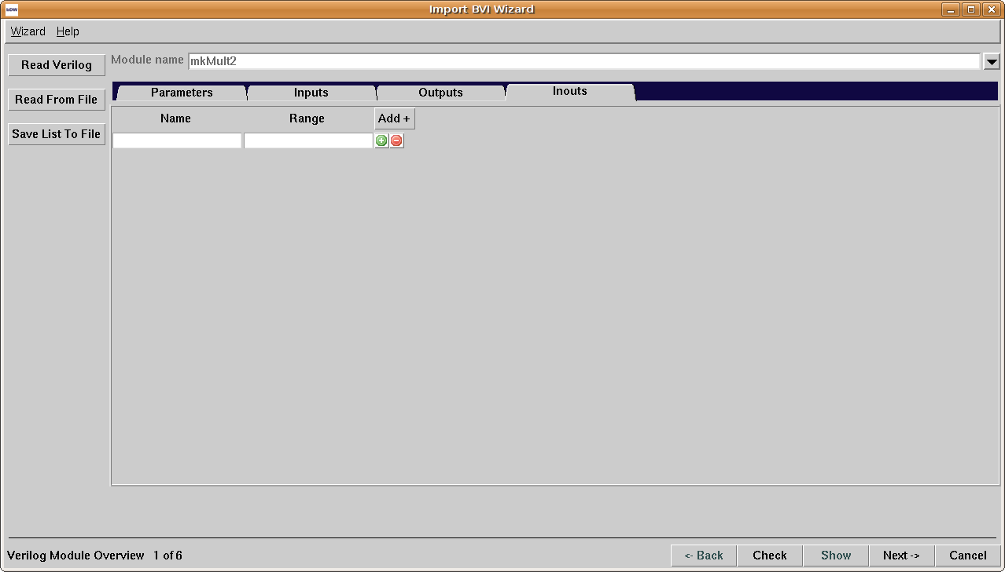Illustration 4: Verilog module overview, "Inouts" tab.

Bluespec Module Definition, Parameter, Clock and Reset Binding
The “Bluespec module definition“ screen will contain entries for module name and interface type on the top left of the screen. “Define from method” and “Use existing” radiobuttons and “Browse” button will be located under “Interface type” entry. “Browse” button will be enabled only if “Use existing” radiobutton is active. Pressing “Browse” button will open a dialog to load packages and choose an interface. There will be “Package import”, “Provisos” and “Bluespec module arguments” fields located under the entries. “Bluespec module arguments” field will contain 2 entries for type and name.
All the fields will have “+” and “-” buttons on the right side to add/remove the field.
All the information in entries and fields should be specified by the user.
The screen will contain “Parameter Binding”, “Input Clocks”, “Input Resets” and “Inouts” tabs on the left side of the screen.
Each tab will contain fields with corresponding information which will be taken from the first step of the wizard and fields to change/choose the value of the variables. Also an ability to add/remove the mentioned fields will be provided.
“Parameter Binding” tab will consist of 2 entry fields “Verilog parameters” and “BSV expressions”.
“Verilog parameters” entries will contain parameter names which will be taken from the Parameter tab of the “Verilog module overview” screen. The entry will be read only.
The information in the “BSV expressions” entries should be specified by the user.
“Input Clocks” tab will consist of an entry for “BSV clock”, 2 comboboxes “Verilog clock” and “Verilog clock gate”, a checkbutton “Default clock” and an entry “Expression”.
The number of fields in the tab will be created according to the input ports (from Input tab of the Verilog module overview screen) which are chosen as “clock”.
“Input Resets” tab will consist of an entry for “BSV reset”, 2 comboboxes “Verilog reset” and “Bluespec clock”, a checkbutton “Default reset” and an entry “Expression”.
The number of fields in the tab will be created according to the input ports (from Input tab of the Verilog module overview screen) which are chosen as “reset”.
“Inouts” tab will consist of 3 comboboxes “Verilog clock”, “Bluespec clock”, “Bluespec reset” and an entry “Expression”.
Only one default clock and reset can be chosen.
Pressing the “Check” button will check the Bluespec module/interface name for validation, the “Expression” tab to be not empty. In case if there are no errors an output string will be built (using the embedding a Verilog module in a BSV module) and generated. A temporary file will be created which will contain an empty interface definition and an import BVI module definition with module, interface, provisos, parameters and default clock/reset defined.

The “Bluespec module definition“ screen shots are illustrated below:
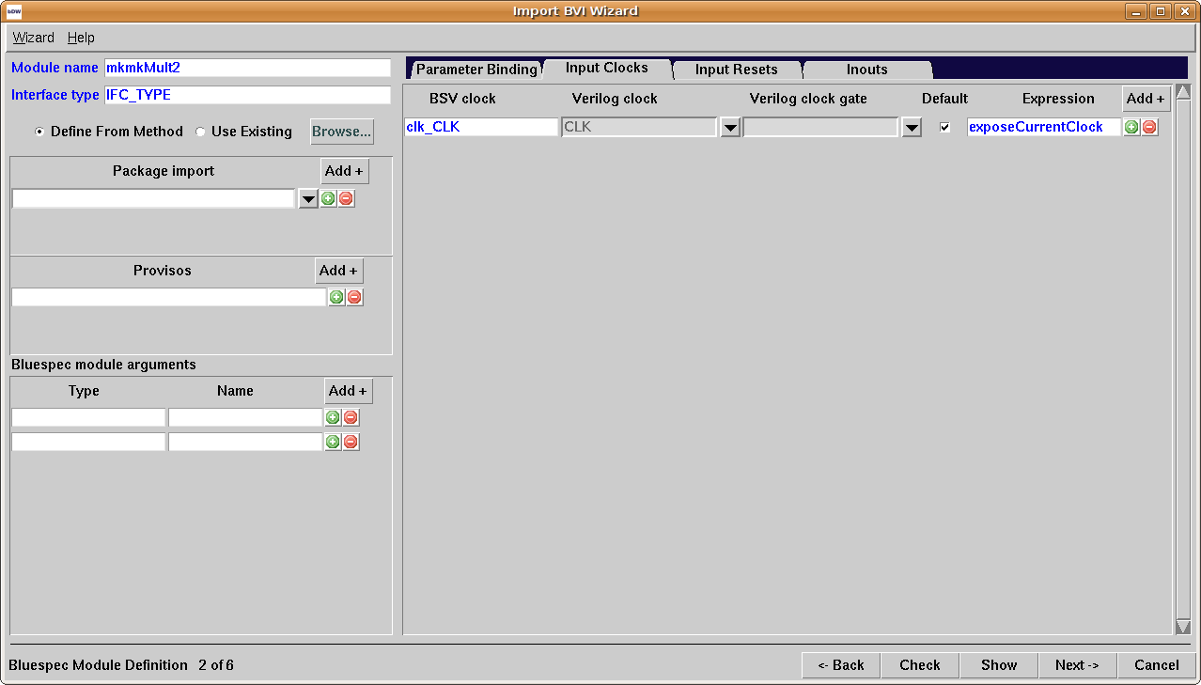Illustration 6: Bluespec module definition, "Input Clocks" tab
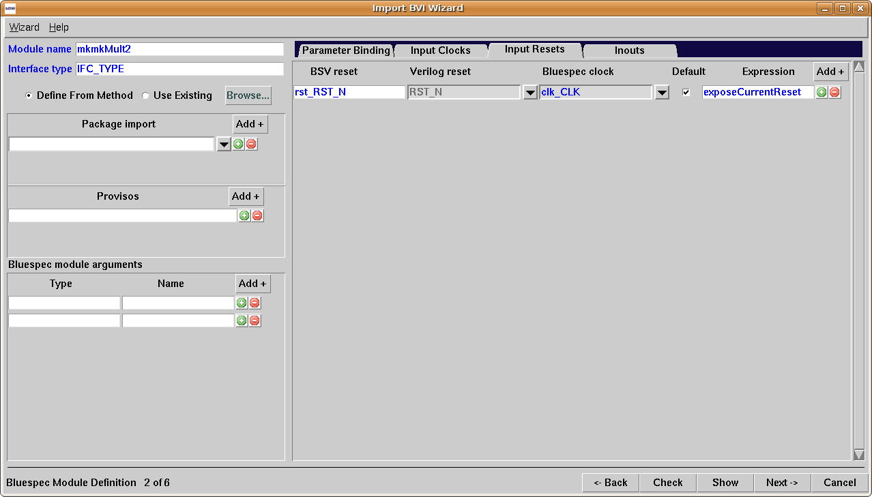Illustration 7: Bluespec module definition, "Input Resets" tab

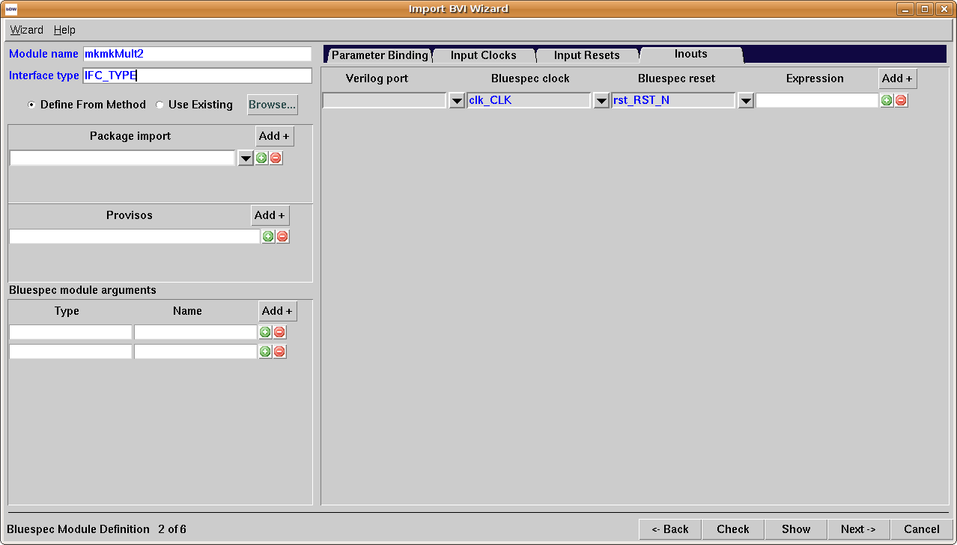Illustration 8: Bluespec module definition, "Inpouts" tab

Method Port Binding
The screen will contain “Interface type” entry, “Define from method” and “Use existing” radiobuttons and “Browse” button on the top of the screen. “Browse” button will be enabled only if “Use existing” radiobutton is active. Pressing “Browse” button will open a dialog to load packages and choose an interface.
The “Method Port Binding“ screen will contain the following buttons:
- Add Port Binding – Adds “Port bindings” section on the screen (see Illustration 7)
- Add Method – Adds “Method bindings” section on the screen (see Illustration 8)
- Add Interface – Adds “Subinterface binding” section on the screen (see Illustration 9)
- Build Skeleton – Creates methods/interfaces according to contents of the Interface from “Interface type” entry. The button is active only if “Use Existing” radiobutton is active.
- Auto Create From Verilog - Creates skeleton interface based on interface (Method/Subinterface bindings sections will be created). For each verilog port an appropriate method (for all input/output ports except clocks and resets) or an interface (for inout ports) will be created. For each verilog input/output clock/reset port an appropriate interface will be created. The button is active only if “Define From Method” radiobutton is active.
“Port bindings” section contains a field which itself contains “Verilog name” entry and “BSV expression” combobox, also “+” and “-” buttons to add/remove the field. The section will have “-” button to remove itself.
“Method bindings” section contains an entry for method name, radiobuttons to select the type (Action, ActionValue, Value) of the method, comboboxes to select enable/ready signals (if the Value radiobutton is selected the enable entry will be disabled) return type/signal and clocked/reset by, also there is a section for method arguments which contains an entry for BSV type, a combobox for Verilog name and “+” and “-” buttons to add/remove the field. The section will have “-” button to remove section.
“Subinterface binding” section contains entries for interface name/type, and buttons “Build Skeleton”, “Add Method”, “Add Interface”. The functionality of the buttons is described above. The section will have “-” button to remove section.
A temporary file will be created which will contain an interface definition with methods/subinterfaces defined and an import BVI module definition with module, interface, provisos, parameters, methods/subinterfaces and default clock/reset defined.A checkbox for method/interface/port names bindings will be on the left.
“Method bindings” section of “Method Port binding” screen shot is illustrated below:
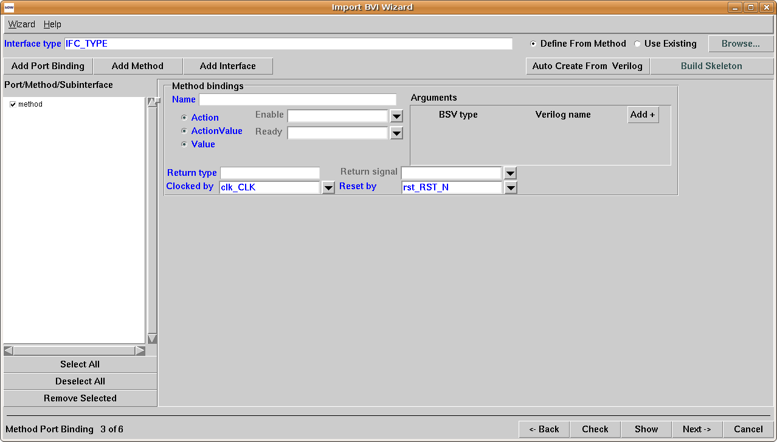Illustration 9: “Method bindings” section of Method Port Binding screen

“Subinterface binding” section of “Method Port binding” screen shot is illustrated below:
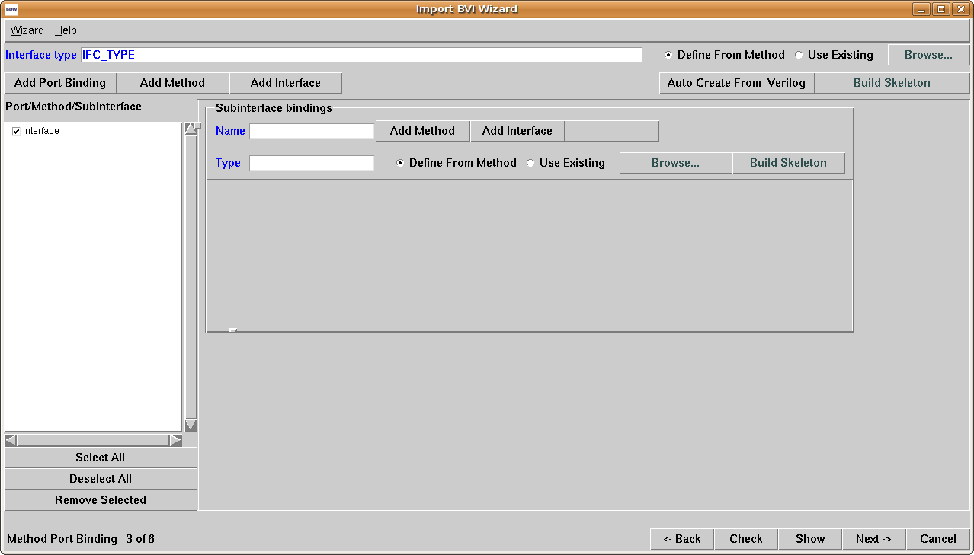Illustration 10: Subinterface binding” section of Method Port Binding screen
“Port bindings” section of “Method Port binding” screen shot is illustrated below:
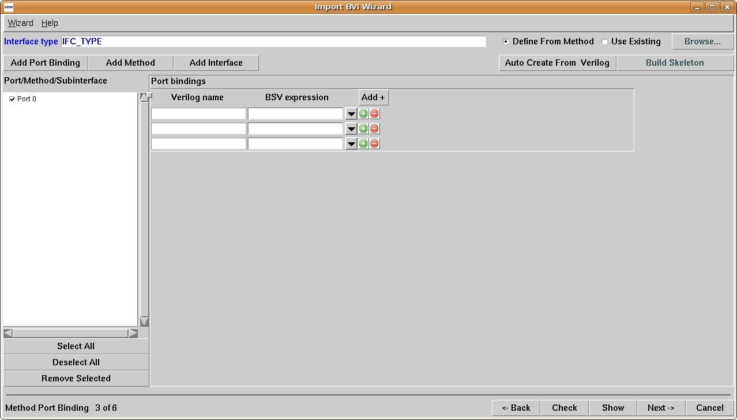Illustration 11: “Port bindings” section of Method Port Binding screen

Combinational Paths
The “Combinational paths” screen will contain a field which will contain “Input” field on the left side and “Output” field on the right. An ability to add/remove fields will be provided.
The “Input”/“Output” fields will contain comboboxes for input/output ports. The comboboxes will contain input/output port names.
A path contains 1 or more Verilog inputs and 1 or more outputs.
Pressing the “Check” button will check if the input list and the output list are non-empty in each path on the path list.
A temporary file will be created which will contain an interface definition with methods/subinterfaces defined and an import BVI module definition with module, interface, provisos, parameters, methods/subinterfaces, default clock/reset and combinational path defined.
The “Combinational paths” screen shot is illustrated below:
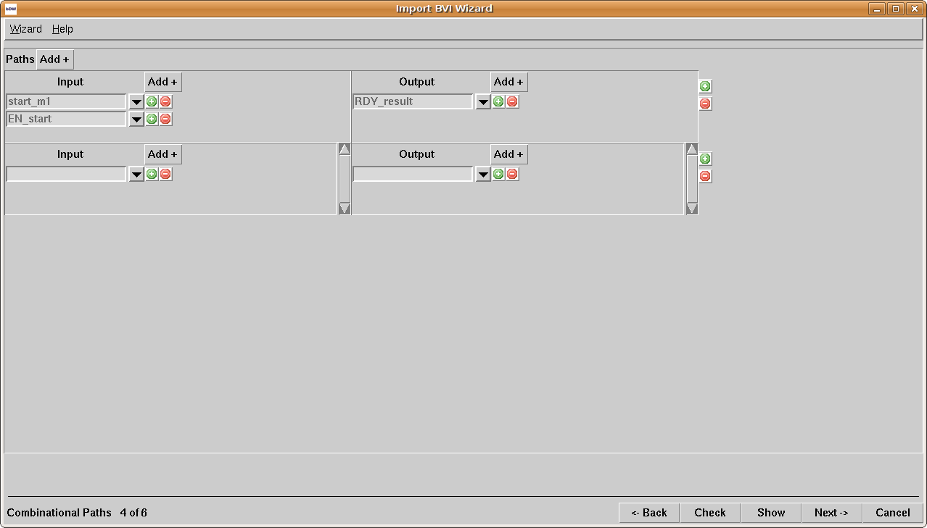Illustration 12: Combinational paths

Scheduling Annotation
The “Schedule Annotation” screen will contain “Scheduling annotations” field.
“Scheduling annotations” field will contain two entryfield for methods and a combobox to choose an annotation for the methods.
The scheduling annotations between all pairs of methods will be shown ( n*(n+1)/2 ).
There will be the following defaults for scheduling attributes:
- Methods which are in different clock domains – CF
- Value to Value method - CF
- Value to Action method - SB
- Value to ActionValue method - SB
- Action to Action method - C
- Action to Value method - SA
- Action to ActionValue method - C
- ActionValue to ActionValue method - C
- ActionValue to ActionValue method - C
- ActionValue to Value method - SA

Pressing the “Check” button will check if there is a scheduling annotation between all method pairs.
A temporary file will be created which will contain an interface definition with methods/subinterfaces defined and an import BVI module definition with module, interface, provisos, parameters, methods/subinterfaces, default clock/reset, combinational path and scheduling annotations defined.
The “Schedule Annotation” screen shot is illustrated below:
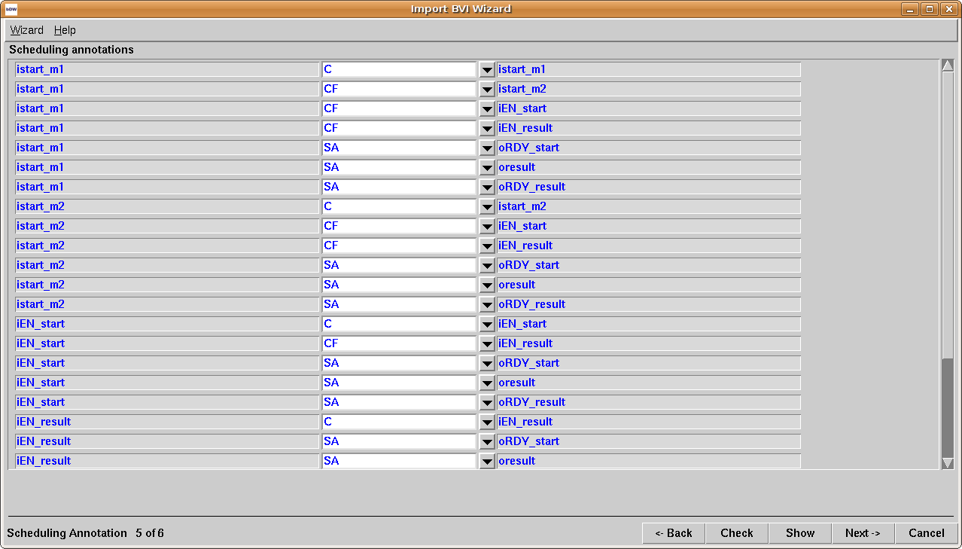Illustration 13: Schedule Annotation

Finish
The “Finish” screen will contain an entry where the file should be specified, a Browse button to specify the directory and an editable text area where the generated code will be shown.. All the information shown in the text-box will be written in the file.
The “Check” button will be disabled.
The “Next” button will be renamed to “Close”. The “Close” button will be active after saving the information into file. Pressing “Close” button will close the wizard without giving a warning message.
The “Finish” screen shot is illustrated below:
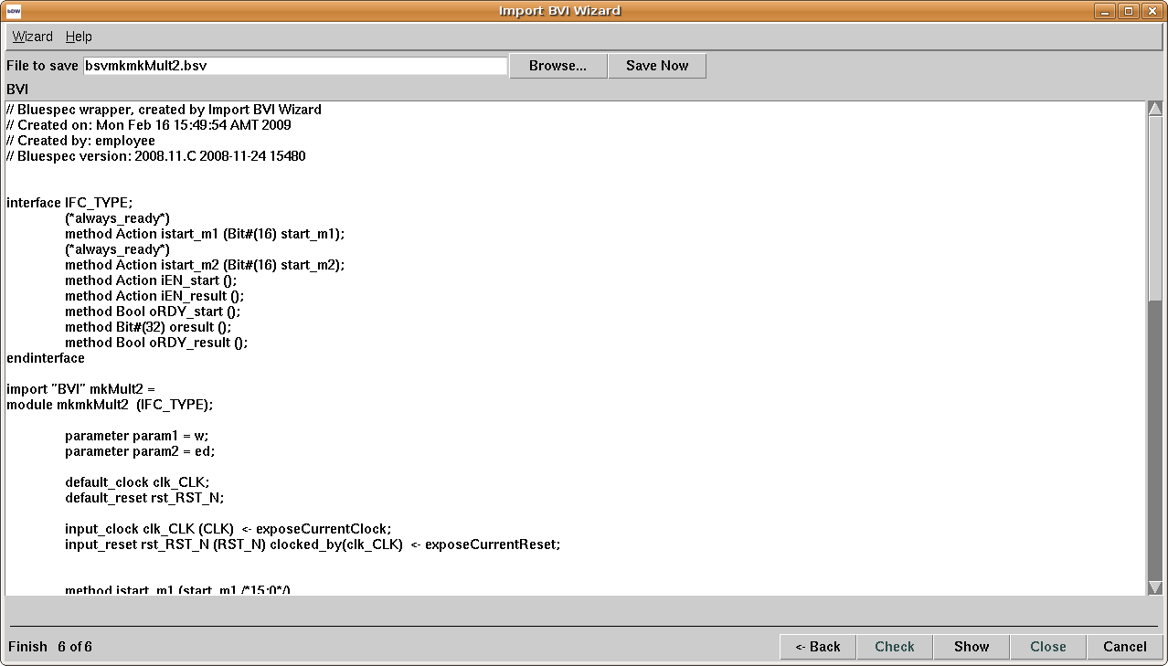Illustration 14: Finish

Use cases coverage
TBD.

Dependencies, Assumptions, Risks
TBD.

Questions and Answers
Q1. Should there be an ability to add more than one “Port Bindings” section?
A1. Yes.
Q2. Should an appropriate (input, output) port be specified for each port? If yes, see Q3.
A2.
Q3. Should the path field contain 2 comboboxes - for input and output port names, and “+” “-” buttons to add/remove the field?
A3.
Q4. Should there be an ability to specify an annotation between interfaces (all methods of interfaces)?
A4.
Q5. Should a grouping for methods (e.g. methods which are defined in the same interface) be provided?
A5:
Q5: Is there a syntax allowing to specify more than one couple of Verilog ports in combinational path definition (e.g path (ip1, op1, ip2, op2))?
If no, what's the purpose of having multiple fields in i/o comboboxes?
A5:

