# Introduction

This chapter reports on a series of interviews conducted with overseas voters demonstrating three different voting systems: two front end simulations of the Star-Vote [1] voting system originally developed by a consortium of academics and Travis County, TX election administrators, and the Helios [2] voting system developed by Ben Adida. The key differences between the three systems were how end-to-end (E2E) verifiable concepts were presented. The Star-Vote variations contained two content related differences (see **Attachment 1**) concerning descriptions of E2E properties as well as two further display variations (see **Attachment 2**). The differences between systems are summarized in **Table 1**.

**Table 1: Voting System Differences**

|  |  |  |  |
| --- | --- | --- | --- |
| **System Differences** | **Helios** | **Star-Vote 1** | **Star-Vote 2** |
| Verification of Ballot | *‘Audit Your Ballot’* | *‘Spoil Your Ballot’* | *‘Practice Ballot’* |
| Display Variations |  | Solid Select (with picture) | Spartan |
| Content Variations |  | Jargon | Gentle |

The aim of these interviews was to gain an understanding of the issues that overseas voters might have with the implementation of a remote End-to-End Verifiable Internet Voting (E2E VIV) system, their ability to use that system correctly, their understanding of the system and its security properties, and their attitude towards ‘online voting’. What was particularly important was to identify issues at an early stage that could be addressed in future derivatives of E2E VIV systems developed for use by the overseas population. The nature of these issues follows similar usability studies and ranges from straightforward usability issues to security features that users are unwilling or unable to use [3].

# Methodology

Interviewing focus groups has previously been successful in capturing voter attitudes concerning remote voting [4]. These interviews provide a good way of identifying a range of reactions and viewpoints at an early stage of development, while high level design decisions are still under discussion. The intention in our case was to use three very different E2E VIV prototypes to obtain reactions, concerns and aspects of voter understanding concerning the properties and capabilities of E2E systems. This data would then inform development of the next versions of E2E VIV systems that will be designed for remote use.

Interview participants were selected from the respondent pool to the Overseas Vote Foundation (OVF) 2014 Post Election Survey. The OVF 2014 Post Election survey was deployed on 4 November 2014 and sent to 112,477 OVF users. In that survey, respondents were given an opportunity to volunteer for future research by providing their email address. Of the total survey cohort, 322 respondents indicated their willingness to volunteer and provided their email addresses.

On 15 April 2015, all 322 volunteers were contacted via their email address (see **Attachment 3**) and invited to participate in the E2E VIV usability interviews. They were given instructions concerning what information would be required in order to participate in the interviews, and when the interviews would be taking place. The first thirty respondents who contacted the research@overseasvotefoundation.org email address with the appropriate information and availability were included in the study. Of this thirty, one participant cancelled, one participant was ultimately unable to participate due to scheduling conflicts, and one participant cancelled due to a family emergency. As such, 27 participants were included in this usability interview process.

Demographic data for the usability participants was collated from the 2014 Post Election Survey and is presented in **Table 2** along with the corresponding data from the 2014 Post Election Survey as a means of comparison. Based on this information, the sample is broadly representative of the OVF survey results, however there are some exceptions. Prior survey demographics from OVF have shown a broadly equivalent gender distribution, however in the usability participant sample, males outnumber females. Additionally, while Non-Hispanic White and Euro-Americans dominate ethnicity distributions, in the usability participant sample, other ethnic classifications have greater representation. Importantly, the age, education and occupation classifications reflect the variety of overseas voters and provide a good opportunity to capture a diverse range of usability experiences from the appropriate target user group.

It is important to note that the usability interview scheme *did not* include any overseas military personnel or any individuals that identified themselves as being disabled. However, two participants did not speak English as their first language.

**Table 2: Demographic Characteristics of Usability Participants from 2014 OVF Post-Election Survey**

|  |  |  |  |
| --- | --- | --- | --- |
|  |  | **Usability Participants** | **OVF 2014** |
| **Gender** | Female | 29.6% | 51.2% |
|  | Male | 70.4% | 48.8% |
| **Age** | 30-39 | 3.7% | 12.6% |
|  | 40-49 | 18.5% | 16.8% |
|  | 50-59 | 33.4% | 22.4% |
|  | 60-69 | 29.6% | 25.2% |
|  | 70-79 | 14.8% | 14.0% |
| **Education** | High School Graduate | 3.7% | 5.9% |
|  | Trade School | 3.7% | 2.1% |
|  | College or Associates Degree | 18.5% | 9.2% |
|  | Bachelors Degree | 33.4% | 32.1% |
|  | Masters Degree | 29.6% | 34.5% |
|  | Doctorate | 11.1% | 15.6% |
| **Ethnicity** | Non-Hispanic White or Euro-American | 88.9% | 80.4% |
|  | Latino or Hispanic American | 7.4% | 3.3% |
|  | Multiracial American | 3.7% | 2.9% |
| **Occupation** | Architecture and Related Occupations | 7.4% | .9% |
|  | Arts, Entertainment and Related Occupations | 3.7% | 5.5% |
|  | Computers and Technology Related Occupations | 7.4% | 4.8% |
|  | Education, Teaching, Academic Research and Related Occupations | 22.2% | 18.2% |
|  | Finance and Financial Related Occupations | 3.7% | 2.5% |
|  | Management, Professional and Related Occupations | 14.8% | 8.2% |
|  | Medical Practitioner and Related Occupations | 3.7% | 4.2% |
|  | Office and Administrative Support | 3.7% | 1.5% |
|  | Other | 11.1% | 6.1% |
|  | Retired | 18.6% | 20.8% |
|  | Missing Value | 3.7% | 7.9% |

# UOCAVA Status

The Uniformed and Overseas Citizens Absentee Voting Act is commonly referred to as UOCAVA. UOCAVA voters are U.S. citizens who are active members of the Uniformed Services, the Merchant Marine, and the commissioned corps of the Public Health Service and the National Oceanic and Atmospheric Administration, their family members, and U.S. citizens residing outside the U.S. The Act, passed in 1986, provides the legal basis for absentee voting requirements for these citizens. Since 2004, OVF has been collecting particular data that is unique and significant to this group. This data is relevant to this usability interviewing process because it provides further insight into the characteristics of the cohort and their voting history. Further, the data provides the participant’s current country of residence and state of legal voting residence, both important considerations when contemplating remote voting.

As developers understand, the election system in the U.S. is very decentralized with a wide array of voting rules and regulations that need to be taken into consideration when developing and deploying any voting system. Further, certain countries pose different levels of security concerns regarding U.S. elections, as well as varying levels of Internet access for U.S. citizens. The UOCAVA data concerning the usability participants is shown in **Table 3**.

**Table 3: UOCAVA Data**

|  |  |  |  |
| --- | --- | --- | --- |
|  |  | **Usability Participants** | **OVF 2014** |
| **UOCAVA Status** | U.S. citizen living outside the U.S. *temporarily*, and I intend to return | 7.4% | 13.8% |
|  | U.S. citizen living outside the U.S. *indefinitely*, and my return is not certain | 88.9% | 64.8% |
|  | Missing Value | 3.7% | 17.7% |
| **Voting History** | I have not voted, or attempted to vote, prior to the 2014 Midterm Election. | 3.7% | 2.1% |
|  | I have only voted as an overseas or military absentee voter, but never in the U.S. | 14.8% | 11.0% |
|  | I have voted both in the U.S. and as an overseas or military absentee voter. | 77.8% | 64.7% |
|  | Missing Value | 3.7% | 17.7% |
| **When did you last reside in the U.S.?** | At least 1 year but less than 2 years ago | 3.7% | 1.8% |
|  | At least 2 years but less than 5 years ago | 18.5% | 7.9% |
|  | At least 5 years but less than 10 years ago | 11.1% | 16.7% |
|  | 10 or more years ago | 63.0% | 67.3% |
|  | Don’t know/Don’t remember | 3.7% | .6% |
| **Country of Residence** | Argentina | 3.7% | .5% |
|  | Australia | 14.8% | 5.9% |
|  | Canada | 7.4% | 14.1% |
|  | China, People’s Republic of | 3.7% | 1.6% |
|  | Costa Rica | 7.4% | .6% |
|  | France | 3.7% | 8.8% |
|  | Germany | 3.7% | 8.8% |
|  | Israel | 37.1% | 7.3% |
|  | Mexico | 3.7% | 2.5% |
|  | Netherlands | 3.7% | 1.9% |
|  | Philippines | 3.7% | 1.1% |
|  | Singapore | 3.7% | .9% |
|  | Turkey | 3.7% | .5% |
| **Legal Voting Residence in U.S.** | California | 7.4% | 12.7% |
|  | Colorado | 7.4% | 2.5% |
|  | Florida | 3.7% | 4.6% |
|  | Illinois | 11.1% | 2.9% |
|  | Indiana | 3.7% | .9% |
|  | Maryland | 3.7% | 2.0% |
|  | Massachusetts | 3.7% | 3.4% |
|  | Michigan | 3.7% | 2.8% |
|  | Minnesota | 3.7% | 4.9% |
|  | Nevada | 3.7% | .6% |
|  | New Jersey | 7.4% | 2.7% |
|  | New York | 22.3% | 19.5% |
|  | Ohio | 7.4% | 4.1% |
|  | Texas | 7.4% | 8.1% |
|  | Washington | 3.7% | 2.7% |

# Research Design

Due to the geographic distribution of the interview participants, the interviews were held via Skype. Participants were given a specific date and time for their interview. Once contacted, participants were notified that in addition to the moderator, an assistant from OVF would be on the call.

Information concerning the interview was provided to each participant, followed by a request to audio record the interview. If permission was given, the interview was recorded using QuickTime Player. There were two instances where an audio recording was not possible due to a poor Internet connection. In these cases, the interview was conducted over the telephone. Each interview lasted around 30 minutes.

The interviews began with a preliminary set of questions concerning voting habits and Internet use. In this case, an understanding of where participants access the Internet and what devices they use was an important addition to the discussion concerning security concerns, which include coercion, as related to deployment of remote E2E VIV systems [5].

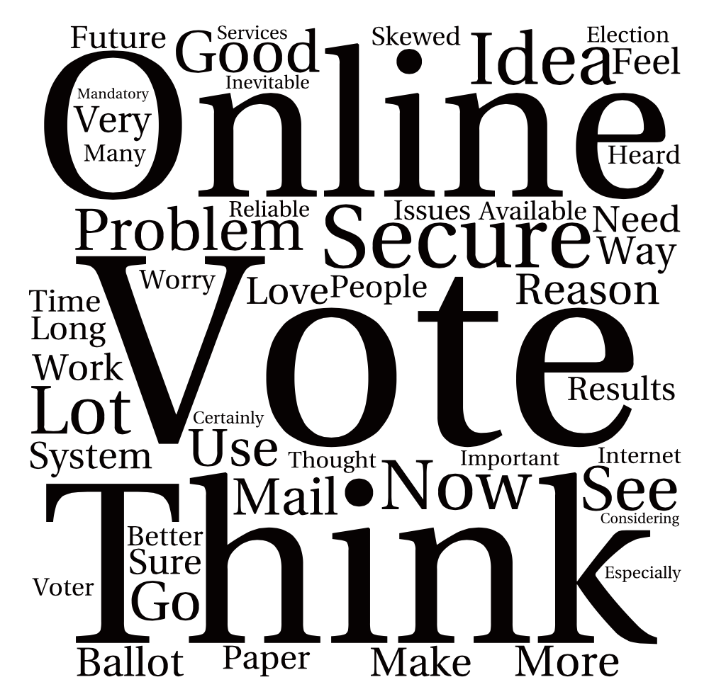Additional questions were asked regarding general views of online voting and the participants’ thoughts regarding the system requirements or desired properties for any online voting system. A visual representation of the participants’ responses is presented using data visualizations. The use of data visualizations is an effective tool for preliminary textual analysis, and quickly highlights points of interest while giving direction to future analysis [6]. These visualizations were created using Tagul and reflect the top 50 pieces of text data from the combined text of all 27 interviews. The intent is to present the most salient points and themes captured in the interviews.

Figure 1: What do you think about online voting?

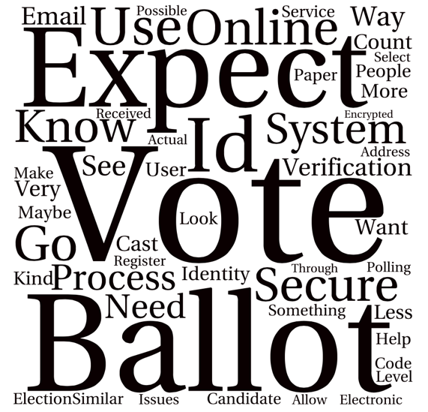As seen in **Table 4**, all participants would favor an online voting system over the current paper based system used by overseas voters. Given this, it was not surprising that the majority of participants viewed online voting favorably, noting that it seems ‘inevitable’. However, many noted the importance of security, most notably concerning the authentication and identity verification process.

Security issues including coercion and ballot secrecy were not seen to be as important as ensuring that only those who are legally allowed to vote can vote. This same sentiment followed through to the expected functions of an online voting system. Participants expressed the necessity to have a robust authentication system, as well as the desire to have the process be as close to the in-person voting experience as possible. This included ballot design and user language.

Figure 2: What would you expect of an online voting system?

**Table 4: Preliminary Questions**

|  |  |  |
| --- | --- | --- |
| **How often do you vote in US Elections?** | Always | 33.3% |
|  | Almost Always | 59.3% |
|  | Occasionally | 3.7% |
|  | Try but unable to complete the process | 3.7% |
| **How comfortable do you feel using the internet?** | Very comfortable | 92.6% |
|  | Somewhat comfortable | 7.4% |
| **Where do you most often access the internet? (Multiple responses)** | At home | 92.6% |
|  | From my office | 59.3% |
|  | Off site at client offices | 3.7% |
|  | Due to travel at airports and hotels | 3.7% |
| **What type of devices do you use to access the internet? (Multiple responses)** | Home computer or laptop | 96.3% |
|  | Mobile device i.e. smartphone or IPhone | 55.6% |
|  | Tablet i.e., IPad or Kindle | 48.1% |
| **If given an option, would you choose to vote online or continue to use paper?** | Online | 100% |
|  | Paper | 0% |

Following this series of questions, participants were asked to screen share via Skype in order to allow the moderator and assistant to follow the participant’s interactions with each voting system. Once this function was enabled, participants were first sent the link to the Star-Vote voting system via Skype Chat, along with an access code. They were then sent the link to the Helios voting system.

Once the Star-Vote voting system was accessed, one of the four possible variations of Star-Vote was to be presented to the participant via an automatic randomization function. After the interviews commenced on day one, Galois provided a new link to the Star-Vote system with a new list of access codes. However, this change disabled all the links to the Star-Vote system. As such, for two interviews, participants could only access the Helios systems. These participants were subsequently sent working links to the Star-Vote system and provided feedback via email. Additionally, the moderator and assistant observed that the automatic randomization of the derivatives of the Star-Vote system did not seem to be functioning properly as it was not until the afternoon of day three of interviewing that the solid select display variant appeared. The moderator enquired if data was available indicating the access frequency of each variant but was told logs of this data were not available. Given these issues, there are some problems with the data concerning the Star-Vote system in that it is not possible to provide the level of specificity that was originally envisioned.

There were no significant problems accessing Helios, however as noted in the results section of this chapter, despite creating a designated log in for this testing, participants were very reluctant to log in to Yahoo, Facebook or Google in order to cast their ballot. It was decided to bypass this step because in doing so, the material functioning of Helios was not altered and participants were more comfortable testing that system. Of importance to participants was the inability to edit your ballot selections in ‘Step 2 Review’ of the Helios flow. This was reported to the individual who set up the OVF election on the Helios system who subsequently reported the error to Helios operators.

# Technical Descriptions

The voting systems forming the basis of this usability testing are Star-Vote and Helios. For screen shots of STAR-Vote, see **Attachment 4** and for Helios, see **Attachment 5**.

## Helios

Helios [7], proposed by Ben Adida, is an open-source online voting system specifically meant for remote environments where the risk of voter coercion is thought to be low, while secrecy and trust are important. The key contribution of Helios is that it brings together innovations from different systems to build an efficient and usable E2E VIV voting system that has proved fairly influential in the academic research community.

One of the key properties of Helios, the notion of voter initiated auditing, was introduced by Josh Benaloh [8] and is now referred to as the ‘Benaloh Challenge’. Voter initiated auditing allows the voter to audit their ballot on the spot before casting it to develop confidence that the voting machine was correctly encrypting their vote. Helios uses the concept of Benaloh’s challenge to convince the voter their vote is cast as intended.

When the voter has made their candidate choice on the voting terminal, the machine performs the vote encryption and their receipt is printed but not released. The voter is then asked whether they wish to cast the vote or challenge it. If the voter chooses to cast it, the machine affixes a digital signature on the receipt and discharges it. If the voter wishes to challenge it, the machine prints on the receipt the contents of the ballot and the randomizing element used in the encryption. Using this information, any observer can check the correctness of the encryption for themselves. The voter can then repeat the vote casting process.

## STAR-Vote

Like Helios, STAR-Vote follows the standard template of voter-initiated auditing systems. The system is designed to be both paper based and electronic in order to support audit trails. However, the derivative used in these interviews was only electronic.

On Election Day, the voter identifies themselves to polling staff as an eligible voter and is issued voting credentials, which include information regarding the appropriate ballot style and precinct. The voter then walks to a voting terminal, enters their credentials, and is presented with the correct ballot. The voter then makes their choices on the screen. The machine then encrypts their vote and prints out two items: a physical copy of the ballot, which is human-readable information pertaining to their choices; and a receipt to take home which includes voting information such as time of voting, and the machine used.

The voter is also given a short character string, which is the cryptographic association to their vote, but does not reveal what the vote was. The voter can then:

1. Confirm that their choice has been correctly marked on the ballot copy;
2. Cast their ballot into a physical ballot box in the precinct;
3. Or, alternatively, opt to challenge the machine to see if it has correctly encrypted the vote.

# Results

## HELIOS

The results of the interviews concerning Helios did not significantly deviate from prior Helios usability testing [9][10]. Participants found Helios very unfriendly, with many of the concepts presented regarding Helios lacking meaning and context.

## Vote Verification

Participants specifically suggested that words like ‘audit’, ‘verifiability’, or ‘ballot fingerprint’ do not equate with their voting experience. They did not understand what these concepts meant in the election context because they were not actions they had ever taken before in a prior election. Concerning vote verification, the majority of participants indicated they would *not* be likely to verify their vote by taking note of their ballot’s cryptographic string and verifying on a public bulletin board, and preferred to receive some verification or confirmation ‘Your vote has been cast’ notice via email. Only two participants said they would actively track their ballot, but expressed a lack of clarity at what that process would entail.

*‘It doesn't really tell me what I should do with the tracker’*

## Challenges

Two potential challenges likely obstruct the verifiability aspect of E2E systems: the first being that the voter finds the verification process too difficult, and the second that the voter does not perceive the need to verify their vote [11]. One possible explanation concerning this perception is the absence of trust transference from election authorities to the voter. For example, Olembo et al. found that while voters may initially verify their vote out of curiosity, after continued use of an E2E voting system requiring verification, trust would be established in the voting system and verification would be deemed unnecessary [12].

*‘The language of Helios is convincingly obtuse’*

In respect to the need to verify their vote, participants using both Helios and STAR-Vote noted they had a tacit level of trust in *any* voting system provided it was officially branded i.e. Jurisdiction x Official Election Website. If the voting system met this very basic criterion, the participants considered vote verification unnecessary, as trust was implicit in the voting system.

*‘I don’t like using social media. I would rather have a system that has a robust authentication ’ verification system/ID.*

Participants also expressed concern over the security of the Helios authentication process, which involves logging into Google, Yahoo or Facebook in order to receive a voter receipt at the associated email address for the various accounts. This sentiment occurred despite having a designated participant log-in account with Google for use during the interviews. Participants did not find this reassuring and felt it compromised their privacy.

*‘When I see the cryptography on the screen it makes me feel some assurance’*

Nevertheless, there were features of Helios that were favorable, including the status bar which indicated the workflow and the ballot-like features including a tick box to select candidates. Further, several participants liked seeing their ballot being encrypted on screen.

## STAR-Vote

During the testing, it became quite evident that STAR-Vote was the preferred system, with voters noting that the language and interface was easier to use. However, there were many comments concerning font size, as well as the use of candidate pictures and instructions.

*‘I was completely unsure and not feeling too good about the concept of "spoiling" the ballot.*

The prototype seemed to lack some of the key functions required in an E2E system and this was not lost on the participants. For example, many participants indicated they were unable to perform some of the tasks outlined in the description, for example checking and verifying their ballot. The concept of “spoiling” a ballot (Benaloh challenge) did not make sense to most participants primarily because it was not clear that this was the process to challenge the accuracy of the system. For those participants that did spoil their ballot, the result did not provide enough information to inform the participant what happened to their spoiled ballot.

*‘Needs some type of preamble "This is an election for…"’*

Several participants noted the need for more detailed instructions. For example, confirmations after each candidate selection, replacing ‘next step’ with ‘next race’, replacing ‘done with this ballot’ with ‘review your ballot’ and using the full candidate party affiliation descriptor rather than an abbreviated version. Additionally, many participants felt the pictures of the candidates were too small, and wanted a ‘tick box’ to select their choices rather than a highlighted ‘bar’. This supports many assertions that participants want the interface to look as close as possible to an actual paper ballot as possible.

There were several universal themes that emerged concerning both systems. Firstly, voters liked having candidate pictures on the ballot because most admitted they were not familiar with the candidates due to their remote location. Secondly, participants wanted embedded links in the candidate lists that would provide additional information concerning the candidates. Thirdly, participants wanted the ability to vote a straight party ticket. Additionally, as noted previously in this chapter, English was not the primary language for two participants. Both noted the need to ‘make the system bilingual’.

*‘I would much rather see a replication of the actual paper ballot’*

*‘I would like a link to a candidate statement for information’*

Finally, the issue of vote verification was a persistent problem in both systems. Individual vote verification is a new concept for voters. They must participate in the vote verification process in order to take advantage of the security guarantees E2E systems offer. The goal of verifiability is to provide some evidence to voters that the election outcome is correct. The participants in this study did not understand the vote verification concept, regardless of the system they used.

*‘I don't understand this - and because I don't understand it does not give me confidence’*

Voter verification protocols as they exist now simply may not be enough to convince voters to verify their vote. Indeed, as Schneider et al. found in their study concerning Pret-a-Voter, simply confirming that a voter’s encrypted vote on a bulletin board corresponds to a receipt does not provide sufficient security guarantees for voters [13]. From this interview process, it is clear that a novel approach to vote verification is needed.

# Conclusion

These interviews have provided some initial information concerning overseas voters feelings about remote online voting, their expectations of any E2E voting system that could potentially be deployed, and given insight into several design issues that need to be taken into consideration in future E2E system developments.

Broadly speaking, participants are very positive concerning implementing ‘online voting’, but expressed concerns regarding the need for strict voter authentication protocols. In the U.S. context, the requirements for voter authentication will be largely determined by the individual states. However, this does not preclude developers from considering a variety of ways in which remote voters could authenticate themselves safely and securely, for example one-time passwords or the use of digital certificates.

The importance of accessible language and terminology cannot be understated. Words like ‘receipt’ have pre-existing meanings to users that may not apply to the properties of E2E voting systems. Using incorrect terminology raises expectations of users by inadvertently connecting to a more familiar experience. For example, participants reported that receipts usually contain full and complete information, not a series of numbers and letters. Ensuring the use of accurate and simple terminology will be essential in future development.

Most participants were able to work through the flow of the voting systems presented to them, but were less clear concerning the vote verification process. As other usability studies have found, relying on a voter’s understanding of a voting system as motivation for carrying out ballot audit and receipt checking is not sufficient [14]. Further, as these interviews revealed, participants were unlikely to verify their vote for a variety of reasons not related to understanding of the voting system. Given this, the approach to vote verification needs to be considered carefully form the perspective of the end user. This means approaching vote verification in a new and novel way if the development of E2E systems is to move forward.

# References

[1]Susan Bell, Josh Benaloh, Michael D Byrne, Dana DeBeauvoir, Bryce Eakin, Gail Fisher, Philip Kortum, Neal McBurnett, Julian Montoya, Michelle Parker, et al. 2013. Star-vote: A secure, transparent, auditable, and reliable voting system. The USENIX Journal of Election Technology Systems, 1 (1), pages 18–37.

[2]Ben Adida. 2008. Helios: Web-based open-audit voting. In USENIX Security Symposium , volume 17, pages 335–348.

[3]Schneider,S.,Llewellyn,M.,Culnane,C.,Heather,J.,Srinivasan,S.,Xia,Z. 2011. Focus Group Views on Prˆet a` Voter 1.0. In: International Workshop on Requirements Engineering for Electronic Voting Systems.

[4] T. Storer, L. Little, and I. Duncan. An exploratory study of voter attitudes towards a pollsterless remote voting system. In D. Chaum, R. Rivest, and P. Ryan, editors, IaVoSS Workshop on Trustworthy Elections (WOTE 06) Pre-Proceedings, pages 77–86, 2006.

[5]Michael Clarkson, Stephen Chong, and Andrew Myers. 2008. Civitas: Toward a Secure Voting System. In *IEEE Symposium on Security and Privacy*. IEEE Computer Society, Oakland, CA, USA, 354–368.

[6] McNaught, Carmel and Lam, Paul*.* 2010*.* Using Wordle as a Supplementary Research Tool. *The Qualitative Report* Volume 15 Number 3 May 2010 630-643 http://www.nova.edu/ssss/QR/QR15-3/mcnaught.pdf

[7]Ben Adida. 2008. Helios: Web-based open-audit voting. In USENIX Security Symposium , volume 17, pages 335–348.

[8]Josh Benaloh. Ballot casting assurance via voter-initiated poll station auditing.

In Proceedings of the USENIX Workshop on Accurate Electronic Voting

Technology , pages 14–14. USENIX Association, 2007.

[9] Acemyan, Claudia Z., Kortum, Philip, Byrne, Michael D. and Wallach, Dan S. 2014. Usability of Voter Verifiable, End-to-end Voting Systems: Baseline Data for Helios, Prêt à Voter, and Scantegrity II in *USENIX Journal of Election Technology and Systems (JETS*), 2(3) July 2014, pp. 26-56.

[10]Karayumak, Fatih, Olembo, Maina M., Kauer, Michaela and Volkamer, Melanie. 2011. Usability Analysis of Helios - An Open Source Verifiable Remote ElectronicVoting System.

[11] Olembo, Maina M., Renaud, Karen, Bartsch, Steffen and Volkamer, Melanie. 2014. Voter, What Message Will Motivate You to Verify your Vote? Workshop on Usable Security, USEC, 2014.

[12] Olembo, Maina M., Renaud, Karen, Bartsch, Steffen and Volkamer, Melanie. 2014. Voter, What Message Will Motivate You to Verify your Vote? Workshop on Usable Security, USEC, 2014.

[13] Schneider,S.,Llewellyn,M.,Culnane,C.,Heather,J.,Srinivasan,S.,Xia,Z. 2011. Focus Group Views on Prˆet a` Voter 1.0. In: International Workshop on Requirements Engineering for Electronic Voting Systems.

[14] Schneider,S.,Llewellyn,M.,Culnane,C.,Heather,J.,Srinivasan,S.,Xia,Z. 2011. Focus Group Views on Prˆet a` Voter 1.0. In: International Workshop on Requirements Engineering for Electronic Voting Systems.

# Attachments

**Attachment 1: Jargon v. Gentle**

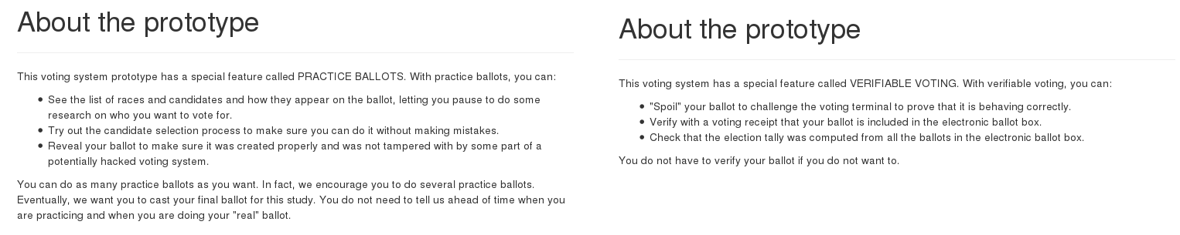

**Attachment 2: Spartan v. Solid Select (with pictures)**

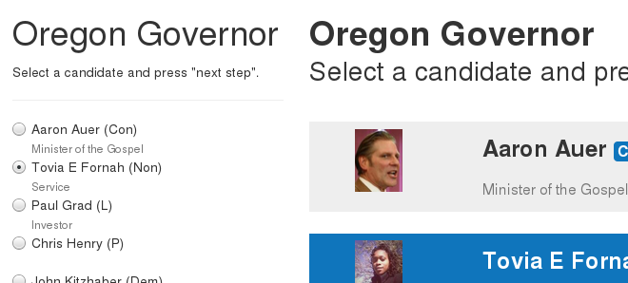

**Attachment 3: Research Participation Invitation**

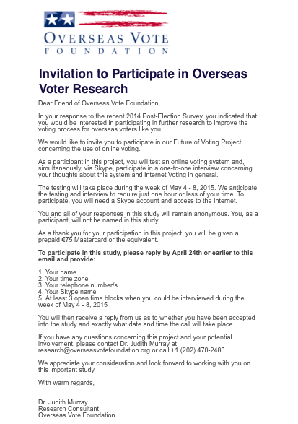

**Attachment 4: Star-Vote**

1.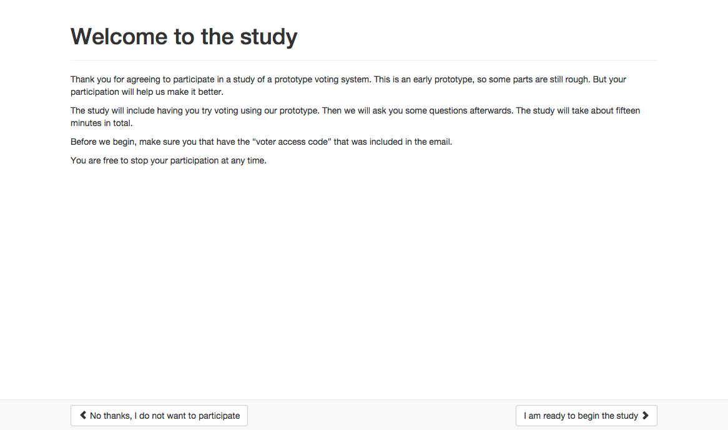

2. 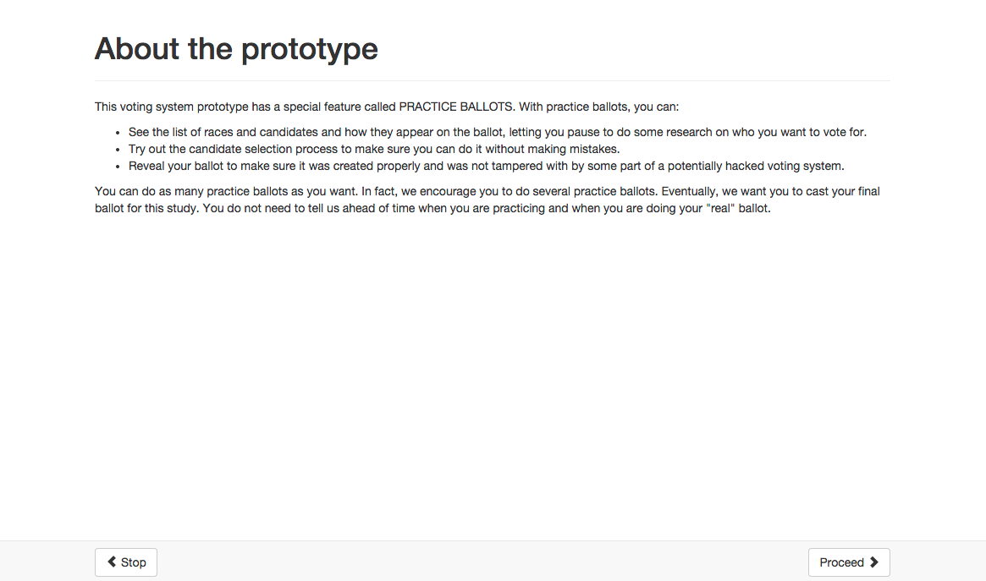

3. 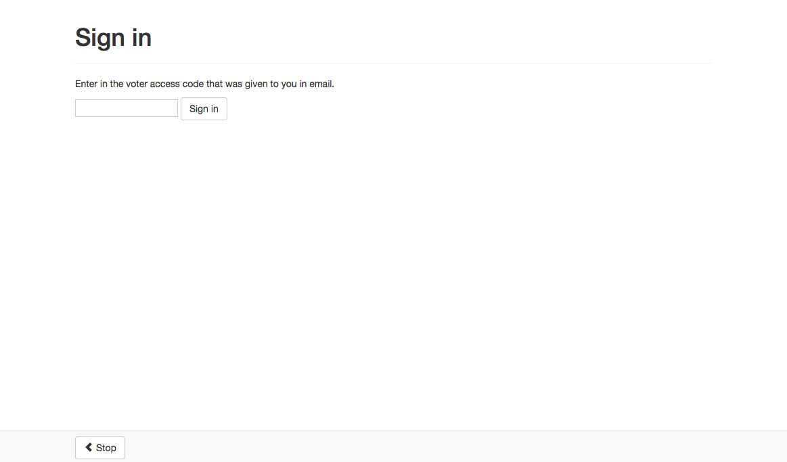

4. 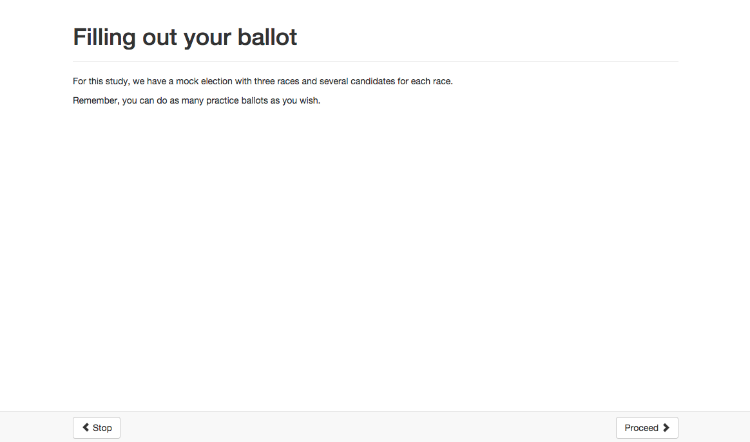

5. 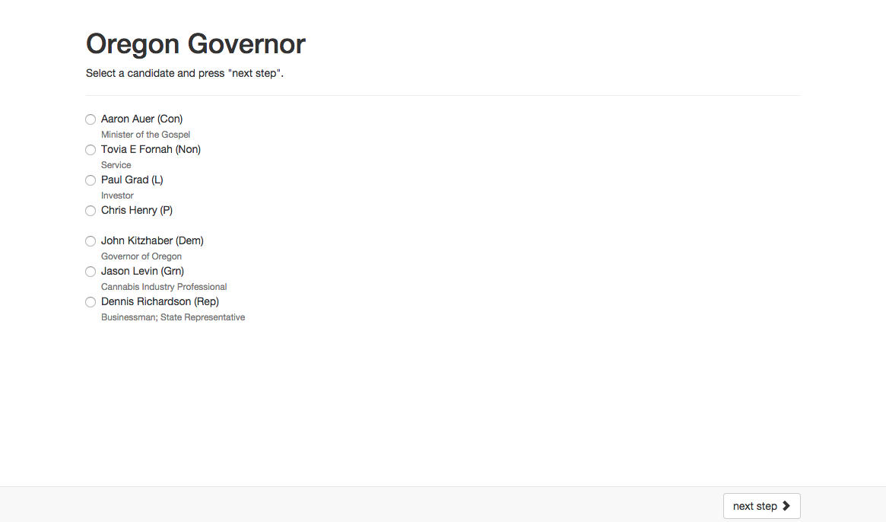

6. 

7. 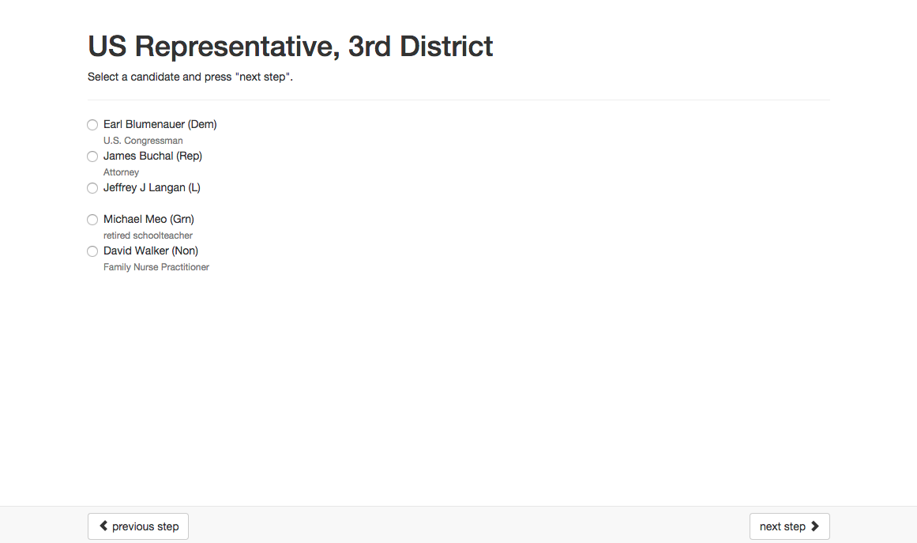

8.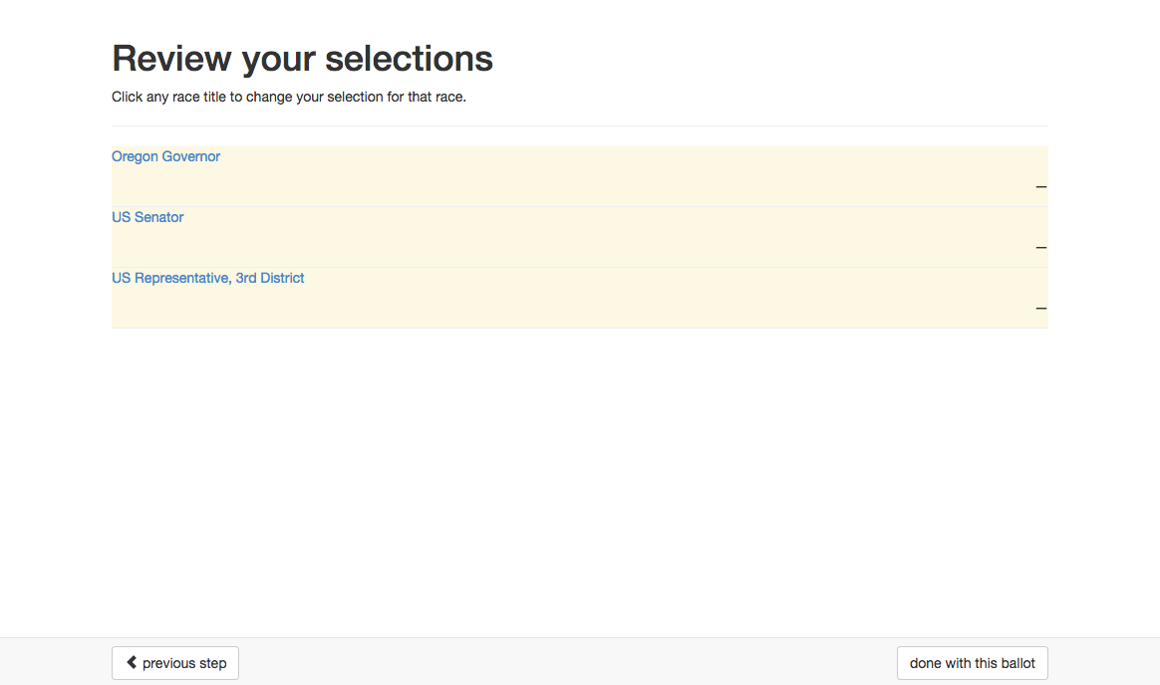

9.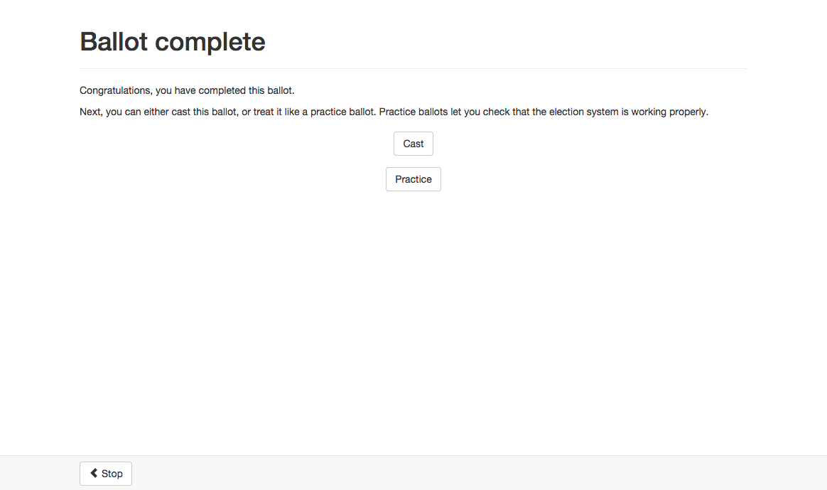

10. 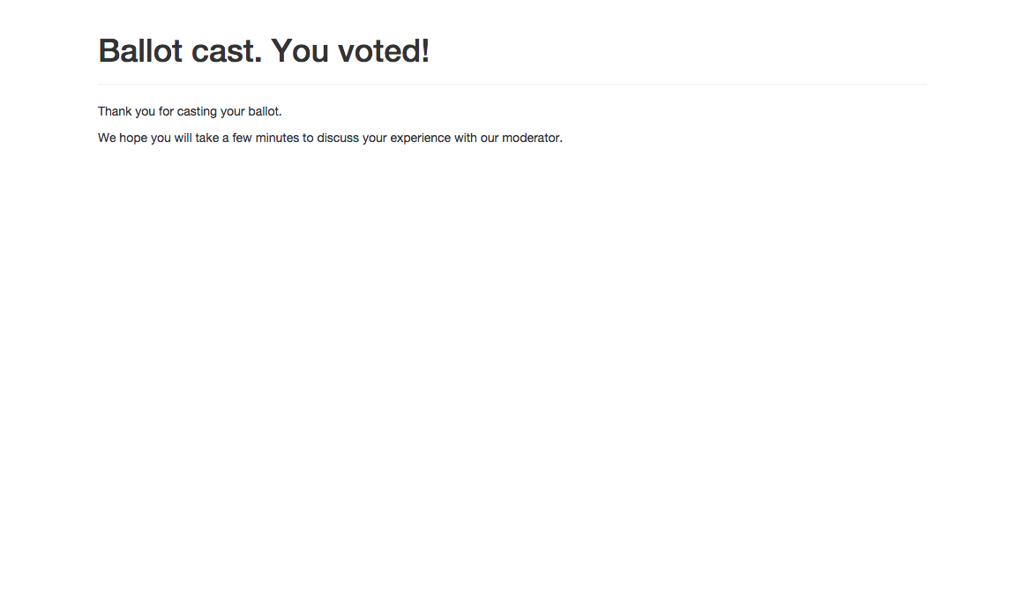

**Attachment 5: Helios**

1.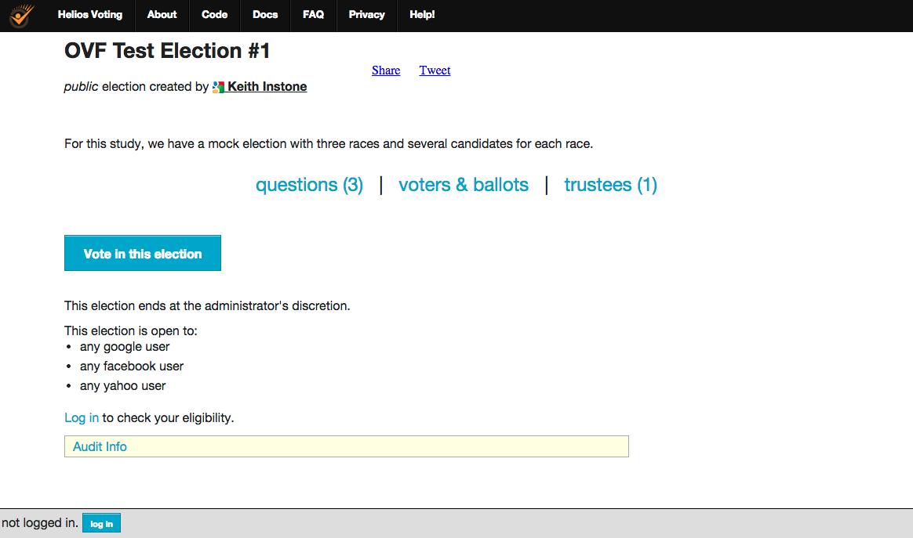

2. (questions)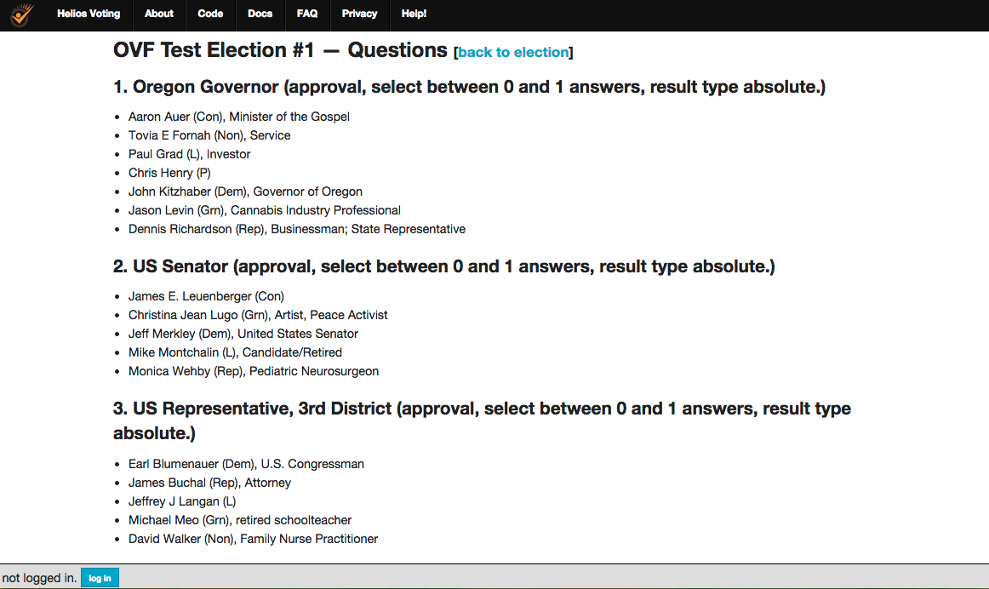

3. (ballots & voters)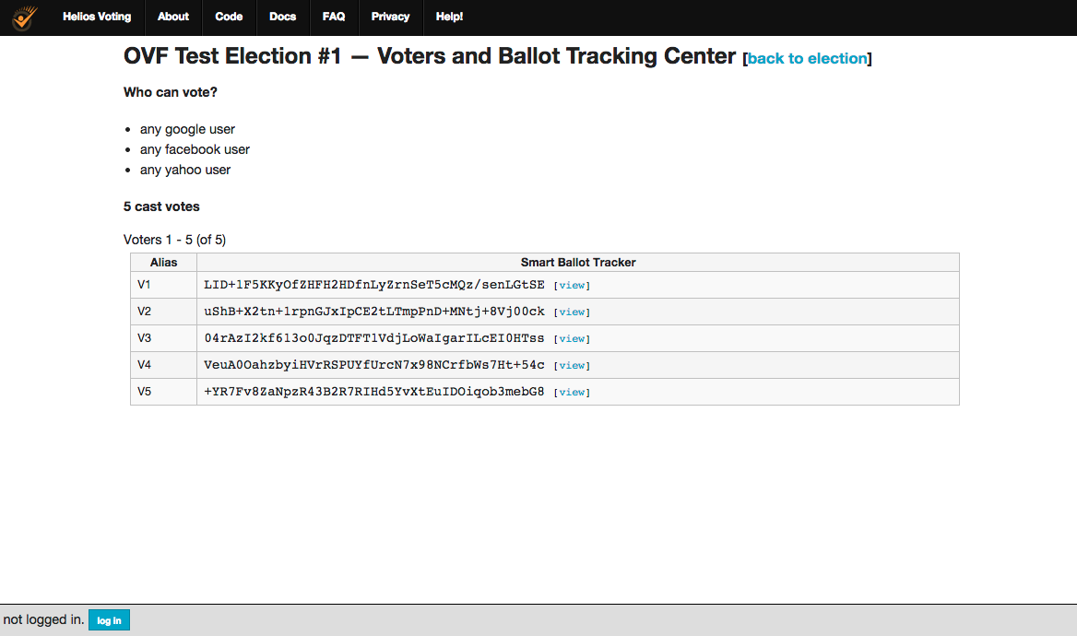

4. (trustees)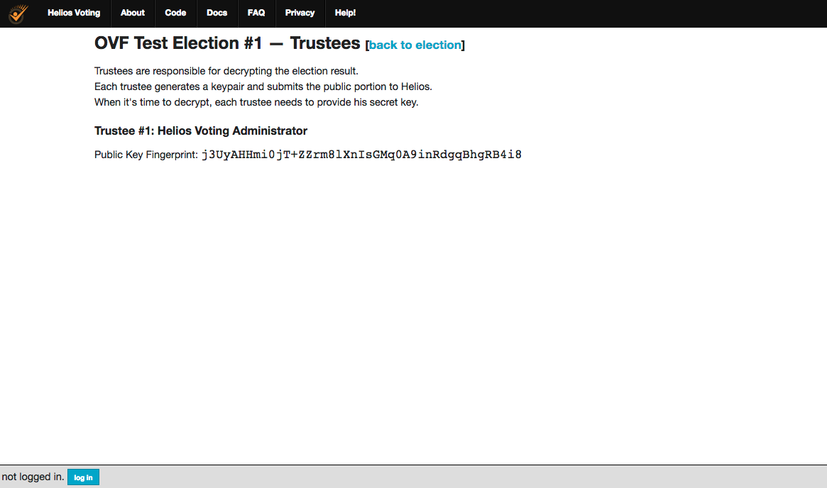

5. (audit info)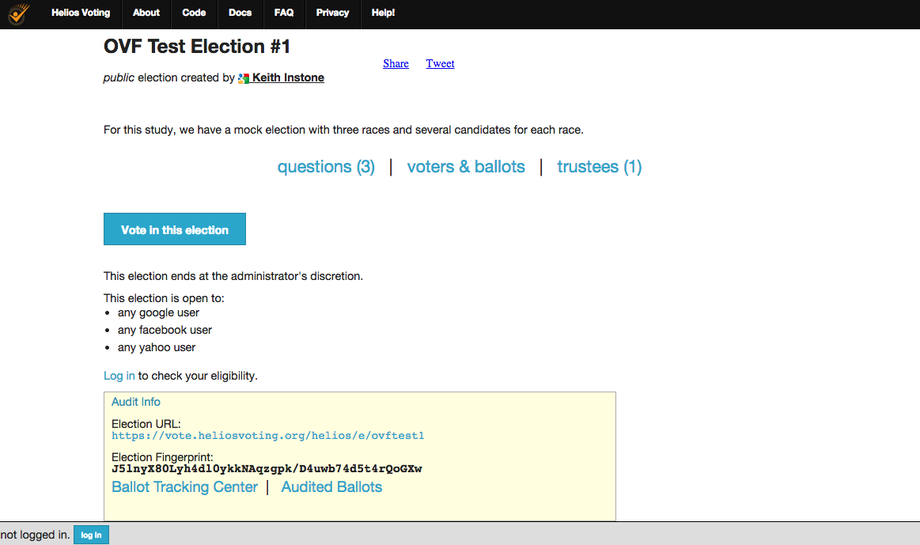

6. (start)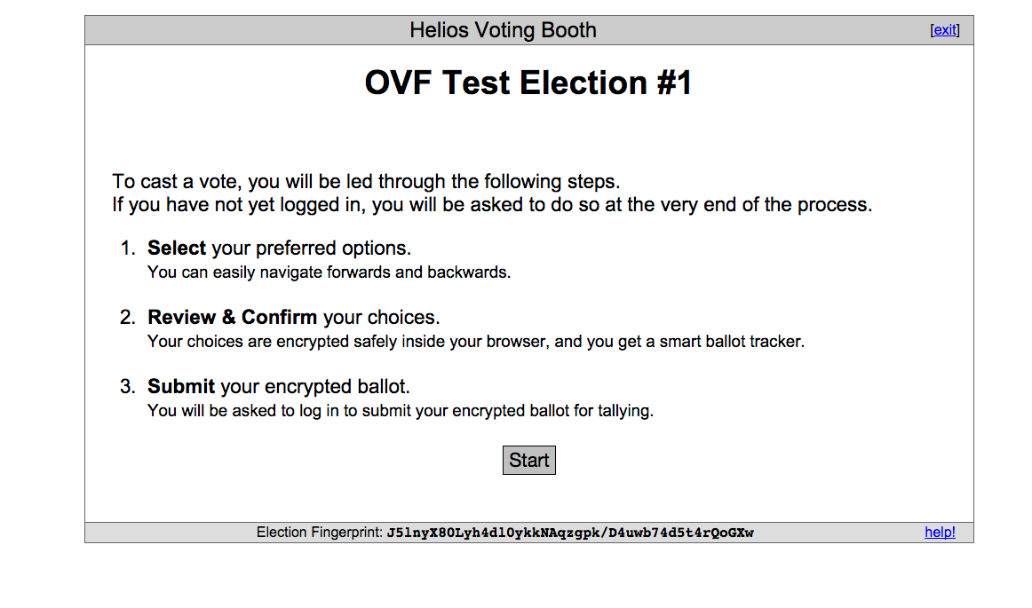

7. (race #1)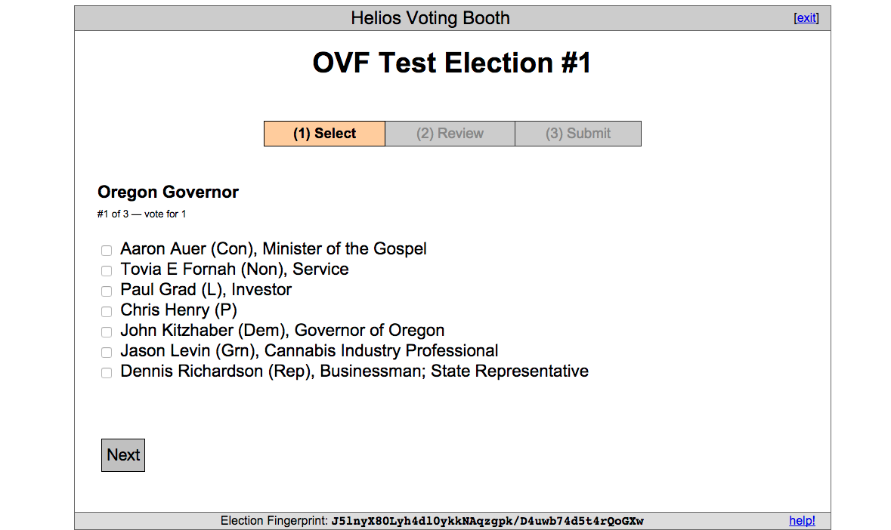

8. (race #2)

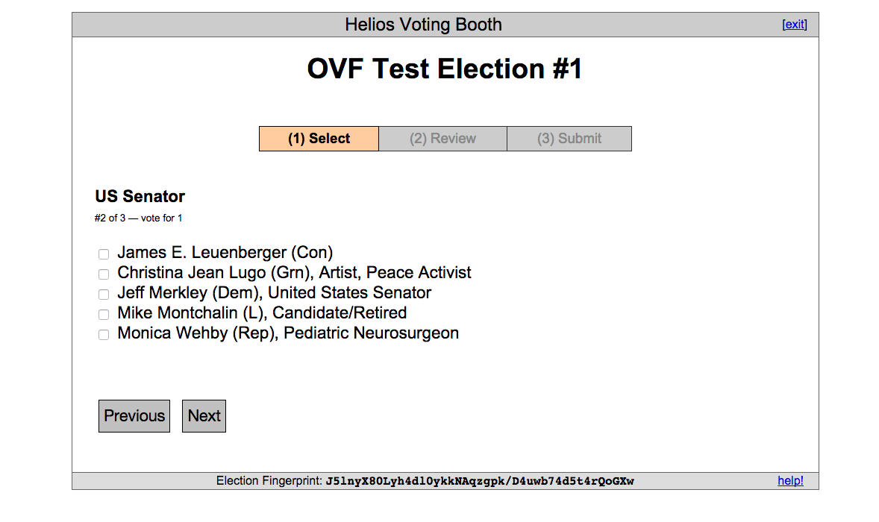

9. (race 3)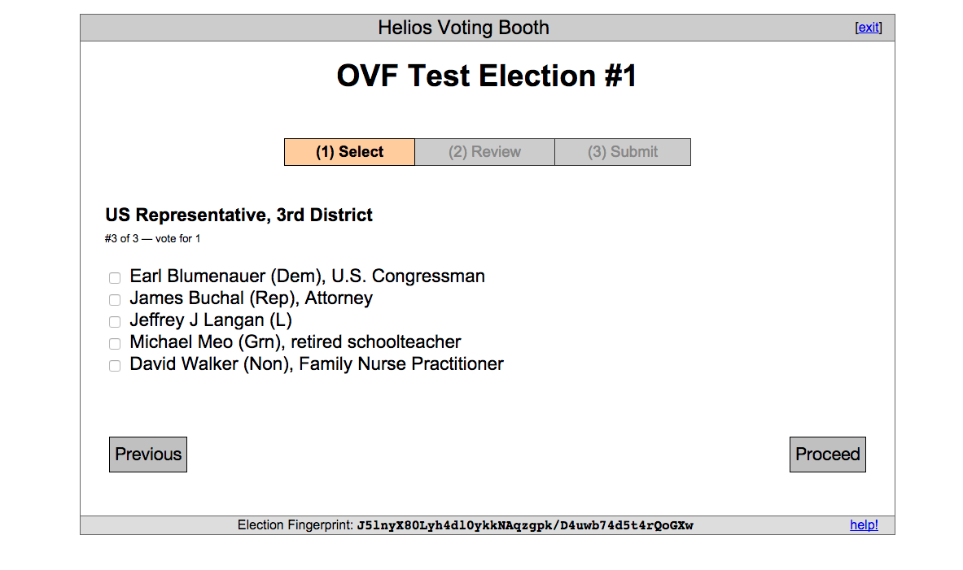

10. (encryption)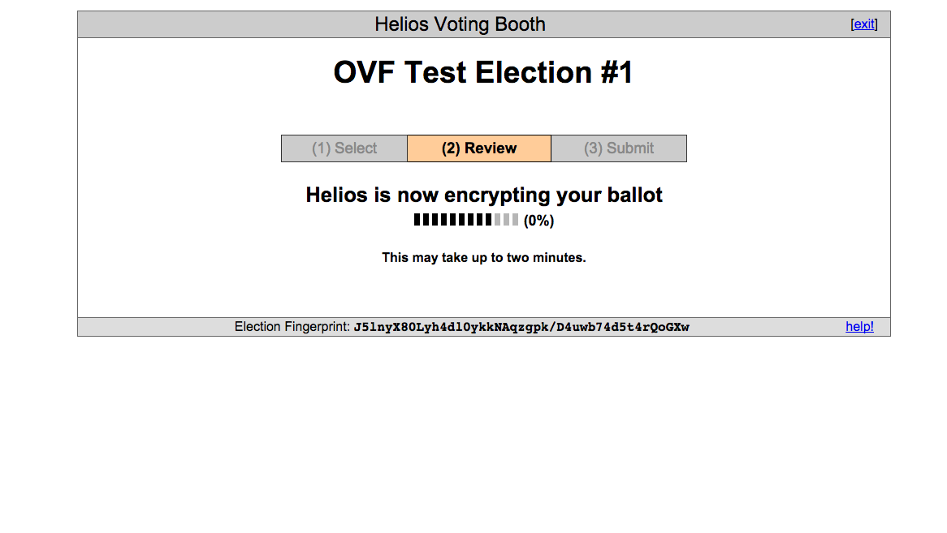

11. (review ballot)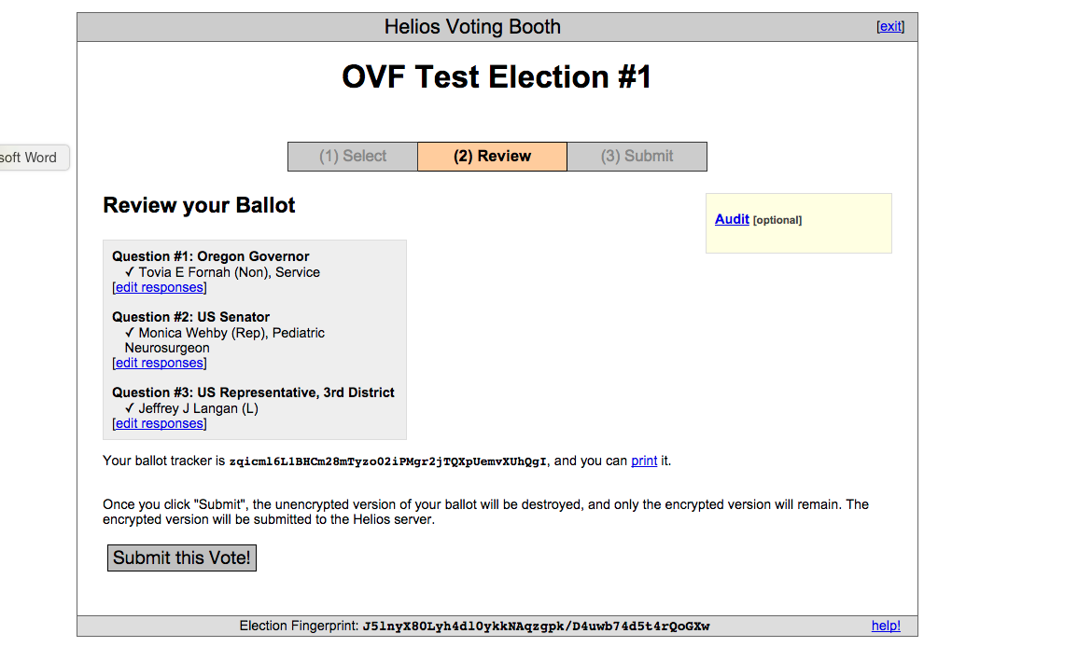

12. (review ballot/ audit)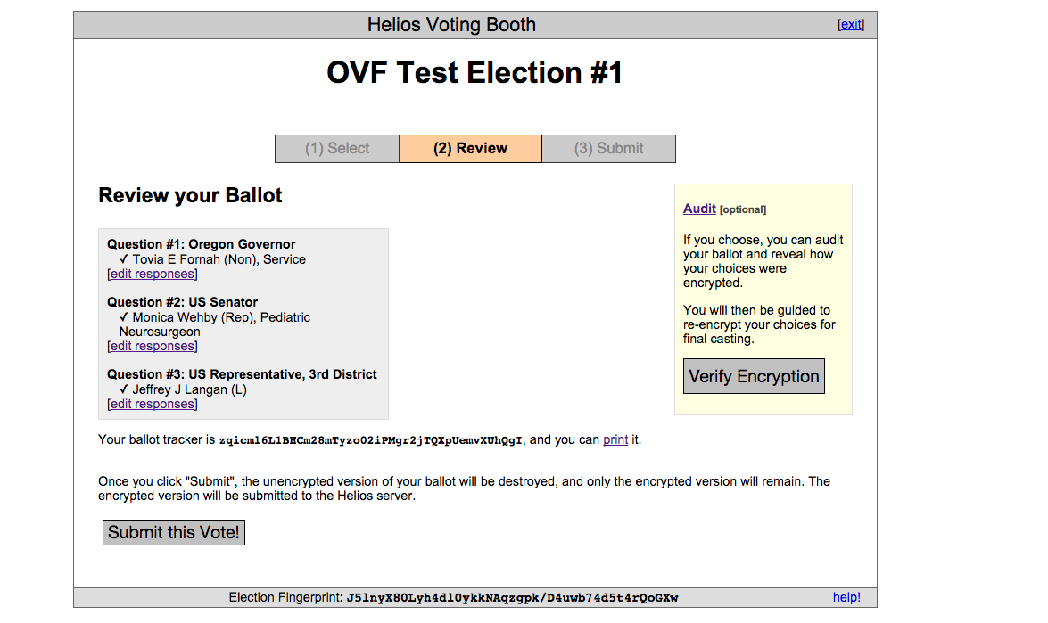

13. (audit ballot)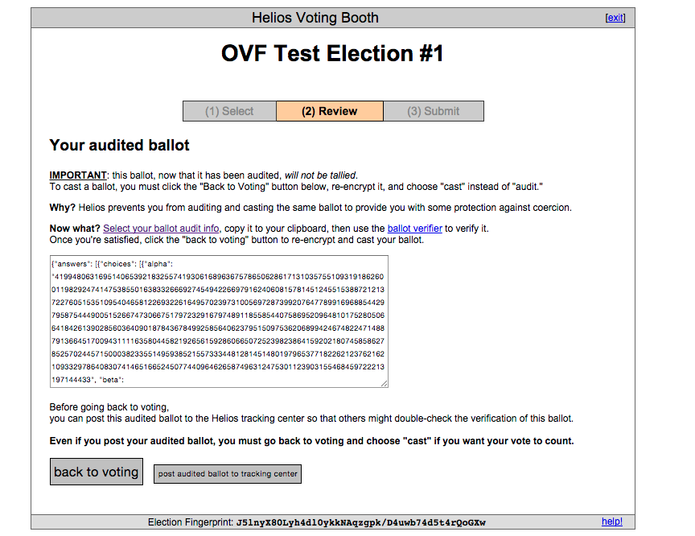

14. (final page)