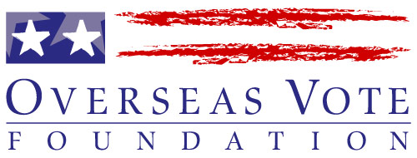 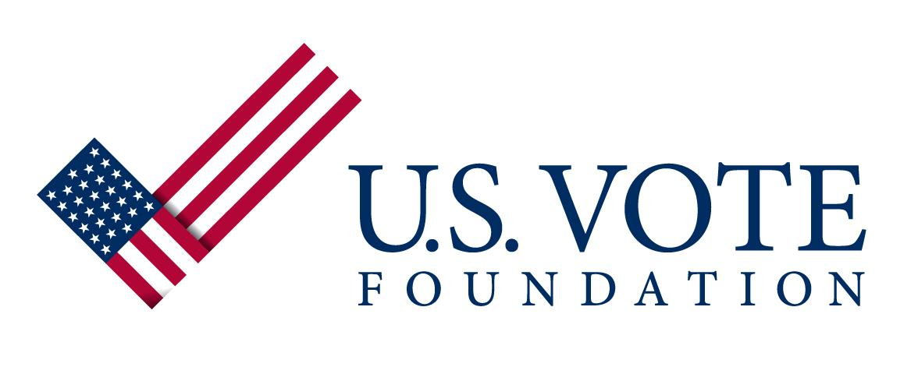

Andy Wasser

Associate Dean, School of ISM

Sean R. Beggs

Director, MISM & MSISPM

Heinz College

Carnegie Mellon University March 20, 2014

Dear Sean, Dear Andy,

I am delighted to present this short series of ideas for Capstone projects for the Spring and Fall sessions. Each project is presented below in a list, and then written-up very briefly in the ensuing pages.

Because we have six new projects to propose, and one continuation, my objective was to allow you to skim through them efficiently, and to easily identify what is of interest. We will be glad to develop and submit more in-depth proposals on any projects that you would like to pursue.

As you will see, some of the projects relate to the work of the Foundation, others to the ongoing End-to-End Verifiable Internet Voting Specification and Feasibility Study that is underway.

U.S. Vote Foundation and Overseas Vote Foundation   
A major aspect of our foundation’s work is to develop and provide voter services to voter in the U.S. and abroad. Staying abreast of voting challenges and developing innovative applications that drive voter engagement form a key goal of our development efforts. We have more ideas than resources. Projects of interest to the foundation are as follows:

1. **Automated Nationwide Election Dates and Deadlines Database and API –** this project involves data crawling and scraping and API development. Will require review of available information, development of a technical approach, front and back-end programming
2. **Software Development with Purpose – My Voter Account** – take this voter engagement software application concept and evolve it into a winning application of its own – a breakthrough concept that changes voter engagement in the U.S.
3. **Mobile App Development**: Transform the *My Voter Account* service into an Android and iPhone mobile app that will reach a much greater audience of voters, especially young voters and drive voter engagement and action

End-to-End Verifiable Internet Voting: Specification and Feasibility Study  
This project affords us the opportunity to develop what may be the future of voting in our country at some point. We can define Capstone project in many areas – they do not need to be limited to these ideas. Please let me know if you have particular areas of interest.

1. **Software System Usability Analysis** – tackle the notoriously difficult aspect of E2E V systems - their Usability. To include test plan/s and actual tests.
2. **Voting System Functionality, Scaling, and Security Testing** – for one or two existing E2E remote voting systems develop testing rationale, approach, and plans. Execute against these tests. This project may need to be broken into three separate testing projects.
3. **Definition and SWOT Analysis of E2E VIV System Models** – examination of at least three system models for E2E VIV voting: 1) E2E with paper; 2) E2E with electronic second channel; 3) E2E with no second channel
4. **E2E VIV Systems Comparative Analysis** – continuation of Winter 2014 project –recommendations are anticipated by the current team

Following is a brief write-up on six of the seven proposed projects. The exception is with the continuation of the current E2E VIV Systems Comparative Analysis project, which is not written up as we are waiting for results and recommendations. However, it is very likely that it can be continued in a second Capstone round.

I would like to emphasize that these projects are flexible – we are open to your input, ideas, and any thoughts on how to improve the projects if you see more ways to capitalize on the opportunities.

Thank you for continued support of the foundation and the E2E VIV Project.

Regards,



Susan Dzieduszycka-Suinat  
President and CEO  
U.S. and Overseas Vote Foundation

**Proposed Project 1.**

**Automated Nationwide Election Dates and Deadlines Database and API**  
This project will require review of available online election information, development of a technical approach, front and back-end programming and API development.

**Problem Description and Project Purpose**

**How can you vote in an election that you don’t know is taking place?**

There is no reliable single source that provides data for the election dates and associated deadlines for *all* elections in the U.S. at *all* levels: federal, state *and local/municipal*. The data is stashed in all forms in many places around the web – on websites, in charts, in .doc and .pdf files, and visible by almost no one. This project will pull this data out and make it visible to the voters who need it.

**How do we transform redundancy of effort into results-oriented action?**Many nonprofits collect federal and state level election data, but none provide it across all states in a continual data stream. These efforts are largely redundant. States, counties and municipalities concern themselves with their own elections only. This project can help to change this situation. Rather than effort being expended on collecting only the top level of data, organizations can focus on increasing awareness of the elections taking place.

**Actions and Deliverables**

* Examine, analyze and determine whether the needed data regarding the election dates and deadlines for U.S. elections at federal, state ***and*** local/municipal is available and in what forms
* Determine whether this data can be crawled and scraped and transformed into a useful database and how much human interaction is needed
* Define the scope of the work, and the methods to use to ultimately create a mechanism that enables the data to be collected and to automatically self-update on a constant basis with minimal human oversight
* Execute the required programming to develop the main data resource
* Design and develop the user interface for accessing the data
* Develop an API and the associated transfer/subscription mechanism that will allow the foundation to distribute the data to organizations and entities that will use it, present it through their own sites and apps, and ultimately promote greater electoral participation.
* Develop the system backend and documentation necessary for data maintenance and quality monitoring
* Develop API access mechanism and documentation

**Foundation Resources and Support** will include full access to our operations team, tech team, codebase and applications software systems.

**Proposed Project 2.**

**Software Development with Purpose – My Voter Account**   
This project examines a particular online voter engagement application, My Voter Account, and challenges the team to evolve it into a winning concept of its own – maybe even its own website.

**Problem** **Description and Project Purpose**

**What is the kind of breakthrough idea that changes the experience of voter engagement in the U.S.?**

This project asks a CMU Capstone team to rethink the challenges of US voter engagement and to use technology to enhance and transform the online civic experience.

The team does not need to start from scratch, but we ask them to help us move a concept from good to great. The foundation has developed an application called My Voter Account (MVA). MVA is designed to help voters cultivate and manage their voter engagement. It’s a fine vision, and a real start to something. We need *real innovation* to help us ‘cross the chasm’.

Our broad goal is that every citizen has a Voter Account, which functions as a ‘personal democracy dashboard.’ A Voter Account moves with the voter, informs him/her, and offers real value to support voting activity. At present, it can help to alleviate the complexity, repetitiveness and redundancy of the U.S. voter registration and ballot request process.

MVA can also be used to preselect and “push” relevant data to voters. Data from third party sources, when made available through an Application Programming Interface (API), can also be presented to voters through MVA.

Can we inspire US citizens to cultivate, inform and manage their voter engagement?

**Actions and Deliverables**

* Identify and document what equals real, compelling value for users of online voter services – what do they need and want
* Specify and recommend a set of innovations would enhance the personal experience of their Voter Account and what it would involve to realize these innovations
* Decide which of the innovations to program and implement
* Work together with the foundation’s tech team to execute, test, QA the new development concepts
* Launch the work! Develop a demo and a way to communicate the value of the new innovations to voting public and the elections community

**Foundation Resources and Support** will include full access to our operations team, tech team, codebase and applications software systems.

**Proposed Project 3.**

**Mobile App Development** **– Android and iPhone**

Transform the My Voter Account website experience into an Android and iPhone mobile app that will reach a much greater audience of voters, especially young voters and further drive voter engagement and action.

**Problem** **Description and Project Purpose**

**How do we make voter engagement a more regular part of our lives?**

One way is to make it easily accessible. This project asks a CMU Capstone team to take the My Voter Account (MVA) voter engagement application and transform it into a winning mobile app experience.

The foundation has developed an application called My Voter Account (MVA) with the intent to help voters cultivate and manage their voter engagement. We need the MVA ‘personal democracy dashboard’ to be in every individual’s hand.

To do that, we need to MVA to be optimized for mobile handheld devices on both the Android and iPhone platforms.

This project puts democracy into every citizen’s hands!

**Actions and Deliverables**

* Examine the application and determine a design approach on both Android and iPhone platforms
* Document and specify the development, test, QA and deployment plans
* Present and discuss the proposed plans with the foundation’s development and project management team
* Agree development schedule and milestones
* Program, test, and QA the new apps
* Work with the foundation’s dev team to deploy the applications
* Launch the work! Develop a demo and a way to communicate the value of the new innovations to voting public and the elections community

**Foundation Resources and Support** will include full access to our operations team, tech team, codebase and applications software systems.

**Proposed Project 4.**

**Software System Usability Analysis**

End-to-End verifiable (E2E V) remote voting systems are notoriously difficult to use. Very likely, this is because they have not benefited from in-depth usability testing and subsequent recommendations. This project will examine the usability challenges of one to two existing E2E V systems, propose new approaches, develop and conduct usability test plans, document the tests results and derive a set of recommendations for future development of such systems.

**Problem** **Description and Project Purpose**

Our country is at a near standstill on voting system innovation and development. The hardware-based systems can no longer be maintained. We need new systems that run on COTS hardware and which evolve the management of security, while offering auditability of the system and verifiability of the vote.

E2E verifiability may provide answers to many of security problems plaguing remote voting systems – security, verifiability, auditability and so on. However, the concepts will never move forward if they cannot be presented in a usable manner to the average voter.

Existing boutique systems have yet to make it past the great hurdle of Usability. They cater more to highly educated audiences, rather than the general public. If simply understanding the mechanism of the voting process is so difficult, the likelihood of its market acceptance is zero. The function of the voting system itself should not be a barrier to voting.

There must be a better way to vote using an E2E V system; something the average Joe could successfully do; maybe even something that voters with special needs could do. Finding those answers would set us all ahead in the development of usable E2E V remote voting systems.

**Actions and Deliverables**

* Learn and understand the concepts and protocol of E2E V remote voting
* Identify and decide on a set of voting system Personas to test and document reasons for choices
* Round 1: Examine one to two existing E2E V remote voting systems from a usability standpoint:
  + Document current usability approach and protocol; identify chief usability issues
  + Develop test plans for current systems and conduct actual usability tests
  + Evaluate results, present recommendations and design changes
* Round 2:
  + Develop system mockups with revisions
  + Conduct new round of usability tests and document outcome
* Analyze overall test results and present conclusions including rationale and recommendations to tackle usability challenges inherent in E2E V remote voting.

**Proposed Project 5.**

**Voting System Functionality, Scaling, and Security Testing**   
For one or two existing E2E remote voting systems develop testing rationale, approach, and plans. Execute against these tests. This project may need to be broken into three separate testing projects.  
  
**Problem** **Description and Project Purpose**  
It is an achievable goal to create a voting system that meets the requirements of both security experts and election officials, and one that the voting public will view as trustworthy and accessible?

There is a reason that the phrase “Trust, but Verify,” is so popular and it is not just because it has to do with preventing nuclear catastrophe. It is because in our culture, testing is a credible verification.

Given that the future of the country and the world depends on the accuracy of our elections, that the ballots are cast as intended and counted as cast, a voting system should stand up to test before it is declared secure or accurate, scalable or reliable or anything at all, right? Meet the current voting systems industry where certification is a buzzword and testing is very nearly something to avoid.

Our overall E2E VIV Specification and Feasibility Study aims to bring testing to the forefront and put it in full view of the public. This project gives the Capstone team a front seat on those challenges and the opportunity to make a major contribution to advance the project in the realm of testing.

**Actions and Deliverables**

Specify and develop plans for each of the three tests below, conduct the tests and document the results for one to two existing E2E VIV systems.

* Software testing of large-scale software packages used for critical infrastructure. During development, standard software practices should be in use for testing that the software produces results that are correct based on the specifications. This includes unit testing, static analysis, and similar standard means for ensuring software quality.
* Test software at scale as it would be used by voters in an election: This involves testing volume usage under normal load, including high volume normal load, to ensure robustness, correctness of results even under stress, and to calibrate degradation of performance as load increases beyond intended design limits. Transactions would come from many locations (IP addresses, etc.) over a period of a few weeks, in volumes that were unpredictable but could run to millions of votes. Determine whether under stress, the software would respond properly to continue the process of voting?
* Denial of service (DoS) attacks: Attacks on the system, especially DoS, must be anticipated. Testing of the system must include simulation of DoS attacks that would resemble but go beyond normal peak/stress loads for voting. We would not expect any system to survive attacks at extreme load, but the calibrated degradation of service during an attack should be analyzed.

**Proposed Project 6.**

**Definition and SWOT Analysis of E2E VIV System Models**   
  
Examination of at least three system models for E2E Verifiable Internet Voting: 1) E2E with paper; 2) E2E with electronic second channel; 3) E2E with no second channel. This project may have some carryover into the arena of voter authentication and voter credentials.

**Problem** **Description and Project Purpose**

Currently there are no widely adopted Internet Voting systems in place in the US, despite the push from certain vendors. This is largely due to the security challenges, and the concerns of wholesale election tampering or disruption.

That said, experts agree that if Internet Voting were to happen, it would be unconscionable that it would be anything other than an E2E Verifiable system. However, how much we use the Internet in a voting system remains an open question. Should the system combine Internet and paper to achieve greater security? What are the tradeoffs? Does this defeat the purpose of Internet Voting so much that it is not worth pursuing? Or is it irresponsible to pursue E2E VIV without considering all options.

Bottom line, can we really get to an *all* online system? What are the options and combinations for partially online? What are the advantages and disadvantages of and E2E V system with more than one “channel” of communication to the voter?

**Actions and Deliverables**

Conduct the following and present findings in a report. Use visual representations wherever possible:

* Analyze and describe in detail, including SWOT, at minimum, three system models for E2E VIV including:
  + E2E with paper;
  + E2E with electronic second channel;
  + E2E with no second channel.
* Define and compare the different types of systems/channels and their considerations regarding:
  + Ballot integrity
  + Voter authentication
  + Voter credentials
  + System security / threats
  + Usability
  + Election Administration
* Research dual channel development and systems used in the financial sector, where security and fraud are major issues, and examine those applications/innovations and their feasibility/applicability to the voting paradigm.