**LAPORAN**

**"…….."**



Disusun Oleh :

NAMA : GALUH SAPUTRI

NIM : 203110027

PRODI : RPLA

UNIVERSITAS TEKNOLOGI DIGITAL INDONESIA

TAHUN AJARAN

2022

1. Arsitektur MVVM

[MVVM](https://developer.android.com/jetpack/guide) adalah salah satu arsitektur pembuatan aplikasi berbasis GUI yang berfokus pada pemisahan antara kode untuk logika bisnis dan tampilan aplikasi. Dalam penerapannya, MVVM terbagi atas beberapa layer, yaitu Model, View, dan ViewModel. Simak pembahasan ketiga layer tersebut di bawah ini.

* **Model**  
  Layer ini adalah model atau entitas yang merepresentasikan data yang akan digunakan pada logika bisnis. Umumnya kelas-kelas yang ada di dalamnya berupa POJO atau Plain Old Java Object dan Data Classes jika kita menggunakan Kotlin.
* **View**Tidak seperti layer sebelumnya, layer ini berisi UI dari aplikasi untuk mengatur bagaimana informasi akan ditampilkan. Layer ini akan berisi kelas-kelas, seperti Activity dan Fragment.
* **ViewModel**Layer terakhir adalah **ViewModel** yang bertugas untuk berinteraksi dengan **model** di mana data yang ada akan diteruskan ke layer **view**.

1. ViewModel (Data Binding, Live Data)
2. Model (Update, Notify)
3. Room Database (DAO, Entity, SQLite)
4. Network API (retrofit, webservice, moshi)
5. View (Desain UI: theme, style, color)
6. Repository Pattern
7. **Soal bercabang**
8. **Apa nama Aplikasi android yang anda kembangkan?**

GithubUsers

1. **Jelaskan apa fungsi/guna aplikasi yang anda kembangkan**

Digunakan untuk menampilkan pengguna github. Sehingga kita dapat melihat data follower dan following dari pengguna tersebut, dan juga kita dapat melihat banyaknya repository yang dibuat.

1. **Webservice apa yang anda gunakan? Berikan tautannya/ linknya**

<https://api.github.com>

1. **Berikan tautan/link menuju sumber belajar yang anda gunakan sebagai dasar projek.**

**https://github.com/Aditprayogo/GithubUsers**

1. **Soal kedua**
   1. **Apa nama repository dari projek akhir anda di github**

**UAS_PNM_2**

* 1. **Berikan tautan menuju repository(github) projek akhir ande**

**https://github.com/Gals18/UAS_PNM_2**

* 1. **Pastikan setiap fitur berikut da dalam komentar/penjelasan dalam repository aplikasi github**
     1. **View (data binding)**

<https://github.com/Gals18/UAS_PNM_2/blob/main/app/src/main/java/com/galuhsaputri/githubusers/ui/main/MainActivity.kt>

Pada baris ke 3 5

* + 1. **ViewModel(live data)**

[**https://github.com/Gals18/UAS_PNM_2/blob/main/app/src/main/java/com/galuhsaputri/githubusers/ui/main/MainViewModel.kt**](https://github.com/Gals18/UAS_PNM_2/blob/main/app/src/main/java/com/galuhsaputri/githubusers/ui/main/MainViewModel.kt)

**Baris ke 15 – 32**

* + 1. **Adapter(untuk tampil ke recycleview)**

[**https://github.com/Gals18/UAS_PNM_2/blob/main/app/src/main/java/com/galuhsaputri/githubusers/ui/main/MainAdapter.kt**](https://github.com/Gals18/UAS_PNM_2/blob/main/app/src/main/java/com/galuhsaputri/githubusers/ui/main/MainAdapter.kt)

**Baris ke 21**

* + 1. **Class data(objek data)**

[**https://github.com/Gals18/UAS_PNM_2/blob/main/core/src/main/java/com/galuhsaputri/core/data/local/db/entity/UserFavoriteEntity.kt**](https://github.com/Gals18/UAS_PNM_2/blob/main/core/src/main/java/com/galuhsaputri/core/data/local/db/entity/UserFavoriteEntity.kt)

**Baris 8-23**

* + 1. **Network API**

[**https://github.com/Gals18/UAS_PNM_2/blob/main/core/build.gradle**](https://github.com/Gals18/UAS_PNM_2/blob/main/core/build.gradle)

**Baris 23 -24**

* + 1. **Repository**

[**https://github.com/Gals18/UAS_PNM_2/blob/main/core/src/main/java/com/galuhsaputri/core/data/UserRepositoryImpl.kt**](https://github.com/Gals18/UAS_PNM_2/blob/main/core/src/main/java/com/galuhsaputri/core/data/UserRepositoryImpl.kt)

* + 1. **Room DB**

[**https://github.com/Gals18/UAS_PNM_2/blob/main/core/src/main/java/com/galuhsaputri/core/data/local/db/AppDatabase.kt**](https://github.com/Gals18/UAS_PNM_2/blob/main/core/src/main/java/com/galuhsaputri/core/data/local/db/AppDatabase.kt)

* + 1. **DAO**

[**https://github.com/Gals18/UAS_PNM_2/blob/main/core/src/main/java/com/galuhsaputri/core/data/local/db/dao/UserFavoriteDao.kt**](https://github.com/Gals18/UAS_PNM_2/blob/main/core/src/main/java/com/galuhsaputri/core/data/local/db/dao/UserFavoriteDao.kt)

* + 1. **Entity**

[**https://github.com/Gals18/UAS_PNM_2/blob/main/core/src/main/java/com/galuhsaputri/core/data/local/db/entity/UserFavoriteEntity.kt**](https://github.com/Gals18/UAS_PNM_2/blob/main/core/src/main/java/com/galuhsaputri/core/data/local/db/entity/UserFavoriteEntity.kt)

1. **Soal ketiga**
   1. **Apa nama kelas package dari projek anda**

package com.galuhsaputri.githubusers

* 1. **Ada berapa kelas dalam projek anda**

**Sekitar 38 kelas**

* 1. **Idetifikasi nama class yang terdapat fitur berikut:**
     1. **View (data binding)**

[UAS_PNM_2](https://github.com/Gals18/UAS_PNM_2)/[app](https://github.com/Gals18/UAS_PNM_2/tree/main/app)/[src](https://github.com/Gals18/UAS_PNM_2/tree/main/app/src)/[main](https://github.com/Gals18/UAS_PNM_2/tree/main/app/src/main)/[java](https://github.com/Gals18/UAS_PNM_2/tree/main/app/src/main/java)/[com](https://github.com/Gals18/UAS_PNM_2/tree/main/app/src/main/java/com)/[galuhsaputri](https://github.com/Gals18/UAS_PNM_2/tree/main/app/src/main/java/com/galuhsaputri)/[githubusers](https://github.com/Gals18/UAS_PNM_2/tree/main/app/src/main/java/com/galuhsaputri/githubusers)/[ui](https://github.com/Gals18/UAS_PNM_2/tree/main/app/src/main/java/com/galuhsaputri/githubusers/ui)/[main](https://github.com/Gals18/UAS_PNM_2/tree/main/app/src/main/java/com/galuhsaputri/githubusers/ui/main)/**MainActivity.kt**

Pada baris ke 3 5

* + 1. **ViewModel(live data)**

## [UAS_PNM_2](https://github.com/Gals18/UAS_PNM_2)/[app](https://github.com/Gals18/UAS_PNM_2/tree/main/app)/[src](https://github.com/Gals18/UAS_PNM_2/tree/main/app/src)/[main](https://github.com/Gals18/UAS_PNM_2/tree/main/app/src/main)/[java](https://github.com/Gals18/UAS_PNM_2/tree/main/app/src/main/java)/[com](https://github.com/Gals18/UAS_PNM_2/tree/main/app/src/main/java/com)/[galuhsaputri](https://github.com/Gals18/UAS_PNM_2/tree/main/app/src/main/java/com/galuhsaputri)/[githubusers](https://github.com/Gals18/UAS_PNM_2/tree/main/app/src/main/java/com/galuhsaputri/githubusers)/[ui](https://github.com/Gals18/UAS_PNM_2/tree/main/app/src/main/java/com/galuhsaputri/githubusers/ui)/[main](https://github.com/Gals18/UAS_PNM_2/tree/main/app/src/main/java/com/galuhsaputri/githubusers/ui/main)/****MainViewModel.kt****

**Baris ke 15 – 32**

* + 1. **Adapter(untuk tampil ke recycleview)**

## [UAS_PNM_2](https://github.com/Gals18/UAS_PNM_2)/[app](https://github.com/Gals18/UAS_PNM_2/tree/main/app)/[src](https://github.com/Gals18/UAS_PNM_2/tree/main/app/src)/[main](https://github.com/Gals18/UAS_PNM_2/tree/main/app/src/main)/[java](https://github.com/Gals18/UAS_PNM_2/tree/main/app/src/main/java)/[com](https://github.com/Gals18/UAS_PNM_2/tree/main/app/src/main/java/com)/[galuhsaputri](https://github.com/Gals18/UAS_PNM_2/tree/main/app/src/main/java/com/galuhsaputri)/[githubusers](https://github.com/Gals18/UAS_PNM_2/tree/main/app/src/main/java/com/galuhsaputri/githubusers)/[ui](https://github.com/Gals18/UAS_PNM_2/tree/main/app/src/main/java/com/galuhsaputri/githubusers/ui)/[main](https://github.com/Gals18/UAS_PNM_2/tree/main/app/src/main/java/com/galuhsaputri/githubusers/ui/main)/****MainAdapter.kt****

**Baris ke 21**

* + 1. **Class data(objek data)**

## [UAS_PNM_2](https://github.com/Gals18/UAS_PNM_2)/[core](https://github.com/Gals18/UAS_PNM_2/tree/main/core)/[src](https://github.com/Gals18/UAS_PNM_2/tree/main/core/src)/[main](https://github.com/Gals18/UAS_PNM_2/tree/main/core/src/main)/[java](https://github.com/Gals18/UAS_PNM_2/tree/main/core/src/main/java)/[com](https://github.com/Gals18/UAS_PNM_2/tree/main/core/src/main/java/com)/[galuhsaputri](https://github.com/Gals18/UAS_PNM_2/tree/main/core/src/main/java/com/galuhsaputri)/[core](https://github.com/Gals18/UAS_PNM_2/tree/main/core/src/main/java/com/galuhsaputri/core)/[data](https://github.com/Gals18/UAS_PNM_2/tree/main/core/src/main/java/com/galuhsaputri/core/data)/[local](https://github.com/Gals18/UAS_PNM_2/tree/main/core/src/main/java/com/galuhsaputri/core/data/local)/[db](https://github.com/Gals18/UAS_PNM_2/tree/main/core/src/main/java/com/galuhsaputri/core/data/local/db)/[entity](https://github.com/Gals18/UAS_PNM_2/tree/main/core/src/main/java/com/galuhsaputri/core/data/local/db/entity)/****UserFavoriteEntity.kt****

**Baris 8-23**

* + 1. **Network API**

## [UAS_PNM_2](https://github.com/Gals18/UAS_PNM_2)/[core](https://github.com/Gals18/UAS_PNM_2/tree/main/core)/****build.gradle****

**Baris 23 -24**

* + 1. **Repository**

## [UAS_PNM_2](https://github.com/Gals18/UAS_PNM_2)/[core](https://github.com/Gals18/UAS_PNM_2/tree/main/core)/[src](https://github.com/Gals18/UAS_PNM_2/tree/main/core/src)/[main](https://github.com/Gals18/UAS_PNM_2/tree/main/core/src/main)/[java](https://github.com/Gals18/UAS_PNM_2/tree/main/core/src/main/java)/[com](https://github.com/Gals18/UAS_PNM_2/tree/main/core/src/main/java/com)/[galuhsaputri](https://github.com/Gals18/UAS_PNM_2/tree/main/core/src/main/java/com/galuhsaputri)/[core](https://github.com/Gals18/UAS_PNM_2/tree/main/core/src/main/java/com/galuhsaputri/core)/[data](https://github.com/Gals18/UAS_PNM_2/tree/main/core/src/main/java/com/galuhsaputri/core/data)/****UserRepositoryImpl.kt****

* + 1. **Room DB**

## [UAS_PNM_2](https://github.com/Gals18/UAS_PNM_2)/[core](https://github.com/Gals18/UAS_PNM_2/tree/main/core)/[src](https://github.com/Gals18/UAS_PNM_2/tree/main/core/src)/[main](https://github.com/Gals18/UAS_PNM_2/tree/main/core/src/main)/[java](https://github.com/Gals18/UAS_PNM_2/tree/main/core/src/main/java)/[com](https://github.com/Gals18/UAS_PNM_2/tree/main/core/src/main/java/com)/[galuhsaputri](https://github.com/Gals18/UAS_PNM_2/tree/main/core/src/main/java/com/galuhsaputri)/[core](https://github.com/Gals18/UAS_PNM_2/tree/main/core/src/main/java/com/galuhsaputri/core)/[data](https://github.com/Gals18/UAS_PNM_2/tree/main/core/src/main/java/com/galuhsaputri/core/data)/[local](https://github.com/Gals18/UAS_PNM_2/tree/main/core/src/main/java/com/galuhsaputri/core/data/local)/[db](https://github.com/Gals18/UAS_PNM_2/tree/main/core/src/main/java/com/galuhsaputri/core/data/local/db)/****AppDatabase.kt****

* + 1. **DAO**

## [UAS_PNM_2](https://github.com/Gals18/UAS_PNM_2)/[core](https://github.com/Gals18/UAS_PNM_2/tree/main/core)/[src](https://github.com/Gals18/UAS_PNM_2/tree/main/core/src)/[main](https://github.com/Gals18/UAS_PNM_2/tree/main/core/src/main)/[java](https://github.com/Gals18/UAS_PNM_2/tree/main/core/src/main/java)/[com](https://github.com/Gals18/UAS_PNM_2/tree/main/core/src/main/java/com)/[galuhsaputri](https://github.com/Gals18/UAS_PNM_2/tree/main/core/src/main/java/com/galuhsaputri)/[core](https://github.com/Gals18/UAS_PNM_2/tree/main/core/src/main/java/com/galuhsaputri/core)/[data](https://github.com/Gals18/UAS_PNM_2/tree/main/core/src/main/java/com/galuhsaputri/core/data)/[local](https://github.com/Gals18/UAS_PNM_2/tree/main/core/src/main/java/com/galuhsaputri/core/data/local)/[db](https://github.com/Gals18/UAS_PNM_2/tree/main/core/src/main/java/com/galuhsaputri/core/data/local/db)/[dao](https://github.com/Gals18/UAS_PNM_2/tree/main/core/src/main/java/com/galuhsaputri/core/data/local/db/dao)/****UserFavoriteDao.kt****

* + 1. **Entity**

## [UAS_PNM_2](https://github.com/Gals18/UAS_PNM_2)/[core](https://github.com/Gals18/UAS_PNM_2/tree/main/core)/[src](https://github.com/Gals18/UAS_PNM_2/tree/main/core/src)/[main](https://github.com/Gals18/UAS_PNM_2/tree/main/core/src/main)/[java](https://github.com/Gals18/UAS_PNM_2/tree/main/core/src/main/java)/[com](https://github.com/Gals18/UAS_PNM_2/tree/main/core/src/main/java/com)/[galuhsaputri](https://github.com/Gals18/UAS_PNM_2/tree/main/core/src/main/java/com/galuhsaputri)/[core](https://github.com/Gals18/UAS_PNM_2/tree/main/core/src/main/java/com/galuhsaputri/core)/[data](https://github.com/Gals18/UAS_PNM_2/tree/main/core/src/main/java/com/galuhsaputri/core/data)/[local](https://github.com/Gals18/UAS_PNM_2/tree/main/core/src/main/java/com/galuhsaputri/core/data/local)/[db](https://github.com/Gals18/UAS_PNM_2/tree/main/core/src/main/java/com/galuhsaputri/core/data/local/db)/[entity](https://github.com/Gals18/UAS_PNM_2/tree/main/core/src/main/java/com/galuhsaputri/core/data/local/db/entity)/****UserFavoriteEntity.kt****

1. **Soal keempat**
2. **Unggah screenshoot pada kode yang menunjukan request ke webservice dan parsing data json yang diperoleh**

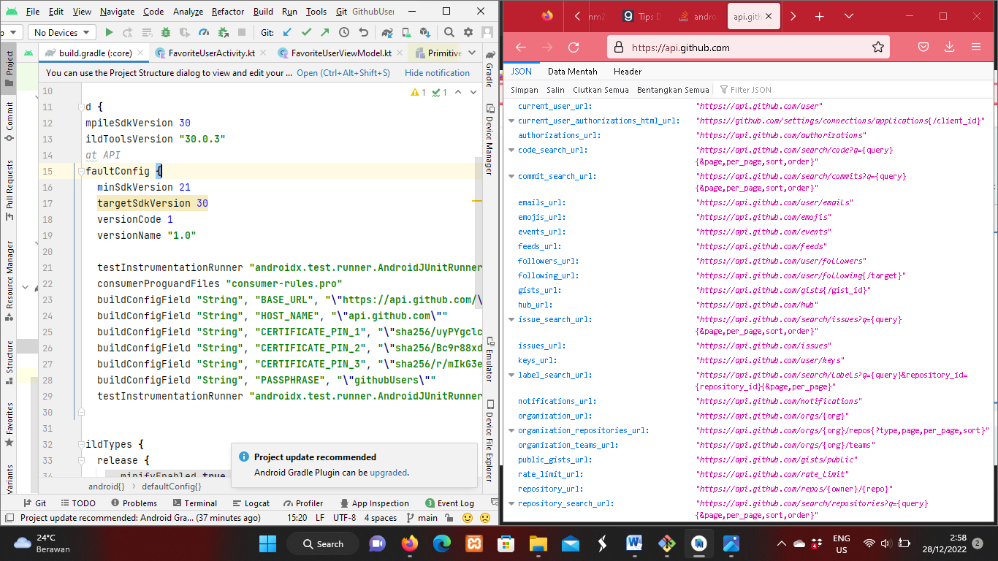

1. **Unnggah ss pd kode yg menunjukan penggunaan roomDB (sqlite)**

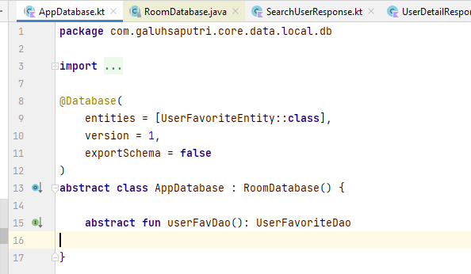

1. **Unggah ss pd kode yg menunjukan repository(sumberdat) yg diakses jika tidak ada jaringan.**

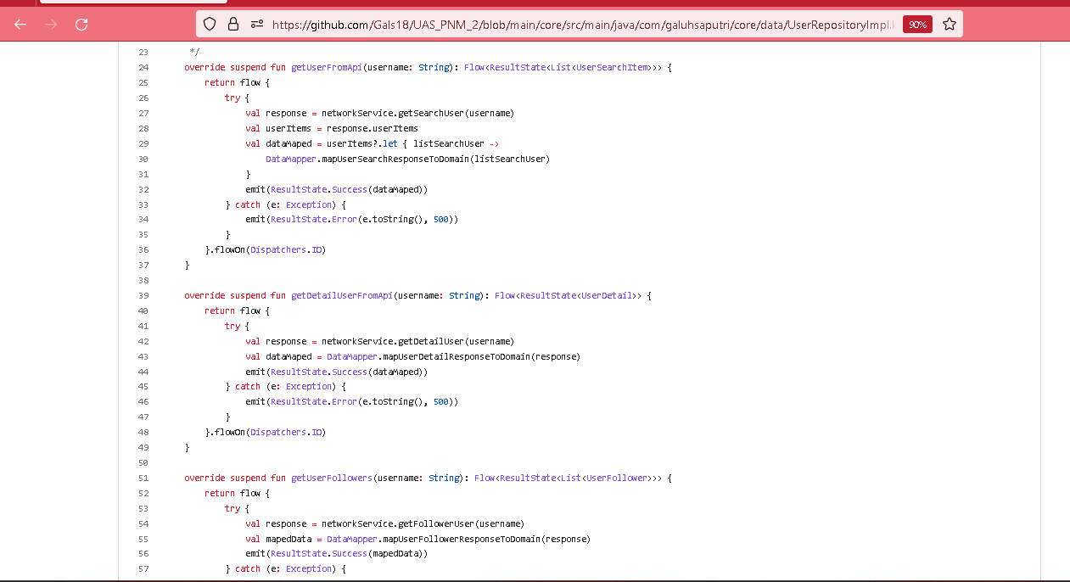

1. **Soal kelima**
2. **Unggah ss yg menampilkan halaman utama dari projek akhir anda**

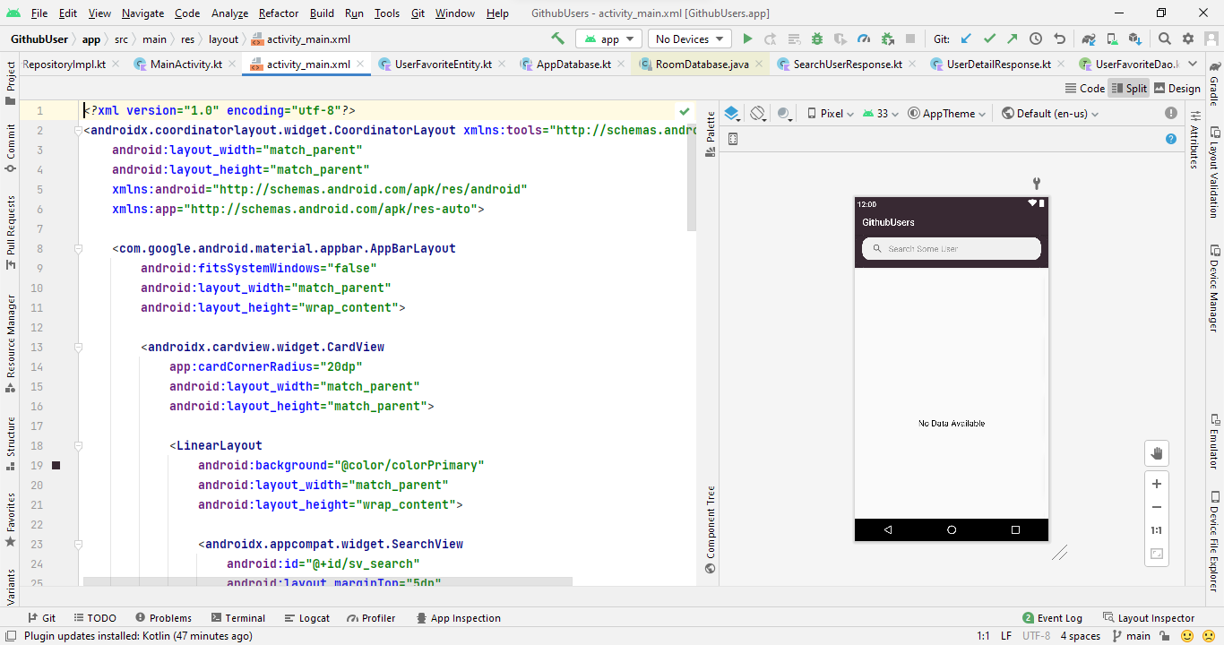

1. **Unggah ss yg menampilkan halaman kedua dari projek akhir anda**

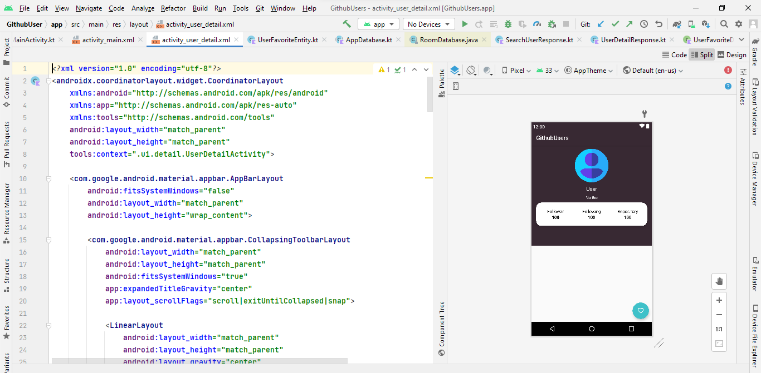

1. **Unggah ss yang menampilkan halaman repositorygithub dari projek akhir anda.**

