Task 1

Triangle  
  
There is no output as operation method didn’t called in main method

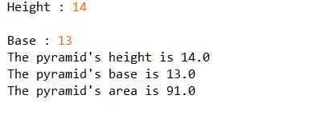Task 2

3. a)object – tri  
 b)user defined methods with return value – getHeight(), getBase(), getArea()  
 c)user defined methods with passing-parameters - setHeight(double length), setBase(double base1), set(double length, double base1)  
 d) accessor methods - getHeight(), getBase(), getArea()  
 e) mutator methods - setHeight(double length), setBase(double base1), set(double length, double base1)

Task 3