Task 1

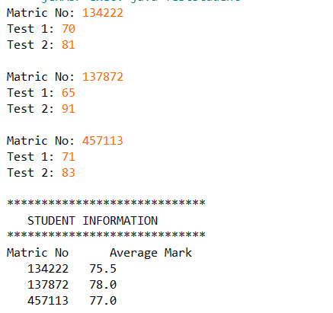Q1

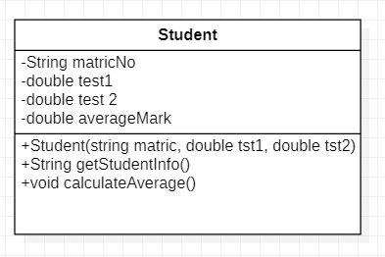

Q2

String

Student

134222

Matric No

**Q3**

70

Test 1

81

Test 2

String

Student

studDegree[]

83

71

91

65

String

457113

137872

Test 2

Test 2

Test 1

Test 1

Matric No

Matric No

Student

2

3

1