• What will be the output when running the above code?

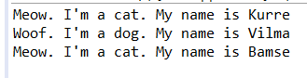

• What is meant by polymorphism ?  
- Polymorphism is the ability of an object to take on many forms which common use when  parent class reference is used to refer to a child class object.

• How does polymorphism work in the above program?

 Method overriding, where a child class can override a method in its parent

• The method introduceYourself of Animal appears to be never called? Why not?  
Because the method introduceYourself () was appears in every clases that the array called.  
  
• Comment out the method introduceYourself in Dog. What happens now when you run the program?  
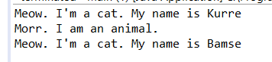

• Where is the name stored for the instances of Cat and Dog? (In what / which classes did you put the instance variable that refers to the name of the animal? Both Cat and Dog, or just in Animal?)  
Cat and Dog  
  
• How does the code in the test program work?  
Dog and Cat class have the same features of Animal. In main class. Animal class has been called in array type and data has been stored. Loop has been used to print out the output .

• How does an array work?  
Array is container object and contain an element while you assigned a value . Which element has its own numerical indeks.  
  
• In the above programs we have used a while loop to step through the array and to get information about the animals. But there is a more appropriate loop statement here. What is it?  
for (int i = 0 ; i<allAnimals.length ; i++)  
 allAnimals[i].introduceYourself();