• What will be printed?  
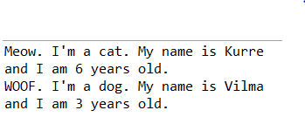  
• Explain how it is that the instance variable age of Animal can be used in Cat and Dog when it is declared in Animal.  
Because Cat and Dog extends Animal which means using the same features from the Animal  
  
• What actually consists an instance of?  
An instance variable can be declared public or private or default (no modifier). When we do not want our variable’s value to be changed out-side our class we should declare them private. public variables can be accessed and changed from outside of the class.  
  
• And what consists a class of?  
A class contains data field descriptions (or properties, fields, data members, or attributes). These are usually field types and names that will be associated with state variables at program run time; these state variables either belong to the class or specific instances of the class.  
  
• What is the difference between a class and an instance?  
If there is only one copy of the variable shared with all instance of the class, those variables are called class variables and if each instance of the class has its own copy of the variable, then those variables are called instance variables.  
  
• Change the declaration of the instance variable age of Animal to a class variable using static, in this way:  
public static int age;  
• What is the result of the output now? Why?

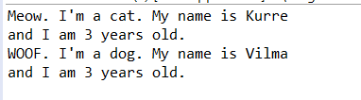  
The values of static variables will not be preserved during the de-serialization process. In-fact static variables are also not serialized but since these belongs to the class. After de-serialization they get their current values from the class which means static variables print the new (current)value from the class.

• It may happen that you get warnings from the compiler that you should access the variable age via Animal.age, but it should be possible to run the program anyway. Otherwise, change the references to age into Animal.age.  
• Where is the value of an instance variable stored?  
owned by instances of the class which means that for each object or instance of a class, the instance variables are different.  
  
• Where is the value of a class variable stored?  
class variables are shared by all instances of the class  
  
• What refers the variable this to?  
The classes where has been used