NIMESA TECHNOLOGIES – ASSIGNMENT ROUND

ASSIGNMENT 1:

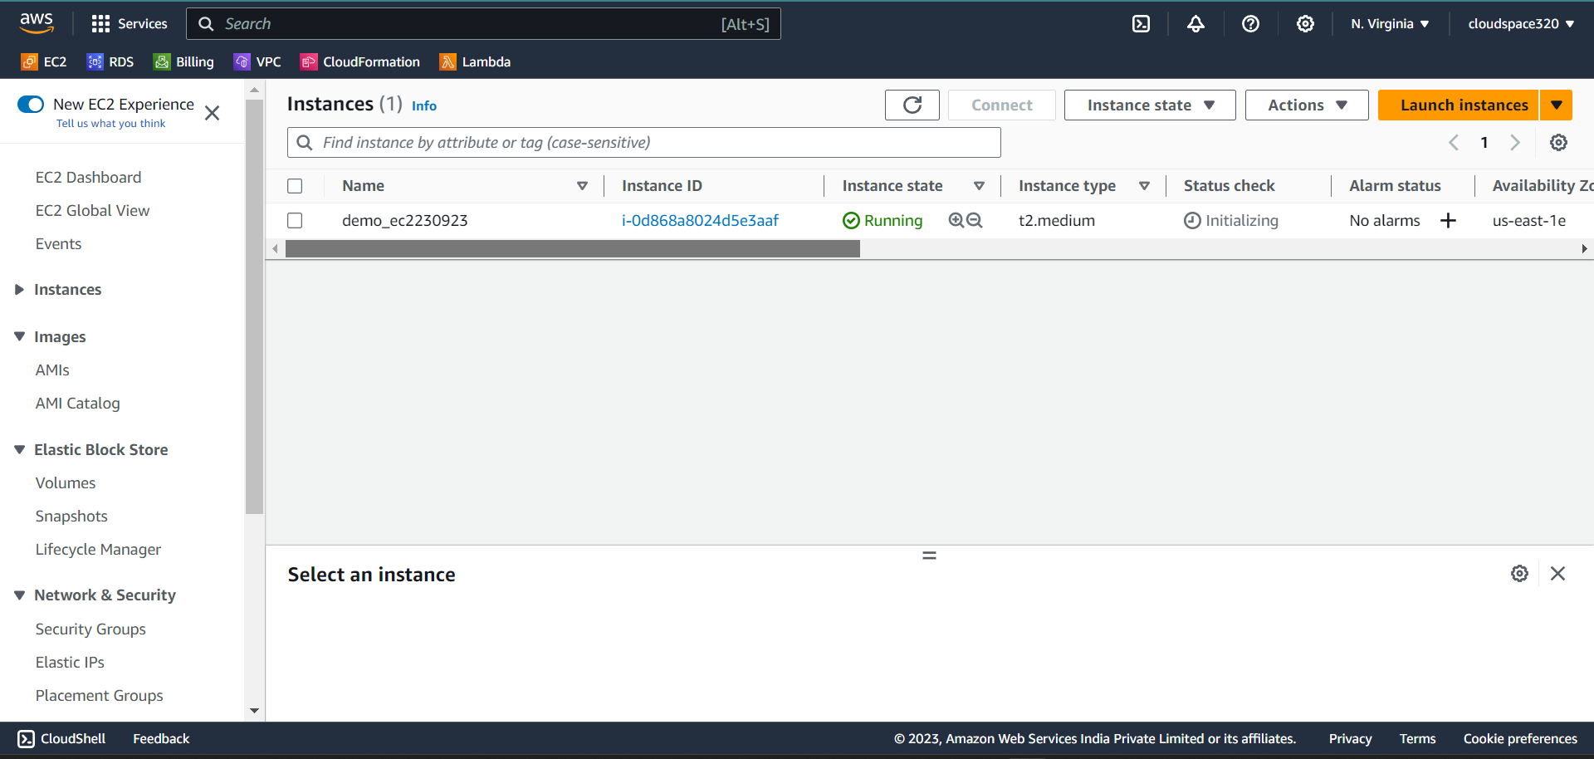

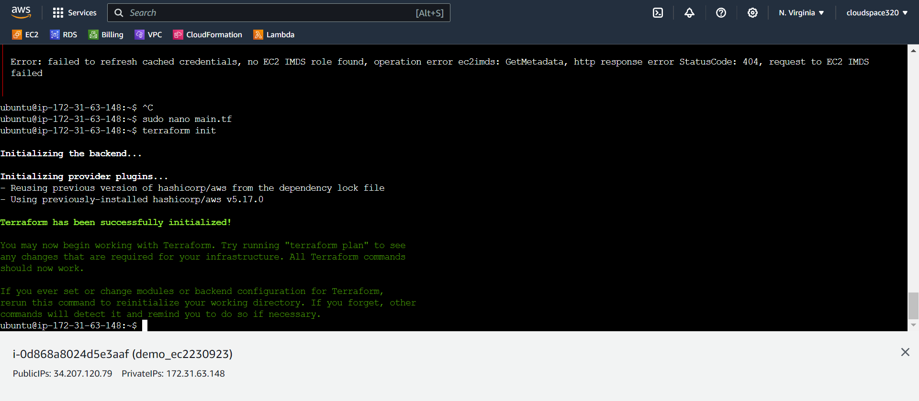

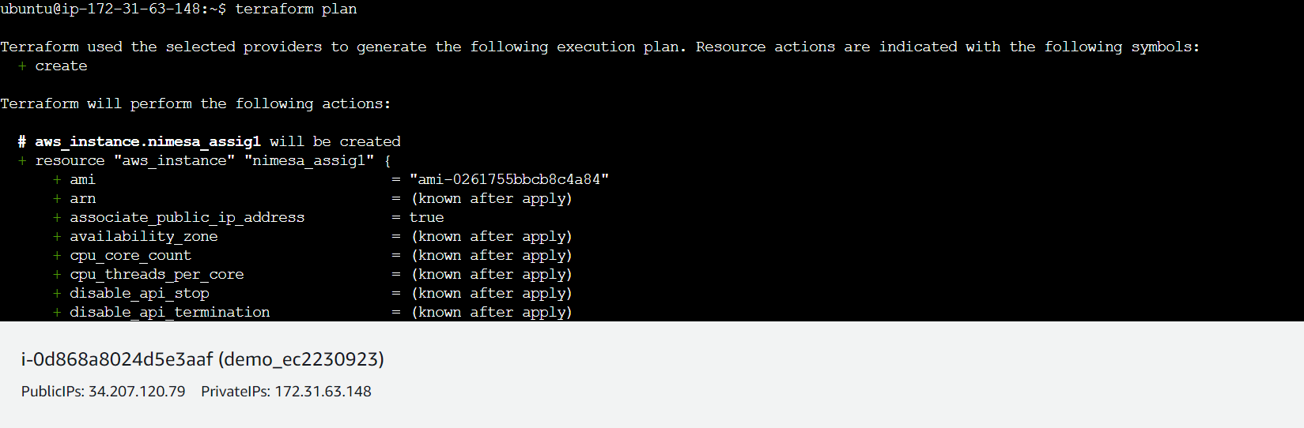

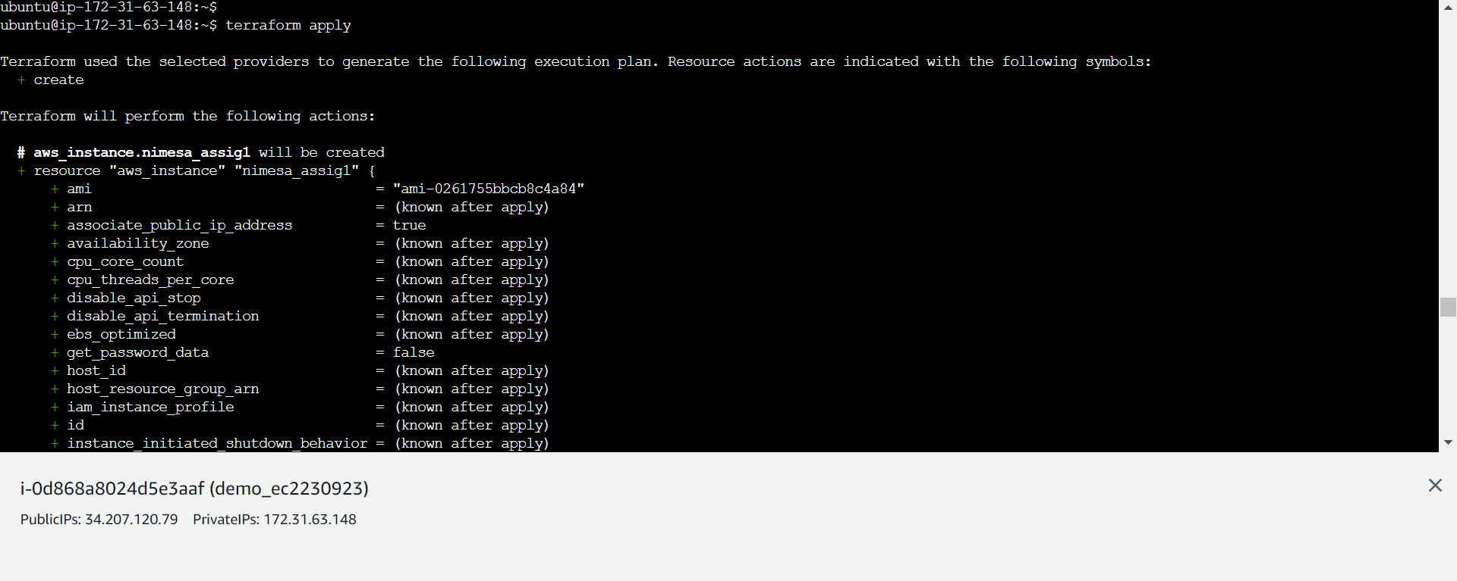

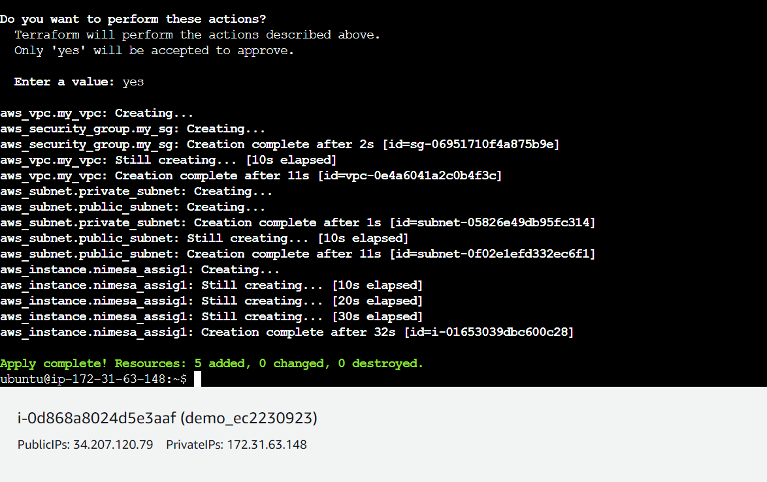

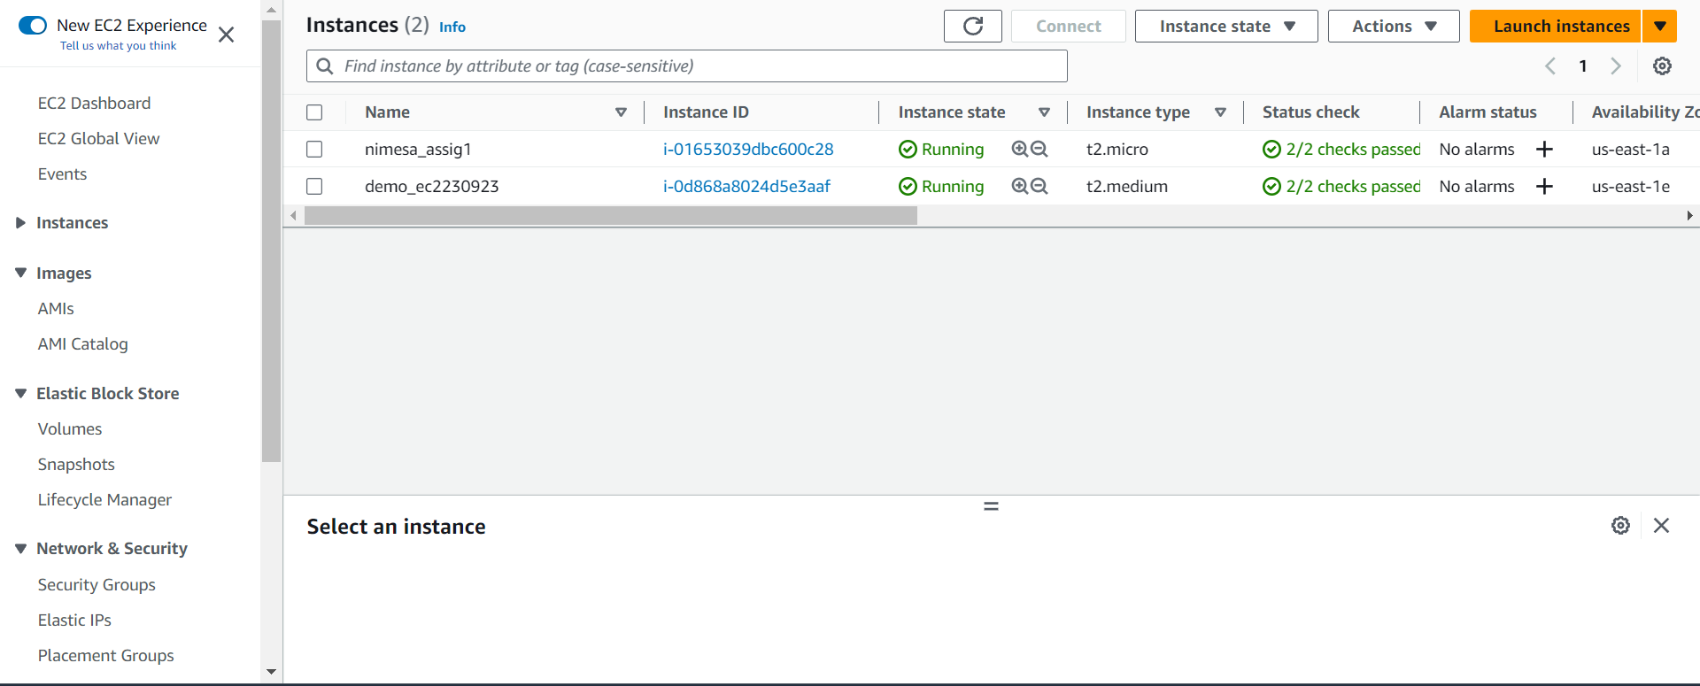

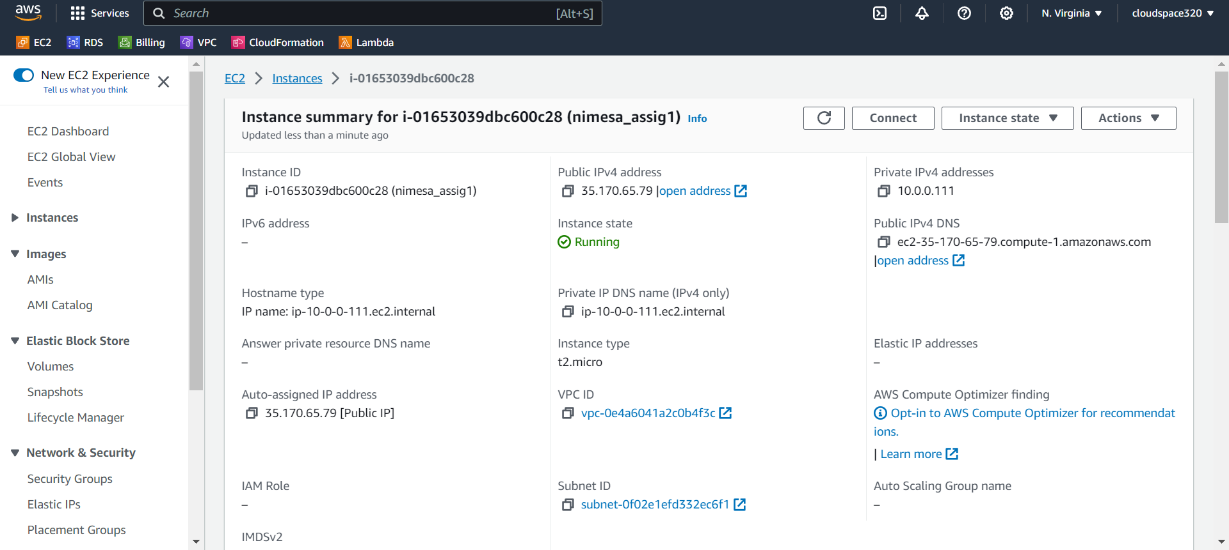

Commands:

1 sudo apt update

2 wget -O- https://apt.releases.hashicorp.com/gpg | sudo gpg --dearmor -o /usr/share/keyrings/hashicorp-archive-keyring.gpg

3 echo "deb [signed-by=/usr/share/keyrings/hashicorp-archive-keyring.gpg] https://apt.releases.hashicorp.com $(lsb_release -cs) main" | sudo tee /etc/apt/sources.list.d/hashicorp.list

4 sudo apt update && sudo apt install terraform

5 terraform --verseion

6 sudo nano main.tf

7 terraform init

8 sudo terraform init

9 sudo nano main.tf

10 terraform init

11 terraform plan

12 sudo nano main.tf

13 terraform init

14 terraform plan

15 terraform apply

16 history