Technical Report – Mộc Cafe Drink Ordering App (PRM393)

1. Team Introduction
The team has four members and splits the work evenly, 25% each. Each member owns one critical function area end to end (screens, provider and repository), plus secondary functions and one supporting task. Replace the placeholders with real names and student IDs.
Member | Student ID | Role | Main functions (critical) | Secondary functions | Supporting task | Share
[Member 1] | [ID] | Team leader, architecture and data | SQLite database design (8 tables); Provider architecture and navigation | Dark mode; release APK and Chrome web build | Compiles the report | 25%
[Member 2] | [ID] | Accounts and menu | Login, register, auto-login, logout; menu by category with search | Edit profile; login widget test and validator unit tests | Presentation slides | 25%
[Member 3] | [ID] | Drinks, cart and checkout | Drink detail (size, toppings); cart; checkout with simulated payment | Store map; cart unit tests | – | 25%
[Member 4] | [ID] | Orders, shop owner and notifications | Order history and detail with cancel; owner order management; order status notifications | Chat with the shop | draw.io diagrams | 25%
Every member can also explain the shared flow UI → Provider → Repository → SQLite, so any of us can answer questions about it.

2. Case Study
Mộc Cafe & Milk Tea is a small independent shop in Hải Châu, Đà Nẵng that sells coffee, milk tea, fruit tea and blended ice drinks for delivery. The app replaces phone and chat-message ordering with one mobile channel for customers and the shop owner. The domain is "e-commerce for independent shops" from the project brief.
Problem today. Orders arrive by phone and Facebook messages, so staff retype them and often miss the size, toppings or a note such as "less ice". Customers cannot see whether their order was accepted, and the owner has no single list of open orders.
Solution. Customers browse the menu by category, customise each drink, pay (simulated) and follow the order through five statuses with a notification at each step. The owner sees every order in one screen, moves it forward, and answers customer questions in an in-app chat.
Actor | Goal | Main functions
Customer | Order a drink exactly as wanted and know when it arrives | Register, log in, browse menu, customise, cart, checkout, track order, notifications, map, chat, edit profile
Shop owner (admin) | Handle every order quickly and keep customers informed | Log in, view and filter orders, change order status, cancel pending orders, reply to chats
Business rules
- A drink has a base price for size S; size M adds 6,000 VND and size L adds 10,000 VND.
- Toppings cost 5,000 to 10,000 VND each and can be combined freely.
- One cup costs base price + size surcharge + toppings; the line total is that times the quantity.
- Identical drinks (same size, toppings and note) merge into one cart line.
- An order moves Pending → Confirmed → Preparing → Delivering → Completed; it can be cancelled only while Pending.
- MoMo and card payments are simulated and mark the order as paid; cash is paid on delivery.
- Each order line stores the drink name and price at order time, so later menu price changes do not alter past orders.

3. Business Analysis / System Design
Thirteen functions serve two actors, built as a layered Provider app on a local SQLite database. We started from the shop's current ordering problems (section 2), listed what each actor must do, then designed the layers, tables and screens around those functions.

3.1 Functional requirements
ID | Function | Actor | Description
FR-01 | Register | Customer | Name, email, phone, password and confirmation, validated inline; a duplicate email is rejected
FR-02 | Log in, auto-login, log out | Both | Email and password; the session is kept in SharedPreferences; the role opens the customer or owner home
FR-03 | Browse menu by category | Customer | 4 categories, 14 drinks, category chips and search by name
FR-04 | Drink detail | Customer | Size S, M or L, any toppings, a note and quantity, with a live price
FR-05 | Cart | Customer | Merge identical lines, change quantity, swipe to delete, clear all, running total
FR-06 | Checkout and simulated payment | Customer | Receiver, phone, address, note; cash, MoMo or card; a 2-second simulated gateway
FR-07 | Order history and detail | Customer | Newest first, a status timeline, cancel while Pending
FR-08 | Order status notifications | Customer | A system notification and an in-app list with an unread badge on every status change
FR-09 | Store location map | Customer | Map with the shop marker, address, phone, opening hours, directions in Google Maps
FR-10 | Chat with the shop | Both | One conversation per customer; the owner sees all conversations
FR-11 | Order management | Owner | All orders with a status filter and counts; advance the status or cancel a pending order
FR-12 | Dark mode | Customer | A switch saved in SharedPreferences
FR-13 | Edit profile | Customer | Change name and phone; change the password after entering the current one; the email stays fixed

3.2 Non-functional requirements
Quality | Requirement | How the app meets it
Usability | Vietnamese, consistent Material 3 UI | Inline validation messages, empty states, loading indicators, dark mode
Performance | Smooth scrolling and few rebuilds | ListView and GridView builders, const widgets, Selector and context.select for badges
Reliability | No half-saved orders | An order and its lines are written in one SQLite transaction
Offline use | Core features work without internet | All data is local; only map images and directions need a connection
Responsiveness | Phones and wide screens | Menu grid has 2 columns under 600 px and 4 above; the store screen goes side by side above 600 px
Maintainability | Clear separation of concerns | UI, Provider, Repository and DatabaseHelper layers, commented code
Testability | Business logic testable without UI | Cart logic and validators are plain Dart; 21 automated tests
Security | Users only see their own data | Queries filter by user id; passwords are stored in plain text, a known limitation (section 6)

3.3 Architecture (Provider)
Screens never run SQL: they call a provider, the provider calls a repository, and repositories share one SQLite connection.
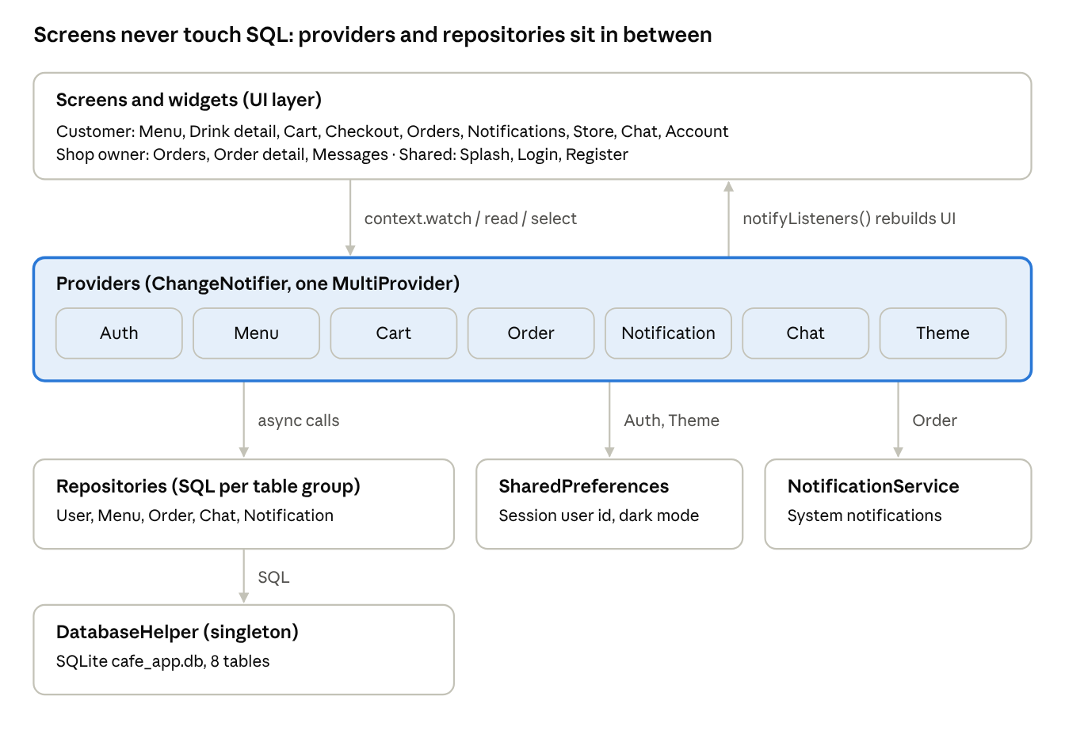
layered Provider architecture · 4 layers
Only CartProvider keeps its state purely in memory; the other six persist through a repository, SharedPreferences, or both.
Provider | State it holds | Main screens
AuthProvider | Current user; login, register, auto-login, logout | Splash, Login, Register
MenuProvider | Categories, drinks, toppings, selected category, search text | Menu, Drink detail
CartProvider | Cart lines, cup count, total | Cart badge, Cart, Checkout
OrderProvider | Order list, loading flag; place order, change status | Order history, Order detail, Owner orders
NotificationProvider | Notifications, unread count | Bottom bar badge, Notifications
ChatProvider | Messages, conversation list | Chat, Owner messages
ThemeProvider | Dark mode flag | App root, Account
All seven sit in one MultiProvider above MaterialApp. Screens read state with context.watch, call actions with context.read, and the badges rebuild alone through Selector and context.select.

3.4 Database design
Eight SQLite tables hold all data. Orders belong to users and own their order lines; each line copies the drink name and price so history never changes.
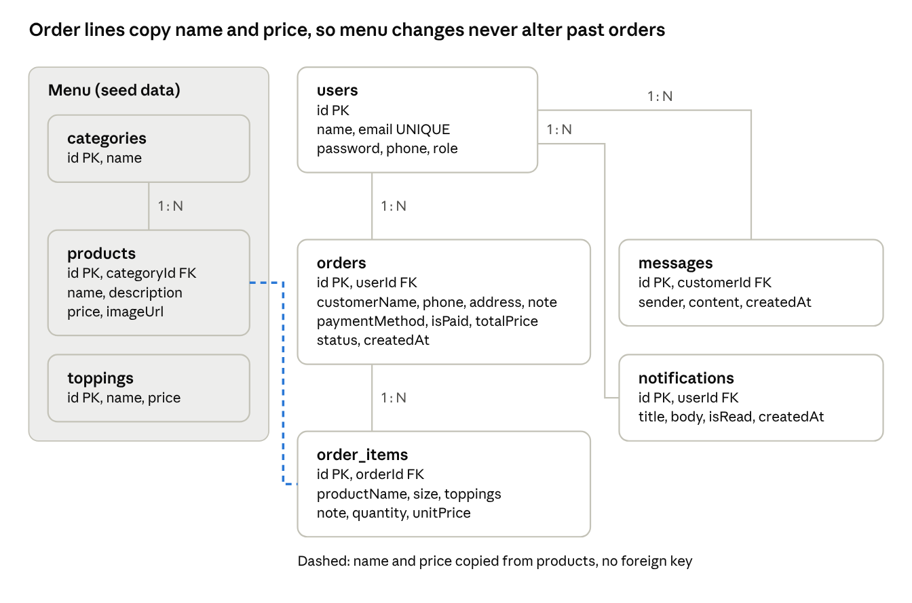
database schema · 8 tables
A user owns many orders, messages and notifications; an order owns many lines. The dashed link is a copy made at order time, not a foreign key.
Table | Columns | Notes
users | id PK, name, email UNIQUE, password, phone, role | role is customer or admin
categories | id PK, name | 4 seeded
products | id PK, categoryId FK, name, description, price, imageUrl | 14 seeded, price in VND for size S
toppings | id PK, name, price | 5 seeded
orders | id PK, userId FK, customerName, phone, address, note, paymentMethod, isPaid, totalPrice, status, createdAt | enums stored by name, isPaid as 0/1
order_items | id PK, orderId FK, productName, size, toppings, note, quantity, unitPrice | price snapshot at order time
messages | id PK, customerId FK, sender, content, createdAt | sender is customer or shop
notifications | id PK, userId FK, title, body, isRead, createdAt | feeds the Notifications tab

3.5 Order status flow
An order has five normal states and one exit; only the owner moves it forward, and only a Pending order can be cancelled.
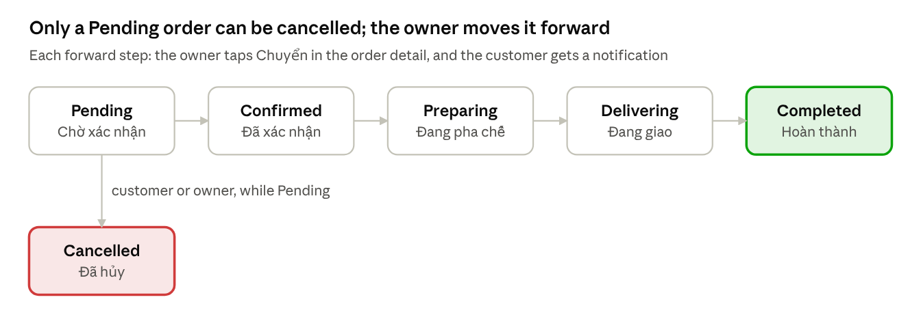
order status flow · 6 states
The customer sees the same steps as a timeline in the order detail screen, with the Vietnamese labels shown under each state.

3.6 UI flow
The splash screen routes by saved session and role: customers land on five tabs, the owner on two.
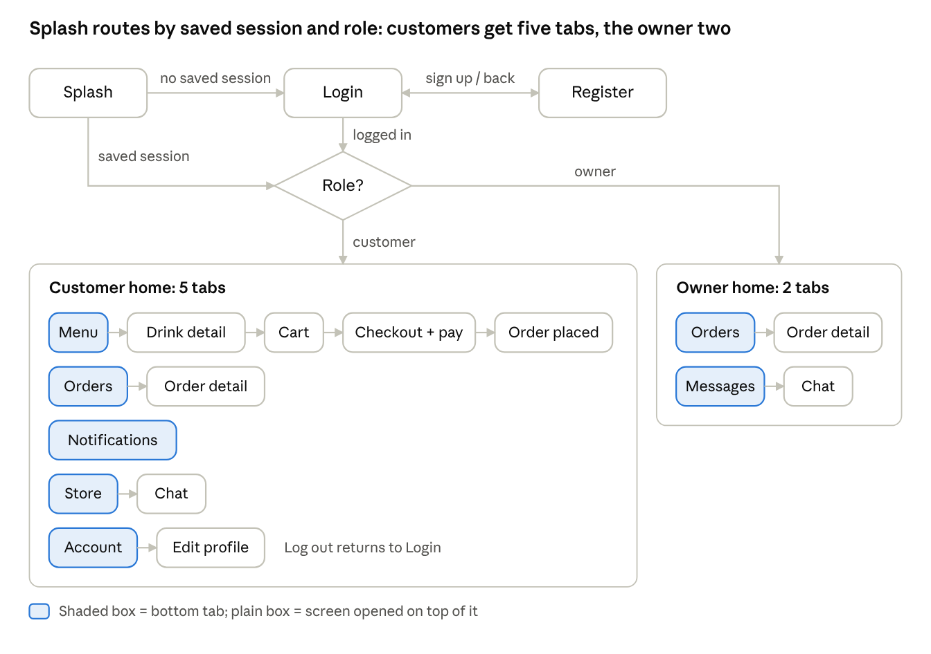
UI flow · 18 screens
Checkout opens the simulated payment dialog for MoMo and card before the order is saved; logging out from either home clears the session and returns to Login.

3.7 Data access (API) design
The app has no REST backend; five repository classes are its data API. Models convert rows with toMap() and fromMap(), the same pattern as fromJson in Module 8, so moving to a REST API later changes only the repositories.
Repository | Methods | Tables
UserRepository | register, login, getUserById | users
MenuRepository | getCategories, getProducts, getToppings | categories, products, toppings
OrderRepository | createOrder (transaction), getOrdersByUser, getAllOrders, getOrderItems, updateStatus | orders, order_items
ChatRepository | getMessages, sendMessage, getConversations (JOIN + GROUP BY) | messages, users
NotificationRepository | insert, getByUser, markAsRead, markAllAsRead | notifications

3.8 New technologies (not covered in class)
Technology | Used for | Why we chose it
flutter_map 8 + latlong2 | Store map with a marker | Free OpenStreetMap maps with no API key or billing account
tile.openstreetmap.de tile server | Map images | openstreetmap.org resolved to 127.0.0.1 (blocked) on our network
url_launcher | Directions in Google Maps, calling the shop | Opens other apps from a URL
RadioGroup (Flutter 3.32+) | Size and payment choices | Replaces the deprecated groupValue and onChanged on each Radio
Enhanced enums | OrderStatus and PaymentMethod with labels and next step | Label, message and transition live in one place
SQLite transaction, JOIN and GROUP BY | Atomic order save; latest message per customer | Goes beyond the basic CRUD of Module 9
sqflite_common_ffi_web | SQLite database in the Chrome web build | sqflite has no web support; this runs SQLite as WebAssembly with IndexedDB storage

4. Development Requirements
All required areas are met: 18 screens, Provider state management, a local SQLite database, a release APK tested on Android 15, and 21 passing tests.
Requirement | Implementation | Evidence
UI implementation | 18 screens and 8 reusable widgets, Material 3 light and dark themes, Vietnamese labels | lib/screens, lib/widgets, screenshots in section 5
State management | Provider: 7 ChangeNotifier classes in one MultiProvider | lib/providers, section 3.3
Local database | SQLite (sqflite) with 8 tables and seed data; SharedPreferences for session and theme | lib/data/database_helper.dart, section 3.4
Deployment | Release APK built and installed on an Android 15 emulator | Build log in 4.2, screenshots in section 5
Testing | 17 unit tests and 4 widget tests, all passing | Test log in 4.3

4.1 Course knowledge applied
Module | Applied in the app
M2–M3 Dart, OOP, async | Models with fromMap factories, enums, async/await, singleton DatabaseHelper, repository pattern
M4 UI widgets | Scaffold, Card, ListTile, GridView, BottomNavigationBar, RadioListTile, CheckboxListTile, SwitchListTile, Badge, ThemeData
M5 Navigation and state | Named routes, push, pushReplacementNamed, pushNamedAndRemoveUntil, Provider with watch, read and Selector
M6 Responsive UI | MediaQuery for 2 or 4 grid columns, LayoutBuilder on the store screen, SafeArea, Expanded, Wrap
M7 Forms | Form with GlobalKey, validators, password confirmation, AutovalidateMode.onUserInteraction, show and hide password
M8 JSON and service layer | toMap and fromMap, FutureBuilder for order lines, loading, empty and error states
M9 Local storage | sqflite CRUD, transaction, JOIN and GROUP BY; SharedPreferences; Dismissible
M10 Auth and notifications | Simulated auth service, splash auto-login, logout, local notifications
M11 Testing | Unit and widget tests, widget keys
M12 Performance and deployment | const, extracted widgets, Selector, builder lists, ValueKey, release build

4.2 Deployment (release mode)
The release APK was built, installed and run on an Android 15 (API 35) emulator; every screenshot in section 5 comes from this build.
> flutter build apk --release
Font asset "MaterialIcons-Regular.otf" was tree-shaken, reducing it from 1645184 to 6532 bytes (99.6% reduction).
√ Built build\app\outputs\flutter-apk\app-release.apk (52.4MB)
> adb install -r build/app/outputs/flutter-apk/app-release.apk
Success
- R8 shrinks the release code; proguard-rules.pro keeps the notification plugin classes and res/raw/keep.xml keeps the notification icon.
- Core library desugaring is enabled because flutter_local_notifications requires it.
- android.permission.INTERNET is declared in the main manifest, which release builds need for map images.
- kotlin.incremental=false avoids a Kotlin cache error when the project (drive D:) and the Pub cache (drive C:) sit on different drives.
Web build (Chrome). The same code also runs in Chrome from flutter build web --release; on 14 October 2026 it was served at http://localhost:8080 and tested with login, ordering and the map. sqflite has no web support, so main() switches to sqflite_common_ffi_web on the web. It runs SQLite compiled to WebAssembly (web/sqlite3.wasm) in a shared worker (web/sqflite_sw.js) and stores the database in the browser's IndexedDB. On a wide window the menu shows 4 columns and the store screen puts the map beside the shop details.

4.3 Testing
File | Type | Tests | What it checks
test/unit/cart_provider_test.dart | Unit | 9 | Price formula, merging identical lines, quantity changes, clear, order status flow
test/unit/validators_test.dart | Unit | 8 | Email, password and phone rules
test/widget/login_screen_test.dart | Widget | 4 | Fields render, empty-form errors, invalid email error, demo-account chip fills the form
> flutter test
00:03 +21: All tests passed!

4.4 Performance optimization
- const constructors on every static widget, so Flutter skips rebuilding them.
- Extracted widgets (ProductCard, CartItemTile, OrderCard) keep rebuilds local to one item.
- The cart badge uses Selector and the notification badge uses context.select, so only the badge redraws.
- GridView.builder and ListView.builder with ValueKey build only visible rows.
- FutureBuilder futures are created once in initState, never in build.
- Icon tree-shaking cut the icon font from 1,645,184 to 6,532 bytes.
Open question: record a DevTools performance trace in profile mode (flutter run --profile) to show frame times in the demo.

5. Demo of the Application
Every function was run end to end on the release APK on an Android 15 emulator on 14 October 2026. The screenshots follow one order, #1, from login to the owner's chat reply.

5.1 Demo script (15 minutes)
- Launch and accounts (1 min): splash screen, login validation errors, register a new account.
- Ordering (3 min): filter by category, search, open a drink, choose size L and a topping, merge lines in the cart, swipe to delete, check out with simulated MoMo payment.
- Tracking (2 min): order history, the status timeline, the store map, a chat message to the shop.
- Shop owner (3 min): log out, log in as owner, filter orders, move the order to Confirmed and Preparing, reply in the chat.
- Back as the customer (2 min): notification badge and list, updated timeline, edit the profile, dark mode, restart the app to show auto-login.
- State and data flow (2 min): CartProvider.addItem calls notifyListeners and only the Selector badge redraws; walk through the SQLite tables.
- Tests and builds (2 min): flutter test with 21 passing tests, the release APK, the Chrome web build.

5.2 Screenshots from the release build
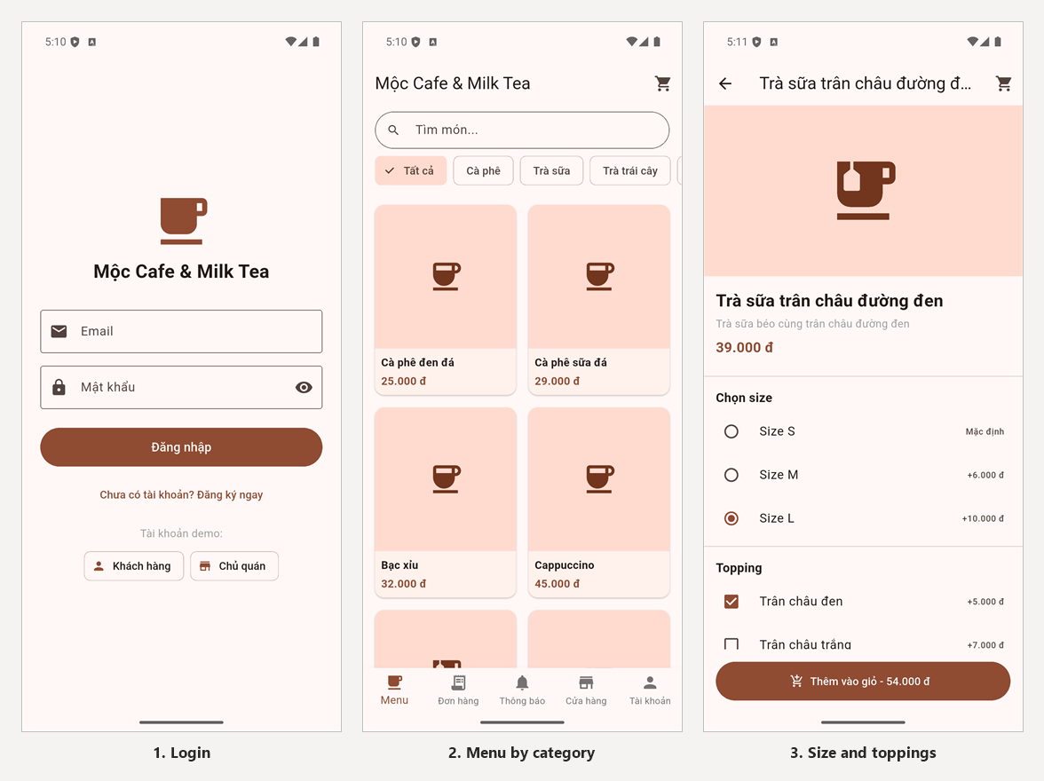
The demo-account chips fill the login form; the Trà sữa filter shows four drinks; size L with black pearls raises the cup to 54,000 VND.
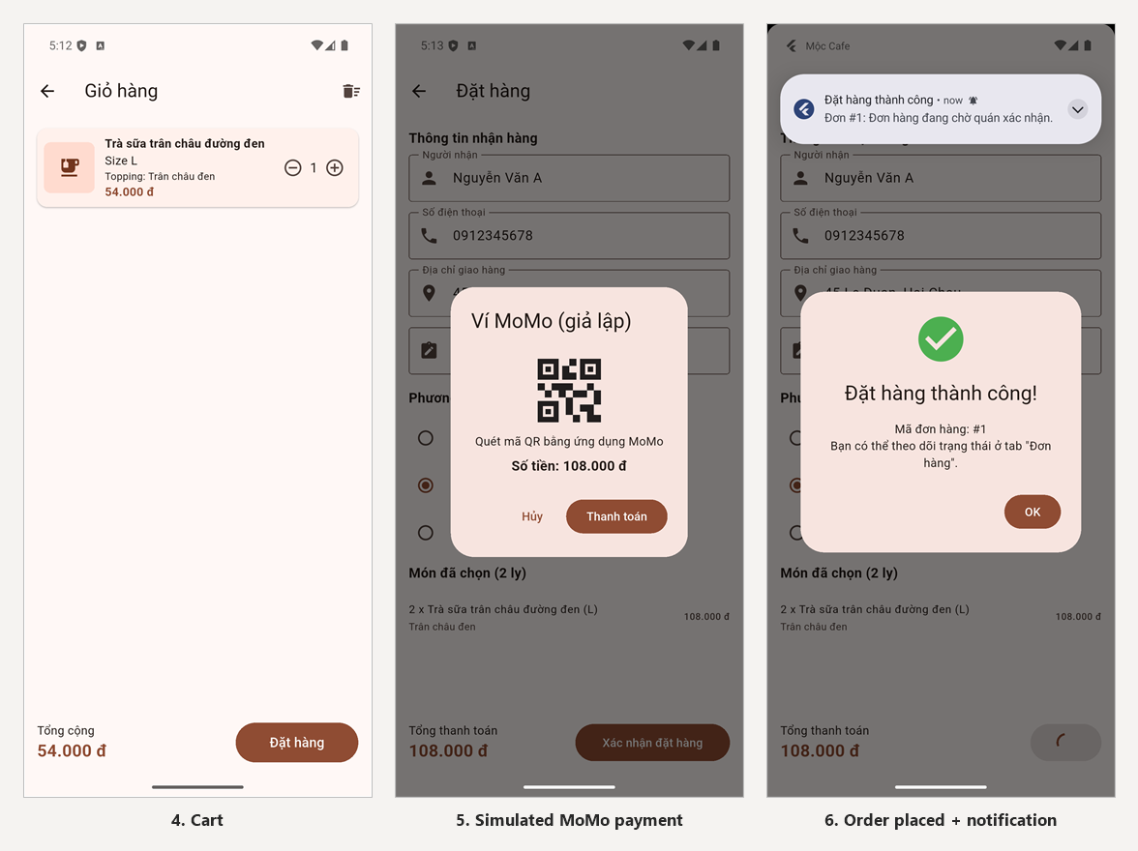
Two cups come to 108,000 VND. The simulated gateway approves after 2 seconds, and a system notification confirms order #1.
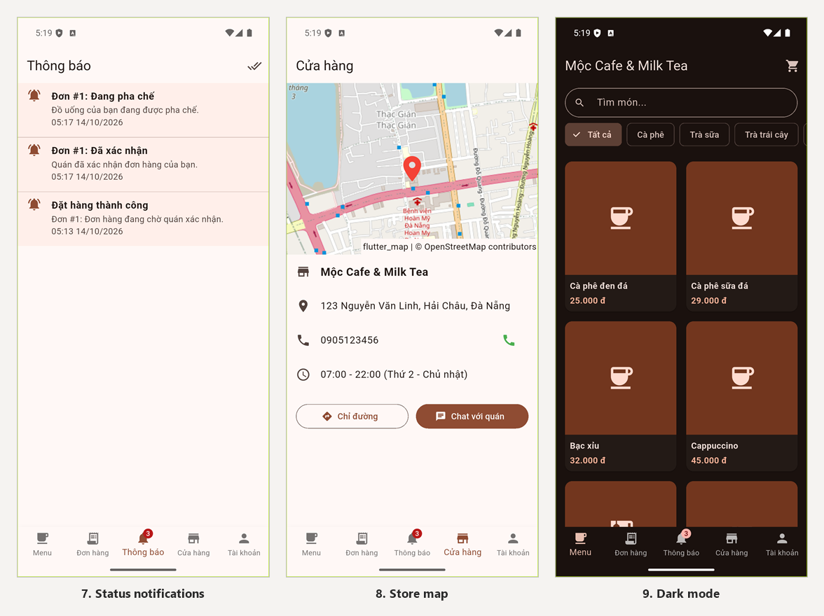
The customer receives one notification per status change, finds the shop on the map, and can switch the whole app to dark mode.
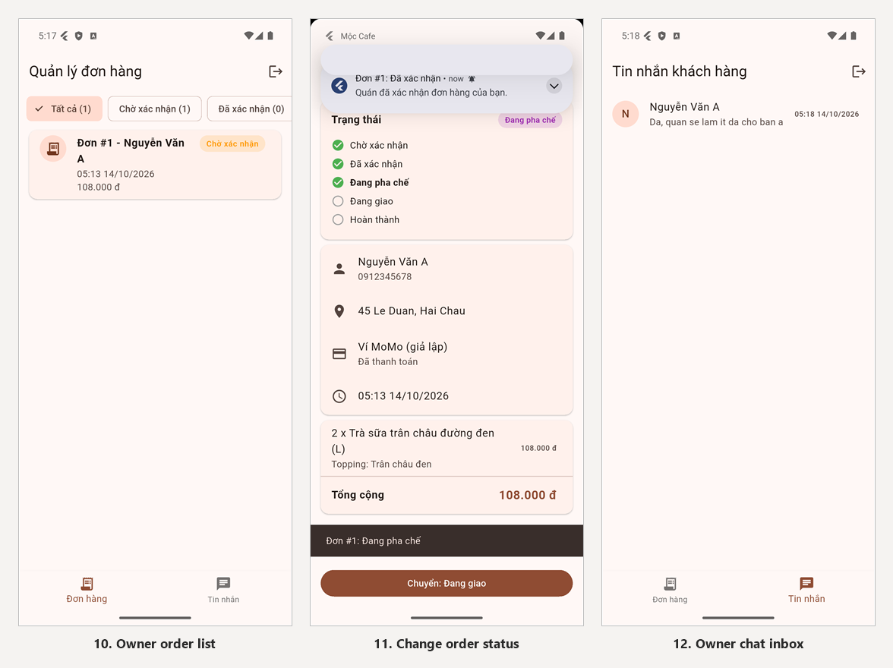
The owner sees order #1, moves it to Preparing while the customer is notified, and answers the customer from the chat inbox.

6. Conclusion and Discussion
The app covers every function of the project sample plus dark mode; its main limit for real use is the single-device local database.

6.1 Pros
- One complete flow for both actors, from browsing the menu to the owner marking the order Completed.
- Data is local, so screens load instantly and everything except the map works offline.
- Layered code: replacing SQLite with a REST API or Firebase changes only the repositories.
- Responsive layout for phones and wide screens, plus dark mode.
- Business logic is covered by 21 automated tests, and the release build was verified on a device.

6.2 Cons
- The customer and the owner must share one device; there is no real-time sync or cross-device push notification.
- Passwords are stored in plain text and there is no password reset.
- Payment is simulated; no real gateway is called.
- Drinks show icons instead of photos, and the owner cannot edit the menu or see revenue.
- Map images depend on an external tile server that some networks may block.

6.3 What we learned
- Placing state with Provider, and choosing between watch, read and select to avoid needless rebuilds.
- Designing a relational schema in SQLite and keeping order history correct with price snapshots and transactions.
- Form UX: when to validate, focus order, and loading states that prevent double submission.
- Release engineering: R8 keep rules, desugaring, manifest permissions, and fixing a Kotlin cache error.
- Testing on a real build finds issues no static check shows: the blocked map server appeared only when the APK ran.

6.4 Future improvements
- Move data to Firebase Firestore or a REST API for multi-device use, real-time chat and FCM push notifications.
- Hash passwords on a server; add password reset and Google Sign-In (Module 10).
- Integrate a real payment SDK such as MoMo or VNPay.
- Let the owner add, edit and hide drinks with photos, and add a revenue dashboard.
- Add sugar and ice levels, vouchers and loyalty points.
- Add integration tests for the full order flow (Module 11).

7. Contribution
The work is split evenly: each member contributes 25% to every task, as agreed by the team.
Topic | Team effort | [Member 1] | [Member 2] | [Member 3] | [Member 4]
Case study analysis | 100% | 25% | 25% | 25% | 25%
Business analysis | 100% | 25% | 25% | 25% | 25%
System design | 100% | 25% | 25% | 25% | 25%
Implementation | 100% | 25% | 25% | 25% | 25%
Documentation | 100% | 25% | 25% | 25% | 25%

Appendix: Build, Run and References
The source code is in the submitted zip and on GitHub; it needs Flutter 3.47 or later.

A. Demo accounts
Role | Email | Password
Customer | khach@gmail.com | 123456
Shop owner | admin@cafe.com | admin123

B. Run on Android
flutter pub get
flutter run # debug build on an emulator or phone
flutter test # 21 unit and widget tests
flutter build apk --release # build/app/outputs/flutter-apk/app-release.apk

C. Run in Chrome
For the demo the quickest way is flutter run -d chrome, which builds the app and opens Chrome by itself.
flutter run -d chrome # debug build, opens Chrome automatically
flutter build web --release # release build in build/web
dart pub global activate dhttpd # one time: a small static web server
dhttpd --path build/web --port 8080 # then open http://localhost:8080
web/sqlite3.wasm and web/sqflite_sw.js come from dart run sqflite_common_ffi_web:setup and must be committed with the code. Web data lives in the browser, separate from the phone's database.

D. Source structure
lib/
main.dart MultiProvider, themes, named routes
data/ DatabaseHelper: SQLite tables and seed data
models/ User, Product, CartItem, Order, ChatMessage, AppNotification
repositories/ SQL queries per table group
providers/ 7 ChangeNotifier classes
services/ local notification service
screens/ auth, customer, admin, shared screens
widgets/ reusable widgets
utils/ constants, formatting, validators, logout
test/unit/ cart, order status and validator tests
test/widget/ login screen tests
Editable diagrams: each diagram in section 3 has its own draw.io file in docs/diagrams/: 1_architecture.drawio, 2_database_erd.drawio, 3_order_status.drawio and 4_ui_flow.drawio. Open them in draw.io (diagrams.net) to edit or export PNG and PDF.

E. References
- PRM393 course slides, Modules 1–12, based on Kevin Moore, Mastering Flutter 2025, Packt Publishing.
- Flutter documentation
- provider, sqflite, shared_preferences
- flutter_local_notifications, url_launcher
- flutter_map, latlong2; map data © OpenStreetMap contributors

