**Midterm Assignment**

Kyle Galway

991418738

Sheridan College

PROG32365

.Net Technologies with C#

Mahboob Ali

June 23rdth, 2023

**Landing Page**

**Functionalities Page**

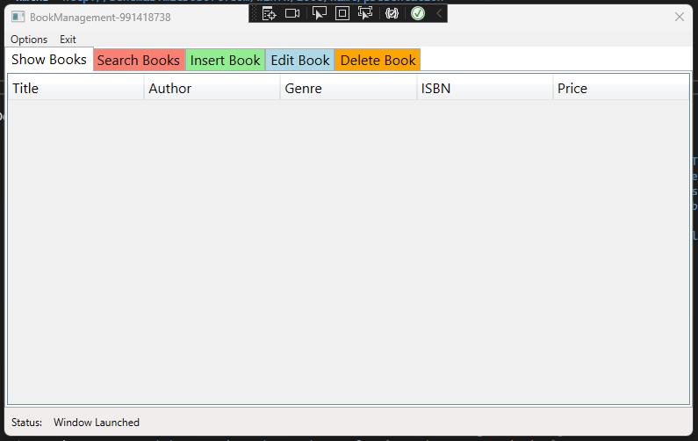

**Insert Page**

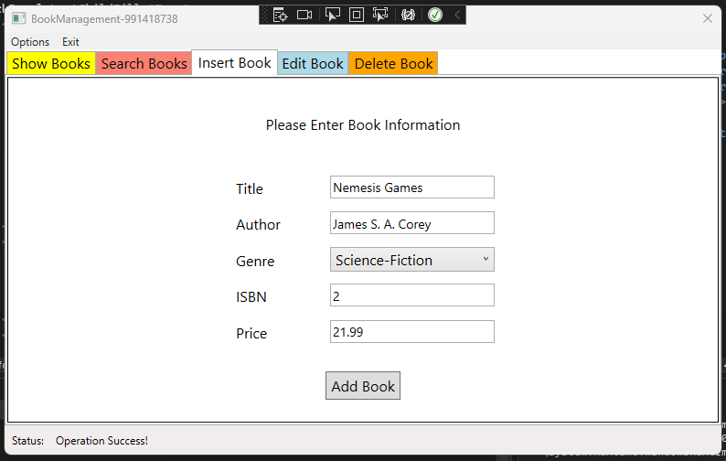

**Searched Tab**

**Edit Tab**

**Operation Success and Test**

**Layouts**

**Collection Operations**

