Answer the questions:

1. Computational model – is a stack of different operations and values which can calculate a sequences with difference values to identify some another values.
2. Functional model is oldest.
3. Imperative model – Used to make some sequences of different commands which is used to calculate some operations to change the state.

Functional model – Creates an environment to use arguments a functions and use this functions and values in the other functions. Returns functions.

Logic model – Represents relations between different values and computations. Programs identify some relations.

1. Programming language is a very complicated list of different sequences and algorithms which used different own syntax and semantics to make an environment for writing different programs.
2. Programming language first of all have own, unique keywords and vocabulary for different programming languages. And also has an own syntax and semantics.
3. Syntax – is an instrument which used to identify the way and sequence of computations.

Semantics – is a bridge between computations and syntax. Semantics bond this two parts and create a connection for actions and calculations.

1. In terms of decidability, this models used to be same. Because decidability used to answer the question “May this theory can be solved or not?”. And all of these models used to give a decision. Therefore, when we have an exact answer, it can be said as decidable.

Practice

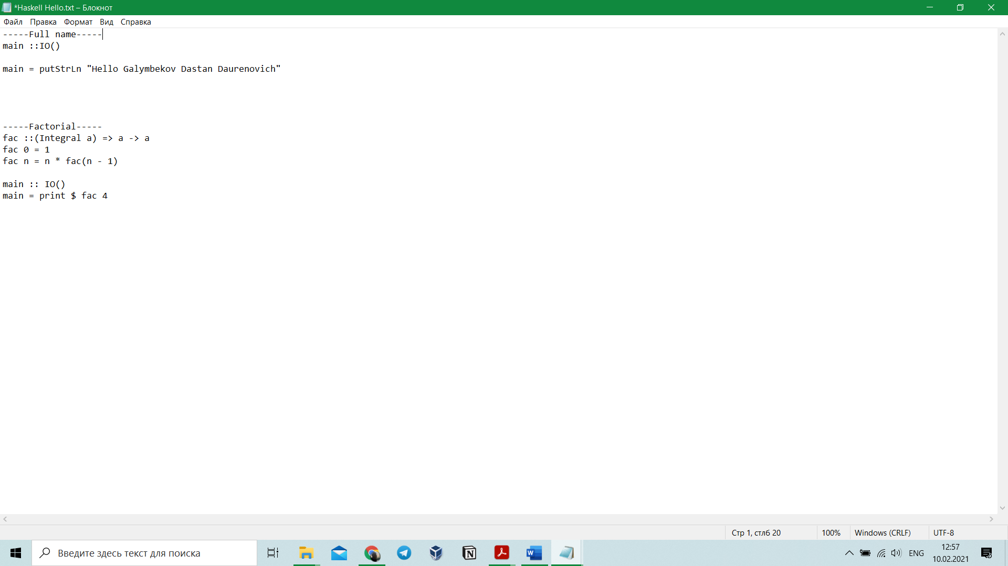Haskell:

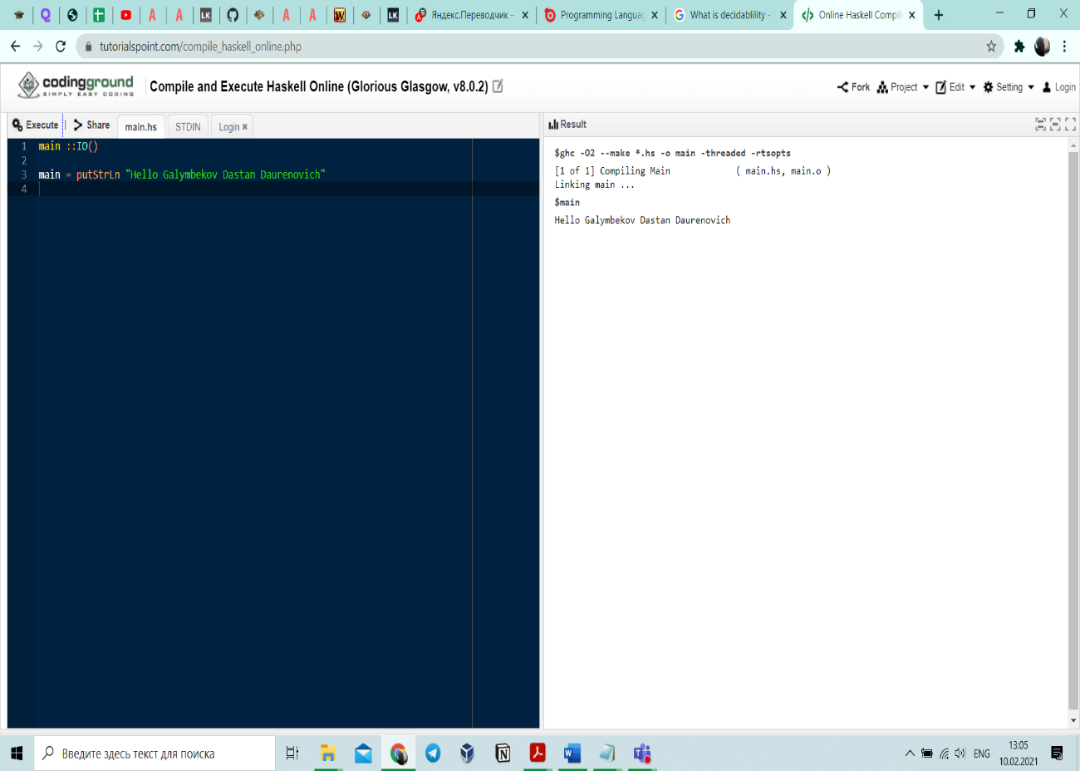Full name:

Factorial:

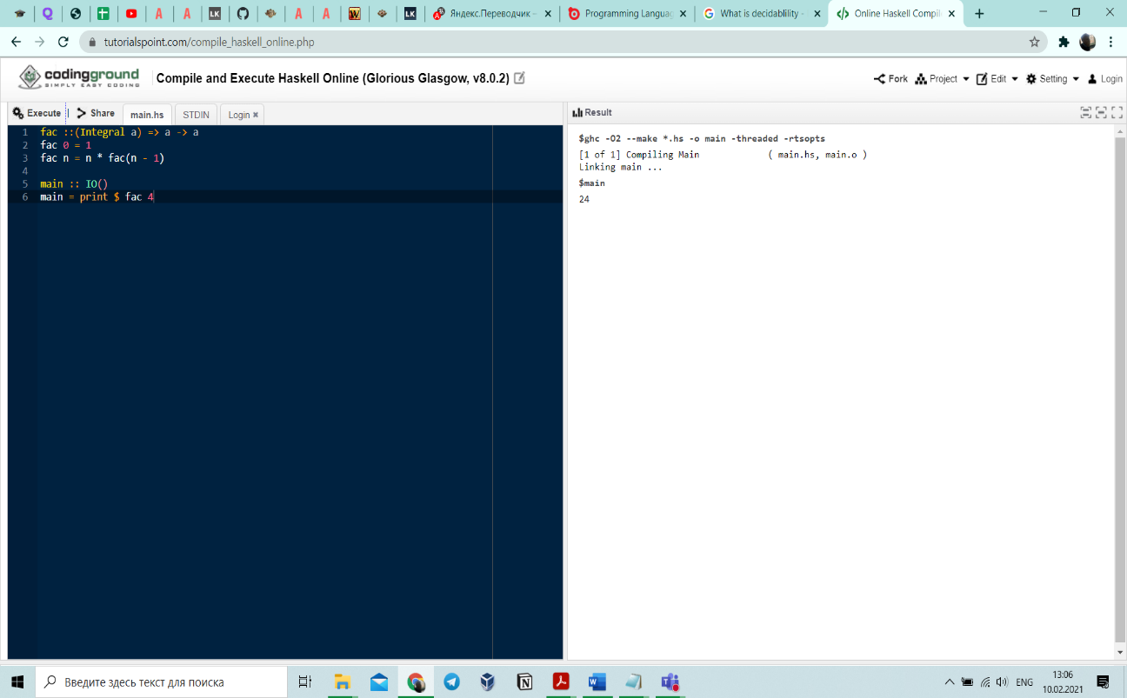

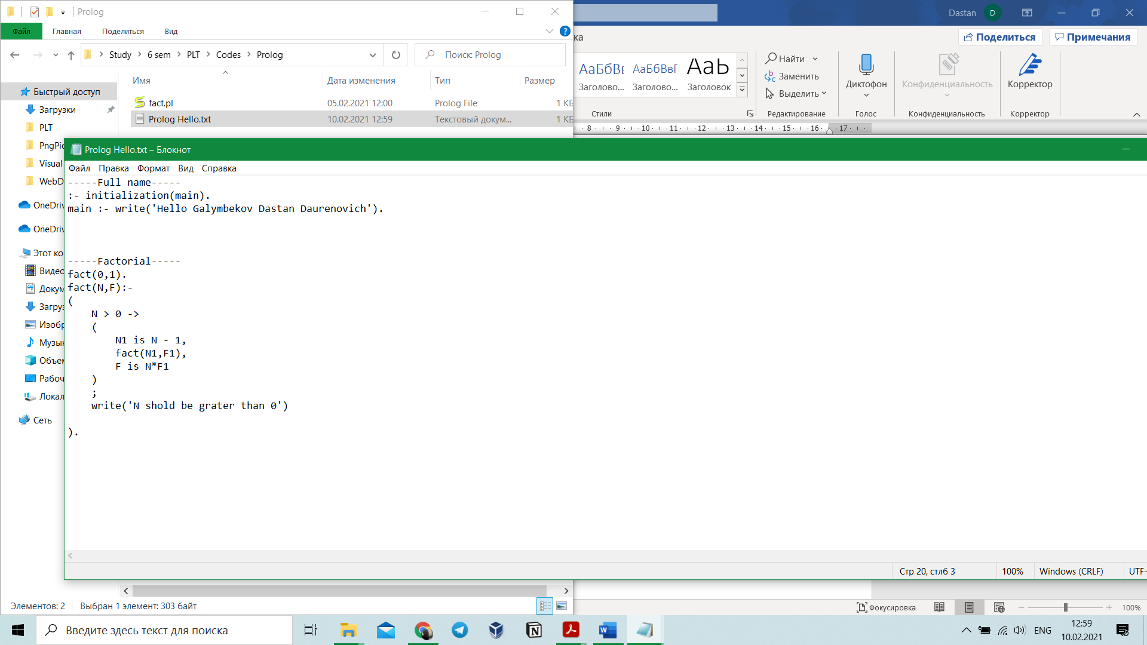Prolog:

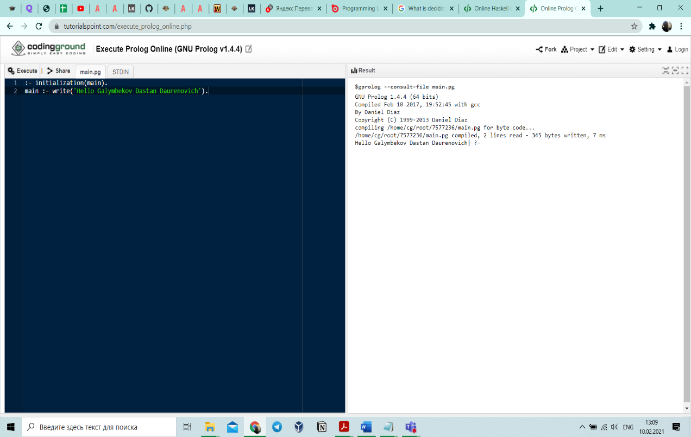Full name:

Factorial:

