**Laboratory work 4**

**Tasks:**

**1. Retrieve all airline names in uppercase.**

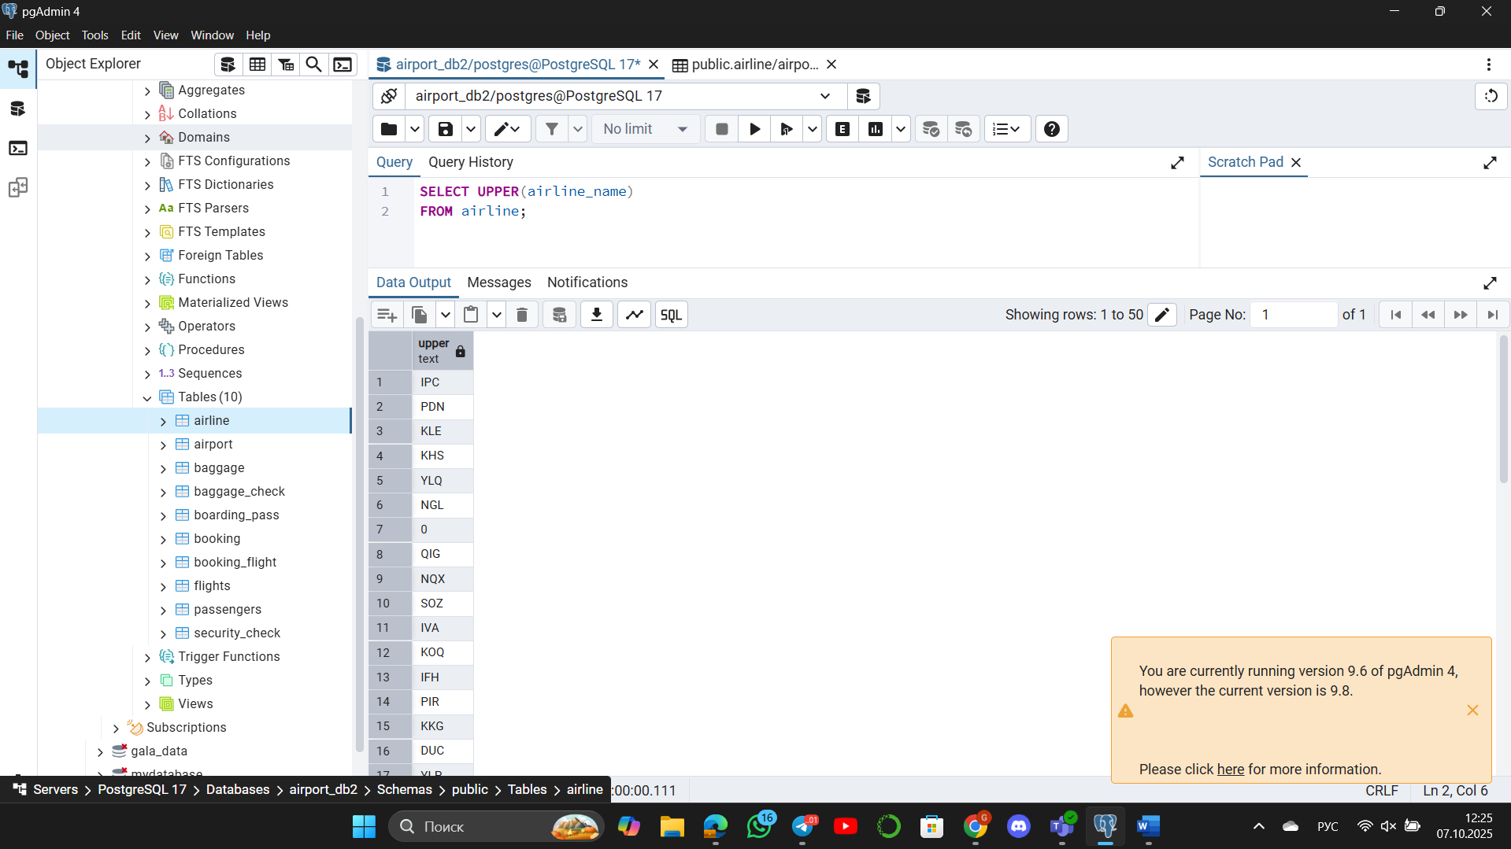

**2. Replace any occurrence of the word "Air" in airline names with "Aero".**

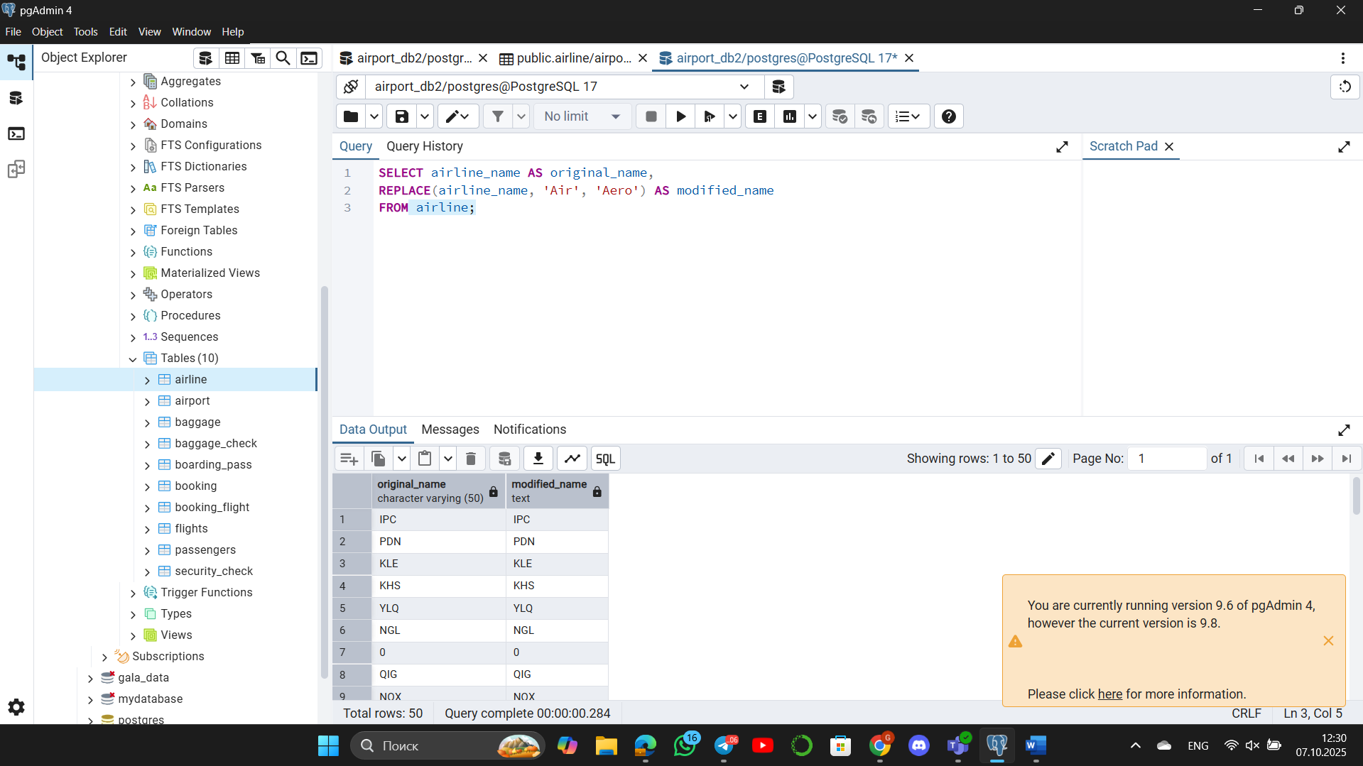

**3. Fing all flight numbers that coordinates with both airline 1 and airline 2.**

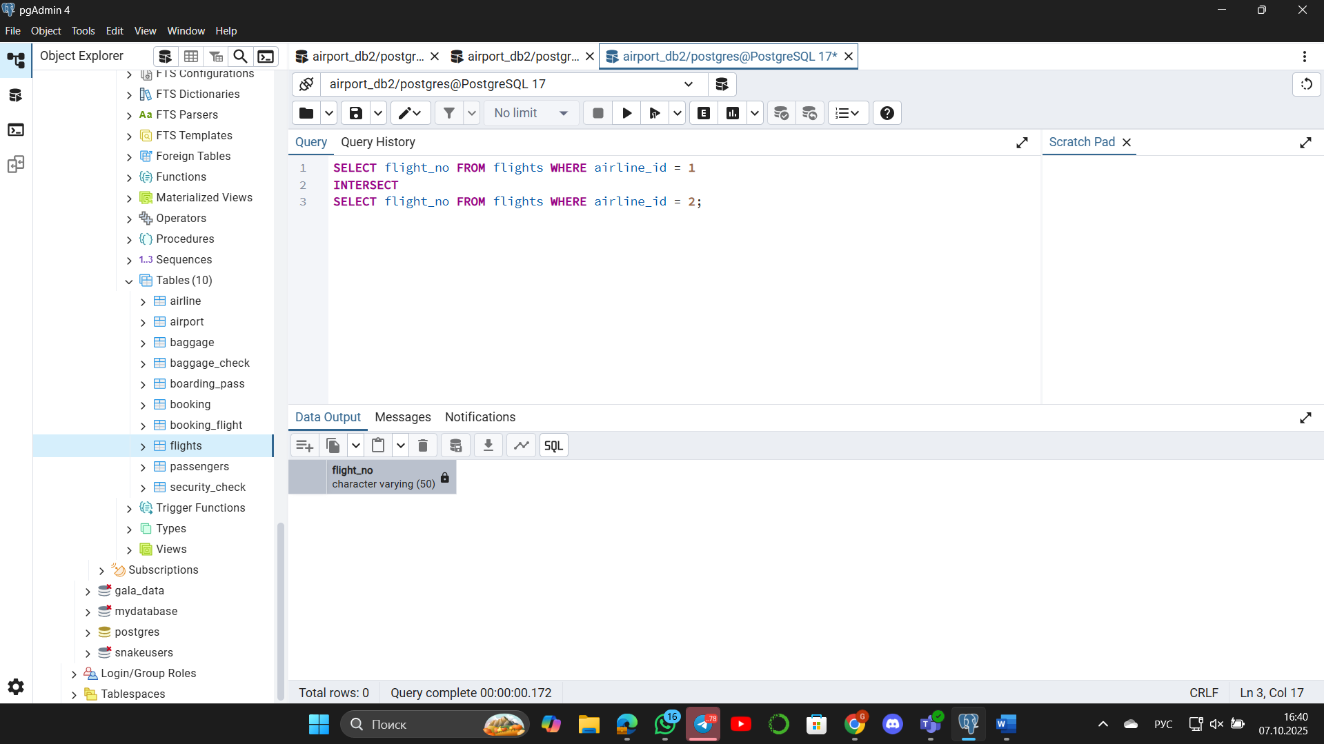

The result **Total rows: 0** means that there is no flight number (flight_no) that belongs to both the airline with ID=1 and the airline with ID=2.

**4. Retrieve airports that contain the word "Reginal" and "Air" in their names.**

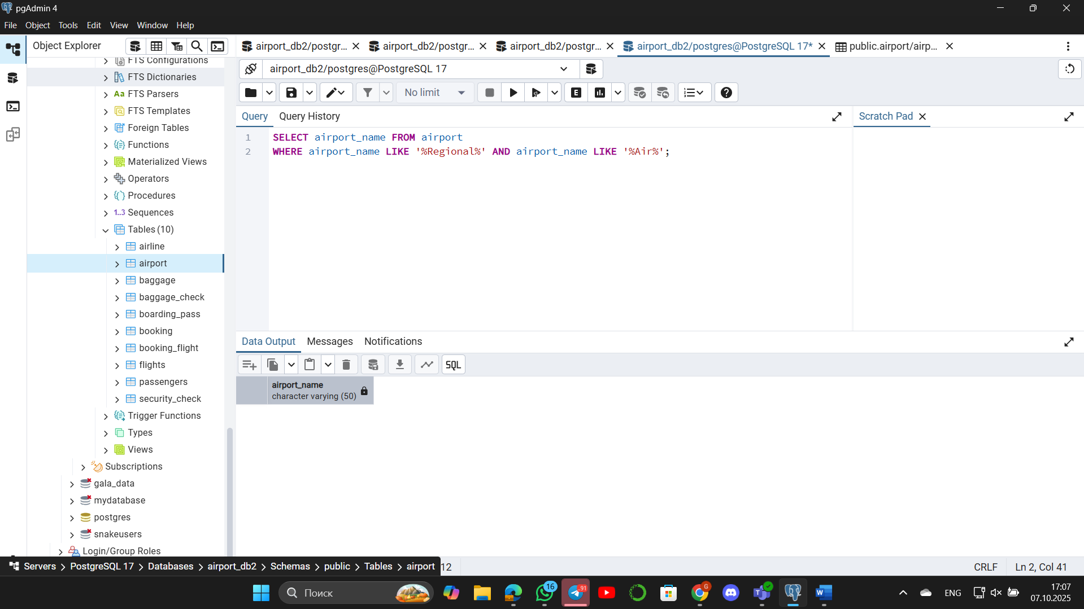

**5. Retrieve passenger names and format their birth dates as 'Month DD, YYYY'..o**

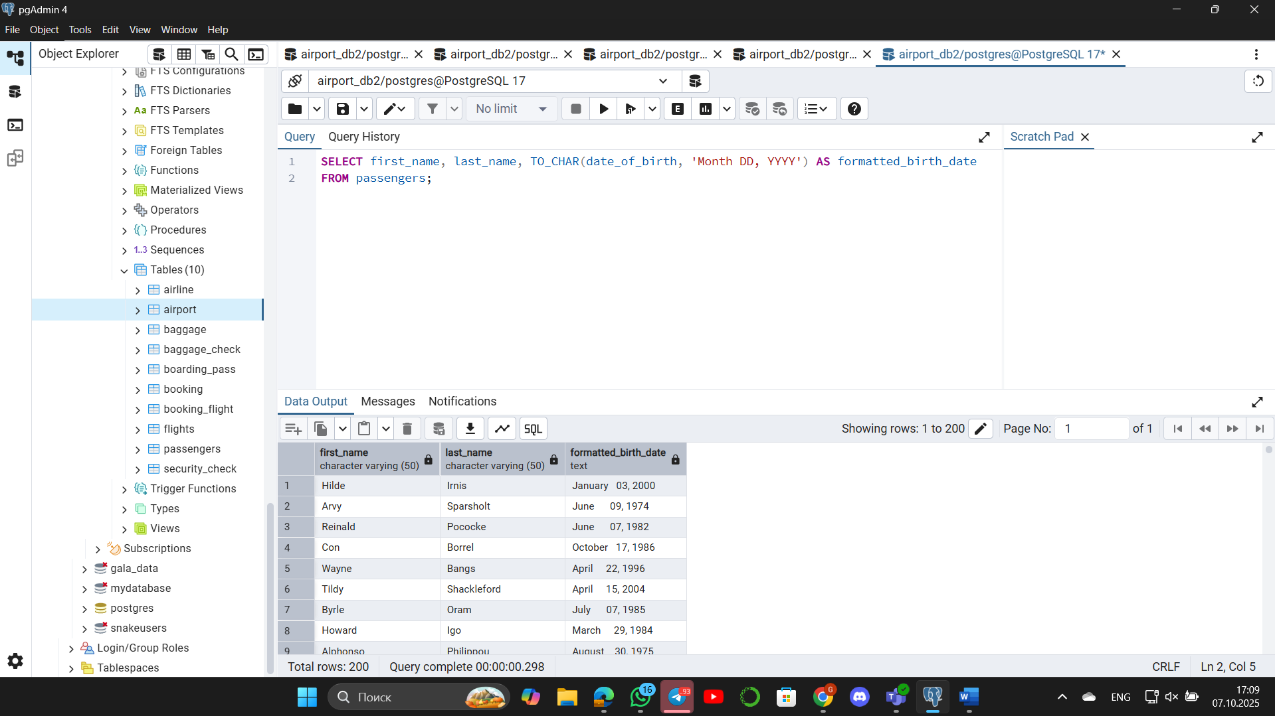

**6. Find flight numbers that have been delayed based on the actual arrival time.**

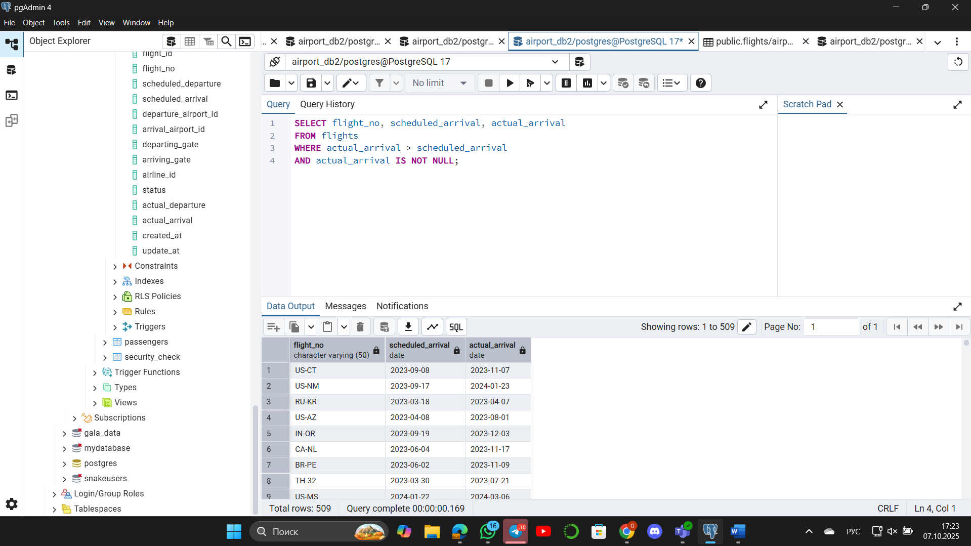

**7. Create a query that divides passengers into age groups like ‘Young’ and ‘Adult’ based on their birth date. Young passengers age between 18 and 35, Adult passengers age between 36 and 55.**

**Изображение выглядит как текст, программное обеспечение, Значок на компьютере, дисплей

Содержимое, созданное искусственным интеллектом, может быть неверным.**

**8. Create a query that categorizes ticket prices based on their price as "Cheap," "Medium" or "Expensive."**

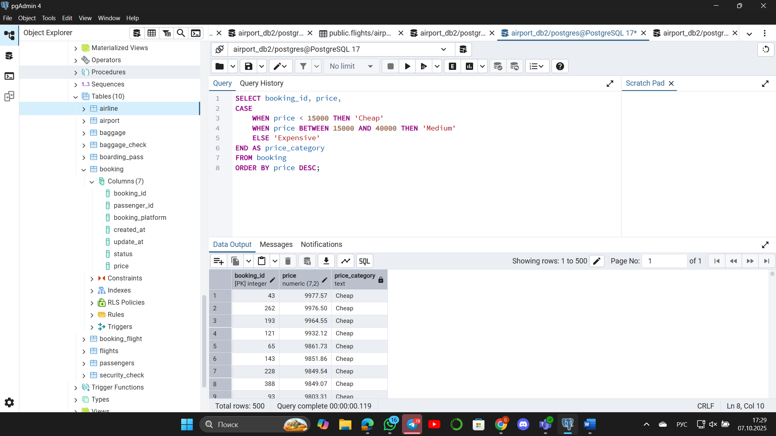

**9. Find number of airline names in each airline country.**

**Изображение выглядит как текст, снимок экрана, программное обеспечение, Значок на компьютере

Содержимое, созданное искусственным интеллектом, может быть неверным.**

**10. Find flights that arrived late according to their actual arrival time compared to the scheduled arrival time.**

