**Laboratory work 5**

**Tasks:**

**1. Add a CHECK constraint to passenger table to provide that passengers must be at least 10 years old.**

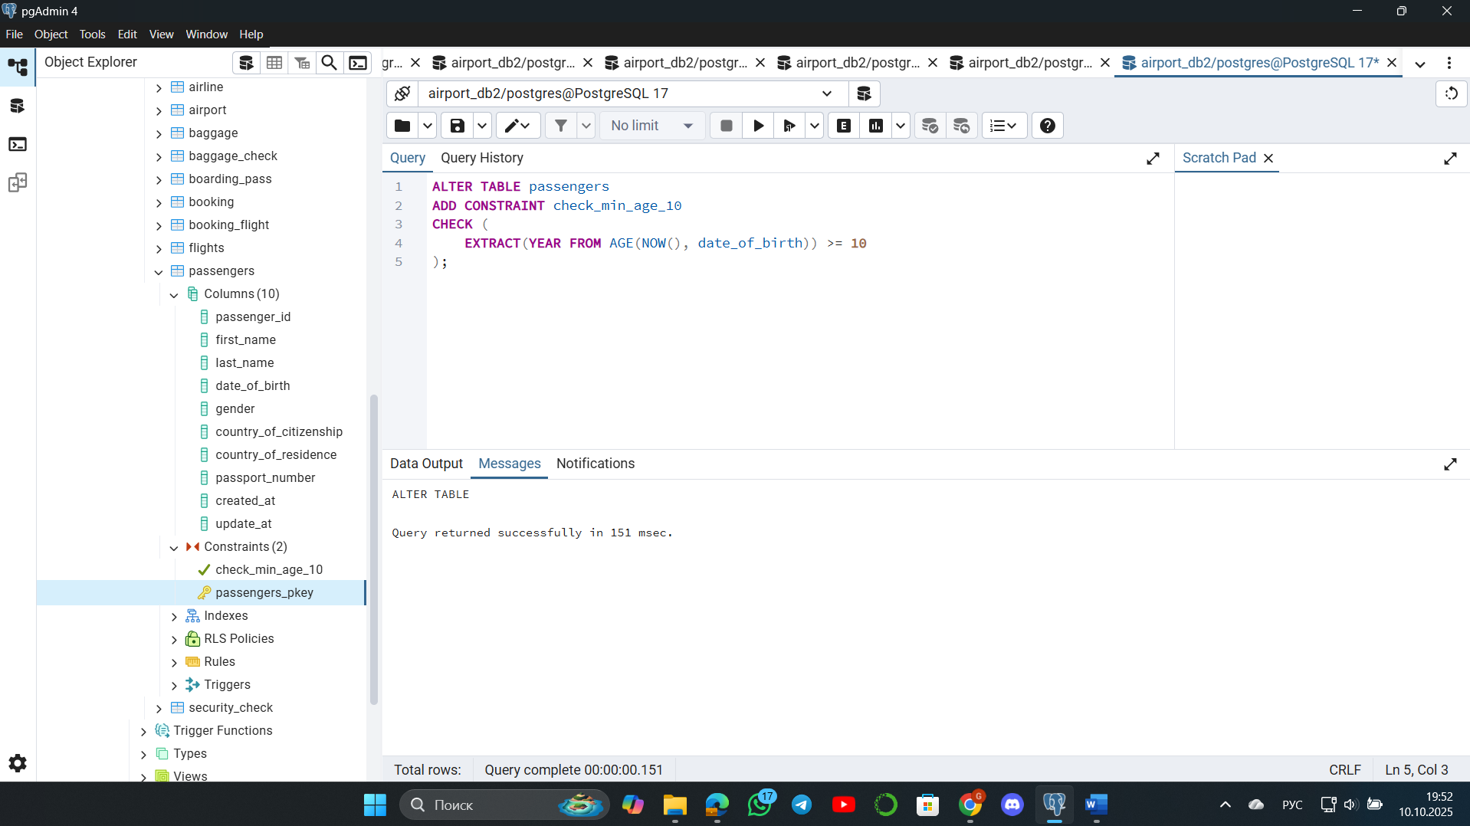

**2. Add a CHECK constraint to accept values in booking price not more than 50000tg and less than 0tg.**

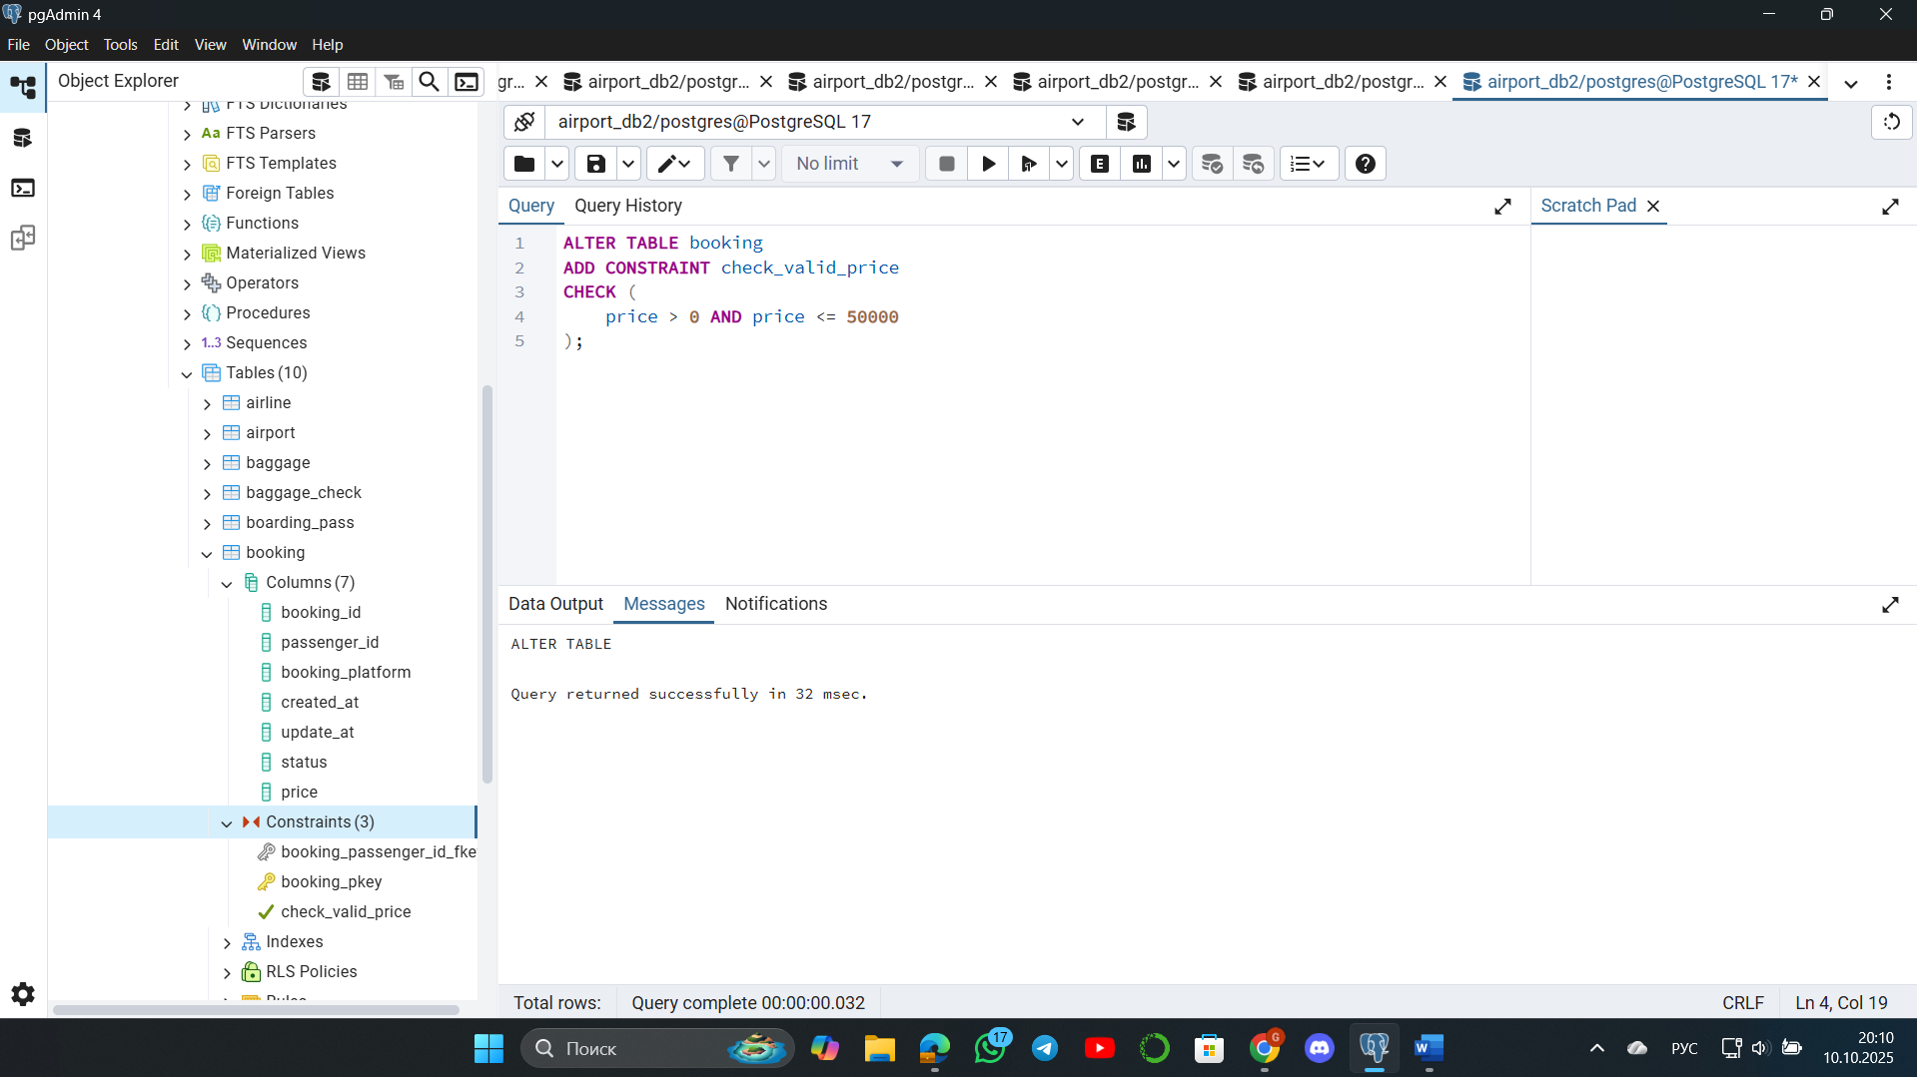

**3. Add a CHECK constraint to accept the luggage weight between 1 and 23 kg.**

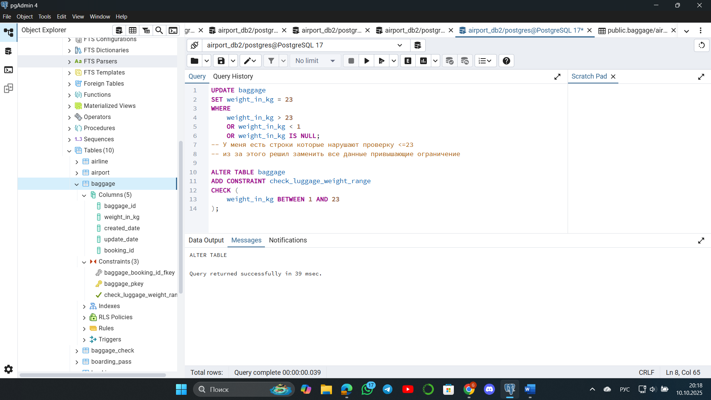

**4. Add a CHECK constraint to ensure that all values in airport_name must have at least 10 characters.**

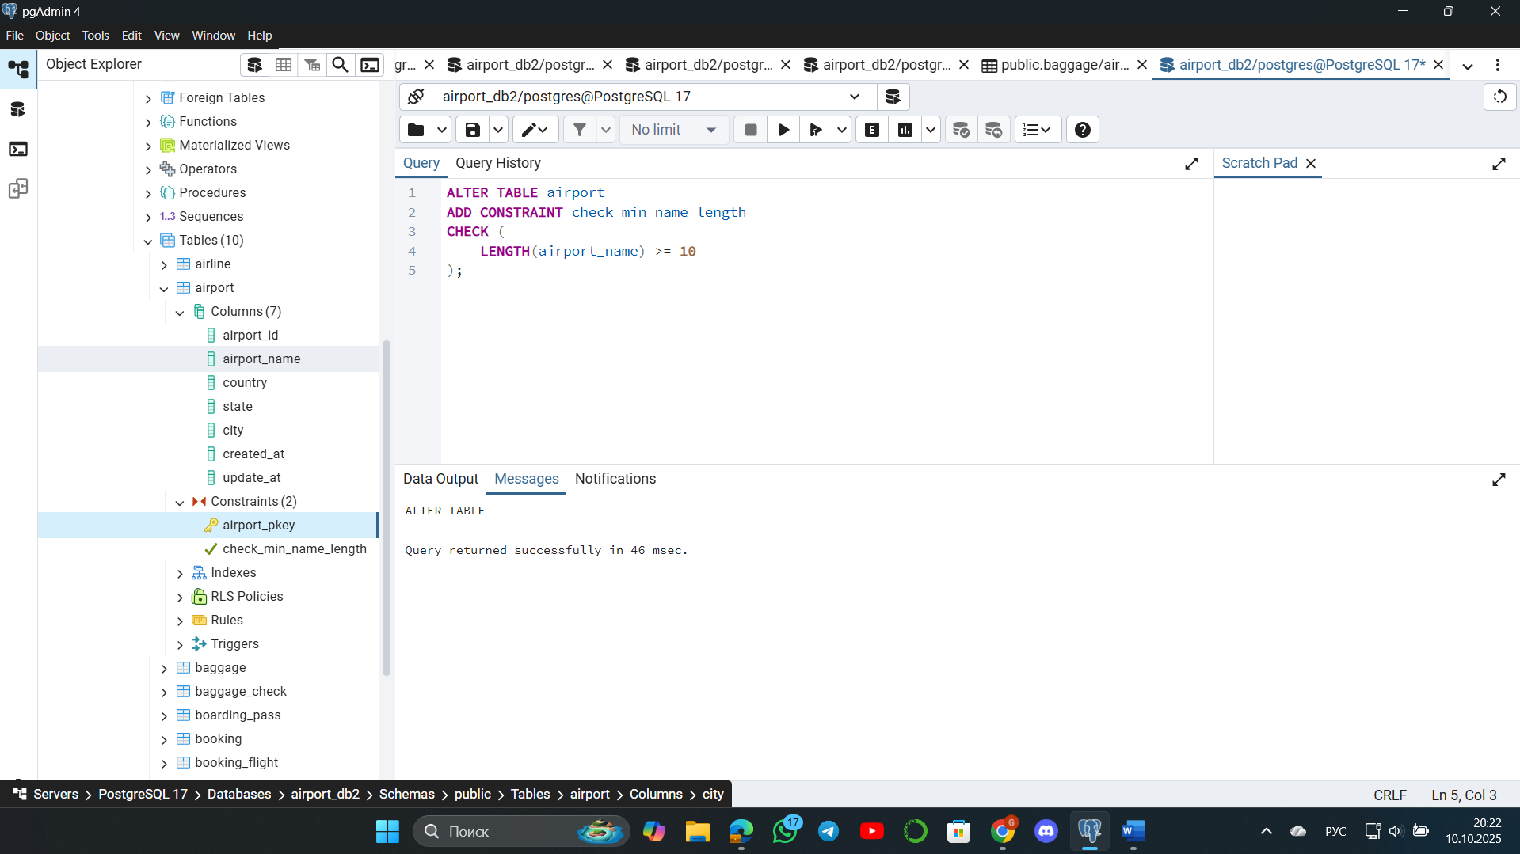

**5. Add UNIQUE constraint to some columns in each table in database.**

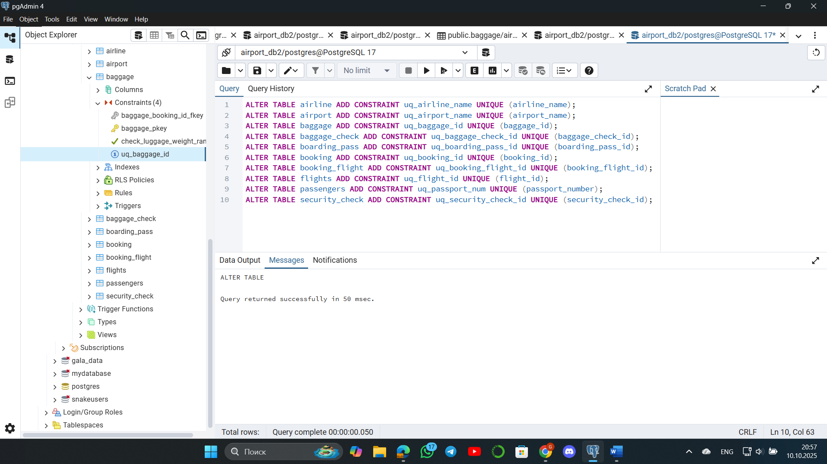

**6. Add a CHECK constraint to ensure that male passengers must be at least 18 years old and female passengers must be 19 years old.**

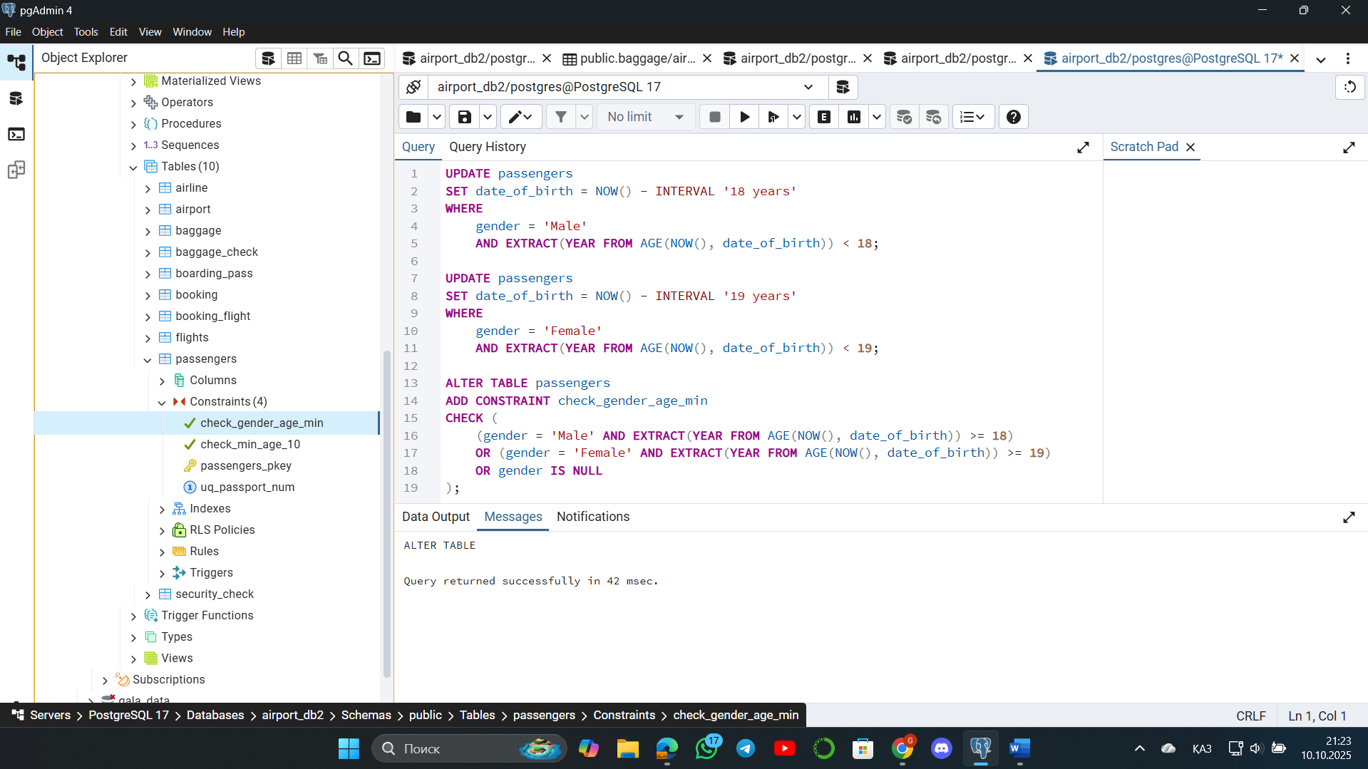

**7. Add a CHECK constraint to add rule as follow (use column country_of_citizenship):**

**· Passengers from Kazakhstan must be at least 18 years old.**

**· Passengers from France must be at least 17 years old.**

**· Passengers from other countries must be at least 19 years old.**

**Изображение выглядит как текст, снимок экрана, программное обеспечение, Значок на компьютере

Содержимое, созданное искусственным интеллектом, может быть неверным.**

**8. Add a ticket_discount column to table booking and a CHECK constraint to apply some discount based on ticket price and created time:**

**· the constraint applies a 5% discount for tickets created after 2024-01-01, and 10% discount for tickets created before 2024-01-01.**

