MIDTERM PROJECT
Design and Prototype a Business Information System
Fundamentals of Business for Information Systems
Project | Details
Project / product | Gul Almaty — Online Flower Store
Business | Fictional three-branch flower shop in Almaty, Kazakhstan
Team | Yessentur Nuraslanbek; Ashirbekov Adiz; Murat Alikhan; Bekmuratov Galymzhomart; Bakir Didar

Team roles
Student | Role | Main responsibility
Yessentur Nuraslanbek | Project Manager | Coordinates tasks, reviews goals and submits the report.
Ashirbekov Adiz | Systems Analyst | Explains ERP and SCM; prepares the data-flow diagram.
Murat Alikhan | Marketing & CRM Specialist | Defines customers and business problems; explains CRM and online sales.
Bekmuratov Galymzhomart | Prototype Designer | Designs five mobile mockup screens and checks the user journey.
Bakir Didar | Business & Risk Analyst | Reviews costs, risks, implementation phases and references.

1. Business problem and plan
1.1 Chosen business
Gul Almaty is a proposed flower shop with three branches in Almaty. It sells bouquets, potted plants and small gifts. Customers currently buy in-store or contact the shop by phone, Instagram or WhatsApp. A mobile online store would put orders in one place and connect them to stock, suppliers and customer records.
Business detail | Working assumption
Branches and staff | 3 branches; about 12 employees
Products | Bouquets, plants, gift cards and corporate orders
Suppliers | Local greenhouses and wholesalers
Peak demand | 14 February, 8 March, Nauryz and 1 September

Kazakhstan’s growing e-commerce market supports the idea of a direct online channel. Marketplaces dominate online retail, so Gul Almaty must offer something different: reliable delivery slots, personal messages and loyalty rewards [1–3].
1.2 Three business problems
Problem | Business effect | Proposed solution
Orders spread across chats and calls | Orders can be missed or duplicated | E-commerce + ERP: shared order list
No shared stock by branch | Flowers may be wasted or unavailable | ERP + SCM: livestock and purchasing
Limited customer history | Few reminders or repeat sales | CRM: loyalty, dates and complaint tickets

1.3 Target customers
Segment | Need | Channel
Busy gift buyers | Quick mobile order and chosen delivery slot | Mobile store, Instagram
Corporate customers | Repeat orders and invoices | Business account
Date-driven buyers | Pre-orders for birthdays and events | Mobile store, phone

1.4 Goals
G1. Record all orders in one system. G2. Reduce flower waste using branch stock and purchasing records. G3. Increase repeat orders through loyalty and reminders. G4. Make online ordering simple on mobile.
1.5 One measurable target
Within six months of launch, reduce the value of flower write-offs from a hypothetical baseline of 18% to no more than 10% of flower purchases. Formula: monthly write-off value ÷ monthly flower purchase value × 100%. The baseline must be measured before any real implementation.
2. System design
2.1 Approach
The chosen product is a mobile-friendly online flower store. It exchanges information with ERP (stock and orders), SCM (suppliers and purchasing) and CRM (customers and loyalty). Figure 1 is a conceptual data-flow diagram; no live integrations are claimed.
2.2 Four systems
System | Main functions | Main data
E-commerce | Catalog, cart, delivery slot, Kaspi Pay/card/COD checkout | Products, orders, payment method and status
Mini ERP | Branch stock, orders, bouquet materials, waste, sales | Stock, recipes, orders, write-offs
SCM | Suppliers, purchase orders, deliveries, quality checks | Suppliers, orders, delivery dates
CRM | Customer profiles, consent, points, reminders, complaints | Customer phone, consent, order history, points

2.3 Data-flow diagram
Figure 1 shows the data exchanges. The numbered arrows are explained in Table 6. Physical receipt of flowers is confirmed by branch staff before ERP stock is updated.
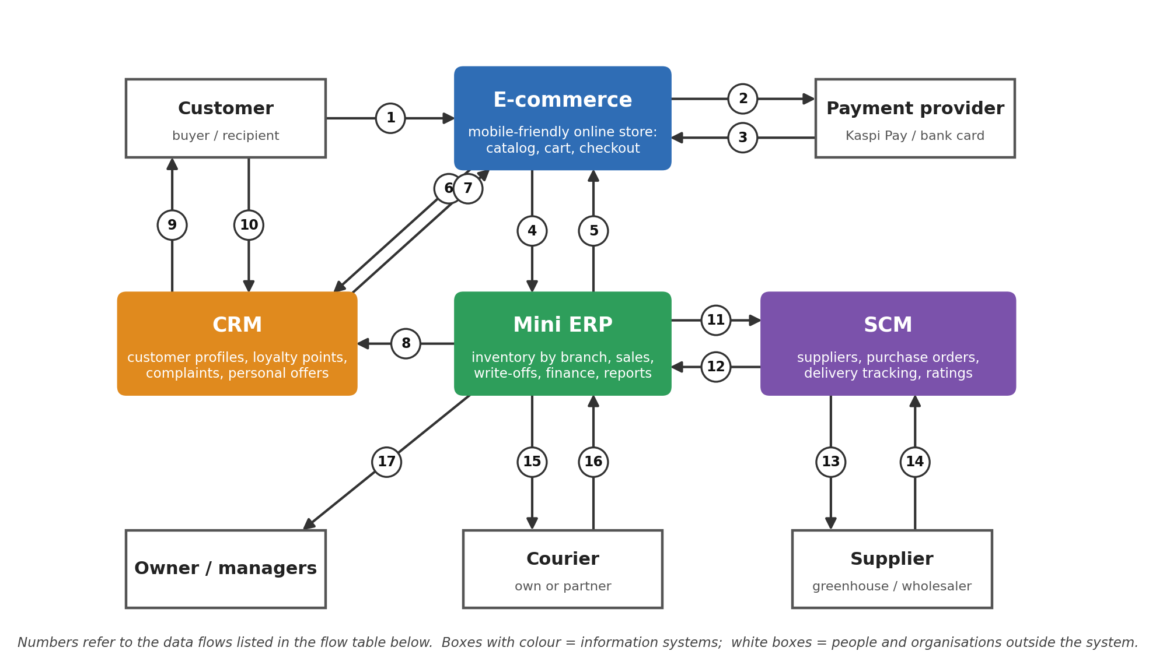
Figure 1. Data flows between E-commerce, ERP, SCM, CRM and external participants.
Table 6. Data flows
# | From | To | Data transferred
1 | Customer | E-commerce | Cart, address, time and card message
2 | E-commerce | Payment provider | Online payment request
3 | Payment provider | E-commerce | Payment success or failure
4 | E-commerce | ERP | Accepted order, payment method and status; COD stays unpaid
5 | ERP | E-commerce | Availability and prices by branch
6 | E-commerce | CRM | Customer details, consent and order history
7 | CRM | E-commerce | Loyalty points and offers
8 | ERP | CRM | Delivered order and paid amount; award points after payment
9 | CRM | Customer | Reminders and replies via WhatsApp/SMS
10 | Customer | CRM | Complaints and feedback
11 | ERP | SCM | Stock, reorder alerts and sales history
12 | SCM | ERP | Staff-confirmed goods receipt, invoice and supplier rating
13 | SCM | Supplier | Purchase order
14 | Supplier | SCM | Availability, prices and delivery notes
15 | ERP | Courier | Delivery task and recipient details
16 | Courier | ERP | Delivery status and proof
17 | ERP | Owner/managers | Sales, waste and performance reports

2.4 Who uses each system
User | E-commerce | ERP | SCM | CRM
Customer | Shop | — | — | Own account
Order manager | Orders | Orders | — | View
Florist | — | Own orders | — | —
Branch manager | View | Own branch | Requests | Complaints
Purchasing manager | — | View stock | Manage | —
Marketing specialist | Content | Sales summary | — | Manage
Accountant | — | Finance | Invoices | —
Courier | — | Own tasks | — | —
Supplier | — | — | Own orders | —
Owner | View | Reports | View | View

2.5 Example order
Aigerim selects a bouquet and delivery slot. ERP checks stock (flow 5). The website processes Kaspi Pay through the provider (flows 2–3), or records cash on delivery as unpaid until collection. ERP reserves stock (flow 4) and sends a courier task (15). After delivery (16) and payment, ERP informs CRM (8), which adds loyalty points. Low stock triggers SCM purchasing (11–14). The owner reviews results (17).
3. Prototype: mobile website mockup
Figure 2 shows five static high-fidelity mockup screens. Coloured dots in the design concept identify which system supplies the data.
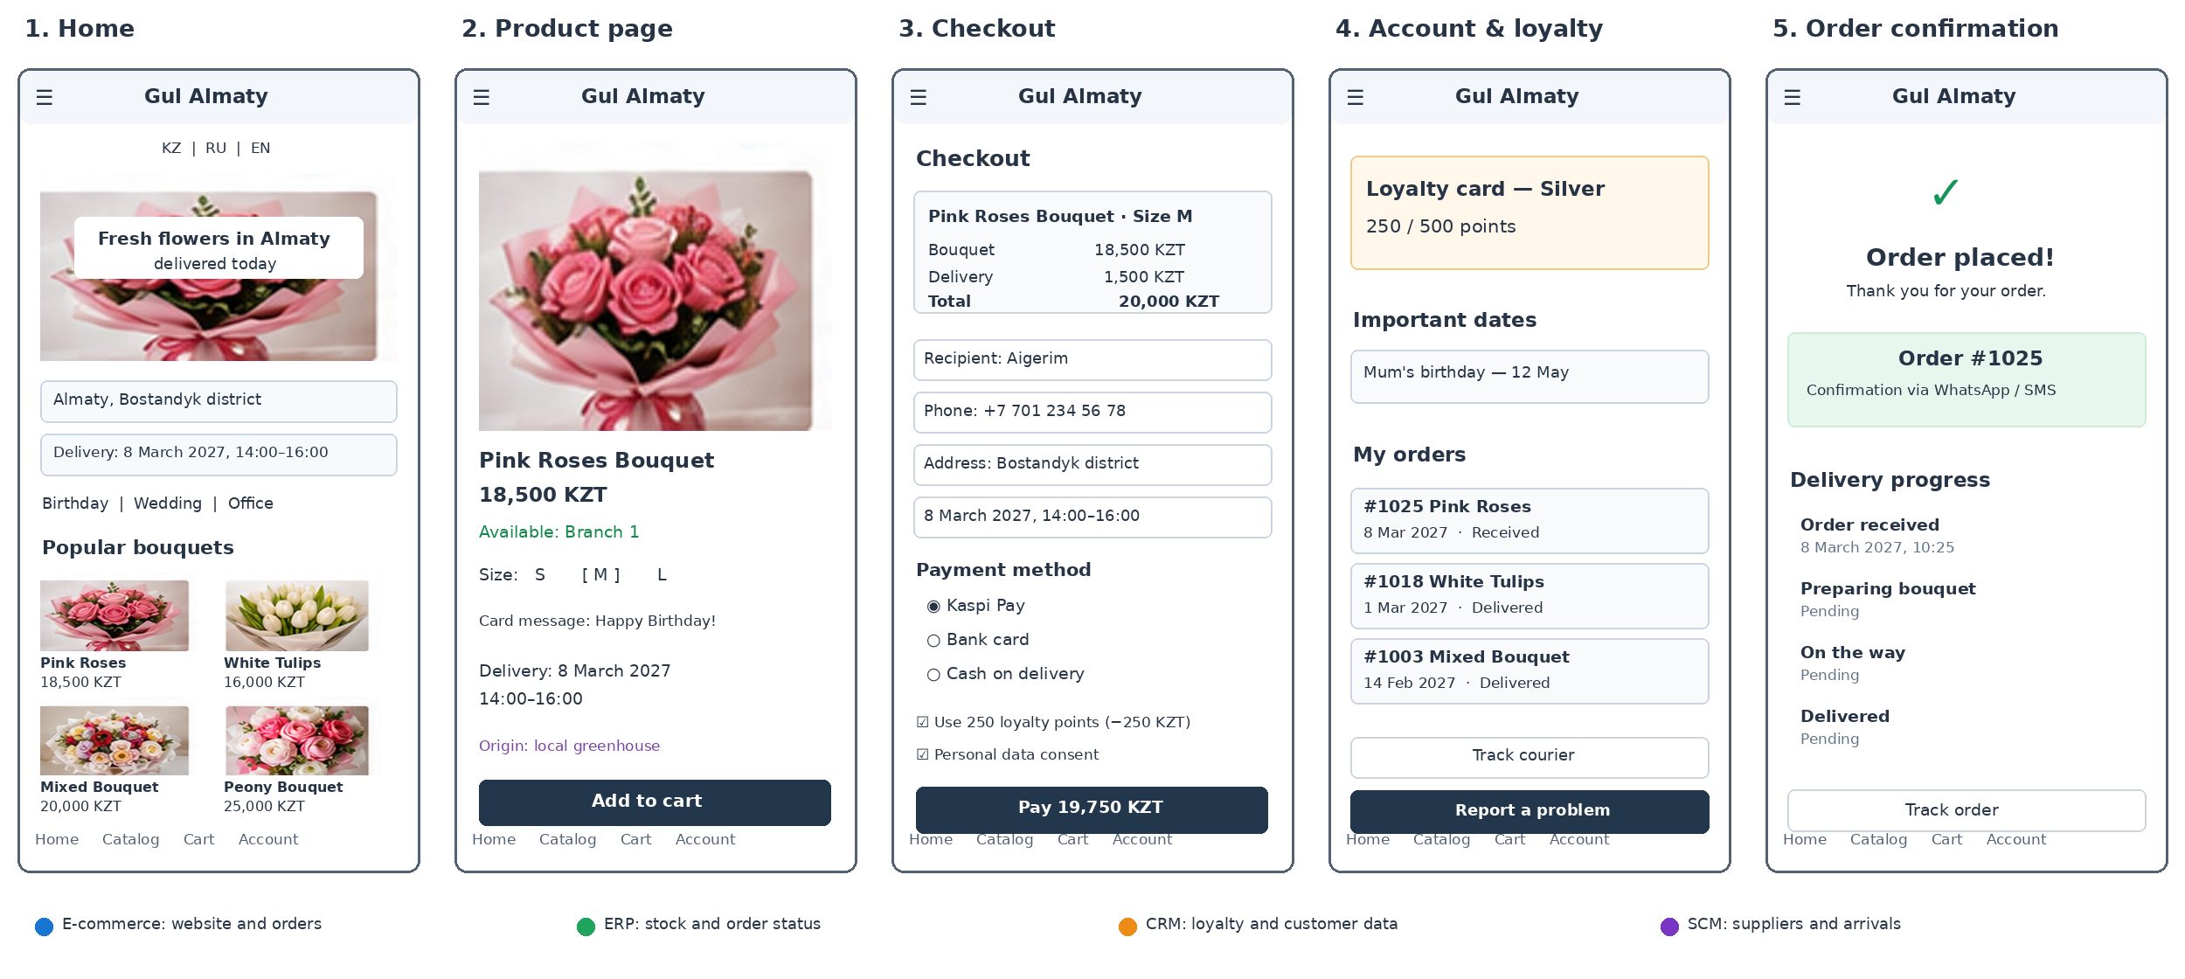
Figure 2. Gul Almaty mobile website mockup: Home, Product Page, Checkout, Account & Loyalty, and Order Confirmation.
Table 8. Screen purpose
Screen | Key elements | Connected systems
1. Home | Bouquets, categories, delivery location and date | E-commerce, ERP
2. Product | Photos, sizes, price, stock and supplier origin | E-commerce, ERP, SCM
3. Checkout | Recipient, address, payment, loyalty and consent | E-commerce, CRM, ERP
4. Account & loyalty | Points, dates, order history and complaints | CRM, ERP
5. Order confirmation | Order ID, WhatsApp/SMS confirmation and tracking | E-commerce, ERP, CRM

3.1 Design decisions and next step
The five screens follow a short path: Home → Product → Checkout → Confirmation → Account. Kaspi Pay is listed first, while bank card and cash on delivery remain available. Availability comes from ERP, supplier information from SCM and loyalty information from CRM. A next step is to ask 3–5 classmates to find a bouquet, choose a delivery slot and complete the mock checkout; results have not yet been collected.
4. Risks and challenges
Risk | How it could affect the project | Mitigation | Owner
Cost | Subscriptions and setup may exceed budget | Pilot one branch; start with essential functions | Bakir Didar / Project Manager
Data security | Customer phones, addresses and dates could be exposed | Consent, access controls, MFA, backups; check Kazakhstan requirements [4–5] | Ashirbekov Adiz
Staff training | Employees may return to manual chats | Short role-based sessions and a branch super-user | Yessentur Nuraslanbek
Data migration | Duplicate products and customer records | Clean lists, back up, test 50 records before full import | Murat Alikhan / Ashirbekov Adiz

4.1 Indicative project budget
The figures below are internal planning estimates in KZT, not verified vendor quotes. Subscription prices and Kazakhstan-specific compliance must be checked before purchase.
Cost item | Phase 1 (months 1–2) | Phase 2 (months 3–4) | Phase 3 (months 5–6)
Website and hosting | 60,000 | 40,000 | 40,000
ERP/CRM/SCM tools | 60,000 | 100,000 | 140,000
Setup and staff training | 80,000 | 50,000 | 40,000
Estimated total | 200,000 | 190,000 | 220,000

Estimated six-month total: 610,000 KZT, excluding payment transaction fees, hardware and taxes. These are budget allowances, not published Tilda, Airtable or Odoo tariffs.
4.2 Phased rollout
Phase | Time | What changes | Success check
1 | Months 1–2 | Website, central orders, branch stock and payments | Orders captured in one place
2 | Months 3–4 | CRM, loyalty, reminders and complaints | Customers can view points and order history
3 | Months 5–6 | SCM purchasing, supplier reviews and forecasts | Monthly waste ratio moves toward 10%

5. Conclusion
Gul Almaty combines a direct online flower store with ERP, SCM and CRM. The design addresses scattered orders, stock waste and limited customer information. The project proposes one measurable six-month waste-reduction target and a three-phase implementation plan.
References
[1] The Astana Times (2026). Kazakhstan’s E-Commerce Market Reaches Nearly $8 Billion. https://astanatimes.com/2026/06/kazakhstans-e-commerce-market-reaches-nearly-8-billion-latest-statistics-show/
[2] The Times of Central Asia (2026). Kazakhstan E-Commerce Grows. https://timesca.com/kazakhstan-e-commerce-shoppers-spend-8-billion-2025/
[3] PwC Kazakhstan (2025). Retail e-commerce market, first half of 2025. https://www.pwc.com/kz/en/publications/e-commerce-analysis/e-commerce-6m2025.html
[4] Mondaq (2020). Data protection compliance guide. https://www.mondaq.com/russianfederation/data-protection/1014076/data-protection-compliance-an-essential-guide-from-kazakhstan-russia-and-ukraine
[5] Mondaq (2013). Kazakhstan Introduces New Privacy Law. https://www.mondaq.com/privacy-protection/283254/kazakhstan-introduces-new-privacy-law
(We used the first three sources to understand the e-commerce market in Kazakhstan and explain why our flower shop needs an online store. The last two sources helped us identify data privacy risks and suggest ways to protect customer information.)

Project assumptions and visual credits. Gul Almaty is a fictional case; branch details, the 18% baseline, budget and sample orders are team assumptions. Bouquet images used in the mockup are cropped from the team-supplied draft graphic; original photo authorship and reuse permission have not been verified. No real customer study or live system implementation is claimed.

