Laboratory work 7
Tasks:
1. Create an index on the actual_departure column in the flights table.
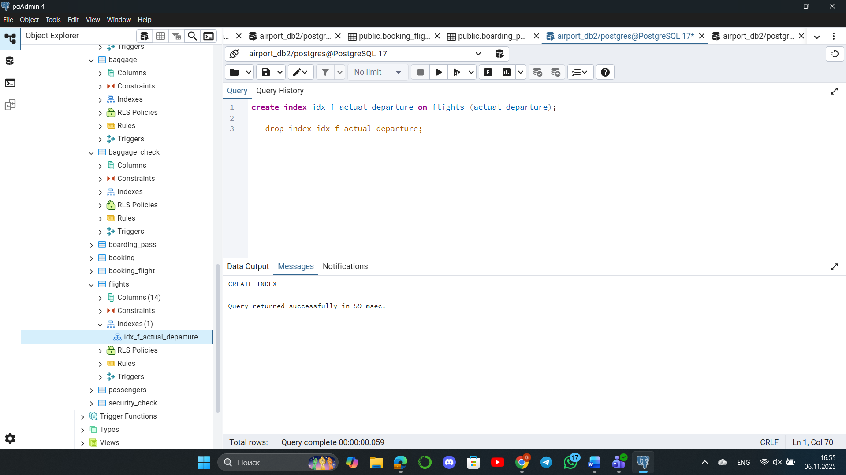
2. Create a unique index to ensure flight_no and scheduled_departure combinations are unique.
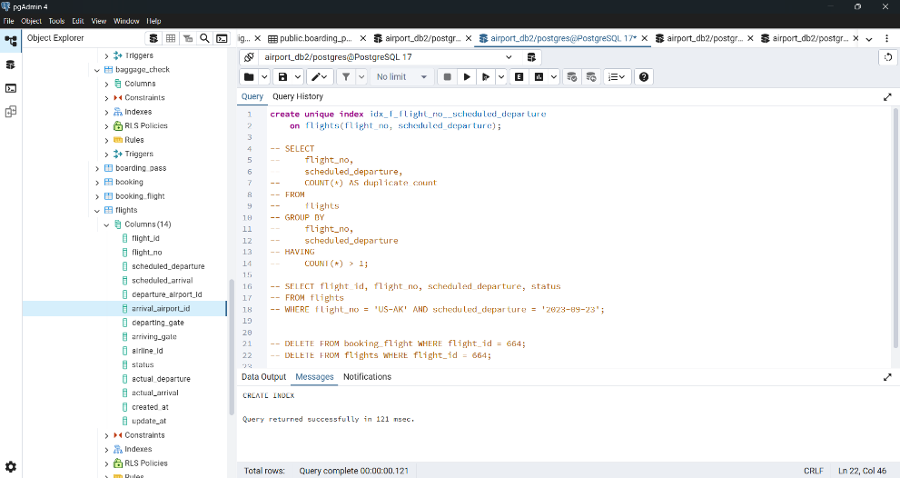
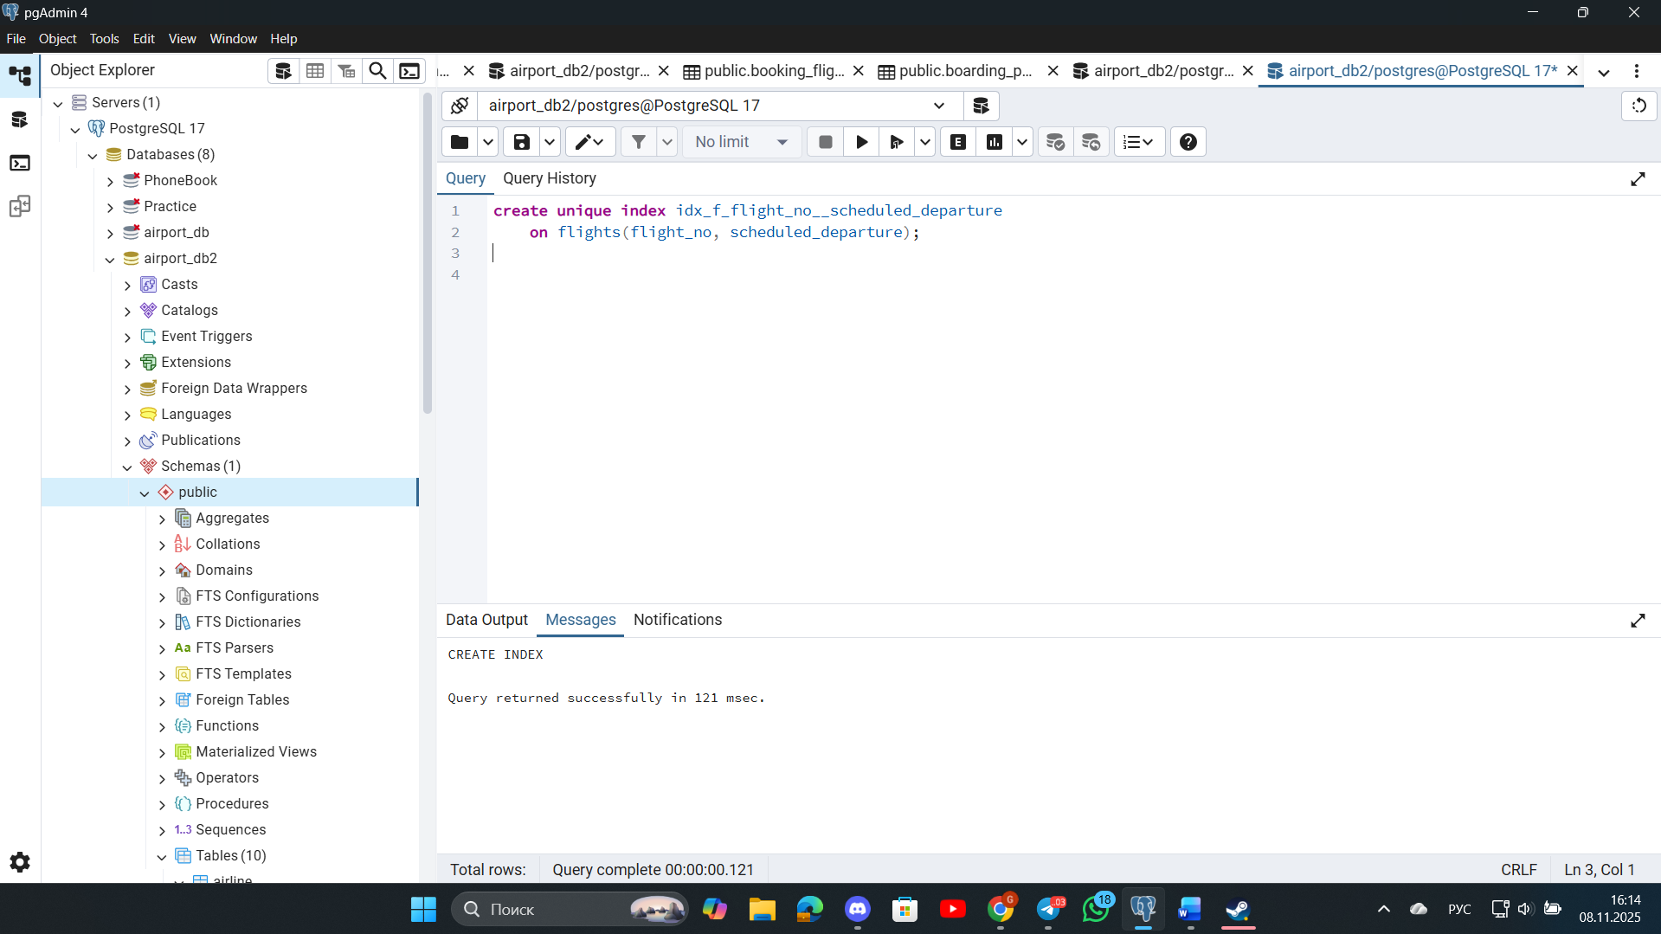
3. Create a composite index on the departure_airport_id and arrival_airport_id columns.
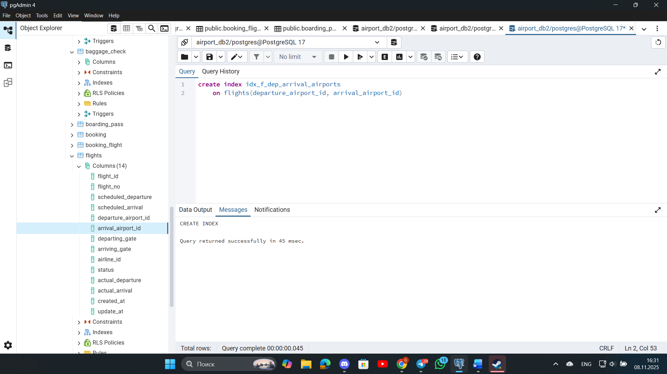
4. Evaluate the difference in query performance with and without indexes. Measure performance differences.
With index:
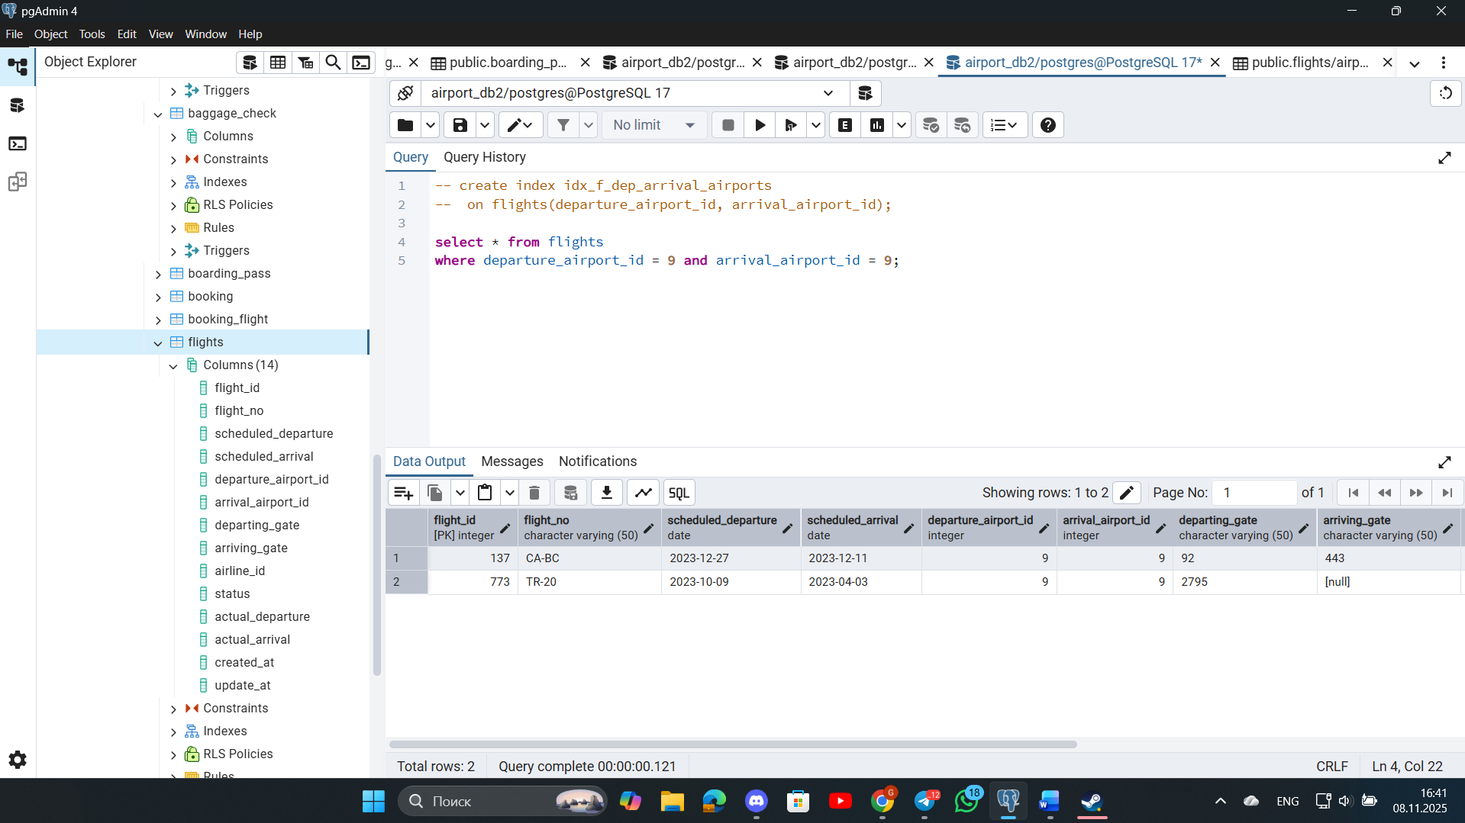
Without index:
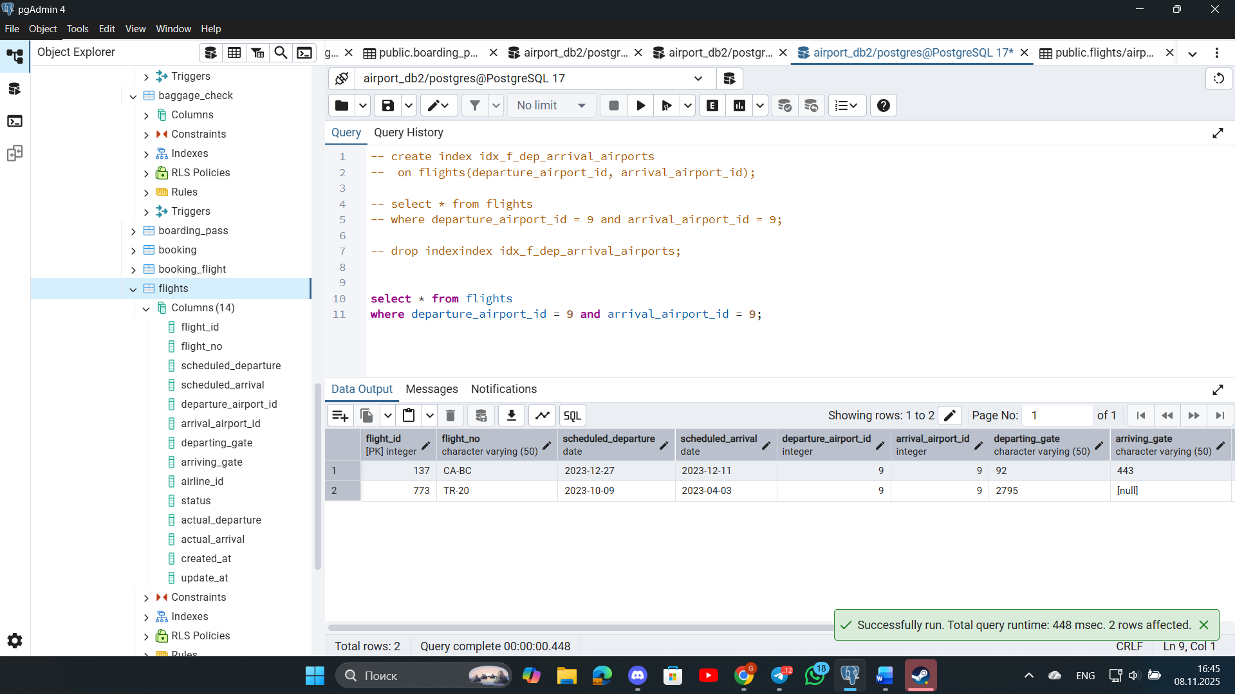
Query execution time with indexes is much faster.
5. Use EXPLAIN ANALYZE to check index usage in a query filtering by departure_airport and arrival_airport.
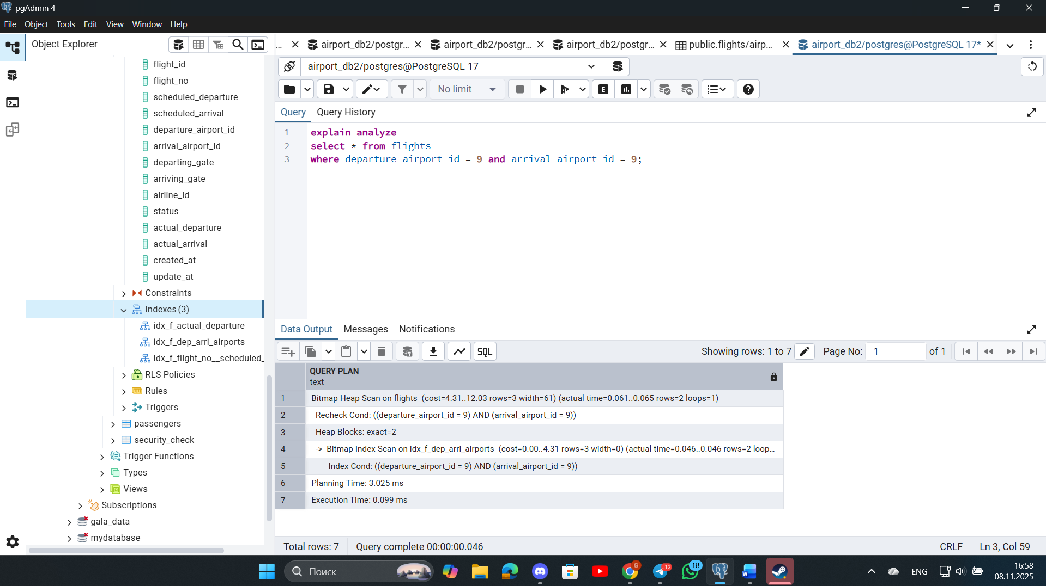
6. Create a unique index for the passport_number of the Passengers table. Check if the index was created or not. Insert into the table two new passengers.
Explain in your own words what is going on in the output?
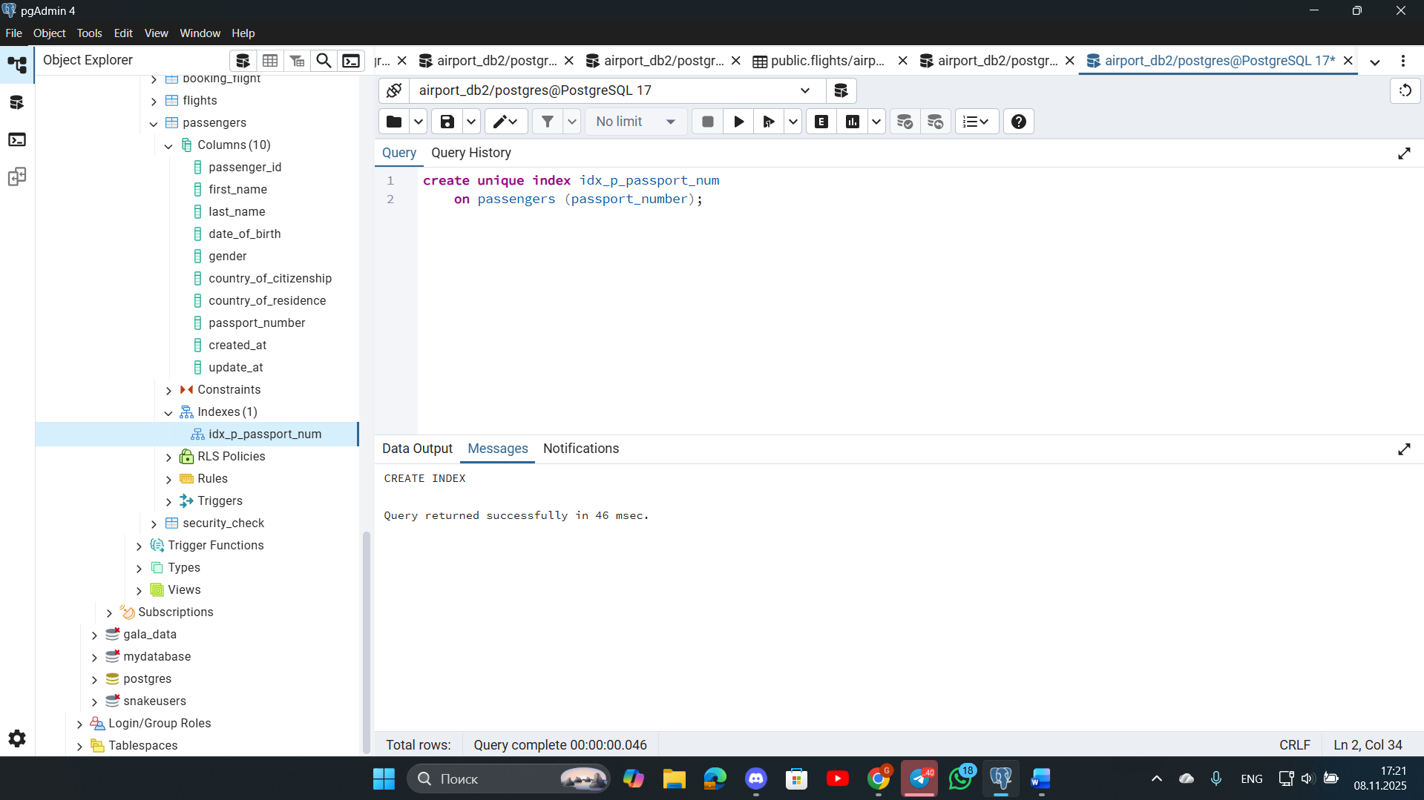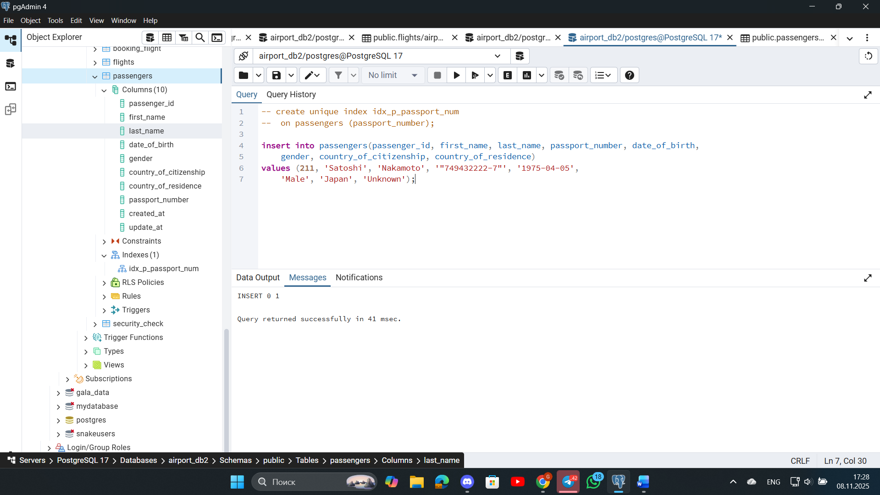
here I enter the data, and the second time I will enter other data, but with the same passport_number, to check the operation of my UNIQUE INDEX. 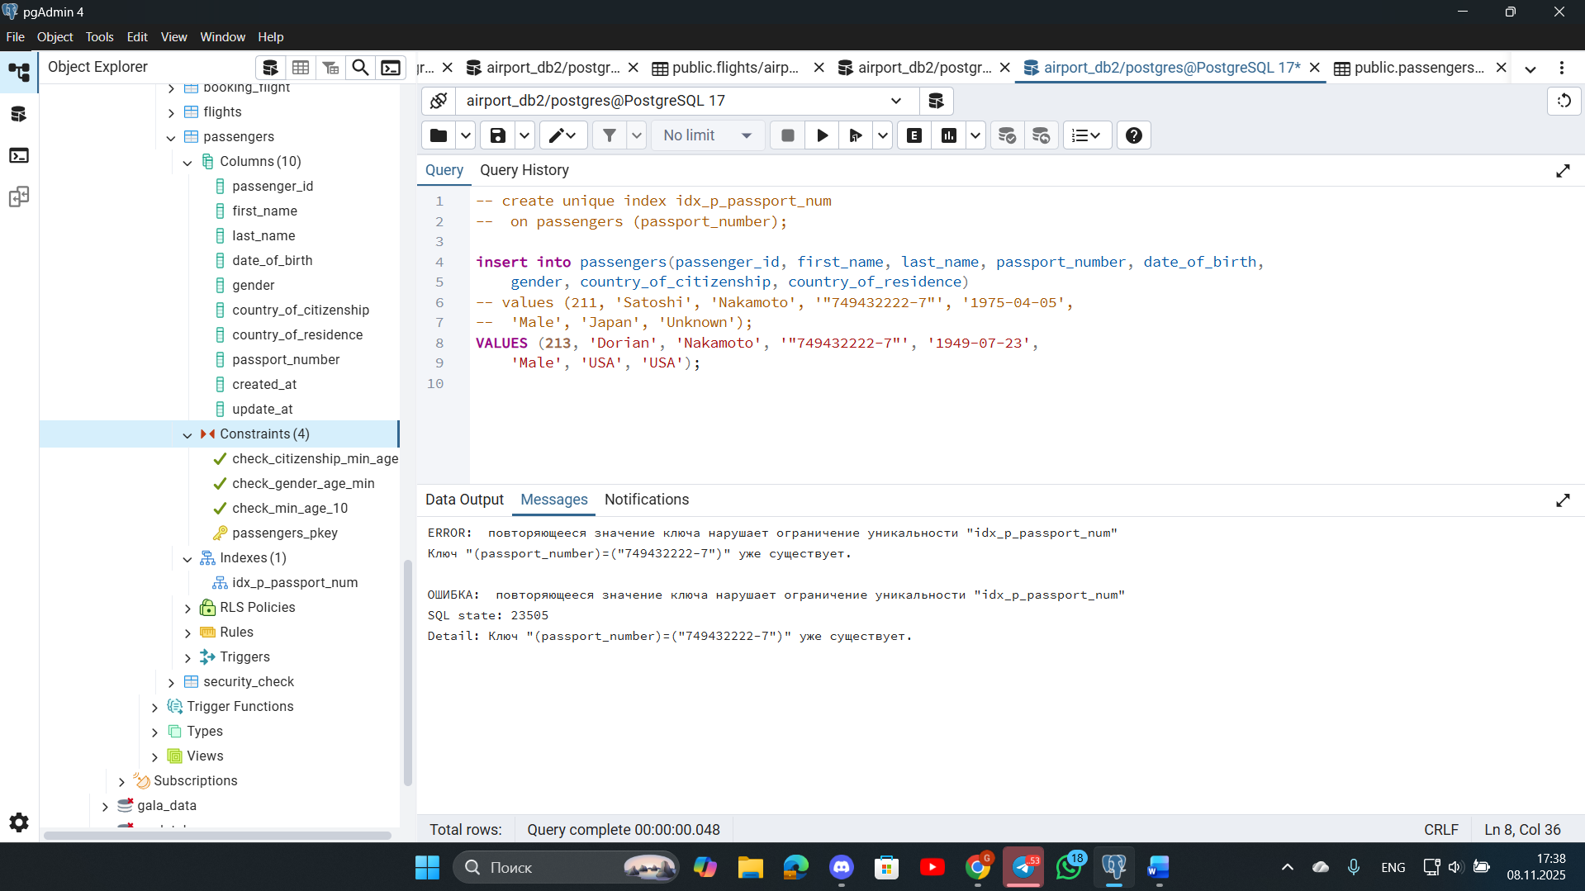
7. Create an index for the Passengers table. Use for that first name, last name, date of birth and country of citizenship. Then, write a SQL query to find a passenger who was born in Philippines and was born in 1984 and check if the query uses indexes or not. Give the explanation of the results.
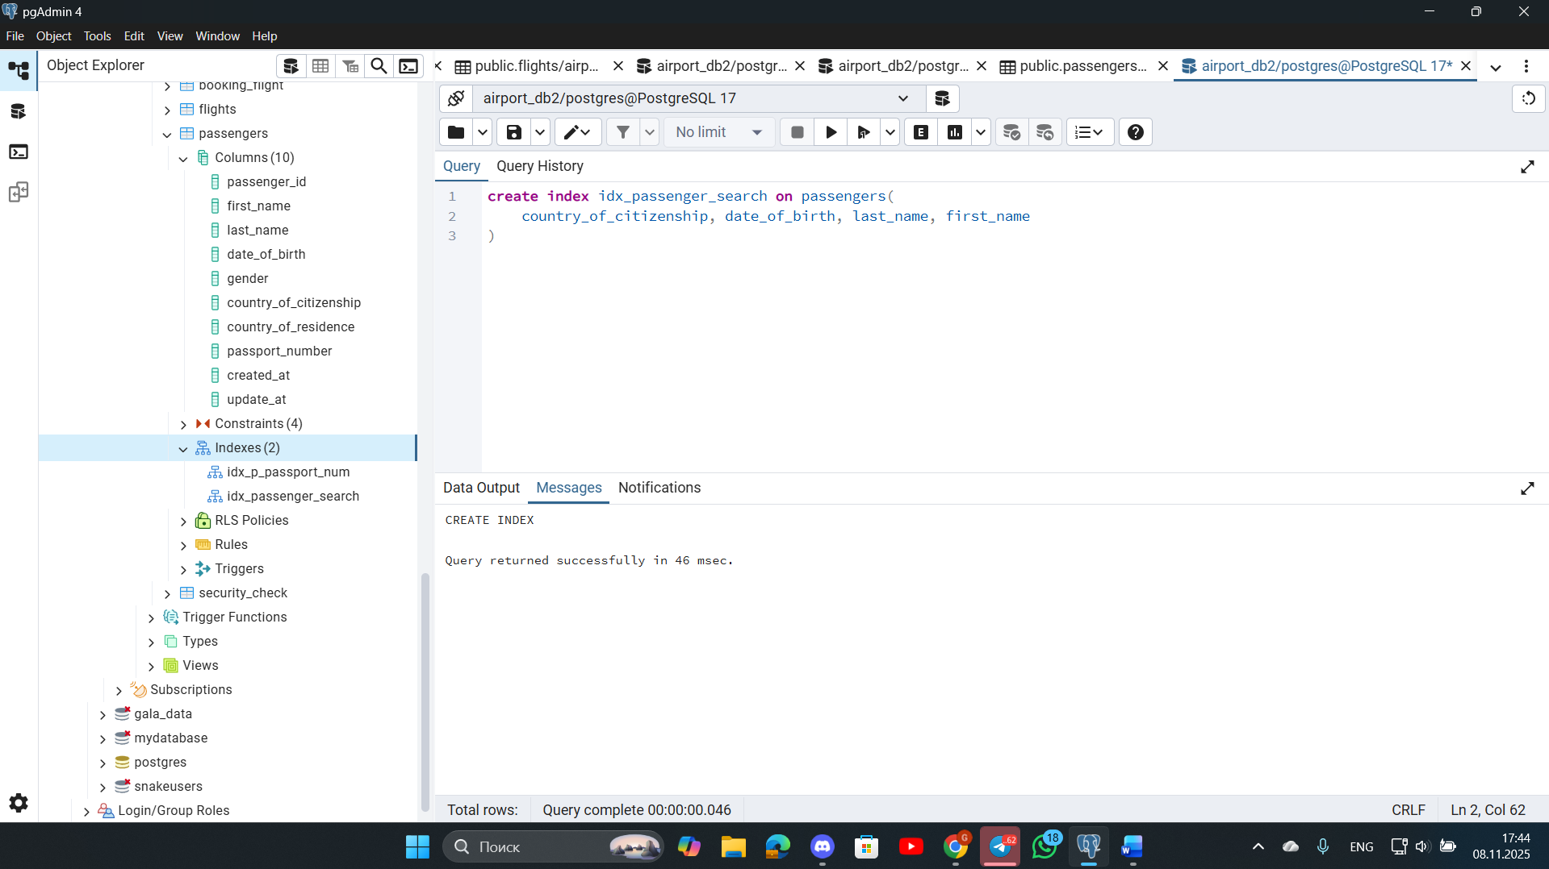
With index, it works faster:
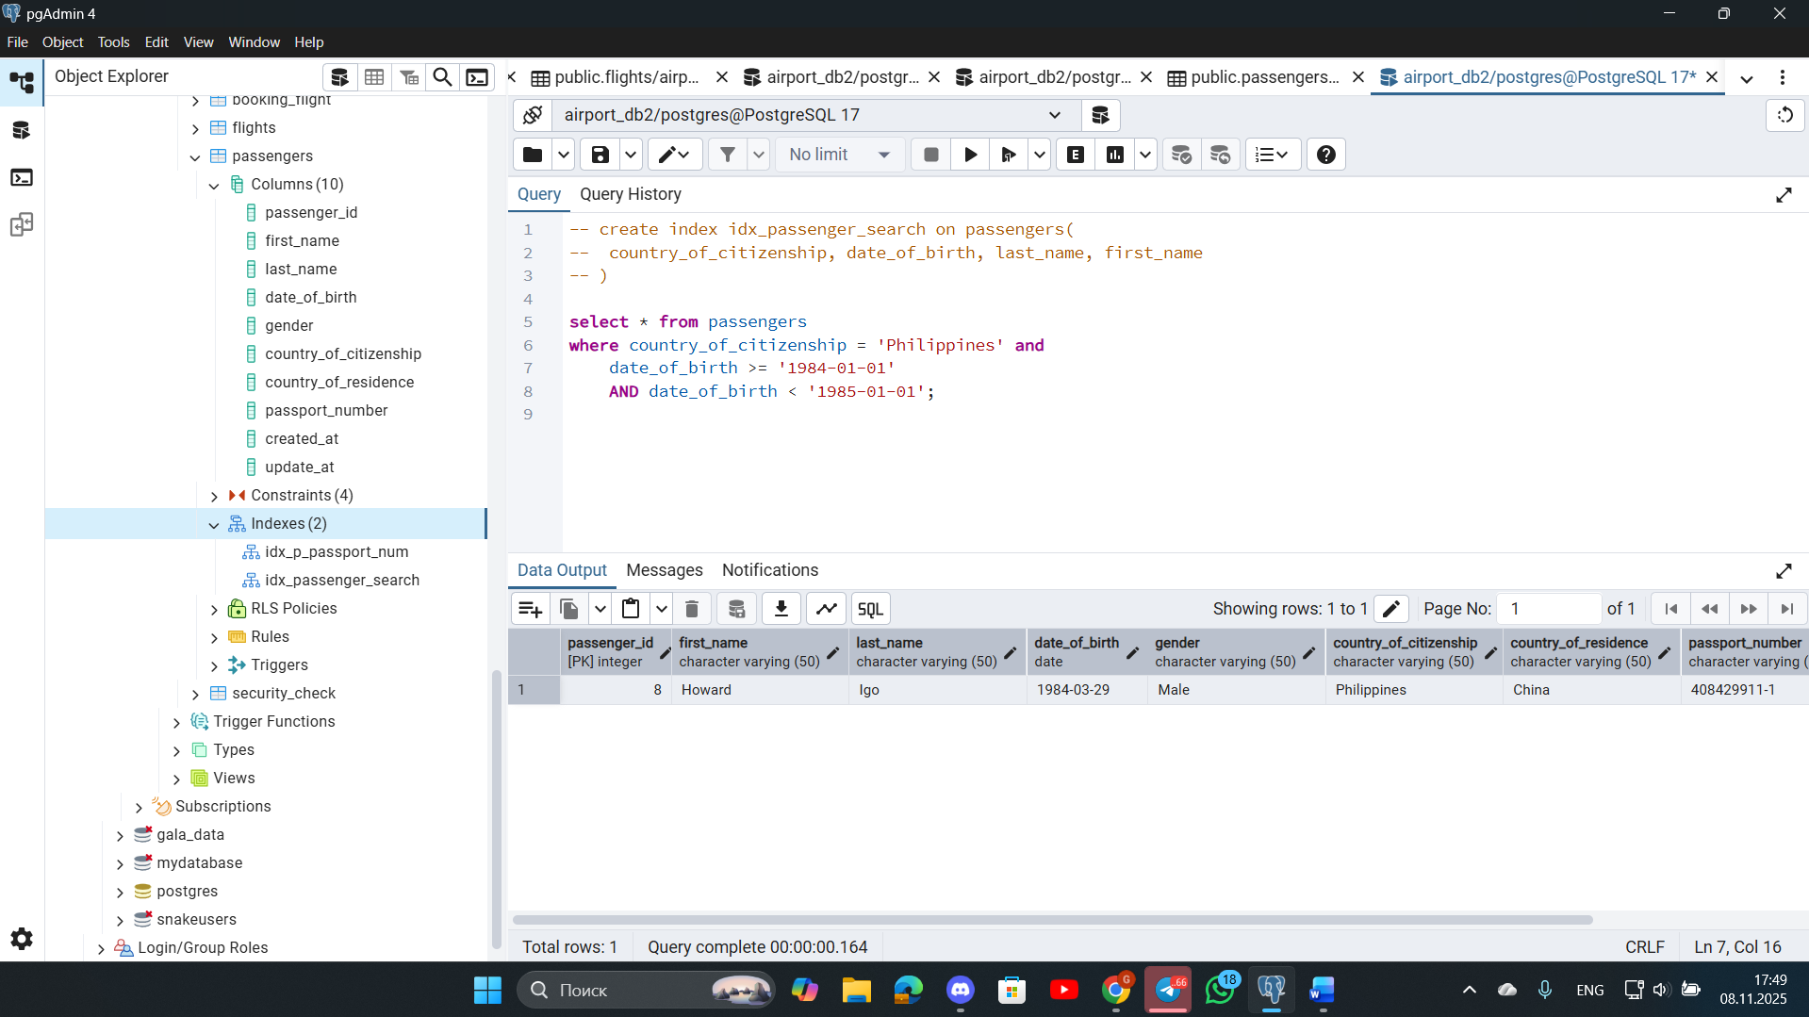
Without index:
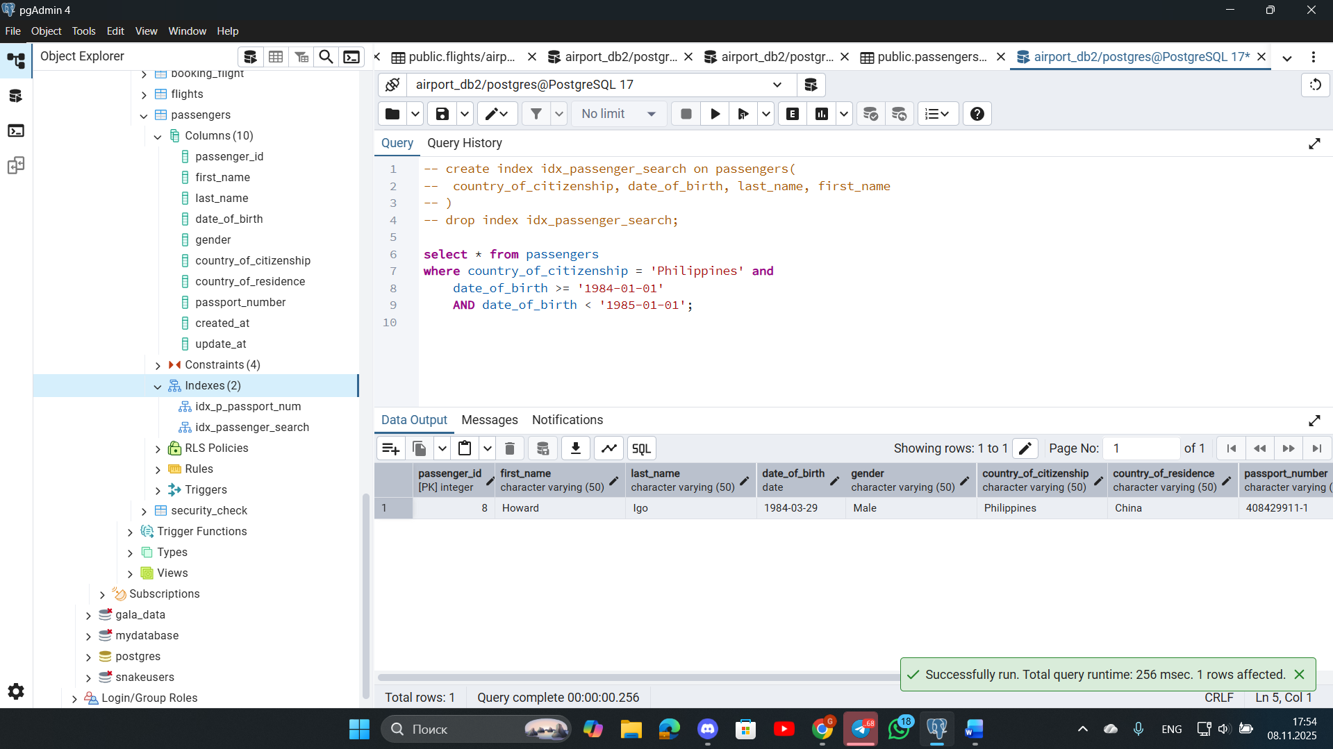
8. Write a SQL query to list indexes for table Passengers. After delete the created indexes.
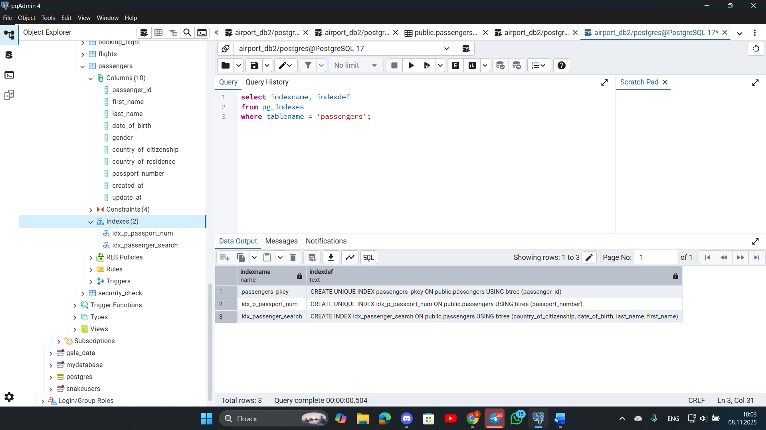
I wrote an SQL query to compile a list of indexes for passenger tables.
now we delete the indexes:
