Laboratory work 8
VIEW.
1. Create a view to show details of all flights that are departing on a specific date.
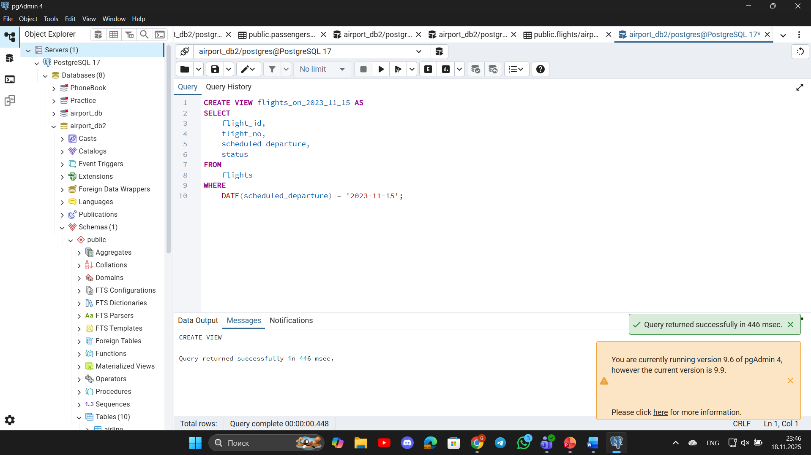
2. Create a view that shows bookings for flights scheduled to depart within the next week.
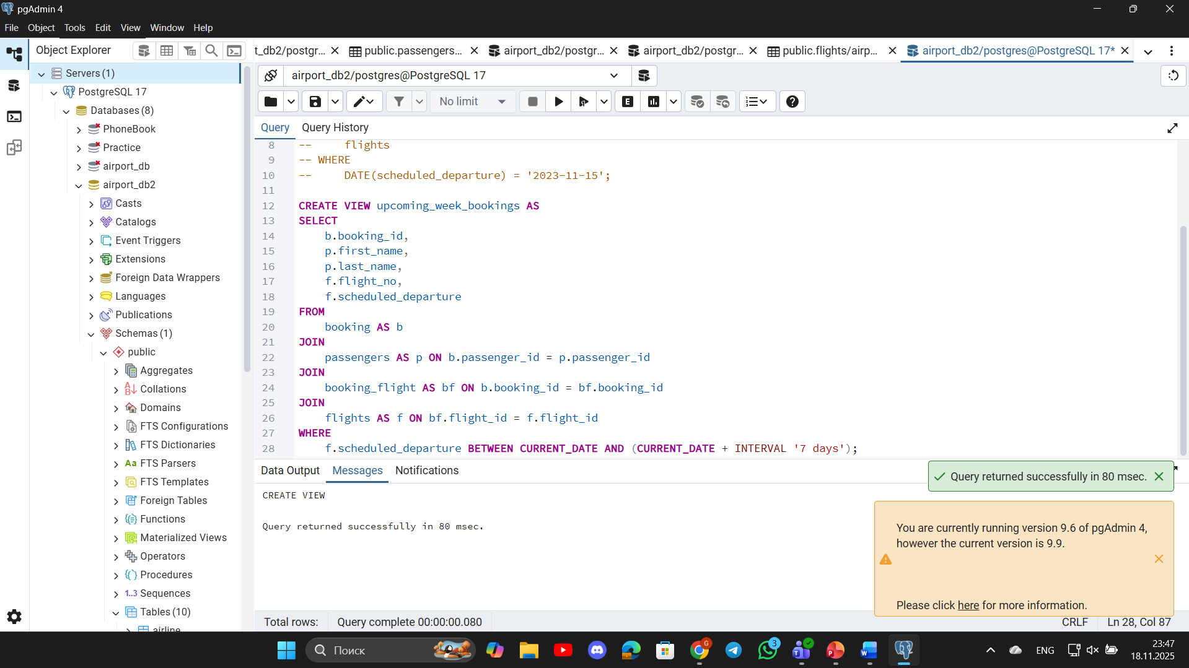
3. Create a view to show the top 5 most popular flight routes based on the number of bookings.
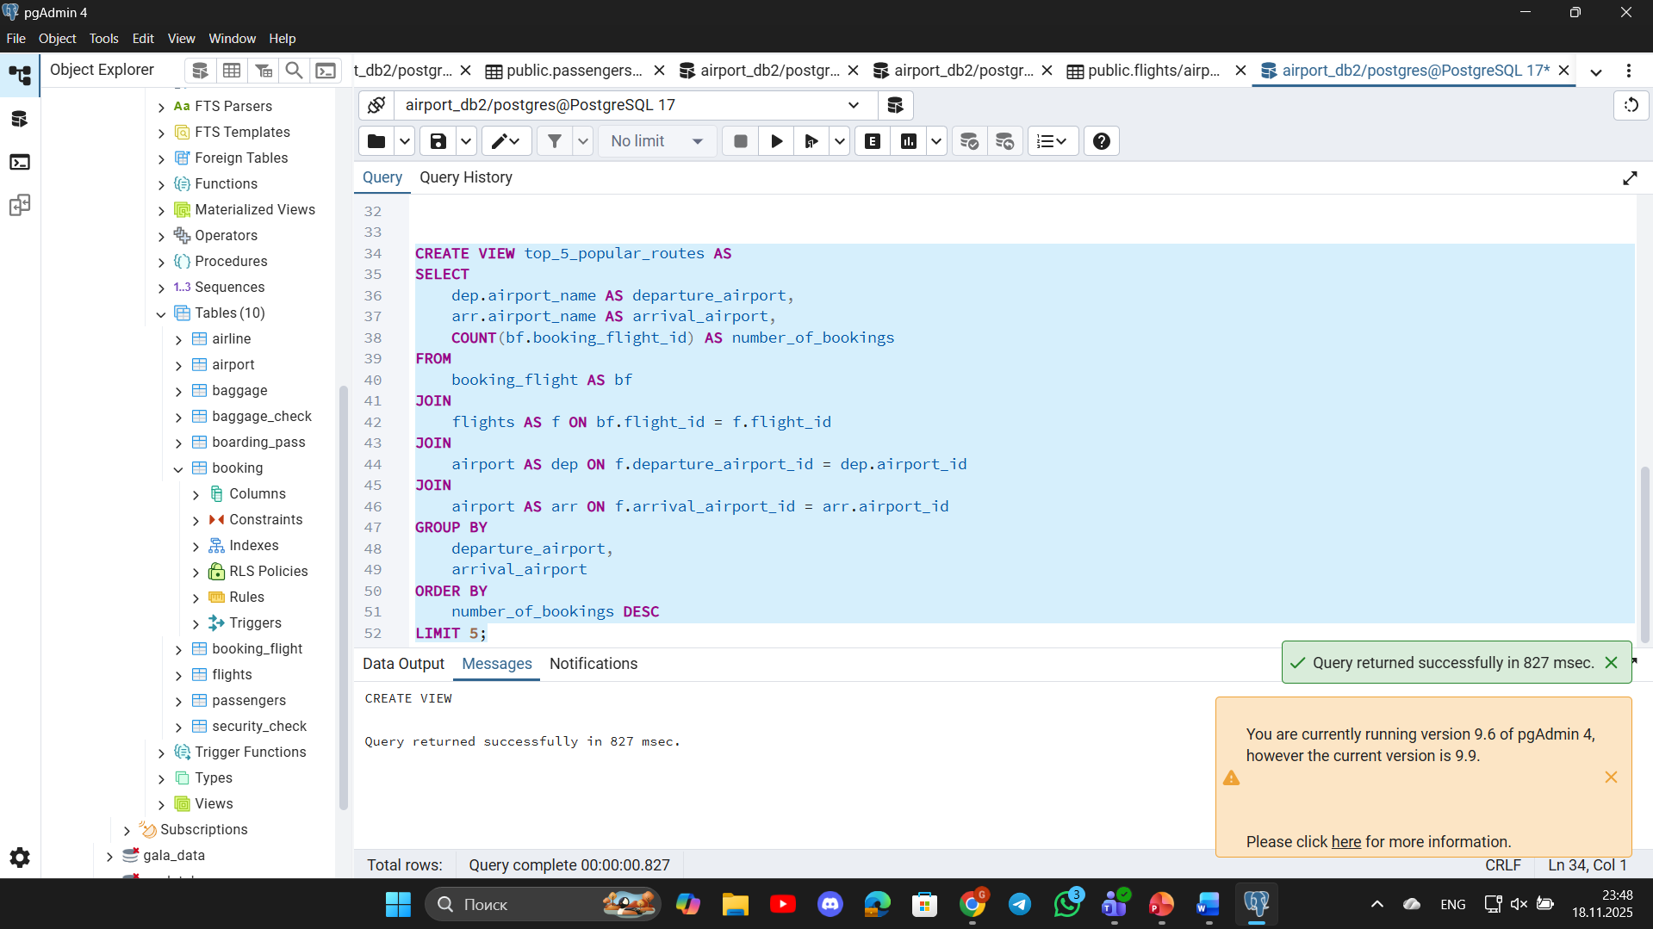
4. Create a view that lists all flights for a specific airline.
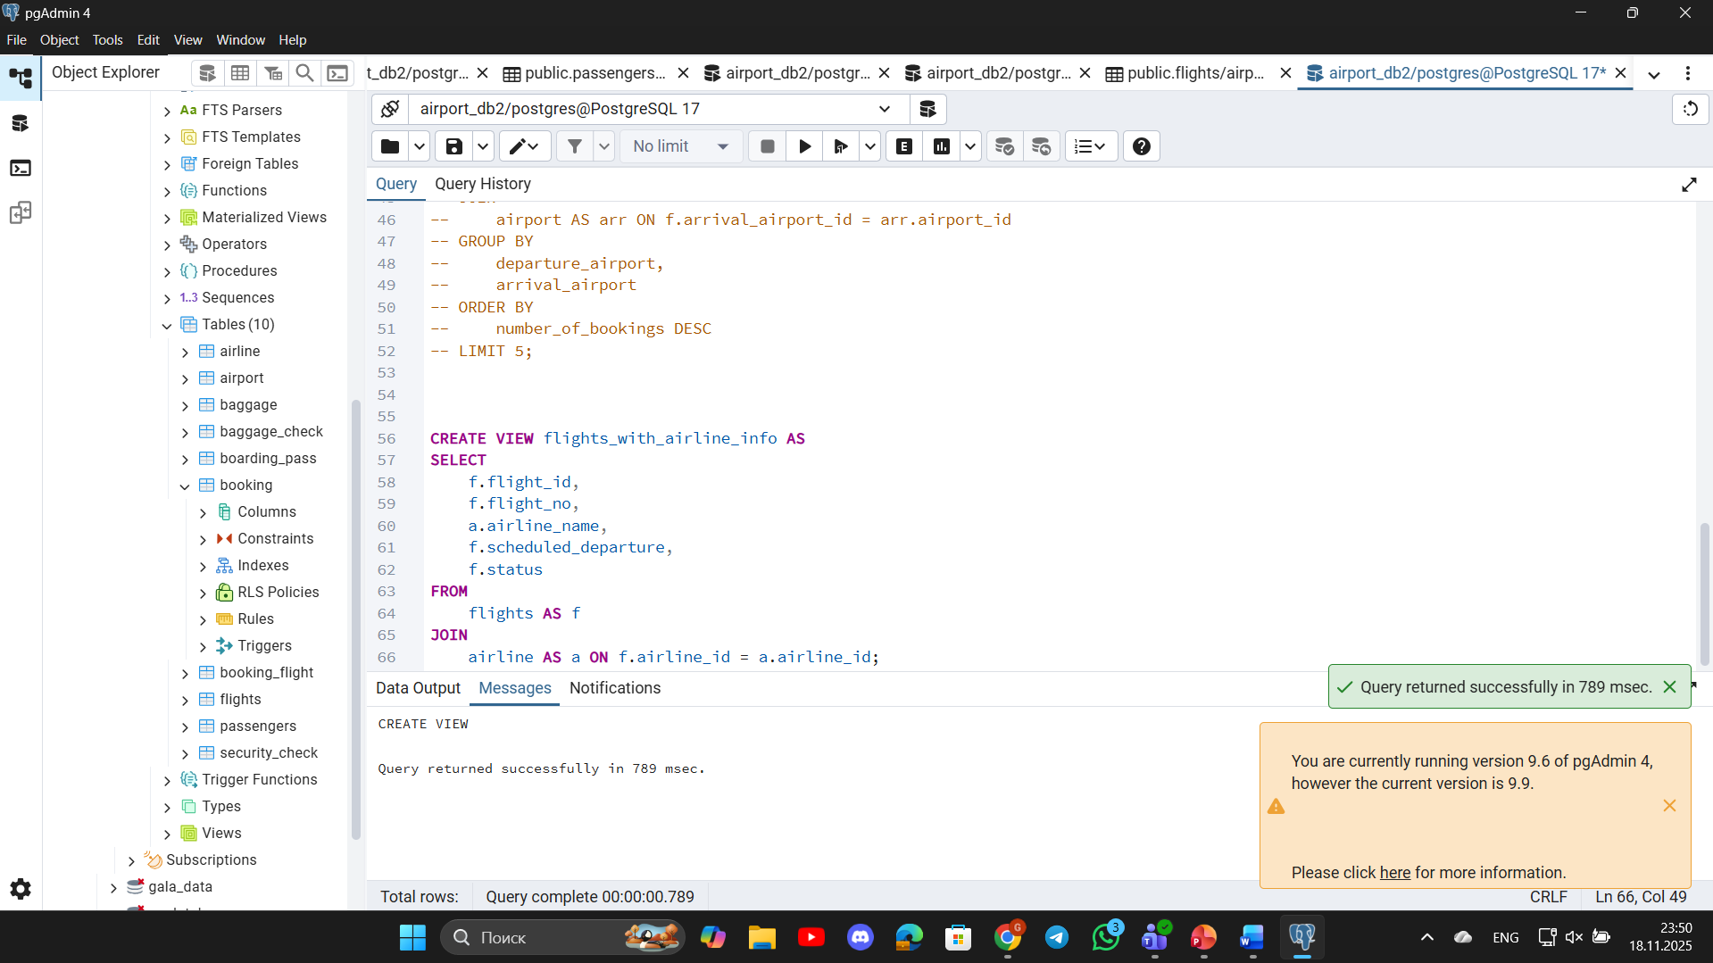
5. Modify the view created in task 4 to show only flights departing within the next 7 days for a specific airline.
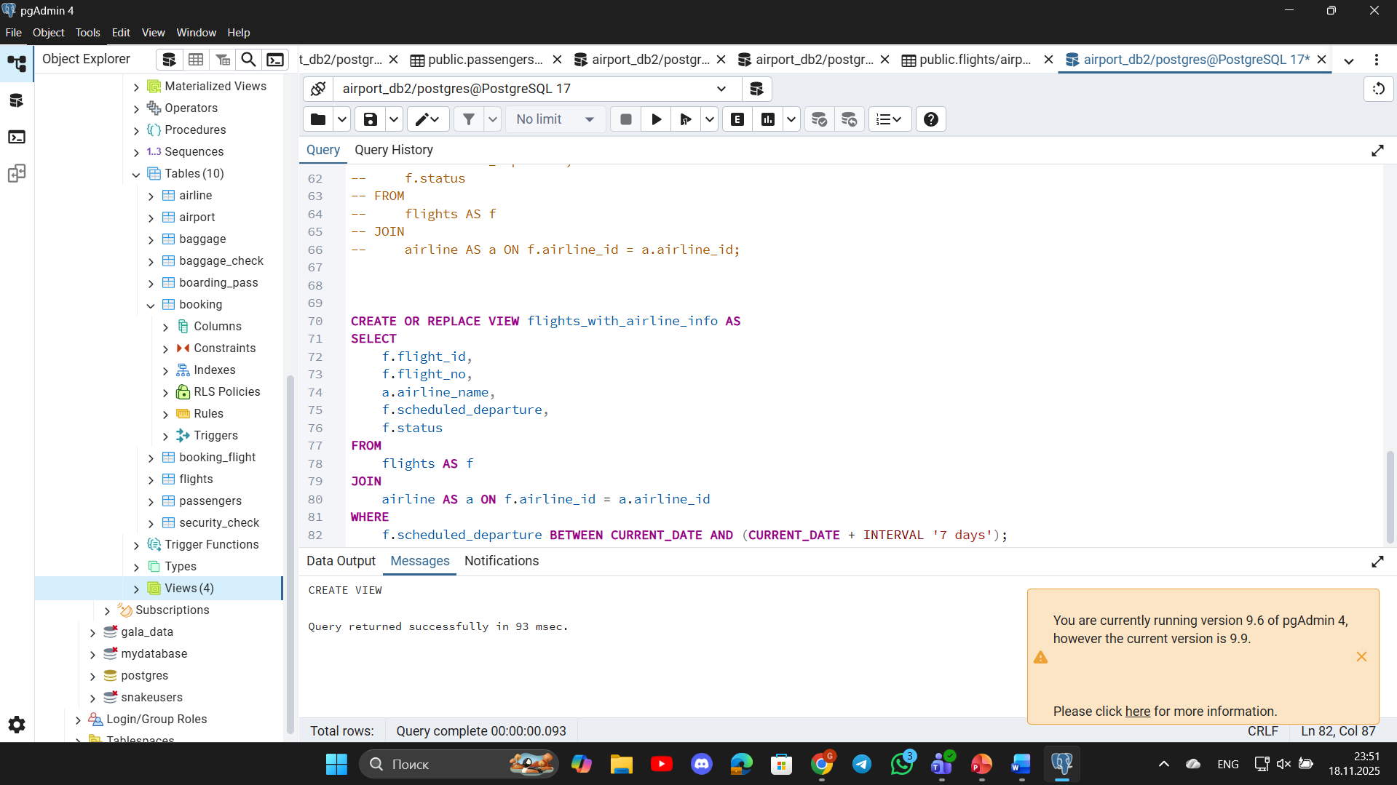
6. Create a view to show flights that are delayed by more than 24 hours.
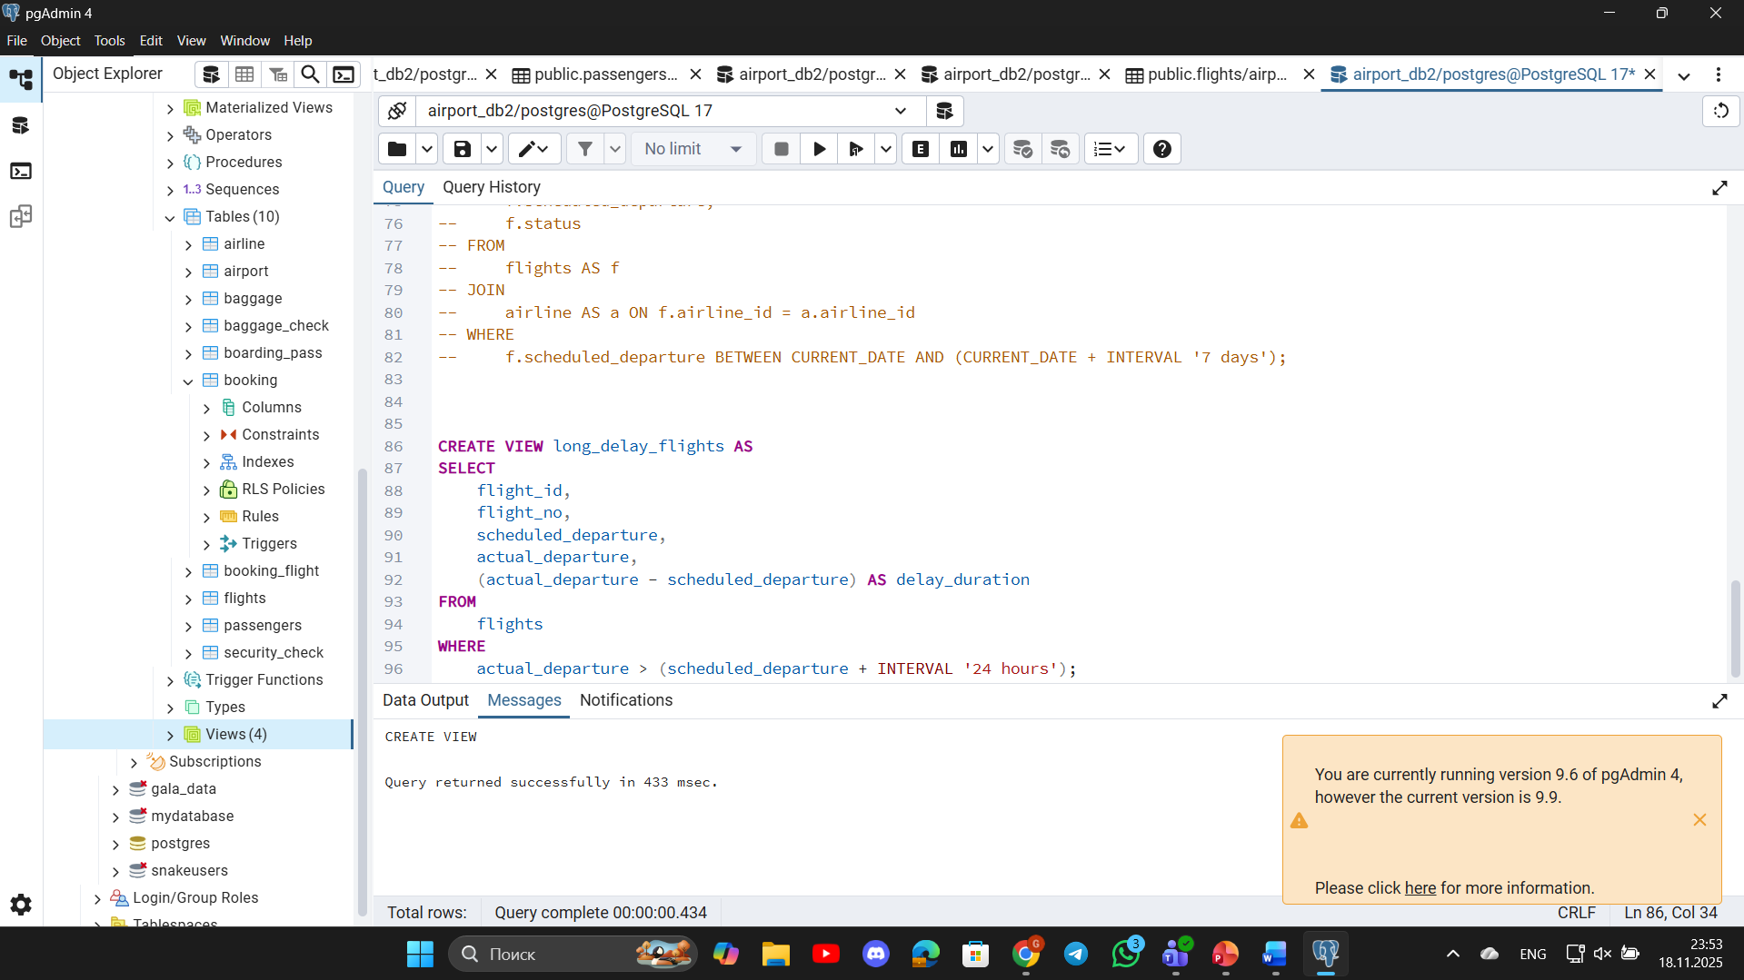
7. Create a view in which you can display the full name and country of origin of passengers who made bookings on Leffler-Thompson platform. Then show the list of that passengers.
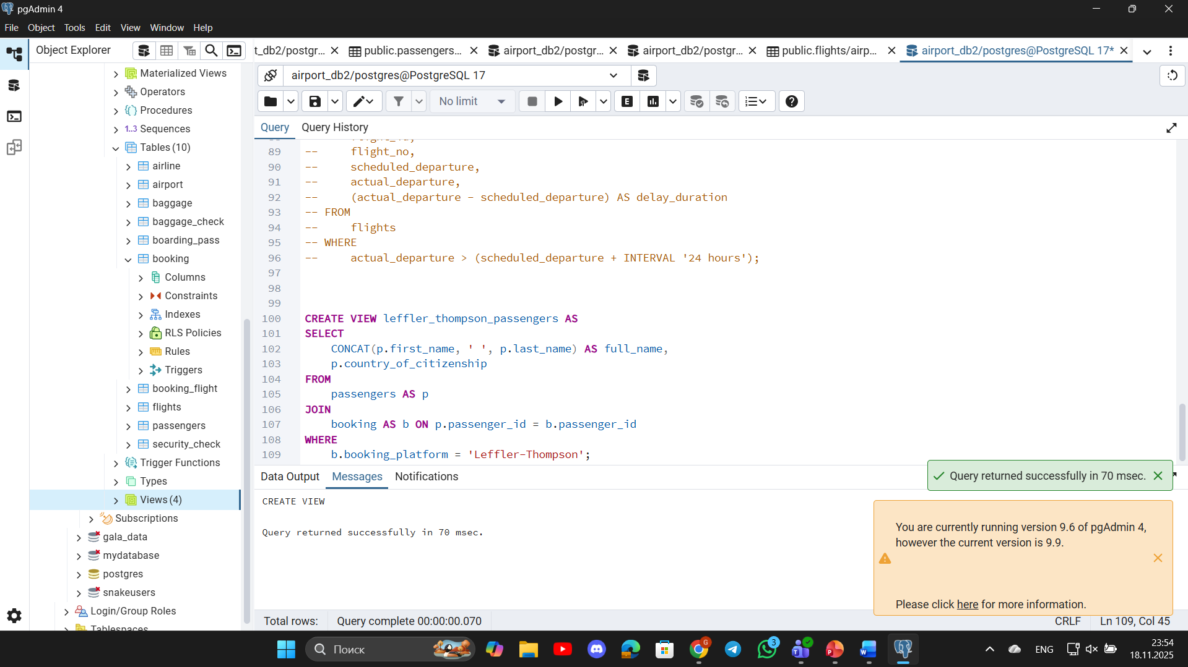
8. Create a view that shows top 10 most visited countries.
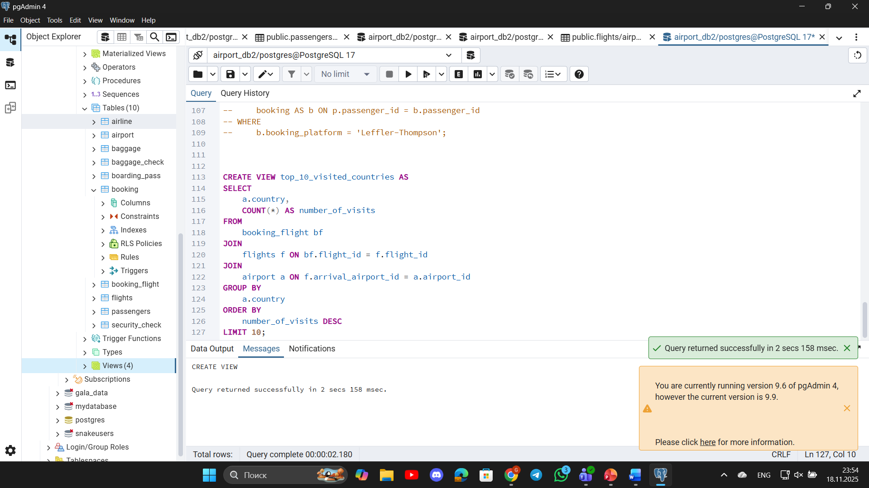
9. Update any of the created views by adding new information in the view table. Show results.
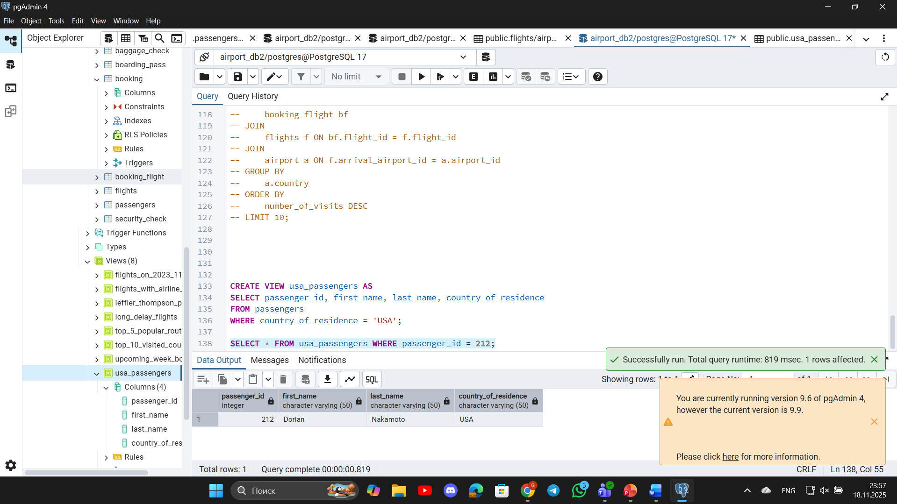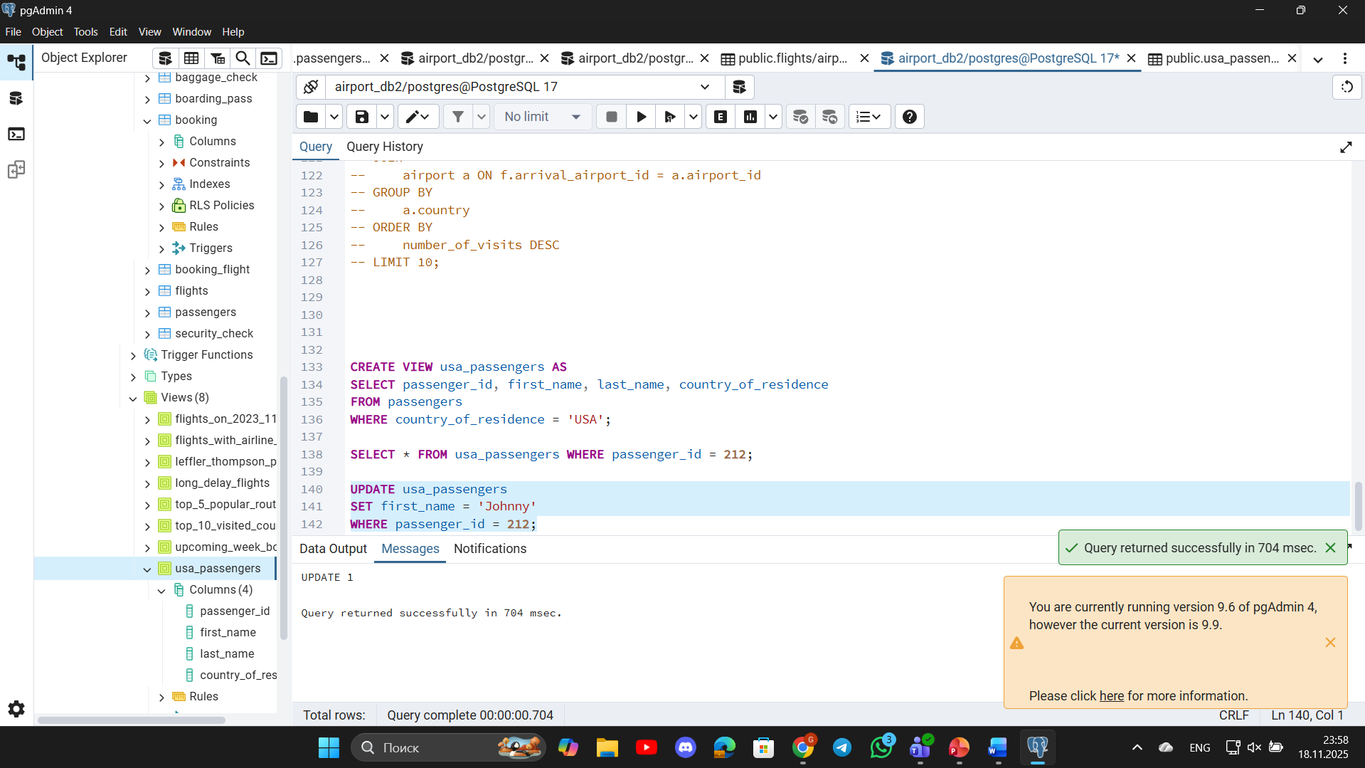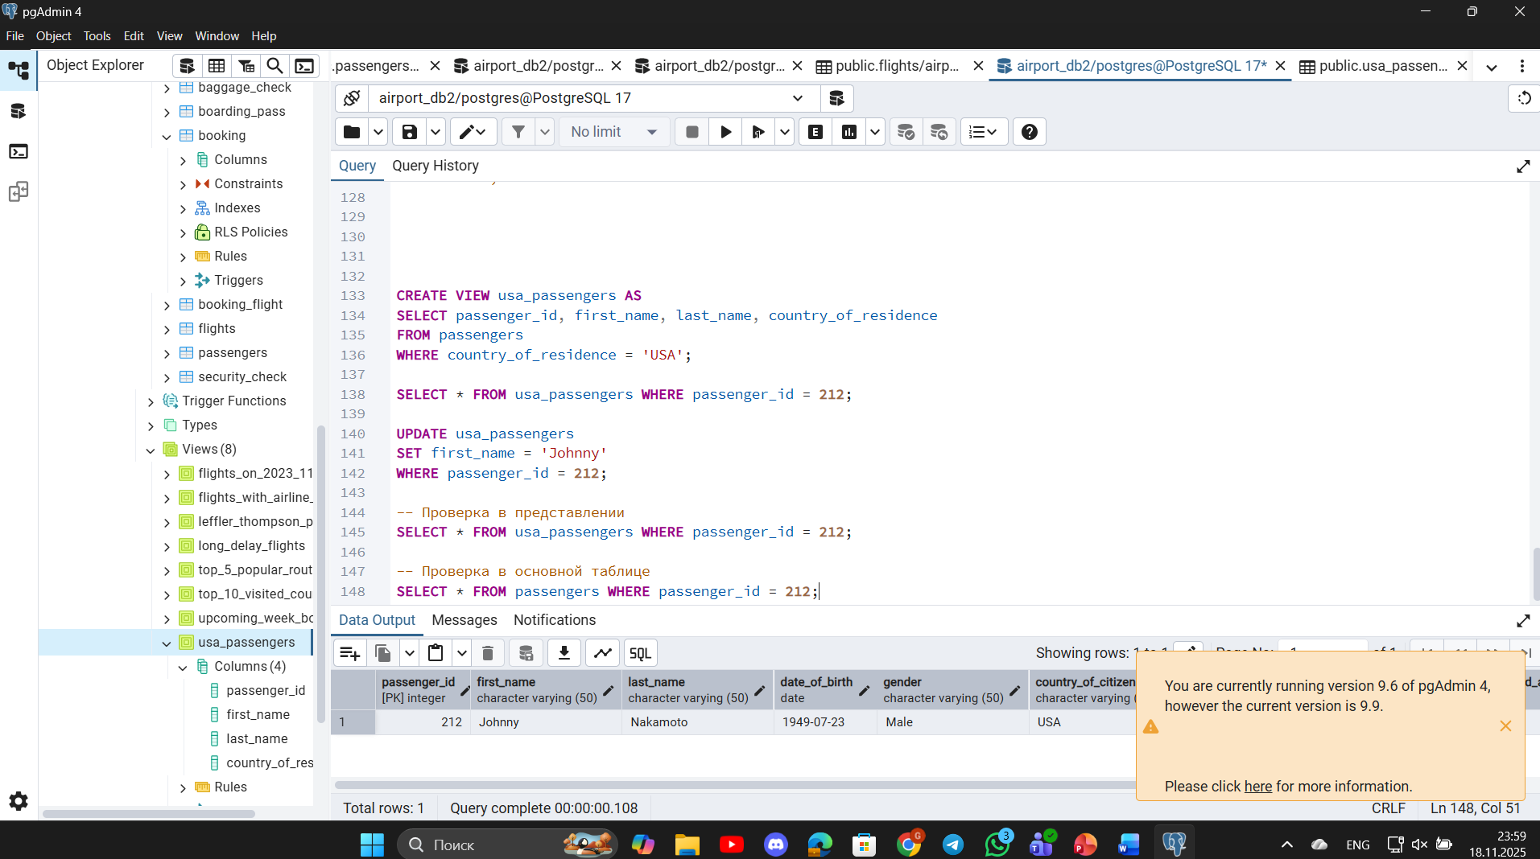
10. Drop all existing views.
