**Clap Sensor**

1. Description

This project was inspired by the old school clap detection sensors commercials. The idea is that a sound sensor/microphone detects a higher intensity sound that the ambient sounds and switches a light. In place of the light bulb I used a simple LED as a proof of concept and the whole logic is handled by a Raspberry Pi.

1. Schematic

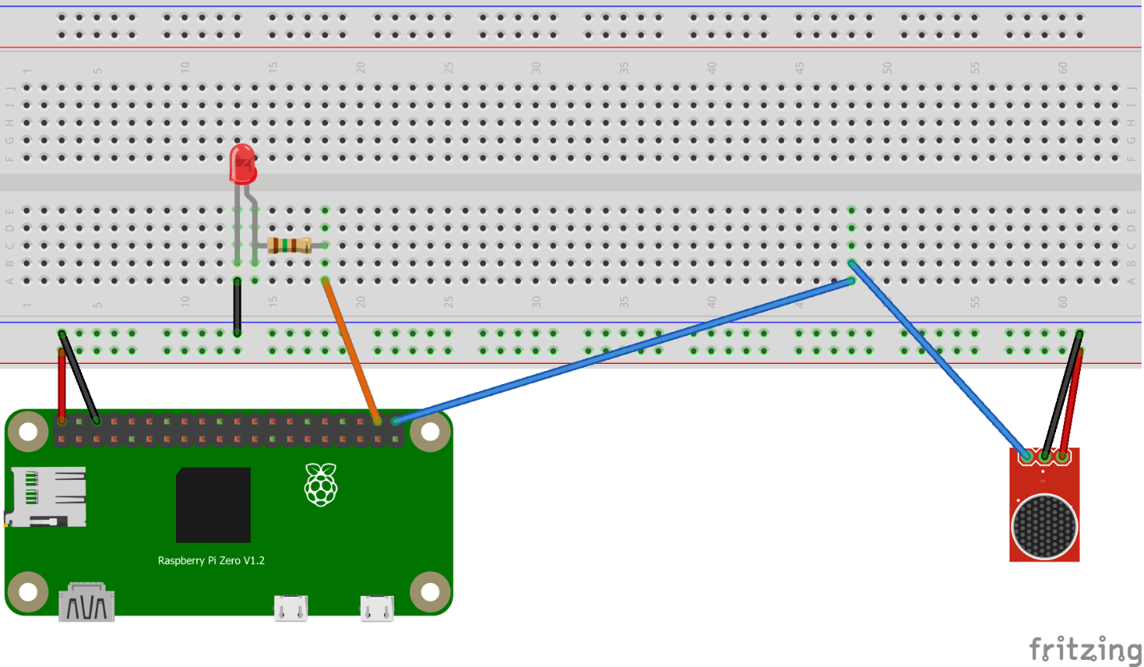

1. Hardware Components
   1. Raspberry Pi Zero WH
      1. https://peppe8o.com/raspberry-pi-zero-wh-datasheet/
   2. Sound Sensor Module LM393
      1. <https://www.optimusdigital.ro/ro/senzori-altele/108-modul-senzor-sunet.html>
   3. 1 Red LED
   4. 1 150Ω resistance
   5. 1 Bread Board
   6. 7 input-output cables
   7. 1 input-input cable
2. Software Components
   1. NOOBS OS
      1. <https://www.raspberrypi.com/news/introducing-noobs/>
   2. Python
      1. <https://www.python.org/>
   3. RPi GPIO library
      1. <https://pypi.org/project/RPi.GPIO/>
3. Setup
   1. Find the optimal sensitivity for the sound sensor module
   2. Wire all the components together according to the schematic
   3. Connect the Raspberry Pi to a power source
4. Running
   1. Run the python script
   2. Clap/snap your fingers/tap on a surface
   3. The LED will turn on when the sound sensor detects any kind of sound above the set threshold
5. GitHub repository
   1. <https://github.com/GamaCatalin/ClapSensor_RaspberryPi>