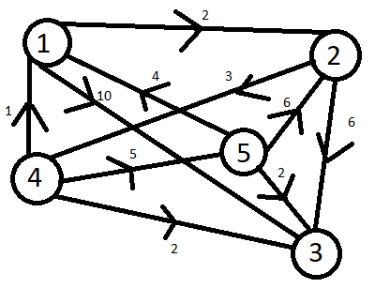
Manual execution

Costs:
1->2: 2
1->3: 10
2->3: 6
2->4: 3
4->1: 1
4->3: 2
4->5: 5
5->1: 4
5->2: 6
5->3: 2

Find the shortest walk from 1 to 3

Node | Neighbour | Distance | Predecesor
- | - | [0,inf,inf,inf,inf] | [None,None,None,None,None]
1 | 2 | [0,2,inf,inf,inf] | [None,1,None,None,None]
1 | 3 | [0,2,10,inf,inf] | [None,1,1,None,None]
2 | 3 | [0,2,8,inf,inf] | [None,1,2,None,None]
2 | 4 | [0,2,8,5,inf] | [None,1,2,2,None]
3 | - | [0,2,8,5,inf] | [None,1,2,2,None]
4 | 1 | [0,2,8,5,inf] | [None,1,2,2,None]
4 | 3 | [0,2,7,5,inf] | [None,1,4,2,None]
4 | 5 | [0,2,7,5,10] | [None,1,4,2,4]
5 | 1 | [0,2,7,5,10] | [None,1,4,2,4]
5 | 2 | [0,2,7,5,10] | [None,1,4,2,4]
5 | 3 | [0,2,7,5,10] | [None,1,4,2,4]
1 | 2 | [0,2,7,5,10] | [None,1,4,2,4]
1 | 3 | [0,2,7,5,10] | [None,1,4,2,4]
2 | 3 | [0,2,7,5,10] | [None,1,4,2,4]
2 | 4 | [0,2,7,5,10] | [None,1,4,2,4]
3 | - | [0,2,7,5,10] | [None,1,4,2,4]
4 | 1 | [0,2,7,5,10] | [None,1,4,2,4]
4 | 3 | [0,2,7,5,10] | [None,1,4,2,4]
4 | 5 | [0,2,7,5,10] | [None,1,4,2,4]
5 | 1 | [0,2,7,5,10] | [None,1,4,2,4]
5 | 2 | [0,2,7,5,10] | [None,1,4,2,4]
5 | 3 | [0,2,7,5,10] | [None,1,4,2,4]

Shortest walk: [1,2,4,3]
Distance: 7

