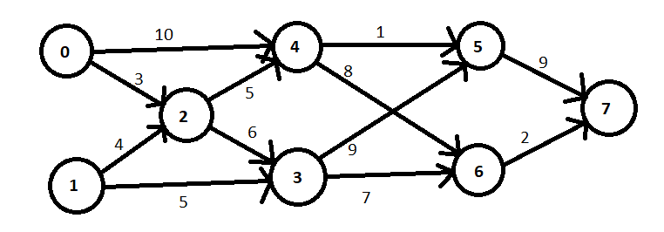
Manual execution

Input file:

8 12
0 2 3
0 4 10
1 2 4
1 3 5
2 3 6
2 4 5
3 5 9
3 6 7
4 5 1
4 6 8
5 7 9
6 7 2

Topological sort:
Iteration | Predecessor count | Queue | Sorted
Initialization | 0 1 2 3 4 5 6 7 | [0,1] | []
Initialization | 0 0 2 2 2 2 2 2 | [0,1] | []
1 | 0 1 2 3 4 5 6 7 | [1] | [0]
1 | 0 0 1 2 1 2 2 2 | [1] | [0]
2 | 0 1 2 3 4 5 6 7 | [2] | [0,1]
2 | 0 0 0 1 1 2 2 2 | [2] | [0,1]
3 | 0 1 2 3 4 5 6 7 | [3,4] | [0,1,2]
3 | 0 0 0 0 0 2 2 2 | [3,4] | [0,1,2]
4 | 0 1 2 3 4 5 6 7 | [4] | [0,1,2,3]
4 | 0 0 0 0 0 1 1 2 | [4] | [0,1,2,3]
5 | 0 1 2 3 4 5 6 7 | [5,6] | [0,1,2,3,4]
5 | 0 0 0 0 0 0 0 2 | [5,6] | [0,1,2,3,4]
6 | 0 1 2 3 4 5 6 7 | [6] | [0,1,2,3,4,5]
6 | 0 0 0 0 0 0 0 1 | [6] | [0,1,2,3,4,5]
7 | 0 1 2 3 4 5 6 7 | [7] | [0,1,2,3,4,5,6]
7 | 0 0 0 0 0 0 0 0 | [7] | [0,1,2,3,4,5,6]
8 | 0 1 2 3 4 5 6 7 | [] | [0,1,2,3,4,5,6,7]
8 | 0 0 0 0 0 0 0 0 | [] | [0,1,2,3,4,5,6,7]

