Results

Graph 1:

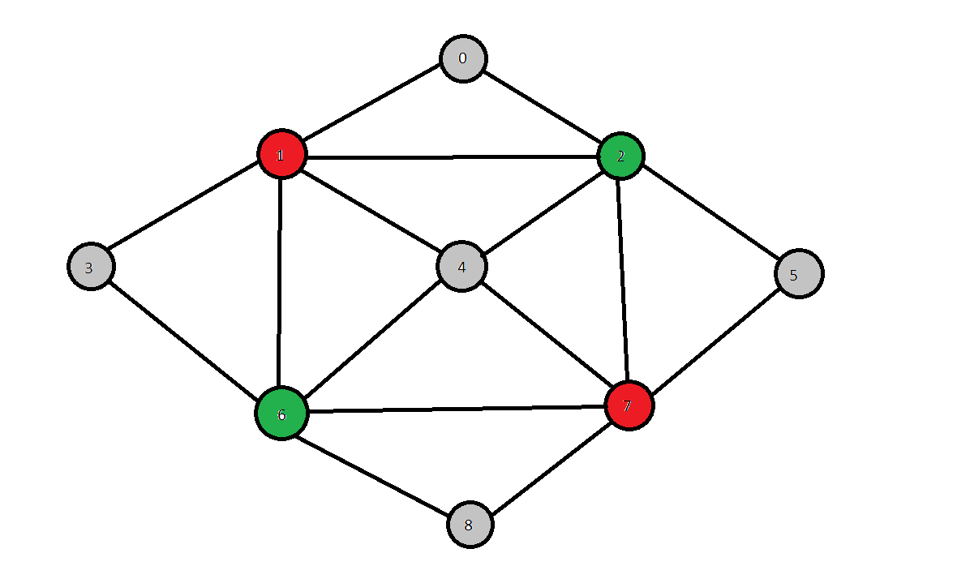
Input file:  9 16  0 1 0  0 2 0  1 2 0  1 3 0  1 4 0  1 6 0  2 4 0  2 5 0  2 7 0  3 6 0  4 6 0  4 7 0  5 7 0  6 7 0  6 8 0  7 8 0 | Results:  Vertex 0 has color 0  Vertex 1 has color 1  Vertex 2 has color 2  Vertex 3 has color 0  Vertex 4 has color 0  Vertex 5 has color 0  Vertex 6 has color 2  Vertex 7 has color 1  Vertex 8 has color 0

Graph 2:

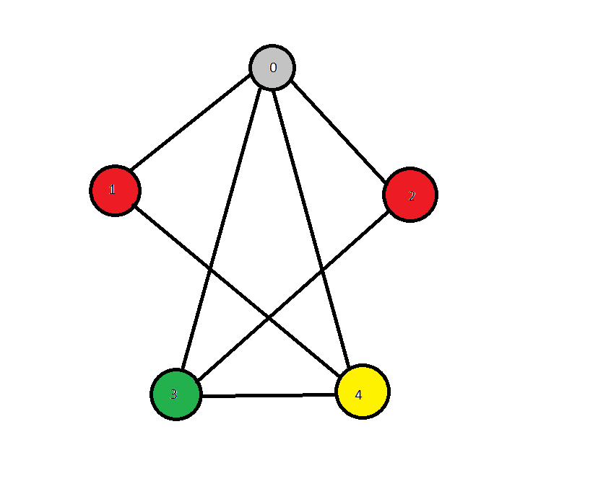
Input file:  5 7  0 1 0  0 2 0  0 3 0  0 4 0  1 4 0  2 3 0  3 4 0 | Results:  Vertex 0 has color 0  Vertex 1 has color 1  Vertex 2 has color 1  Vertex 3 has color 2  Vertex 4 has color 3

