|  |  |
| --- | --- |
| Gamal Abdul Hameed Nasef Newysar | 19015550 |

* Original Draw:

* Variables changes:
* orthoLeft

As we increase orthoLeft, the left start of the two lines moves left.

orthoLeft = 0

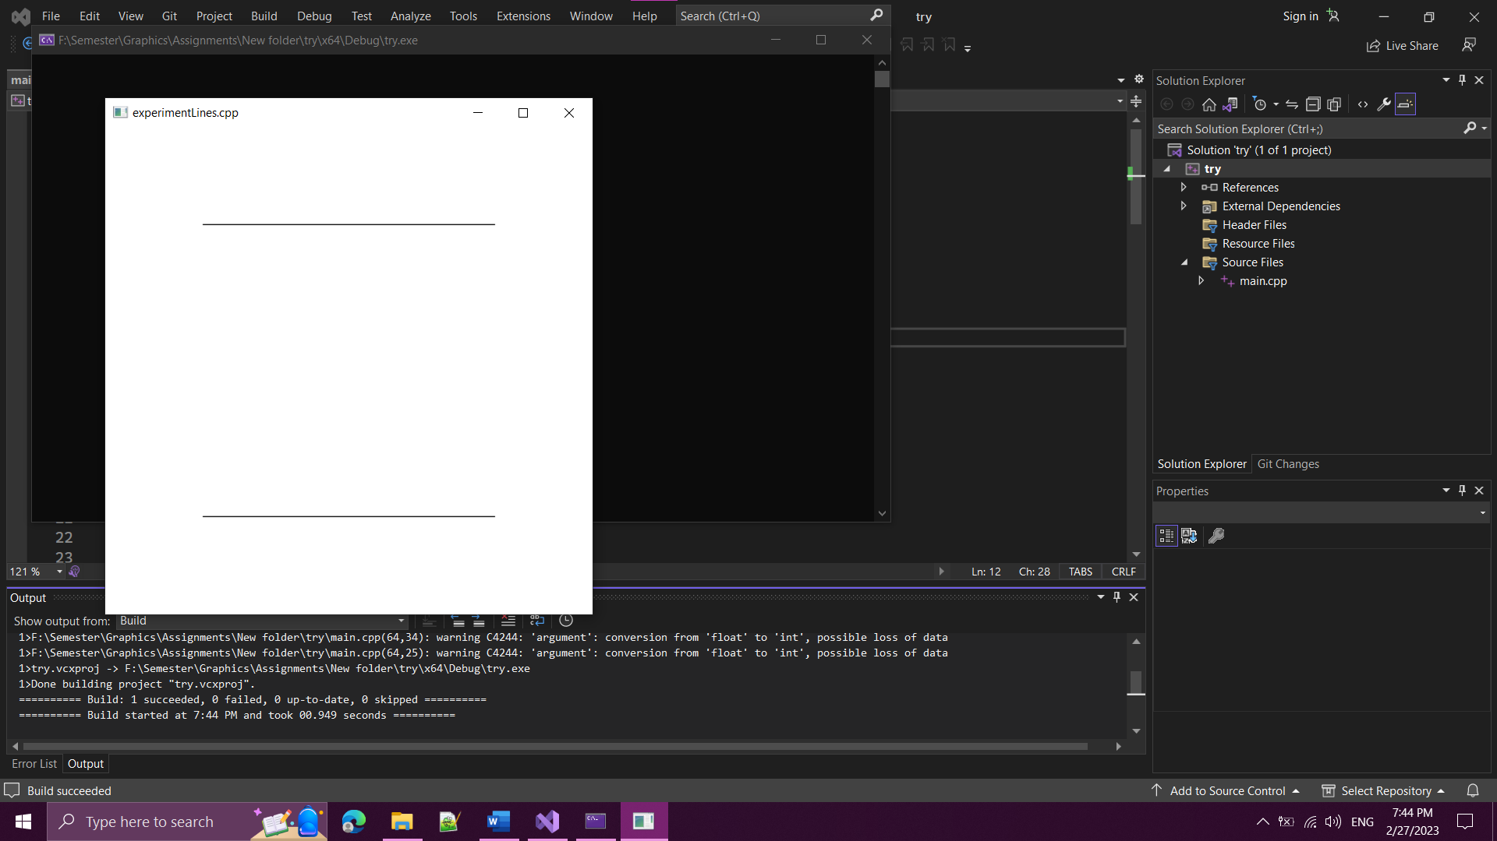

orthoLeft = 20

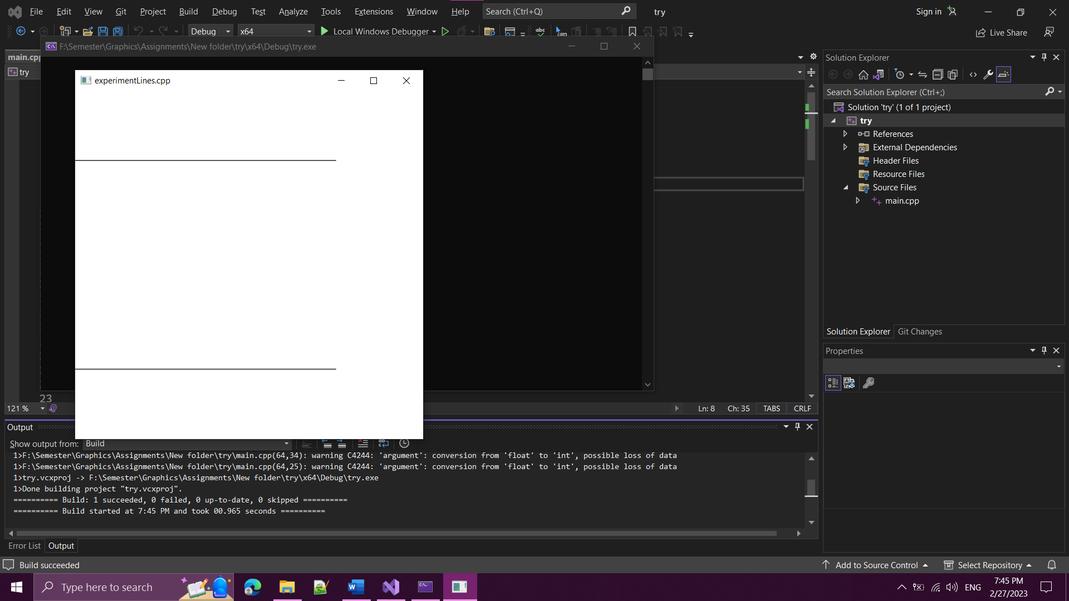

* orthoRight

As we increase orthoRight, the right start of the two lines moves left.

orthoRight = 80

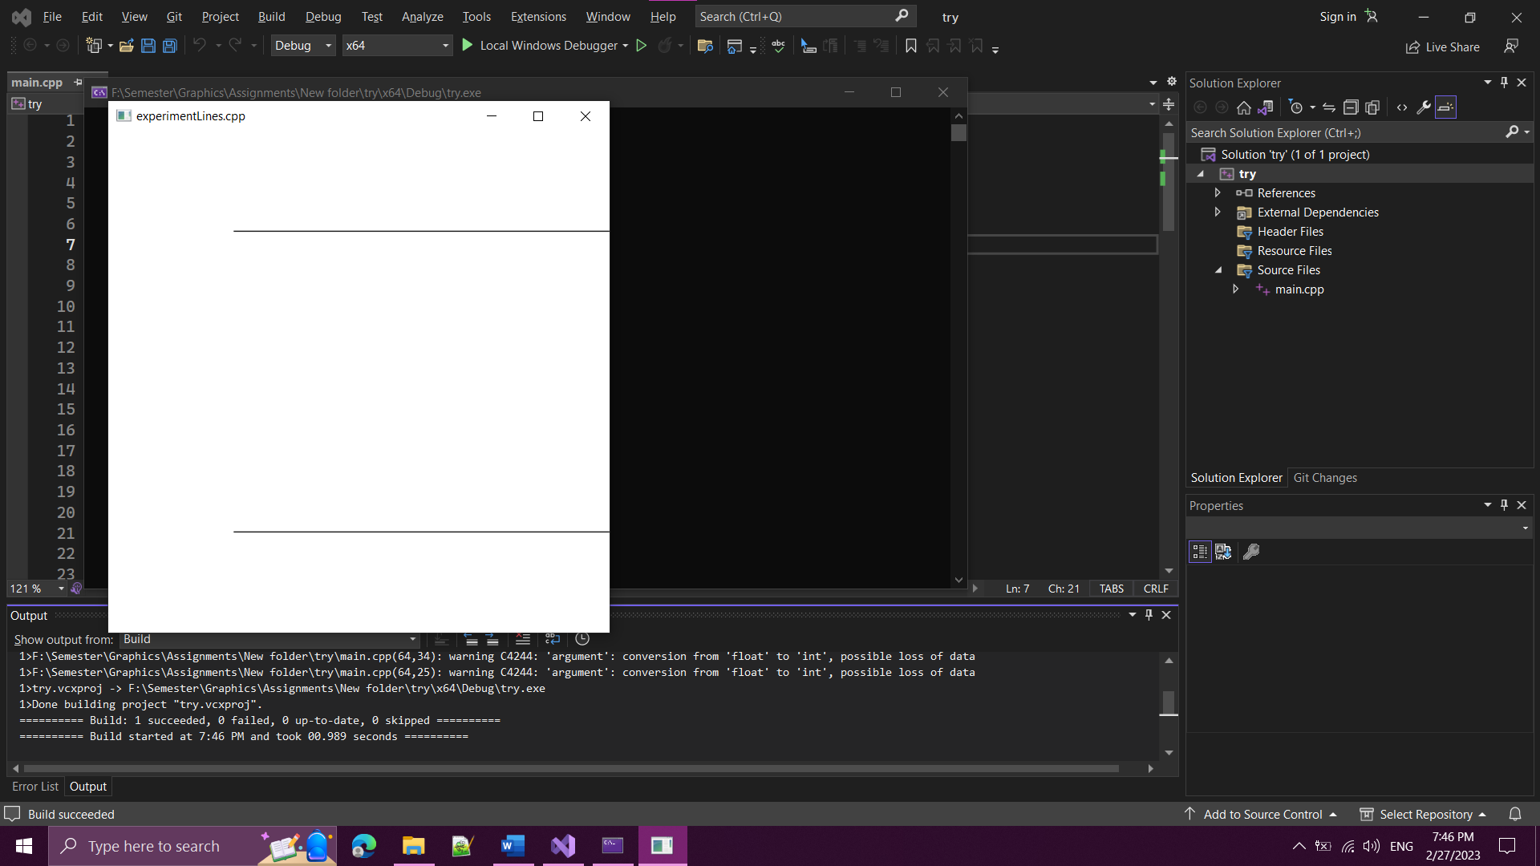

orthoRight = 100

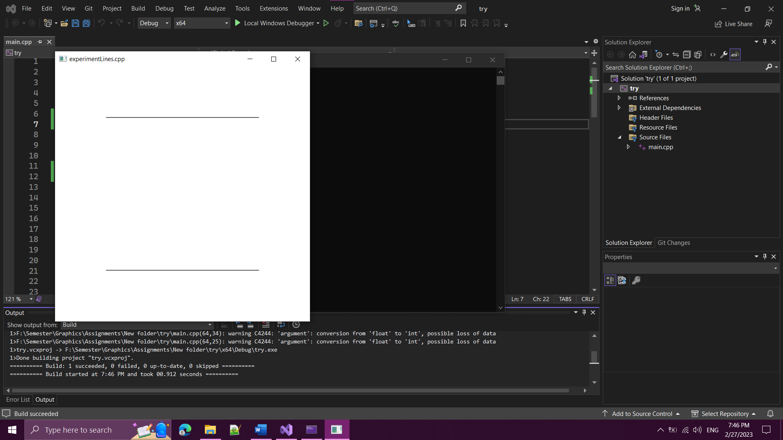

* orthoBottom

As we increase orthoBottom, the two lines move down.

orthoBottom = 0

orthoBottom = 19

* orthoTop

As we increase orthoTop, the two lines move down.

orthoTop = 81

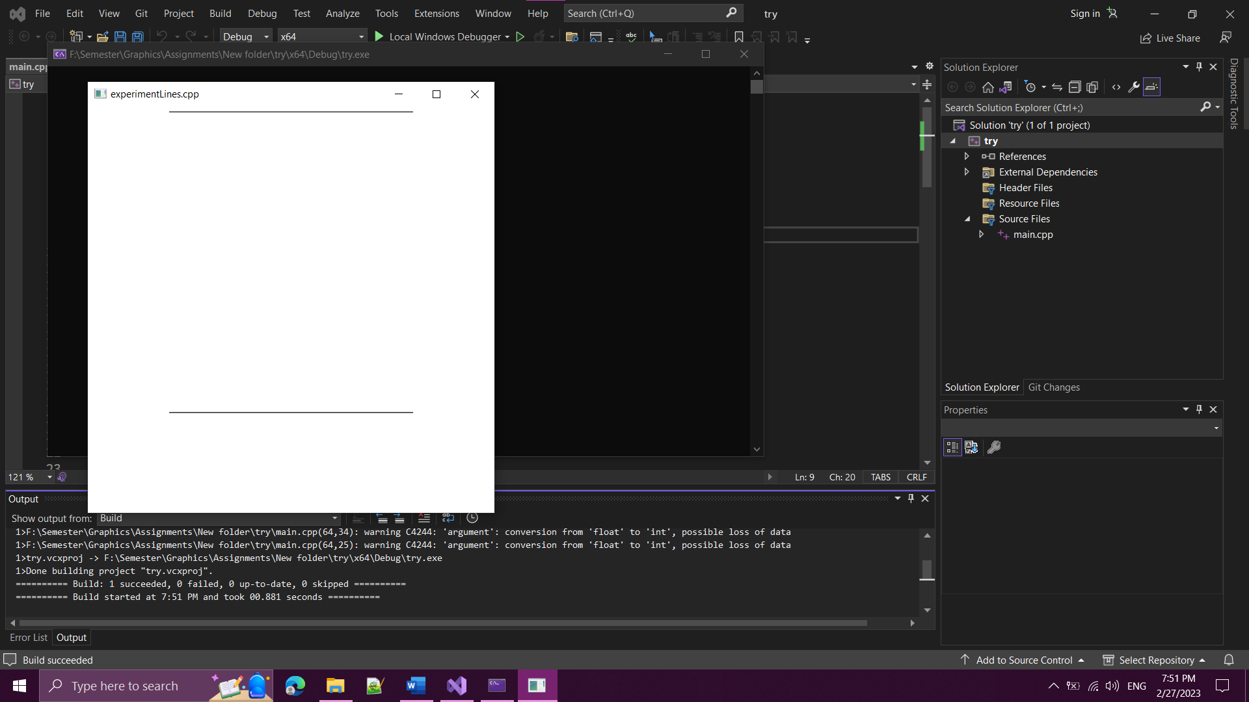

orthoTop = 100

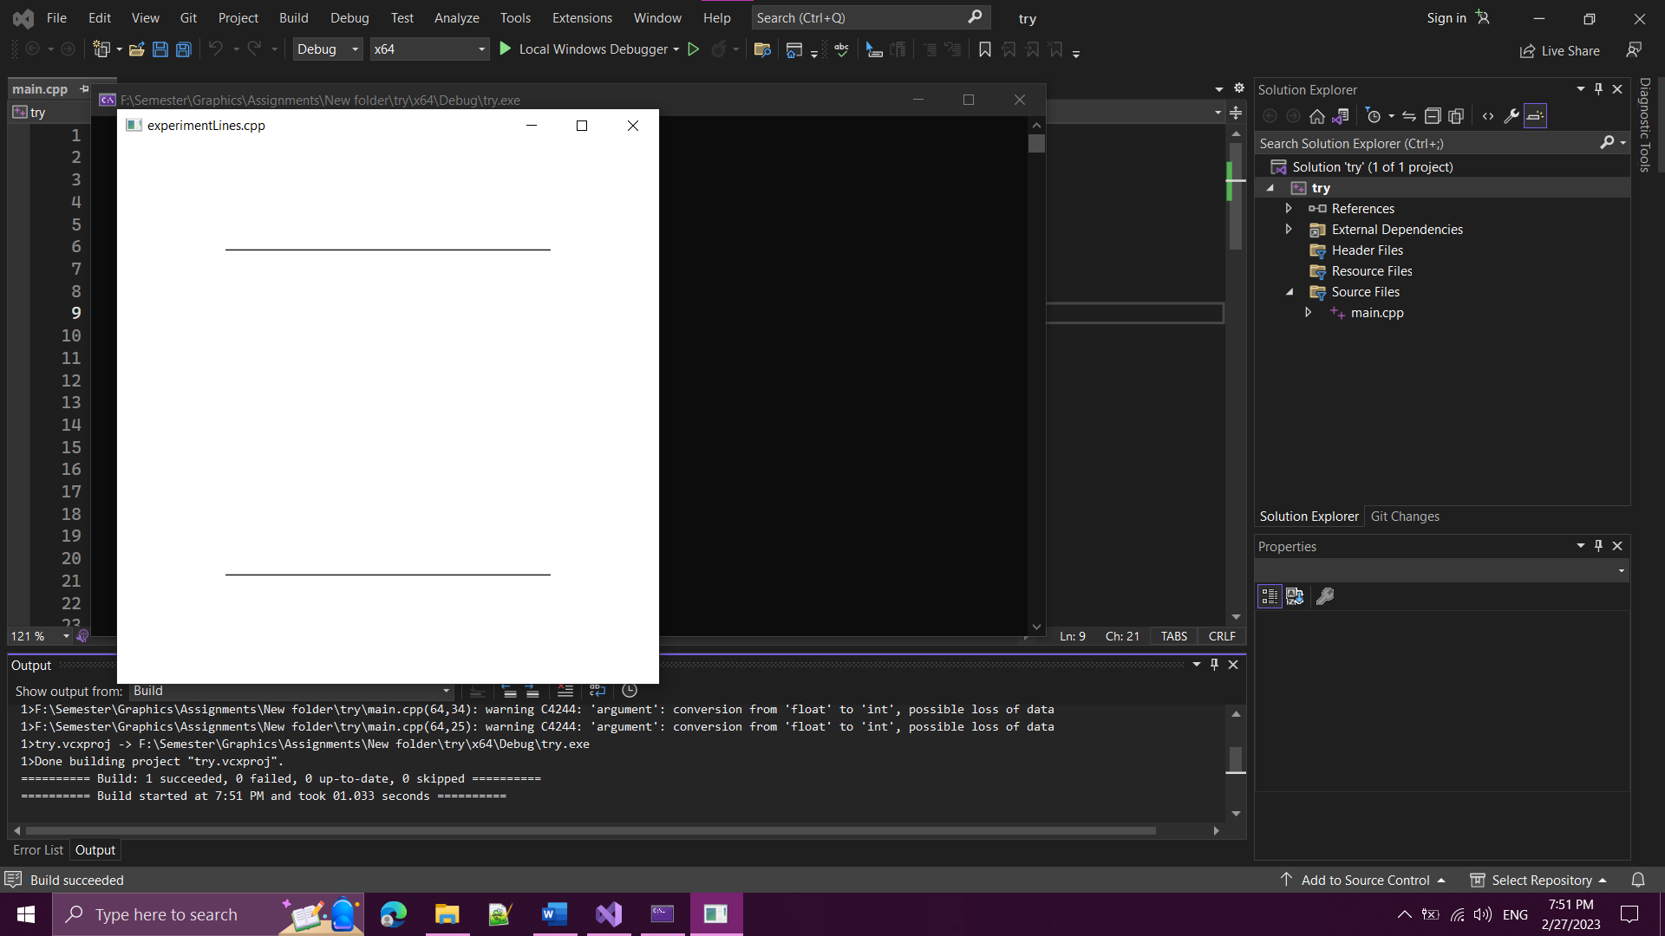

* orthoNear

when orthoNear is positive, the two lines disappear.

orthoNear = -1

orthoNear = 1

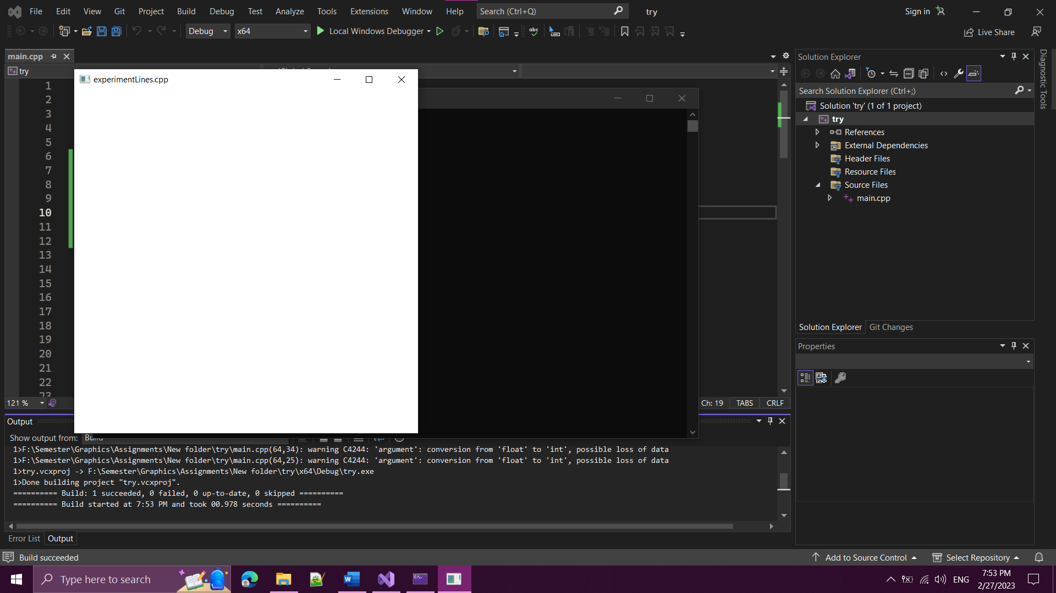

* orthoFar

when orthoFar is negative, the two lines disappear.

orthoFar = -1

orthoFar = 1

* offsetX

As we increase offsetX, the window of the draws moves right.

offsetX = 100

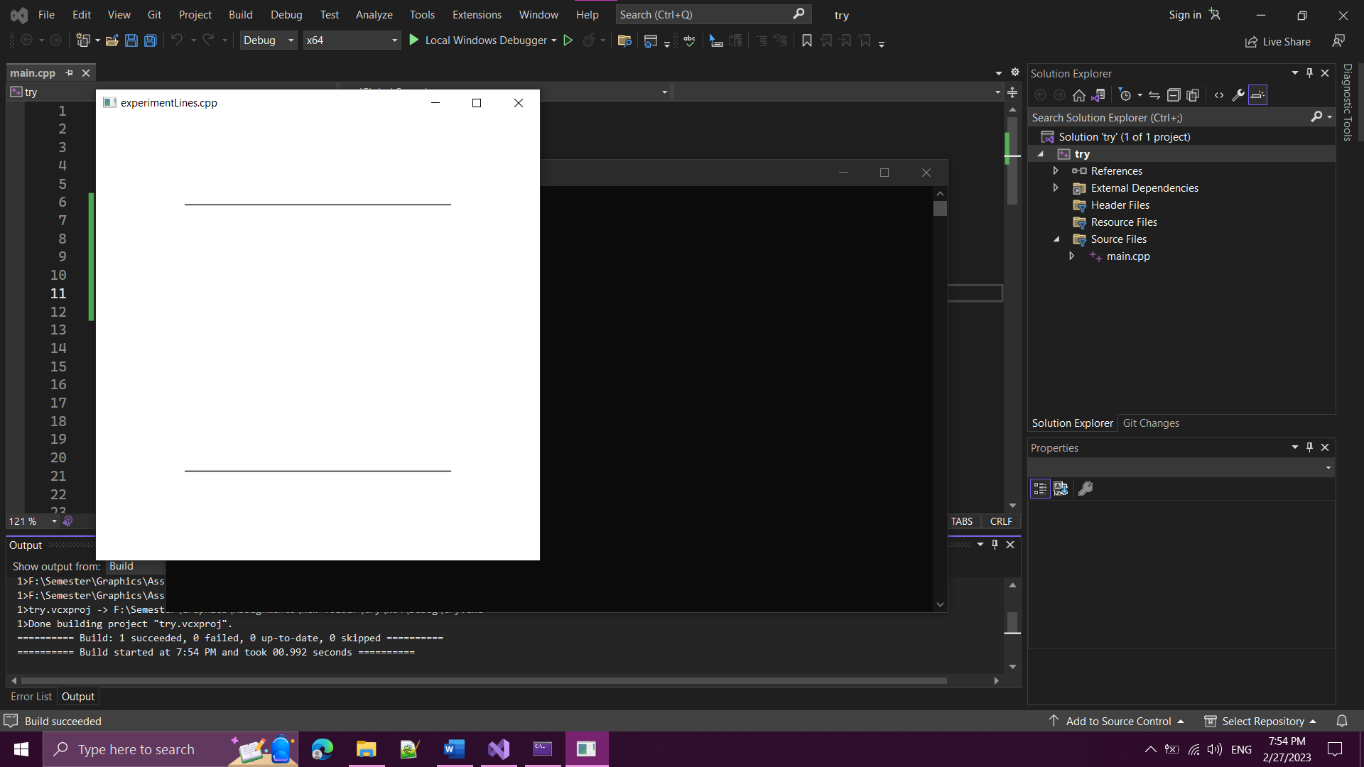

offsetX = 500

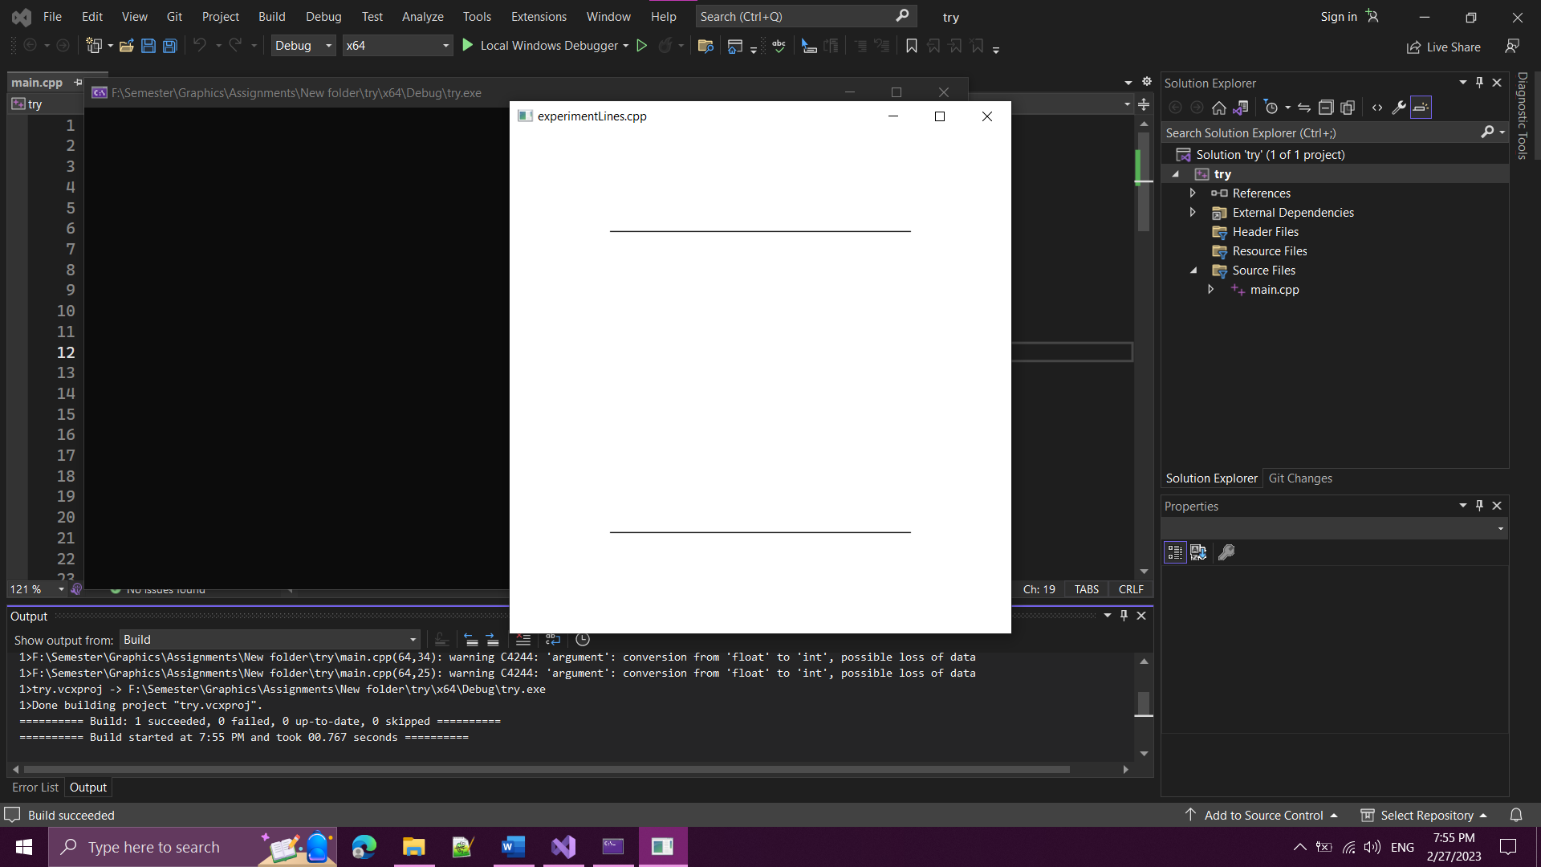

* offsetY

As we increase offsetY, the window of the draws moves down.

offsetY = 100

offsetY = 290

* windowWidth

As we increase windowWidth, the width of the window of the draws increases.

windowWidth = 500

windowWidth = 1000

* windowHeight

As we increase windowWidth, the height of the window of the drawings increases.

windowHeight = 500

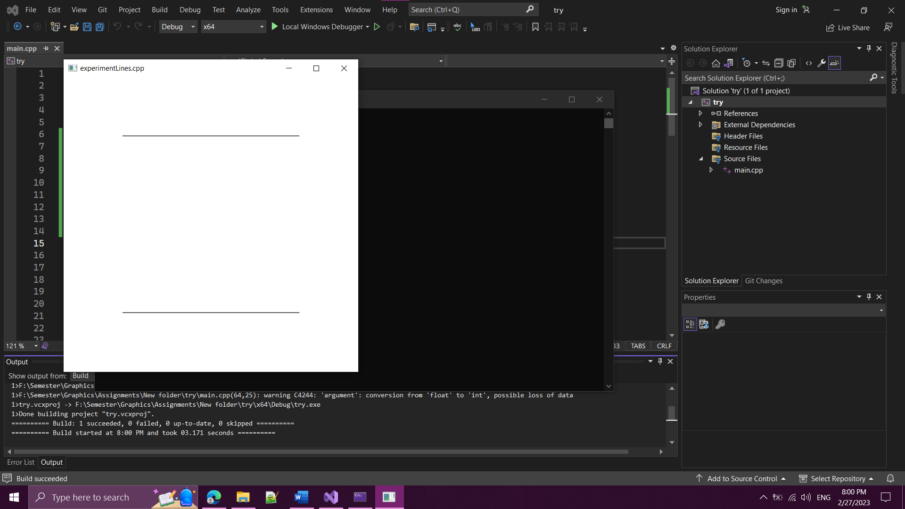

windowHeight = 650

* Deduction:

The origin (0, 0) is located at the top-left corner, with x-axis pointing right and y-axis pointing down. The Coordinate System is the Right-Hand Coordinate System (RHS): the x-axis is pointing right, y-axis is pointing up, and z-axis is pointing out of the screen.

* Resources:

[3D Graphics with OpenGL - The Basic Theory (ntu.edu.sg)](https://www3.ntu.edu.sg/home/ehchua/programming/opengl/CG_BasicsTheory.html)