1. Using vi write your CV in the file mycv. Your CV should include your name, age, school, college, experience,..

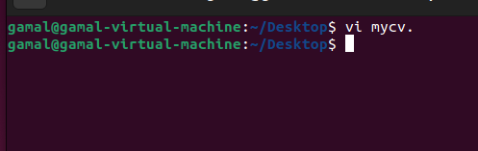

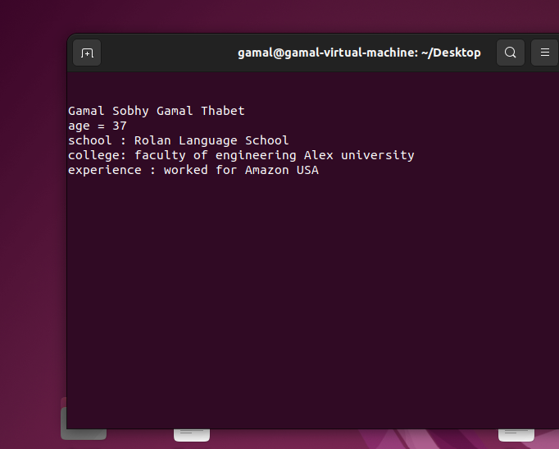

2. Open mycv file using vi command then: Without using arrows state how to:

a. Move the cursor down one line at time.

by using “o”

b. Move the cursor up one line at time.

by using “O”

c. Search for word age

by using “/age”

d. Step to line 5 (assuming that you are in line 1 and file is more than 5 lines).

by using “5G”

e. Delete the line you are on and line 5.

by using “DD ,5d”

f. How to step to the end of line and change to writing mode in one-step.

by using “e”

3. List the available shells in your system.

**Global initilization files**

*/etc/profile*

**Intilization files**

*~/.profile*

*/etc/bash.bashrc*

*~/.bash_profile or ~/.bash_login*

**startup files**

*~/.bashrc*

4. List the environment variables in your current shell.

$HOME

$path

$PWD

$SHELL

$USER

$HOSTNAME

5. List all of the environment variables for the bash shell.

USE THE COMMAND

MAN BASH

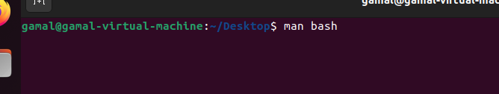

/shell variables

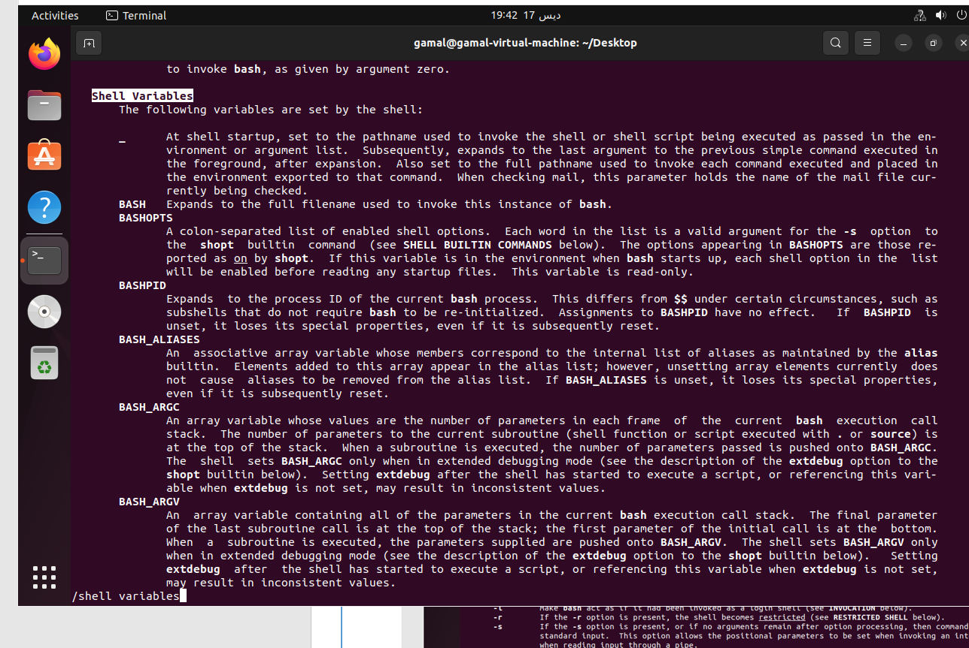

6-What are the commands that list the value of a specific variable?

1-set

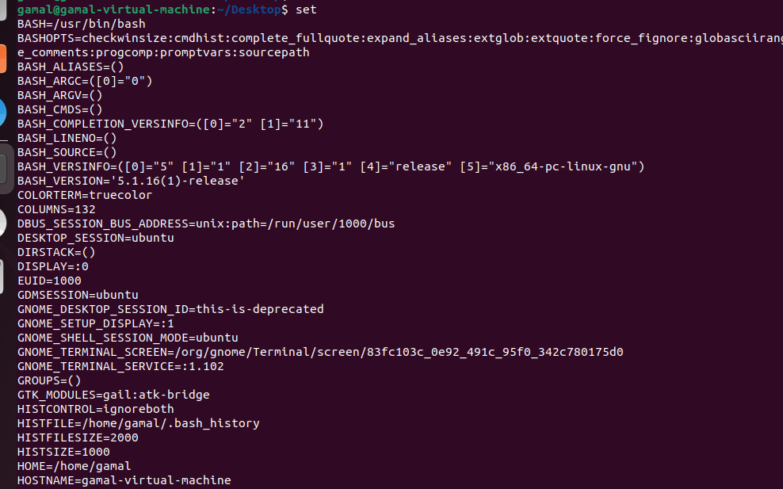

2-env

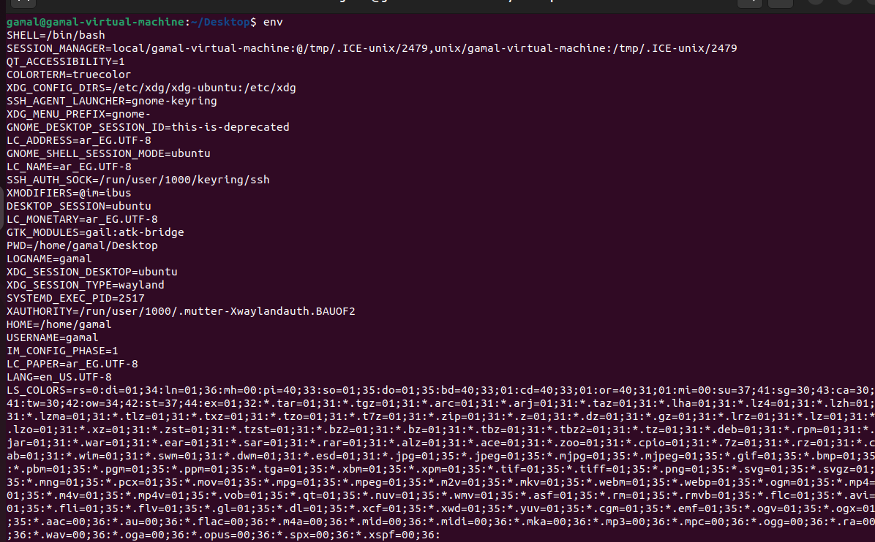

7. Display your current shell name

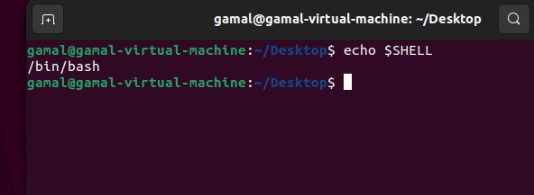

8. State the initialization files of: sh, ksh, bash.

by searching on goggle we ‘ll find the following :

|  |  |  |  |  |  |  |  |  |  |  |  |  |  |  |  |  |  |  |  |  |  |  |
| --- | --- | --- | --- | --- | --- | --- | --- | --- | --- | --- | --- | --- | --- | --- | --- | --- | --- | --- | --- | --- | --- | --- |
| **C Shell Initialization Files**  **C shell****initialization files run in a particular sequence after the user logs in to the system. For the C shell, initialization files are run in the following sequence:**   |  |  | | --- | --- | | **1.** | **Commands in /etc/.login are executed.** | | **2.** | **Commands****from the $HOME/.cshrc file (located in the user's home directory) are executed. In addition, each time the user starts a new shell or opens a new window in the CDE, commands from $HOME/.cshrc are run.** | | **3.** | **The shell executes commands from the $HOME/.login file (located in the user's home directory). Typically, the $HOME/.login file contains commands to specify the terminal type and****environment.** | | **4.** | **When startup processing is complete, the C shell begins reading commands from the default input device, the terminal.** |   **Although it****is not part of the initialization of the shell, when the C shell terminates, it performs commands from the $HOME/.logout file (if that file exists in the****home directory).**  **Bourne Shell Initialization Files**  **Bourne****shell initialization files run in a particular sequence after the user logs in to the system. For the Bourne shell, initialization files are run in the following sequence:**   |  |  | | --- | --- | | **1.** | **Commands in /etc/profile are executed.** | | **2.** | **Commands****from the $HOME/.profile file (located in the user's home directory) are executed. Typically, the $HOME/.profile file contains commands to specify the terminal type and environment.** | | **3.** | **When startup processing is complete, the Bourne shell begins reading commands from the default input device, the****terminal.** |   **Korn Shell Initialization Files**  **Korn shell****initialization files run in a particular sequence after the user logs in to the system. For the Korn shell, initialization files are run in the following sequence:**   |  |  | | --- | --- | | **1.** | **Commands in /etc/profile are executed.** | | **2.** | **Commands****from the $HOME/.profile file (located in the user's home directory) are executed. Typically, the $HOME/.profile file contains commands to specify the terminal type and environment.** | | **3.** | **If the $HOME/.kshrc file is present, commands located in this file are executed. In addition, this initialization file gets read (and the commands get executed) every time a new Korn shell is started after login.** | | **4.** | **When startup processing is complete, the Korn shell begins reading commands from the default input device, the****terminal.** | |

9. Edit in your profile to display date at login and change your prompt permanently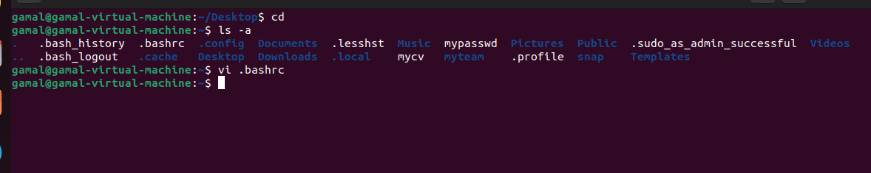

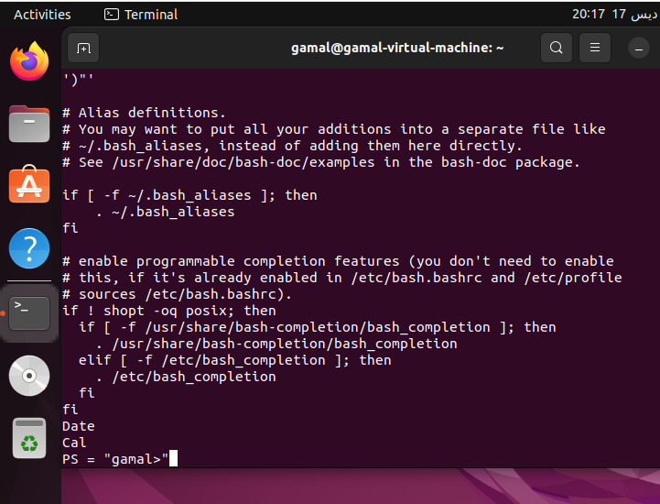

10.Execute the following command : echo \ then press enter

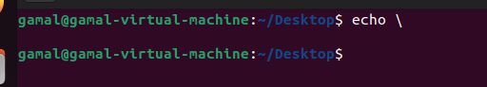

What is the purpose of \ ?

starting new line

Notice the prompt ”>” what is that?

That's indicating that whatever command you typed wasn't complete, and it's still waiting for you to type the rest of it.

and how can you change it from “>” to “:”

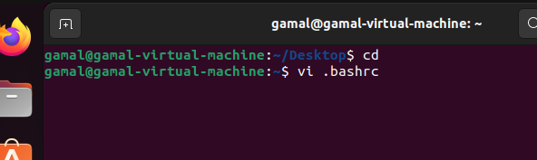

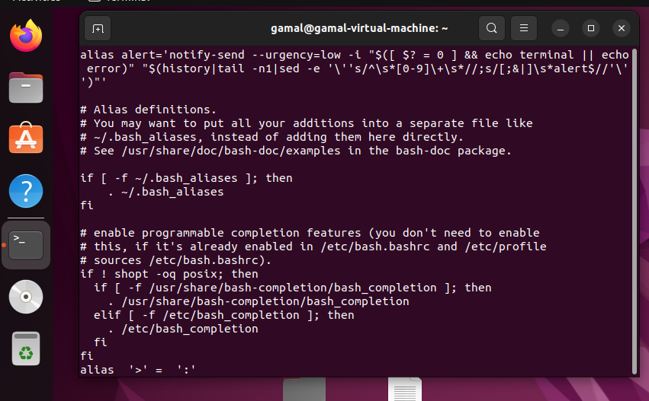

11.Create a Bash shell alias named ls for the “ls –l” command

