**Mintops Api Documentation**

**API Documentation**

**Introduction**

Welcome to the API documentation for our project. This document serves as the central resource for understanding the APIs provided by this workspace. Whether you are a new team member or an existing developer, this guide will help you navigate our API ecosystem efficiently.

**Authentication**

**Endpoints:**

* **POST /register**: Register a new user.
* **POST /login**: Authenticate and log in a user.
* **POST /logout**: Log out the current user session.

**Category Management**

**Endpoints:**

* **GET /categories**: Retrieve the list of available categories.
* **GET /categories/{id}**: Show details of a specific category.
* **GET /categories/last-visited**: Retrieve the last visited categories.

**Task Management**

**Endpoints:**

* **POST /tasks**: Create a new task.
* **GET /tasks**: Retrieve all tasks.
* **PUT /tasks/{id}**: Edit an existing task.
* **DELETE /tasks/{id}**: Delete a task.
* **PATCH /tasks/{id}/restore**: Restore a deleted task.
* **GET /tasks/{id}**: Show details of a specific task.
* **GET /tasks/deleted**: Retrieve deleted tasks.

**Team Management**

**Endpoints:**

* **POST /teams**: Create a new team.
* **POST /teams/{id}/members**: Add a member to a team.
* **GET /teams/{id}/members/{memberId}**: Remove a member from a team.
* **DELETE /teams/{id}**: Delete a team.
* **GET /teams**: Retrieve all teams.
* **GET /teams/{id}/members**: Get members of a specific team.

**User Management**

* **GET /users**: Retrieve all users.

**Environments**

This workspace is set up with various environments to manage API keys, tokens, and base URLs. Use the appropriate environment for development, staging, or production.

**Help and Support**

For any issues or further assistance, please contact the API development team.

**Authentication**

* **POST /register**: Register a new user.

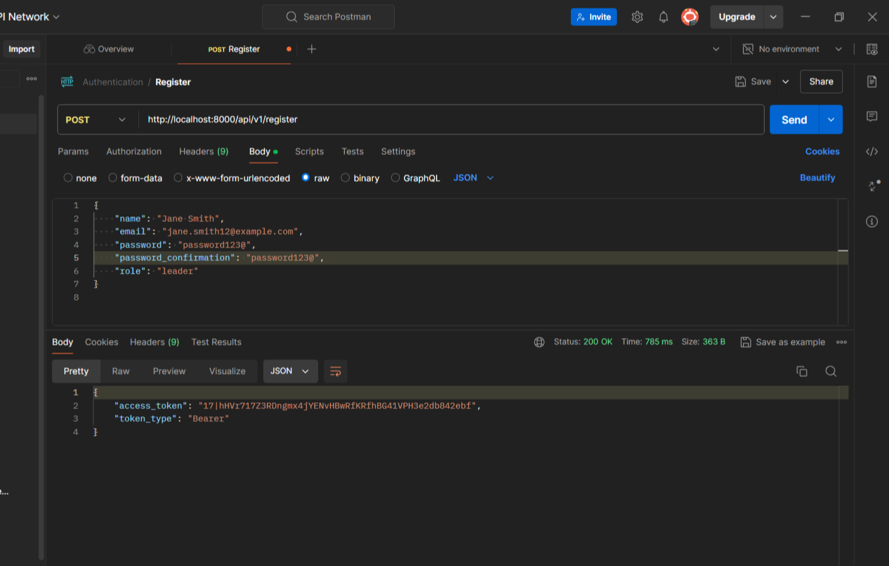

* **POST /login**: Authenticate and log in a user.

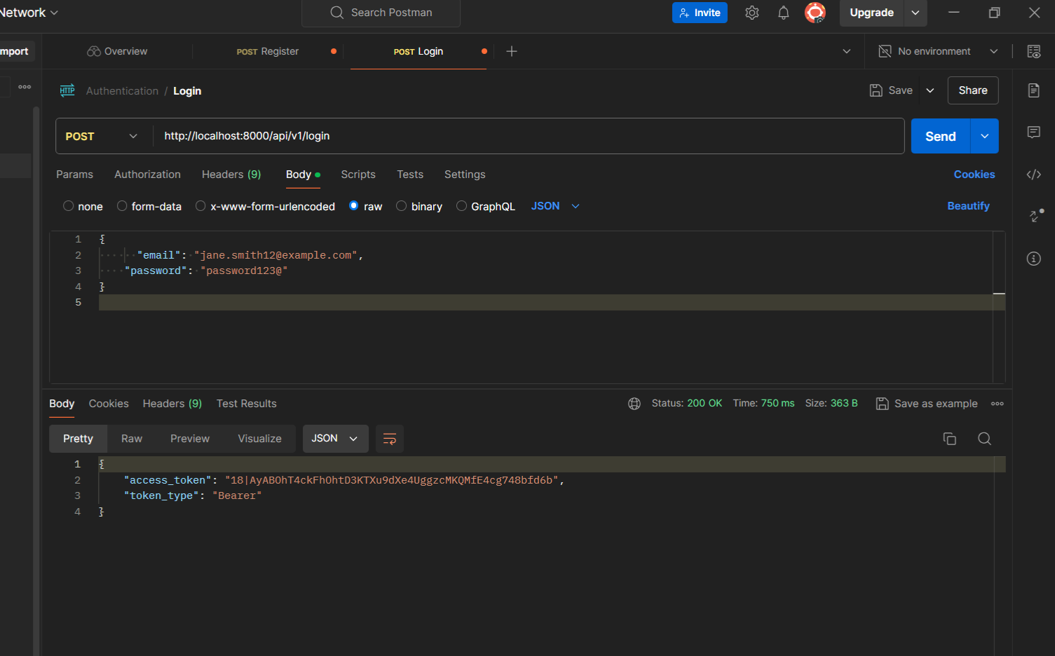

All the upcoming requests should be attached with the authorization token

* **POST /logout**: Log out the current user session.

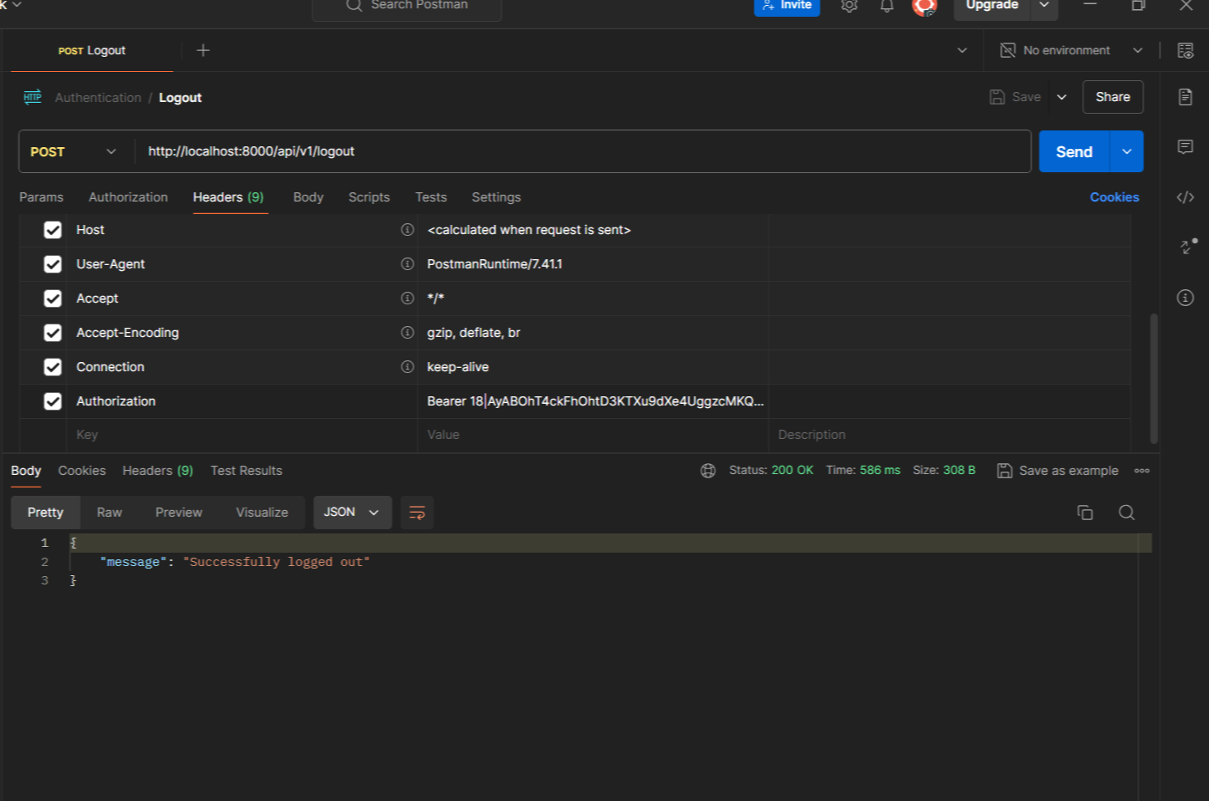

**Category Management**

* **GET /categories**: Retrieve the list of available categories.

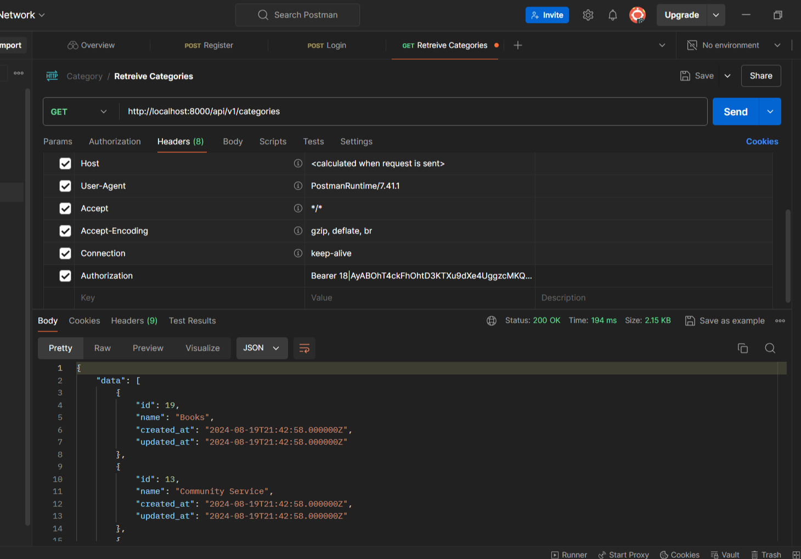

* **GET /categories/{id}**: Show details of a specific category.

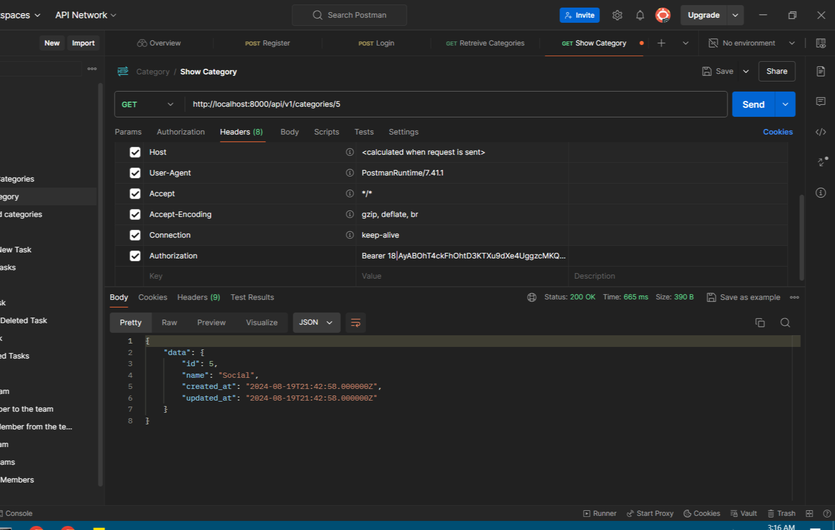

* **GET /categories/last-visited**: Retrieve the last visited categories.

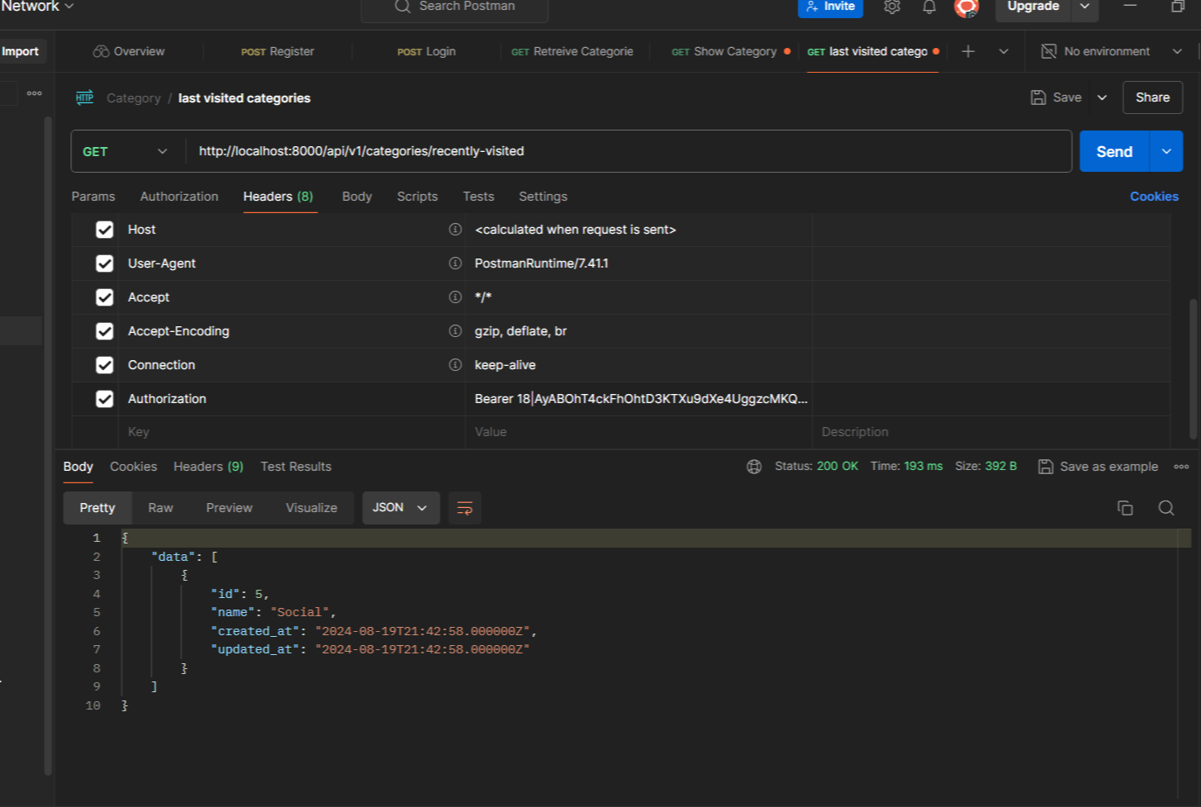

**Team Management**

**Endpoints:**

* **POST /teams**: Create a new team.

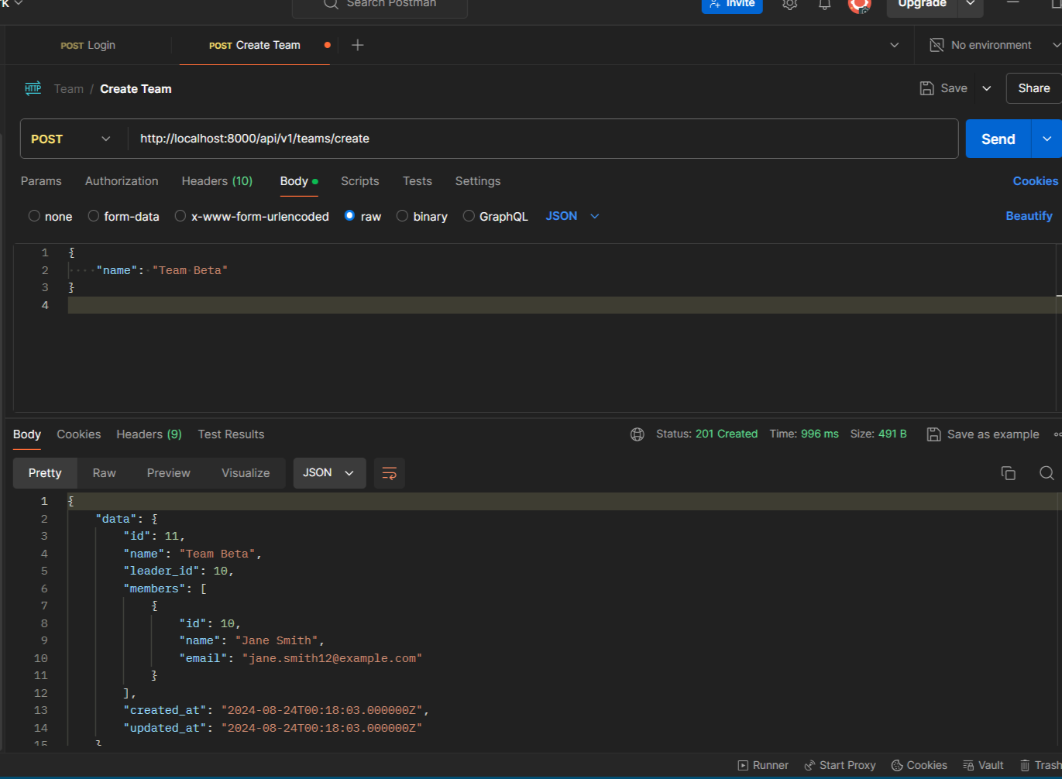

* **POST /teams/{id}/members**: Add a member to a team.

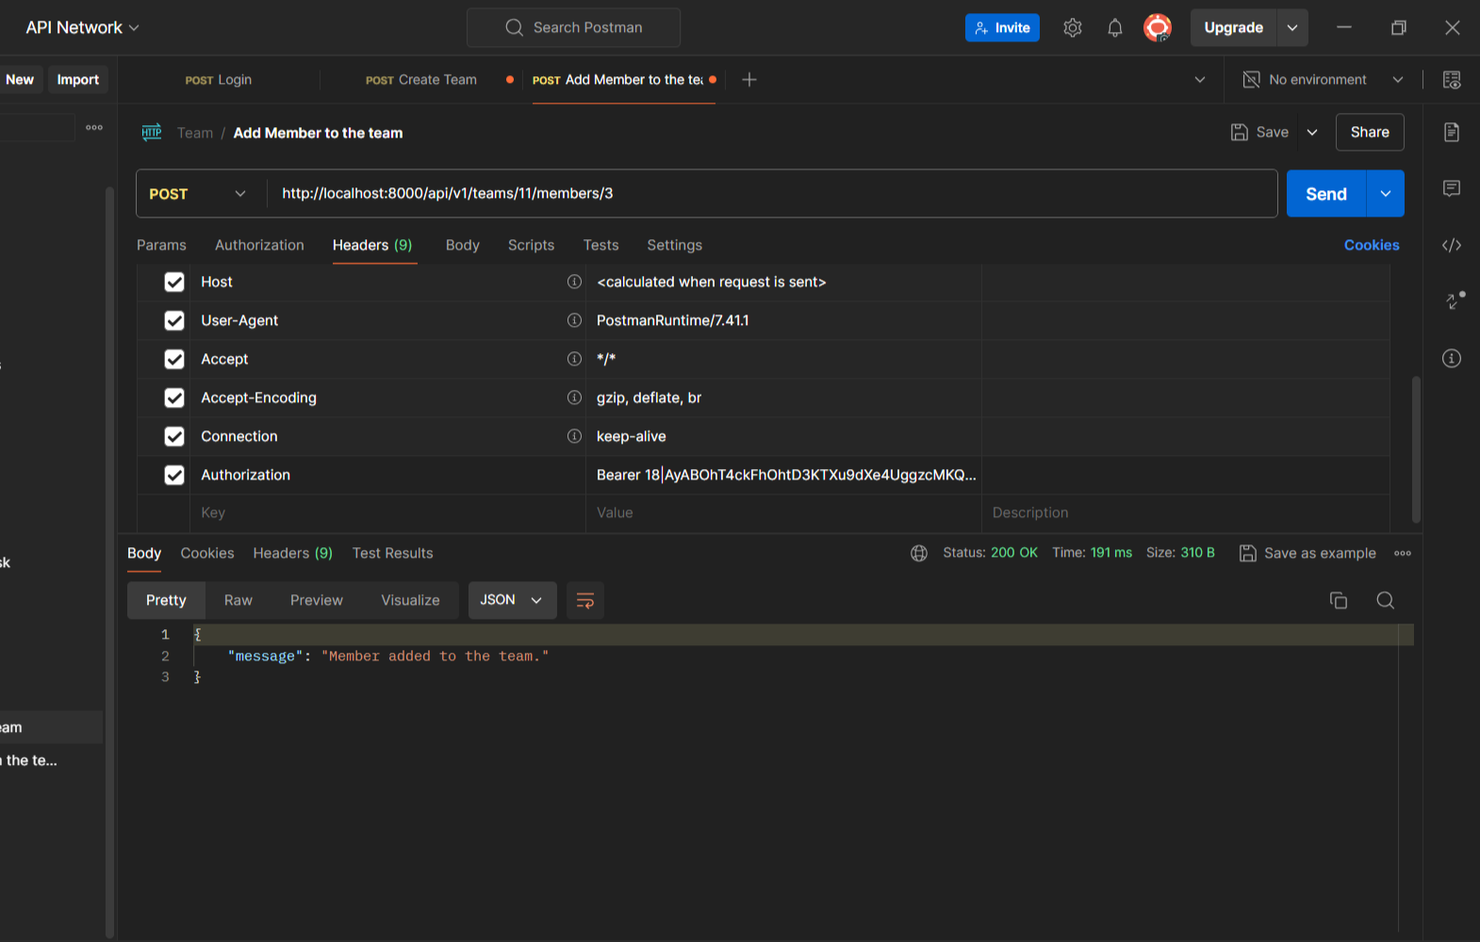

* **GET /teams/{id}/members/{memberId}**: Remove a member from a team.

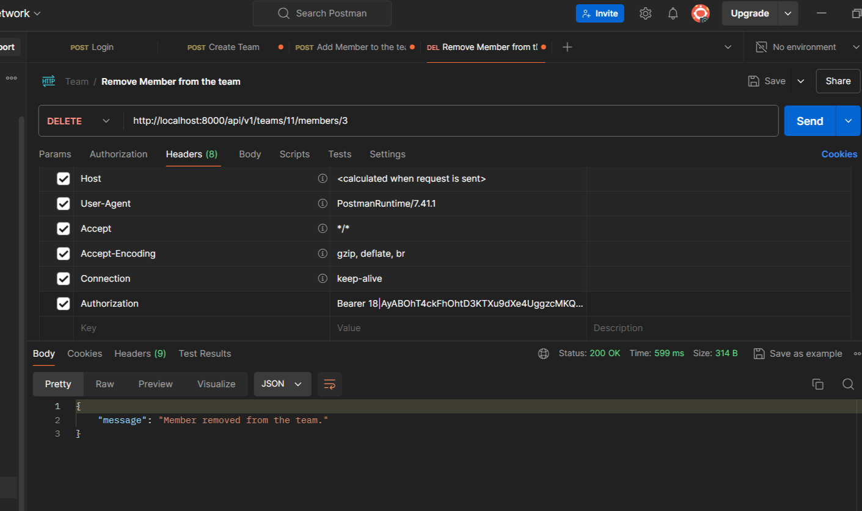

* **GET /teams**: Retrieve all teams.

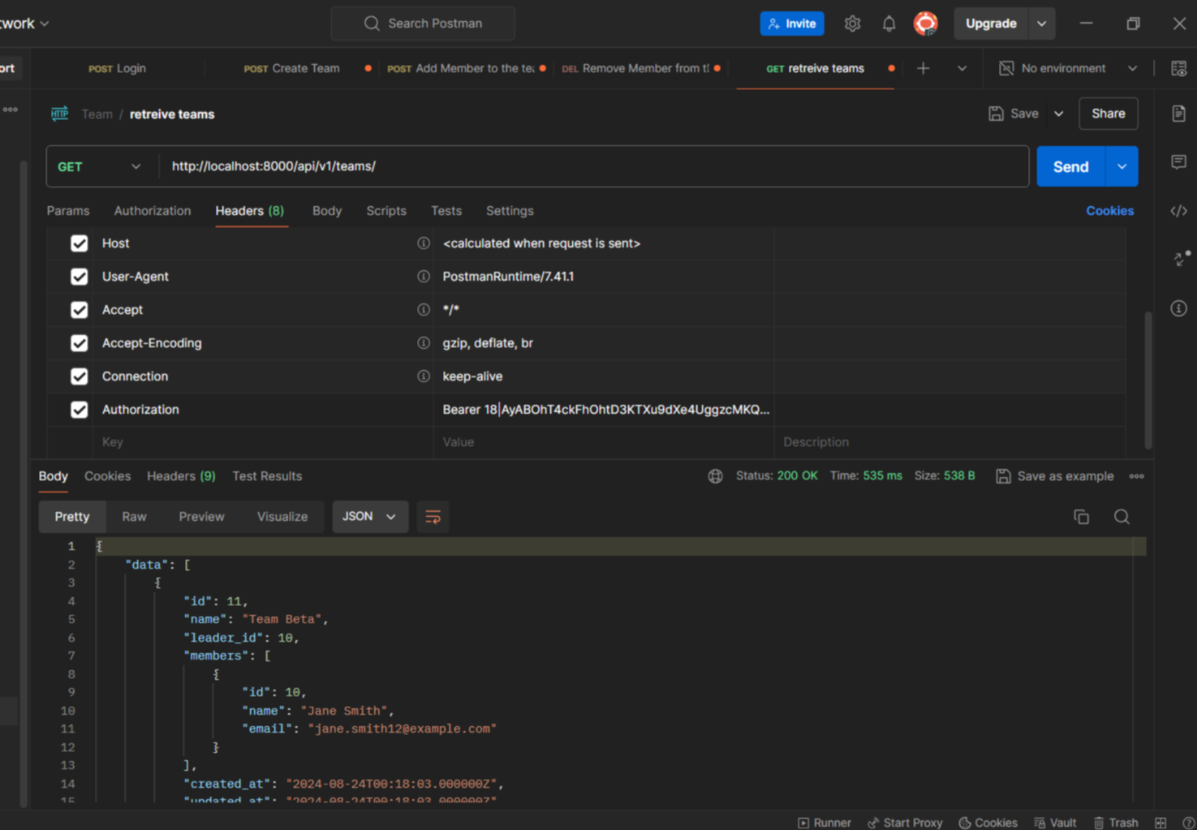

* **GET /teams/{id}/members**: Get members of a specific team.

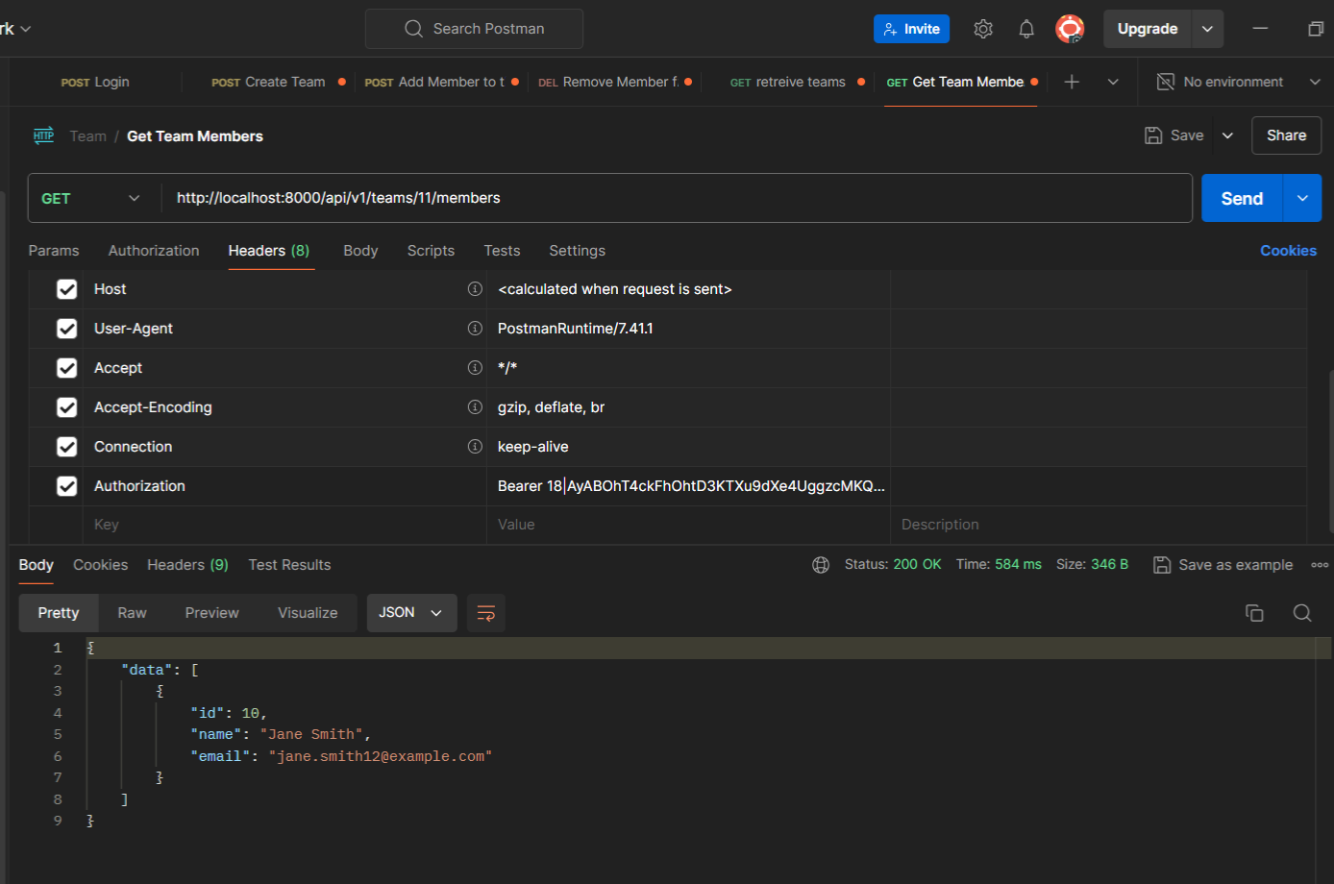

**User Management**

* **GET /users**: Retrieve all users.

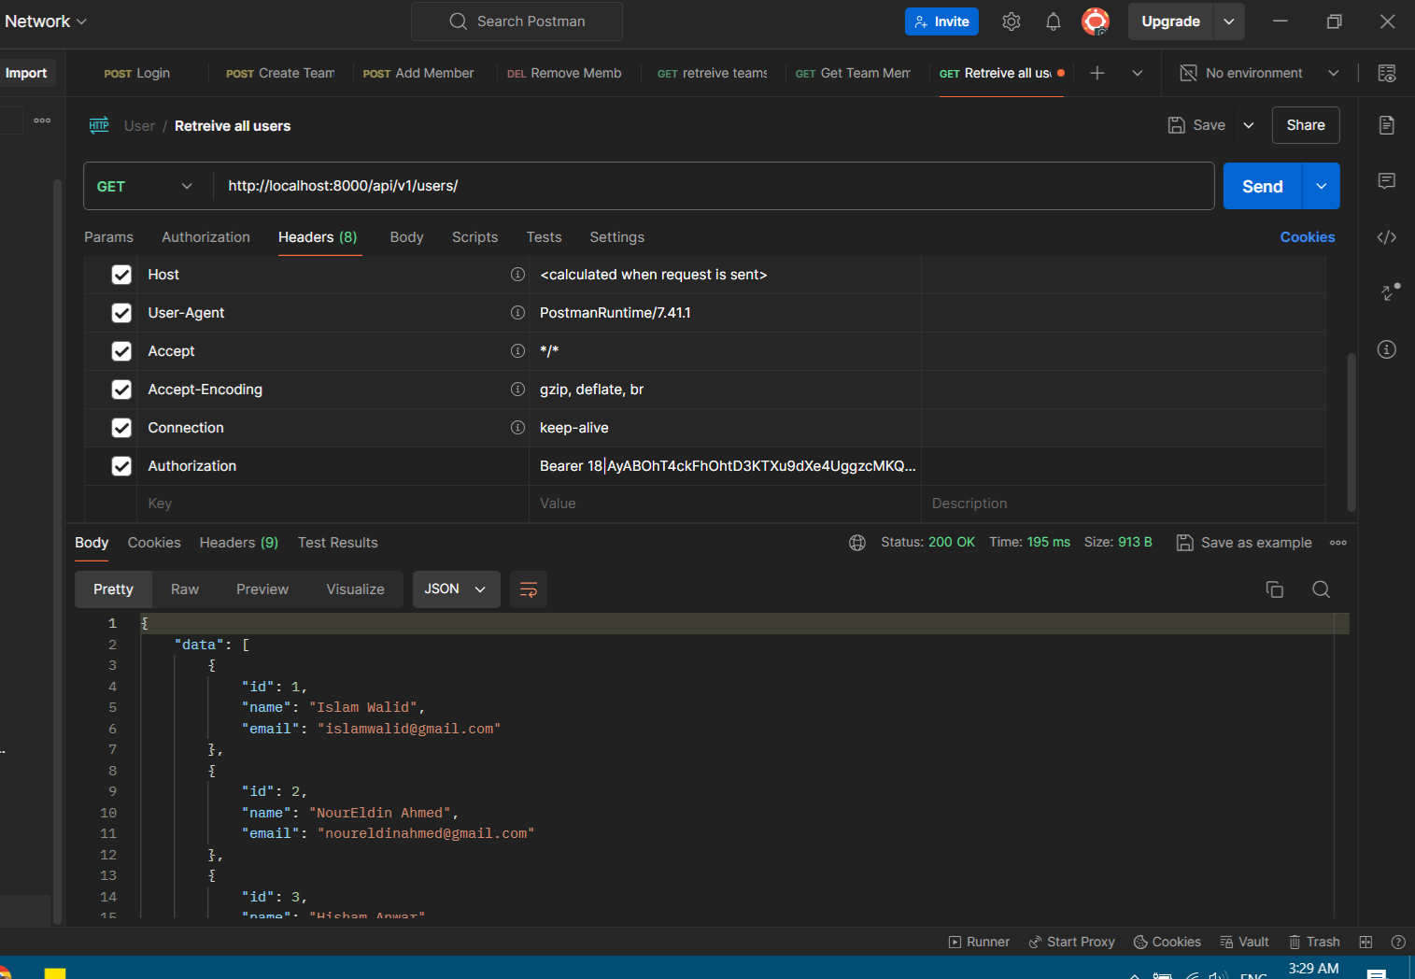

**Task Management**

**Endpoints:**

* **POST /tasks**: Create a new task.

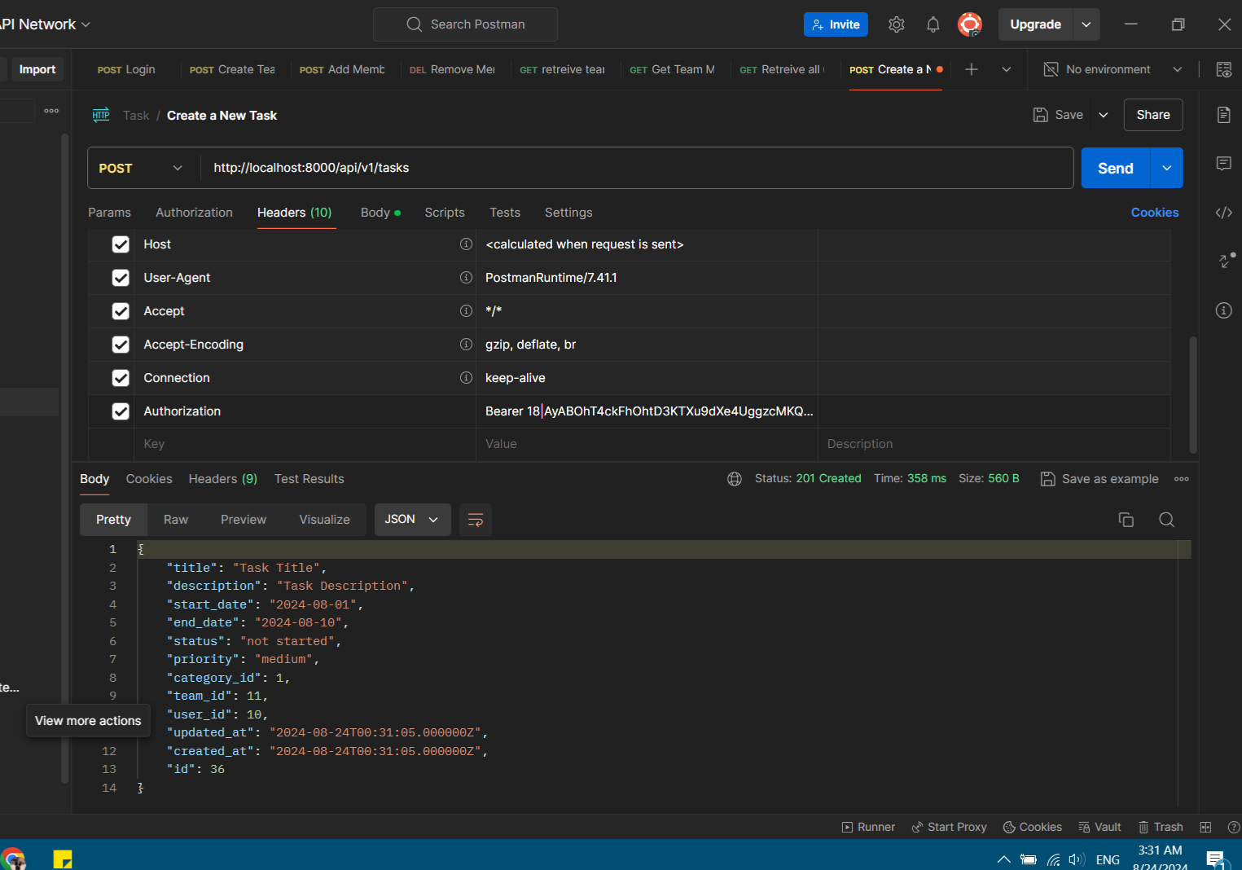

* **GET /tasks**: Retrieve all tasks.

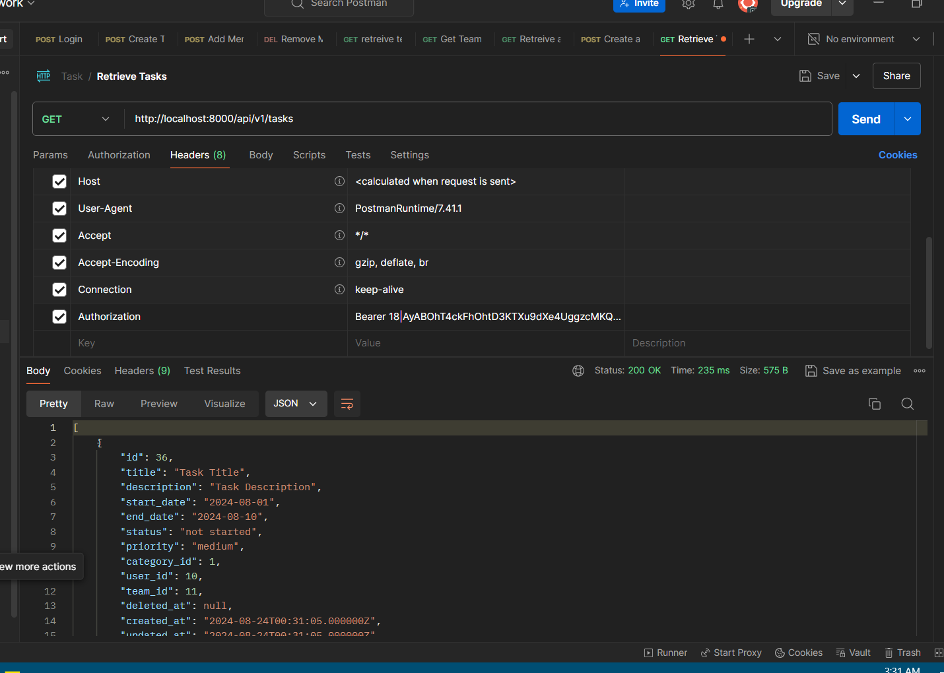

* **PUT /tasks/{id}**: Edit an existing task.

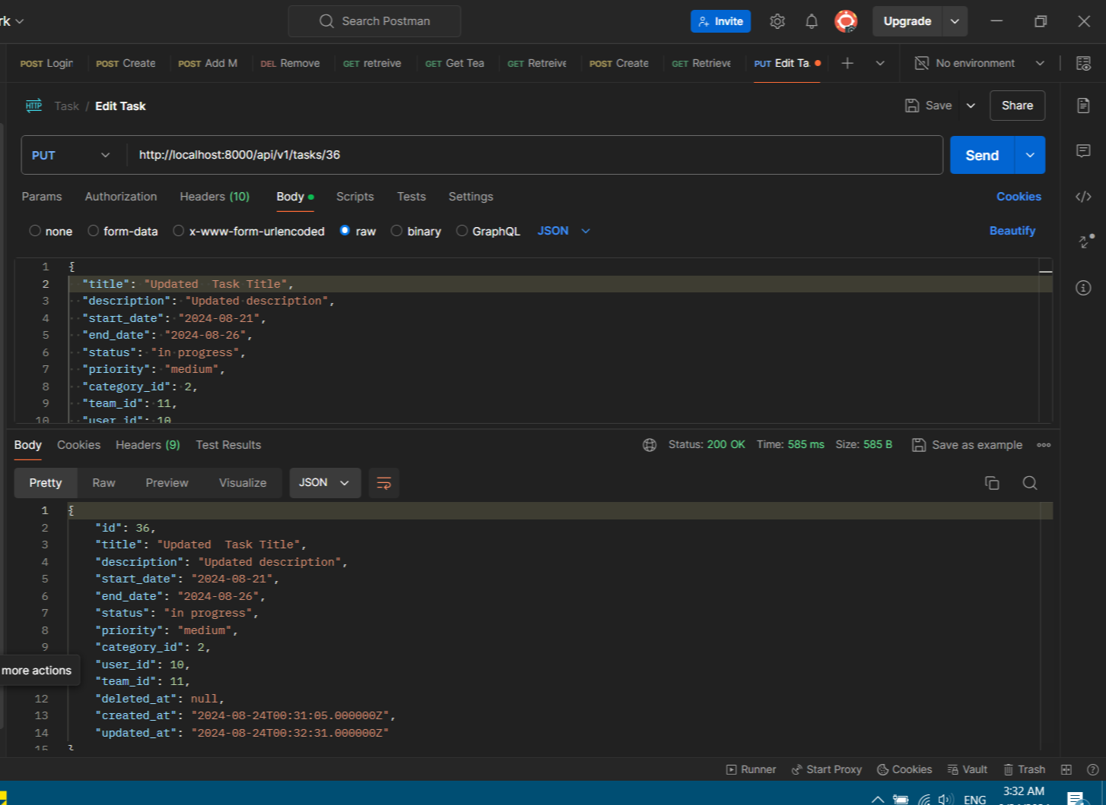

* **DELETE /tasks/{id}**: Delete a task.

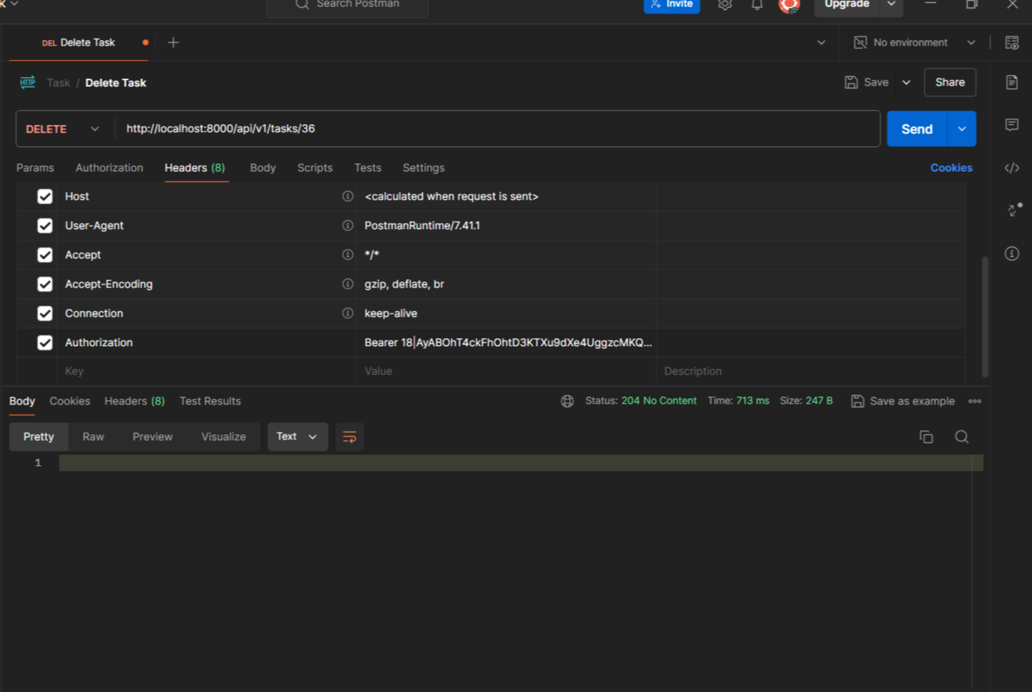

* **PATCH /tasks/{id}/restore**: Restore a deleted task.

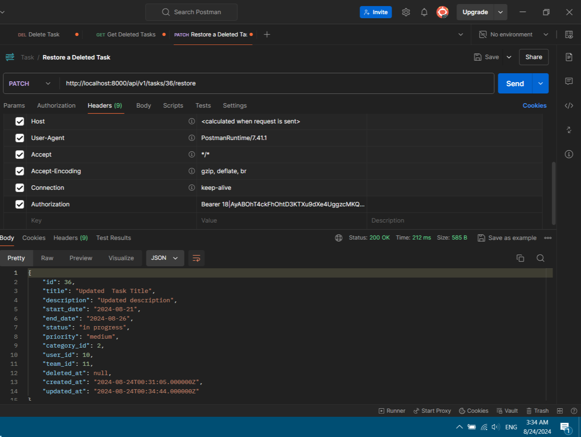

* **GET /tasks/{id}**: Show details of a specific task.

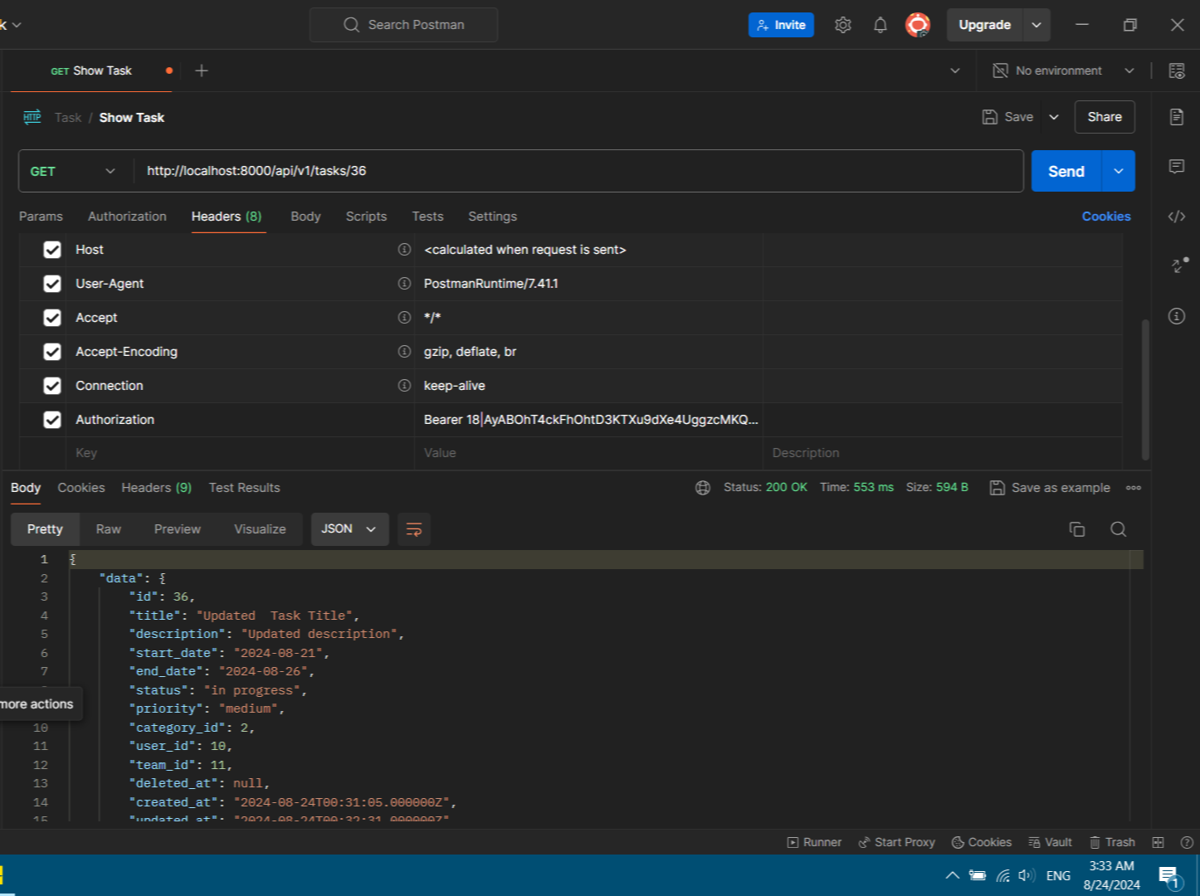

* **GET /tasks/deleted**: Retrieve deleted tasks.

