COS10007 Developing Technical Software Semester 2 2018

Assignment 2 report

Name: Gamaliel D’mello Student ID:102117407

Lab group: Monday 3:30 – 5:30 Tutor: Srikanth Thudumu

Due Date: Sunday 16th December 2018 at 11:59 pm

Date Submitted: Sunday 19th December 2018 at 11:59 am

Question: 1

Program description

the aim of the program is to encode and decode numbers using specific
Remove the grey text and insert your content.
algorithms

Inputs and Outputs
The inputs and outputs for this program are described in Table 1.

Table 1. Data dictionary:
Data to be stored | Sample data | Type of data | C++ type | Input method | In /  Out | Variable name
num | 10 | Integer | Int | Scanf | Printf | Ans

3. Algorithm
Program steps:
  - Prompt for input
  - Enter the number
  - Check range – if too small or too big return to a.
  - Between 10 and 99 swap first and second
  - Between 100 and 999 swap first and last
  - Between 1000+ the digit + 1 divide by 10 increminting 1 for every unit place

Coding logic:
The equation and constants go here

Decoding logic:

You then can represent algorithm as pseudocode or flowchart.

Source code:

#include <stdio.h>
#include <math.h>

int main()
{

int ans;
printf("input a value ");
scanf("%d", &ans);

int count, i = 0;

while(ans != 0)
{
ans /= 10;
++count;
printf("%d", count);
}

if (ans <= 10)
{
printf("Invalid input Please Re-nter");
}
else
if ((ans >=10) && (ans <=100))
{
printf("12");

int D1, D2, SN, count;
D1 = ans/10;
D2 = ans %10;

printf ("%d%d", D2,D1);
}
else
if ((ans >=100) && (ans <=999))
{
printf("13");
int LD, FD, SN, count, temp;

temp = ans;
LD = temp % 10;
count = (int)log10(temp);

while(temp>=10)
{
temp /= 10;
}
FD = temp;
SN = (LD * pow(10, count) + FD) + (ans - (FD * pow(10, count) + LD));
printf("%d is swapped to %d\n", ans, SN);
}
else
if (ans >999)
{
printf("1");

printf("2");

int d[count];
while(ans > 0)
{
d[i]= ans % 10 ;
ans /= 10 ;
++i;
d[i] = (d[i]+ count+1)/10;
}
printf("3");

while (i<0)
{
printf("%d", d[i]);
--i;

}
printf("4");

}

else
if(count = 8)
{
int d[8], i, temp;
while(i < 8)
{
d[i]= ans % 10;
ans /= 10;
++i;

}

temp = d[1];
d[1]= d[8];
d[8] = temp;

temp = d[2];
d[2]= d[7];
d[7] = temp;

temp = d[3];
d[3]= d[6];
d[6] = temp;

temp = d[4];
d[4]= d[5];
d[5] = temp;

while (i<0)
{
printf("%d", d[i]);
--i;

}

temp = d[1];
d[1]= d[8];
d[8] = temp;

temp = d[2];
d[2]= d[7];
d[7] = temp;

temp = d[3];
d[3]= d[6];
d[6] = temp;

temp = d[4];
d[4]= d[5];
d[5] = temp;

while (i<0)
{
printf("%d", d[i]);
--i;

}

}

Screenshots showing working program (Show all possible outcome):

Paste in views of your program running in a msys, Mac or Linux command window
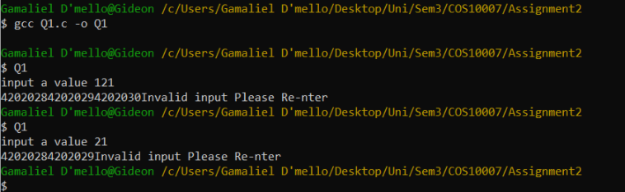

Question 2:

Program description

A fun game like program that gives users random questions and
Remove the grey text and insert your content.
Provides feedback to the question

Inputs and Outputs
The inputs and outputs for this program are described in Table 1.

Table 1. Data dictionary:
Data to be stored | Sample data | Type of data | C++ type | Input method | In /  Out | Variable name
Answer | 7 | Integer | Int | Scanf | Printf | Ans

3. Algorithm
Program steps:
  - Provide two random one didgit number
  - Add the numbers
  - Ask for user input
  - Match the user input to ans
  - If the answer is correct random select one of the feedback options
  - If the answer is correct randomly select one of the engouement feedback options
Coding logic:
The equation and constants go here

Decoding logic:

You then can represent algorithm as pseudocode or flowchart.

Source code:
// Gamaliel D'mello, 102117407, Qn5
#include <stdio.h>
#include <stdlib.h>
#include <time.h>
//Header files
#define EndCode -1
//declaration of constant

int Rand_Num1(int Num1)
{
srand(time(NULL));// sets the seed of the random number generator to the time so that the same reandom numbers wont keep generating
Num1 = (rand() % 10);
return Num1;
}
//generates a random number from 0 -9

int Rand_Num2(int Num2)
{
srand(time(NULL));
Num2 = (rand() % 9)+1;
return Num2;
}// generates a random number from 1-8 and then adds one

int Sum(int Total)
{
int Num1, Num2, Rand1, Rand2;
int Operator, Opt;

Rand1 = Rand_Num1(Num1);
Rand2 = Rand_Num2(Num2);

Total = Rand1 + Rand2;

return Total;
//random generated from operator decides what what Aritmitic operation will be done
//then perfroms the operation on the two random numbers
}

void Question()
{
int Num1, Num2, Rand1, Rand2,Total;
int Operator, Opt;
Rand1 = Rand_Num1(Num1);
Rand2 = Rand_Num2(Num2);

printf("what is %d + %d (-1 to end): ", Rand1, Rand2);
//uses the operator to print out the question

}

int main()
{
int Answer,STotal, Total, Correct,Incorrect, i = 0;

do{

if (i == 0)
{
STotal = Sum(Total);
Question();
scanf("%d" , &Answer);
}
//if the answer is correct print new questions

if (i == 1)
{
printf("it is: ");
fflush(stdin); //clears the buffer of standaed input
scanf("%d" , &Answer);
}
// if answer is incorrect allow users to enter new questions
if (Answer == STotal)
{
srand(time(NULL));
Correct = (rand() % 3);
switch (Correct)
{
case 0:
printf("Very Good!\n\n");
break;

case 1:
printf("Excellent!\n\n");
break;

case 2:
printf("Nice Work!\n\n");
break;

case 3:
printf("Keep up the good work\n\n");
break;
}
i = 0;
//if answer is right randomly selects one statement to print
}
else if ((Answer == EndCode) && (Answer == Total))
{
srand(time(NULL));
Correct = (rand() % 3);
switch (Correct)
{
case 0:
printf("Very Good!\n\n");
break;

case 1:
printf("Excellent!\n\n");
break;

case 2:
printf("Nice Work!\n\n");
break;

case 3:
printf("Keep up the good work\n\n");
break;
default:
printf("Invalid Entry");
break;
}
i = 0;
Answer = 0;
//if answer is right and it is the endcode randomly selects one statement to print
}
else if(Answer == EndCode)
{
printf("Program Has Ended\n\n");
}
//if the endcode is entered and it is not the right answer tells user the program is ending
else
{
srand(time(NULL));
Incorrect = (rand() % 3);
switch (Incorrect)
{
case 0:
printf("No. Please try again\n\n");
break;

case 1:
printf("Wrong Try Once More\n\n");
break;

case 2:
printf("Dont Give up!\n\n");
break;

case 3:
printf("No. Keep Trying\n\n");
break;
default:
printf("Invalid Entry");
break;
}

i = 1;

} //randomly selects statemetnt if answer is wrong

} while (Answer != EndCode); //do this untill -1 is entered

return 0;
}

Screenshots showing working program (Show all possible outcome):

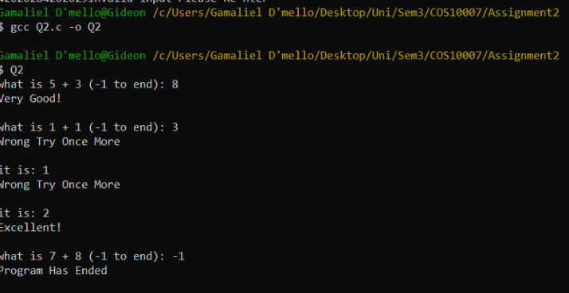

Question 3:

Program description

a program that helps sorts random letters that have been inputed
Remove the grey text and insert your content.

Inputs and Outputs
The inputs and outputs for this program are described in Table 1.

Table 1. Data dictionary:
Data to be stored | Sample data | Type of data | C++ type | Input method | In /  Out | Variable name
Alphabet | Fano | Char | Char | Scanf | Printf | Alpha

3. Algorithm
Program steps:
  - Input letters
  - See if the letters are alphabets
  - See If there are any duplicates
  - Sort using bubble sort the array of letters
Coding logic:
The equation and constants go here

Decoding logic:

You then can represent algorithm as pseudocode or flowchart.

Source code:

#include <stdio.h>
#include <stdlib.h>
#include <string.h>

void swap(char *xp, int *yp)
{
int temp = *xp;
*xp = *yp;
*yp = temp;
}

void bubbleSort(char arr[], int n)
{
int i, j;
for (i = 0; i < n-1; i++)

// Last i elements are already in place
for (j = 0; j < n-i-1; j++)
if (arr[j] > arr[j+1])
swap(&arr[j], &arr[j+1]);
}

int main()
{
char alpha[28], let, results;
int i = 0, a = 0 , freq;

while (i<28)
{
printf("Enter 28 Alphabets");
scanf("%c", alpha[i]);
if( (alpha[i]>='a' && alpha[i]<='z') || (alpha[i]>='A' && alpha[i]<='Z'))
{
while (a<28)
{
results = strcmp((char)alpha[i], (char)alpha[a]);
if (results == 0)
{
printf("Duplicate letters");

}
else
{
a++;
}
}

i++;
a = 0;
}
else
{
printf(" nonalphabetical letter is entered");
}
}

bubbleSort(alpha, 28);

return 0;
}

Screenshots showing working program (Show all possible outcome):

