
COS10007 – Developing Technical Software

Exercises (Submit all four questions)

- Explain the below in your own words using examples (Examples must be different from lecture slide examples). All example programs should be executed- programs and screenshots are mandatory
  - Differences between variables and arrays with examples
Variables are used to store and represent data, the data can be stored as different types including character, numeric and decimal. Whereas An array is a systematic arrangement of the same data type that stores data in consecutive memory locations the difference between the two is that a variable can hold a single data entry until changed and an array can hold multiple data entries
- Variable
#include <stdio.h>

int main()
{
int x;
printf("Enter value ");
scanf("%d", &x);
printf("value of x is %d", x);
return 0;
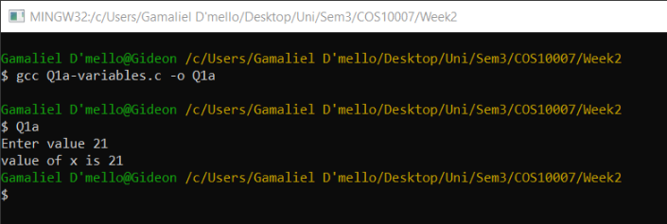
}

- Arrays
#include <stdio.h>

int main()
{
int x[4];
int i = 0;
printf("input data\n");
while (i<4)
{
scanf("%d", &x[i]);
i++;
}
printf("array includes ");
i = 0;
while (i<4)
{
printf("%d ", x[i]);
i++;
}
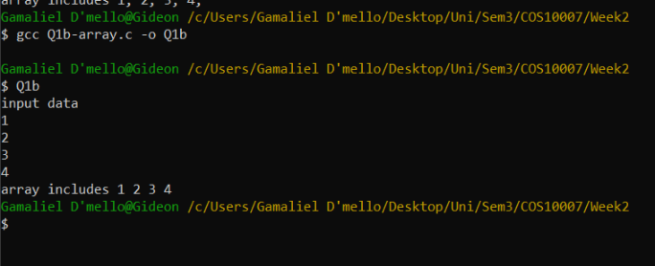

  - Differences between pointers and arrays with examples
A pointer points to a location of a variable or an array whereas an array is a systematic arrangement of the same data type that stores data in consecutive memory locations
  - Pointer
#include <stdio.h>

int main()
{
int x, *ptr_x;
x = 2;
ptr_x = &x;
printf("value of x is %d\n", x);
printf("location of x is %d\n", ptr_x);
printf("value that ptr_x is pointing to is %d", *ptr_x);

return 0;
}

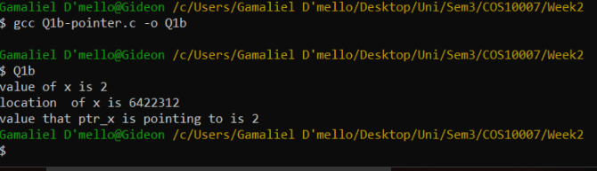

- Arrays
#include <stdio.h>

int main()
{
int x[4];
int i = 0;
printf("input data\n");
while (i<4)
{
scanf("%d", &x[i]);
i++;
}
printf("array includes ");
i = 0;
while (i<4)
{
printf("%d ", x[i]);
i++;
}

  - Define Recursive function and give an example
A recursive function is a function that calls upon itself

  - Code:
#include <stdio.h>

int fact(int i);

int main()
{
int x;
printf("enter value ");
scanf("%d", &x);
printf("Factorial of %d is %d", x, fact(x));
}

int fact (int i)
{
if (i<=1)
{
return 1;
}
else
{
return i*fact(i-1);
}
}

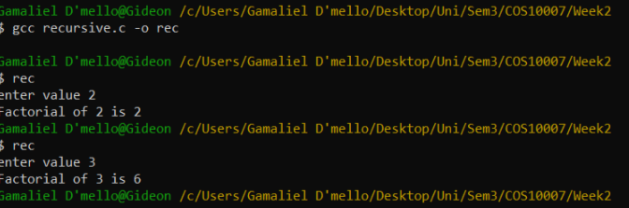

  - Differences between with or without programmer defined function with examples
with programmer defined functions are functions that are written by the programmer whereas system defined functions are functions that are used from the c libraries like main the difference is that if a main function was missing the program wouldn’t execute successfully yet if the code in the user defined function was in main the code will compile successfully
  - User defined
#include <stdio.h>

int larger(int x, int y)
{
int i;
if (x<y)
{
return i = y;
}
else
{
return i =x;
}
}

int main()
{
int x, y;
printf("Enter data ");
scanf("%d",&x);
printf("data entered was %d\n", x);
printf("Enter data ");
scanf("%d",&y);
printf("data entered was %d\n", y);
printf("largest number was %d",larger(x, y));
return 0;
}

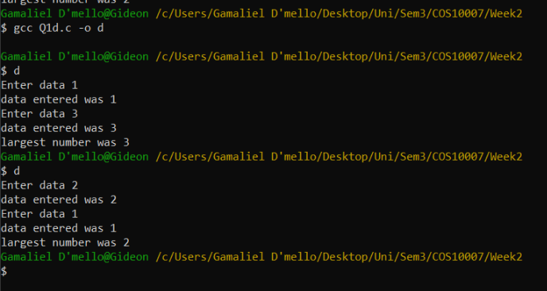

  - System defined functions
#include <stdio.h>

int main()
{
int x, y, i;
printf("Enter data ");
scanf("%d",&x);
printf("data entered was %d\n", x);
printf("Enter data ");
scanf("%d",&y);
printf("data entered was %d\n", y);
if (x<y)
{
i = y;
}
else
{
i =x;
}
printf("largest number was %d",i);

return 0;
}

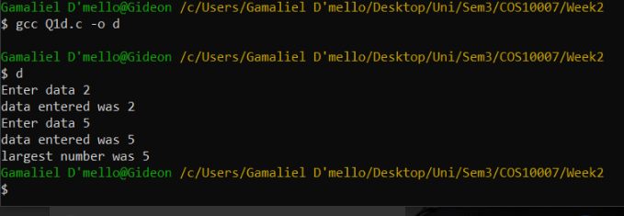

  - Differences between “Call by value and Call by reference” with examples
call be value copies the value into the function thus any changes made to it will not be made to/ passed to the calling function. call by reference get the actual value by using pointers to point to the location instead of creating a copy hence and changes made to the value will be made to all variables locally and globally

  - Code
#include <stdio.h>

void swap(int x, int y)
{
int i;
i = x;
x = y;
y = i;
}

int main()
{
int x = 100;
int y = 200;
printf("x: %d, y: %d\n", x, y);
swap (x, y);
printf("x: %d, y: %d\n", x, y);
}

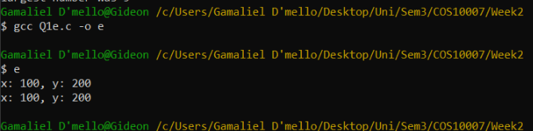
  - By reference
#include <stdio.h>

void swap(int *x, int *y)
{
int temp;
temp = *x;
*x = *y;
*x = temp;
}

int main()
{
int x = 100;
int y = 200;
printf("x: %d, y: %d\n", x, y);
swap (&x, &y);
printf("x: %d, y: %d\n", x, y);

return 0;
}

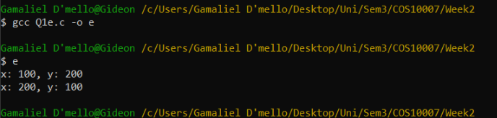
- Write a swap() function with the following function header:
#include <stdio.h>

void swap(int *p1, int *p2)
{
int x;
x = *p1;
*p1 = *p2;
*p2 = x;
}

int main()
{
int x = 50;
int y = 60;
printf("x: %d, y: %d\n", x, y);
swap (&x, &y); // swap
printf("x: %d, y: %d\n", x, y); // Should print out x: 60, y: 50
}
- Write a function that reorders the values in three integer variables such that the values are in ascending order. Assume that the corresponding function prototype statement is

void reorder(int *a, int *b ,int *c);
where a, b, and c are pointers to the three variables.

void reorder(int *a, int *b ,int *c);
where a, b, and c are pointers to the three variables.
#include <stdio.h>
void order(int *a, int *b, int *c)
{
int i;

if(*a > *b)
{
i = *a;
*a = *b;
*b = i;
}
if(*a > *c)
{
i = *a;
*a = *c;
*c = i;
}
if(*b > *c)
{
i = *b;
*b = *c;
*c = i;
}
}

int main ()
{
int x,y,z;

printf("Enter 1st number: \n");
scanf("%d",&x);
printf("Enter 2nd number: \n");
scanf("%d",&y);
printf("Enter 3rd number: \n");
scanf("%d",&z);

printf("Before the reorder, the numbers are:\n %d\n %d\n %d\n",x,y,z);

order(&x,&y,&z);

printf("After the reorder, the numbers are:\n %d\n %d\n %d\n",x,y,z);

return 0;
}

- Write a function called AddTwo(). It will receive three pointers to floats. It will add the numbers pointed to by the first two floats and store their sum in the location pointed to by the third pointer. In main(), define j, k and m. Scan in j and k, send their addresses to AddTwo() and have main() print the address of m and its value that is in it from AddTwo().

#include <stdio.h>
#include <math.h>

float AddTwo(float *a, float *b)
{
float sum;
sum = *a + *b;

return sum;
}

int main ()
{
float j,k,t;

printf("Enter 1st number: ");
scanf("%f",&a);
printf("Enter 2nd number: ");
scanf("%f",&b);

printf("The values you inputed are: %f, %f\n",a,b);

t = AddTwo(&a,&b);

printf("The sum of %.2f and %.2f is %.2f\n",a,b,t);

return 0;
}

