You may be asked to demonstrate/explain your work to the tutor, if you are absent/unavailable or fail to demonstrate properly, zero marks will be awarded.

Exercises:

- Explain the below with an example (an example should be a complete c program with a screenshot of the output)
  - Function prototypes
A function prototype informs the compiler that the main function will reference a function
  - Code
#include <stdio.h>

int add_two(int x, int y);

int main()
{
int x, y;
printf("Please Input first number ");
scanf("%d", &x);
printf("please input second number ");
scanf("%d", &y);
printf("%d + %d = %d", x, y, add_two(x,y));
return 0;
}

int add_two(int x, int y)
{
return x+y;
}

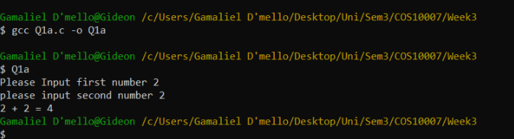

  - Typedef’s
#include <stdio.h>
#include <string.h>

typedef struct Books {
char title[50];
char author[50];
} Book;

int main( ) {

Book book;

strcpy( book.title, "C Programming");
strcpy( book.author, "Gamaliel D'mello");

printf( "Book title : %s\n", book.title);
printf( "Book author : %s\n", book.author);

return 0;
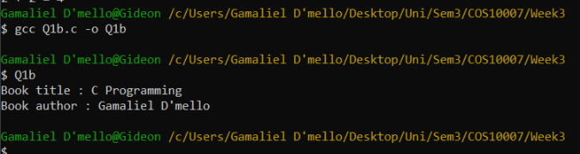
}

  - Typecasting
Typecasting is converting one data type to another

#include <stdio.h>

int main() {

int sum = 17, count = 9;
double mean;

mean = (double) sum / count;
printf("Value of mean : %lf\n", mean );
}
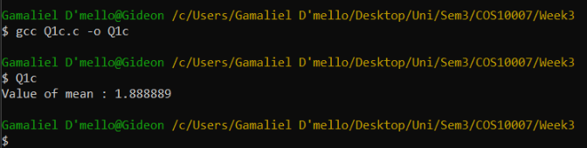

  - Structures
A structure is a user generated data type that holds multiple data types
#include <stdio.h>
#include <string.h>

struct Books {
char title[50];
char author[50];
};

int main( ) {

struct Books Book1;

strcpy( Book1.title, "C Programming");
strcpy( Book1.author, "Gamaliel D'mello");

printf( "Book 1 title : %s\n", Book1.title);
printf( "Book 1 author : %s\n", Book1.author);

return 0;
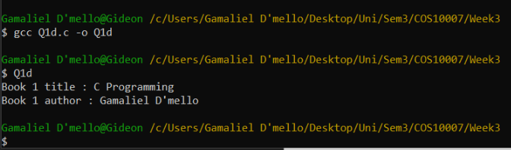
}

  - Self-referential structures
A self referential structure is a structure that contains a pointer that points to the location of the structure it is in

#include <stdio.h>

typedef struct NODE {
struct NODE *new;
int value;
}Node;

int main(void)
{
Node previous, current;
previous.new = &current;
previous.value = 100;
}
  - malloc() function
creates a block of memory with the size of being the type entered to it

  - realloc () function used after the malloc call to increase the block of size needed
#include <stdio.h>
#include <stdlib.h>
#include <string.h>

int main () {
char *str;

str = (char *) malloc(15);
strcpy(str, "C Programming");
printf("String = %s, Address = %u\n", str, str);

str = (char *) realloc(str, 25);
strcat(str, ".com");
printf("String = %s, Address = %u\n", str, str);

free(str);

return(0);
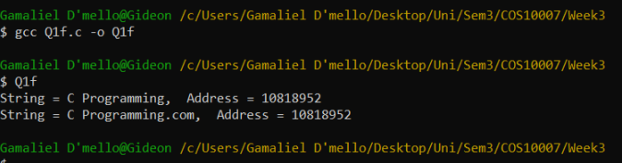
}

- Explain the differences between
  - The difference between an array and a structure is that an array is a collection of related data of the same type, whereas a structure can have elements of different types.
  - A self-referential structure is those that have one or more pointers whereas a structure is can have elements of different types with no pointers.
  - User defined datatypes is the basic set of data types defined in the c language. Whereas system defined data types give the programmer the control to define and use them as required.

After implementing functions, you have to write a complete C program.

- Declare a structure and then write a main(),inside the main store the structure in a local variable. main() will call a function PrintData() by Passing this local variable and print the values of structure in PrintData().
#include <stdio.h>
#include <string.h>

struct Books {
char title[50];
char author[50];
};

void PrintData(struct Books Book1)
{
printf( "Book 1 title : %s\n", Book1.title);
printf( "Book 1 author : %s\n", Book1.author);
}

int main( )
{
struct Books Book1;
strcpy( Book1.title, "C Programming");
strcpy( Book1.author, "Gamaliel D'mello");

PrintData(Book1);
return 0;
}
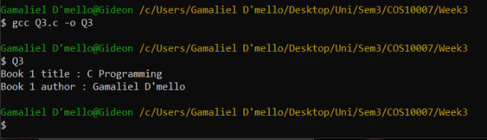
For question 4 use the following structure

// structure definition
struct Date
{
int yy, mm, dd;
};

struct Emp
{
char EmpName[25]; float Salary;
struct Date hired;
};

4.
- Write main(), which will define an array called a[5] of type struct Emp. main() will then call GetData() in a loop 5 times, each time getting the data in the proper slot of the array. Then main() will call PrintData() in a loop so that the data is printed in reverse order.

#include <stdio.h>
#include <stdlib.h>
#include <string.h>

typedef struct Emps
{
char EmpName[25];
int Salary;
int date;
} emp[5];

void Getdata(emp a)
{
printf("Enter name ");
scanf("%s", a->EmpName);

printf("enter salary ");
scanf("%d", &a->Salary);

printf("enter date hired ");
scanf("%d", &a->date);
}

void printdata (emp a)
{
printf("employee's name is: %s\n", a->EmpName);
printf("%s salary is is: %d\n", a->EmpName, a->Salary);
printf("%s was hired on: %d\n", a->EmpName, a->date);
printf("\n");

}

int main()
{
int i;
emp a[5];

for (i = 0; i<5;i++)
{
printf("\nEnter Employee Details \n");
Getdata(a[i]);
}
printf("\n\n");
for (i = 4; i>-1;i--)
{

printdata(a[i]);
}

return 0;
}

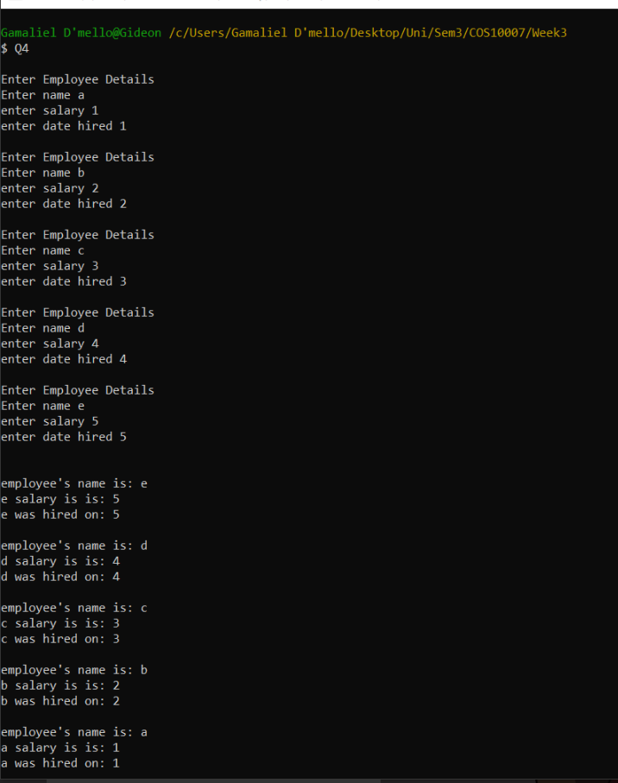
// function prototypes
struct Emp GetData();
void PrintData(struct Emp);

- Write a function that will receive one array of type struct Emp and an integer that gives the size of the array. Remember that, if the size is 5, then the largest index of the array should be
- It will then return those employees’ average salary.

// function prototypes
struct Emp GetData();
double GetAverage(struct Emp [], int);

- Write a function that will receive one array of type struct Emp and name of an employee. The function should return the salary of that employee.

// function prototypes
struct Emp GetData();
float findsalary(struct Emp x[],char p[]);

