You may be asked to demonstrate/explain your work to the tutor, if you are absent/unavailable or fail to demonstrate properly, zero marks will be awarded.

Text book: Deitel, H M & Deitel, P J 2013, C: How to program, 7th edn, Pearson Prentice- Hall, Upper Saddle River, New Jersey.

- Please answer the below using examples and diagrams
  - Explain the differences between an array and a linked list
an array has elements stored contagiously and allows immediate access to any array element whereas liked lists cannot be immediately accessed as nodes are not stores contiguously even if they appear to be

 | array | Linked list
Example | #include <stdio.h>  int main()  {  int x[4];  int i = 0;  printf("input data\n");  while (i<4)  {  scanf("%d", &x[i]);  i++;  }  printf("array includes ");  i = 0;  while (i<4)  {  printf("%d ", x[i]);  i++;  }  } | #include <stdio.h>  #include <stdlib.h>  struct listNode  {  char data;  struct listNode *nextPtr;  };  typedef struct listNode ListNode;  typedef ListNode *ListNodePtr;  void insert( ListNodePtr *sPtr, char value);  char delete( ListNodePtr *sPtr, char value);  int isEmpty( ListNodePtr sPtr );  void printList( ListNodePtr currentPtr);  void instructions( void);  int main( void )  {  ListNodePtr startPtr = NULL;  unsigned int choice;  char item;  instructions();  printf( "%s" , "?" );  scanf( "%u", &choice );  while (choice != 3 )  {  switch ( choice )  {  case 1:  printf( "%s", "Enter a character:" );  scanf ( "\n%c", &item );  insert( &startPtr, item);  printList( startPtr );  break;  case 2:  if ( !isEmpty( startPtr ) )  {  printf( "%s", "Enter character to be deleted: " );  scanf( "\n%c", &item );  if ( delete( &startPtr, item ))  {  printf( "%c deleted.\n" , item );  printList( startPtr );  }  else  {  printf( "%c not found.\n\n" , item);  }  }  else  {  puts( "List is empty.\n" );  }  break;  default:  puts ("Invalid choice.\n" );  instructions();  break;  }  printf( "%s" , "? " );  scanf( "%u" , &choice );  }  puts( "End of run." );  }  void instructions( void )  {  puts( "Enter your choice:\n"  " 1 to insert an element into the list.\n"  " 2 to delete an element from the list.\n"  " 3 to end.");  }  void insert( ListNodePtr *sPtr, char value )  {  ListNodePtr newPtr;  ListNodePtr previousPtr;  ListNodePtr currentPtr;  newPtr = malloc( sizeof( ListNode ));  if ( newPtr != NULL )  {  newPtr->data = value;  newPtr->nextPtr = NULL;  previousPtr = NULL;  currentPtr = *sPtr;  while ( currentPtr != NULL && value > currentPtr ->data)  {  previousPtr = currentPtr;  currentPtr = currentPtr->nextPtr;  }  if ( previousPtr == NULL )  {  newPtr->nextPtr = *sPtr;  *sPtr = newPtr;  }  else  {  previousPtr->nextPtr = newPtr;  newPtr->nextPtr = currentPtr;  }  }  else  {  printf( "%c not inserted. No memory available.\n", value );  }  }  char delete( ListNodePtr *sPtr, char value )  {  ListNodePtr previousPtr;  ListNodePtr currentPtr;  ListNodePtr tempPtr;  if ( value == (*sPtr )-> data )  {  tempPtr = *sPtr;  *sPtr = ( *sPtr )->nextPtr;  free( tempPtr );  return value;  }  else  {  previousPtr = *sPtr;  currentPtr = ( *sPtr )->nextPtr;  while ( currentPtr != NULL && currentPtr -> data != value)  {  previousPtr = currentPtr;  currentPtr = currentPtr -> nextPtr;  }  if ( currentPtr != NULL )  {  tempPtr = currentPtr;  previousPtr->nextPtr = currentPtr->nextPtr;  free( tempPtr );  return value;  }  }  return '\0';  }  int isEmpty( ListNodePtr sPtr )  {  return sPtr == NULL;  }  void printList( ListNodePtr currentPtr )  {  if ( isEmpty( currentPtr ))  {  puts( "List is empty.\n" );  }  else  {  puts( "The list is: " );  while ( currentPtr != NULL )  {  printf( "%c --> ", currentPtr->data );  currentPtr = currentPtr ->nextPtr;  }  puts( "NULL\n" );  }  }
image | 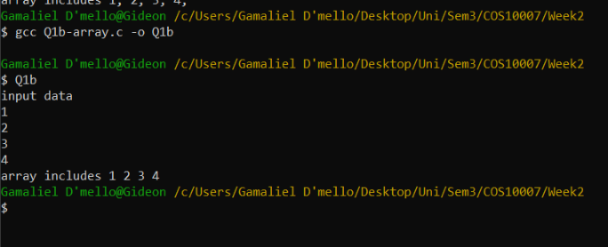 | 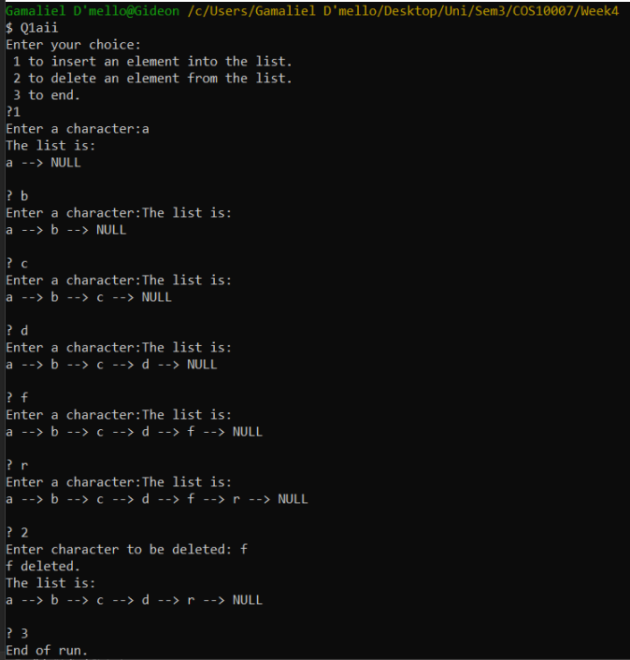
diagram | 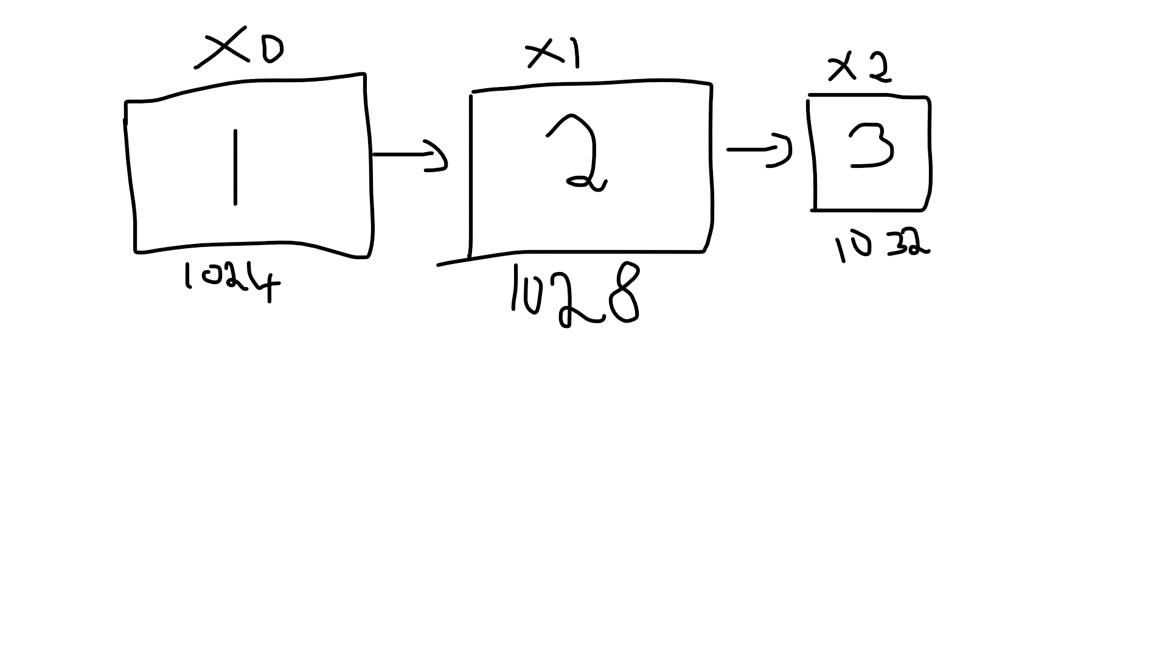 | 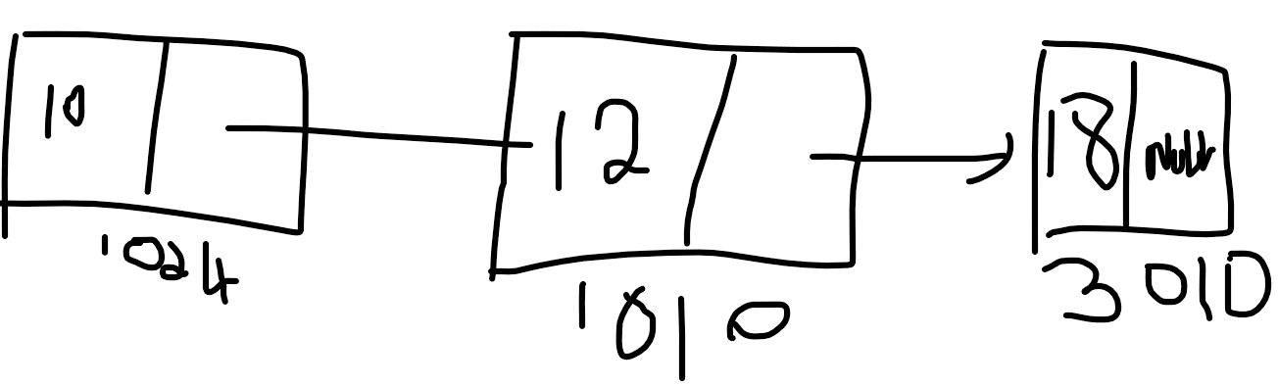

  - Describe the steps to insert data at the starting of a linked list.
Code | #include <stdio.h>  #include <stdlib.h>  /* Structure of a node */  struct node {  int data; // Data  struct node *next; // Address  }*head;  void createList(int n);  void insertNodeAtEnd(int data);  void displayList();  int main()  {  int n, data;  /*  * Create a singly linked list of n nodes  */  printf("Enter the total number of nodes: ");  scanf("%d", &n);  createList(n);  printf("\nData in the list \n");  displayList();  /*  * Insert data at the end of the singly linked list  */  printf("\nEnter data to insert at end of the list: ");  scanf("%d", &data);  insertNodeAtEnd(data);  printf("\nData in the list \n");  displayList();  return 0;  }  /*  * Create a list of n nodes  */  void createList(int n)  {  struct node *newNode, *temp;  int data, i;  head = (struct node *)malloc(sizeof(struct node));  /*  * If unable to allocate memory for head node  */  if(head == NULL)  {  printf("Unable to allocate memory.");  }  else  {  /*  * Reads data of node from the user  */  printf("Enter the data of node 1: ");  scanf("%d", &data);  head->data = data; // Link the data field with data  head->next = NULL; // Link the address field to NULL  temp = head;  /*  * Create n nodes and adds to linked list  */  for(i=2; i<=n; i++)  {  newNode = (struct node *)malloc(sizeof(struct node));  /* If memory is not allocated for newNode */  if(newNode == NULL)  {  printf("Unable to allocate memory.");  break;  }  else  {  printf("Enter the data of node %d: ", i);  scanf("%d", &data);  newNode->data = data; // Link the data field of newNode with data  newNode->next = NULL; // Link the address field of newNode with NULL  temp->next = newNode; // Link previous node i.e. temp to the newNode  temp = temp->next;  }  }  printf("SINGLY LINKED LIST CREATED SUCCESSFULLY\n");  }  }  /*  * Create a new node and inserts at the end of the linked list.  */  void insertNodeAtEnd(int data)  {  struct node *newNode, *temp;  newNode = (struct node*)malloc(sizeof(struct node));  if(newNode == NULL)  {  printf("Unable to allocate memory.");  }  else  {  newNode->data = data; // Link the data part  newNode->next = NULL;  temp = head;  // Traverse to the last node  while(temp->next != NULL)  temp = temp->next;  temp->next = newNode; // Link address part  printf("DATA INSERTED SUCCESSFULLY\n");  }  }  /*  * Display entire list  */  void displayList()  {  struct node *temp;  /*  * If the list is empty i.e. head = NULL  */  if(head == NULL)  {  printf("List is empty.");  }  else  {  temp = head;  while(temp != NULL)  {  printf("Data = %d\n", temp->data); // Print data of current node  temp = temp->next; // Move to next node  }  }  }
Diagram | 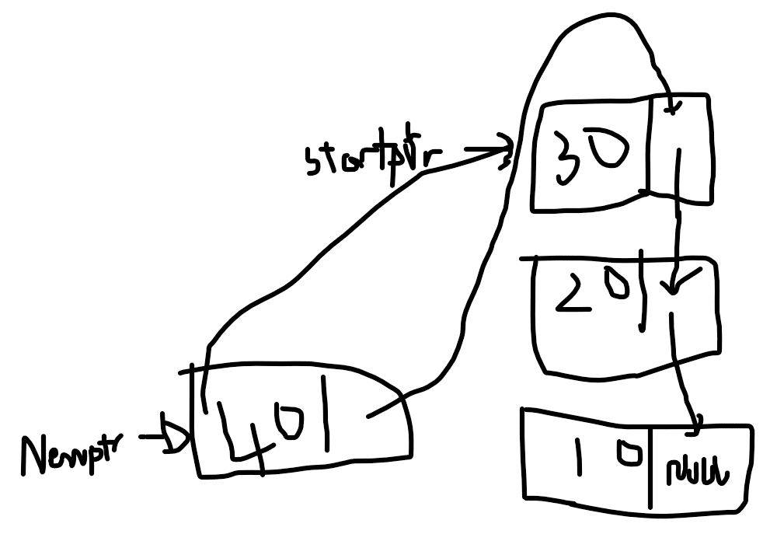

  - Describe the steps to insert data at the ending of a linked list.
Code | void insert( ListNodePtr *sPtr, char value )  {  ListNodePtr newPtr;  ListNodePtr previousPtr;  ListNodePtr currentPtr;  newPtr = malloc( sizeof( ListNode ));  if ( newPtr != NULL )  {  newPtr->data = value;  newPtr->nextPtr = NULL;  previousPtr = NULL;  currentPtr = *sPtr;  while ( currentPtr != NULL && value > currentPtr ->data)  {  previousPtr = currentPtr;  currentPtr = currentPtr->nextPtr;  }  if ( previousPtr == NULL )  {  newPtr->nextPtr = *sPtr;  *sPtr = newPtr;  }  else  {  previousPtr->nextPtr = newPtr;  newPtr->nextPtr = currentPtr;  }  }  else  {  printf( "%c not inserted. No memory available.\n", value );  }  }
Diagram | 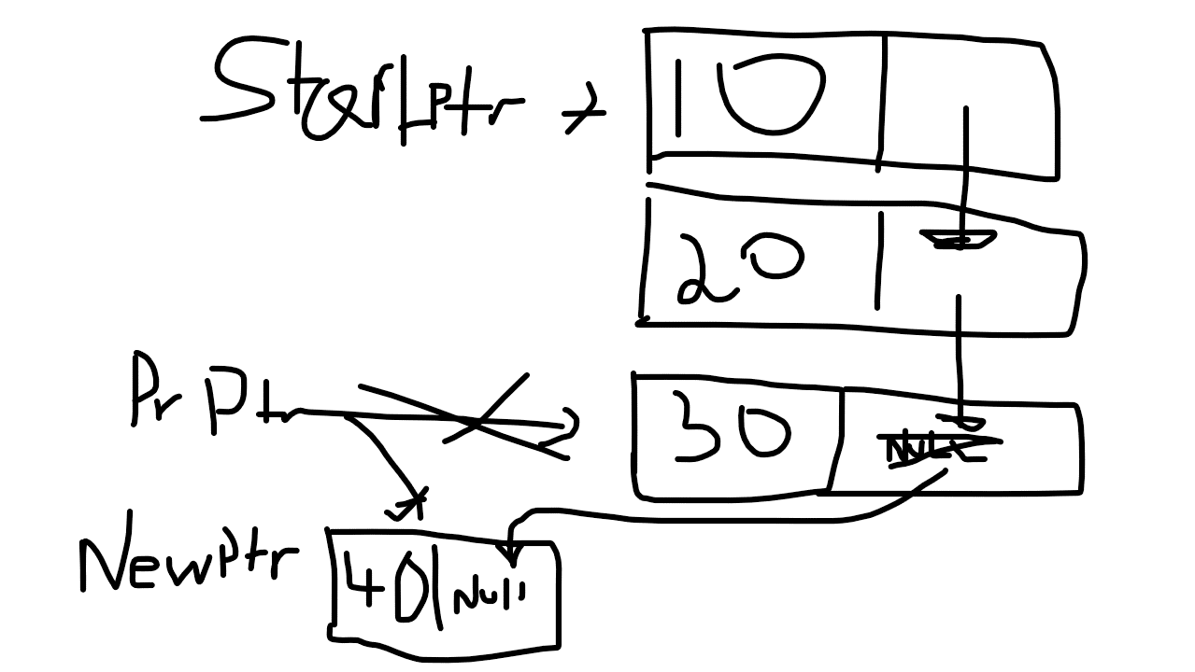

  - Describe the steps to delete a node from the linked list.
Code | char delete( ListNodePtr *sPtr, char value )  {  ListNodePtr previousPtr;  ListNodePtr currentPtr;  ListNodePtr tempPtr;  if ( value == (*sPtr )-> data )  {  tempPtr = *sPtr;  *sPtr = ( *sPtr )->nextPtr;  free( tempPtr );  return value;  }  else  {  previousPtr = *sPtr;  currentPtr = ( *sPtr )->nextPtr;  while ( currentPtr != NULL && currentPtr -> data != value)  {  previousPtr = currentPtr;  currentPtr = currentPtr -> nextPtr;  }  if ( currentPtr != NULL )  {  tempPtr = currentPtr;  previousPtr->nextPtr = currentPtr->nextPtr;  free( tempPtr );  return value;  }  }  return '\0';  }
Diagram | 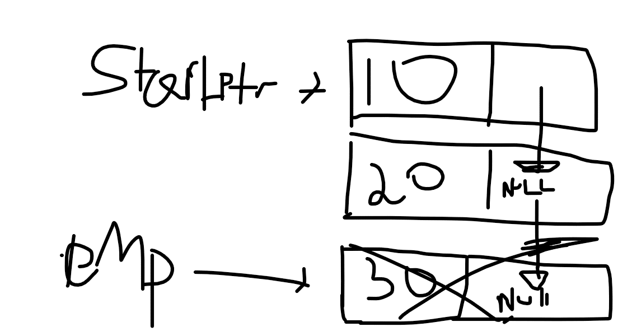

- Write a statement or set of statements to accomplish each of the following. Assume that all the manipulations occur in main (therefore, no addresses of pointer variables are needed), and assume the following definitions:
struct bankEmployee { char name[20]; int salary;
struct bankEmployee *next;
};

typedef struct bankEmployee BANKEmployee;
typedef BANKEmployee *BANKEmployeePtr;

  - Create a pointer to the start of the list called startPtr. The list is empty.

  - Create a new node of type BANKEmployee that's pointed to by pointer newPtr of type BANKEmployeePtr. Assign the string "Justin" to member name and the value 1000 to member salary (use strcpy). Provide any necessary declarations and statements.

  - Assume that the list pointed to by startPtr currently consists of 2 nodes one containing "Justin " and one containing "Sam". The nodes are in alphabetical order. Provide the statements necessary to insert in order nodes containing the following data for name and salary:
"Antony" 200
"Tony" 300
"Peter" 400
Use pointers previousPtr; currentPtr and newPtr to perform the insertions; State what previousPtr and currentPtr point to before each insertion. Assume that newPtr always points to the new node, and that the new node has already been assigned the data.
  - Write a while loop that prints the data in each node of the list. Use pointer currentPtr
to move along the list.

  - Write a while loop that deletes all the nodes in the list and frees the
memory associated with each node. Use pointer currentPtr and pointer tempPtr
to walk along the list and free memory, respectively.

  - Incorporate all these into a complete C program, your linked list should contain all 5 nodes (Antony, Justin, Peter, Sam, Tony in alphabetical order).
#include <stdio.h>
#inclulde <stdlib.h>

struct bankEmployee
{
char name[20];
int salary;
struct bankEmployee *next;
};

typedef struct bankEmployee BANKEmployee;
typedef BANKEmployee *BANKEmployeePtr;

int isEmpty( ListNodePtr sPtr )
{
return sPtr == NULL;
} /* end function isEmpty*/
/* print the list*/
void printList( ListNodePtr currentPtr )
{
/* if list is empty*/
if ( isEmpty( currentPtr ))
{
puts( "List is empty.\n" );
} /* end if*/
else
{
puts( "The list is: " );
/* while not the end of the list*/
while ( currentPtr != NULL )
{
printf( "%c --> ", currentPtr->data );
currentPtr = currentPtr ->nextPtr;
} /* end while*/
puts( "NULL\n" );
} /* end else*/
} /* end function printList */

void insert( BANKEmployee *sPtr, char value, int sal )

{

BANKEmployee newPtr;
BANKEmployee previousPtr;
BANKEmployee currentPtr;

newPtr = malloc( sizeof( BANKEmployee));

if ( newPtr != NULL ) /* is space available*/
{
newptr -> name = x;
newptr -> salary = sal;
newPtr -> next = NULL;; /* node does not link to another node*/
previousPtr = NULL;
currentPtr = *sPtr;
/* loop to find the correct location in the list*/
while ( currentPtr != NULL && value > currentPtr ->Name)
{
previousPtr = currentPtr; /* walk to ...*/
currentPtr = currentPtr->nextPtr; /* ... next node*/
} /* end while*/
/* insert new node at beginning of list*/
if ( previousPtr == NULL )
{
newPtr->nextPtr = *sPtr;
*sPtr = newPtr;
} /* end if*/
else /* insert new node between previousPtr and currentPtr*/
{
previousPtr->nextPtr = newPtr;
newPtr->nextPtr = currentPtr;
} /* end else*/
} /* end if*/
else
{
printf( "%c not inserted. No memory available.\n", value );
} /* end else*/
}

int main()
{
ListNodePtr startPtr = NULL;

char x;
int sal = 1000;

stpcpy(x, Antony);
sal = 200;
insert( &startPtr, x, sal);

stpcpy(x, peter);
sal = 400;
insert( &startPtr, x, sal);
stpcpy(x, sam);
sal = 100;
insert( &startPtr, x, sal);

stpcpy(x, tony);
sal = 300;
insert( &startPtr, x, sal);

stpcpy(x, justin);
insert( &startPtr, x, sal);

printList( startPtr );

BANKEmployee previousPtr; /* pointer to previous node in list*/
BANKEmployee currentPtr; /* pointer to current node in list*/
BANKEmployee tempPtr; /* temporary node pointer*/
/* delete first node*/
if ( value == (*sPtr )-> data )
{
tempPtr = *sPtr; /* hold onto node being removed*/
*sPtr = ( *sPtr )->nextPtr; /* de-thread the node*/
free( tempPtr ); /* free the de-threaded node*/
return value;
} /* end if*/
else
{
previousPtr = *sPtr;
currentPtr = ( *sPtr )->nextPtr;
/* loop to find the correct location in the list*/
while ( currentPtr != NULL && currentPtr -> data != value)
{
previousPtr = currentPtr; /* walk to ...*/
currentPtr = currentPtr -> nextPtr; /*... next node*/
} /* end while*/
/* delete node at currentPtr*/
if ( currentPtr != NULL )
{
tempPtr = currentPtr;
previousPtr->nextPtr = currentPtr->nextPtr;
free( tempPtr );
return value;
} /* end if*/
} /* end else*/

} /* end function delete*/

- Please represent the above Linked list graphically. Need to introduce a new diagram step by step such as creating a new block of memory, assigning null, introducing a current pointer, introducing a previous pointer etc. (This question is very important – Question 2 will not be marked without this question)
