
COS10007 – Developing Technical Software

You may be asked to demonstrate/explain your work to the tutor, if you are absent/unavailable or fail to demonstrate properly, zero marks will be awarded.

Text book: Deitel, H M & Deitel, P J 2013, C: How to program, 7th edn, Pearson Prentice- Hall, Upper Saddle River, New Jersey.
Week 5

- Explain the below
  - Data structures
a data structure is a way of organizing and storing data to efficiently manage, theses include two types liner data structures and non-linear data structures
  - Differences between linear data structures and non-linear data structures
A liner data structure is an array as the data is stored in a contiguous manner and the insertion and deletion is in a liner fashion and the ptr points to one data type at a singular point in time whereas a non-liner data structure stores one node connected to many nodes at one point in time
Liner | Non-liner
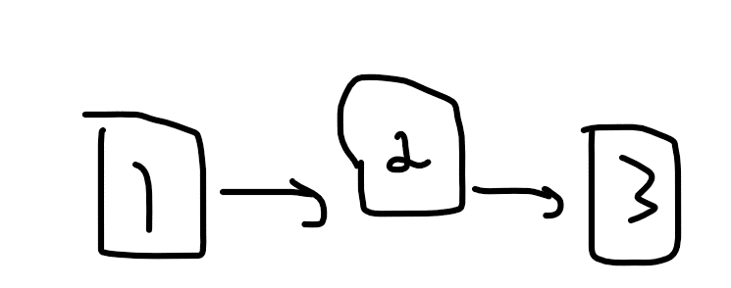 | 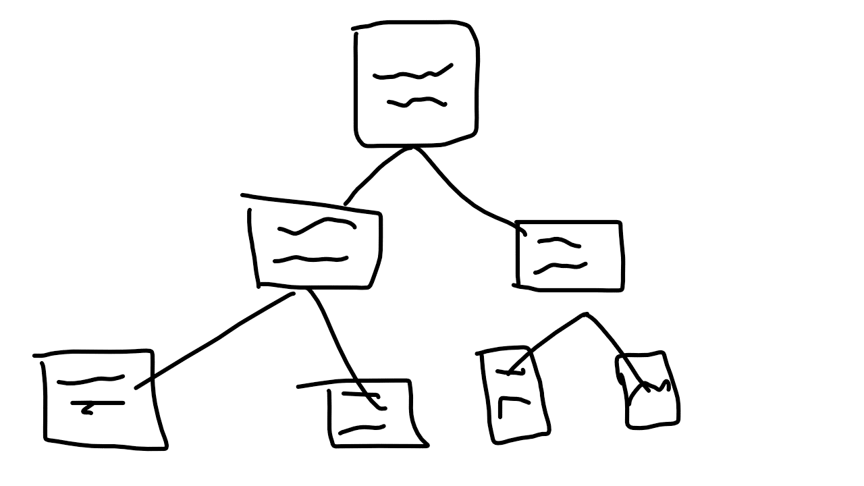

  - Stacks with diagrammatic representation (include a separate diagram for each operation of the stack)
a stack is a last-in, first out data structure, new nodes can be added at the top and removed only at the top
Push | Pop
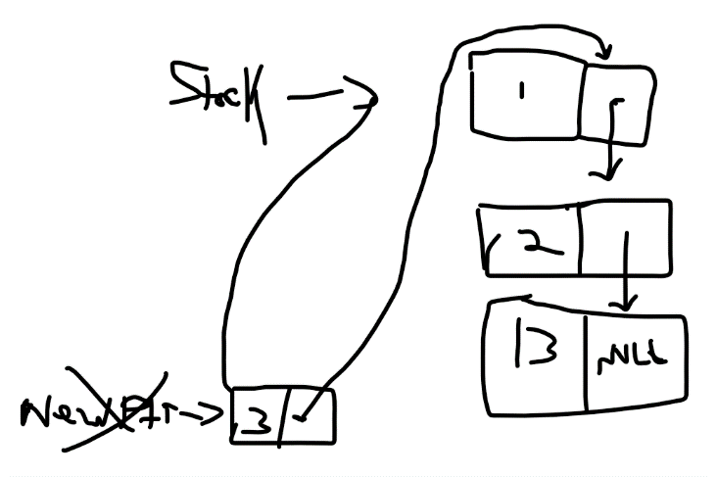 | 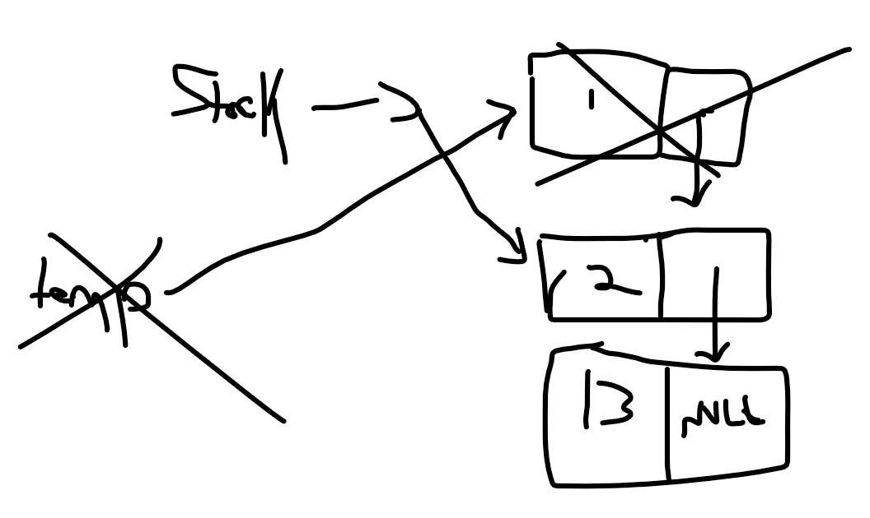

  - Differences between Linked lists and Stacks
the primary difference between a linked list and a stack is that a linked list can input data anywhere in the list whereas the stack can only input data at the top
  - Give two applications of stacks
stacks can revers a sentence and it can determine if the word can be spelled backwards

- (Reversing the Words of a Sentence) Write a program that inputs a line of text and uses a stack to print the line reversed.
#include <stdio.h>
#include <string.h>
#define max 100

int top = -1;
int item;
char stack_string[max];
void push(char item);
char pop(void);
int isempt(void);
int isfull(void);

int main()
{
char str[max];
int i;
printf("\ninput a string: ");
scanf("%s", str);
for (i=0;i<strlen(str);i++)
{
push(str[i]);
}
for(i=0;i<strlen(str);i++)
{
str[i]=pop();
}
printf("\n reverse string is %s", str);

return 0;
}

void push(char item)
{
if(isfull())
{
printf("\nstack is full");
return;
}
top = top+1;
stack_string[top] = item;
}

char pop()
{
if(isempt())
{
printf("\n stack is empty");
return 0;
}

item = stack_string[top];
top = top-1;
return item;
}

int isempt()
{
if(top == -1)
{
return 1;
}
else
{
return 0;
}
}

int isfull()
{
if (top==max-1)
{
return 1;
}
else
{
return 0;
}
}

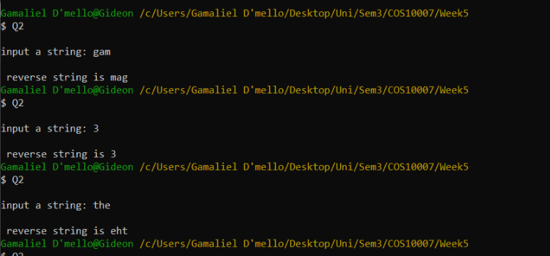

- (Palindrome Tester)Write a program that uses a stack to determine whether a string is a palindrome (i.e., the string is spelled identically backward and forward). The program should ignore spaces and punctuation.
#include <stdio.h>
#include <string.h>
#define max 100

int top = -1;
int item;
char stack_string[max];
void push(char item);
char pop(void);
int isempt(void);
int isfull(void);

int main()
{
char str[max], check[max];
int i, ret;
printf("\ninput a string: ");
scanf("%s", str);
strcpy(check,str);
for (i=0;i<strlen(str);i++)
{
push(str[i]);
}
for(i=0;i<strlen(str);i++)
{
str[i]=pop();
}
printf("\n reverse string is %s", str);

ret = strcmp(str,check);
if (ret == 0)
{
printf("\nit is a pallidrome");
}
else
{
printf("\nit is not pallidrome");
}

return 0;
}

void push(char item)
{
if(isfull())
{
printf("\nstack is full");
return;
}
top = top+1;
stack_string[top] = item;
}

char pop()
{
if(isempt())
{
printf("\n stack is empty");
return 0;
}

item = stack_string[top];
top = top-1;
return item;
}

int isempt()
{
if(top == -1)
{
return 1;
}
else
{
return 0;
}
}

int isfull()
{
if (top==max-1)
{
return 1;
}
else
{
return 0;
}
}

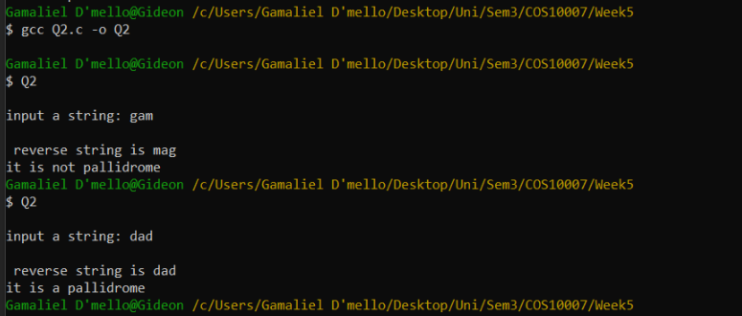

©Copyright: 2018 Swinburne University of Technology CRICOS: 0011D TOID: 3059
Week 5 Lab 26/10/2018
Version 2 Page 1 of 1

