
COS10007 – Developing Technical Software

You may be asked to demonstrate/explain your work to the tutor, if you are absent/unavailable or fail to demonstrate properly, zero marks will be awarded.
Text book: Deitel, H M & Deitel, P J 2013, C: How to program, 7th edn, Pearson Prentice- Hall, Upper Saddle River, New Jersey.

- Explain the logic of the below using examples and diagrams
  - Bubble sort
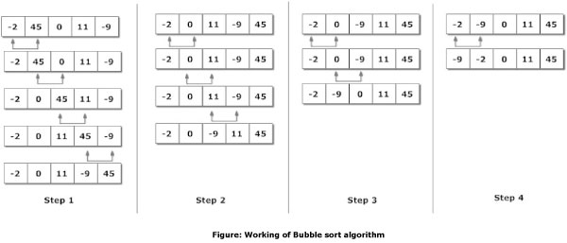
  - Selection sort
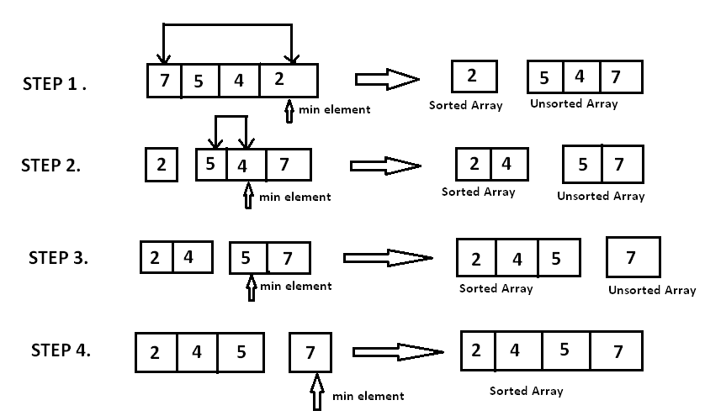

  - Insertion sort
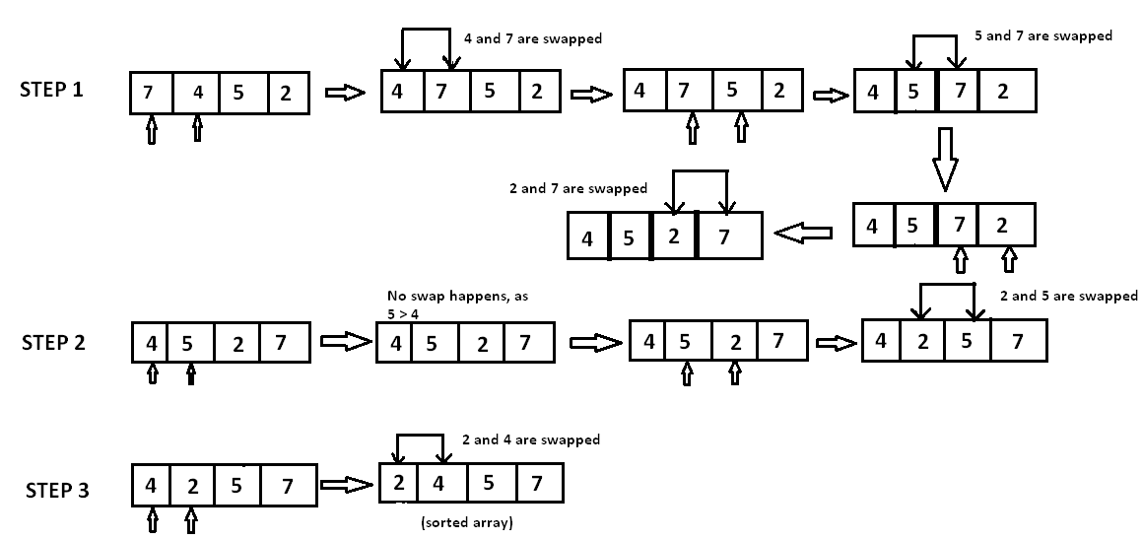
  - Merge sort

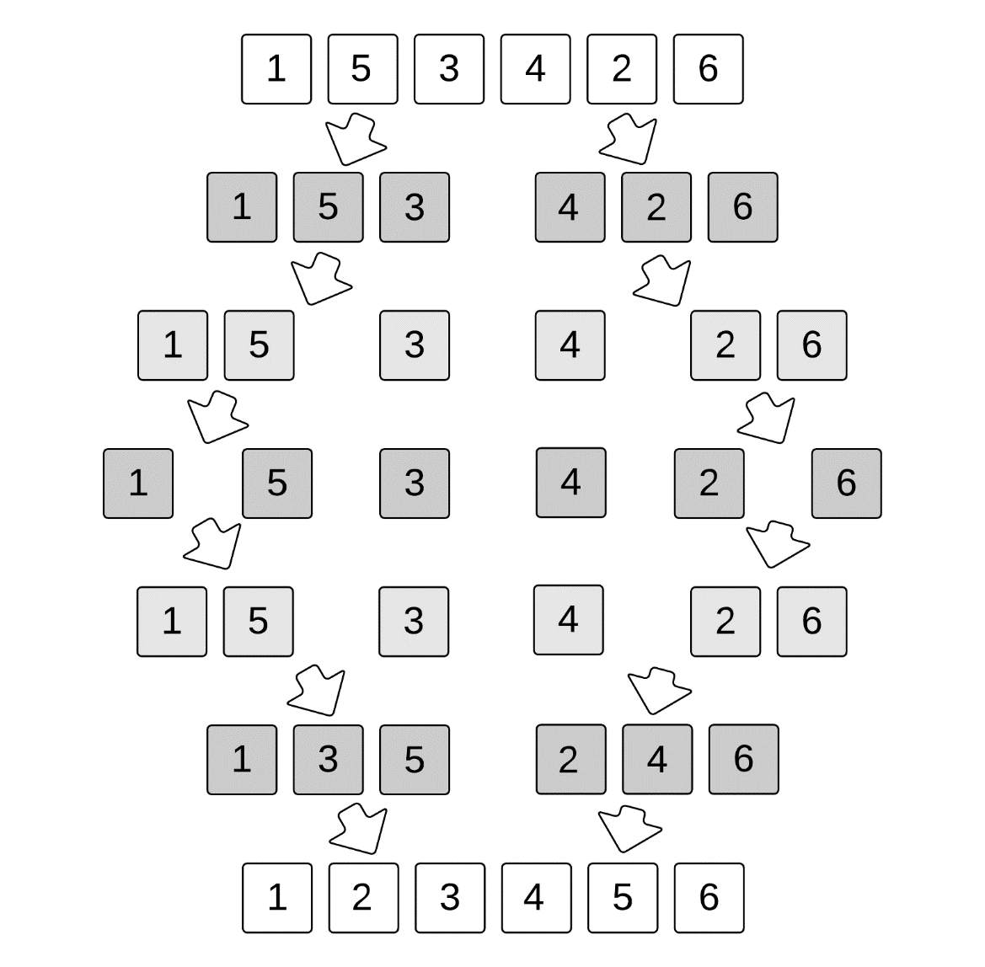
  - Quick sort

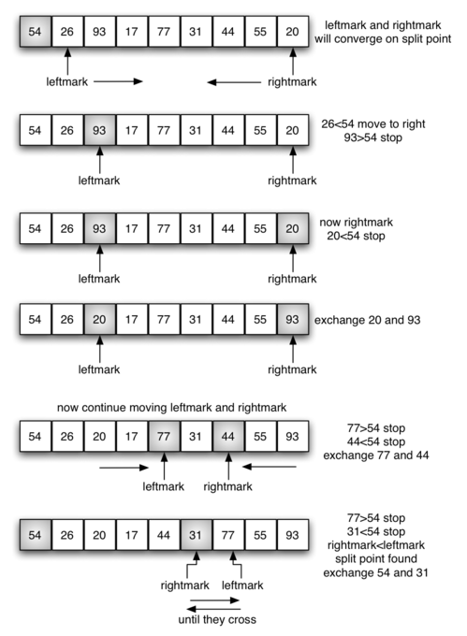

- Write a complete C program to implement the following sorting algorithms, using an array of size 10, populated with random integers, e.g. 0 – 100 to test your program. Don’t forget to print initial array and final (sorted) array.
  - Bubble sort
  - Selection sort
  - Insertion sort

#include <stdio.h>
#include <stdlib.h>
#include <time.h>

void random(int arr[], int size)
{
int i;

srand(time(NULL));;
printf("unsorted list: ");
for(i=0;i<size;i++)
{
arr[i] = rand() % 101;
printf("%d ", arr[i]);
}
printf("\n");
}

void bubble(int arr[], int size)
{
int d, c, temp;
for (c = 0 ; c < size - 1; c++)
{
for (d = 0 ; d < size - c - 1; d++)
{
if (arr[d] > arr[d+1])
{
temp = arr[d];
arr[d] = arr[d+1];
arr[d+1] = temp;
}
}
}

printf("Bubble sort: ");

for (c = 0; c < size; c++)
{
printf("%d ", arr[c]);
}
printf("\n\n");
}

void selection(int arr[], int size)
{
int i;
for (i = 0; i < size - 1; ++i)
{
int j, min, temp;
min = i;
for (j = i+1; j < size; ++j)
{
if (arr[j] < arr[min])
min = j;
}
temp = arr[i];
arr[i] = arr[min];
arr[min] = temp;
}
printf("Selection sort: ");
for (i = 0; i < size; i++)
{
printf("%d ", arr[i]);
}
printf("\n\n");
}

void insertion(int arr[], int size)
{
int i, j, index;
for (i = 1; i < size; ++i)
{
index = arr[i];
for (j = i; j > 0 && arr[j-1] > index; j--)
arr[j] = arr[j-1];

arr[j] = index;
}

printf("Insertion sort: ");

for (i = 0; i < size; i++)
{
printf("%d ", arr[i]);
}
printf("\n\n");
}

int main()
{
int size = 10;
int array[size];
random(array, size);
bubble(array, size);
random(array, size);
selection(array,size);
random(array, size);
insertion(array,size);

return 0;
}

©Copyright: 2018 Swinburne University of Technology CRICOS: 0011D TOID: 3059
Week 7 Lab 09/11/2018
Version 2 Page 1 of 1

