
COS10007 – Developing Technical Software

You may be asked to demonstrate/explain your work to the tutor, if you are absent/unavailable or fail to demonstrate properly, zero marks will be awarded.
Text book: Deitel, H M & Deitel, P J 2013, C: How to program, 7th edn, Pearson Prentice-Hall, Upper Saddle River, New Jersey.

- Explain Linear search and binary search with examples.
Linear search goes trough each element and finds if the value you are looking for matches binary needs the data to be sorted and then it goes to the middle array and if it doesn’t match it will spit the array into sub arrays look for the key there

- Write a complete C program to implement the following sorting algorithms:
Using an array of size 10, populated with random integers, e.g. 0 – 100 to test your program. Don’t forget to print initial array, and output (for binary search, print also each sub-array during the searching process).

  - Linear Search
    - The function should receive an integer array, a search key and the size of the array as arguments.
    - If the search key is found, return the location in the array where the search key is found; otherwise, return -1.
  - Binary Search
    - The function should receive an integer array, a search key, the starting subscript and ending subscript as arguments.
    - If the search key is found, return the location in the array where the search key is found; otherwise, return -1.

#include <stdio.h>
#include <stdlib.h>
#include <time.h>

void random(int arr[], int size)
{
int i;

srand(time(NULL));;
printf("unsorted list: ");
for(i=0;i<size;i++)
{
arr[i] = rand() % 101;
printf("%d ", arr[i]);
}
printf("\n");
}

int linear(int array[], int key, int size)
{
int i;
for ( i = 0; i < size; i++ ){
if (array[i] == key ){
return i;
}
}
return -1;

}

int binary(int arr[], int l, int r, int x)
{
while (l <= r)
{
int m = l + (r - l) / 2;
// Check if x is present at mid
if (arr[m] == x)
{
return m;
}

// If x greater, ignore left half
if (arr[m] < x)
{
l = m + 1;
}
// If x is smaller, ignore right half
else
{
r = m - 1;
}
}

// if we reach here, then element was
// not present
return -1;
}

int selection(int arr[], int size, int k, int n)
{
int i, ans;
for (i = 0; i < size - 1; ++i)
{
int j, min, temp;
min = i;
for (j = i+1; j < size; ++j)
{
if (arr[j] < arr[min])
min = j;
}
temp = arr[i];
arr[i] = arr[min];
arr[min] = temp;
}
printf("sorted array ");
for (i = 0; i < size; i++)
{
printf("%d ", arr[i]);
}
printf("\n");

ans = binary(arr, 0, n-1, size);
printf("ans is %d\n", ans);
return ans;
}

int main()
{
int size = 10, k, ans;
int arr[size];
int n = sizeof(arr) / sizeof(arr[0]);
random(arr, size);
printf("Enter a search key ");
scanf("%d", &k);
ans = linear(arr, k, size);
if (ans != -1)
{
printf("The key: %d is in the %d position\n", k, ans);
}
else
{
printf("key %d could not be found in the array\n", k);
}
printf("\n");
random(arr, size);
printf("Enter a search key ");
scanf("%d", &k);
ans = selection(arr, size, k, n);
if (ans != -1)
{
printf("The key: %d is in the %d position", k, ans);
}
else
{
printf("key %d could not be found in the array", k);
}

}

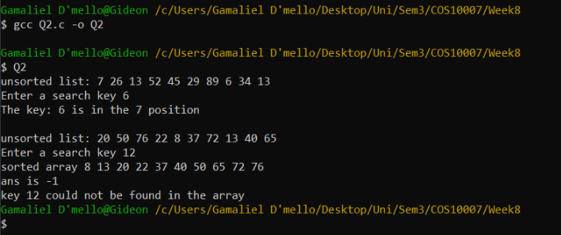

©Copyright: 2018 Swinburne University of Technology CRICOS: 0011D TOID: 3059
Week 8 Lab 12/11/2018
Version 2 Page 1 of 1

