SWE20004 Technical Software Development Semester 2 2019

Assignment 2 report

Name: Gamaliel M D’mello Student ID:102117407

Lab class: Thu / 12:30 / EN413 Tutor: Kai Renshaw

Due Date: Friday 11th October 2019 at 11:59 pm

Date Submitted: Friday 11th October 2019

Assignment Title: Card Validator

Program description

This Program accepts credit card numbers as an input and checks using luhn’s algorithm if it is a valid credit card by comparing the checksum and the last digit match

Inputs and Outputs
The inputs and outputs for this program are described in Table 1.

Table 1. Data dictionary:
Data to be stored | Sample data | Type of data | C++ type | Input method | In /  Out | Variable name
Card Num | 5 2 4 2 | integers | Int array | Asignment | In | Card[SIZE]
Size of the array | 20 | Integer | Const int | Define | N/A | SIZE
The value user types to end the program | -1 | Integer | Const int | Define | N/A | END
The length of the users input | 8 | Integer | Int | Increment, assignment | In | Count
The sum of even values excluding the last digit | 61 | Integer | Int | Assignment | In | even
The sum of odd digits excluding the last number | 43 | Integer | Int | Assignment | In | odd
The individual value used to get the number | 5 | Integer | Int | Cin | In | value
Checks if the value is valid | True | True of false | Boolean | Assignment | in | check
Counter | 1 | Integer | Int | Increment, assignment | In | I
Temp variable used to make calculation | 6 | Integer | Int | Assignment | In | Num
Check | 7 | Integer | Int | Assignment | In | Check
Total of sum 1 and sum 2 | 100 | Integer | Int | Assignment | In | Total

3. Algorithm
Program steps:
- Prompts users to input a value
- Terminates loop with END(-1)
- Calls print
- Goes trough loop and prints value
- Calls sum1 and saves value to return
- Checks if the values are even from the last digit
- If numbers are bigger than 9
- Separate the total and add it together
- Calls sum 2 and assigns it to odd
- Gets all the odd values from excluding the last digit
- Calculates the checksum by getting the total and multiplying by 9 and getting the last digit
- Prints out check and last digit
- If last digit and check match print valid
- If check and last digit don’t match
- Print invalid

Sum1 Coding logic
- Gets even number from rightmost
- Doubles it
- If number is greater than 9
- Take away 9
- Add value to the total

Sum2 Coding logic:
- Gets the odd numbers from rightmost
- Add value to the total

Checksum coding Logic:
- Totals sum1 and sum2
- Multiply it by 9
- Mod 10 to get the last digit

Source code:

/*Name: Gamaliel D'mello
Student id: 102117407
File name: 102117407_Assignment2
Purpose: Using a version of luhn's algorithm to determine
weather a credit card is valid or not
*/

#include<iostream>
#include<string>

#define SIZE 20
#define END -1

using namespace std;

//Function Prototype
int sum1(int card[], int count);
int sum2(int card[], int count);
int getnum();
void print(int card[], int count);
void checksum(int card[], int count, int total);

//Main calls other functions and
//has a loop to save the digits
// into the array
int main()
{
int i = 0;
int card[SIZE];
int count = 0;
int even;
int odd;

cout << "enter -1 when finished entering card number" << endl;
cout << "Enter Card number: " << endl;
for (i = 0;i < SIZE;i++)
{
card[i] = getnum();
if (card[i] != END)
{
count++;
}
else
{
break;
}
}

print(card, count);

even = sum1(card, count);
cout << "Sum 1 is: " << even << endl;

odd = sum2(card, count);
cout << "Sum 2 is: " << odd << endl;

checksum(card, count, even + odd);

return 0;
}

//Getnum Is a used to Validate if a number is within
//the limits and if it is it will return the value
//to main where its been called
int getnum()
{
int value = 0;
bool check;

do
{
cin >> value;
if ((value >= 0) && (value <= 9)||value == END)
{
check = false;
}
else
{
cout << value << "is Not A valid Number Please re-enter: ";
check = true;
}
} while (check);
return value;
}

//the print Function gets the array and its length
//to print the contents of the array to the screen
void print(int card[], int count)
{
int i = 0;
cout << "Card Number is: ";

for (i = 0;i < count;i++)
{
cout << card[i];
}

cout << endl;
}

//Sum 1 gets the rightmost value after the last digit
//and goes trough the array and adds the values
//to be returned to main
int sum1(int card[], int count)
{
int i;
int num;
int even = 0;

cout << "The Numbers for Sum 1 are: ";

if (count % 2 == 0) //if lenght of array is even
{
for (i = 0;i < count - 1;i += 2) //starts at 1st digit
{
cout << card[i] << " ";
num = card[i];
num *= 2;//doubles the number
if (num > 9)
{
num -= 9;//takes away 9 as any single digit number thats
// been doubled and the value is greater than
// 9, its values when seperated and added together
// is the same as taking away 9
}

even += num;
}
}
else
{
for (i = 1;i < count - 1;i += 2)//starts at the 2nd digit
{
cout << card[i] << " ";
num = card[i];
num *= 2;
if (num > 9)
{
num -= 9;
}

even += num;
}
}
cout << endl;
return even;
}

//sum 2 gets every 2nd from the from the rightmost value
//and returns the value to main
int sum2(int card[], int count)
{
int i = 0;
int odd = 0;

cout << "The Numbers for Sum 2 Are: ";

if (count % 2 == 0)
{
for (i = 1;i < count - 1;i += 2)
{
cout << card[i] << " ";
odd += card[i];
}
}
else
{
for (i = 0;i < count - 1;i += 2)
{
cout << card[i] << " ";
odd += card[i];
}
}

cout << endl;
return odd;
}

//Checksum gets the checksum vaue and uses that to test if
//a card is valid depending on checksum and the last digit
//it will print an appropriate message
void checksum(int card[], int count, int total)
{
int check = 0;
check = (total * 9) % 10;

cout << "Check Sum is: " << check << endl;
cout << "Last Digit is: " << card[count - 1] << endl;

if (check == card[count - 1])
{
cout << "Check Sum: " << check << " And Last Digit: " << card[count - 1] << " Are the same: Valid Credit Card Number" << endl;
}
else
{
cout << "Check Sum: " << check << " And Last Digit: " << card[count - 1] << " Are not the same: Invalid Credit Card Number" << endl;
}
}

Screenshots showing working program (Show all possible outcome):
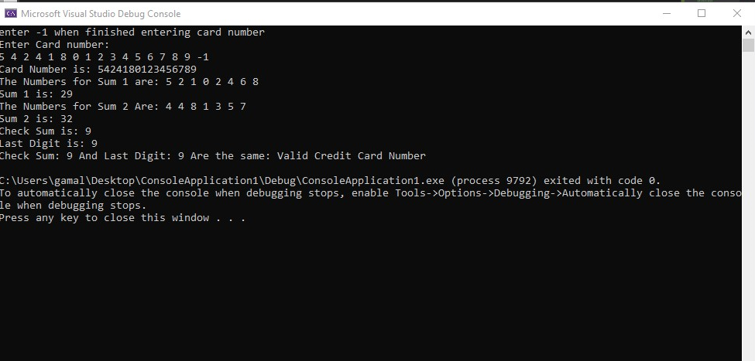

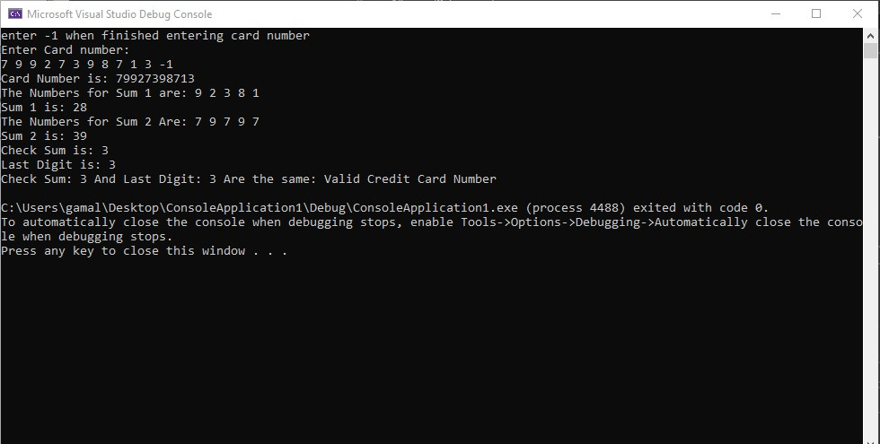

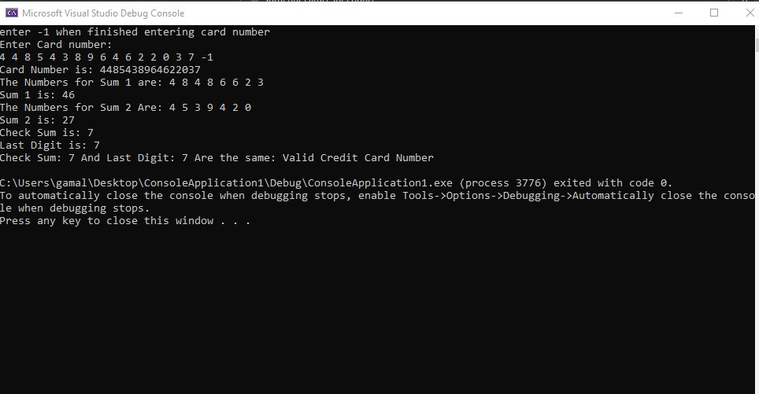
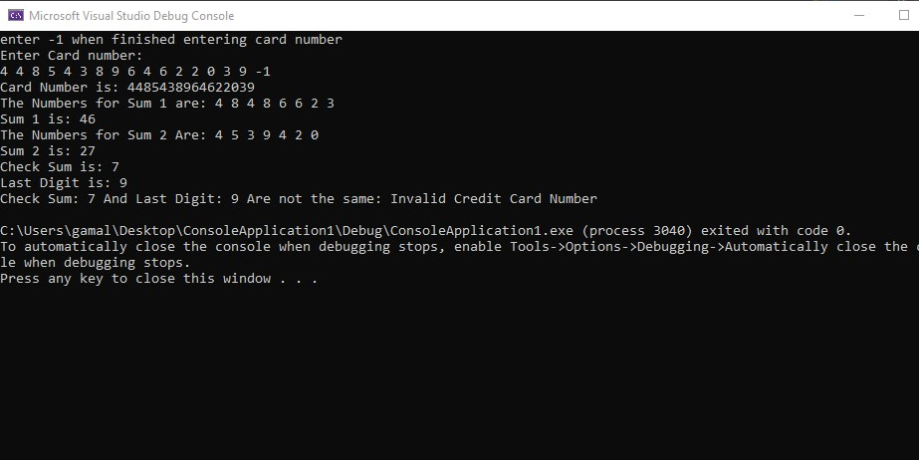

Task 5.3

Program description
A console based game that allows you to guess the auto random generated number

Source Code
- #include<iostream>
- #include<string>
- #include <cstdlib>
- #include<ctime>

- int ActualNum();
- bool Check(unsigned int Count, unsigned int Actual);
- void Msg(unsigned int Count);

- using namespace std;

- int main()
- {
- bool Eventloop = true;
- while (Eventloop)
- {
- bool Ans = true, error = true;
- unsigned int guess;
- int Count = 0, Actual = 0;

- Actual = ActualNum();

- cout << "I have a number between 1 and 1000." << endl;
- cout << "Can you guess my number?" << endl;
- cout << "Please type your first guess" << endl;

- cin >> guess;

- while (Ans)
- {
- bool Checker;
- Checker = Check(guess, Actual);
- Count = Count + 1;

- if (Checker == false)
- {
- cin >> guess;
- }

- if (Checker == true)
- {
- Msg(Count);

- char choice;

- cout << "Excellent! You guessed the number!" << endl;
- cout << "Would you like to play again? (y or n)" << endl;
- cin >> choice;

- if (choice == 'y')
- {
- Ans = false;
- }
- if (choice == 'n')
- {
- Ans = false;
- Eventloop = false;
- }

- }
- }
- }
- return 0;
- }

- int ActualNum()
- {
- srand(time(NULL));
- return rand() % 1000 + 1;
- }

- bool Check(unsigned int guess, unsigned int Actual)
- {
- string message;

- if (guess < Actual)
- {
- cout << "Too Low" << endl;
- }
- if (guess > Actual)
- {
- cout << "Too High" << endl;
- }
- if (guess == Actual)
- {
- return true;
- }
- return false;
- }

- void Msg(unsigned int Count)
- {
- if (Count < 10)
- {
- cout << "Either you know the secret or you got lucky!" << endl;
- }
- else if (Count == 10)
- {
- cout << "Ahah! You know the secret!" << endl;
- }
- else if (Count > 10)
- {
- cout << "You should be able to do better!" << endl;
- }

- }

Screenshots showing working program
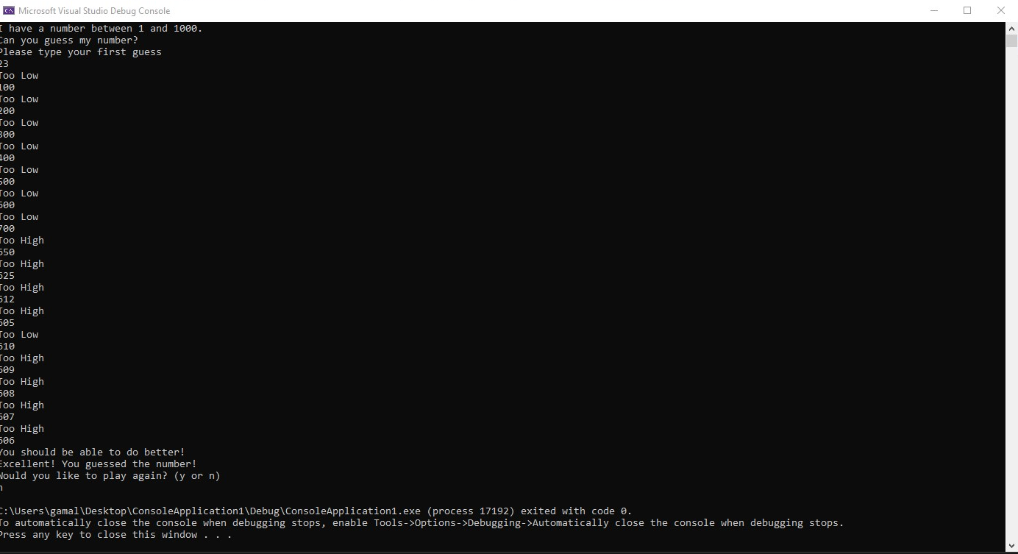

Task 5.4

Program description

Source Code
- #include<iostream>
- #include<string>
- #include <cstdlib>
- #include<ctime>

- int RandomNumberGenerator();
- int roll();
- int again(int firstRoll, int bet, int Balance);
- int Bank(bool win, int value, int Balance);
- bool check(int Balance);
- void message(int value, int type);

- using namespace std;

- int main()
- {
- int bet, total, Balance = 1000, count = 0;
- bool playAgain = true, invalid;
- srand (time(NULL));

- while (playAgain)
- {
- bet = 0;
- cout<<"Your Bank Balance is: "<<Bank(true,bet, Balance )<<endl;
- cout<<"What is your bet?: "<<endl;

- if (Balance > 3000)
- {
- message(20, 119);
- }

- invalid = true;
- while (invalid)
- {
- invalid = false;
- cin>>bet;

- if (bet>Balance)
- {
- cout<<"Invalid bet"<<endl<<"You Do not have the required Funds"<<endl;
- invalid = true;
- }
- if (cin.fail())
- {
- cout<<"Invalid bet"<<endl<<"Invalid Value used for Funds"<<endl;
- invalid = true;
- cin.clear();
- cin.ignore(256, '/n');
- break;
- }
- }

- if (bet < 100)
- {
- count +=1;
- message(count, 76);
- }
- if (bet == Balance)
- {
- message(20, 65);
- }

- total = roll();

- if (total == 7 || total == 11)
- {
- cout<<"Player Win" << endl;
- Balance = Bank(true, bet, Balance);
- cout<<"Your Bank Balance is: "<<Balance<<endl;
- }
- else if (total == 2 || total == 8 || total == 12)
- {
- cout << " Player Lose" << endl;
- Balance = Bank(false, bet, Balance);
- cout<<"Your Bank Balance is: "<<Balance<<endl;
- }
- else
- {
- cout<<endl;
- Balance = again(total, bet, Balance);
- }
- playAgain = check(Balance);
- }
- return 0;
- }

- int RandomNumberGenerator()
- {
- return rand() %6 + 1;
- }

- int roll()
- {
- int dice1, dice2,total;
- dice1 = RandomNumberGenerator();
- dice2 = RandomNumberGenerator();
- total = dice1 + dice2;
- cout<<"Dice 1:"<<dice1<<endl;
- cout<<"Dice 2:"<<dice2<<endl;
- cout << "Player's throw = " << total<<endl;
- return total;
- }
- int again(int firstRoll, int bet, int Balance)
- {
- int total;
- bool win = true;
- while (win)
- {
- total = roll();
- if (total == firstRoll)
- {
- cout << "Player Win" << endl;
- win = false;
- Balance = Bank(true, bet, Balance);
- cout<<"Your Bank Balance is: "<<Balance<<endl;
- }
- else if (total == 7)
- {
- cout << "Player Lose" << endl;
- win = false;
- Balance = Bank(false, bet,Balance);
- cout<<"Your Bank Balance is: "<<Balance<<endl;
- }
- else
- {
- cout<<endl;
- }
- }
- return Balance;
- }

- int Bank(bool win, int value, int Balance)
- {
- if(win)
- {
- Balance += value;
- }
- else
- {
- Balance -= value;
- }
- return Balance;
- }

- bool check(int Balance)
- {
- bool playAgain, invalid = true;
- char choice;

- if (Balance==0)
- {
- cout<<"You've Busted"<<endl;
- playAgain = false;
- }
- else if (Balance > 0)
- {
- cout<<"Play Again?: ";
- while (invalid){
- cin>>choice;
- if(choice == 'y')
- {
- playAgain = true;
- invalid = false;
- }
- else if(choice == 'n')
- {
- playAgain = false;
- invalid = false;
- }
- else
- {
- invalid = true;
- }
- }
- }
- return playAgain;
- }

- void message(int value, int type)
- {
- if(value >10)
- {
- if (type == 65)
- {
- cout<<"Oh, You're Going for broke, huh"<<endl;
- }
- else if (type == 199 )
- {
- cout<<"You're up big. Now's the time to cash out"<<endl;
- }
- else if (type == 76)
- {
- cout<<"Aw cmon, take a chance!"<<endl;
- }
- }
- }

Screenshots showing working program
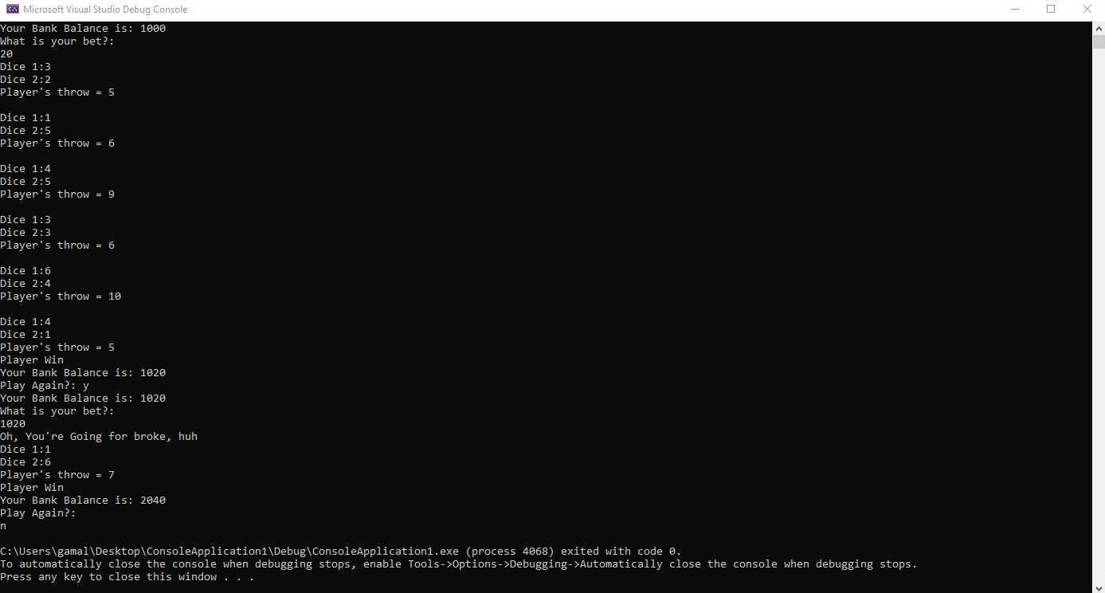

Task 7.3

Program description

A conole based application that checks all every character inputted and checks if it a number or a alphabet and sorts the array and prints the most common letter and how often it occurs

Source Code
- #include<iostream>
- #include<string>
- #define SIZE 20

- using namespace std;

- bool check(char input);
- void Swap(char *ch1, char *ch2);
- void Sort(char input[]);
- void frequency(char input[]);

- int main()
- {
- int i = 0, k = 0;
- char in, input[SIZE];
- bool sanitized = false;
- cout<<"Enter 20 Alphabets"<<endl;
- for (i = 0;i<SIZE;i++)
- {
- do
- {
- cin>>in;
- sanitized = check(in);
- if (sanitized == false)
- {
- cout<<in<<" is not an Alphabet"<<endl;
- }
- } while (sanitized==false);

- input[i]=in;
- for (k = 0;k<i;k++)
- {
- if (input[i] == input[k])
- {
- cout<<in<<" is a duplicate Letter"<<endl;
- }
- }
- }
- Sort(input);

- for (i = 0;i<SIZE;i++)
- {
- cout<<input[i];
- }
- cout<<endl;

- frequency(input);
- return 0;
- }

- bool check(char input)
- {
- if(!(isdigit(input)))
- {
- return true;
- }
- return false;
- }

- void swap(char *ch1, char *ch2)
- {
- int temp = *ch1;
- *ch1 = *ch2;
- *ch2 = temp;
- }

- void Sort(char input[])
- {
- int i, j;
- bool swapped;
- for (i = 0; i < SIZE-1; i++)
- {
- swapped = false;
- for (j = 0; j < SIZE-i-1; j++)
- {
- if (input[j] > input[j+1])
- {
- swap(&input[j], &input[j+1]); //sends the address of the two values (Call by reference)
- swapped = true;
- }
- }

- if (swapped == false)
- {
- break;
- }
- }
- }

- void frequency(char input[])
- {
- int j = 0, k = 0,temp = 0, mode = 0, fre;
- for (j = 0; j<SIZE;j++)
- {
- for (k = 0;k<SIZE;k++)
- {
- if (input[j] == input[k])
- {
- temp++;
- }
- }

- if(temp>mode)
- {
- mode = temp;
- fre = j;
- }
- temp = 0;
- }
- cout<<"The Most Frequent Letter is "<<input[fre]<<" mode is "<<mode<<endl;
- }

Screenshots showing working program
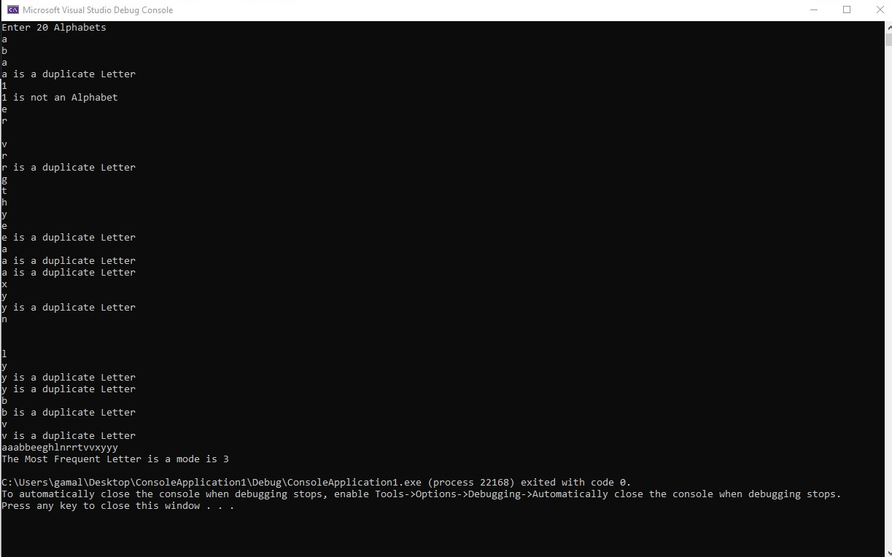

Task 7.4

Program description
A game that “rolls” a dice 50,00 times and checks the face values of the dice and adds it to an array and checks the total times that both dice had the same face value if the value is grater than 8350 the player wins otherwise the player losses

Source Code
- #include<iostream>
- #include<string>
- #include<ctime>
- #include<cstdlib>
- #include<iomanip>

- #define SIZE 7
- #define WIN 8350

- using namespace std;

- int random_Number_Generator();
- void Borders();

- int main()
- {
- srand(time(NULL));
- int roll[SIZE][SIZE] = { 0 };
- int i;
- int j;
- int dice1;
- int dice2;
- int total = 0;

- for (i = 0;i <= 50000; i++)
- {
- dice1 = random_Number_Generator();
- dice2 = random_Number_Generator();

- roll[dice1][dice2] += 1;
- }

- Borders();
- for (i = 1;i < SIZE; i++)
- {
- cout << " | ";
- for (j = 1;j < SIZE; j++)
- {
- cout << setw(5) << roll[j][i] << " | ";
- }
- cout << endl;
- }
- Borders();

- cout << "The Sum of The Diagonal Elements are: " << endl << endl;

- for (i = 1;i < SIZE;i++)
- {
- cout << roll[i][i] << " +" << endl;
- total += roll[i][i];
- }
- cout << "___________" << endl;
- cout << total << endl;

- if (total >= WIN)
- {
- cout << total << " is Greater than " << WIN << " The Player Has Won the game :)" << endl;
- }
- else
- {
- cout << total << " is Less than " << WIN << " The Player Has Lost the game :(" << endl;
- }

- return 0;
- }

- int random_Number_Generator()
- {
- return (rand() % 6 + 1);
- }

- void Borders()
- {
- int i = 0;

- cout << " |";

- for (i = 0; i < 40;i += 7)
- {

- cout << " " << setw(7) << setfill(' ') << setw(7) << setfill('-');
- cout << " |";
- }

- cout << endl;
- cout << setfill(' ');

- }

Screenshots showing working program
