 | University of Management and Technology  School of Systems and Technology  Software Engineering Department
Course: CC211: Data Structures and Algorithms
Campus ID: _____________________________
Section: _________
Instructor: Arifah Azhar
Exam: Final Exam
Date: July 8, 2025
Time Allowed: 120 minutes

DO NOT OPEN THIS EXAM UNTIL TOLD TO DO SO!!!

Instructions:
- These instructions must be followed strictly. Failure to do so may result in serious grade loss.
- This is NOT an open book / open notes examination.
- You are NOT allowed to:

  - Talk to anyone once the exam begins.
  - Leave the exam room and then return.
  - Think in the air or see here and there.
  - Wear a mask, cap, digital/smart watch.
  - Use a communication device such as a cell phone, pager, and email device
  - Borrow stationary, calculator or any other material from other students.
  - Continue holding a writing instrument in your hands upon the “Stop Writing/ Pens Down” announcement by the invigilator.
- Write your answers only in the space provided against each question, and write legibly to get any credit.
- Solve only Q4 on answer sheet only.
- Please count the number of pages and make sure that no page is missing from this book. There are total 7pages (including this title page).
- Manage time properly, and try to attempt easy problems first.

All the Best!!!

Problem No. | 1 | 2 | 3 | 4 | Total
CLO | 1 | 2 | 3 | 4
Max. Marks | 5 | 20 | 10 | 20 | 55
Obtained Marks

- [5 points] Analyze the code snippet [CLO2]
int main() {
LinkedList list;
list.insertAtEnd(10);
list.insertAtEnd(20);
list.insertAtEnd(30);
list.displayList();

Node temp = list.getHeadCopy();
temp.printNode();
return 0;
}

class Node {
private:
int data;
Node* next;
public:
Node(int d, Node* n = nullptr) : data(d), next(n) {}
Node(const Node& other) {
data = other.data;
next = other.next;
cout << "[Copy Constructor Called] ";
}
int getData() const { return data; }
Node* getNext() const { return next; }
void setData(int d) { data = d; }
void setNext(Node* n) { next = n; }
void printNode() const {
cout << data << " ";
}
};
class LinkedList {
private:
Node* head;
public:
LinkedList() : head(nullptr) {}
void insertAtEnd(int value) {
Node* newNode = new Node(value);
if (!head) {
head = newNode;
return;
}
Node* current = head;
while (current->getNext()) {
current = current->getNext();
}
current->setNext(newNode);
}
void displayList() const {
Node* current = head;
while (current) {
current->printNode();
current = current->getNext();
}
cout << endl;
}
Node getHeadCopy() const {
return *head;
}
};
A | What is the exact output of the above program? [2]
B | Clearly explain which line triggers the copy constructor and why. [1+2]

- [20 points] Analyze and Apply Logic of DSA to the following Short Questions [CLO2, CLO3]
- What issue do you identify with respect to the following BSTs?
- 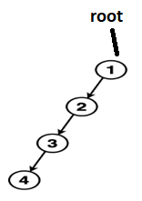b. 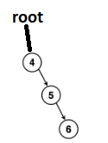
Issue [2]

- Could this issue be resolved due to selection of another DS? __________ [1]
- If you specified yes above, which other DS could you use to improve the above structures? ________________________________________________ [1]
- Why did you choose this particular structure? [2]

- Evaluate the post-order traversal sequence 1, 3, 2, 6, 5, 9, 12, 11, 8, 4

  - construct the corresponding Binary Search Tree (BST) [3]

  - Also explain briefly how the tree is reconstructed from this post-order sequence.[2]

- For the following scenario, recommend a data structure (from those you've studied) and justify your choice in 2–3 lines. A flight booking system where you need to maintain a sorted list of available flights and book/cancel flights as needed. The frequency of flight bookings (booking/cancellation) is high [2]

- Following code is written to use binary search algorithm to search in an array.
  - Is there any pre-requisite for using binary search? Why? _________________________________________________________________
____________________________________________________________________[1+1]
  - Is the code working correctly? If not, identify and rectify errors. The errors might be syntax based or logical [5]
bool binarySearch(int arr[], int low, int high, int x)
{
int mid = low + (high - low) / 2;
if (high <= low) {

if (arr[mid] == x)
return mid;

if (arr[mid] > x)
return binarySearch(arr, low-1, mid + 1, x);

return BinarySearch(*arr, mid + 1, high-1, x);
}
retun -1;
}

- [10 points] Expression Evaluation using stacks [CLO1]
SST-SE has decided to launch their own IDE including the editor, compiler, translator, linker and debugger. Your team is responsible for implementing the compiler for this IDE. The first task that you do is decide a method for expression evaluation.
- How would the user input data? Select one. Prefix / infix / postfix [1]
- Which type of expression will the compiler use to create object code? Select one. Prefix / infix / postfix [1]
- Why?________________________________________________________________
__________________________________________________________________[1]
- Convert the following infix expression to its corresponding polish notation using stack you can use the precedence and associativity chart on the next page for reference. [7]
(((A << B) ^ (C >> D)) &= ((E |= F) ^ (G ^= H))) >>= (I <<= J)

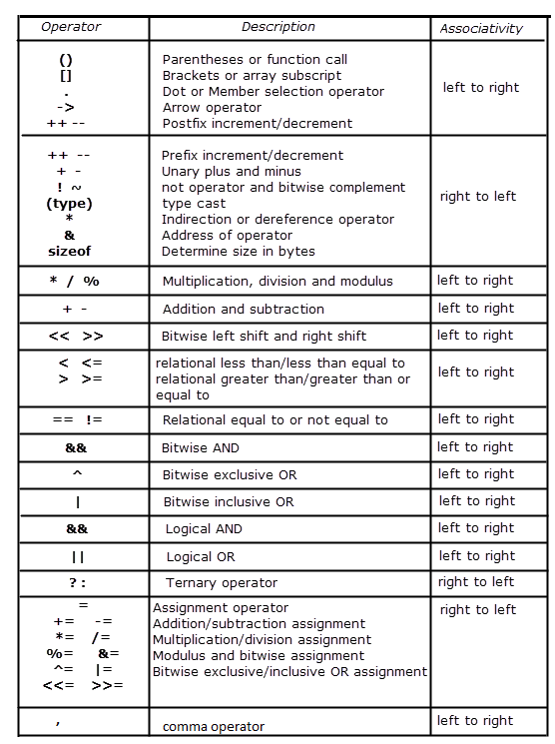

- [20 points] Visual Representation (AVL Tree) [CLO4]

Analyze and Build an AVL based on following information with explanation (of operation being performed on each step with types of rotation you will have to perform)

SST has asked you to create a digital yearbook system for its final year student. The yearbook contains a list of students, each with a unique ID, name, and GPA. SST wants to ensure that student data is quickly accessible and efficiently maintained. To achieve this, you are required to build an AVL tree (a self-balancing binary search tree) to store the students' information based on their names. The AVL tree should keep the student data balanced, providing efficient search, insertion, and deletion operations.

Perform following operations on tree, insert T, delete D, updateU

T("Mariam"),
T("Maaz"),
T("Mahiya"),
U(“Mariam”, “Maryam”),
U(“"Mahiya" , “Mahira”),
T("Muneeb"),
T("Maya"),
D(“Maaz”),
T("Misha"),
T("Minahil"),
T("Mahnoor"),
T("Mehwish"),
T("Moiz"),
D(“Moeez”),
D(“Moiz”),
T("Moiz")

