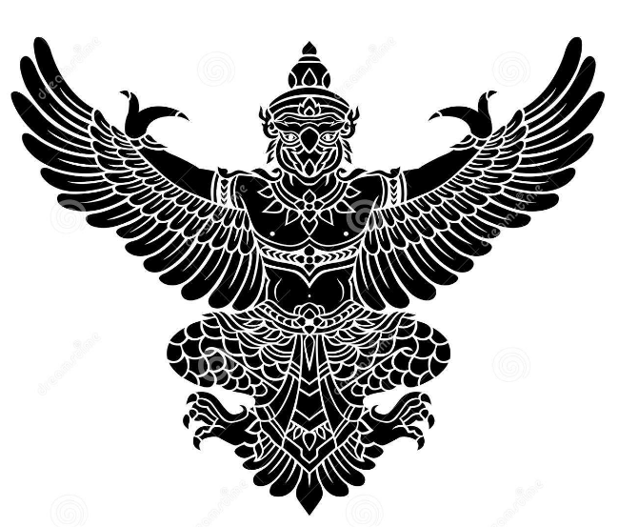

**NEGATIVE PRESSURE BOOTH**

**-**Team

Vishwakarma Institute of Technology

Yatharth GARG

Ansh GAIKWAD

Arshad PATEL

**INTRODUCTION**

In today’s highly contagious environment, it is important to reduce the spread of the COVID-19 virus. One way to reduce the spread of infection at the community level is through early detection, which requires that large numbers of people be tested in a short time. Presently, testing is limited to people who are showing symptoms of COVID-19. To test more widely, hospitals need to build facilities for mass testing. Traditional laboratory-based sample collection methods are not suitable for testing large numbers of people during the community transmission phase. A separate sample collection method needs to be implemented for the general public following BSL-2 standards. This document proposes the design of a mobile COVID-19 sample collection booth that can be assembled quickly and moved easily to facilitate sample collection from urban and remote areas. The safety of the sample collection staff and persons visiting the booth to be tested has utmost priority according to BSL-2 standards.

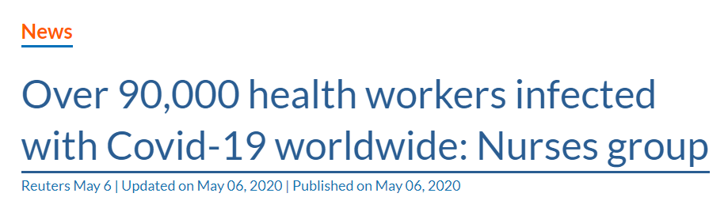

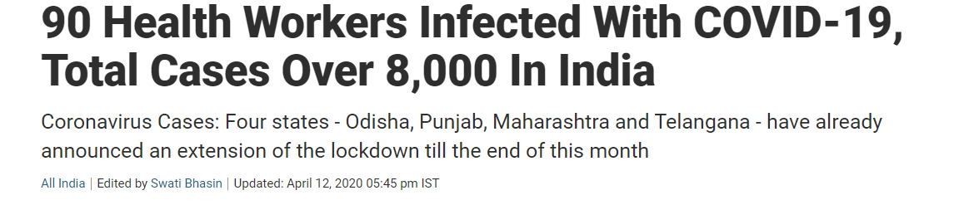

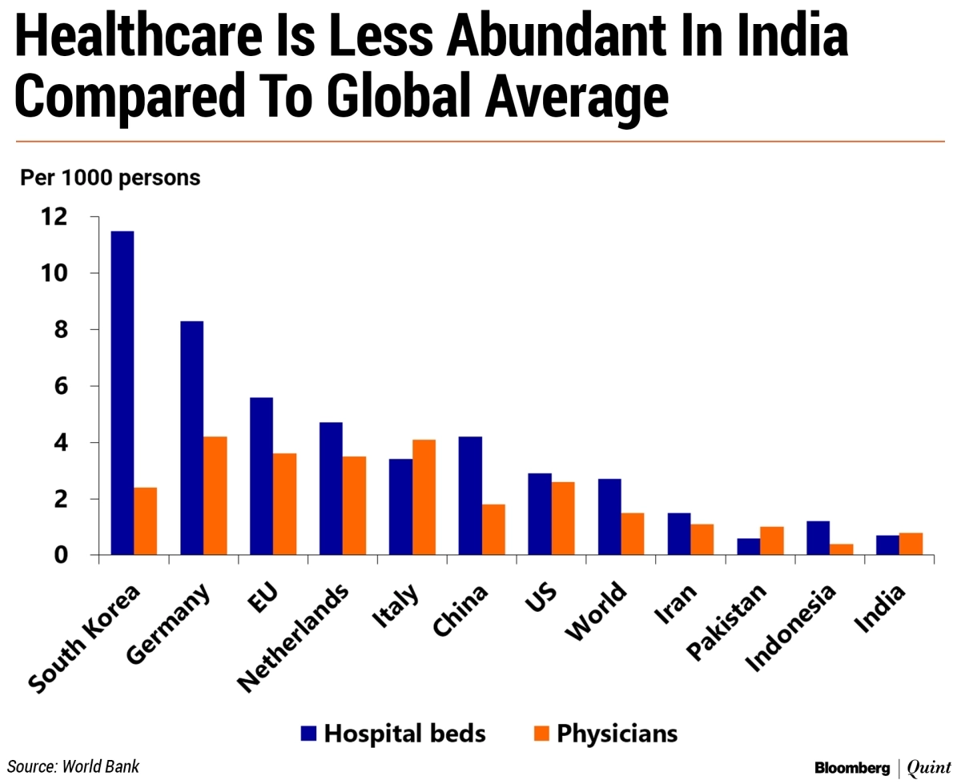

**OBJECTIVE**

The main objective of the Negative Pressure Booth is to avoid direct contact between the sample collecting staff and the person providing the sample. Further, the next person visiting the booth should not become infected by the nasal or oral plumes of the previous person. The overall sample collection time including changing plastic gloves and disinfecting the booth should not be more than five to seven minutes per person, so that a large number of samples can be collected in a day. The NPB is built on the negative pressure room concept, which involves maintaining a negative pressure inside booth so that air inside the room does not leak out through the gaps. Air from inside the booth is discharged outside in a controlled manner after filtering.

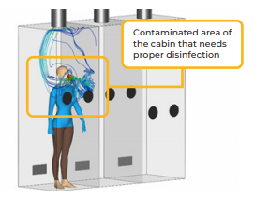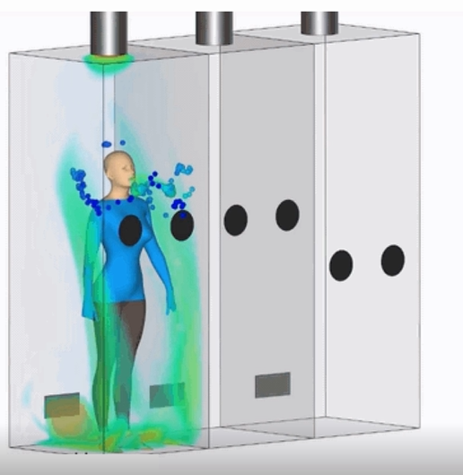

**METHODOLOGY**

In NPB, negative pressure is maintained in the booth to prevent leakage of any contaminants outside. Smoke detection can be done at the key openings to ensure that air is moving inwards. Ventilated air is discharged outside the room and filtered through a portable HEPA filtration unit to discard cleaned exhaust to the outside environment. The air flow rate is set to around 24 air changes per hours that it takes approximately 2.5 minutes to ventilate most of the room air. The air flow rate can be controlled using a flow control valve before the HEPA filter/blower unit. The medical staff interacts with the patient through an isolation glove box to avoid physical contact or direct air contact. The flow rate is selected so that the expelled gases from the patient’s breathing, coughing or sneezing are directly ventilated outward without much circulation in the room.

NPB consists of multiple sample collection cabins with dimensions of 2.5ft. x 2.5 ft. x 7 ft., each with a door. A square 45-degree downward louver is fitted 6 in. above the ground on the door of the cabin. A circular exhaust duct is fitted in the centre at the top of cabin. The transparent wall of the cabin has two circular holes for glove-box-style hand gloves. The exhaust duct is connected to an exhaust system consisting of a HEPA filter and exhaust blower. The sizes of the inlet vent and circular exhaust are selected such that the flow area at the inlet and exhaust are similar. Below table shows the overall dimensions and operating parameters for the cabin.

|  |  |
| --- | --- |
| Parameter | Value |
| Cabin dimensions | 2.5 ft. x 2.5 ft. x 7 ft. |
| Inlet vent size | 10 in. |
| Inlet vent location | 6 in. above ground |
| Exhaust vent diameter | 8 in. |
| Air flow rate | 24 air changes per hour (ACH) |
| Exhaust velocity | ~1fps |

**MATERIALS REQUIRED FOR NPB**

NPB consists of multiple sample collection cabins with dimensions of 2.5ft. x 2.5 ft. x 7 ft., each with a door. A square 45-degree downward louver is fitted 6 inch above the ground on the door of the cabin. A circular exhaust duct is fitted in the centre at the top of the cabin. The transparent wall of the cabin has two circular holes for glove-box-style hand gloves. The exhaust duct is connected to an exhaust system consisting of a HEPA filter and exhaust blower. The sizes of the inlet vent and circular exhaust are selected such that the flow area at the inlet and exhaust are similar. Below table shows the overall dimensions and operating parameters for the cabin.

1. Acrylic sheets
2. Aluminium frame
3. 45-degree downward louver
4. 125 cubic feet per minute (CFM) HEPA filter
5. Power backup unit
6. 8-inch ID flexible hose
7. Fumigation system
8. Rubber gloves.

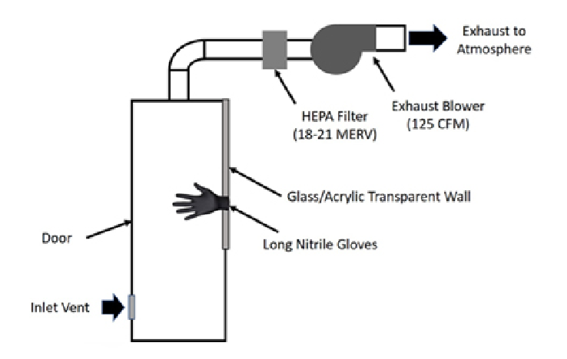

**STEPS FOR OPERATING NPB**

The booth consists of a negative pressure cabin for the person giving the sample and works on the principle of a biosafe, isolation glove box design. The sample is collected in the following manner:

1. Sample collecting staff stays outside of the cabin wearing PPE kit.
2. Person enters the disinfected cabin, removes mask and talks by speaker phone with the sample collecting staff to provide the required information.
3. Sample collecting staff collects the swab sample using glove-box-style hand gloves fitted to the cabin.
4. Person leaves the cabin after putting the mask back on.
5. A staff member of the sample collection team changes the plastic gloves, disinfects the room and puts the sample in a box.
6. The cabin is then ready for the next person.

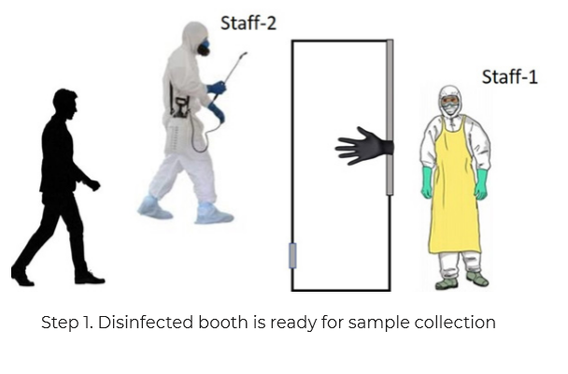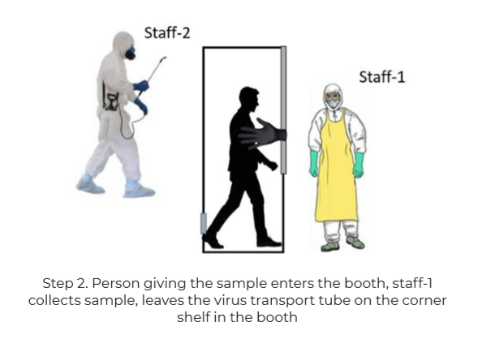

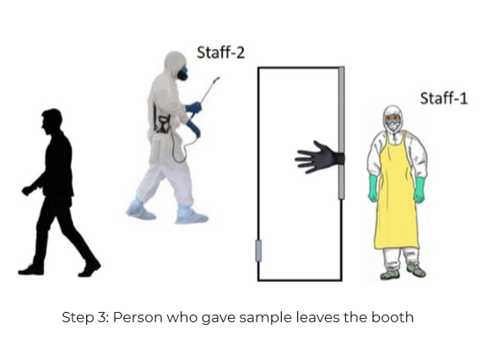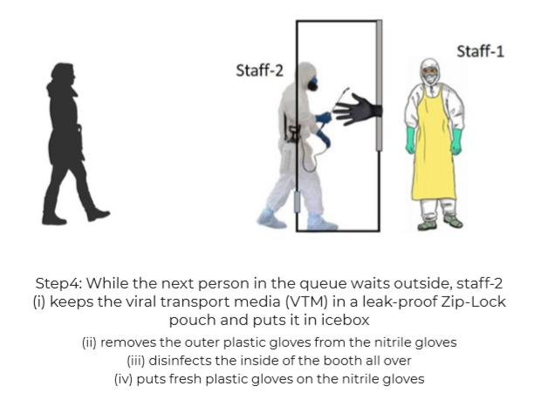

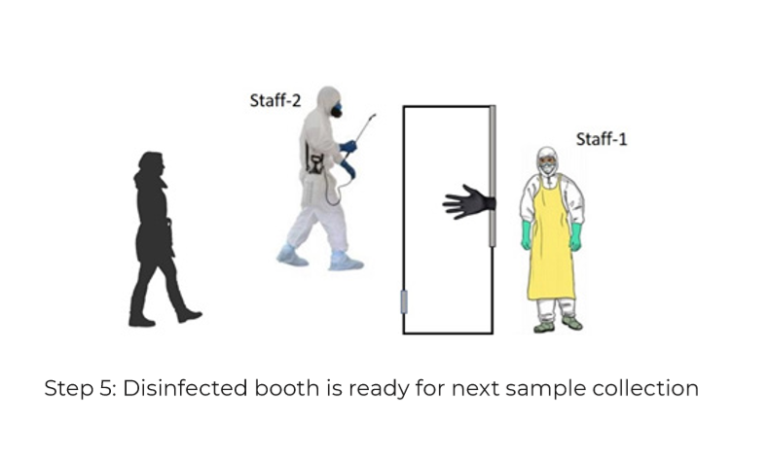

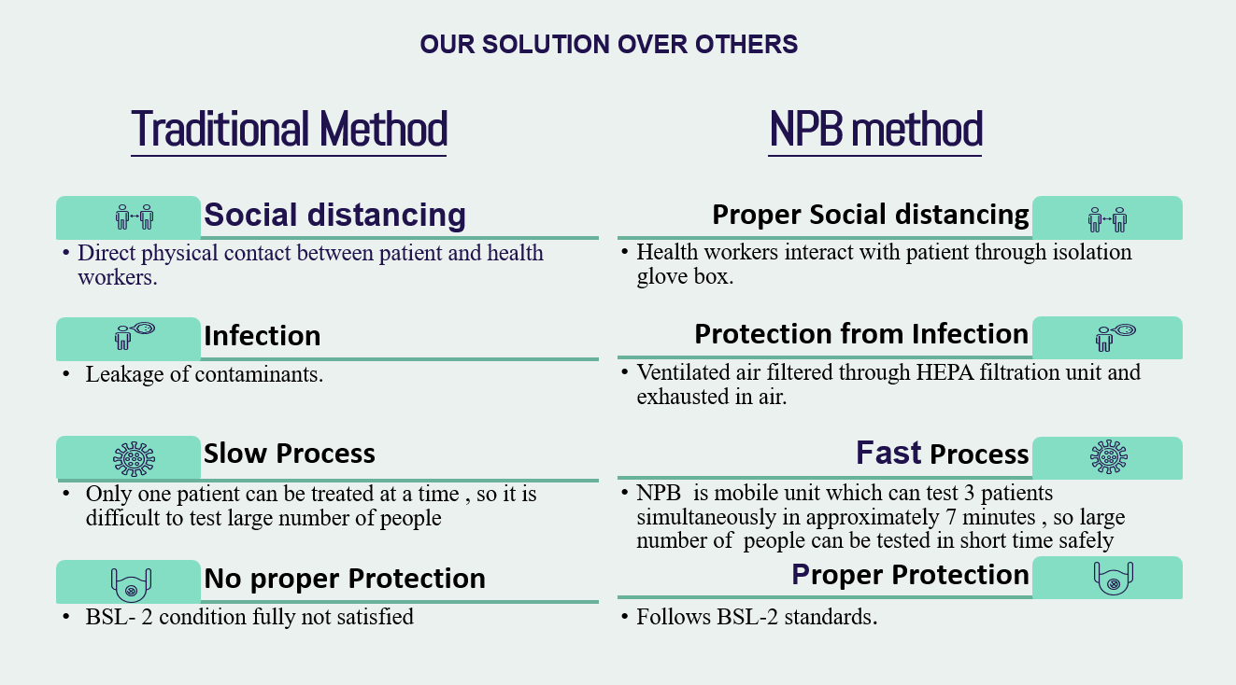

**SUMMARY**

The NPB, is mounted on a small truck as a mobile unit. The booth can be built quickly to test large numbers of patients at a rate of roughly seven minutes per patient. BSL level 2 specifications are achieved with the correct choice of materials listed in World Health Organization guidelines. The nasal and oral plumes are swept out of the cabin easily toward the exhaust without a large re-circulation within the cabin. Air from inside the booth is discharged outside in a controlled manner after filtering. Thus, the design is suitable and ensures minimum contamination of the cabin in case the person providing the sample is COVID-19 positive.