Matthew Gamboa

Module 7.2

April 28, 2024

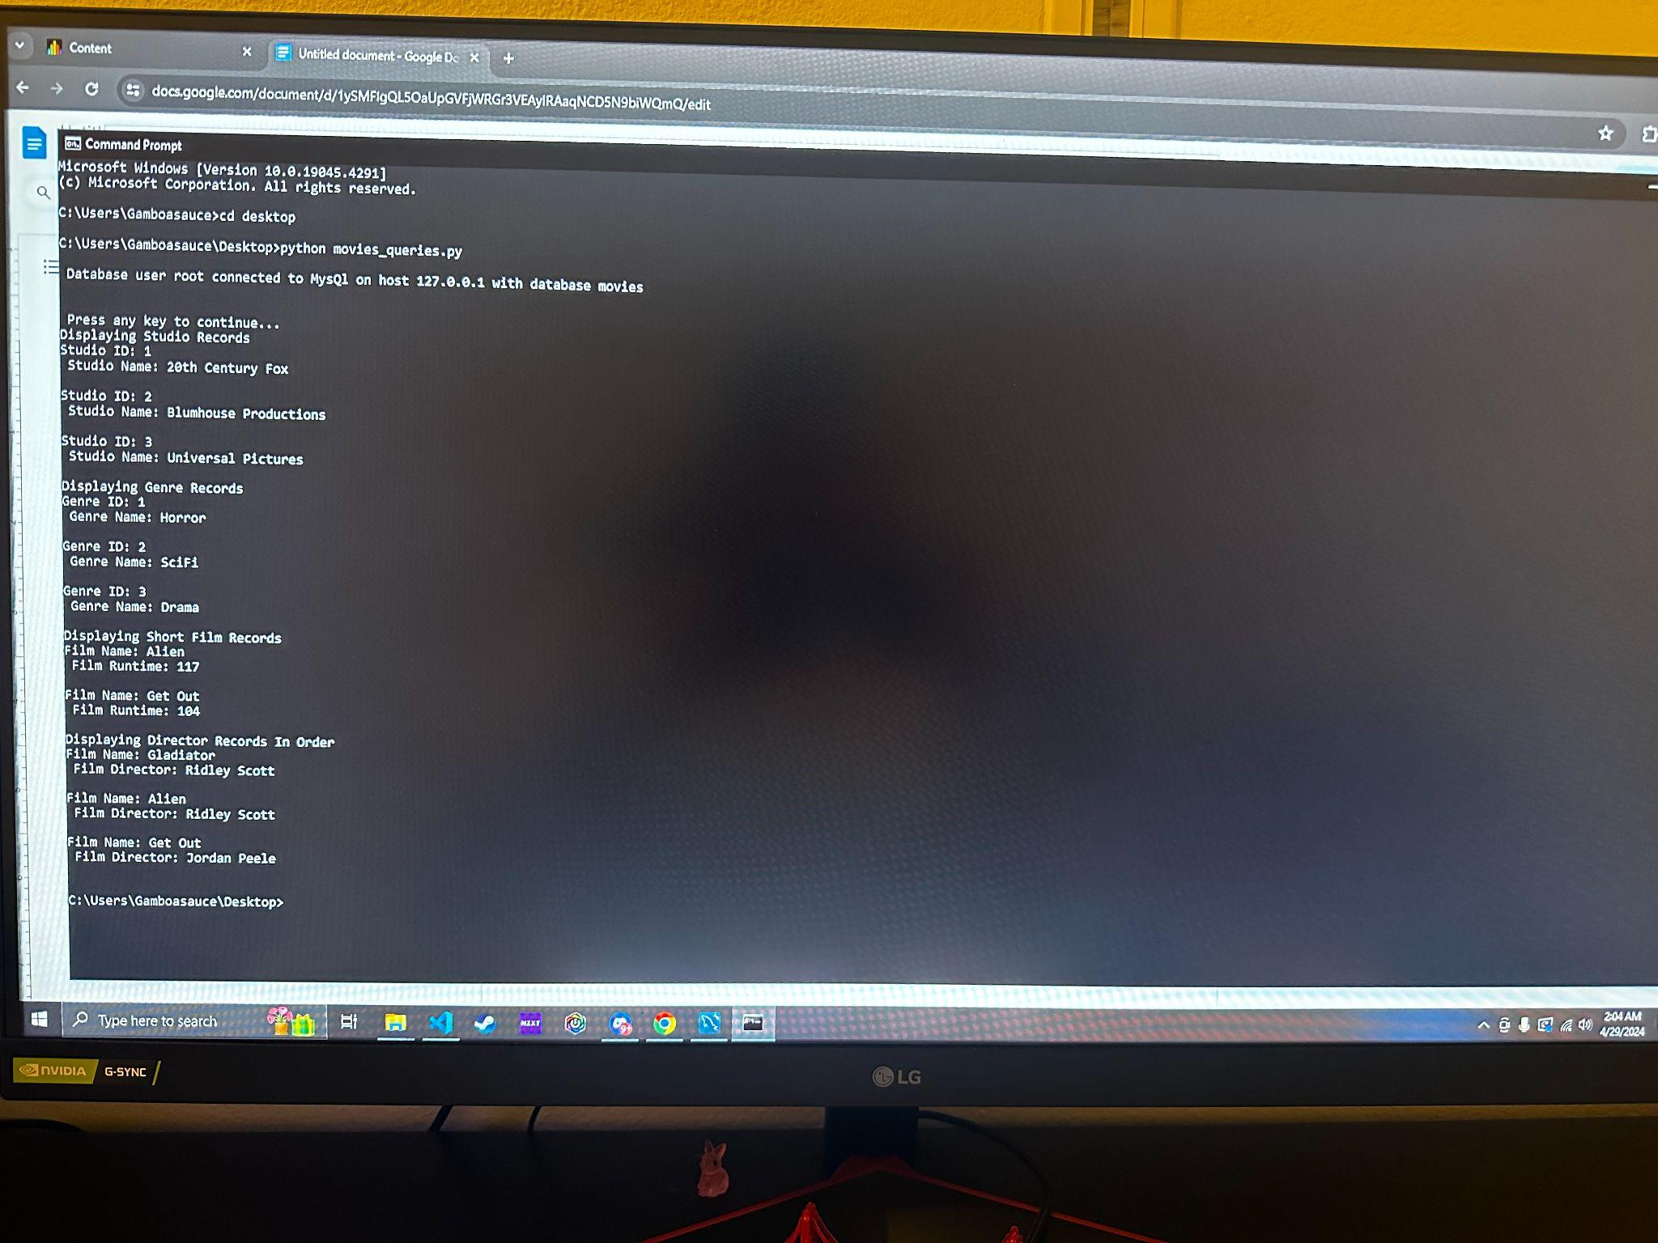

GitHub Link: https://github.com/Gamboasauce/csd-310